G. Lourinho
P. S. D. Brito
L. F. T. G. Rodrigues
Effluent streams originating from swine production can be a major cause of point-source pollution and very dangerous for the surrounding environment. In this work, biogas and biomethane potential of swine-derived effluents were assessed under mesophilic conditions (37 °C) among different production stages (Farrowing, Gestation, Weaners, and Fattening) in order to investigate the suitability of anaerobic digestion as a treatment technology and energy recovery tool. Anaerobic biodegradability and kinetic modeling of the different wastewaters were also evaluated in order to better understand the degradation patterns of each waste stream. The specific methane yields for each substrate wastewater were successfully determined gravimetrically and ranged from 293.9 ± 31.6 mL CH4.gVS added for Gestation, 248.0 ± 246.6 mLCH4.gVS added-1 for Fattening, and 172.4 ± 1.62 mLCH4.gVS added-1 for Weaners. Farrowing wastewater presented no detectable biomethane production in the studied conditions probably due to very low organics content. Anaerobic biodegradability results showed that wastewaters from Gestation (60.28%) had a higher biodegradability index when compared with Fattening (37.96%) and Weaners (45.97%) stages. The Logistic and Gompertz models fitted the experimental results well and may provide valuable knowledge for the treatment of specific swine wastewater streams at different growth stages within a perspective of producing biogas. The results obtained in this work should be encouraging for on-farm energy recovery and anaerobic digestion technology viewed as an important contributor to alleviate the increasing energy demand within the swine industry. However, as indicated by biodegradability data and organics removal percentages, biological treatment does not comprise a complete solution and should be complemented with other treatment methods.

Introduction and scope

General considerations about swine wastewater (SW) production
Livestock production, including swine production, is one of the most important agricultural sub-sectors in the European Union (EU), with a long tradition across all member states. In 2015, the pig farming sector accounted for more than 8% of agricultural output [1] in the EU with most of the production depending on intensive methods conducted in large farms. In fact, the current trend across Europe involves large numbers of animals concentrated in small regional clusters in countries like Denmark, Germany, Spain, France, Poland and the Netherlands, which accounted for more than 70 % of pig population [1] in 2015. The role of Portugal in this European pig farming scenario is still very limited with the country hosting a pig population of about 2 million heads in a universe of 148 million (about 1,5 %, 2015 data) [1]; however, the general trend for intensive production, concentration in small areas, and increase on the average farm size is the same as in Europe, with many environmental impacts at a local level well documented.
Despite meat consumption being somewhat constant in last few years within the EU [2], uncertainties surrounding increased competition and regulation still remain. This is the case not only for Portuguese farm owners, but to the whole pig farming sector at EU level due to criticisms related to the environmental impact of farm activities and challenges related to energy use and economical viability at farm level. Therefore, the need for the development of novel manure management and processing techniques is present and has drawn extensive attention and interest in recent years among scientists and private farm owners. In fact, swine wastes like the liquid fraction of swine manure, are increasingly viewed as an important bioenergy feedstock with an associated economic value. Beyond its traditional application as soil fertilizer, swine wastewater is believed to be a promising option for biogas and hydrogen production with the capability to at least complement the energy demand of many farms while contributing to alleviate the financial pressure on farm owners. This scenario thus opens a new window for research ventures related to the remediation of swine-derived wastewaters with the aim of producing energy and value-added products while respecting environmental regulations.
Swine wastes are a complex biogenic organic-inorganic waste generated by the natural process of animal food digestion and can be defined as a mixture of animal excrements (45% solid and 55% liquid [3]) and process waters used for sanitary purposes in swine farms [4]; [5]. The general classification of these byproduct varieties in pig breeding can be preliminary divided in three groups according to the dry matter content of the wastes, namely: wastewaters (less than 5% DM), slurries (between 5-15% DM) and solid manures (more than 15% DM). As the main by-product of swine farms, the liquid fraction of swine manure is typically generated in large quantities in non-bedding intensive animal farming being the subject of great environmental concern in the modern world as a major cause of point-source pollution from wastewater discharge or overfertilization of soils. Specifically, high amounts of discharged nutrients and organic matter can lead to eutrophication of water bodies, soil and air pollution from accumulation of nutrients, gas emissions such as ammonia, as well as odors. Moreover, waste streams derived from pig production are also a source of microbiological and heavy metal contamination, which can lead to human health hazards. For example, livestock excrete many different pathogenic microorganisms of relevance to human health which can be water-borne or food-borne and enter human food chain through agricultural contamination in many irrigation systems [6]. Within this framework, European policy makers have advanced with a series of regulations and instruments in order to minimize environmental concerns. In 1991, the Nitrate Directive [7] for the protection of water bodies was adopted and established a limit of 50 mg.L⁻¹ for wastewater discharge. Later, the Water Framework Directive [8] imposed standards for “good quality” of surface and underground waters. As a result, legislation was adopted in Portugal regarding pollutant concentrations for treated wastewaters. The maximum permissible values related with industrial wastewaters discharge in Portugal including swine farm effluents, are summarized in Table ???. Also, the Gothenburg Protocol [9] was adopted in 2001 setting national targets for five pollutants (SO₂, NO_{x}, volatile organic compounds (VOC), NH₃ and fine particulate matter) responsible for acidification, eutrophication and ground-level ozone pollution. As a result of this effort,SO₂ emissions were reduced by 82%, NO_{x} emissions by 47%, non-methane VOC emissions by 56% and NH₃ emissions by 28% in the EU between 1990 and 2010. More recently, new emission commitments were adopted for 2020 and 2030 [10]. Of special interest for swine production activities are NH₃ emissions with Portugal aiming a reduction target of 7% and 15% for 2020 and 2030 relative to 2005 levels.
At present, the main challenge in swine waste management in large farms is thus effluent processing. As a consequence, extensive research has been carried out on the use of novel technologies to adequately handle effluent generation at a farm level. There are three primary approaches for swine waste remediation at farm scale: solid/liquid separation methods, solid fraction treatments, and liquid fraction treatments. A list of available technologies can be found in Table ???. From those mentioned, the most common process to improve the characteristics of SW is anaerobic digestion (AD). AD is the biotechnological application of methanogenesis, a process which uses microorganisms to achieve partial degradation of organic matter in the absence of oxygen. In AD, complex microbial communities mediate the conversion process in a series of consecutive steps (hydrolysis, acidogenesis, acetogenesis and methanogenesis) and yield a mixture of gaseous products comprising mainly CH₄ and CO₂ called biogas. The presence of CH₄ in high quantities (typically 60-65 %) in biogas has established its use as a fuel within many applications [11]; [12].
Some important studies have been published dealing with the digestion characteristics of liquid swine wastes in many farms. Nevertheless, there are few studies which portrait a complete picture of animal growth cycle as these studies often do not include the variability between the various growth stages in which large farms usually operate. Among those that share some relevance with the present work, three studies are worth highlighting. Zhang et al [13] investigated the characteristics of anaerobic digestion of pig manure from different growth stages in a large-scaled pig farm in Southern China. The authors performed batch experiments using gestating sow manure (GSM), swine nursery with post-weaned piglet manure (SNM), growing fattening manure (GFM) and mixed manure (MM)) at four substrate concentrations (40, 50, 65 and 80 gVS.L⁻¹) under mesophilic conditions. They concluded that the characteristics of GSM, SNM, GFM and MM were significantly different due to different feed strategy and nutrient digestibility at different growth stages. The maximum methane yields of MM, SNM, GSM and GFM were 354.7, 328.7, 282.4 and 263.5 mLCH₄.gVSadded⁻¹, respectively, at a substrate concentreation of 40 gVS.L⁻¹. Guo et al [14], in turn, evaluated the efficiency of a full-scale biogas plant operating at low temperatures on a pig farm also in China. In order to compare the methane production on-site with the biogas potential of the manures originating from different production stages, batch tests were carried out on the individual substrates at 37 degrees C (mesophilic conditions) and 20 degrees C. In this research the methane yields for sows, piglets and fattening were 290, 290, 270 mLCH₄.gVSadded⁻¹. Finally, Gopalan et al [15] studied the impact of production stages in the anaerobic digestion of swine effluent streams. Methane potentials were evaluated by means of BMP tests with a inoculum to substrate ratio of 1:1 and degradation kinetics was also studied. Authors found that the methane yields varied substantially between stages with finishers (470 ± 170 mLCH₄.gVSadded⁻¹), weaners (450 ± 150 mLCH₄.gVSadded⁻¹) and growers (460 ± 160 mLCH₄.gVSadded⁻¹) effluent streams attaining superior results than dry sows (260 ± 120 mLCH₄.gVSadded⁻¹) and farrowing streams (380 ± 160 mLCH₄.gVSadded⁻¹). It was also concluded that the variation on degradaton kinetics may be related with different management practices within the industry such as feed type, feeding techniques and effluent handling methods.
Maximum allowable values for industrial wastewater discharge in Portugal
Parameter | Units | Maximum allowable value
pH | Sorensen scale | 6.0-9.0
BOD₅ | mg.L⁻¹ | 40
COD | mg.L⁻¹ | 150
TSS | mg.L⁻¹ | 60
Odor | - | undetectable at 1:20 dilution
Color | - | not visible in 1:20 dilution
C₆H₅OH | mg.L⁻¹ | 0.5
Oils and Fats | mg.L⁻¹ | 15
S | mg.L⁻¹ | 1
SO₃ | mg.L⁻¹ | 1
SO₄ | mg.L⁻¹ | 2000
TP | mg.L⁻¹ | 10
N-NH₄ | mg.L⁻¹ | 10
TN | mg.L⁻¹ | 15
NO₃ | mg.L⁻¹ | 50
Summary of existing effluent process technologies
Category | Technology | Objectives
Solid-Liquid separation | Coagulation / Flocculation | Phase separation to enhance further treatments or better
 | Electrocoagulation | managing each phase separetely. Includes mechanical,
 | Grid separation | chemical and electrochemical methods.
 | Sieve separation
 | Screw pressing
 | Filter pressing
 | Drum filters
 | Centrifuge
 | Natural settling
 | Air flotation
Solid fraction treatment | Composting /Vermicomposting | Solid phase treatment focused on nutrient management
 | Bio-drying | or energy recovery. Includes biological and thermochemical
 | Thermal-drying | methods
 | Pelletizing
 | Combustion
 | Gasification
 | Pyrolysis
 | Wet oxidation
Liquid fraction treatment | Anaerobic digestion
 | Ammonia stripping
 | Carbon-dioxide stripping
 | Ozonation
 | Vacuum evaporation
 | Aerobic digestion
 | Membrane filtration
 | Electrooxidation
 | Nitrification-Denitrification
 | Struvite precipitation
 | Calcium phosphate precipitation
 | Algae production
 | Constructed wetlands

The present study
This paper is focused on the characterization and evaluation of biogas and biomethane potential of swine-derived effluents from different production stages. The study specifically assesses the degradation patterns of the swine waste streams produced in a large scale farm using BMP assays and kinetic modelling. The primary aim is to demonstrate the inadequacy of AD as a full scale treatment technology of specially dirty effluents such as swine wastewater while simultaneously providing valuable insights for a future in situ implementation of the technology, in this way not devaluing its importance as an energy recovery tool for agroindustries.

Materials and Methods

Farm description, substrates and inoculum
The swine wastewater used in the study was obtained from a large scale pig farm located in Alentejo, Portugal. The farm operates in a closed cycle, i.e, pigs are raised in separated breeding units which are classified as gestation (gestation sows until right before giving birth), swine nurseries/farrowing (gestation sows a few days before giving birth to until weaning), weaners (from farrowing to 28 kg of bw) and growing fattening (from 28 kg to 110 kg of bw). The management of wastewater on farm follows a traditional pathway based on sequential process comprising a solid-liquid separation unit and biological treatment (aerobic lagoons). Swine wastewater samples were collected from drainpipes that carried wastewater from the slatted floors inside buildings to external tanks before any treatment was applied. Each sample was classified according to the different growth stages and stored at - 20C until usage in the present work. The inoculum was fresh cow manure obtained from a local farm in Portalegre, Portugal, and had the following characteristics: pH 7.3 , 20.44 0.45 %TS and 60.96 1.39% VS (%TS).

Analytical techniques
Substrates were characterized based on selected physicochemical and biochemical parameters relevant for the digestion process. pH, EC, ORP and TDS were measured prior to sample storage using a Hanna pH meter. TS and TVS were determined gravimetrically using standard methods by placing the sample in the oven for at least 24h at 105C and the obtained dried mass subsequently placed in a furnace at 550C for 2h to obtain the volatile solids content as a fraction of the total solid (%TS). Chemical oxygen demand (COD) was determined by the standard dichromate method using digestion vials. After chemical digestion at 150C for 2h (Aqualytic AL32 thermoreactor), samples were returned to ambient temperature and COD determination achieved using a photometer (Aqualytic COD vario – PC compact) [16]. 5‐day biochemical oxygen demand (BOD₅) was determined using a Aqualytic A311 sensor system based on the manometric principle and following the standard methods 5210D procedure. Ultimate analysis to determine carbon (C), nitrogen (N), hydrogen (H) and Sulfur (S) contents was performed for the generation of stoichiometric description of the wastewater. Samples were firstly oven dried at 105C until constant weight was obtained and then analyzed using a Flash Thermo CHNS-O 2000. Oxygen content (O) was calculated by difference, O% = 1-C% - N% - H% - S% - ash%).

Biogas and biomethane assay experimental procedure
The experimental procedure followed in this study was based on the principles described by [17] and later revised by other researchers [18]; [19]. Specifically, BMP assays were carried out in serum bottles (Schott Duran, Germany) of 1000 mL, with a working liquid volume of 600 mL and a headspace volume of 400 mL. Bottles contained appropriate quantities of inoculum/substrate in a ratio of 3.0 g VS inoculum/g VS substrate. The bottles were flushed with nitrogen gas, sealed with 5mm thick silicone discs (Schott Duran, Germany) and closed by a plastic screw cap (Schott Duran, Germany). Each bottle was then placed in an incubator at a constant mesophilic temperature (37 °C). Biogas production was measured indirectly by mass loss (gravimetric method) as detailed by [20]. The mass of each reactor was determined to the nearest 10 mg before and after any period of biogas production, during which time biogas was removed/collected in gas bags by puncturing with a hypodermic needle until atmospheric pressure/equilibrium was reached. The collected biogas was immediately characterized by a portable gas analyzer (GasData GFM406) which allows to measure the volume percentages of CO₂,CH₄,O₂,H₂S, CO in the mixture. Mixing was performed manually during the incubation period at regular times. BMP assay was ended when biogas production ceased or reached a plateau. All experimental assays were performed in duplicate and control/blank bottles with only inoculum/water were included in order to correct the obtained methane production. All values are expressed at standard temperature and pressure.

Theoretical BMP and methane-based biodegradability
The amount of biogas produced from the degradation of a specific sample, in the case SW from different production stages, can be theoretically estimated using its elemental composition and COD characterization. From the work of Symons and Buswell from the 1930s [21], a basic understanding of the biochemical oxidation-reduction reactions occurring during AD was reached, allowing for the calculation of the expected methane production of a known biochemical compound. According to the method, which is known as Buswell equation, the elemental composition of the substrate (C, H, O, N, S) is used to derive an empirical formula of the substrate and calculate the volumes of CH₄ and CO₂ resulting from its degradation. The formula, however, presumes that only biodegradable matter is present and that all electrons donated are exclusively used for metabolic energy, neglecting the energy demand of microbial populations (cellular synthesis)[22]; [23]. Total stoichiometric conversion of the organic compounds is therefore assumed, resulting in overestimation of methane potential. Nonetheless, the method can provide fast and easy indication as to the biogas composition of a given substrate [24].
$C_{c}H_{h}O_{o}N_{n}S_{s}+\frac{(4c−h−2o+3n+2s)}{4}H_{2}O→\frac{(4c−h+2o+3n+2s)}{8}CO_{2}+\frac{(4c+h−2o−3n−2s)}{8}CH_{4}+nNH_{3}+sH_{2}S$
$BMP_{th}=\frac{22.4\left(\frac{c}{2}+\frac{h}{8}−\frac{o}{4}\right)}{12c+h+16o} \left(STP \frac{L CH_{4}}{g VS}\right)$
COD concentration can also be used to estimate the theoretical CH₄ yield as COD indirectly measures the amount of organic matter present in a given substrate. This method is based on the assumption that 1 mole of methane requires 2 moles of oxygen to oxidise carbon to carbon-dioxide and water [25]; [26].
$BMP_{thCOD}=\frac{n_{CH_{4}}RT}{pVS_{added}}$
$n_{CH_{4}}=\frac{COD}{64 \left(g.mol^{−1}\right)}$
where $BMP_{thCOD}$ is the theoretical production in ideal conditions, $R$ is the gas constant (R= 0.082 atmL.mol⁻¹K⁻¹), $T$ is the temperature of the Reactor (308 K), p is the atmospheric pressure (1 atm), $VS_{added}$ (g) are the volatile solids of the substrate and $nCH_{4}$ is the amount of molecular methane (mol).
Methane-based biodegradability of a given substrate can then be expressed regarding methane production as the ratio between the experimental methane yield ($BMP_{exp}$) and the theoretical methane yield estimated by elemental composition ($BMP_{th}$) or COD composition ($BMP_{thCOD}$). The result corresponds to the substrate fraction which can potentially be biodegraded, based on methane production [27]; [28].
$B \left(\%\right)=\frac{BMP_{exp}}{BMP_{th}}⋅100$
$B \left(\%\right)=\frac{BMP_{exp}}{BMP_{thCOD}}⋅100$

Kinetic modelling
Biogas production data was fitted against three classical model formulas for microbial growth (Logistic, Gompertz, and Richards) using grofit R package [29]. Grofit software was developed to describe many biological growth curves obtained under different conditions but has rarely been applied to biogas production modelling. It enables a semiautomatic fitting of the parameters describing most growth processes which typically present a phase of slow gas production (lag phase) followed by a period of rapid gas production and then by a stationary phase. Generally, kinetics of biogas production is assumed to be proportional to microbial activity in the digester with little adjustments between models. The logistic model, for example, assumes the rate of biogas production to have correspondence to the microbial activity in the digester; the Gompertz model follows the same principle but with fermentation efficiency decreasing with time; Richards model, in turn, introduces some flexibility in the shape of the curve, being a generalization of the Logistic model [30]. The best fitting model is automatically chosen by grofit using the Akaike criterion [31]. In this study, the fitting of modified sigmoidal models (see [32] for details) to the cumulative biogas production curves with respect to time allows the determination of parameters with biological meaning such as the maximum biogas yield ($A$), the maximum rate of biogas production ($μ_{m}$), as well as the length of the lag phase ($λ$), as described below for the different models [32]; [33]; [30].
Logistic model
$y=\frac{A}{\left(1+exp\left[\frac{4μ_{m}}{A\left(λ−t\right)+2}\right]\right)}$
Gompertz model
$y=A.exp\left[−exp\left(\frac{μ_{m}e}{A}\left(λ−t\right)+1\right)\right]$
Richards model
$y=\frac{A}{{\left(1+d .exp\left(1+d\right).exp\left[\frac{μ_{m}}{A}. \left(1+d\right)\left(1+\frac{1}{d}\right).\left(λ−t\right)\right]\right)}^{\left(−\frac{1}{d}\right)}}$
where $y$ is the cumulative biogas production (mL.gVS⁻¹), $A$ is the maximum biogas production potential (mL.gVS added⁻¹), $μ_{m}$ the maximum rate of methane production rate (mL.gVS added⁻¹).d⁻¹), $e$ is Euler’s constant, $λ$: lag-phase (days), $t$ is the incubation time (days), and $d$ the shape coefficient.

Data analysis
Statistical analysis of the experimental results with respect to samples characterization and BMP potential was carried out by means of R software [34]. A one-way ANOVA test was implemented to evaluate the different growth stages, after which post hoc multiple comparison was carried out by means of the Tukey HSD test at the 95% confidence level. All values correspond to the mean of two independent replicates (n =2) ± standard deviation (SD).

Results and discussion

Characteristics of substrate
The characteristics of SW samples from different production stages in the studied farm is presented in Table 3. Regarding the different production stages, pH was 7.83 with some variability; one way ANOVA analysis showed significant differences among production stages with higher pH values for weaning and fattening phases (8.15 and 8.05, respectively). Also significant was the variation in EC values with a maximum of 13185 S.cm⁻¹ in fattening sows probably due to the presence of salts in diets [35]; [36]; [37]. In terms of ORP, although no significant differences were obtained among the production stages, more negative ORP values were obtained in farrowing and fattening wastewaters (-55.5 and -48.0, respectively) likely because of higher particulate and dissolves organics matter loads which often have a negative surface charge [38].
In the present work, the ANOVA test has shown significant differences (P 0.05) in terms of organic content as measured by COD and BOD₅ for the different stages considered. The COD mean values were only 283 mg.L⁻¹ for farrowing, being notably higher for the fattening phase (9200 mg.L⁻¹). This difference is probably due to different feed strategies (diets) between production stages. In terms of BOD, Tukey’s HSD test revealed no significant differences between gestation, weaners, and fattening; only farrowing wastewaters presented significantly low biodegradable organic content (153 mg.L⁻¹). With respect to solids, ANOVA showed significant differences between the farming stages for every solids parameter. The highest and lowest TS (12088-752 mg.L⁻¹), TVS (5220-398 mg.L⁻¹) and TDS (6685-405mg.L⁻¹) contents were found in fattening and farrowing, respectively, with the difference likely explained by different nutrient digestibility at different growth stages [13]. Furthermore, Tukey’s HSD test revealed the existence of no significantly differences between gestation and weaning phased in all parameters. Overall, the solids and organics content of swine wastewater samples were significantly lower than the results reported by [36], [37], and [35] probably due to wastewater dilution.
Concerning elemental composition, fattening wastewaters exhibited higher C, H and N contents than the other types of wastewaters. There was no significant difference in elemental composition between the remaining production phases as revealed by Tukey’s HSD test. The average S content of the different wastewater samples was 1.06%. Finally, carbon- to-nitrogen ratio (C/N) is important for the activity of anaerobic microorganisms. Past studies indicate that the C/N ratio should be between 20:1 and 30:1 in order to achieve desirable conditions for the digestion process [39]; [40]. The C/N ratios found for weaning and fattening phases (41 and 15, respectively) may be unsuitable for optimal digestion of these wastewaters.
Characteristics of different SW samples according to production stage.
Parameter | Units | Gestation | Farrowing | Weaners | Fattening
Physical Parameters
pH | - | 7.8 ± 0.01 | 7.3 ± 0.01 | 8.15 ± 0.01 | 8.05 ± 0.06
EC | μS.cm-1 | 8635 ± 895 | 560 ± 40 | 6525 ± 125 | 13185 ± 615
ORP | mV | -35.5 ± 7.5 | -36.5 ± 0.5 | -55.5 ± 9.5 | -48 ± 1.0
Solids
TS | mg.L⁻¹ | 4651 ± 101 | 752 ± 38 | 6158 ± 8 | 12088 ± 630
 | % | 0.48 ± 0.01 | 0.07 ± 0.0 | 0.63 ± 0.0 | 1.31 ± 0.02
TVS | mg.L⁻¹ | 1820 ± 167 | 398 ± 15 | 2348 ± 22 | 5220 ± 793
 | % | 37.03 ± 2.23 | 36.28 ± 3.81 | 36.92 ± 0.0 | 47.02 ± 0.26
TDS | mg.L⁻¹ | 5000 ± 220 | 405 ± 185 | 4380 ± 120 | 6685 ± 15
Ash | % | 62.97 ± 2.23 | 63.72 ± 3.81 | 63.08 ± 0.0 | 52.98 ± 0.26
Organic Matter
COD | mg.L⁻¹ | 1405 ± 84.5 | 283 ± 19.0 | 2315 ± 125 | 9200 ± 300
BOD5 | mg.L⁻¹ | 1425 ± 25 | 153 ± 1.5 | 1800 ± 200 | 1400 ± 200
Elemental composition
C | % | 17.9 ± 0.0 | 11.75 ± 3.05 | 16.25 ± 0.35 | 27.9 ± 0.0
H | % | 2.45 ± 0.05 | 1.85 ± 0.45 | 1.8 ± 0.1 | 3.6 ± 0.1
O | % | 14.98 ± 2.28 | 21.18 ± 7.81 | 17.37 ± 0.45 | 12.67 ± 0.05
N | % | 0.6 ± 2.28 | 0.45 ± 7.81 | 0.4 ± 0.45 | 1.85 ± 0.09
S | % | 1.1 ± 0.0 | 1.05 ± 0.15 | 1.1 ± 0.0 | 1.0 ± 0.1
C/N ratio | - | 29.83 ± 0.0 | 52.7 ± 34.25 | 40.63 ± 0.88 | 15.18 ± 1.23

Experimental biogas and biomethane production
The cumulative biogas production, daily biogas production, and methane content in the biogas produced during the digestion of SW from different production stages under mesophilic conditions are presented in Fig.1, Fig.2, and Fig.3.
Biogas production started immediately on the first 5 days of digestion in all reactors but those containing weaners wastewaters. Biogas production was very low in these digesters until day 9 when the gas production began to sustainably increase until day 14. Thereafter, biogas production remained relatively constant until day 21 before slowly decreasing and ceasing production in day 54. In the reactors containing gestation and fattening wastewaters, biogas production rapidly increased until days 14 and 9, respectively, before continuously decrease until the end of the experiment. Peak values for the daily biogas production rate were calculated to be 25.0 ± 0.78, 13.8 ± 0.74, and 17.9 ± 1.49 mL.gVS added⁻¹ after 14, 14, and 9 days for swine wastewater from gestation, weaners, and fattening stages, respectively. Farrowing wastewater showed no detectable biogas production in the studied conditions due to their very low organics content as measured by VS and COD; in reality, however, some biogas was likely produced during the experiment but in such a low amount that it was not measureable gravimetrically.
Gestation wastewater presented the largest average biogas potential after 54 days (461.3 ± 33.7) mL.gVS added⁻¹) followed by weaners (245.8 ± 3.16) mL.g VS added⁻¹) wastewater. Fattening wastewater, in turn, presented a biogas potential of 348.6 ± 342.54 mL.gVS added⁻¹) after 61 days. ANOVA on the cumulative biogas production showed no statistically significant differences between different stages. As shown in Fig. 1, most of the final biogas yields were obtained in the first 28-36 days of digestion for each production stage, specifically 89.8%, 90.1%, and 95.8% for fattening, gestation and weaners wastewater, after 36, 28, and 36 days, respectively. These values may be used as suitable hydraulic retention times in the treatment of each wastewater in a continuous system [41].
The methane content in the biogas produced presented a similar trend in all digesters. Fattening wastewater presented the higher methane contents with values increasing from 28.85% ± 7.00 to 60.2% ± 8.34 between day 5 and day 21. With respect to gestation wastewater, the methane content increased from 8.70% ± 3.54 in day 5 to a maximum value of 47.1% ± after about 36 days. In the digesters containing weaners wastewater, a peak value of 45.45% ± 0.07 methane was achieved in day 36, increasing from 4.6% ± 0.00 in day 5 of digestion. The specific methane yield for each substrate wastewater was 248.0 ± 246.6 mLCH₄.gVS added⁻¹, 293.9 ± 31.6 mLCH₄.gVS added⁻¹, and 172.4 ± 1.62 mLCH₄.gVS added⁻¹ for fattening, gestation, and weaners wastewater. From these results, it is apparent that the digesters containing fattening wastewater showed a very high variability between duplicates. Despite similar sampling procedures during collection, issues may have occurred during sample management prior to storage resulting in uneven samples for digestion. In fact, according to previous research, representative and uniform samples cannot be obtained without using proper agitation methods during sample collection and storage [42]. Nevertheless, when consistently comparing these results with typical methane values obtained by other researchers (see Table 5), similarities can be found suggesting that the overall yield obtained for fattening wastewater is reasonable [14]; [13].
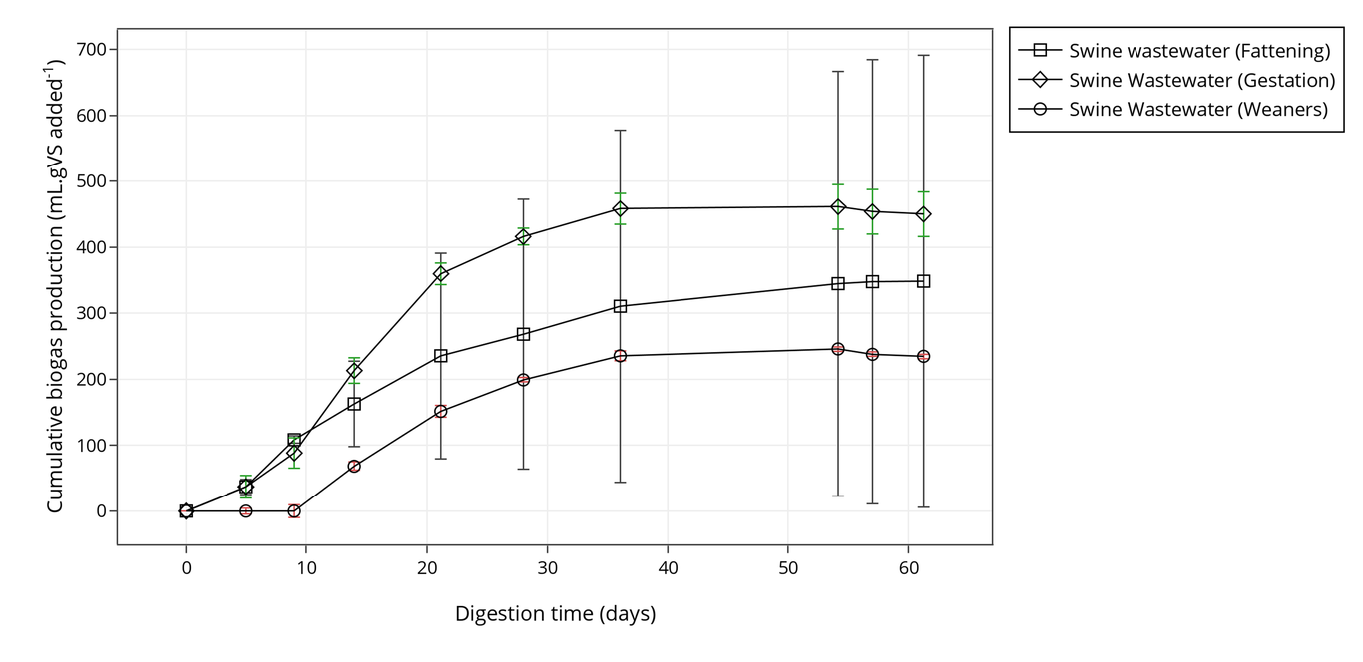
Cumulative biogas production (ml . gVS added⁻¹) of fattening, gestation and weaners wastewater.
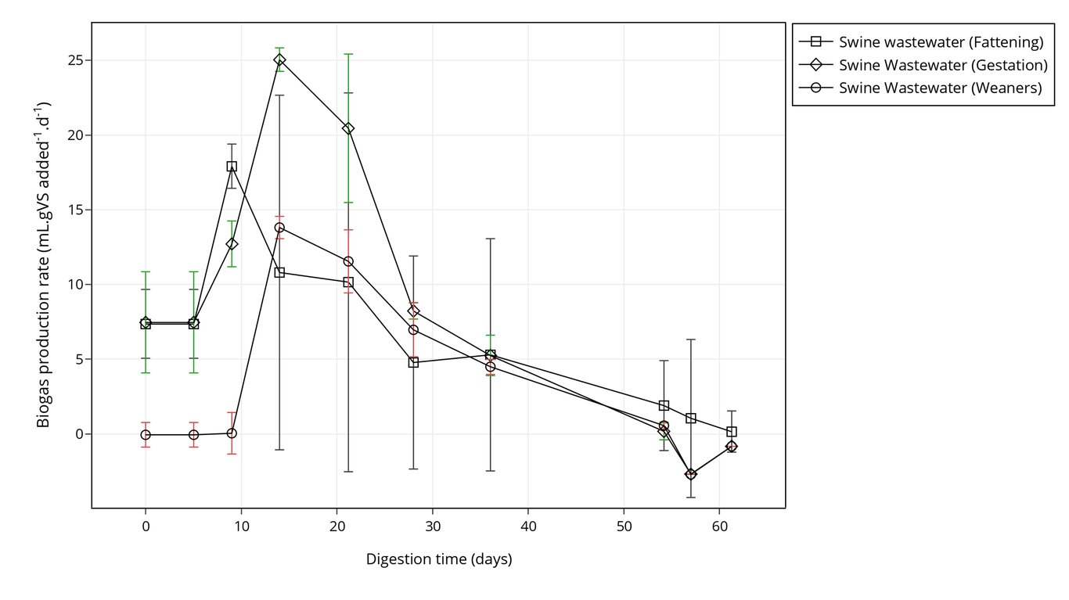
Biogas production rate (ml . gVS added⁻¹ . d⁻¹) of fattening, gestation and weaners wastewater.
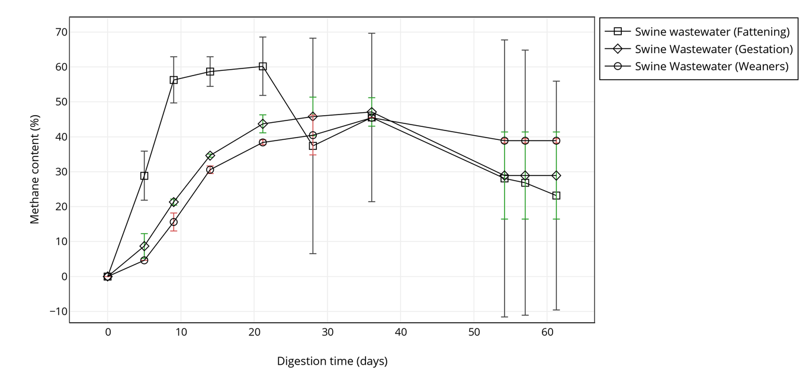
Methane content (%) of fattening, gestation and weaners wastewater.
Comparison of specific methane yield (mL CH4 . gVS added⁻¹) with results from other studies.
Research | Units | Gestation | Weaners | Fattening
Zhang et al | (mL.CH₄.gVS added⁻¹) | 282.4 | 328.7 | 263.5
Guo et al | (mL.CH₄.gVS added⁻¹) | 290 | 290 | 270
This study | (mL.CH₄.gVS added⁻¹) | 293.86 | 172.38 | 248.04

Theoretical BMP and methane-based biodegradability
In order to evaluate the biodegradability of the tested wastewaters, the specific methane yield obtained in the BMP assay was compared with the theoretical methane yield estimated using its elemental composition and organics content measured via COD. Table 6 presents theoretical results (BMP_{th}, BMP_{thCOD}, and CH_{4th} ) using both methodologies, as well as experimental results (specific methane yields and CH_{4exp}) and biodegradability. Theoretical methane potential calculation results showed that wastewaters from the fattening stage (BMP_{th} = 653.46, BMP_{thCOD} = 991.47) had a higher thoeretical potential than gestation (BMP_{th} = 487.65, BMP_{thCOD} = 471.69) or weaners (BMP_{th} = 374.98, BMP_{thCOD} = 618.84) wastewater. In general, the theoretical results obtained from elemental composition presented a better agreement with the experimental results. According to this methodology, the biodegradability of gestation, fattening, and weaners wastewater was 61.45%, 39.57%, and 46.49%. The results are in the range to those obtained by other authors [13] who experimented with similar swine wastewater streams. Despite having the higher theoretical potential, experimental values for fattening wastewater were lower when compared to gestation wastewater due to lower biodegradability, indicating that gestation wastewater is a more desirable substrate for anaerobic digestion. Also, the superior theoretical potentials in terms of COD for fattening and weaners wastewater suggest the presence of recalcitrant organic compounds not easily treated via biological methods. This is likely the case for fattening wastewaters as BOD₅/COD ratio, which may be conceived as an acceptable index of biological treatability, is relatively low (0.15) [43]. For weaners wastewater, however, some level of process inhibition may have occured probably due to non optimized conditions.
Theoretical BMP and biodegradability of gestation, weaners, and fattening wastewater based on different methodologies
Parameter |  | Units | Gestation | Weaners | Fattening
Empirical formula |  | - | C₄₃H₇₁O₂₇NS | C₄₇H₆₃O₃₈NS | C₇₄H₁₁₅O₂₅N₄S
Theoretical methane yield | BMP_{th} | (mL.CH₄.gVS added⁻¹) | 487.65 | 374.98 | 653.46
 | BMP_{thCOD} | (mL.CH₄.gVS added⁻¹) | 471.69 | 618.84 | 991.47
Speficic methane yield | BMP_{exp} | (mL.CH₄.gVS added⁻¹) | 293.86 | 172.38 | 248.04
Biodegradability | BD_{th} | % | 60.26 | 45.97 | 37.96
 | BD_{COD} | % | 62.3 | 27.86 | 25.02
Methane content | CH_{4exp} | % | 47.09 | 45.45 | 60.2
 | CH_{4th} | % | 54.06 | 45.74 | 58.95

Kinetic model
Cumulative biogas yield obtained from the experimental assays was used to fit a kinetic model of biogas production with the modeled results found to have the best fit plotted against the experimental cumulative biogas production in Fig.4, Fig.5, and Fig.6 depending on the growth stage. The parameters determined in the optimization process as well as statistical indicators and the difference between the predicted and experimental biogas production are presented in Table 6. Concerning the kinetics of the process, the biogas production of the microorganisms typically displayed a lag phase in which the bacterial cells modified their physiological state to adapt to the environment inside the reactor. The developed biosystem then multiplied and degraded volatile solids into biogas with an exponential phase and a final stationary phase in a reverse L-shape curve typical of simple organic substrates. As seen in the figures, the curves for gestation, fattening and weaners wastewaters all show a similar trend upon visual inspection, i.e., the chosen model adequately describes the biogas production from the tested effluents.
Among the tested models, the best fit was obtained from the Logistic and Gompertz equation for gestation, and weaners and fattening wastewaters, respectively. One-way ANOVA has shown some differences between λ, μ_{m} and A parameters for each production stage (Table 6). Calculated lag time (λ), for example, was found to be about 2 days for fattening wastewaters, varying from 6 and almost 10 days for gestation and weaners waste streams. No significant difference in λ values was found for gestating and fattening wastewaters, but the lag phase for weaners was significantly higher than that for fattening. The high bioavailability of readily degradable organics in the latter wastewaters can be the reason for the shorter lag phase. The highest and lowest maximum biogas production (μ_{m} rate) values were estimated for gestating and fattening sows (26.46-12.87 mL.gVS added⁻¹.d⁻¹) with the values for gestation wastewater being statistically different than that of weaners and fattening as revealed by Tukey’s HSD test. Finally, maximum biogas yield (A) has presented statistically significant differences between production stages with higher values for wastewaters from gestation (458.73 mL.gVS added⁻¹) followed by fattening and weaners (347.33 mL.gVS added⁻¹ and 239.94 mL.gVS added⁻¹ respectively). The statistical indicators (R² values, F-statistic and p-value) are also shown in respective figures. R² ranged between (0.9970–0.9957) showing that the traditional models tested are very useful in providing an accurate description of the experimental data. The kinetic parameters determined from the modelling provided further insights into the results of the experimental assays, in particularly the biodegradation patterns of the different wastewaters. During the first 5-10 days kinetics is better for fattening wastewaters with the low λ and μ_{m} values suggesting the presence of a fraction of readily biodegradable organic matter which is rapidly consumed (e.g. volatile fatty acids and low molecular weight carbohydrates)), while the remaining fraction may be classified as slowly biodegradable. Indeed, after 10 days the behaviour changes and gestation biogas productivity increases and surpasses that of fattening as revealed by the maximum biogas production rate of 26.46 mL.gVS added⁻¹.d⁻¹ and maximum biogas yield. This performance indicates the presence of slowly or less readily biodegradable organics in gestation effluents which makes the process slower at the beginning. Alternatively, the microorganisms may also not be acclimated to the wastewater. For weaners effluents, the extended lag phase (9.64 days) and the lower biogas productivity (13.91 mL.gVS added⁻¹.d⁻¹) suggest the occurrence of some level of process inhibition.
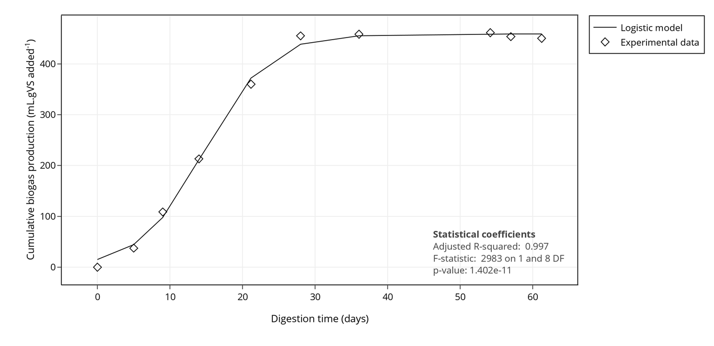
Fitting of logistic model to cumulative biogas production data obtained from Gestation wastewater digestion.
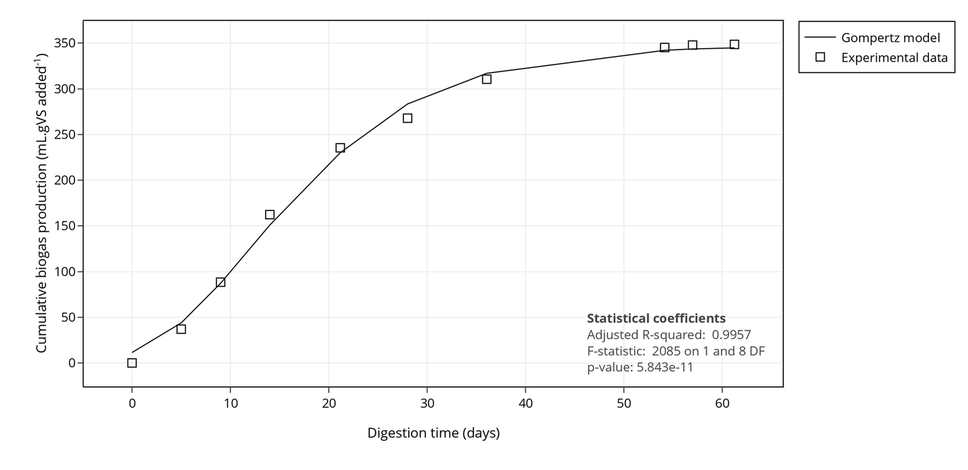
Fitting of Gompertz model to cumulative biogas production data obtained from Fattening wastewater digestion.
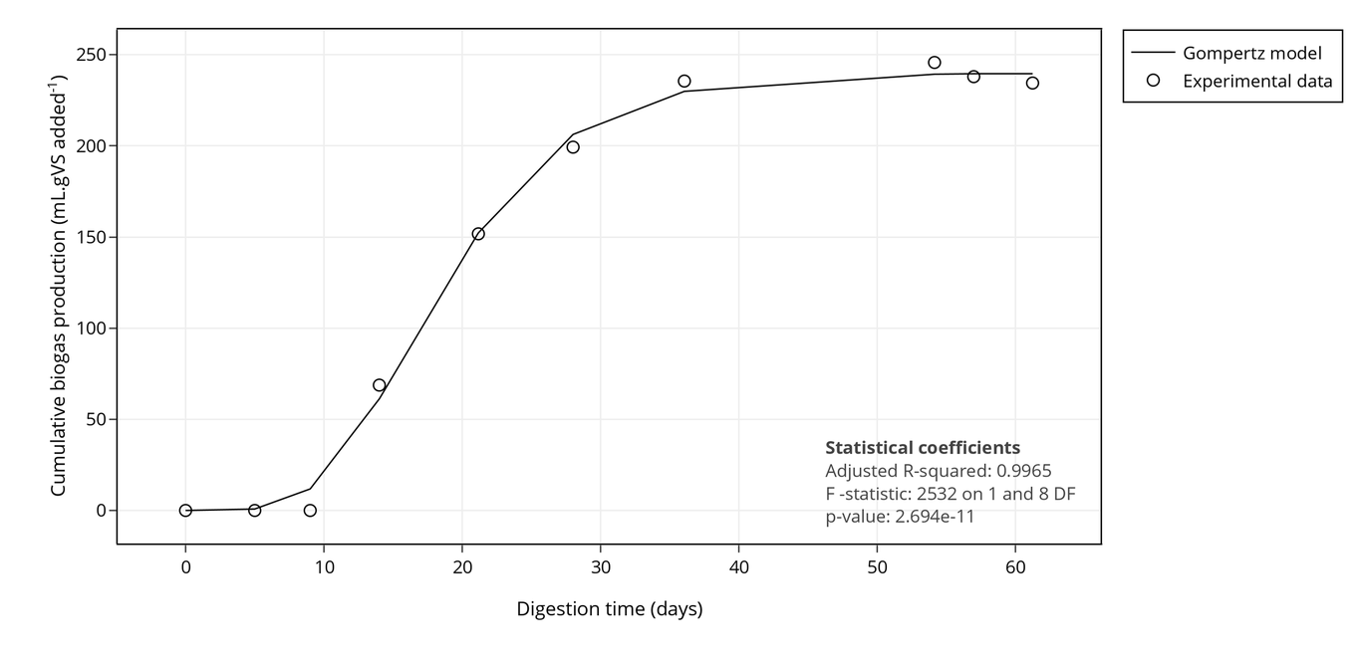
Fitting of Gompertz model to cumulative biogas production data obtained from Weaners wastewater digestion.
Results of kinetic modelling of biogas production using three different models.
Parameter |  | Units | Gestation | Weaners | Fattening
Kinetic model
Best model |  | - | Logistic | Gompertz | Gompertz
Lag phase (λ) |  | d | 6.0 ± 0.58 | 9.64 ± 0.67 | 2.28 ± 0.78
Maximum biogas production rate (μ_{m)} |  | (mL..gVS added^{-1.}d⁻¹) | 26.46 ± 1.7 | 13.91 ± 1.07 | 12.87 ± 0.81
Maximum biogas yield (A)
 | Predicted | (mL.gVS added⁻¹) | 458.73 ± 5.62 | 239.94 ± 3.87 | 347.33 ± 6.12
 | Measured | (mL.gVS added⁻¹) | 450.24 ± 33.7 | 234.62 ± 3.16 | 348.61 ± 342.54
 | Difference | % | 1.89 | 2.27 | 0.37
Statistical
Adjusted R-squared |  | - | 1.0 | 1.0 | 1.0
F-statistic |  | - | 2983 | 2532 | 2085
p-value |  | - | 1.4e-11 | 2.69e-11 | 5.84e-11

Conclusion
In this study, swine wastewaters from a farrow to finish farm were anaerobically digested under mesophilic conditions. In general, the characteristics of gestation, weaners, fattening, and farrowing wastewaters were significantly different due to different feed strategy and nutrient digestibility at different growth stages. Fattening wastewater presented higher solids and organics contents, while farrowing effluent streams were considered low strength due to mild physicochemical characteristics. The specific methane yields for each substrate wastewater was successfully determined gravimetrically and ranged from 293.9 mLCH4.gVS added⁻¹ for gestation and 172.4 mLCH4.gVS added⁻¹ for weaners. Farrowing wastewater presented no detectable biogas productionin the studied conditions probably due to very low organics content. These values are encouraging for on-farm energy recovery and may provide an important contributor to alleviate the increasing energy demand within the industry. The Logistic and Gompertz model fitted the experimental results well and may provide valuable knowledge for the treatment of specific swine wastewater streams at different growth stages within a perspective of producing biogas. With this in mind, experimental data suggest an HRT between 28–36 days for an effective treatment under continuous operations. However, as indicated by the partial biodegradability of the waste streams, AD should not be viewed as a complete solution and should be integrated with other treatment methods, either as pre-treatment or post-treatment.

Acnowledgements
G. Lourinho would like to thank FCT- Fundação para a Ciência e Tecnologia - for financial support regarding the grant SFRH/BDE/111878/2015.

References
Eurostat, Agriculture, forestry and fishery statistics - 2016 edition. Publications Office of the European Union, 2016, p. 230.
[2]OECD and FAO, OECD-FAO Agricultural Outlook 2016-2025. OECD Publishing, 2016, p. 136 [Online]. Available at: http://www.oecd-ilibrary.org/agriculture-and-food/oecd-fao-agricultural-outlook-2016{_}agr{_}outlook-2016-en
[3]C. A. Villamar, T. Cañuta, M. Belmonte, and G. Vidal, “Characterization of Swine Wastewater by Toxicity Identification Evaluation Methodology (TIE)”, Water Air, & Soil Pollution, vol. 223, no. 1, pp. 363–369, Jun. 2011 [Online]. Available at: https://doi.org/10.1007%2Fs11270-011-0864-z
[4]S. V. Vassilev, D. Baxter, L. K. Andersen, and C. G. Vassileva, “An overview of the composition and application of biomass ash. Part 1. Phasemineral and chemical composition and classification”, Fuel, vol. 105, pp. 40–76, Mar. 2013 [Online]. Available at: https://doi.org/10.1016%2Fj.fuel.2012.09.041
[5]M. Marszałek, Z. Kowalski, and A. Makara, “Physicochemical and Microbiological Characteristics of Pig Slurry”, Technical Transactions Chemistry, no. 18, pp. 81–91, 2014.
[6]K. Andersson, M. Osbeck, A. Pakhomau, L. Hertman, K. Navickas, and M. Ponomarev, “Pig production in the Neman/Nemunas River Basin: A study on transboundary measures, institutional capacity, bio-security and local development”, Stockholm Environment Institute, p. 38, 2013.
[7]Council of the European Communities, “Council Directive 91/676/EEC of 12 December 1991 concerning the protection of waters against pollution caused by nitrates from agricultural sources”, Official Journal, no. L 375, pp. 1–8, 1991 [Online]. Available at: http://publications.europa.eu/en/publication-detail/-/publication/82c54cc1-8126-482d-9106-2a5dad52ef1f
[8]European Parliament and Council of the European Union, “Directive 2000/60/EC of the European Parliament and of the Council of 23 October 2000 establishing a framework for Community action in the field of water policy”, Official Journal of the European Communities, vol. 43, no. L 327, pp. 1–73, 2000 [Online]. Available at: http://eur-lex.europa.eu/legal-content/EN/TXT/?uri=CELEX:02000L0060-20141120
[9]European Parliament and Council of the European Union, “Directive 2001/81/EC of the European Parliament and of the Council of 23 October 2001 on national emission ceilings for certain atmospheric pollutants”, Official Journal of the European Communities, vol. 44, no. L 309, pp. 22–30, 2001 [Online]. Available at: http://eur-lex.europa.eu/legal-content/EN/TXT/?uri=CELEX:32001L0081
[10]European Parliament and Council of the European Union, “Directive (EU) 2016/2284 of the European Parliament and of the Council of 14 December 2016 on the reduction of national emissions of certain atmospheric pollutants, amending Directive 2003/35/EC and repealing Directive 2001/81/EC”, Official Journal of the European Union, vol. 59, no. L 344, pp. 1–31, 2016 [Online]. Available at: http://eur-lex.europa.eu/legal-content/EN/TXT/?uri=uriserv:OJ.L{_}.2016.344.01.0001.01.ENG
[11]J. Mata-Alvarez, J. Dosta, M. S. Romero-Güiza, X. Fonoll, M. Peces, and S. Astals, “A critical review on anaerobic co-digestion achievements between 2010 and 2013”, Renewable and Sustainable Energy Reviews, vol. 36, pp. 412–427, Aug. 2014 [Online]. Available at: https://doi.org/10.1016%2Fj.rser.2014.04.039
[12]V. OFlaherty, G. Collins, and T. Mahony, “Anaerobic Digestion of Agricultural Residues”, in Environmental Microbiology, John Wiley & Sons Inc., 2010, pp. 259–279 [Online]. Available at: https://doi.org/10.1002%2F9780470495117.ch11
[13]W. Zhang, Q. Lang, S. Wu, W. Li, H. Bah, and R. Dong, “Anaerobic digestion characteristics of pig manures depending on various growth stages and initial substrate concentrations in a scaled pig farm in Southern China”, Bioresource Technology, vol. 156, pp. 63–69, Mar. 2014 [Online]. Available at: https://doi.org/10.1016%2Fj.biortech.2014.01.013
[14]J. Guo, J. Clemens, X. Li, P. Xu, and R. Dong, “Performance evaluation of a Chinese medium-sized agricultural biogas plant at ambient temperature”, Engineering in Life Sciences, vol. 12, no. 3, pp. 336–342, Jun. 2012 [Online]. Available at: https://doi.org/10.1002%2Felsc.201100084
[15]P. Gopalan, P. D. Jensen, and D. J. Batstone, “Anaerobic digestion of swine effluent: Impact of production stages”, Biomass and Bioenergy, vol. 48, pp. 121–129, Jan. 2013 [Online]. Available at: https://doi.org/10.1016%2Fj.biombioe.2012.11.012
[16]International Organization for Standardization, “Water quality: Determination of the chemical oxygen demand index (ST-COD) – Small-scale sealed-tube method. ISO 15705:2002.”. 2002.
[17]W. F. Owen, D. C. Stuckey, J. B. Healy, L. Y. Young, and P. L. McCarty, “Bioassay for monitoring biochemical methane potential and anaerobic toxicity”, Water Research, vol. 13, no. 6, pp. 485–492, Jan. 1979 [Online]. Available at: https://doi.org/10.1016%2F0043-1354%2879%2990043-5
[18]I. Angelidaki et al., “Defining the biomethane potential (BMP) of solid organic wastes and energy crops: a proposed protocol for batch assays”, Water Science & Technology, vol. 59, no. 5, p. 927, Mar. 2009 [Online]. Available at: https://doi.org/10.2166%2Fwst.2009.040
[19]C. Holliger et al., “Towards a standardization of biomethane potential tests”, Water Science and Technology, vol. 74, no. 11, pp. 2515–2522, Sep. 2016 [Online]. Available at: https://doi.org/10.2166%2Fwst.2016.336
[20]S. D. Hafner, C. Rennuit, J. M. Triolo, and B. K. Richards, “Validation of a simple gravimetric method for measuring biogas production in laboratory experiments”, Biomass and Bioenergy, vol. 83, pp. 297–301, Dec. 2015 [Online]. Available at: https://doi.org/10.1016%2Fj.biombioe.2015.10.003
[21]G. E. Symons and A. M. Buswell, “The Methane Fermentation of Carbohydrates1,2”, Journal of the American Chemical Society, vol. 55, no. 5, pp. 2028–2036, May 1933 [Online]. Available at: https://doi.org/10.1021%2Fja01332a039
[22]R. A. Labatut, L. T. Angenent, and N. R. Scott, “Biochemical methane potential and biodegradability of complex organic substrates”, Bioresource Technology, vol. 102, no. 3, pp. 2255–2264, Feb. 2011 [Online]. Available at: https://doi.org/10.1016%2Fj.biortech.2010.10.035
[23]M. Lesteur et al., “Alternative methods for determining anaerobic biodegradability: A review”, Process Biochemistry, vol. 45, no. 4, pp. 431–440, Apr. 2010 [Online]. Available at: https://doi.org/10.1016%2Fj.procbio.2009.11.018
[24]A. Ware and N. Power, “Biogas from cattle slaughterhouse waste: Energy recovery towards an energy self-sufficient industry in Ireland”, Renewable Energy, vol. 97, pp. 541–549, Nov. 2016 [Online]. Available at: https://doi.org/10.1016%2Fj.renene.2016.05.068
[25]R. M. Jingura and R. Kamusoko, “Methods for determination of biomethane potential of feedstocks: a review”, Biofuel Research Journal, vol. 4, no. 2, pp. 573–586, Jun. 2017 [Online]. Available at: https://doi.org/10.18331%2Fbrj2017.4.2.3
[26]A. Nielfa, R. Cano, and M. Fdz-Polanco, “Theoretical methane production generated by the co-digestion of organic fraction municipal solid waste and biological sludge”, Biotechnology Reports, vol. 5, pp. 14–21, Mar. 2015 [Online]. Available at: https://doi.org/10.1016%2Fj.btre.2014.10.005
[27]L. Maya-Altamira, A. Baun, I. Angelidaki, and J. E. Schmidt, “Influence of wastewater characteristics on methane potential in food-processing industry wastewaters”, Water Research, vol. 42, no. 8-9, pp. 2195–2203, Apr. 2008 [Online]. Available at: https://doi.org/10.1016%2Fj.watres.2007.11.033
[28]D. Hidalgo, J. M. Martín-Marroquín, and P. Nieto, “Anaerobic co-digestion of agro-food waste mixtures in a fed-batch basis”, Environmental Technology, vol. 37, no. 20, pp. 2590–2598, Mar. 2016 [Online]. Available at: https://doi.org/10.1080%2F09593330.2016.1155654
[29]M. Kahm, M. Kahm, G. Hasenbrink, H. Lichtenberg-Frate, J. Ludwig, and M. Kschischo, “Grofit: Fitting biological growth curves”, Nature Precedings, Jun. 2010 [Online]. Available at: https://doi.org/10.1038%2Fnpre.2010.4508.1
[30]L. Altaş, “Inhibitory effect of heavy metals on methane-producing anaerobic granular sludge”, Journal of Hazardous Materials, vol. 162, no. 2-3, pp. 1551–1556, Mar. 2009 [Online]. Available at: https://doi.org/10.1016%2Fj.jhazmat.2008.06.048
[31]G. Hasenbrink, L. Kolacna, J. Ludwig, H. Sychrova, M. Kschischo, and H. Lichtenberg-Fraté, “Ring test assessment of the mKir2.1 growth based assay in Saccharomyces cerevisiae using parametric models and model-free fits”, Applied Microbiology and Biotechnology, vol. 73, no. 5, pp. 1212–1221, Nov. 2006 [Online]. Available at: https://doi.org/10.1007%2Fs00253-006-0589-x
[32]M. H. Zwietering, I. Jongenburger, F. M. Rombouts, and ’t R. K. van, “Modeling of the bacterial growth curve.”, Appl Environ Microbiol, vol. 56, pp. 1875–81, 1990.
[33]A. Ware and N. Power, “Modelling methane production kinetics of complex poultry slaughterhouse wastes using sigmoidal growth functions”, Renewable Energy, vol. 104, pp. 50–59, Apr. 2017 [Online]. Available at: https://doi.org/10.1016%2Fj.renene.2016.11.045
[34]R Core Team, R: A Language and Environment for Statistical Computing. Vienna, Austria: R Foundation for Statistical Computing, 2016 [Online]. Available at: https://www.R-project.org/
[35]L. Martínez-Suller, A. Azzellino, and G. Provolo, “Analysis of livestock slurries from farms across Northern Italy: Relationship between indicators and nutrient content”, Biosystems Engineering, vol. 99, no. 4, pp. 540–552, Apr. 2008 [Online]. Available at: https://doi.org/10.1016%2Fj.biosystemseng.2007.12.002
[36]R. Moral, M. D. Perez-Murcia, A. Perez-Espinosa, J. Moreno-Caselles, and C. Paredes, “Estimation of nutrient values of pig slurries in Southeast Spain using easily determined properties”, Waste Management, vol. 25, no. 7, pp. 719–725, Jan. 2005 [Online]. Available at: https://doi.org/10.1016%2Fj.wasman.2004.09.010
[37]R. Moral, M. D. Perez-Murcia, A. Perez-Espinosa, J. Moreno-Caselles, C. Paredes, and B. Rufete, “Salinity organic content, micronutrients and heavy metals in pig slurries from South-eastern Spain”, Waste Management, vol. 28, no. 2, pp. 367–371, Jan. 2008 [Online]. Available at: https://doi.org/10.1016%2Fj.wasman.2007.01.009
[38]M. Hjorth, K. V. Christensen, M. L. Christensen, and S. G. Sommer, “SolidLiquid Separation of Animal Slurry in Theory and Practice”, in Sustainable Agriculture Volume 2, Springer Netherlands, 2011, pp. 953–986 [Online]. Available at: https://doi.org/10.1007%2F978-94-007-0394-0_43
[39]“Alkalinity and pH”, in Wastewater Microbiology Series, John Wiley & Sons Inc., pp. 99–103 [Online]. Available at: https://doi.org/10.1002%2F0471468967.ch16
[40]K. Fricke, H. Santen, R. Wallmann, A. Hüttner, and N. Dichtl, “Operating problems in anaerobic digestion plants resulting from nitrogen in MSW”, Waste Management, vol. 27, no. 1, pp. 30–43, Jan. 2007 [Online]. Available at: https://doi.org/10.1016%2Fj.wasman.2006.03.003
[41]Y. Li et al., “Evaluating Methane Production from Anaerobic Mono- and Co-digestion of Kitchen Waste Corn Stover, and Chicken Manure”, Energy & Fuels, vol. 27, no. 4, pp. 2085–2091, Apr. 2013 [Online]. Available at: https://doi.org/10.1021%2Fef400117f
[42]J. Zhu, P. M. Ndegwa, and Z. Zhang, “Manure sampling procedures and nutrient estimation by the hydrometer method for gestation pigs”, Bioresource Technology, vol. 92, no. 3, pp. 243–250, May 2004 [Online]. Available at: https://doi.org/10.1016%2Fj.biortech.2003.09.010
[43]D. Orhon, E. Ateş, S. Sözen, and E. U. Çokgör, “Characterization and COD fractionation of domestic wastewaters”, Environmental Pollution, vol. 95, no. 2, pp. 191–204, 1997 [Online]. Available at: https://doi.org/10.1016%2Fs0269-7491%2896%2900111-x
[44]CMS/CERN, “A New Boson with a Mass of 125 GeV Observed with the CMS Experiment at the Large Hadron Collider”, Science, vol. 338, no. 6114, pp. 1569–1575, 2012.
[45]B. R. Holstein, “The mysterious disappearance of Ettore Majorana”, J. Phys.: Conf. Ser., vol. 173, p. 012019, Jun. 2009 [Online]. Available at: http://dx.doi.org/10.1088/1742-6596/173/1/012019
[46]M. Holubcik and J. Jandacka, “Chemical composition in relation with biomass ash structure”, 2014 [Online]. Available at: https://doi.org/10.1063%2F1.4892704
[47]C. Mao, Y. Feng, X. Wang, and G. Ren, “ChemInform Abstract: Review on Research Achievements of Biogas from Anaerobic Digestion”, ChemInform, vol. 47, no. 28, Jun. 2016 [Online]. Available at: https://doi.org/10.1002%2Fchin.201628297
[48]K. Rajeshwar, J. G. Ibanez, and G. M. Swain, “Electrochemistry and the environment”, Journal of Applied Electrochemistry, vol. 24, no. 11, Nov. 1994 [Online]. Available at: https://doi.org/10.1007%2Fbf00241305
[49]C. A. Martínez-Huitle and S. Ferro, “Electrochemical oxidation of organic pollutants for the wastewater treatment: direct and indirect processes”, Chem. Soc. Rev., vol. 35, no. 12, pp. 1324–1340, 2006 [Online]. Available at: https://doi.org/10.1039%2Fb517632h
[50]J. Radjenovic and D. L. Sedlak, “Challenges and Opportunities for Electrochemical Processes as Next-Generation Technologies for the Treatment of Contaminated Water”, Environmental Science & Technology, vol. 49, no. 19, pp. 11292–11302, Oct. 2015 [Online]. Available at: https://doi.org/10.1021%2Facs.est.5b02414
[51]Ministry of Environment, “Decree-law 236/98”, Diário Da República, vol. 176. pp. 3676–3722, 1998 [Online]. Available at: https://dre.pt/
[52]X. Flotats Ripoll, H. Foged, A. Bonmatí Blasi, J. Palatsi Civit, A. Magrí Aloy, and K. M. Schelde, “Manure processing technologies”, no. Ii, 2012 [Online]. Available at: http://upcommons.upc.edu/e-prints/handle/2117/18944
[53]H. Foged, X. Flotats Ripoll, A. Bonmatí Blasi, J. Palatsi Civit, A. Magrí Aloy, and K. M. Schelde, “Inventory of manure processing activities in Europe”, 2012 [Online]. Available at: http://hdl.handle.net/2117/18943
[54]M. L. Christensen, M. Hjorth, and K. Keiding, “Characterization of pig slurry with reference to flocculation and separation”, Water Research, vol. 43, no. 3, pp. 773–783, Feb. 2009 [Online]. Available at: https://doi.org/10.1016%2Fj.watres.2008.11.010
[55]M.-L. Daumer, F. Béline, and M.Spérandio, “THE EFFECT OF PIG DIET AND SOLID/LIQUID SEPARATION OF PIG SLURRY ON PHOSPHORUS FRACTIONATION”, in Animal Agricultural and Food Processing Wastes - IX [Online]. Available at: https://doi.org/10.13031%2F2013.15284
[56]L. S. Jensen and S. G. Sommer, “Manure Organic Matter - Characteristics and Microbial Transformations”, in Animal Manure Recycling, John Wiley & Sons Ltd, 2013, pp. 67–90 [Online]. Available at: https://doi.org/10.1002%2F9781118676677.ch5
[57]R. Hai, Y. He, X. Wang, and Y. Li, “Simultaneous removal of nitrogen and phosphorus from swine wastewater in a sequencing batch biofilm reactor”, Chinese Journal of Chemical Engineering, vol. 23, no. 1, pp. 303–308, Jan. 2015 [Online]. Available at: https://doi.org/10.1016%2Fj.cjche.2014.09.036
[58]V. Córdoba, M. Fernández, and E. Santalla, “The effect of different inoculums on anaerobic digestion of swine wastewater”, Journal of Environmental Chemical Engineering, vol. 4, no. 1, pp. 115–122, Mar. 2016 [Online]. Available at: https://doi.org/10.1016%2Fj.jece.2015.11.003
[59]“Anaerobic Digestion of Wastewater and Biosolids”, in Wastewater Microbiology, John Wiley & Sons Inc., 2010, pp. 409–435 [Online]. Available at: https://doi.org/10.1002%2F9780470901243.ch14
[60]M. Hjorth, K. V. Christensen, M. L. Christensen, and S. G. Sommer, “Solidliquid separation of animal slurry in theory and practice. A review”, Agronomy for Sustainable Development, vol. 30, no. 1, pp. 153–180, Mar. 2010 [Online]. Available at: https://doi.org/10.1051%2Fagro%2F2009010

