Spatially-specific delay period activity in the human superior colliculus
Kartik Sreenivasan
Kevin DeSimone

Introduction
Our nervous system labors to represent the rich arrays of percepts and actions in support of meaningful goal-driven behavior. The superior colliculus (SC), a key node in a distributed oculomotor network, mediates orienting behaviors (e.g., gaze shifts) designed to streamline this perception-action cycle. The SC is a laminar structure containing two tightly registered eye-centered topographic maps: a visual map in the superficial layer, and a motor map in the intermediate and deep layers representing the angle and amplitude of saccades ((Wurtz and Albano 1980); (Sparks 1986); (Sparks 1999); (Gandhi and Katnani 2011)). Classically, the motor map is subdivided into a rostral zone containing neurons that actively maintain fixation and a caudal zone whose neurons mediate the generation of saccadic eye-movements. These zones form a push-pull mechanism for mediating orienting behaviors ((Munoz and Wurtz 1992); (Munoz and Wurtz 1993); (Munoz and Wurtz 1993)). However, two recent lines of evidence challenge this motor-centric model of SC function. (1) Pharmacological inactivation of the macaque SC motor map induces a form of visual neglect akin to extinction, but does not cause paresis or anopsia ((McPeek and Keller 2004); (Lovejoy and Krauzlis 2010); (Nummela and Krauzlis 2011);(Zénon and Krauzlis 2012)). (2) Neural activity in the cat and macaque SC motor map represents a more abstract location of a behavioral goal, independent of the sequence of eye movements required for acquiring the target ((Bergeron, Matsuo, and Guitton 2003); (Keller, Gandhi, and Weir 1996); (Freedman and Sparks 1997)). Therefore, the functional role of the SC cannot be explained simply in terms of visual input or motor output. Instead, the SC may integrate sensory salience and behavioral relevance signals computed throughout the brain into a common topographical organization, acting as a staging area for organizing flexible and goal-oriented behavior into a prioritized map of space ((Fecteau and Munoz 2006)). Here we sought to explore the extent to which persistent delay-period activity measured in the human SC using functional imaging techniques reflects spatially specific representations of priority apart from visual input and motor output. First, we show that we can derive the detailed retinotopic organization of the human SC using the population receptive field (pRF) model ((Dumoulin and Wandell 2008)).

Methods
Subjects. 4 subjects participated in the study (ages 27-49; 4 male). One subject was left-handed. The subjects were in good health with no history of psychiatric or neurological disorders, had normal or corrected-to-normal visual acuity, and gave informed written consent. The study was approved by the New York University Committee on Activities Involving Human Subjects and the New York University Abu Dhabi Internal Review Board. All subjects participated in three scanning sessions encompassing three different functional experiments.
Display and response hardware. The stimuli were generated on a STIM_PC computer using MATLAB software (The MathWorks) and Psychophysics Toolbox 3 functions ((Brainard 1997); (Pelli 1997)). Stimuli were presented using a PROPixx DLP LED projector (VPixx, Saint-Bruno, QC, Canada) located outside the scanner room and projected through a waveguide and onto a translucent screen located at the end of the scanner bore. Subjects viewed the screen at a total viewing distance of 64 cm through a mirror attached to the head coil. The display subtended approximately 32˚ of visual angle horizontally vertically. A trigger pulse from the scanner synchronized the onsets of stimulus presentation and image acquisition. EYETRACKING
Visual stimuli and procedure. The pRF mapping stimuli consisted of a checkerboard-patterned bar whose elements reversed contrast with a full-cycle frequency of 8 Hz (Figure 1A). The bar subtended 8˚ of visual angle across its width and extended beyond the boundaries of the screen along its length. During a single run, the bar appeared at two orientations (0˚ and 90˚) and transited across the screen perpendicular to the bar orientation and passed through central fixation. Thus, each bar consisted of four 30 s bar sweeps with 12 s mean-luminance blank periods at the beginning and end of each run. Subjects performed a demanding fixation task where they responded via buttonbox as to which of four colors (red, green, blue, yellow) the fixation was set every 1.5 s. To measure the spatial representation for remember locations in the visual field, we used a delayed oculomotor response task with participants responding with eye movements, either towards or away from a visual sample. Each trial commenced with the brief (300 ms) presentation of a visual sample, followed by a 10.5 s delay-period while subjects maintained the sample location and hold central fixation (Figure 1B). After the delay, we presented a randomly located visual stimulus, cueing the subject to execute a visually-guided saccade (VGS) to this location and then to immediately executed a memory-guided saccade (MGS) to the remembered sampled location. Feedback of the true MGS location is given for 500 ms, whereafter the subject returns to central fixation during a 9.8 s inter-trial interval (ITI). The entire trial duration was 22.5 s (15 volume acquisitions), and each run was comprised of 16 trials with two repetitions at each of the eight target locations. The locations of the samples and memory locations were evenly space from 22.5 to 337.5˚ in 45˚ intervals of polar angle and presented at 10˚ eccentricity. Sample locations were were jittered by ±10˚ tangentially and ±1˚ eccentrically from trial to trial. The location of the memory guided saccade (MGS) was always the same as the sample location during pro-saccade trials but was rotated by 180˚ of polar angle for anti-saccade trials. The location of the visually guided saccade for each trial was drawn from a uniform random distribution spanning 360˚, ensuring that the VGS was independent of the sample and MGS locations (Figure 1C).
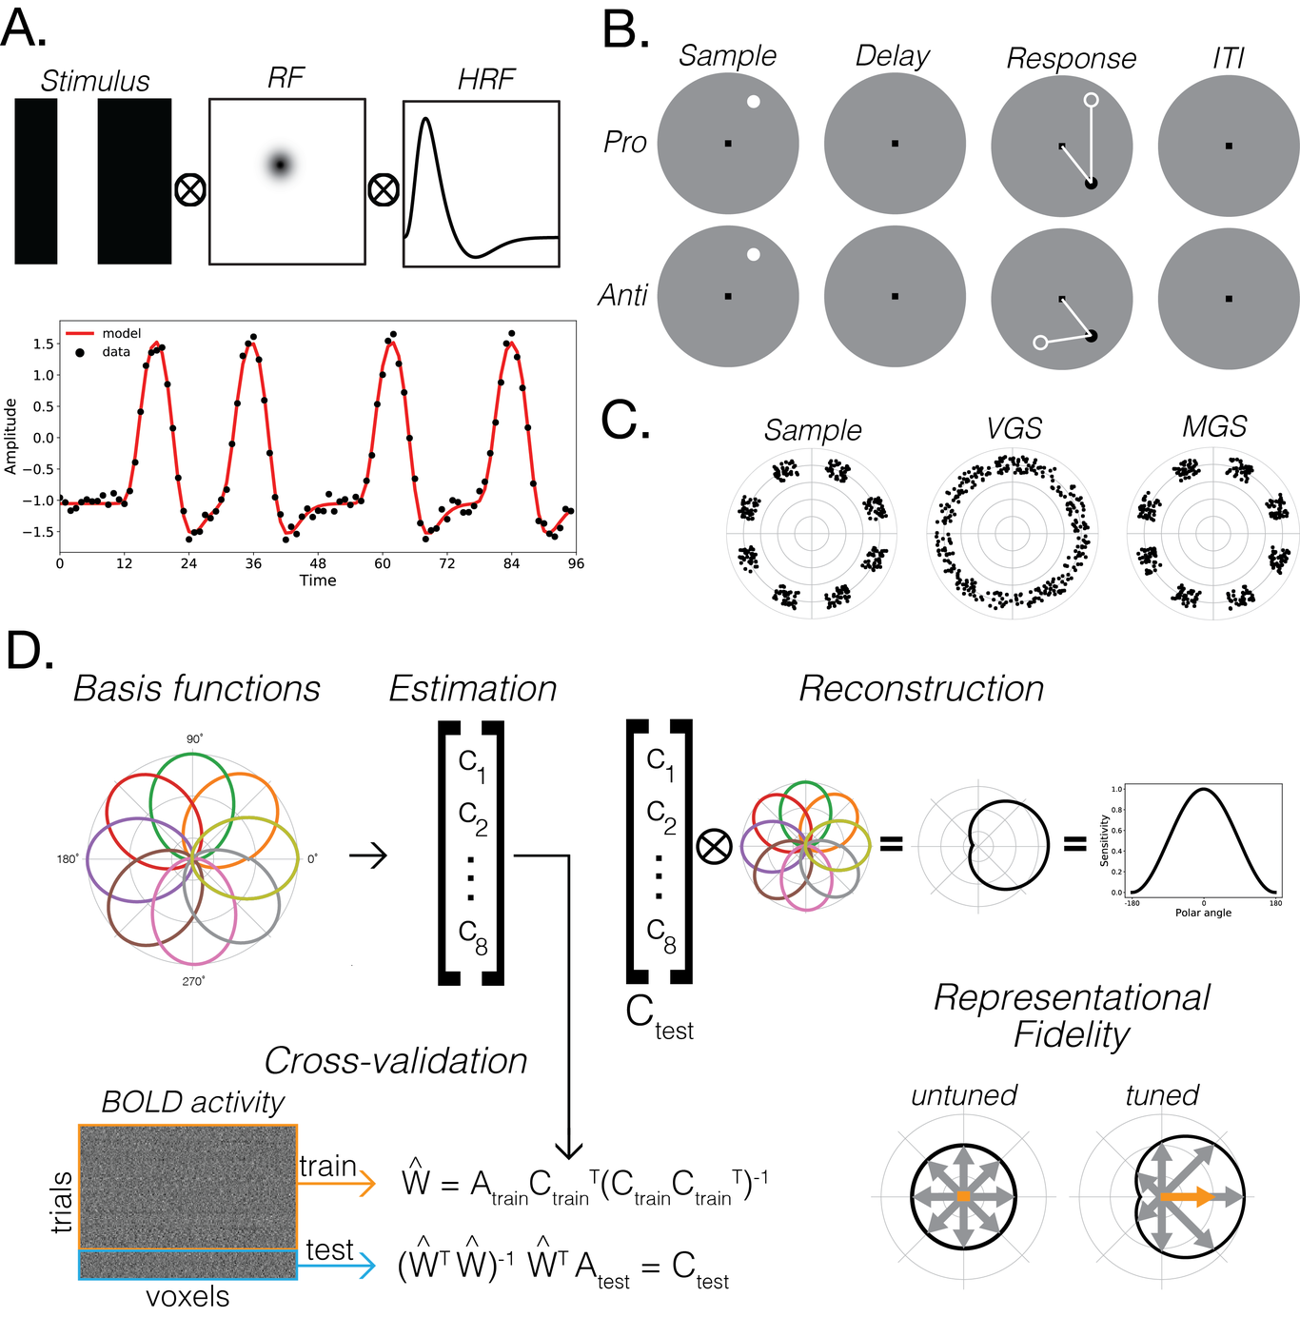
This is a caption
Data acquisition. Data were acquired in the Center for Brain Imaging at NYU with a 3 T Siemens Prisma MRI scanner scanner using a 32-channel head-coil. Twenty functional series of 120 volumes were collected for the retinotopic mapping experiment and twelve functional series of 248 volumes were collected for the spatial working memory experiment. Each functional series experiment. Each functional run were acquired with 14 coronal slices and a gradient echo, echo planar sequence with a 128 square matrix, 192 mm field of view, and 2.0 mm slice thickness, leading to a voxel size of 1.5 x 1.5 x 2.0 mm (TR = 1.5 s, TE = 41 ms, flip angle = 66˚, bandwidth = 752 Hz/pixel). Hz/pixels). A partial Fourier factor of 7/8 was used to acquire an asymmetric fraction of k-space and GRAPPA parallel imaging with a factor of 2 was used to reduce acquisition time. The posterior edge of the acquisition volume was aligned in the mid-sagittal plane with the posterior edge of inferior colliculus. We also collected a high-resolution T₁-weighted MPRAGE (spin-echo, TOMMY PARAMS) for projecting results onto anatomy. In addition, for each scanning session we collected a single whole-brain-coverage functional image with the same spatial resolution as the partial-brain coverage (TR = 10.8 s) in order to align the partial-coverage functional images to the whole-brain anatomical images.
Data processing and analysis. Functional data were motion-corrected and co-registered with the anatomical images. For each voxel, the linear trend was removed and the time series converted to percent signal change. For the mapping experiment, we modeled each voxel in terms of a Gaussian receptive field using methods and tools previously described ((DeSimone, Viviano, and Schneider 2015); (DeSimone, Rokem, and Schneider 2016)). The pRF model estimates provide a description of each voxel’s BOLD response in terms of a retinotopic location and extent. To reconstruct the spatial representations from data measured during the spatial working memory task, we used a spatial inverted encoding model [(IEM), (Sprague and Serences 2013); (Rahmati, Saber, and Curtis 2017))]. Each voxel’s response was modeled as the weighted sum of 9 information channels representing polar angles equally spaced around the visual field spanning 365˚, with each channel defined as a one-dimensional cosine function. Subjects participated in 192 trials each for the delayed pro- and anti-saccade tasks. To increase the signal-to-noise ratio, we combined trials by computing a three-fold mean trial time-series, reducing the total number of trials to 64 composed of 8 exemplars at each of the 8 memory locations. To estimate the spatial IEM, we used a leave-one-out cross-validation procedure where we trained the model using 63 trials and reconstructed the response for the held-out 64th trial. We defined voxel activity as the mean BOLD response during the delay period after the visual sample was presented but before the initiation of the first saccade in the double-step saccade. Channel weights for the training data were estimated using a general linear model, where the response for each voxel was modeled as a set of regression coefficients given the sequence of stimuli. The voxel activity for the held-out trial was then projected onto these trained channel weights to produce new channel responses, which were then convolved by the basis functions to produce a reconstruction of the spatial response for the held-out trial. We aligned and combined reconstructions across trials for each subject. In addition, we used a bootstrap procedure to repeatedly train and reconstruct the spatial IEM with different arrangements of trials for computing the the three-fold mean time-series. This ensured that any effects were not simply due to bias in the sampling and combination of trials. To quantify spatial tuning, we used the representational fidelity metric ((Sprague, Ester, and Serences 2016)).

Results
Retinotopic mapping. We found clear bilateral activation retinotopic activation in the SC. Figure 2A shows the detailed activation maps for a single subject. Activated voxels whose fMRI time-series correlated with the modeled time-series r² > 0.1 are shown. The zoomed activation maps are overlaid on T₁-weighted anatomical images with the inset of the SC highlighted with a red square. The rows show successive coronal slices moving anterior to posterior from the top to bottom rows. The columns show each of the pRF model parameters (polar angle, eccentricity, and pRF size). The topography of the pRF model estimates were congruent with the organization described previously in the macaque and human. We found a complete representation of the contralateral hemifield in each SC, with the a polar angle progression from the upper vertical meridian, the contralateral horizontal meridian, and the lower vertical meridian as one moves from the medial to the lateral extent of each SC. We found the eccentricity representation organized along the anterior-to-posterior axis, with representations of the fovea at the anterior pole the left and right SC, with a steady progression toward peripheral representation moving towards the posterior pole. The representational axis of receptive field size conformed with eccentricity where smaller receptive fields are found at the fovea near the anterior pole and larger fields near periphery near the posterior pole. We summarize these findings in Figure 2B, which shows the direct linear relationship between eccentricity and receptive field size—a hallmark of retinotopic organization throughout the visual system.
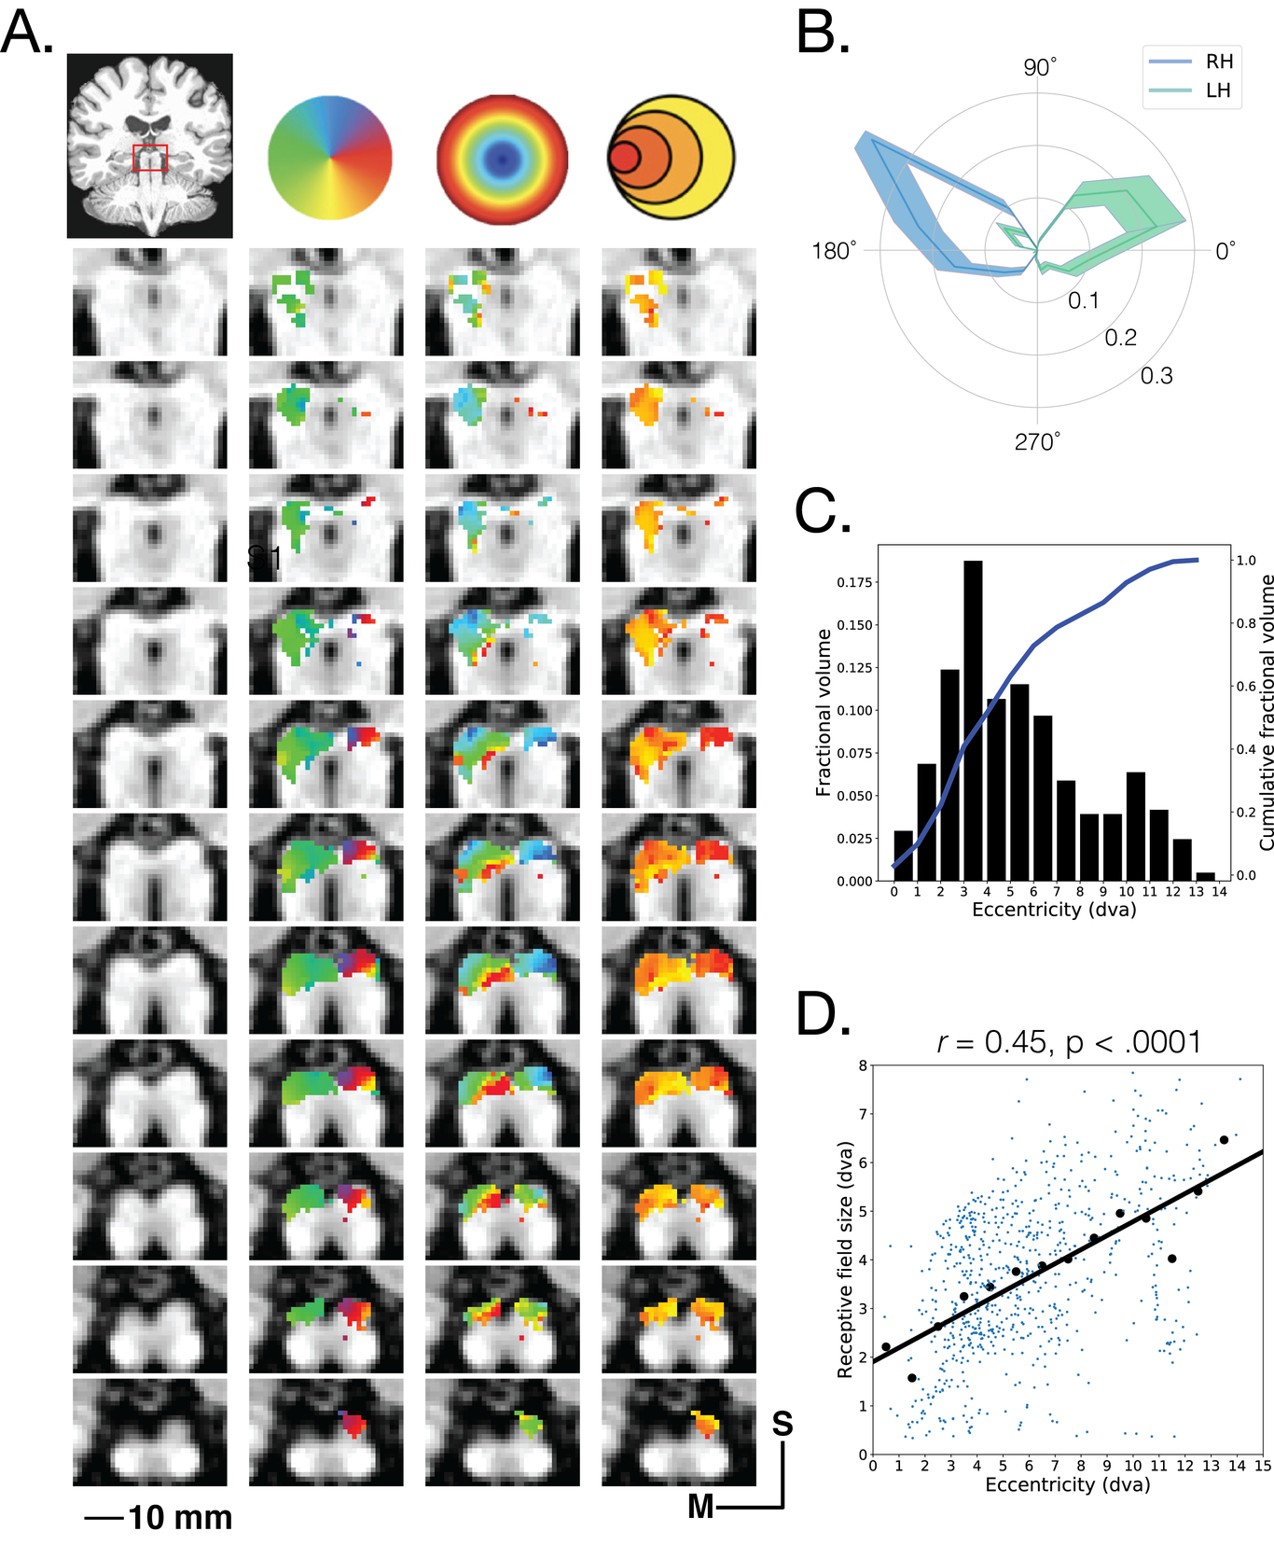
This is a caption
Delayed saccade task. We found spatially-specific BOLD among the voxels of the SC across all four subjects. Figure 3A shows the mean of the aligned reconstructions across trials for each subject (blue) and the reconstructions computed using the same procedure but with randomly shuffled stimulus labels (red) for the pro-saccade task. The shaded region shows the 95% confidence intervals calculated using the error across the 64 folded trials. Each row shows the spatial tuning for the memory location within each of the four subjects. The spatial IEM results suggest that across multiple subjects, the SC contains a representation for the a remembered spatial a remembered spatial location during the delay period between presentation of the visual sample and execution of the eye movement. To quantify the degree of spatial tuning, we compute the representational fidelity for each reconstructed spatial location across bootstraps. Figure 3B shows distributions of representational fidelity computed from the pro-saccade delay-period spatial reconstructions (blue) and their shuffled reconstructions (red) across bootstraps. We find that across all subjects that while the shuffled data are distributed about 0 the distributions of the spatial reconstructions are shifted rightward in the positive direction. This finding suggests that the SC activity during the delay period contains spatially specific information related to the location of the memoranda.memoranda. ANTI

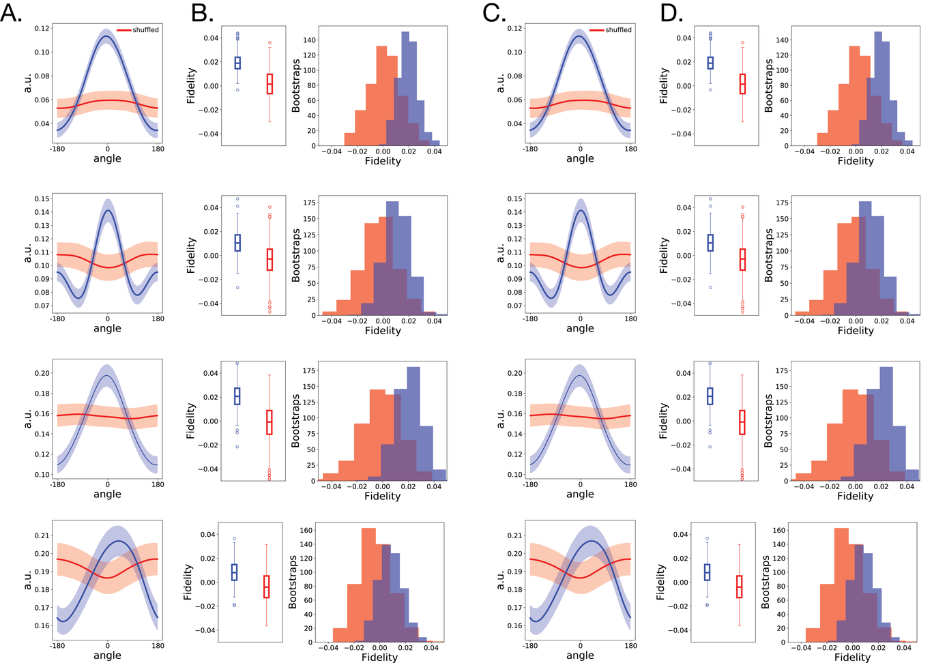
This is a caption

References
Wurtz, R H, and J E Albano. 1980. “Visual-Motor Function of the Primate Superior Colliculus”. Annual Review of Neuroscience 3 (1). Annual Reviews: 189–226. doi:10.1146/annurev.ne.03.030180.001201.
Sparks, DL. 1986. “Translation of Sensory Signals into Commands for Control of Saccadic Eye Movements: Role of Primate Superior Colliculus.”. Physiol Rev 66: 118–71.
———. 1999. “Conceptual Issues Related to the Role of the Superior Colliculus in the Control of Gaze.”. Curr Opin Neurobiol 9: 698–707.
Gandhi, Neeraj J., and Husam A. Katnani. 2011. “Motor Functions of the Superior Colliculus”. Annual Review of Neuroscience 34 (1). Annual Reviews: 205–31. doi:10.1146/annurev-neuro-061010-113728.
Munoz, DP, and RH Wurtz. 1992. “Role of the Rostral Superior Colliculus in Active Visual Fixation and Execution of Express Saccades.”. J Neurophysiol 67: 1000–1002.
———. 1993. “Fixation Cells in Monkey Superior Colliculus. I. Characteristics of Cell Discharge.”. J Neurophysiol 70: 559–75.
———. 1993. “Fixation Cells in Monkey Superior Colliculus. II. Reversible Activation and Deactivation.”. J Neurophysiol 70: 576–89.
McPeek, RM, and EL Keller. 2004. “Deficits in Saccade Target Selection after Inactivation of Superior Colliculus.”. Nat Neurosci 7: 757–63.
Lovejoy, LP, and RJ Krauzlis. 2010. “Inactivation of Primate Superior Colliculus Impairs Covert Selection of Signals for Perceptual Judgments.”. Nat Neurosci 13: 261–66.
Nummela, S. U., and R. J. Krauzlis. 2011. “Superior Colliculus Inactivation Alters the Weighted Integration of Visual Stimuli”. Journal of Neuroscience 31 (22). Society for Neuroscience: 8059–66. doi:10.1523/jneurosci.5480-10.2011.
Zénon, Alexandre, and Richard J. Krauzlis. 2012. “Attention Deficits without Cortical Neuronal Deficits”. Nature 489 (7416). Springer Nature: 434–37. doi:10.1038/nature11497.
Bergeron, André, Satoshi Matsuo, and Daniel Guitton. 2003. “Superior Colliculus Encodes Distance to Target Not Saccade Amplitude, in Multi-Step Gaze Shifts”. Nature Neuroscience 6 (4). Springer Nature: 404–13. doi:10.1038/nn1027.
Keller, EL, NJ Gandhi, and PT Weir. 1996. “Discharge of Superior Collicular Neurons during Saccades Made to Moving Targets.”. J Neurophysiol 76: 3573–77.
Freedman, EG, and DL Sparks. 1997. “Activity of Cells in the Deeper Layers of the Superior Colliculus of the Rhesus Monkey: Evidence for a Gaze Displacement Command.”. J Neurophysiol 78: 1669–90.
Fecteau, JH, and DP Munoz. 2006. “Salience, Relevance, and Firing: a Priority Map for Target Selection.”. Trends Cogn Sci 10: 382–90.
Dumoulin, Serge O., and Brian A. Wandell. 2008. “Population Receptive Field Estimates in Human Visual Cortex”. NeuroImage 39 (2). Elsevier BV: 647–60. doi:10.1016/j.neuroimage.2007.09.034.
Brainard, David H. 1997. “The Psychophysics Toolbox”. Spatial Vision 10 (4). Brill Academic Publishers: 433–36. doi:10.1163/156856897x00357.
Pelli, Denis G. 1997. “The VideoToolbox Software for Visual Psychophysics: Transforming Numbers into Movies”. Spatial Vision 10 (4). Brill Academic Publishers: 437–42. doi:10.1163/156856897x00366.
DeSimone, K., J. D. Viviano, and K. A. Schneider. 2015. “Population Receptive Field Estimation Reveals New Retinotopic Maps in Human Subcortex”. Journal of Neuroscience 35 (27). Society for Neuroscience: 9836–47. doi:10.1523/jneurosci.3840-14.2015.
DeSimone, Kevin, Ariel Rokem, and Keith Schneider. 2016. “Popeye: a Population Receptive Field Estimation Tool”. The Journal of Open Source Software 1 (8). The Open Journal: 103. doi:10.21105/joss.00103.
Sprague, Thomas C, and John T Serences. 2013. “Attention Modulates Spatial Priority Maps in the Human Occipital Parietal and Frontal Cortices”. Nature Neuroscience 16 (12). Springer Nature: 1879–87. doi:10.1038/nn.3574.
Rahmati, Masih, Golbarg T. Saber, and Clayton E. Curtis. 2017. “Population Dynamics of Early Visual Cortex during Working Memory”. Journal of Cognitive Neuroscience, October. MIT Press - Journals, 1–15. doi:10.1162/jocn_a_01196.
Sprague, Thomas C., Edward F. Ester, and John T. Serences. 2016. “Restoring Latent Visual Working Memory Representations in Human Cortex”. Neuron 91 (3). Elsevier BV: 694–707. doi:10.1016/j.neuron.2016.07.006.

