Mathematical model for the ScPI-GBP behavior in Mexico to the world...
Carlos Graciós
linarodr2003
juancarlos.perez
pablo.nuno
This preliminary report describes a mathematical model to analyze the performance of the Social Progres Index (ScPI) in terms of the Gross Domestic Product (GDP) where some parametric factors of the index are included.
Some particular trends have been recognized as a function of the linear and saturation region of the curve and it implies a second order possible behavior.
Parametrical definition is proposed considering the movement of the data in Social Development acquires in the experiments by curve inspection and reasoning by the principles of Least Mean Square method.

Introduction
When the levels of Gross Domestic Product (GBP) are analyzed and the results are evaluated for Social Progress Index (ScPI) in Mexico environment, several states with less incoming than others express a considerable reduction in ScPI as well.
Guerrero, Oaxaca and Chiapas, at the south of the Mexican territory are the 3 states with poor ScPI values and they are correlated with the minor GBP in the regional context.
Due the Social Develoment is one of the fundamental factors with the ScPI value, the incoming salary in the population is a primordial effect in the trend.
-In this case, it is possible to model the non-deterministic behavior of social and human factors where the subjective functional and structural socioeconomic parameters affect the evolution of certain typical values in the model (Figure 1).
The principal factors which modify the dynamic of the Social Index are(“2020 Social Progress Index”, n.d.):
a) Basic human needs. b) Foundations of Well-being c) Opportunity.
Addressing these factor as a parametric value in a equation adjusted, it is possible to obtain a close relationship between the Social development vs. GDP.
In literature there are several methods proposed to model this type of correlations from the statistical framework to the applied mathematical models(Fehder, Porter, and Stern 2018)(Michelini and Fiorentino 2012)(Mantelero 2018).
In this report, a Second order approximation is proposed to model the linear and saturation evolution of the ScPI-GDP graph for the 32 Mexican state and is extended for others provinces and countries around the world.

Social development as a structural and functional description of resources
If the Social perceptions could be inferred as a multi functional parametric correlation, then it can be described as a matrix nxn (n is each influence factor from GDP to ScPI variation) dimensions in terms of the input values of the PIB values(Barrington-Leigh and Escande 2016).
Let be the parametric matrix of the GDP as follows:

Evaluation of the parameters
Considering the linear and saturation evolution in the ScPI-GDP graph, a typical second order and maximum behavior can be described using Less Square Approximation. Starting from the Minimal GDP value to the Maximum value in the graph and below open parabolic function can be observed. By the primary approach, the initial mathematical expression can be expressed as follow:
$ScPI=K\frac{GDP^{2}}{2}$...(1)
where K is a scalar factor to modify the value of the ScPI in terms of the Social development (if it is verified). The 1/2 factor is required to model the maximum effect with the curve reaches the saturation part in terms of the first order derivation, i. e. when 2 other possible factors can be inserted.
If these 2 new factors are included a more robust second order equation is obtained (see eq.2).
$ScPI=K\left[δ\left(GDP\right)−\frac{GDP^{2}}{2}\right]⋅$...(2)
Programming this equation using Excel a first function approach is evaluated.

Developing the model
Table No. 1 is introduced to describe the parameters which possible influence in the performance of the curve(“Social Progres in México”, n.d.).
Parametric elements of ScPI-GDP
Parameter | Definition
K | Proporcional linear factor
$δ$ | “Two regions” effect in the model

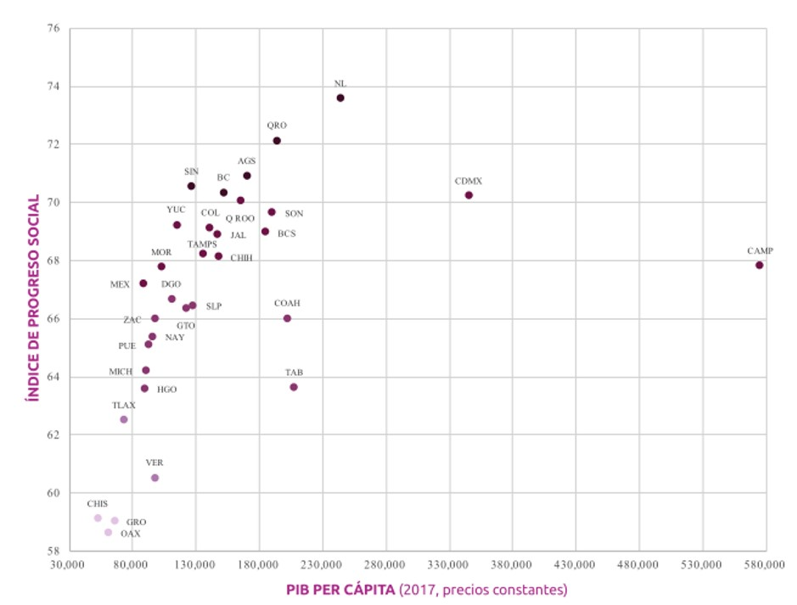
ScPI by GDP relation
If is considered as a transition parameter between the linear and saturation for the mathematical model, it can be separated in 2 differential terms, writing:
$δ=SDV−R...\left(3\right)$
where: SDV represents the Social Development Value associated at the interaction of the dispersion data around the tends of the curve. R will be determined as the resources available to get the facilities in the way to increase the opportunities in the Social Progress.
With this two parameters added, the extension for the new equation can be written as:
$ScPI=K\left[\left(SDV−R\right)GDP−\frac{GDP^{2}}{2}\right]...\left(4\right)$
The differential value is let to break the trends from the linear region to the saturation part(Figure 2).
The differential value let to break the trends from the linear region to the saturation part. In this last region, the trend must be increased slowly with constant slope at the break point as is shown in figure 3.
It is clearly to evaluate the break-point between the linear and saturation parts of the curve which is reached when the ScPI is maximum in the linear region or the GDP value is critical.
It can be obtained evaluating the first differential equation by (4):
$\frac{dScPI}{dGDP}=K(SDV−R)−K*GDP=0...(5)$
The singular point is determined when (5) is equal to zero and then the result of Saturation region is similar at the difference reference which is rewritten in equation (6):
$GDP=SDV−R...\left(6\right)$
This last expression means that the Saturation value for the ScPI is found when the GDP reach the maximum value, i. e. when the saturation region starts and then a 2 new parameters must be inserted in the saturation region model.
Let now describes the GDPsat=Vsat as the critical value for this parameter in terms of the limited product which can be obtained due the particular characteristics for the state of country and is the slope for this modulated saturated region, then the model for this second model is:
$ScPI=\frac{K}{2}{\left(SDV−R\right)}^{2}\left(1+λ\left(GDP−Vsat\right)\right)...\left(7\right)$
where the ScPI conserves its primary second-order trends but the monotonic performance is reflected for the saturation behavior.
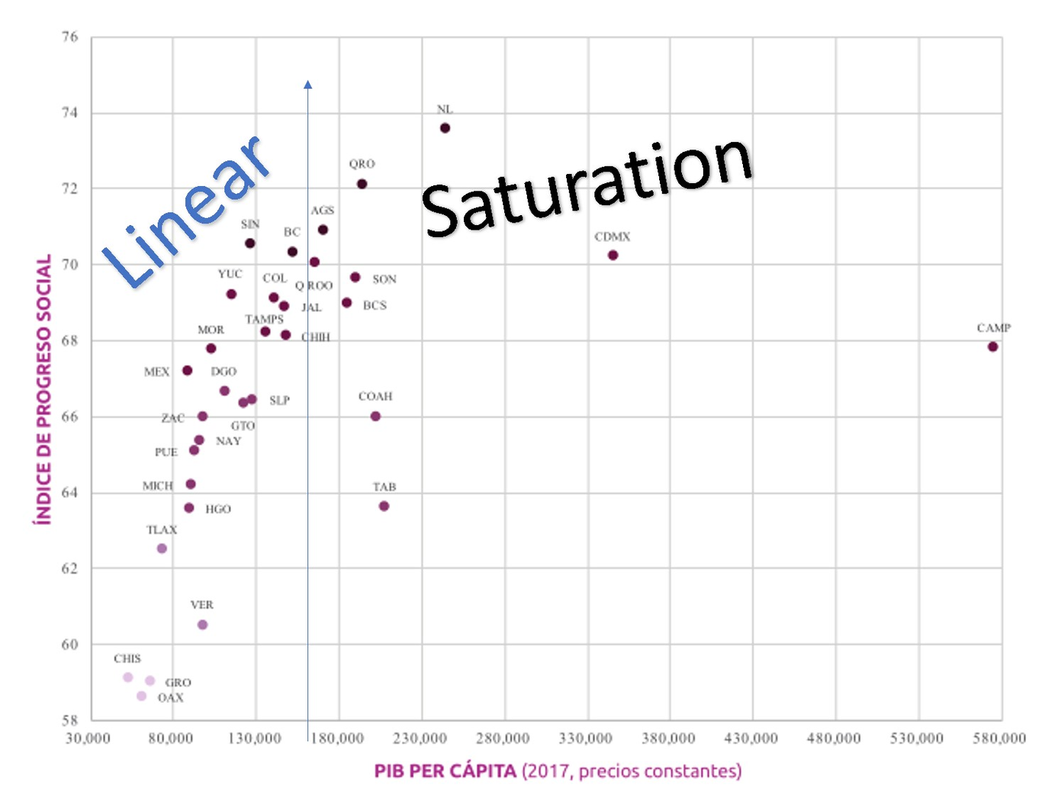
Ranges defined by inspection
In figure 3 is clearly defined almost 3 o 4 regions of influence between the data where the ScPI can be resolved by the differential provoke in .
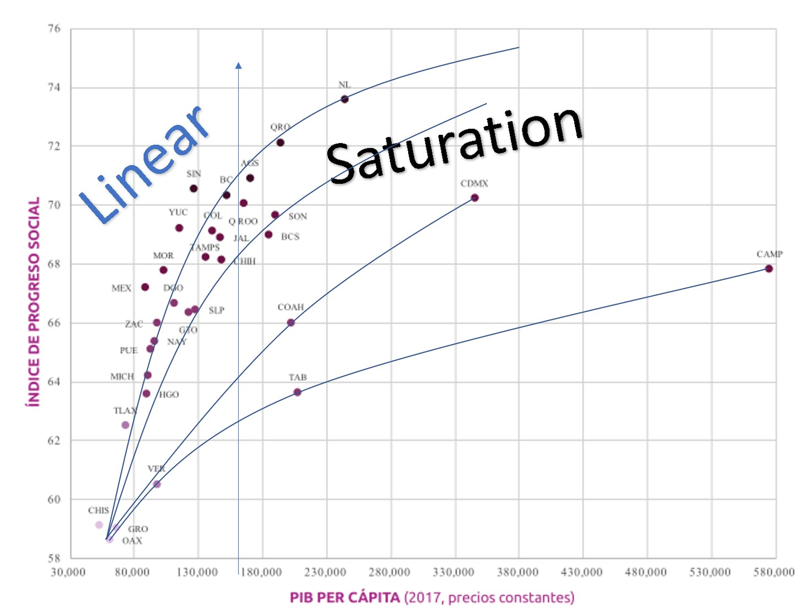
Trends
With this recent criteria, the saturation region can be developed by a new second order equation where the maximum point of both graphs can be disjointed.
If the final value for ScPI with GDP can be well-known, and the scalar value for the slope is determined with a monotonic increment of a new parameters, the saturated expression can be expressed in (5).
Finally. each parameter can be defined in context as: i)Basic human needs, ii) Foundations of Welbeing and iii) Opportunities.

Data analysis
Now it is possible to describe the behavior between the second-order obtained and its correlation with the real social values including their interactions within the trends of the ScPI performance.
In the first try, a close correlation can be distinguished next to the Basic Human needs(BHn) and the Social Imperative displacement. In this parameter, it is reflected an accomplishment near to the incremental value for the model.
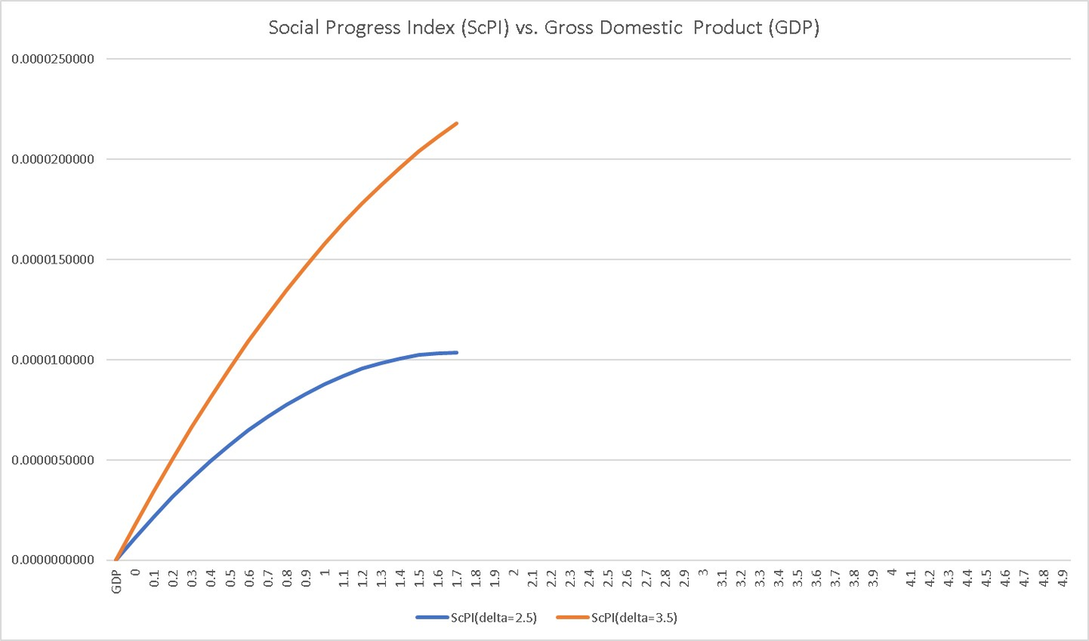
Testing model in Excel…

Conclusion
The feasibility to model the ScPI-GDP performance using two second-order equations is demonstrate with a great level of confidence if the principal factors of the model are included.
A online parametric model can be programmed in the Sintonía webpage to report in “real-time” the evolution of the indexes when the factor are modified.
The study of the model in this paper is preliminary.

Acknowledgment
The authors would like to thank Harvard and UPAEP for the access of the data online.

References
n.d. https://www.socialprogress.org/. https://www.socialprogress.org/.
Fehder, Daniel, Michael Porter, and Scott Stern. 2018. “The Empirics of Social Progress: The Interplay between Subjective Well-Being and Societal Performance”. AEA Papers and Proceedings 108 (May): 477–82. https://doi.org/10.1257/pandp.20181036.
Michelini, Laura, and Daniela Fiorentino. 2012. “New Business Models for Creating Shared Value”. Social Responsibility Journal 8 (4): 561–77. https://doi.org/10.1108/17471111211272129.
Mantelero, Alessandro. 2018. “AI and Big Data: A Blueprint for a Human Rights Social and Ethical Impact Assessment”. Computer Law & Security Review 34 (4): 754–72. https://doi.org/10.1016/j.clsr.2018.05.017.
Barrington-Leigh, Christopher, and Alice Escande. 2016. “Measuring Progress and Well-Being: A Comparative Review of Indicators”. Social Indicators Research 135 (3): 893–925. https://doi.org/10.1007/s11205-016-1505-0.
n.d. https://mexicocomovamos.mx/new/md-multimedia/1573768417-927.pdf. https://mexicocomovamos.mx/new/md-multimedia/1573768417-927.pdf.

