Alternative method for modelling structural and functional behaviour of a Storage Hydroelectric Power Plant using MLD approach
Carlos Graciós, Rosa María , German Ardul Munoz-Hernandez, Sa’ad Mansoor, Gregorio Zamora-Mejía
Carlos Graciós et al.: Alternative method for modelling structural and...

1. INTRODUCTION
The relevant role of the hydroelectric plants in the world is achieved in their particular energy production because of the great amount of energy production between 30% – 60% accord of the total power generation around the world.
The efficiency in terms of the high level actual requirements, depends of the correct balance on the generation, storage and distribution strategies reported in the literature.
In the particular requirement of generation issues, the development of high efficient control architectures are preliminary explored by the primary scheme which is analyzed in recent results(Cleynen, Hoerner, and Thévenin 2017). Here, it is important to evaluate the performance of each part and whole power generation system to define the adequate law control behaviour.
Acord to Lui et al.(Liu et al. 2016) the transient process in hydropower stations, including the interactions among hydraulics, mechanism, and electricity, is complicated. The closure of guide vanes and spherical valve induces a change in the flow inertia, which causes changes in the turbine rotational speed and hydraulic pressure in the piping system.When the working condition dramatically changes during transients, drastic changes in the waterhammer pressure and high rotational speed may lead to serious accidents that will endanger the safety of the hydraulic structure and turbine unit [1–3] and affect the power grid stability [4]. Therefore, simulating the transient process of hydropower stations is necessary. The calculation accuracy is directly related to the design of the water diversion system, safe operation of the hydropower plant, and power quality.
However hydropower generation varies greatly between years with varying inflows, as well as competing water uses, such as flood control, water supply, recreation, and in-stream flow requirements. Given hydropower’s economic value and its role in complex water systems, it is reasonable to monitor and protect the hydropower unit from harmful operation modes.
A unit is often operated through rough zone which will cause the unit vibration and the stability performance will decline.(Qiao and Chen 2015)
Finally, in the case of Great Brittian 1/3 of the cfomplete electrical power is generated by a Hydropower plant installed in Dinorwig Wales with a special characteristics to be demostrated in this report(Nwobi-Okoye and Clement 2012)
Futhermore, section 2 is devoted to describe the Dinorwig Hydropower Plant(DHP) as structural as functional manner. The hybrid model proposed to define the unsual behaviour for the Plant is developed in section 3. Section 4 shows the Model obtained applying the MLD strategy inserted here. The results using the proposed method are discussed in Section 5. Finally, some conclusions are drawn in Section 6 followed by Acknowledgment and relevant references.

2. Dinorwig Hydropower Plant.
In the actual industrial sector for energy production area, the competitiveness provokes to seek an efficient and affordable process. To resolve the high and complicated requirements for the generation, storage, transmission and use of the energy production is constantly reinforced. An adequate balance is need in “real-time” because the soft, intermittent and hard faults in the grid can appears without flag.
Quality and correct amount in the power supply is now the final panacea in the strict goal for electrical energy production. In England,perhaps the commercial demand which is included the half-hour periods of adjust, in the “normal” consumption, the variation changes in fraction of seconds.
Although for financial matters, it is possible make adjust for middle terms, the demand forces to take decision in a seconds fractional time with the catastrophic results in the national grid stations trying to balance the operational power through stress conditions.
In addition, the use of electrical energy is increasing causing a new level Quality/Cost relation requirement because the actual financial and regulations index. It means in short words, to improve the performance in load changes and suitable response in perturbing under hard conditions and Financial Utility. Considering the Quality/Cost index in the electricity supply, voltage and frequency must be provided in standard numbers controlling in the better way against the harmonics variations, non linear behaviour and transient peaks.
In particular, for GB grid, the Dinowig plan, accomplishes with the national grid demand in terms of voltage and frequency of: 230 volts +10/- 6% (residential) y 50 hertz +/- 0.5Hz.
The hydroelectric plants are designed for high flexibility in several operational condition and the capabilities of agility and fault tolerance in fast load response which establish and extensive frequency control scheme verified in the electric net. It could be performance using several strategies. One of them is the redundancy method,i. e. the interconnection of two or more generators to compensate the variations.
Dinorwig is an electrical station located at the North Wales Kingdom that use this type of strategy interconnecting 6 reversible turbo generators with an individual capacity of 300 MW, because this is one of the most powerful in its class around the Europe and its primary contribution is as electrical auxiliary services in The Brisith Electrical Grid. It function is a pumped water lake conducted by 6 tunnel connected, distributed and controlled using penstocks. (penstocks) (Fig. 1) (“Reproducing Oscillatory Behaviour of a Hydroelectric Power Station by Computer Simulation,” 2000), (Kundur 1994).
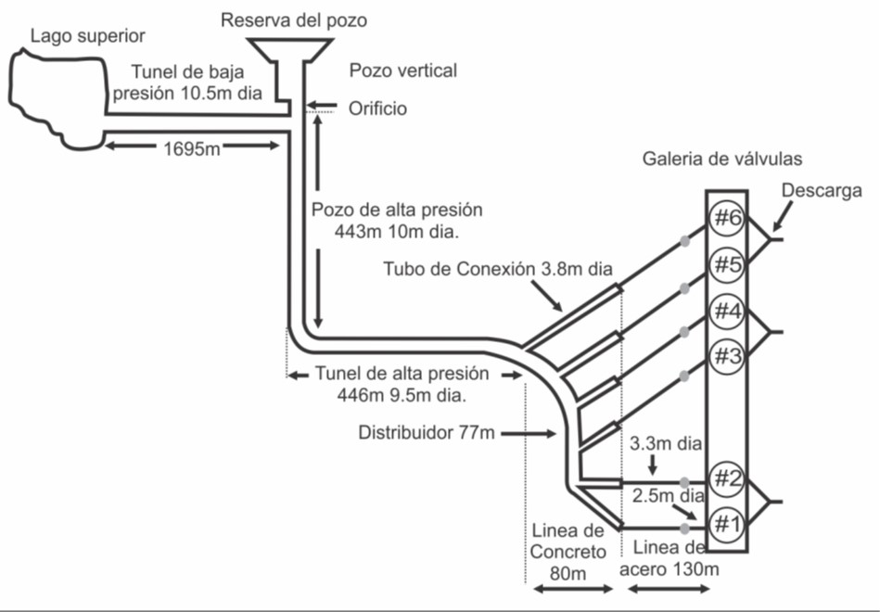
Schematic model for Dinorwig Hydroelectric Plant

3. Hybrid model
A Dynamic Hybrid System (DHS) is whom contains continuous and discrete functional elements in both time domains (“Equivalence of Hybrid Dynamical Models” 2001). This type of systems have been modeled using several techniques, i. e. State Transition Graph (STG) or Diferential Equation Set (DES) which the parametric variables are discrete and continuous form.

3.1. Mixed Logical Dynamic (MLD)
A way to model DHS is applying MLD, Eq. 1 (“Control of Systems Integrating Logic, Dynamics, and Constraints” 1999), (G. A. Munoz-Hernandez and Fuentes-Goiz 2005).
$$\begin{matrix}X_{k+1}=Ax_{k}+Bu_{k}+B_{2}δ_{k}+B_{3}Z_{k} \\ Y_{k}=Cx_{k}+D_{1}u_{k}+D_{2}δ_{k}+D_{3}Z_{k} \\ E_{1}x_{k}+E_{2}u_{k}+E_{3}δ_{k}+E_{4}Z_{k}≤g\end{matrix}$$
where $x_{k}=[x_{k}^{r}x_{k}^{b}],x_{k}^{r}∈R^{n}$ is the continuous state part and $x_{k}^{b}∈\{0,1\}^{n_{b}}$ is the discrete one. In similar form $y_{k}=[y_{k}^{r}y_{k}^{b}],y_{k}^{r}∈R^{m}$ is the continuous output, and $y_{k}^{b}∈\{0,1\}^{m_{b}}$ is the discrete result.
Teherefore $u_{k}=[u_{k}^{r}u_{k}^{b}],u_{k}^{r}∈R^{l}$ is and $u_{k}^{b}∈\{0,1\}^{l_{b}}$ are defined as the input and output respectively. Finally, $Z_{k}∈R^{r_{r}}$ and $δ_{k}∈\{0,1\}^{r_{b}}$ are auxiliar variables, and $A,B_{1},B_{2},B_{3},C,D_{1},D_{2},D_{3},E_{1},E_{2},E_{3},E_{4},g$ are parametric variables for the model.
In MLD schemes the logical expressions in the discrete domain are expressed as equality o inequality restrictions. This is, by logical variables $δ_{1}$ and $δ_{2}$ assigned with 0 or 1 values, upper limit M, under limit m, and/or positive tolerances $ϵ$, any expression can be transform in equality or inequality manner, Ec. 2, Ec. 3, Ec. 4 (Mansoor 2000), (“Complementarity Modelling of Hybrid Systems” 1998).

$$\begin{matrix}L_{1}∧L_{2} is equivalent to δ_{1}+δ_{2}≥1 \\ L_{1}∨L_{2} is equivalent to δ_{1}=1,δ_{2}=1\end{matrix}$$

$$δ_{3}=δ_{1}δ_{2} is equivalent to \left\{\begin{matrix}−δ_{1}+δ_{3}≤0 \\ −δ_{2}+δ_{3}≤0 \\ δ_{1}+δ_{2}−δ_{3}≤1\end{matrix}\right.$$
$$y=δf(x) is equivalent to \left\{\begin{matrix}y≤Mδ \\ y≥mδ \\ y≤f(x)−m(1−δ) \\ y≥f(x)−M(1−δ)\end{matrix}\right.$$

4. MLD Model Procedure.
To emulate the functional behaviour for the Dinorwig HEP system, it is required to generate a mathematical MLD model with the adequate degrees to express the dynamic of the hydraulic turbine defined as the active unit $(G1(s))$, in S-domain in the form of Transfer Function (TF) (Eq. 5) (Working group on prime mover energy supply 1992), (“Modeling and Control Tuning of a Hydro Station with Units Sharing a Common Penstock Section” 1999).

$$G_{1}(s)=\frac{y(s)}{x(s)}=\frac{−2.358s+3.395}{0.076s^{3}+0.8204s^{2}+2.788s+3.031} (5)$$
Because of the TF is represent in continuous time domain , a bilinear programming script was developed in $MATLAB$© to be converted at $Z$ discrete time domain applying the Invariant Impulse Method (Eq. 6) and through the Tustin method or Bilinear Transformation (Eq. 7).
$$\frac{y(z)}{x(z)}=\frac{−0.00294z+0.003116}{0.076z^{3}+0.1977z^{2}+0.04935} (6)$$

$$\frac{y(z)}{x(z)}=\frac{−0.009792z^{3}−0.009212z^{2}+0.01095z+0.01037}{z^{3}−2.6z^{2}+2.251z−0.6487} (7)$$
Now, programming in $Simulink$ © the TF Eq. 5, Eq. 6 y Eq. 7 (Fig. 2), it is possible to write the answer for each stimulus in Unit Step Input.
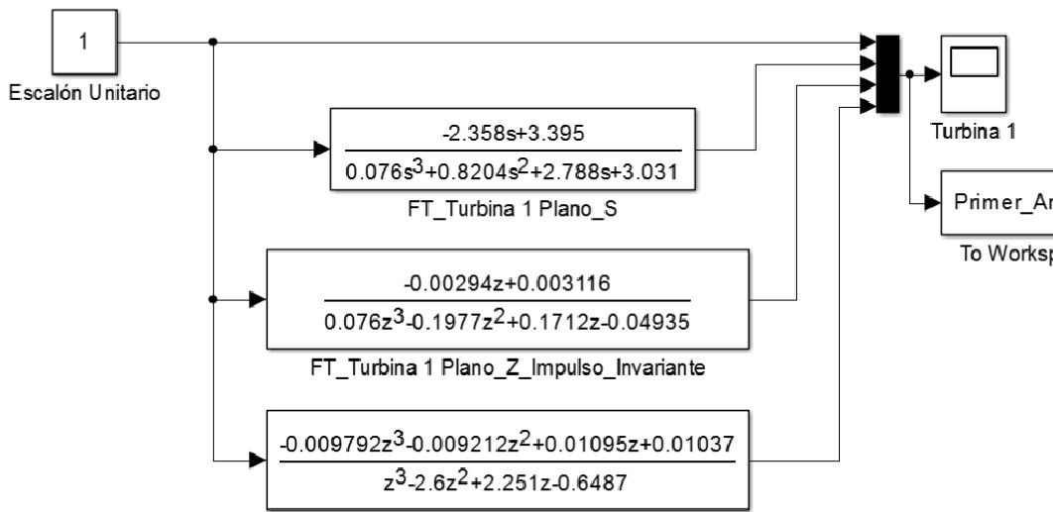
Transfer Function using Simulink
When the first analysis is registered in a specific point for stability region in each method (Fig. 3), then the reponse in the adequate magnitud is found when the bilinear transformation is near to the original TF in S-domain.
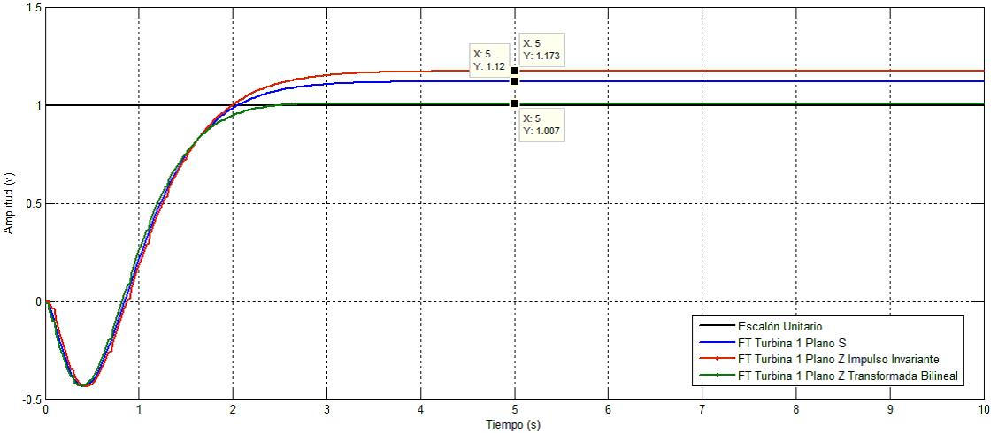
Figure 3. First Response Analysis for each method.
To obtain the behaviour in each method with enough significance, a 4-round digits for the coefficients were determined. (Fig. 4).
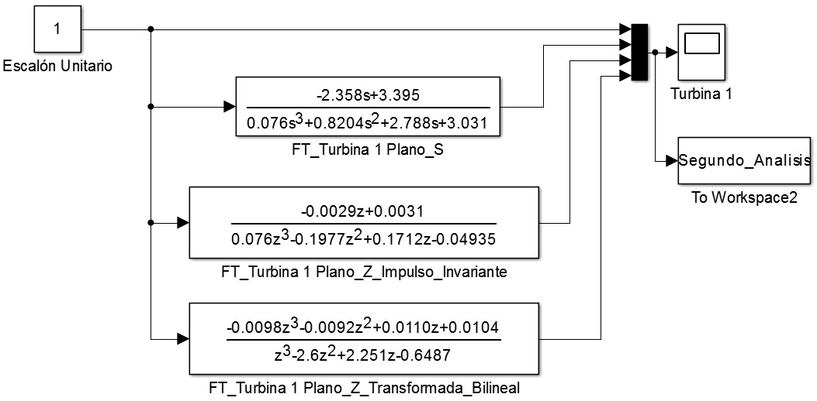
Transfer Functions in Simulink with round
With a second analysis in an arbitrary point (Fig. 5), a comparison between the IIR approach and the bilinear transform determined a relevant increase in the result output change which will let to decide about the MLD bilinear transform to describe the two turbines for the Hydropower scheme.
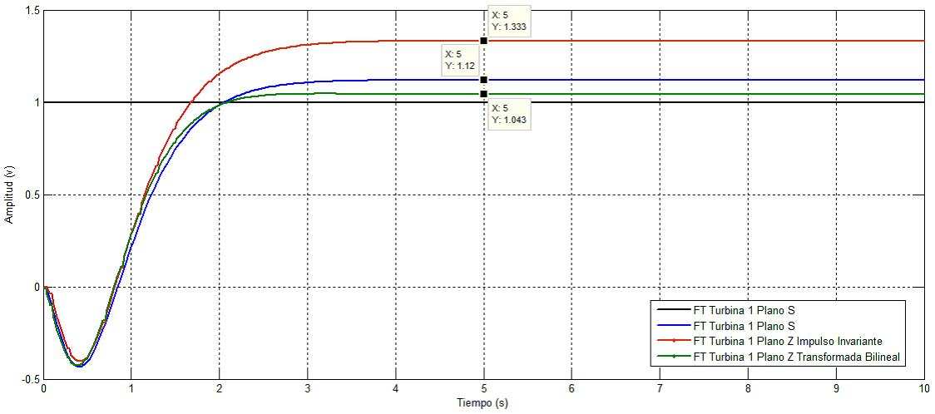
Final responses for each method

5. Results
With the TF defined in $Z$ discrete time domain (Eq. 7) an exponents modification can be determined to represent the delay behaviour for the system (Ec. 8).

$$\frac{G_{1}(z)}{In(z)}=\frac{−0.009792−0.009212z^{−1}+0.01095z^{−2}+0.01037z^{−3}}{1−2.6z^{−1}+2.251z^{−2}−0.6487z^{−3}} (8)$$
To express the output in terms of $G_{1}(z)$, a difference equation for the MLD model is determined (Ec. 9). This equation is the mathematical representation to provide the base response with parametric coefficients within the input and output in different sample time of the whole system.
$G_{1}(z)=−0.009792In(z)−0.009212z^{−1}In(z)+0.01095z^{−2}In(z)+0.01037z^{−3}In(z)−G_{1}(z)+2.6z^{−1}G_{1}(z)−2.251z^{−2}G_{1}(z)+0.6487z^{−3}G_{1}(z) (9)$
Then, the block diagram is developed using the difference equation (Fig. 6). This diagram let describes the Direct Structure I for the Infinite Impulse Response Filter (IIRF) obtained by analogy with the design desire. The structure is non-canonic because it is result in 6 functional delays ($z^{−1}$) for its implementation at the third order TF.
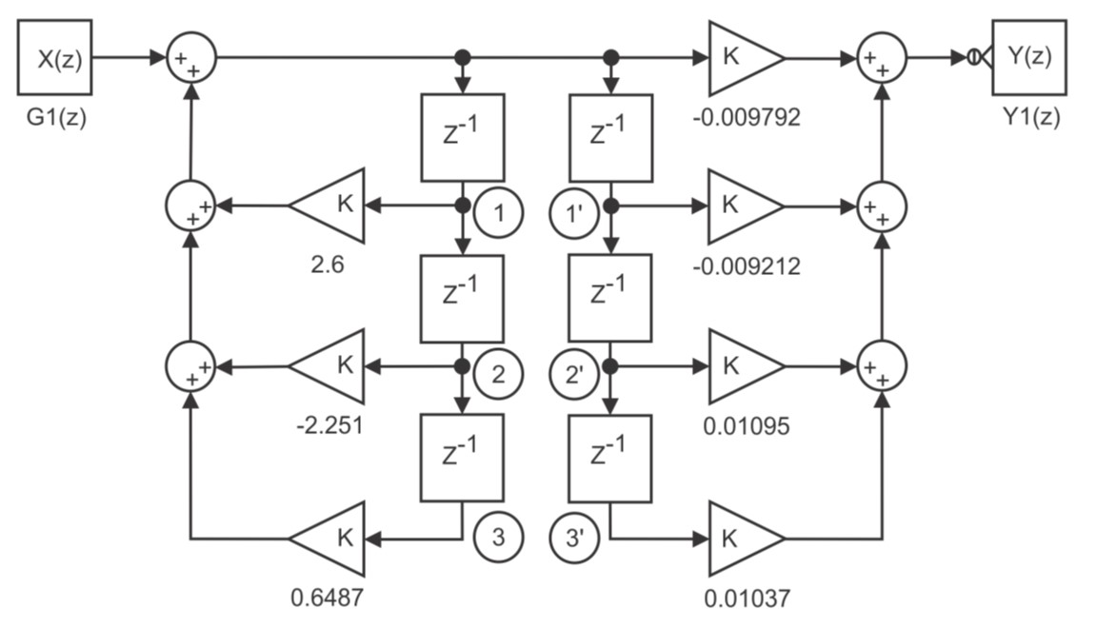
Transpuesta de la función directa
The signal between the 1 and 1’ nodes is the same, in addition, the two first delays can be added in just one delay. In the similar way, the signal in 2-2’ nodes is similar and then the two next delays are accumulated as well. In the end, two final signal are collapsed in one to get the II-Direct Canonical Structure (Fig. 8).
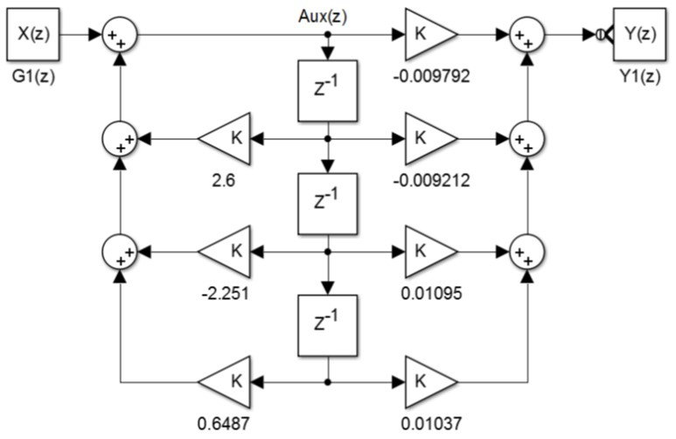
TF in II-Direct form
The TF is represented in the Difference Equation Manner with the I-Direct Structure (Eq. 9) and the Difference Equation (Eq. 10) it is the II-Direct Structure model, which is use a posteriori to determine the resource consumption and to select the suitable FPGA.
$$Aux(z)=−0.009792In(n)−0.009212z^{−1}Aux(z)+0.01095z^{−2}Aux(z)+0.01037z^{−3}Aux(z) (9)$$
$$G_{1}(z)=Aux(z)+2.6z^{−1}Aux(z)−2.251z^{−2}Aux(z)+0.6487z^{−3}Aux(z) (10)$$
By the MATLAB © Script a desktop test is performed in both difference equations.Desktop testing procedure is a numerical tool to verify if an algorithm accomplishes with the specifications defined through several iterations without use any compiler. This procedure lets to debug and fix errors in the system implementation.
The final test results in 100 iteration for both structures considering the Unit Step Input Response. Figure 9 shows the similar behaviour within them. The minimal variation is due the resources applied in the design.
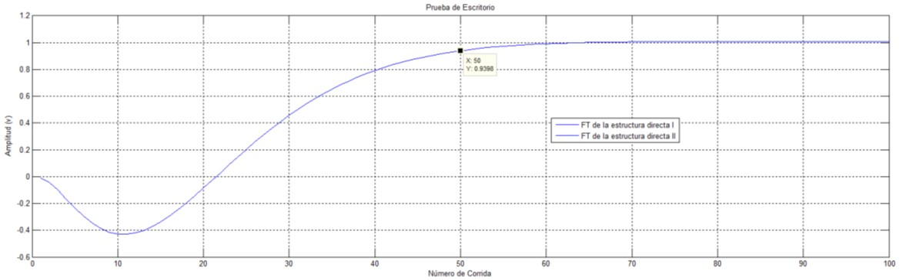
Test desktop for the final TF in Direct Form Type I and II

CONCLUSION
This paper establishes an alternative methodology to implement the MLD Dinorwig HEP. A simple procedure was developed to select the primary S to Z Transformation.
Futhermore, a difference equations for the model was determined. An Infinite Impulse Response Filter was obtained to evaluate the delays in the final model for its final description in canonical structure. At last, the procedure does not affect the behaviour in the Non-Canonical structures when the model is performed in the programmable device. A stability analysis is proposed for future work.

References
Cleynen, Olivier, Stefan Hoerner, and Dominique Thévenin. 2017. “Characterization of Hydraulic Power in Free-Stream Installations”. International Journal of Rotating Machinery 2017: 1–10. https://doi.org/10.1155/2017/9806278.
Liu, Yanna, Jiandong Yang, Jiebin Yang, Chao Wang, and Wei Zeng. 2016. “Transient Simulations in Hydropower Stations Based on a Novel Turbine Boundary”. Mathematical Problems in Engineering 2016: 1–13. https://doi.org/10.1155/2016/1504659.
Qiao, Liangliang, and Qijuan Chen. 2015. “Forecasting Models for Hydropower Unit Stability Using LS-SVM”. Mathematical Problems in Engineering 2015: 1–9. https://doi.org/10.1155/2015/350148.
Nwobi-Okoye, Chidozie, and Igboanugo Clement. 2012. “Performance Evaluation of Hydropower Generation System Using Transfer Function Modelling”. International Journal of Electrical Power & Energy Systems 43 (December): 245–54.
2000. Control Engineering.
Kundur, P. 1994. Power System Stability and Control. New York, USA. Mc Graw Hil.
2001. Automatica 37(7).
1999. Automatica 35(3).
G. A. Munoz-Hernandez, D. I. Jones, and S. I. Fuentes-Goiz. 2005. “Modelling and Simulation of a Hydroelectric Power Station Using MLD”. In Proceedings of the 15th International Conference on Electronics, Communications and Computers.
Mansoor, S. P. 2000. “Behaviour and Operation of Pumped Storage Hydro Plants”. PhD thesis, PhD. Thesis. Bangor, U.K. University of Bangor.
1998. IEEE Trans. Autom. Control 43.
supply, IEEE Working group on prime mover energy. 1992. “Hydraulic Turbine and Turbine Control Model for System Dynamic Studies”. IEEE Transactions on Power Systems.
1999. IEEE Transactions on Power Systems 14.

Carlos Graciós is with Technological University of Puebla, Mexico
Rosa María is with Puebla Institute of Technology
German Ardul Munoz-Hernandez is with Puebla Institute of Technology
Sa’ad Mansoor is with Bangor, Wales University. U. K.
Gregorio Zamora-Mejía is with Affiliation not available

