TXY dgdf
And Turken
Affiliation not available
Abstract
content sretyrte
ity goes here fdgsfdghdsfghdfgdghf
ghygf
hjfty (Swick, Honzel, and Turken 2015)
=1

Introduction
This is a Markdown block and you can use Markdown syntax to bold or italic text.

A few tips
- Click anywhere outside of this Markdown block to render it
- Hover on Preview to see a preview of the rendered content
- Use the Insert Figure button to add images (and data)
- Use LaTeX to add equations, e.g. $\mathcal L_{EM}=-\frac14F^{\mu\nu}F_{\mu\nu}$
- Search scholarly sources and references by clicking cite
- To insert more Markdown blocks, click Insert $→$ Markdown.
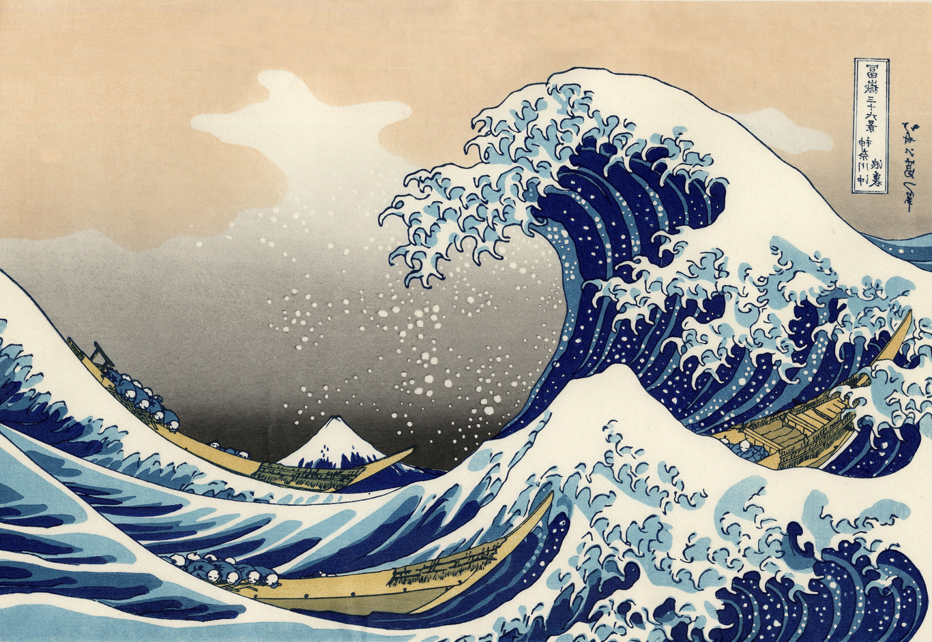
K
Efdgfhgfgdfd

DDDtuhytjyu
fdghfgh (Kang et al. 2012)

Csdtgref
rgrt
trtr
(Swick et al. 2017)
ABCDE

table This is a caption
dataset | x | y
I | 10.0 | 8.04
I | 8.0 | 6.95
I | 13.0 | 7.58
I | 9.0 | 8.81
I | 11.0 | 8.33
I | 14.0 | 9.96
I | 6.0 | 7.24
I | 4.0 | 4.26
I | 12.0 | 10.84
I | 7.0 | 4.82
I | 5.0 | 5.68
II | 10.0 | 9.14
II | 8.0 | 8.14
II | 13.0 | 8.74
II | 9.0 | 8.77
II | 11.0 | 9.26
II | 14.0 | 8.1
II | 6.0 | 6.13
II | 4.0 | 3.1
II | 12.0 | 9.13
II | 7.0 | 7.26
II | 5.0 | 4.74
III | 10.0 | 7.46
III | 8.0 | 6.77
III | 13.0 | 12.74
III | 9.0 | 7.11
III | 11.0 | 7.81
III | 14.0 | 8.84
III | 6.0 | 6.08
III | 4.0 | 5.39
III | 12.0 | 8.15
III | 7.0 | 6.42
III | 5.0 | 5.73
IV | 8.0 | 6.58
IV | 8.0 | 5.76
IV | 8.0 | 7.71
IV | 8.0 | 8.84
IV | 8.0 | 8.47
IV | 8.0 | 7.04
IV | 8.0 | 5.25
IV | 19.0 | 12.5
IV | 8.0 | 5.56
IV | 8.0 | 7.91
IV | 8.0 | 6.89
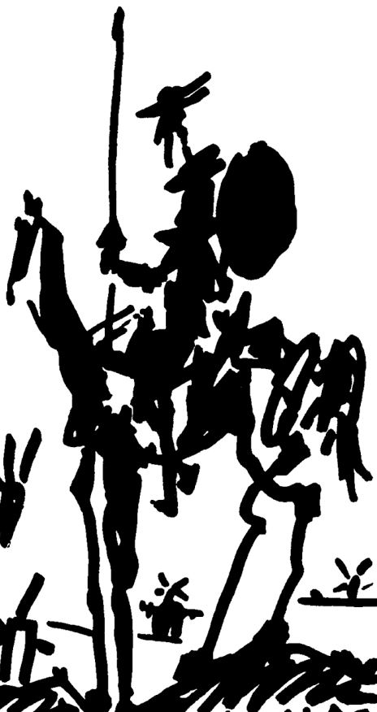
Caption - Tdfyhtyut6
hfgjhythfgd yhtyrdrtye trytretre

TRJH

fhgfh
QWERTY^{ryhty}
(Schendel, Dronkers, and Turken 2016)

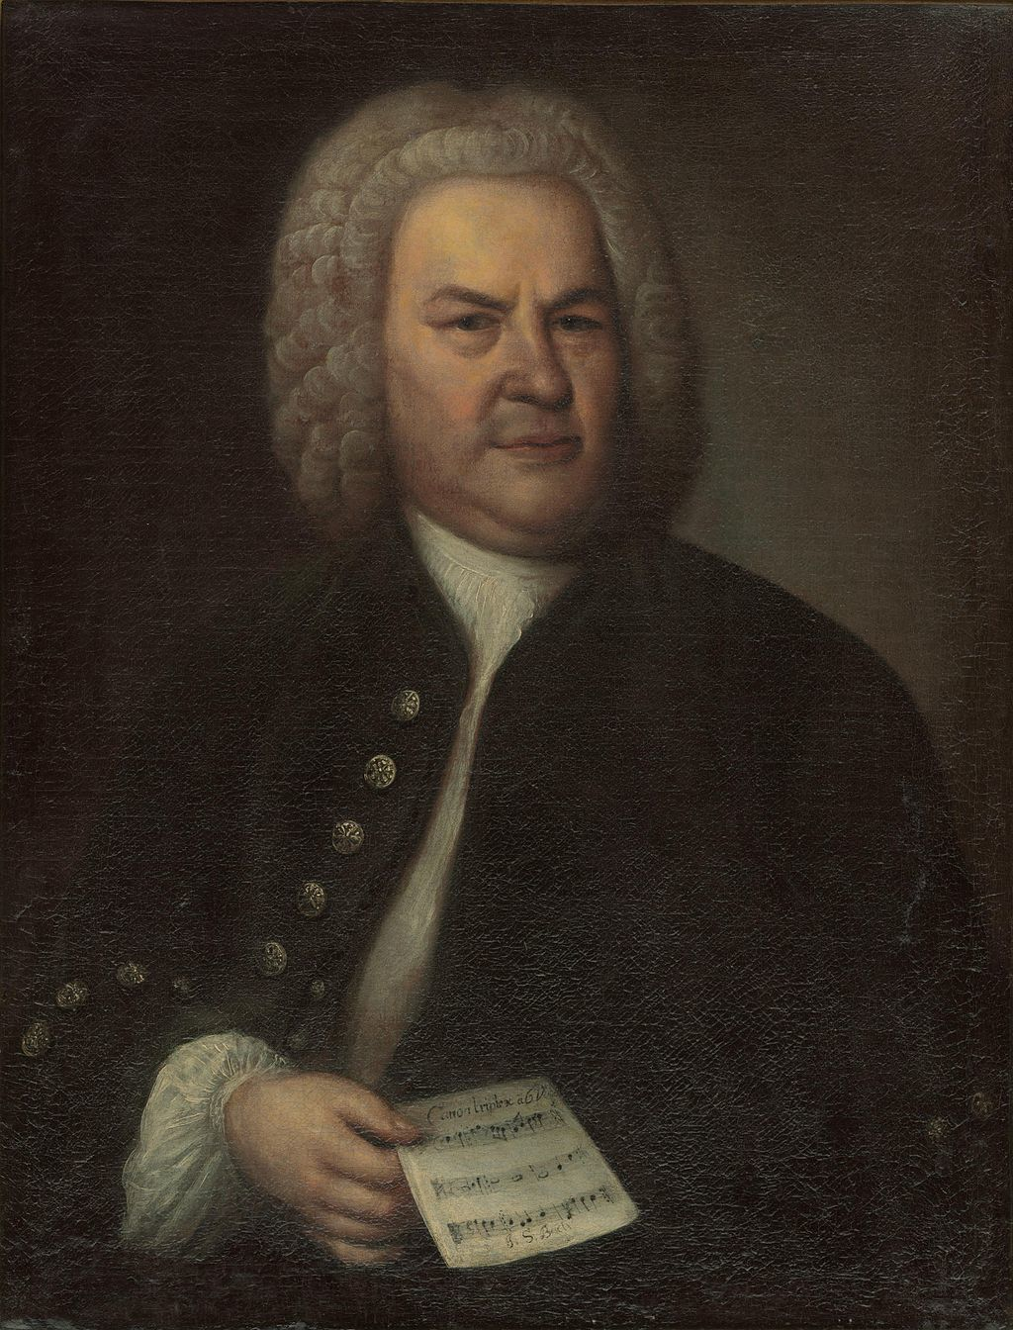
This is a caption

- rt
- ertre
- ertyret
- yrt

- rytr
- tryrt
- tyrt
wery6err67it8ito9898i
etgrtduytr
dtryuyt
ryty
(Ivanova et al. 2018; Baldo et al. 2018)
kjlk

fdgdf
END
m
Figure ??? ???
See ??????
$e = mc^{2}$

XYZ

1

References
Swick, D, N Honzel, and U Turken. 2015. “Intact Error Monitoring in Combat Veterans with Post-Traumatic Stress Disorder.”. Psychiatry Res 234: 227–38.
Kang, X, TJ Herron, AU Turken, and DL Woods. 2012. “Diffusion Properties of Cortical and Pericortical Tissue: Regional Variations, Reliability and Methodological Issues.”. Magn Reson Imaging 30: 1111–22.
Swick, D, J Cayton, V Ashley, and AU Turken. 2017. “Dissociation between Working Memory Performance and Proactive Interference Control in Post-Traumatic Stress Disorder.”. Neuropsychologia 96: 111–21.
Schendel, K, NF Dronkers, and AU Turken. 2016. “Not Just Language: Persisting Lateralized Visuospatial Impairment after Left Hemisphere Stroke.”. J Int Neuropsychol Soc 22: 695–704.
Ivanova, MV, O Dragoy, SV Kuptsova, Akinina S Yu, AG Petrushevskii, ON Fedina, A Turken, VM Shklovsky, and NF Dronkers. 2018. “Neural Mechanisms of Two Different Verbal Working Memory Tasks: A VLSM Study.”. Neuropsychologia.
Baldo, JV, N Kacinik, C Ludy, S Paulraj, A Moncrief, V Piai, B Curran, A Turken, T Herron, and NF Dronkers. 2018. “Voxel-Based Lesion Analysis of Brain Regions Underlying Reading and Writing.”. Neuropsychologia.

