Rentakā (Car Rental)
Akash
Taqi
Tahir
Hinal

Abstract
A car rental is a company that rents automobiles for short periods of time, generally ranging from a few hours to a few weeks. It is often organized with numerous local branches (which allow a user to return a vehicle to a different location), and primarily located near airports or busy city areas and often complemented by a website allowing online reservations. Car rental agencies primarily serve people who require a temporary vehicle, for example, those who do not own their own car, travelers who are out of town, or owners of damaged or destroyed vehicles who are awaiting repair or insurance compensation. Car rental agencies may also serve the self-moving industry needs, by renting vans or trucks, and in certain markets, other types of vehicles such as motorcycles or scooters may also be offered.

Introduction
In this paper, we propose an anonymous car rental service based on NFC technology and/or remote authentication using smart card. Our main features include:
- (1) Anonymity. Users provide their personal information to the app only. The car companies cannot get users’ real identity.
- (2) Self drive. Users enjoy a seamless driving experience across a wide range of luxury cars.
- (3) NFC / Smart Card. Users will be provided with app-associated smart cards or they can use their NFC enabled phones which will be used for authentication.
- (4) Trace ability. If there are customer disputes or accidents, the rental company can track the users’ whereabouts.
- (5) Flexibility. Users are free to choose their preferred vehicle.
A customer has to register his identity via the app (or web-app) on his NFC phone. This registration should be also accompanied with license registration and verification against the driver’s database. The customer should request a temporary anonymous personal identification number (pin) from the app whenever he desires to avail the services. If the license is valid, the company issues the pin for the requested vehicle to the user over the app. The vehicle authenticates the user through his/her NFC phone/smart card. Last, after the user is authenticated, the he/she is allowed to drive the car. When a car is returned, the rental company can collect the charges through a TTP(Trusted Third Party) or the built in wallet facility. If customer disputes arise or there are accidents, the authorities can request to reveal the user’s identity.

Related Research

A. Door Security

Nowadays security is the most essential issue everywhere in the world; so security of everything gains higher and higher importance in recent years. Even in our context, the car door security gains utmost importance since it is the starting point of user interaction with the car. It is necessary to make sure that only authorized users be able to enter the car.

In this paper, we propose a
- Password based
- RFID - smart card
....based authentication system

Password based door locking mechanism:

The programmable electronic code lock device is programmed in such a way that it will operate only with the correct entry of predefined digits. It is also called an integrated combination type lock. The programmable code lock is shown in Fig 1 as below.
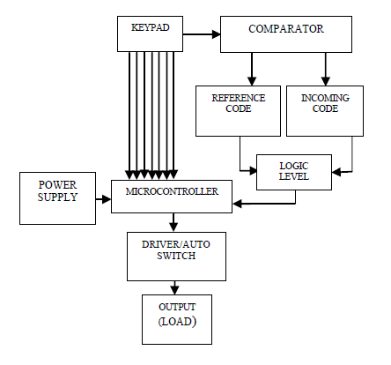
Programmable Electronic Code Lock

In our case, the predefined digits or the reference code will be set each time a user requests a car service. This number will be sent to the user’s phone as an OTP(one time password). Then, the OTP should be entered through keypad on the door and the door will open.

RFID - SmartCard based:

The proposed system will require a RFID reader attached to the car door. It uses a smart card which will be used as an RFID tag to authenticate users. This smart card has information stored in it which will be immediately read by the RFID Reader when it comes in its near field region. The Reader takes this information and matches it with the information stored in it. On successful match, the user will be allowed to enter otherwise not. The following demonstrates the working of RFID based Door locking mechanism.
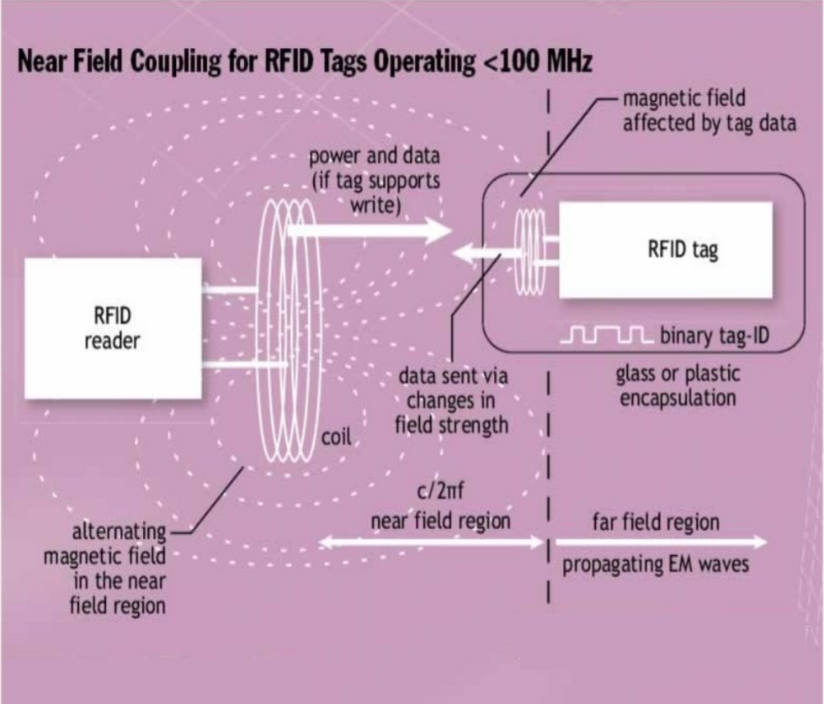
RFID working Principle

Methodology

RFID systems operates from very low frequency(VLF) to extremely high frequency(EHF).RFID system operating in low frequency range make use of electromagnetic wave propagation to communicate their data and commands, these use passive tags. RFID systems operating in low frequency range operates on principle of near field coupling between tag and reader. Faraday‟s principle of electromagnetic induction is the basis of near field coupling. In near field RFID system, electromagnetic waves are transmitted by reader or interrogator which propagates outwards with spherical wave front. Tags placed within field collect some energy. Then exchange of data between tag and reader takes place. The amount of energy available at any particular point is related to distance from the transmitter as expressed as 1/d where d is distance from the transmitter.
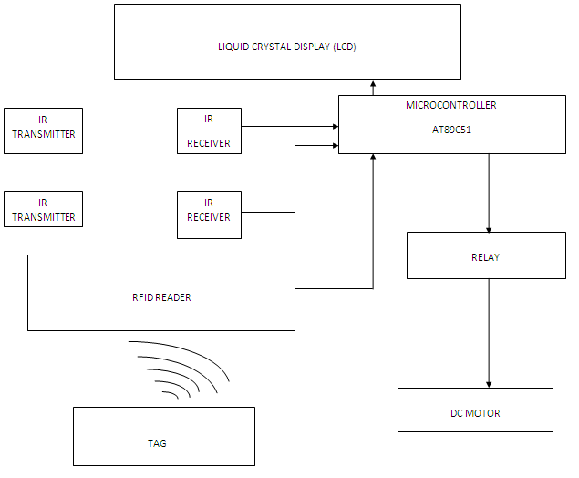
RFID Block Diagram
- a) RFID tag: Tag is the basic building block of RFID. It consists of small silicon chip and an antenna. Silicon chip is used to store the data and antenna is used to energize the chip and communicate with reader.
- b) RFID reader or interrogator: The RFID reader sends a pulse of radio energy to the tag and listens for tag‟s response. The tag detects this energy and sends back a response that contains the tag‟s serial number and other information as well .Implemented RFID reader having frequency of 125 KHz for this design .It reads the tags and output their information to the microcontroller.
- c) Power conversion circuits: Power conversion circuits allow individual modules to make use of existing power supplies.
- d) Microcontroller: Microcontroller to be used is AT89C51.
- e) Relay: Relay used is of 5V.
- f) DC motor: 5V DC motor is used

B. Transaction Management

Once the user is registered through our app, he/she needs to setup the account “wallet”. The user’s Account has an associated wallet, and all purchases made on the provided services, including payments funded from an outside payment source (e.g., a credit card or PayPal account) at the time of the availing the service, are made through the wallet. Wallet funds have no value outside the app and can only be used to make payments for the services provided. Provisions for certain Third Party Services like Paytm, Mobikwik Freecharge etc, could be made for providing optional payment options. You can only hold a certain maximum amount of funds in your wallet as determined by us (“Limit”), using either (i) a credit or debit card; (ii) a prepaid card or promotional code with a specified value where available; or (iii) other payment methods approved by us and made available from time to time in each specific region.

C. Key Holder

The key holder terminal is a device that will be used for marking the start and end times of a trip. The device will take a password as an input and will unlock the key and start the time of trip and once the key is kept back in terminal the timer will stop. This functionality will also be used to calculate the total rent that the customer is liable to pay.

D. Database

In order to validate the Driver’s Credentials, we need data of all drivers from all areas across the region(city). Also, to simplify the process, we aim to generate our own dataset containing relevant features - name, licence number, driver history, age, etc..- using available technologies like python, excel, etc.

Last but not the least, a dataset that contains all the rfid keys which can be associated with the driver’s primary keys(personal identification numbers for driver’s registered with our app) is required which will provide the valid rfid ’tag id’ to the rfid reader on the car door(this will be used for unlocking the car door). This dataset also contains the passwords for the Key holder terminal discussed above which will open on entering the correct password provided through this data.

Conclusion

Hence, we conclude saying that we collectively aim at providing a delightful driving experience to users who cannot afford to get a car of their own, also to users thriving at experiencing a wide variety of automobiles, or to simply anyone in need of a car for transportaion purposes. We also want to take the “car rental” definition to another level by making our cars available to users whenever and wherever they want.

References
- Selvin Pradeep Kumar S,Assistant Professor, Jeppiaar Institute of Technology,“Password Based Remote Controlled Door Opening Using Android Application”, 2016 IJEDR | Volume 4, Issue 4 | ISSN: 2321-9939.
- Pradnya R. Nehete, J. P. Chaudhari, S. R. Pachpande, K. P. Rane, “Literature Survey on Door Lock Security Systems”.International Journal of Computer Applications (0975 – 8887)Volume 153 – No2, November 2016.
- Zhuo Wei, Yang Yanjiang, Yongdong Wu, Jian Weng, and Robert H. Deng, “HIBS-KSharing: Hierarchical Identity-Based Signature Key Sharing for Automotive” IEEE 2017.
- Won Jay SONG and Byung Ha AHN, “PKI-Based Security and Privacy Controls Using Synchronized 2-Way Double-Type Smartcard Terminals for Healthcare Information Access” Systems Engineering and Operations Research Labs, Department of Mechatronics, KwangJu Institute of Science and Technology.
- Hakim. L. Fourar, “A Remote Authentication Model Using Smart Cards”, CIS Lab, Prince Sultan University.
- Sukhraj Singh, Neeraj Kumar, Navjot Kaur, “Design and Development Of RFID Based Intelligent Security System”. International Journal of Advanced Research in Computer Engineering and Technology (IJARCET), Volume 3 Issue 1, January 2014
- Jie-Ci Yang, Chin-Lun Lai, Hsin-Teng Sheu, Jiann-Jone Chen, “An Intelligent Automated Door Control System Based on a Smart Camera”, www.mdpi.com/journal/sensors, 2013.

