Road related vulnerability: A case study in the municipality of Vernier
Cécile Nyffeler${}^{1}$, Marco Ruas${}^{2}$, Lugrin${}^{3}$
EPFL
EPFL
EPFL
Lugrin René, Nyffeler Cécile, Vieira Ruas Marco
Ecole Polytechnique Fédérale de Lausanne

Introduction
In urban areas road networks have grown into a big factor of concern for public health as they become more complex to adapt to the efficiency required by their daily users. Yet within cities, not all populations are impacted in the same manner by the dangers and risk factors which ensue from transportation.
As of now, many studies have been published, which have examined the correlation between a variety of road related nuisances and various levels of social vulnerability. For example, in Montreal, (Carrier et al. 2016) highlighted the fact that lower income populations and visible minorities lived in areas more subject to higher road noise levels. In another study, (Lam and Chung 2012) pointed to the same sort of environmental inequity (see note 1: end of the paper) in Hong-Kong. Indeed, people of lower socioeconomic status were also found to be exposed to higher noise levels.
Another factor to take into account when studying road hazards is accidents, as they represent one of the main causes of death worldwide (Murray and Lopez 1997). A study by (Aguero-Valverde and Jovanis 2006) demonstrated that regions inhabited by an indigent community or predominantly young (under 15) or older adult (over 65) populations were more often affected by car crashes. Age proves as a relevant variable when evaluating population vulnerability in correspondence to road risks, since children tend to underestimate the likelihood of pedestrian accidents (Joshi, Maclean, and Stevens 2018). Thus, they usually lack the ability of recognizing risky situations and anticipating dangers as do the elderly, because the capacity to multitask decreases as people grow older (Verhaeghen and Cerella 2002).
One of the elements associated with road networks often not considered is gas stations. These represent a source of air and ground pollution, which can also have health impacts. (Terrés et al. 2010) investigated the influence gas stations had on air in their surroundings due to VOCs (see note 2: end of paper) emanating from them. The paper concluded stations had an influence on close surroundings with high concentrations of benzene and n-hexane being measured. This influence was shown to depend highly on the characteristic of the area in the direct vicinity of the stations. When gas stations were closely surrounded by buildings the dispersion of VOCs was hindered. High concentrations of pollutants were therefore measured in these areas. In those regions of high pollution, youger and elder populations have also show a higher tendency to be affected healthwise (Fairbairn and Reid 1958).
The aim of the present paper is to regroup the above mentioned approaches in order to create a strong basis of analysis for the municipality of Vernier (Geneva, Switzerland). Vernier is highly diversified and although it makes for a small pool of experience, it might be representative of phenomena that happen at a larger scale. To establish the analysis, two indexes were created, which took into account the more relevant variables to assess both vulnerability and road hazards. The socioeconomic vulnerability index was defined in terms of income, age, unemployment rate, housing assistance and healthcare allowance. The danger index was created considering traffic noise and distance towards gas stations and accidents. The initial statement is that danger related to road hazards tends to be greater in regions inhabited by deprived populations.

Data
The data used to perform the study came from various sources.
The main tool of analysis, the hectometric raster grid, was built upon point coordinates. Those were contained in the demographic data of Switzerland collected from the Swiss Federal Office of Statistics (OFS). Also from the OFS, came the tables containing the age distributions within the municipality and the boundaries of Vernier in the form of a polygon shapefile.
To establish the vulnerability, housing assistance and healthcare allowance data in the municipality of Vernier were used. Both these elements presented themselves as tables and were collected from the OFS as well. As for the other components of the index: income and unemployment data grids were found in the the Inequality Analysis report, provided by the Center of Territorial Inequalities Analysis in Geneva (d’Analyse Territoriale des Inégalités à Genève CATI-GE 2014).
Then, data from the open data collection from the Geneva Territory Information System (SITG) was also used. A polygon shapefile contained the GIREC neighborhoods of the municipality, whereas different point shapefiles displayed the addresses within Vernier and enabled to locate the sites of accidents and gas stations.
Noise data in the form of a raster file was used as well. It was obtained from the Swiss Noise Database (sonBase, 2010). It contained values of noise predicted by models and calculations performed on noise measurements from traffic, urban industries and terrain configurations (Micha Köpfli and Ingold 2009). The sound intensities were evaluated at night, since noise has a direct impact on sleep.
Base and satellite maps of Vernier and its surroundings were obtained from Google Street Maps.
Finally, all vector and raster layers used were projected according to the Swiss coordinates system: EPSG21781.

Methods

Treatment of the data
The investigations concerning the correlation between road exposure and vulnerability were done using the QGIS and GeoDa software, as indicated by the “QGIS User Guide” (Sherman et al. 2004) and the “GeoDa User Guide” (Anselin 2003) respectively.
The variables adopted to define vulnerability were acquired through different means. The address point data vector file was imported in QGIS and intersected with the municipality borders in order to keep the information relevant to Vernier only. This address data file containing both an identifier for each address ( IDPADR ) and one for each sub-sector of Vernier (ID_GIREC) enabled to combine different files containing valuable information, such as allowances, revenue and unemployment rates.
A vulnerability grid, containing initially only the identifiers of the cells (100 m x 100 m) of the inhabited regions of Vernier, was generated. The excel data sheets containing the addresses of the households receiving aids (housing assistance and healthcare allowance) were then imported as tables in QGIS. Using the common identifier IDPADR between the allowance tables and the address vector file, a merging action was performed in order to have the geographical locations of the people needing financial help. A count of the number of people receiving healthcare allowance per cell of the vulnerability grid was then performed. The sum of the people receiving housing assistance was calculated in a similar way. In order to be more rigorous, these sums were converted to percentages by dividing the absolute numbers by the number of inhabitants per cell.
The revenue and unemployment rate data, added as tables in QGIS, were then joined to the vulnerability layer using the common identifier ID_GIREC. Using once again the joint property of QGIS, the age distribution of the citizens per hectometric cell was added to the vulnerability grid, with the id of the cell this time as common identifier.
The vector file containing the accident points was then imported in QGIS. A distance matrix analysis was thereupon performed, seeking for the minimal distance between the centroids of the vulnerability grid and the accident points. The same procedure was applied to the vector file containing the locations of the gas stations within and around Vernier. Finally, a grid containing the average night noise per inhabited cell was loaded on QGIS. The noise data, given in decibels, was previously logarithmically averaged over each cell of the grid, meaning values were primarily elevated to the power of ten, then the zonal statistics tool could be used to compute the averages before converting those averages back into decibels using a logarithm. The distance matrix tables and the noise grid were eventually joined to the vulnerability grid, using the cells’ id as their shared identifier.
These different operations allowed to get one final file containing both the data of Vernier’s inhabitants vulnerability and their exposure to road related hazards, such as accidents, pollution and noise.

Indexes
Once the table containing all the necessary data was computed, the actual purpose of this paper, relating vulnerability to road associated threats, could then finally be pursued. The first step consisted in establishing how vulnerability depended on different factors. As indicated by previous studies and stated in the introduction, the economical situation of a person, as well as its employment status, its reliance on governmental aid and its age all influence exposure to traffic hazards. These factors thus all participate in defining one’s vulnerability to road incidents. Based on that conclusion, and the data available, the vulnerability index was defined in the following manner:
Vulnerability = f(Revenue, Unemployment, Age, State Financial Support)
In order to get a final index describing the precariousness of the inhabitants of the municipality of Vernier, the different selected indicators had to be formatted. The decision was therefore taken to use a linear regression approach to create a sub-index for each of the factors inducing vulnerability. This means that the values of revenue, unemployment rate, housing aid rate, healthcare allowance rate and age distribution were all scaled as to have a value in between 1 and 3. A person being more vulnerable for a category would consequently have a higher score in that category. The linear regression equations used in GeodDa to format the revenue, unemployment rates and allowances indicators are presented in the following Table 1.

Table 1 - Linear regression equations allowing to get the indicators’ sub-indexes of vulnerability
Variable | Linear regression equation | Min vulnerability | Max vulnerability
Median annual revenue | y = -3E-05x + 3.6682 | 89685 | 22461
Unemployment rate | y = 32.154x + 0.5595 | 0.0137 | 0.0759
Housing aid rate | y = 2.3709x + 1 | 0 | 0.8436
Health insurance subside rate | y = 2.0322x + 1 | 0 | 0.9842
The sub-index characterizing the age distribution was computed in a somewhat different way. Considering the findings of (Aguero-Valverde and Jovanis 2006) and (Fairbairn and Reid 1958) it was indeed necessary to take into account that both extremely young and extremely elder people were more vulnerable to road hazards. Another relevant aspect to consider was the relative number of people of a certain category of age living in an area. Acknowledging these elements yielded the determination of the age sub-index as presented in Table 2.

Table 2 - Explanation of the age sub-index
Class of age | Vulnerability value | Age index
0-4 yo | 3 | % of people in that class of age * vulnerability value
5-19 yo | 2 | % of people in that class of age * vulnerability value
20-64 yo | 1 | % of people in that class of age * vulnerability value
65-79 yo | 2 | % of people in that class of age * vulnerability value
> 80 yo | 3 | % of people in that class of age * vulnerability value
Once properly defined, these different indicators were subsequently summed. The output was then rescaled from 0 (minimum vulnerability) to 5 (maximum vulnerability), yielding the following vulnerability index:
Vulnerability Index = Revenue sub-index + Unemployment sub-index + Age sub-index + 0.5 ( Housing aid sub-index + Health insurance subside sub-index )
A lower weight was attributed to the allowance data, as the information carried is often redundant. People needing financial support for housing indeed often need help for paying their health insurance as well. Allowances also correlate with revenue and a person’s employment status. However, the fact that the data supporting these two indicators is address-linked (and not coupled to a GIREC subdivision as it is the case for the revenue and unemployment rate data) is crucial to getting more insight. Healthcare allowance and housing aids are thus representative of a more local spatial distribution of vulnerability.
As introduced above, danger related to roads were described by 3 variables, which are the distance to the nearest service station, the minimal distance to an accident and the night noise due to traffic. The method used to compute the danger index from these 3 variables had to be consistent with the method used for the vulnerability index. It articulated in two parts. The first one was to create sub-indexes with each variable and the second part was to regroup these sub-indexes to form one single representative danger index.
This index is of the form:
Danger = f(Noise, Min distance to service station, Log of min distance to accident)
The results obtained had then to be gathered into one single index following several steps. The first step consisted in transforming the repartition of each of the variables to get close to a gaussian repartition. This condition was verified for the histograms of both noise and distance to service stations, whereas the distance to accident values were highly skewed. Therefore a logarithm was applied to this variable to obtain a more regular distribution (Fig. ???). The 3 variables were then rescaled to resemble the method used for the vulnerability index. A scale with 3 the highest value and 1 the minimum value was chosen. The linear regressions applied are shown in Table 3.

Table 3- Linear regression equations allowing to get the indicators’ sub-indexes of road related dangers

Variable | Linear regression equation | Min danger | Max danger
Night noise due to traffic | y = 0.0939x + 2.6443 | 38.815 | 60.116
Distance to the nearest service station | y = -0.0026x + 3.0411 | 778.91 | 15.694
Log of distance to the nearest accident | y = -0.9466x + 3.4733 | 2.6129 | 0.5

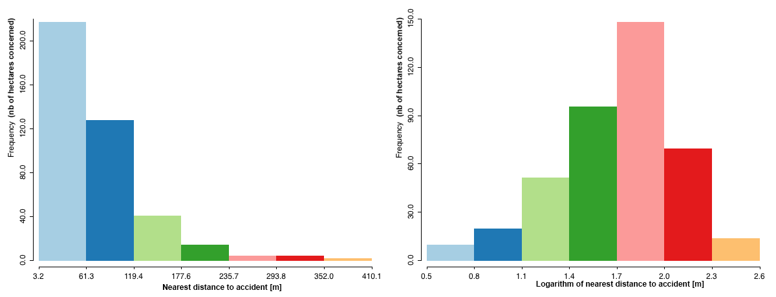
Histogram of nearest distance to accident
The danger could eventually be computed. The same weight was applied to all 3 variables using the following formula:
Danger index = noise sub-index + station sub- index + accident sub- index
Finally, the danger index is rescaled from 0 to 5 as for the vulnerability index.

Methods maps and analysis

Using QGIS’s composer, the recently computed vulnerability and road related danger indexes could be mapped. This allowed to go forth with the analyses and get some insight on the geographical distribution of vulnerability and exposure to road dangers in Vernier. Both vulnerability and danger indexes are represented by a sequential monochromatic scale, increasing vulnerable and dangerous zones being depicted by intenser reds. The different sub regions of the municipality of Vernier, which correspond to the GIREC neighborhoods, can be identified thanks to the GIREC table (Tab. 4).

Table 4- GIREC neighborhoods and their corresponding numbers on the vulnerability, danger and satellite maps
Number on map | Neighborhood Name | GIREC Code
1 | Aire - Pont-BUTIN | 4300101
2 | Aire - Renard | 4300102
3 | Balexert - Crozet | 4300050
4 | Balexert-centre | 4300032
5 | Bel-Ebat | 4300012
6 | Blandonnet | 4300022
7 | Bois-des-Frères | 4300130
8 | Ch. de la Verseuse | 4300110
9 | Champs-Prévost | 4300011
10 | Chatelaine - SIMONET | 4300061
11 | Chatelaine - village | 4300062
12 | Etang - Philibert-de-SAUVAGE | 4300070
13 | Etang-des-Tritons | 4300021
14 | Le Canada | 4300150
15 | Le Lignon | 4300120
16 | Les Avanchets | 4300031
17 | Les Vidollets | 4300160
18 | Libellules | 4300092
19 | Mouille-Galand | 4300180
20 | Poussy - Champ-Claude | 4300190
21 | Rte de Peney - Crotte-au-Loup | 4300170
22 | Rte de Vernier - Pétroliers | 4300080
23 | Usine à gaz | 4300091
24 | Vernier - Cointrin | 4300040
25 | Vernier - village | 4300140
The different indicators, which were used to calculate the indexes, were also mapped (Fig. ???-??? and ???-???), as to appreciate their influence on the index. Punctual values, such as location of gas stations, accidents, housing aid and insurance subsidies, were mapped at their rightful locations. The indicators which were not geographical per se, but rather dependent on the cells of the computed vulnerability grid, were depicted using a newly created centroid map of this grid. Only the locations where some sort of limit was exceeded were then illustrated. The limits chosen as to highlight a habitation zone or not are clarified in Table 5.

Table 5- Limiting values
Indicator | Limiting condition | Limiting value
Revenue | Annual median revenue inferior to the Swiss median (Genève 2015) | 77’268 CHF
Unemployment rate | Median unemployment rate superior to that of Switzerland in 2017 (fédéral de l’économie de la formation et de la recherche DEFR 2017) | 3.10%
Age | Regions with a majority of children and elder people | Age sub-index > 2
Noise | Noise higher to OPB noise sensitivity limit (“OPB RS 814.41 Ordonnance Du 15 Décembre 1986 Sur La Protection Contre Le Bruit”, n.d.) | 55 dB(A)
In order to see whether the different indicators used to describe the road related danger index have any influence on vulnerability, a multivariable regression with dependent spatially weighted variable was subsequently performed using the GeoDa software. The distance to the nearest service station and to the nearest accident (log corrected), as well as the average noise experienced by the inhabitants were considered. A Queen first order of contiguity model was thereupon chosen in order to predict the vulnerability of the different regions of Vernier using the independent variables mentioned. The predicted values of vulnerability obtained were then mapped using a 4 quantiles map.
A similar procedure was performed for the road related danger index. The mentioned index was in that case the dependent variable that the indicators of the vulnerability index tried to predict. A multivariable regression with the dependent spatially weighted variables of revenue, unemployment rate, age distribution and allowances was calculated and mapped thereafter.
Finally, an Index-Index investigation was carried out, allowing to judge if exposure to road related problems and vulnerability were correlated. A Morans’ I bivariate local spatial analysis was primarly performed to get a first clue on the relationship linking both indexes. Several sub-selections using the scatterplot were then performed and analysed.
In addition, two models of multivariate regression (with and without a spatially dependent weighted variable) were performed in order to assess their performance with respect to real data. They are expressed as follows:

Ordinary Linear Regression (OLR):
$y_{i} = β_{0} +Σ β_{k}x_{ki }+ ϵ_{i}$
Spatially weighted regression:
$y_{i} = β_{0} +Σ β_{k}x_{ki }+ρ Σw_{j}y_{j}+ ϵ_{i}$
In both equations the $β_{i}$ represent the regression coefficients, $y_{i}$ the dependent variable , $x_{ki}$ the independent variables and $ϵ_{i}$ the error. For the spatially weighted regression, $ρ$ is the spatial lag and $w_{j}$ the weight of spatial unit $j$ relative to the spatial unit $i$.

Results

Vulnerability
The vulnerability index, scaling from 0 to 5 for increasing precariousness, is represented on the vulnerability map (Fig. ???). The vulnerability map displays various index values for different places. Looking at it a neighborhood driven trend is observable.

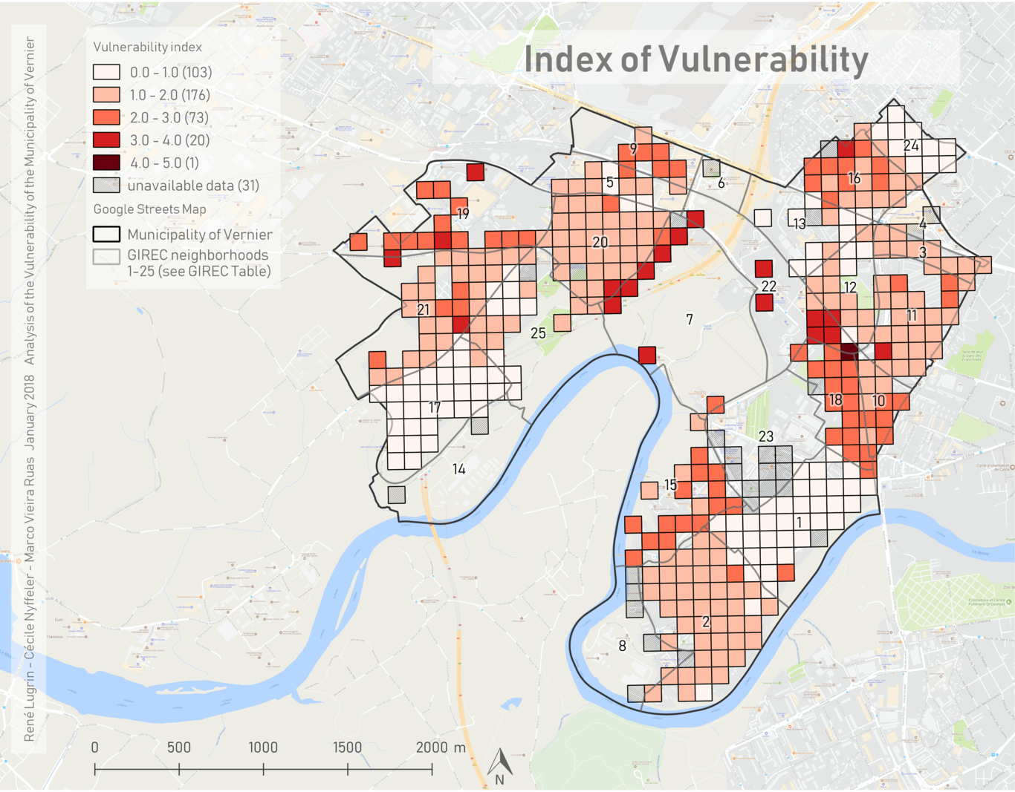
Vulnerability Index Map
It is indeed possible to affirm that the neighborhoods Aire-Pont-Butin (number 1 on the map), Vernier-Cointrin (24) and Les Vidollets (17) almost exclusively show a vulnerability index between 0 and 1. These three regions, along with Vernier-village (25), Balexert-Crozet (3), Aire-Renard (2) and Etang-des-Tritons and Etang-Philibert-de-SAUVAGE (13 and 12 respectively), which all display a vulnerability index value between 1 and 2, can thus be considered as the least vulnerable regions of Vernier.
Contrarily, Usine à gaz (7), Rte de Vernier-Pétroliers (22), Mouille-Galand (19), and Libellules (18), which all exhibit higher vulnerability index values, represent the most precarious neighborhoods of the municipality.
The 13 remaining GIREC areas either present mixed values of vulnerability index, or did not have available data for one of the vulnerability indicators. Even if mixed values are present in one neighborhood, the maximal difference of vulnerability index value is never greater than 2. The distribution is thus quite homogeneous and does not seem randomly spread.
A striking result is the fact that only one cell, located at the junction of the neighborhoods of Libellules (18), Rte de Vernier-Pétroliers (22), and Châtelaine-SIMONET (10), displays the highest vulnerability value. It is also noticeable that most of the cells of the inhabited regions of Vernier show small vulnerability values, as indicated by the low value of the median of the corresponding index: 1.5146 (Tab. 6).

Table 6- Boxplot values of vulnerability index
min | 0
max | 5
Q1 | 0.8986
median | 1.5146
Q3 | 1.9998
IQR | 1.1012
mean | 1.5406
s.d. | 0.8161

The spatially weighted multivariable regression calculated using the danger index indicators, yielded a R² of 0.437160. This represents a correlation coefficient of about 0.66. The probability values, which are high, as well as the regression coefficients of the different indicators are listed in Table 7.

Table 7- Vulnerability index as predicted by danger sub-indexes
Indicator | Coefficient of the regression | Probability
Accident distance (log corrected) | -0.0530067 | 0.61349
Service station distance | 0.00027113 | 0.18044
Noise | 0.00927744 | 0.2655
Constant | 0.115801 | 0.82731

Looking at the quantile maps of the index it seems that the road related danger indicators prediction values of vulnerability (Fig. ??? ) differ from the actual values (Fig. ???). Indeed, the main clusters of high vulnerability in Figure ???, which are Usine à gaz (23), Rte de Vernier-Pétroliers (22), Mouille-Galand (19), Les Avanchets (16), Champs-Prévost (9), Libellules (18) and le Lignon (15) are not all present in Figure ???. Indeed, only the clusters of Usine à gaz, Rte de Vernier-Pétrolier and Libellules are still clearly noticeable. A highly vulnerable cluster, which does not exist in reality, is surprisingly added in the prediction at the neighborhoods of Rte de Peney - Crotte-au-Loup (21) and les Vidollets (17).
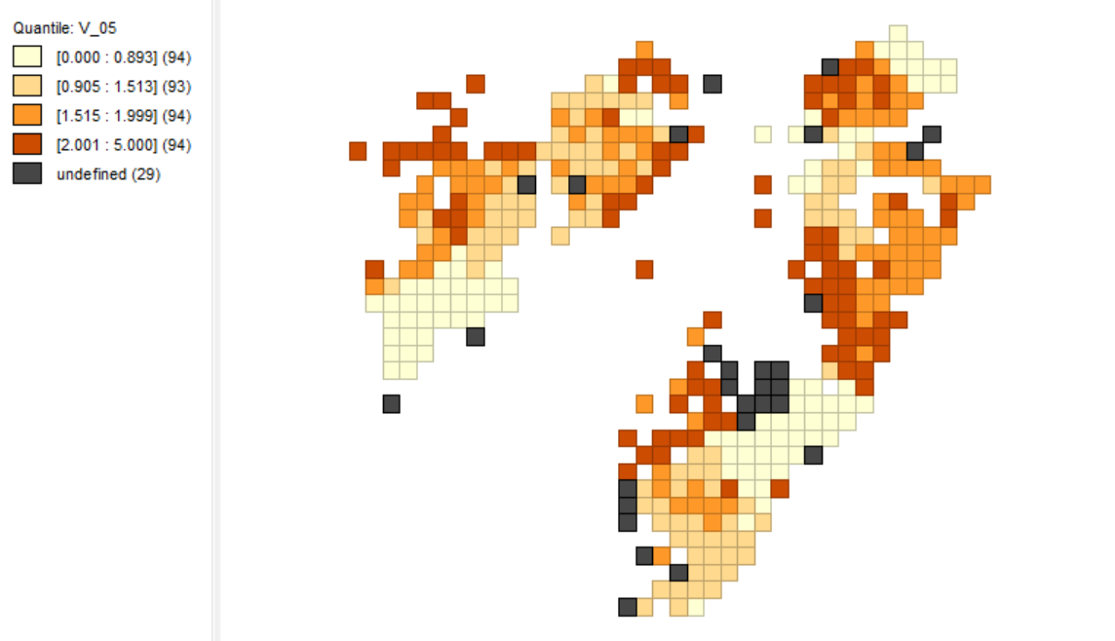
Quantile map of the vulnerability index

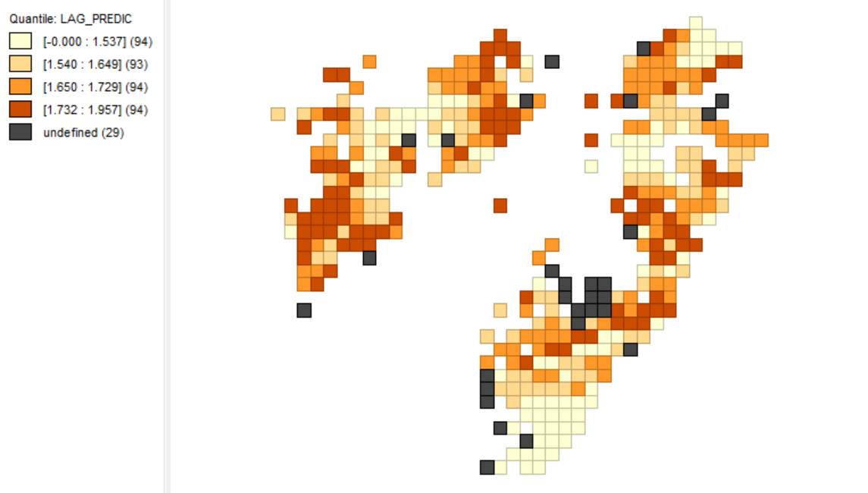
Quantile map of the predicted values of vulnerability index using the danger indicators

Danger related road hazards
The cartographic representation on Figure ??? shows road hazards exposure divided into 5 categories. Some patterns emerge. The lower risk is observed mainly in the district of Aire-Renard (2) while the higher risk zones are clustered in Les Avanchets (16), Ballexert (3, 4) and Libellules (18). The north-western part is less clearly clustered but 2 zones of high risk stand out: Bel-Ebat (5) and at the locations of the big buildings of Vernier-village (25).
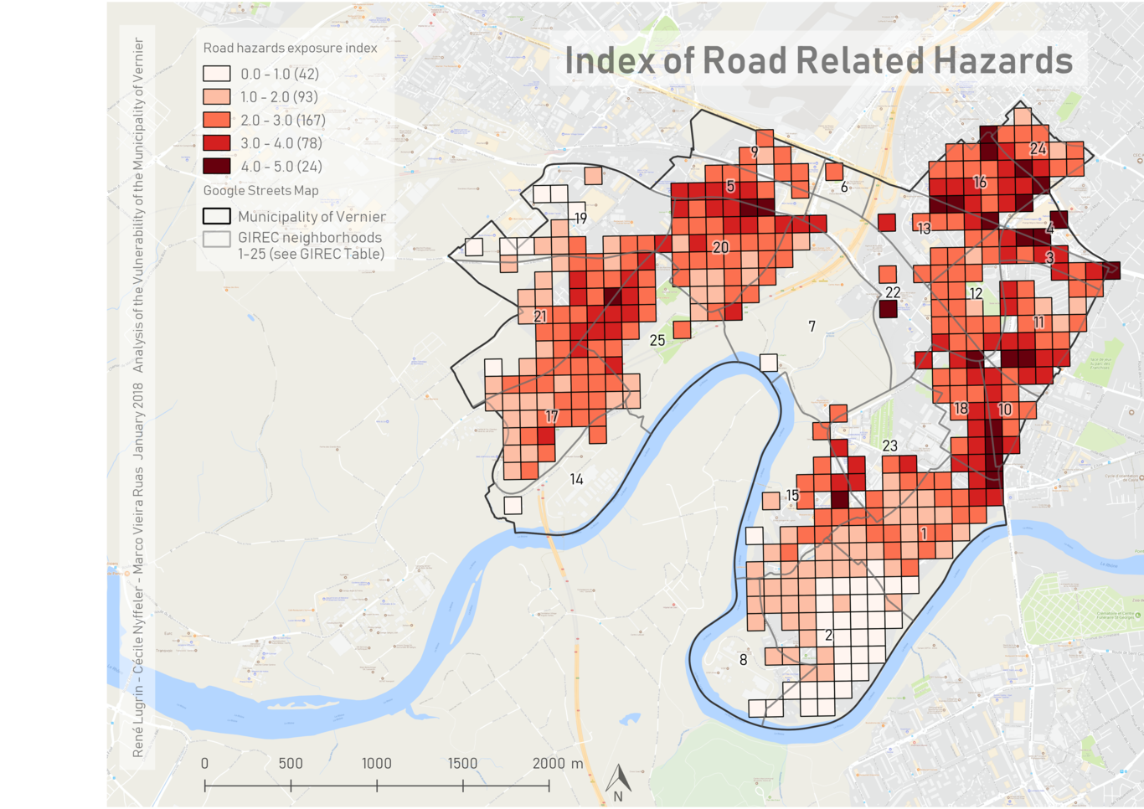
Danger index map
The multivariable regression with the danger index (dependent variable) as function of the five vulnerability sub-indexes (independent variables) gives an R² of 0.67 corresponding to a correlation coefficient R of 0.82. This value is even higher than the one obtained for the vulnerability index (Tab. 7). Coefficients of regression are negative for health insurance, unemployment and age indexes meaning that their correlation with danger is negative (Tab. 8). Revenue and housing indexes have a positive coefficient corresponding to a positive correlation. The p-value for revenue translates a high significance at 1%, housing subsidies are significant at 5% and the 3 other indexes are only significant at a level of 10%.
These results validate a higher and more significant correlation for danger function of vulnerability sub-indexes than the reversed multivariate correlation.

Table 8 - Danger index as predicted by vulnerability sub-indexes
Index | Coefficient | Probability
Health insurance subsidies | -0.335215 | 0.05227
Housing subsidies | 0.635506 | 0.01303
Unemployment | -0.16652 | 0.08049
Revenue | 0.420787 | 0.00007
Age | -0.185221 | 0.0954
The correlation being positive the danger index (Figure ???) should present similarities with a prediction of danger using the 5 vulnerability sub-indexes (Figure ???). In fact regions characterised by high values in Figure ??? are the same as the one in Figure ??? but their spread is different. One difference resides in the fact that some vulnerability sub-indexes could not been computed because of a lack of data. These are represented with black squares in Figure ???.

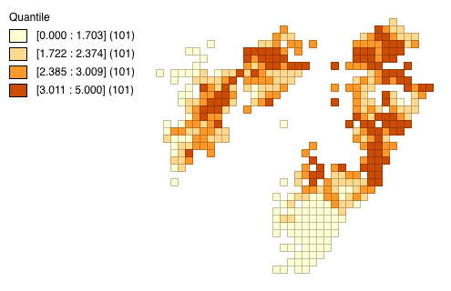
Quantile map of the danger index
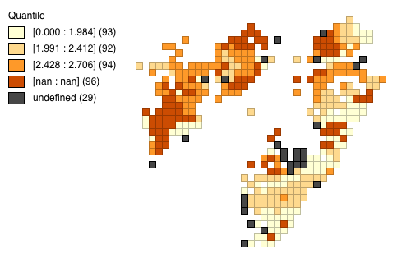
Quantile map of the predicted values of danger index using the vulnerability indicators

Results Index - Index Map

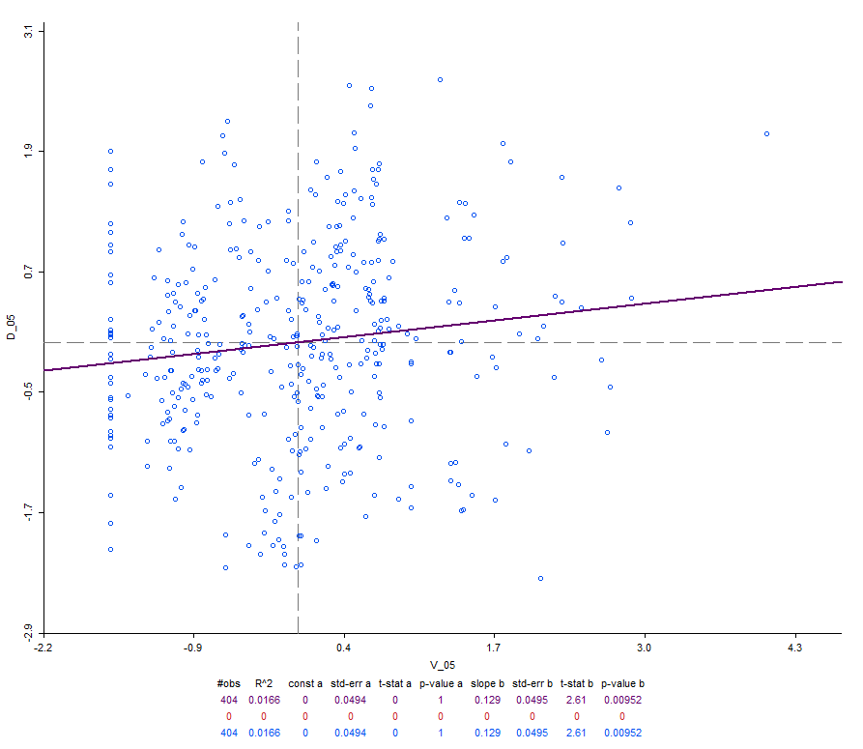
Scatter plot - Index of danger (D_05), index of vulnerability (V_05)
In order to analyze the dependency between the vulnerability and danger indexes a scatter plot was produced. The following is represented in figure ???. The scatter plot shows standardized data (centered around zero) depicting the correlation between the dependent variable (D_05: Index of danger) and the independent variable (V_05:Vulnerability index).
It is noticeable that the values are in both cases spread within the same ranges. In the case of the dependent variable, the data is divided almost uniformly within its range, whereas for the independent variable the data becomes sparser when looking in the higher values of vulnerability. This accounts for almost all the data being regularly spread in a circle-like shape around the mean. The aligned points on the left hand side correspond to the undefined values of the vulnerability index.
The purple line represents the regression line and shows a positive correlation between the values of both indexes (slope b = 0.129). The figure also presents the results of the fitting of the regression to the data with a value of R² = 0.0166 (determination coefficient). Also of importance the p-value denotes the significance of the dependency between these two indexes: p-value b = 0.00952.

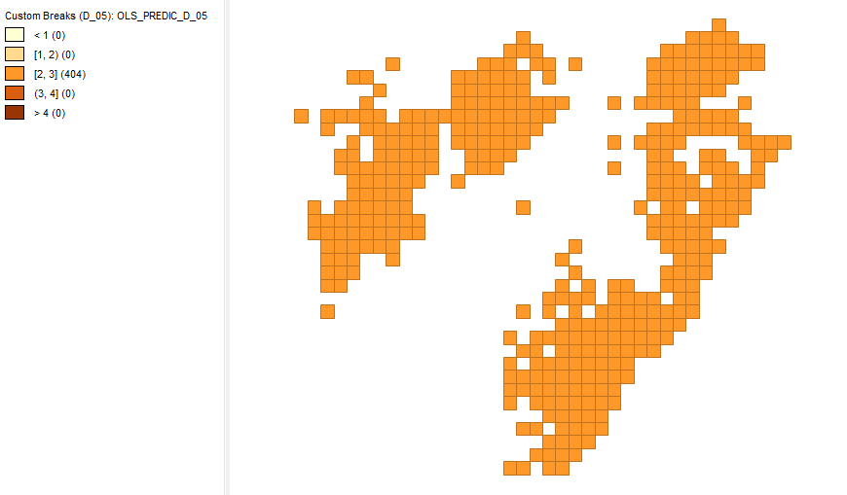
OLR model approximation - index of danger
Figure ??? shows the prediction of the danger index according to an ordinary linear regression (OLR). As can be noticed, all the results find themselves in the median values (between 2 and 3). The results obtained when performing the spatially weighted regression are similar and therefore not presented here.
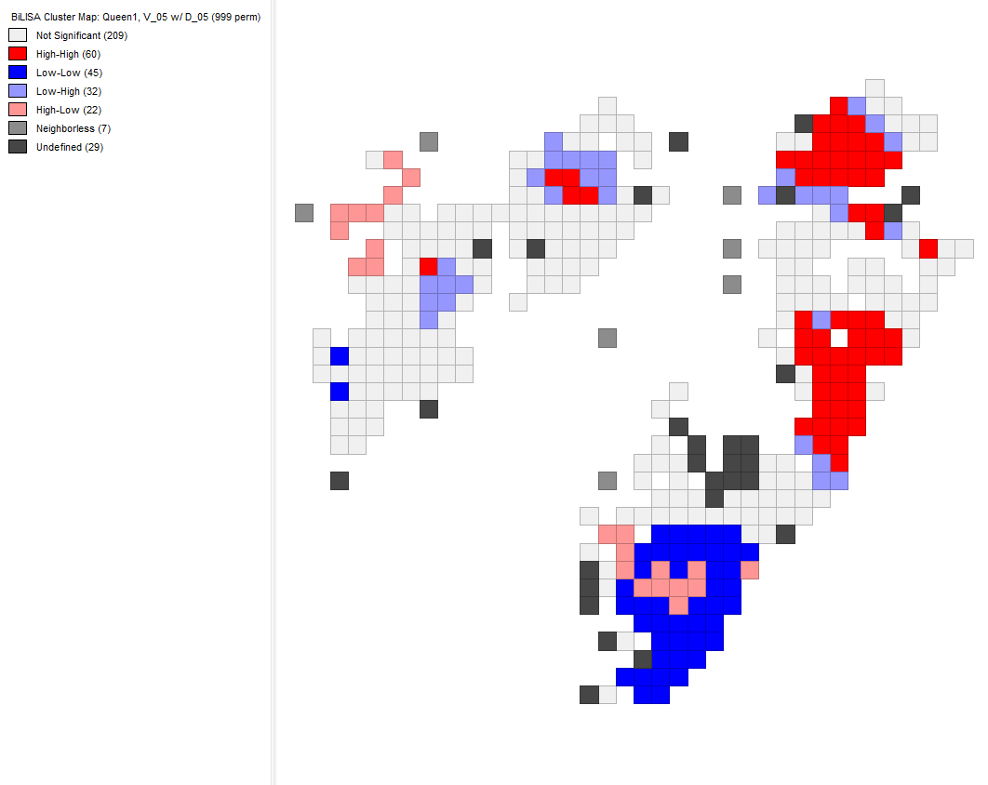
Morans’ I bivariate local spatial analysis - index of danger, index of vulnerability
Figure ??? presents the results of the Morans’ I bivariate local spatial analysis. Again the variables selected were the danger index with respect to the vulnerability index. This figure shows four types of significant cells. Two for which the indexes present values of the same magnitude: high-high (dark red) and low-low (dark blue). The two others correspond to cells with opposite values: high-low (fair red, for a high value of the vulnerability index and a small value of the danger index) and low-high (fair blue for a high value of the danger index and a small value of the vulnerability index).
The other region assigned values are considered as insignificant. Either because the values of the indexes in these cells are close to the mean for one of the variables considered (fair grey), or because no neighbours are located around these cells, meaning that a spatial weighted analysis taking into account the values obtained for the neighbors cannot apply (dark grey). Also excluded from the analysis are the cells where no vulnerability index could be defined (black).
The map shows two main clusters of high-high values. One on the eastern end of the municipality corresponding mainly to the areas of Châtelaine-SIMONET (10) and Libellules (18), as well as parts of Châtelaine-Village (11) and Etang-Philibert-de-Sauvage (12). The second on the northern-eastern part of the municipality corresponding to the area of Les Avanchets (16).
Figure ??? also depicts a low-low region on the southern-eastern end of Vernier corresponding mainly to the neighborhood of Aire-Renard (2).
Furthermore, are also represented in the map two main clusters of high-low values. One encompassed inside the neighborhood of Aire-Renard (2) stretching a bit further to Le Lignon (15), and the other with cells belonging to the neighborhood of Mouille-Galand (19).
Finally, two small low-high clusters are present. Firstly, around the boundaries of Rte de Peney-Crotte-au-Loup (21) and Vernier-Village (25). Secondly, also on both sides of the boundaries of Bel-Ebat (5) and Poussy-Champ-Claude (20).

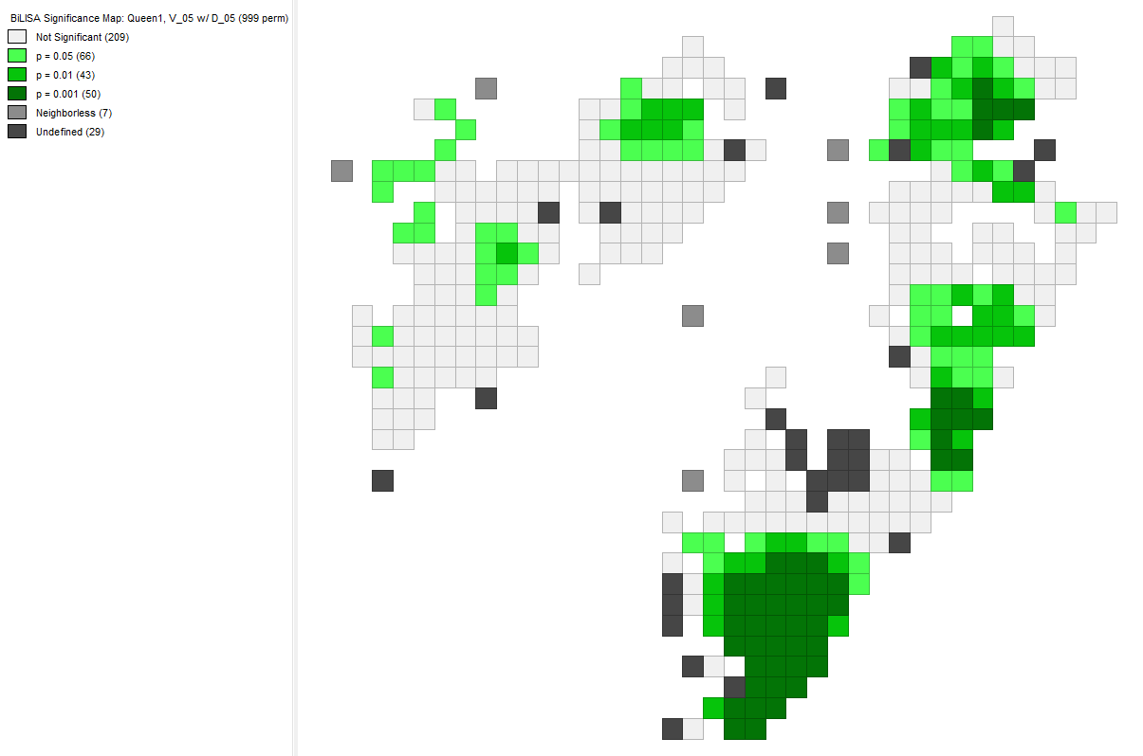
Morans’ I bivariate local spatial analysis - p-value significance
Figure ??? shows the significance of the analysis for the bivariate local spatial analysis relative to the p-value. The regions of interest presented in figure ??? all show a spatial analysis significance. The low-low cluster in the region of Aire-Renard (2) shows very high significance with a p-value equal to 0.001.
In the regions of high-high values such a significance is also to be found but a large amount of cells also have smaller p-values: 0.05 (limit of significance) and 0.01.

Discussion

Vulnerability
It is quite important to be able to justify the correctness and use of an index rather than the simple indicators used to compute it. Being able to gather all the vulnerability information into one single index is of advantage as it allows to get a more global point of view on the vulnerability of Vernier. Now in order to get a feeling on whether the vulnerability index was appropriately computed or not, the indicators that helped to forge it are displayed in Figures ??? to ??? on top of the mentioned index.
Figure ??? shows that almost all cells displaying a vulnerability index superior to 1 seem to have a median annual revenue inferior to that of the swiss median. The fact that almost no cell of index 0-1 is pinpointed shows that if the revenue is high enough, higher than the national median in this case, vulnerability is less probable. Indeed, if the salary is sufficient, no financial support will be necessary, and the fact of having a revenue implies that you are active and neither retired nor unemployed. All other factors of vulnerability are thus ruled out, which explains why high revenue correlates well with very low vulnerability.
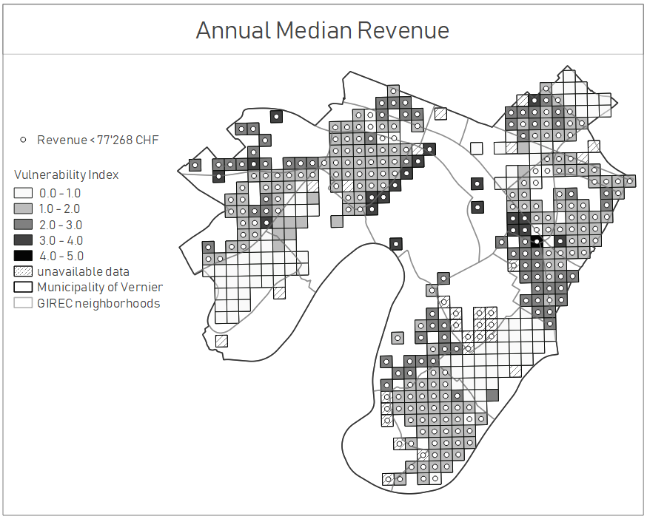
Vulnerability indicator - Annual median revenue
Regions with an unemployment rate inferior to that of the national median show low vulnerability values, as depicted in Figure ???. However, for vulnerability values larger than 1 unemployment rates rise higher than the Swiss median. (Corcoran and Hill 1980) found that if the household head is unemployed, poverty is more probable among that said household. (Bowers and Harkess 1979) additionally found that elder people were more likely to stay unemployed for longer periods of time. The fact that unemployment rate correlates quite well with vulnerability thus makes sense.
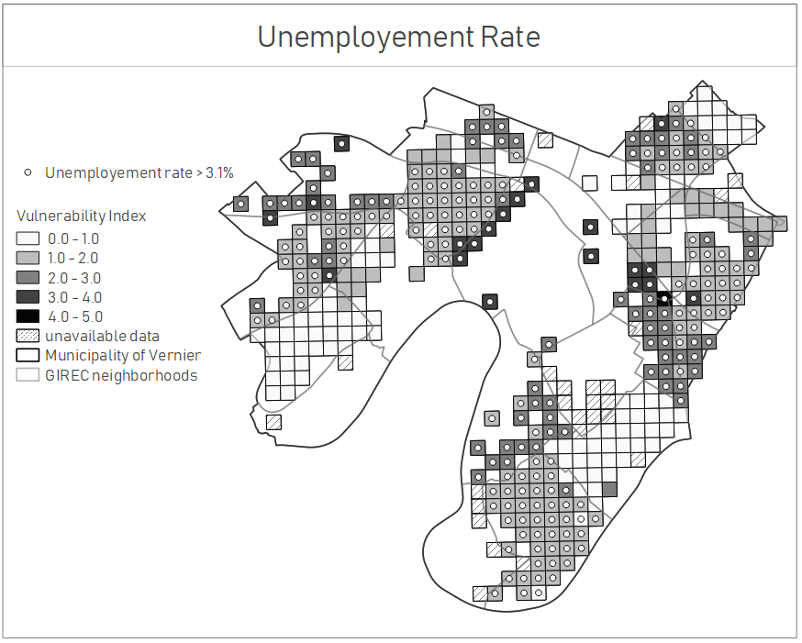
Vulnerability indicator - Unemployment rate
The 100 m by 100 m inhabited regions containing a majority of children or retired people seems randomly scattered over Vernier’s territory. Figure ??? shows that regions with low vulnerability index values generally do contain a majority of active people. The study by (Abramsson and Andersson 2012) states that about a forth of the elderly community leaves their privately-owned house to go live in a residential block. This migration may explain the random distribution of the retired population. The geographical location of children is not so much of interest here, as kids under 19 years old often still live with their parents.
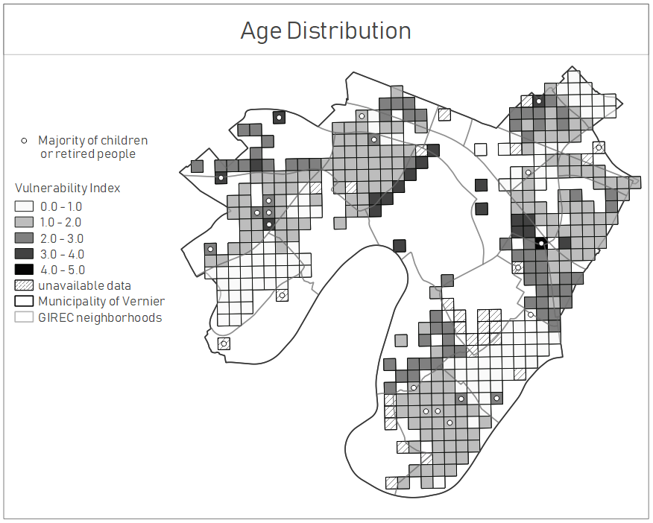
Vulnerability indicator - Age distribution
The locations of the citizens of Vernier needing governmental support in the form of housing aid seem clustered over more vulnerable regions (Fig. ???). Les Avanchets (16), le Lignon (15), Libellules (18) and Chatelaine (10,11), along with Poussy-Champ-Claude (20), are the neighborhoods displaying the majority of these aggregations of people needing financial aid.

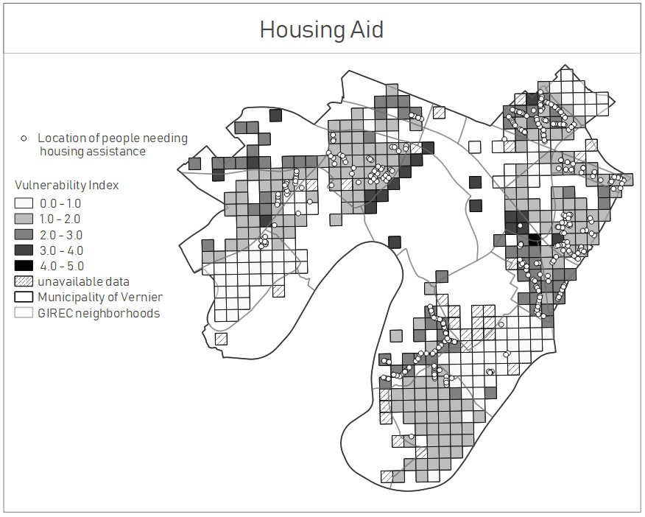
Vulnerability indicator - Housing aid
Oppositely to what could be observed when looking at the other vulnerability indicators, the domicile of people needing healthcare allowance covers almost all Vernier. A first glance to Figure ??? gives the impression that this indicator does not follow any trend with respect to vulnerability.
A reason why people demanding this kind of governmental financial support are so randomly distributed might be that the Canton of Geneva allows its citizen to get healthcare allowance if their annual revenue is inferior to 150’000 CHF or their fortune lower than 250’000 CHF (“Demander Un Subside d’Assurance-Maladie 2018” 2017). Looking back at Figure ??? and noticing that already all zones having a vulnerability index greater than 1 were receiving a median income lower than 77’268 CHF, the assumption can be made that at least some of the households living in the vulnerability 0-1 zone earn less than 150’000 CHF a year. The fact that in these regions (Aire-Pont-Butin (1), Vernier-Cointrin (24) and les Vidollets (17) ) people mainly live in villas (Fig. ???), and thus might have a mortgage on their house, may induce their personal fortune to be lesser than 250’000 CHF. This might explain why people living in less vulnerable zones still perceive healthcare allowance.
One thing though that might be relevant about the geographical location of the healthcare allowance beneficiaries is the fact that in more vulnerable neighborhoods the distribution of their locations seems more organized, aligned with respect to the habitation blocks, than in the less vulnerable regions, where these locations seem more randomly distributed.
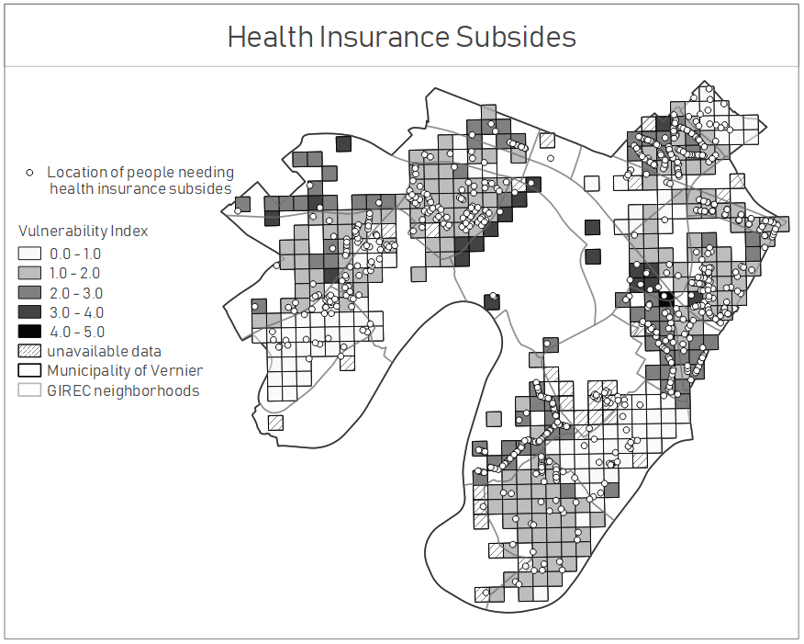
Vulnerability indicator - Healthcare allowance
The vulnerability index thus seems computed correctly as it represents well all the selected vulnerability indicators. Reflecting back on the values obtained in the process of computing the spatially weighted regression (Tab. 7), and especially on the probability ones, it seems however that the vulnerability index cannot be predicted sufficiently well when using the danger indicators. Indeed, a high probability value implies a higher percentage of variation to the actual values that cannot be accounted for. This means that in the case of the minimal log distance to the nearest car accident about 61% of the predicted values corresponding to that indicator are not explained by the GeoDa spatial regression model. The fact that vulnerability cannot be expressed with high precision using the danger indicators actually implies that both danger and vulnerability indexes are necessary, as they carry different information. This justifies the need for computing two indexes, the vulnerability and road related danger ones.

The worth and correctness of the vulnerability index being established, different observations can be made on the vulnerability map (Fig. ???). The neighborhood driven trend that is observable on the vulnerability map can actually also be seen when looking at a satellite image of Vernier (Fig. ???). Indeed, the majority of the least vulnerable neighborhoods mentioned earlier (1, 2, 12, 17, 24 and 25) mainly comprise villas, and habitation blocks are hardly to be seen there. Owning a separate house such as a villa is often associated with a comfortable lifestyle, it is therefore not surprising that those zones correspond to the least vulnerable neighborhoods of Vernier. It can thus be assumed that the inhabitants of those villa areas are less exposed from a financial, age and employment point of view than the remaining of the municipality citizens.
This is not the case of Usine à gaz (23), Rte de Vernier-Pétroliers (22), Mouille-Galand (19), Les Avanchets (16), Champs-Prévost (9) and Le Lignon (15) which all exhibit big buildings. Some also show more asphalt, meaning less green areas like parks, forests and such, and more road related infrastructures. Interestingly these neighborhoods also exhibit higher vulnerability index values.
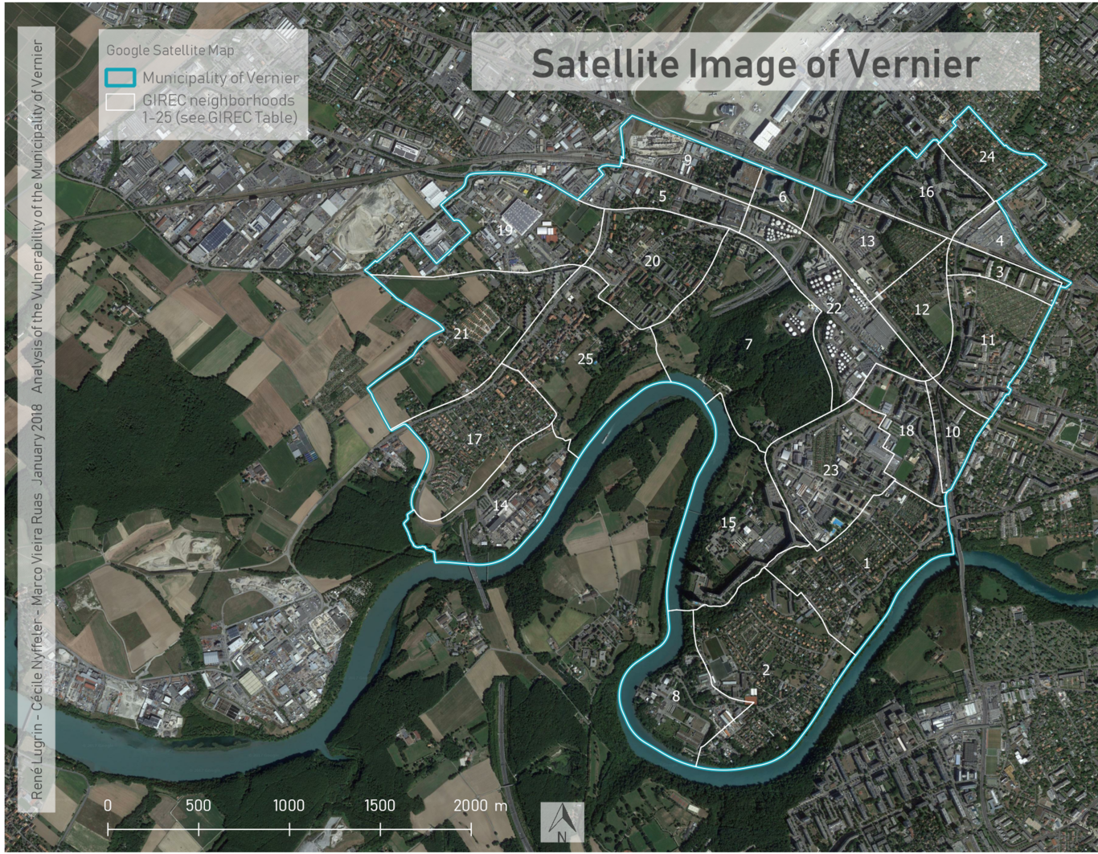
Satellite image of the municipality of Vernier
Looking back at the predicted values of vulnerability (Fig. ???), and noticing the highway crossing the commune of Vernier, an assumption can be made to why Les Vidollets (17), Rte de Peney - Crotte-au-Loup (21) and Vernier-village (25), which are actually considered quite secure and strong, were predicted as highly vulnerable by the spatial regression model. Indeed, the highway passing through these 3 GIREC neighborhoods is causing quite a lot of car crashes in the area, which would correlate with higher vulnerability in the multivariable regression analysis.
However, the accident points (of this location) that are in the vector file provided by SITG do happen underground. The highway is indeed in a tunnel from the western part of Usine à gaz (23) to the southern part of Le Canada (14). This means that the car crashes happening in that tunnel are actually not affecting the population living above it. Further studies on relating road traffic accidents to the inhabitants of a certain region should pay attention to whether the inhabitants are actually exposed to the traffic or if some kind of not directly obvious physical barrier is protecting them. In order to improve the prediction it might have been useful to delete all the accident points which took place in the tunnel.

Danger related to road hazards
Figure ??? presents the night noise within the hectometric cells. 55 dB(A) by night is the threshold exposure limit in sensitivity level II (“OPB RS 814.41 Ordonnance Du 15 Décembre 1986 Sur La Protection Contre Le Bruit”, n.d.). This level is applicable to residential zones or zones with public buildings. For this reason cells with noise exceeding 55 dB are shown with white dots, as they correspond to particularly exposed areas. These cells appear to be grouped in the zones with the highest concentration of high values for the danger index. There is however an exception on the edge of Vernier-village (25) where a petrol station is situated but not particularly concerned by the noise. Surprisingly, the main roads do not correspond to the areas most affected by the night noise. The highway crossing the city from south-east to north-east is probably equipped with sound barriers and houses are probably built further from major highways than from small roads.

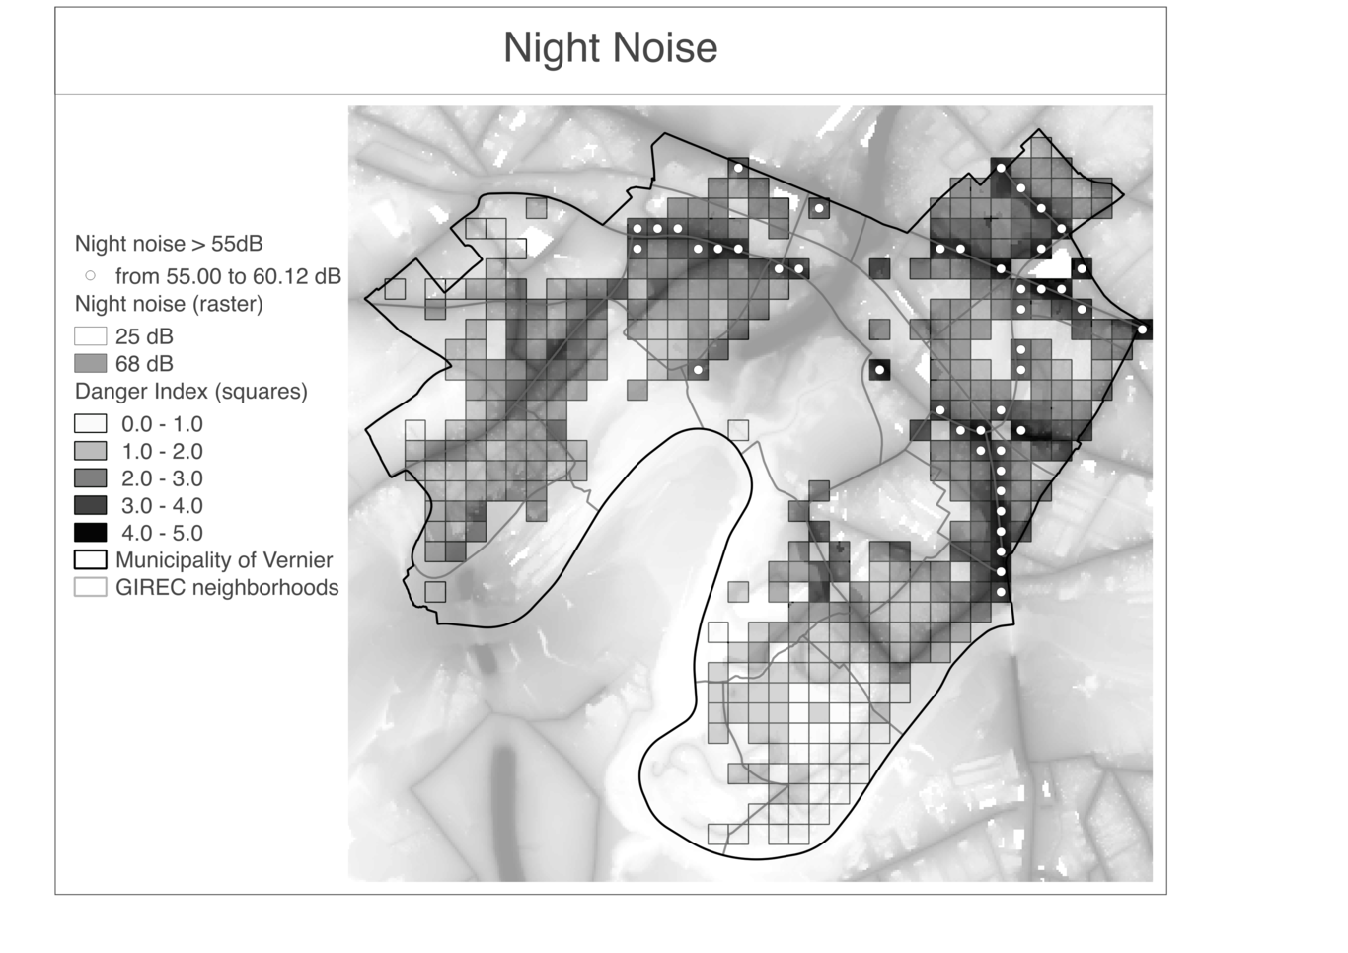
Danger indicator - Night noise
The 15 service stations present in the municipality are shown on Figure ???. The density is higher in the eastern side and highest along the Route de Vernier (22). The points closely correspond to the clusters present on Figure ???. Moreover, the most vulnerable people seem to be located closer to service stations and their related polluted areas. This class of people seems therefore more prone to pollution, as some buildings in cells classified as vulnerable are located within a 75 meters radius from service stations, which is the underprivileged zone, as mentioned in the paper by (Terrés et al. 2010). This comes as an interesting result and adds up to the fact that this group of population usually resides closer to road networks. The most disadvantaged areas are located both close to industrial zones and service stations. To illustrate this, the best example is Bel-Ebat (22). The quietest zones are situated essentially in the southern part which is a kind of a dead-end, due to the presence of the river Rhône that surrounds this relatively sparsely populated area.

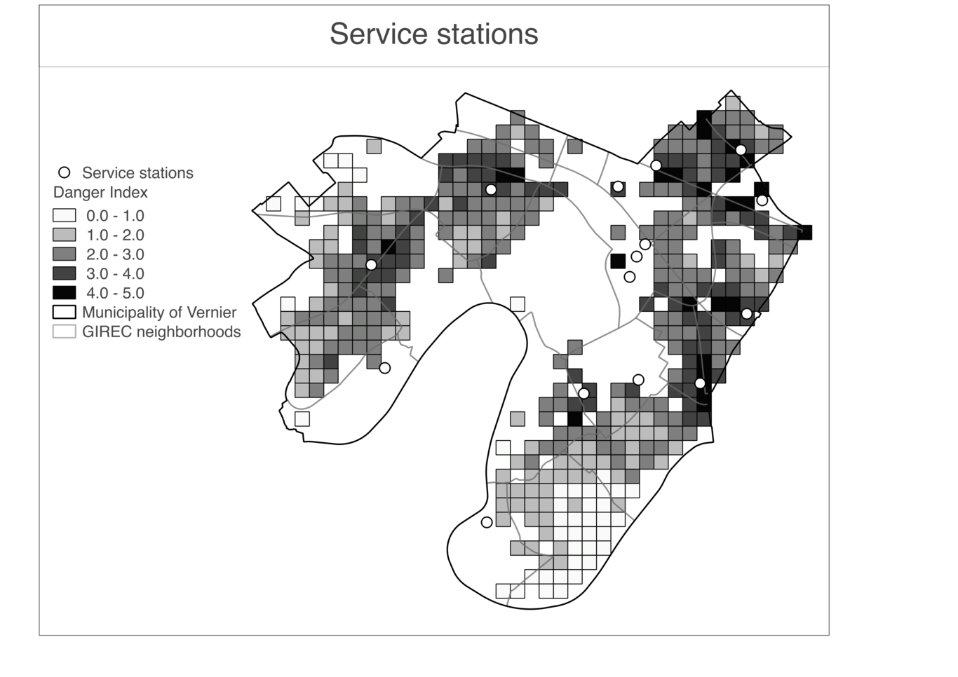
Danger indicator - Service stations
The accident reported on Figure ??? are particularly densely located in the North-Eastern part of Vernier. The two main road axes crossing the municipality from the northwest to the southeast and from the southwest to the northeast are perceptible by the high concentration of accidents that occur there. The place where these two roads meet is particularly affected. A tunnel passage in Vernier-village (25) and Les Vidollets (17) is significantly less affected. On the other hand, the entrance and the exit of the tunnel are not spared. Apart from these two major axes, particularly densely populated areas, and therefore equipped with a large road network, are also affected by a large number of accidents. These areas are typically Les Avanchets (16), Libellules (18) and Chatelaine-Village (11). It contrasts with the villas areas whose population is less dense and also less concerned by accidents. The denser zones of points fits particularly well to the cells presenting night noise values higher than the limit of disturbance (Fig. ???).

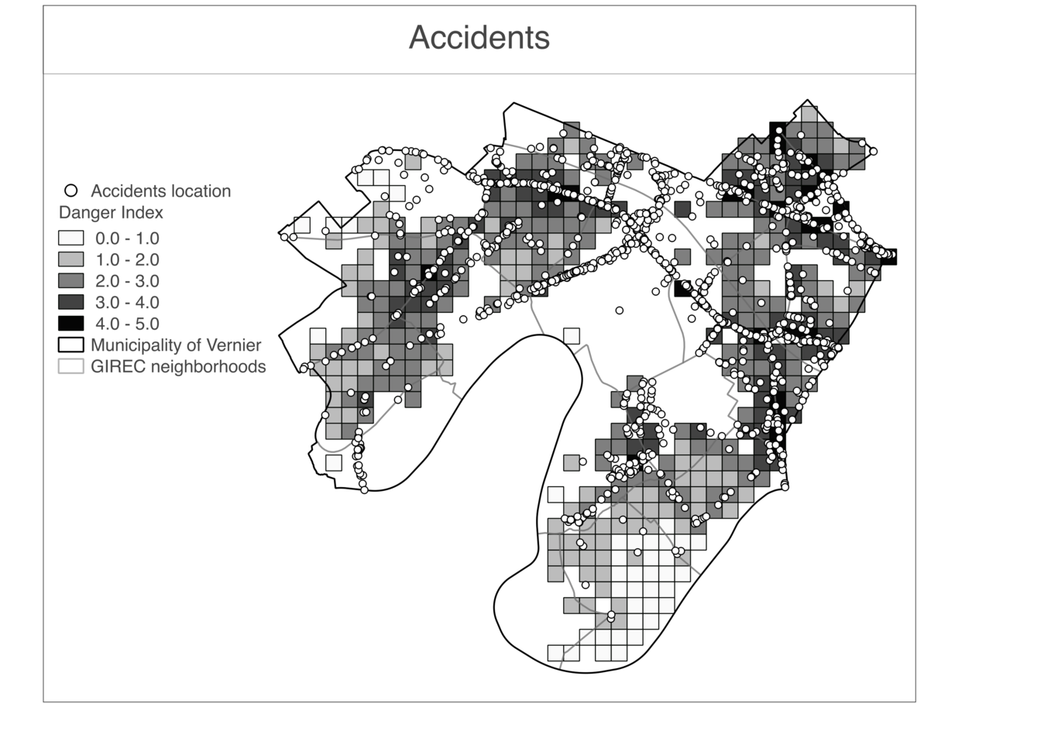
Danger indicator - Accidents

Vulnerability Index - Danger Index
As mentioned in the results section, the scatterplot in figure ??? shows a positive correlation between the vulnerability index and the danger one represented by the positive value of the slope b (=0.129). This tends to confirm the original hypothesis stating that more vulnerable people are located in areas of greater danger in respect to road hazards. The regression factor (R² = 0.0166) being close to zero indicates that the data is not very well fitted by the regression line. This result explains itself by the almost regular spreading of the data around the mean. Nevertheless, the p-value b (=0.00952) being smaller that the 5% mark indicates the results of the evaluation based on the two variables selected can be considered significant.
One could imagine eliminating all zero values of the vulnerability index in order to improve the fitting. Figure ??? show the results obtained when selecting only non-zero values.
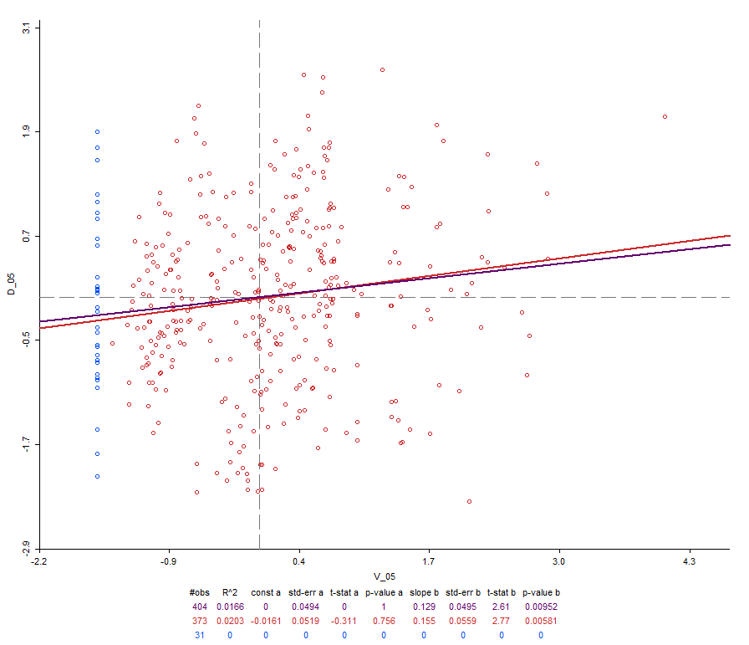
Scatter plot - zero values of vulnerability index not selected
As can be noticed the fitting is slightly improved as well as the significance. The correlation is also more positive. This results tend to strengthen the value of analysis since they reinforce the validation of the initial statement by suppressing non meaningful data.
To further enlarge the analysis it seems interesting to consider the results obtained when selecting only the more extreme values of the index of vulnerability, since they are the only ones showing a clear separation to the regularly spread data. Figure ??? presents this exploration of the data.
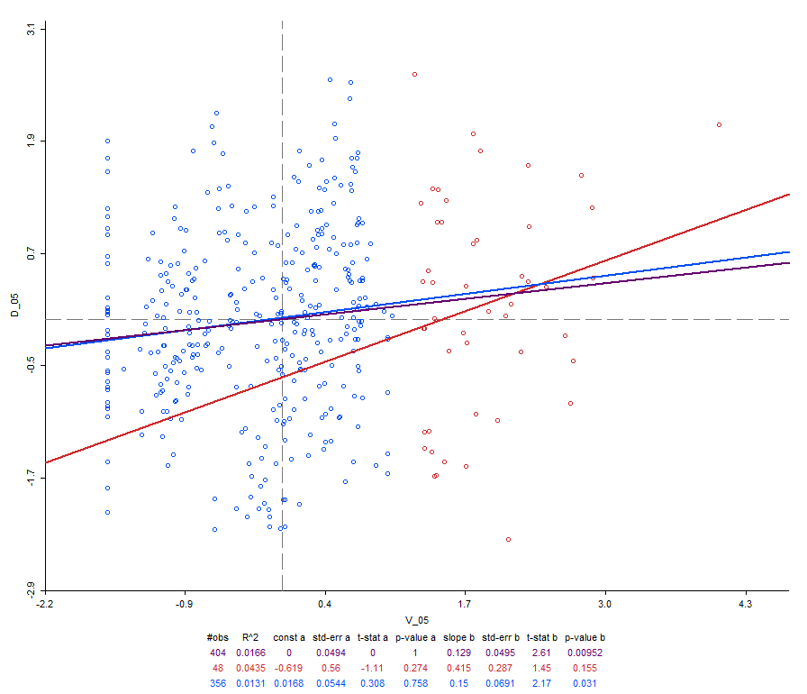
Scatter plot - only higher values of vulnerability index selected
The scatterplot obtained proves valuable for the analysis. Even though the significance is worse to an extent, which can be explained by the small pool of data selected here (circa 10% of the original data), the correlation between both indexes is a lot more positive and the fitting is improved (R² = 0.0435). This reinforces the initial statement and tends to demonstrate that in cases of pronounced vulnerability, the impacts of road hazards are greatly significant and could become a threat to overall security and health of the population here selected.
Concerning health, as mentioned in the danger discussion section, 55dB(A) is the threshold at which noise is considered disturbing for sleep (Murphy and King 2010). Taking that into consideration, it comes as an interesting result that 10 out of the 48 data points selected show night noise levels higher than the 55dB(A) limit. Those 10 data points also correspond to 22.72% (10 out of 44) of the total cells in the grid with levels higher than the mentioned threshold as depicted in figure ???. This puts great emphasis on the validation of the hypothesis, since for a large part the most deprived populations are exposed to worrying levels of noise.
With regard to figure ???, presenting the model approximating the danger index, one can notice that it does not show satisfaction when estimating the data, since all the points find themselves within the median values range.
This could be due to a number of factors but the most predominant one is probably the original distribution of the data. As described in the index-index discussion section figure ??? shows the data as almost symmetrically spread around the mean along the x and y axis. This can explain why the regression models will have a hard time not putting all values around the mean.
It would then be interesting to design other indexes based upon different variables to see if one could find more clearly divided results. Extending the range of the indexes would probably not cause much of a change in the models fitting, since the symmetry would remain but for data spread on a wider range.
As for the bivariate local spatial analysis, the results (figure ???) put great emphasis on the notion of environmental inequity. Indeed, the fact that two large clusters of high values for both indexes are present, reinforces the statement that more vulnerable people will find themselves in regions more prone to road related hazards but also that they will be surrounded by people facing the same kind of issues. More vulnerable people will therefore often find themselves in large “hospots” of road related dangers. The large cluster of low-low values adds to this idea, in the sense that less deprived people will also be grouped together in large privileged areas were road related dangers are also less important.
Moreover, significant cells represent predominantly high-high or low-low values as opposed to low-high and high-low (105 to 54). This is also an argument that holds on to the initial statement and the analysis developed just above.
Interestingly, a high-low cluster of values can be found within the big low-low one. This means a part of the area of Aire-Renar is inhabited by more vulnerable people. Looking at the satellite map (Fig. ???), the presence of blocks inside the villas area accounts for this increase in the vulnerability. The contrast is relevant in this case. This more vulnerable population being located in a predominantly well off area, they are therefore less prone to danger. Indeed, the planning of road construction seemingly avoids the presence of main arteries (highways, primary roads etc.) in those areas.
In this case, a part of the area seems to be inhabited by more vulnerable people, but since they are located in a zone where both indexes are low, these people are less prone to danger.
The eastern end of Vernier shows way more spatial correlation for the two indexes variables. This can be notice even more when increasing the level of p-value significance to 0.01 as presented in figure ???.

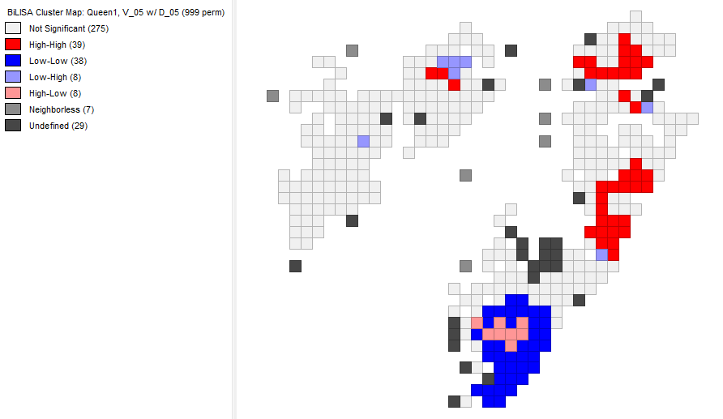
Morans’ I bivariate local spatial analysis - p-value significance limit 0.01
In this map, spatial local correlation is almost nonexistent on the western part of the municipality whereas most of the cells contained in the three main clusters mentioned above remain. This seems to indicate the values for the indexes are closer to the mean on the western part. Therefore environmental inequity is not as present there as it is on the eastern part, with the opposite clusters (high-high against low-low) emphasizing this discrepancy.
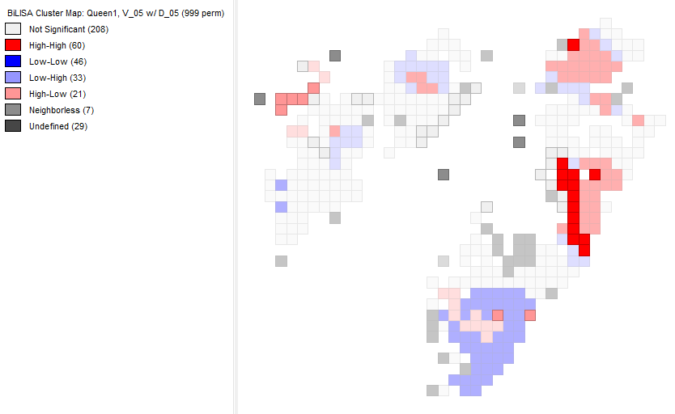
Morans’ I bivariate local spatial analysis - only higher values of vulnerability index selected
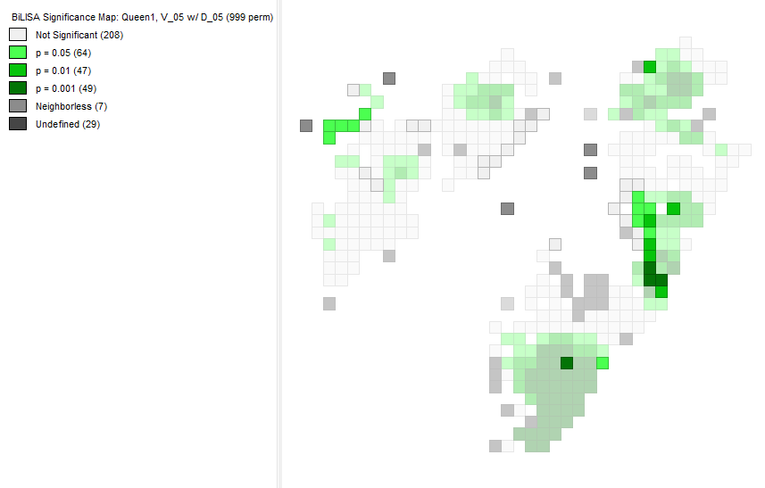
Morans’ I bivariate local spatial analysis - p-value significance with only higher values of vulnerability index selected
Figure ??? presents the selected data from the scatter plot in figure ??? on the bivariate local spatial analysis map. It is noticeable that when only the significant selected data is considered, most of it represents high-high cells (14 out of 21 cells: 66.67%). The validation of this result is sustained by the significance map of the bivariate analysis presented in figure ???. Indeed, the 14 high-high cells mentioned show very good levels of significance with a p-value smaller than the usually considered limit threshold of 5% (9 out of 14 cells: 64.29%). Again, this tends to prove even more that in cases of high to severe vulnerability the exposure to road hazards increases. Considering deprivation as a factor of exposure to danger is therefore a good analysis.
The observation of figure ??? also depicts that areas presenting high levels of both vulnerability and road hazards are often surrounded by similar areas. Indeed, it appears on this figure that the 14 high-high cells of interest find themselves in the two main clusters of high deprivation and danger. Moreover, in the fringes of this clusters, regions of low-high significance (low vulnerability, high danger) are to be found. This is a relevant pattern when considering the mobility of people living in this areas, proving those people will often be confronted to danger zones for a large amount of their movements within their neighborhoods.
This factor is to be taken even more into consideration when looking closely at a particularly vulnerable group of the population: children under 15. Those are considered to spend most of their time within a small distance buffer around their housing. The 500 m buffer defined in (Chambers et al. 2017), would well encompass the two main high-high clusters, showing that children in those areas could potentially spend most of their time in regions with high road related risks.
The spatial in depth study of the municipality indicates that computing vulnerability and road related danger indexes within its boundaries enables to define a priority list for the municipality to take action. Indeed, it seems pertinent to consider that small measures affecting the road related constructions would effectively reduce the risks affecting the most vulnerable populations, more so than trying to reduce their vulnerability. Such a task would be more time demanding and must be considered as a long term project.
Simple measures to limit road hazards in the more danger prone areas could come in the following forms: limiting speed to a certain extent to reduce car crashes and noise, increasing signalization etc. Being able to focus the efforts of a municipality on regions which are considered dangerous and where people are more exposed is a great asset. (Kaplan and Garrick 1981) asserted indeed that risk depends both on the danger of a situation (source of danger), but also on people’s exposure to it (likelihood of conversion of the source of danger into actual delivery of loss).
Intervening primarily in a region like Etang-des-Tritons(13), where road related issues may happen often, as indicated by high values of the danger index, might not make for a great impact. This neighborhood being considered as not vulnerable, the risk there is very small. Indeed, the majority of its inhabitants are employed and go to work daily spending a small amount of time in the neighborhood. Bearing this in mind, they are less exposed to their neighborhood traffic dangers during office hours. These wealthier parts of the municipality also contain less children or senior citizens proportionally, avoiding to a great extent age related aggravating factors of vulnerability. Contrary to that, small changes would prove directly valuable in neighborhoods like Libellules (18) and Rte Vernier-Pétrolier (22) for example, where both vulnerability and danger are high.

Conclusion
The purpose of this paper was to assert the relationship between the dangers ensuing from road networks and socio-economical vulnerability among populations. This consisted in an interesting exercise that allowed for the creation of two different indexes. The results appear to confirm the initial hypothesis stating that danger related to road hazards is a factor of greater importance in areas where more deprived people reside. The analysis tends to show that this statement is even more verified in cases of severe vulnerability. Road related issues do come out as an aggravating factor proving that environmental injustices go together with social ones. This trend was mostly confirmed on the eastern end of the community where disparities between populations are greater.
The indexes making for relevant results prove to be a tool, which could be used again for a larger scope of study such as the entire city of Geneva. To further enhance their significance it would have been interesting to use more variables to define them. This could have accounted for better predictions when using the different spatial models although the development of other models would also be of use.
In conclusion, the study performed allowed for the creation of an interesting tool that enabled good analysis of the current data and could already be taken into consideration by the municipality to include small changes from which deprived populations could benefit. Then next step in the reasearch would be to improve this tool and new models of prediction likewise. This would then not only allow to gauge the current zones needing the most improvement, but also serve as a predictive tool helpful to assess risk in the process of urban-planning decision making. Such a tool would present itself as a potentially good asset to save money for the municipality and even the city.

NOTE 1: VOCs: Volatile Organic Compounds are chemicals that contain carbon. They present themselves in the form of vapors or gases. VOCs are the result of fuel combustion but are emitted by all sorts of household products (paint, cleaning products etc…). Their health effects vary greatly depending on the nature of the compound ranging from simple irritations to causes of cancer development in the case of extended exposures.
NOTE 2: Environmental inequity defines itself by the discrimination that exists in the fact that more deprived populations have to bear a bigger share of the environmental related hazards and their ill effects. Based on this form of inequality, several movements of environmental justice have arisen to fight for the burden to be shared in the same way by all the populations.

References
Carrier, Mathieu, Philippe Apparicio, Anne-Marie Séguin, and Dan Crouse. 2016. “The Cumulative Effect of Nuisances from Road Transportation in Residential Sectors on the Island of Montreal Identification of the Most Exposed Groups and Areas”. Transportation Research Part D: Transport and Environment 46 (July). Elsevier BV: 11–25. doi:10.1016/j.trd.2016.03.005.
Lam, Kin-che, and Yi-tak Teresa Chung. 2012. “Exposure of Urban Populations to Road Traffic Noise in Hong Kong”. Transportation Research Part D: Transport and Environment 17 (6): 466–72.
Murray, Christopher JL, and Alan D Lopez. 1997. “Mortality by Cause for Eight Regions of the World: Global Burden of Disease Study”. The Lancet 349 (9061). Elsevier BV: 1269–76. doi:10.1016/s0140-6736(96)07493-4.
Aguero-Valverde, Jonathan, and Paul P. Jovanis. 2006. “Spatial Analysis of Fatal and Injury Crashes in Pennsylvania”. Accident Analysis & Prevention 38 (3). Elsevier BV: 618–25. doi:10.1016/j.aap.2005.12.006.
Joshi, Mary Sissons, Morag Maclean, and Claire Stevens. 2018. “Accident Frequency and Unrealistic Optimism: Children’s Assessment of Risk”. Accident Analysis & Prevention 111 (February). Elsevier BV: 142–46. doi:10.1016/j.aap.2017.11.034.
Verhaeghen, Paul, and John Cerella. 2002. “Aging, Executive Control, and Attention: a Review of Meta-Analyses”. Neuroscience & Biobehavioral Reviews 26 (7): 849–57. doi:10.1016/S0149-7634(02)00071-4.
Terrés, Isabel M. Morales, Marta Doval Miñarro, Enrique González Ferradas, Antonia Baeza Caracena, and Jonathan Barberá Rico. 2010. “Assessing the Impact of Petrol Stations on Their Immediate Surroundings”. Journal of Environmental Management 91 (12). Elsevier BV: 2754–62. doi:10.1016/j.jenvman.2010.08.009.
Fairbairn, A. S., and D. D. Reid. 1958. “Air Pollution and Other Local Factors in Respiratory Disease”. Journal of Epidemiology & Community Health 12 (2). BMJ: 94–103. doi:10.1136/jech.12.2.94.
d’Analyse Territoriale des Inégalités à Genève CATI-GE, Centre. 2014. “Analyse Des Inégalités Dans Le Canton De Genève Dans Le Cadre De La Politique De Cohésion Sociale En Milieu Urbain”. Faculté des Sciences économiques et sociales Université de Genève.
Micha Köpfli, Reto Höin, Thomas Minder, and Kirk Ingold. 2009. “SonBase - The GIS Noise Database of Switzerland. Technical Report”.
Sherman, Gary E., Tim Sutton, Radim Blazek, and Lars Luthman. 2004. “Quantum GIS User Guide”.
Anselin, Luc. 2003. “GeoDa 0.9 User’s Guide”. Urbana 51: 61801.
Genève, Statistique. 2015. “Enquête Suisse Sur La Structure Des Salaires à Genève, Résultats 2012”. République et Canton de Genève.
fédéral de l’économie de la formation et de la recherche DEFR, Département. 2017. “La Situation Sur Le Marché Du Travail En Novembre 2017”. Confédération suisse.
n.d.
Corcoran, Mary, and Martha S. Hill. 1980. “Unemployment and Poverty”. Social Service Review 54 (3). University of Chicago Press: 407–13. doi:10.1086/643847.
Bowers, J. K., and D. Harkess. 1979. “Duration of Unemployment by Age and Sex”. Economica 46 (183). JSTOR: 239. doi:10.2307/2553742.
Abramsson, Marianne, and Eva K Andersson. 2012. “Residential Mobility Patterns of ElderlyLeaving the House for an Apartment”. Housing Studies 27 (5). Informa UK Limited: 582–604. doi:10.1080/02673037.2012.697553.
2017. https://www.ge.ch/demander-subside-assurance-maladie-2018. https://www.ge.ch/demander-subside-assurance-maladie-2018.
Murphy, E., and E. A. King. 2010. “Strategic Environmental Noise Mapping: Methodological Issues Concerning the Implementation of the EU Environmental Noise Directive and Their Policy Implications”. Environment International 36 (3): 290–98. doi:10.1016/j.envint.2009.11.006.
Chambers, T., A. L. Pearson, I. Kawachi, Z. Rzotkiewicz, J. Stanley, M. Smith, M. barr, C. Ni Mhurchu, and L. Signal. 2017. “Kids in Space: Measuring Children’s Residential Neighborhoods and Other Destinations Using Activity Space GPS and Wearable Camera Data”. Social Science & Medicine 193 (November): 41–50. doi:10.1016/j.socscimed.2017.09.046.
Kaplan, Stanley, and B. John Garrick. 1981. “On The Quantitative Definition of Risk”. Risk Analysis 1 (1). Wiley-Blackwell: 11–27. doi:10.1111/j.1539-6924.1981.tb01350.x.

