A Geospatial Analysis of Anthropogenic Activities and their Impacts on River Narmada in India
Sonal Tiwari
River Narmada is said to the lifeline of Central India. It provides drinking water, fertile plains, rich forests to the people there. Almost four states are benefitted by water supply for irrigation and drinking. Continuous anthropogenic activities have severely degraded the ecosystem of River Narmada. The research figures out the causes of degrading environment of river Narmada. The continuous water flow of once Perennial River is broken at numerous times of a year. The objective of the paper is to enlist different anthropogenic activities and identify their relation in degradation of ecosystem. A literature review based mapping is done to identify and map the various stressors. A review of literature to historically map events has been done. Mapping is done in GIS platform and linkages of causes and impacts are studied. Detail study of one site is done.Land use land cover changes are studied by satellite imagery and topographical sheets.

Introduction:
Anthropogenic activities have damaging impacts on the riverine ecosystem. Rise of Impervious cover in urban/ rural areas leadi to changes in stream morphology, sedimentation and water quality and volume. Alteration of drainage pattern also has resulted in phenomenon’s like flash floods and urban droughts in urban regions. Sinking ground water table eventually follows the above phenomenon’s.
Alteration of riparian channels: These result from dam construction, from trans basin diversions, or by water removal from rivers for irrigation or other consumptive uses, often in combination. (Riparian Areas: Functions and Strategies for Management, 2002). Direct modification of stream channels is common in urban systems, and these direct alterations of channel morphology often are the most damaging changes urban streams experience. Some common process observed are channelization (i.e., channel straightening), channel hardening or armoring (e.g., lining channels and banks with concrete and riprap), creation of dams and impoundments, stream piping and burial. Channel incision and reduced infiltration (again, due to impervious surfaces) act to lower riparian water tables, thereby altering riparian hydrology.Water Pollution: High Phosphorus contents are observed in water bodies near agricultural fields. Lokeshwari and Chandrappa (2006) did a similar study in and around the city of Bangalore, where they assessed the heavy metal contamination of vegetation and soil due to irrigation with sewage-fed lake water on the agricultural land. The results showed significant amount of heavy metals, above the Indian Standard limits in both the soil as well as the vegetation samples.

Study area:Narmada River Riparian zone
Stretched over 92,672.42 Sq.km sq km of area, Narmada riparian zone supports livelihoods in three states in India, namely Madhya Pradesh, Maharashtra and Gujarat. It is a major perennial source which provides drinking water, fishes, water for irrigation of farms, dense forests, rich plains and plenty other sources which are means of survival and sustenance for the people living in the region.It lies between Vindhyans and Satpura is much wide often extending to 250 km. The Deccan trap lava outpoured into the basin during the Mesozoic era consists of alluvium. The deposits in the upper part consists of, Clay, Gravel and ‘Kankar’ and calcareous concretions. The mean height of Narmada Valley is 300 m

Demographics As per 2011 census the riparian zone of river Narmada has a total number of 37, 564 households and a population of 1,92,076 persons (male: 100,00, Female: 92,075) comprising of Scheduled Castes: 30,297 and Scheduled Tribes Population of 33,751. The working population is approximately half of the population with total workers of 80,986 and Marginal workers around 20,275 in numbers.

Methodology:
Data Set: For the purpose of the study, extraction and delineation of Narmada riparian zoneswere done from 30 m Digital Elevation Model or DEM. Processed images of land use land cover of Narmada basin for the year 2004 , 2008 and 2014 were obtained by Central water commission. Shape files of Livelihood zones and land use & land cover of this area from 2004 to 2015 was acquired from Food and Agriculture Organization and Central water commission of India respectively. Using this data, spatial change on eleven major land cover &use classes was measured.
The major four steps of the study are (1).Identification of anthropogenic activities by literature review; (2).Monitoring LULC changes in riparian buffer zone in ARC GIS ; (3). Correlating threats and environmental issues
1. Identification of anthropogenic activities by literature review: A review of research paper which dealt with Narmada river and the tributaries was done to identify urban stressors which affect riparian ecosystem. Google scholar indicated around 2,15,000 plus researches dealing with multiple stressors and their impact on riparian zones. Papers were selected on the criteria to include; 1. Seminal articles in the field, 2.Recent articles which have not been included in earlier reviews, 3. Articles which specifically deal in riparian buffer stressor and the impacts. 4. Articles in refreed journals were selected. The above filter led to identification of 55 research papers on the core issue. Over 50 sources are included in the review. The researches were identified and accessed in between the period of May 2016 to October 2017. Each study led to identification of certain stressor and its related impacts. The frequency of these stressors were studied to identify the most studied and the least studied areas. The review and studies reveal the scale and presence of urban stressors.
A summary of impacts of anthropogenic activities on Narmada River
Sno | Category | Impacts | Reference
1 | Energy | Hydropower | Sandarp
 |  |  | (Kothari, 1989)
2 | Agriculture | Irrigation, agricultural and impervious land use, Excessive ground water pumping | (network, 2010)
3 | Economic and livelihood | Fisheries, mining, | (Ashish Kothari, 1994)
4 | Industrialization | Industrial waste discharges | (Sharma, 2005)
5 | Land cover | Use of impervious surface, increase of impervious surface, Change in ISC, increase in ISC, | (Sonal Tiwari1, 2018)
6 | Ecological issues | Soil erosion, ravine formation, badland creation, Channelization, Stabilizing structures, Urban runoff | (Ashish Kothari, 1994)
 |  | Increased impervious cover, agriculture and impervious land use,
 |  | urban runoff
 |  | Increased stream flow, Water withdrawal, modification of stream hydrology and flood | (Shah, 2016)
 |  | patterns, change in sediment supply, polluted runoffs, waste water discharges, waterlogging and salinity, salt water ingress, loss of land fertility, lake and river pollution, increased BOD, Stream temperature, Decreased DO
 |  | Loss of forest, Riparian fragmentation | (Forsyth, 1871) (Buch, 1991)
 |  | Biodiversity loss,loss of riparian vegetation, Changes in flora, faunal density and diversity, changes in fisheries and spawning grounds
 |  | Microclimate changes, breeding of vectors in reservoirs, | (Poonam Verma, 2011)
7 | Urbanization | Recreation, Roads and railways, Airways, | (Saxena, 2013), (Deshdeep-Saxena, 2013) (Buch, 1991)
 |  | Human population, Urban activities, Faulty planning, Different urban stressors, Increased runoff, 0-5 % urbanization, 5-15 % urbanization, > 15 % urbanization, Urban pattern, motorways,Construction activities
 |  | Alteration of riparian channel, Sewage discharge
8 | Socio cultural impacts | Loss of indigenous livelihoods, changing culture, submergence of historical sites, Impact on tribal communities, displacement, loss of indigenous crafts, | (Baviskar, 1995), (Buch, 1991) (B.K.Dubey, 1967), (Gaatha, 2013) (Forsyth, 1871) (Saxena, 2013) (Sharma Shraddha1, 2011)
Important interventions which had a damaging impact on riparian environment were silvliculture, damming of river, urbanisation, mining etc. The major interventions which had an everlasting impact on the Narmada river ecosystem included
Silviculture: Silviculture interventions to promote trees such as Teak and Sal over other species by forest Department in the late Nineties and early twentieth century (Buch, 1991) The conversion of forests to monoculture rendered the forests more vulnerable to fire, drought, diseases and pests. Minerals and mining: The forests are under immense pressure, for wealth of timber and bamboo that they contain the minerals that lie underfoot and invite exploitation, pressure of grazing, nistar and encroachment and need of more land for development process. (Buch, 1991). The rich minerals lying beneath the forest soils further led to their casues of degradation. Forest conversion: Even as early as 1889 Forsyth remarked that the extension of revenue settlement, which gave value to property in land, resulted in vast forests tracts being brought under the plough. The expansion of railways in this region exterminated both Sal and Teak from huge areas. Prior to British rule the forests were not looked upon as sources of revenue for the state.During the Moghul rule Foryth says the the valleys of Narmada and Tapi were brought under plough.As the Government undertaking of revenue settlements the forests in the plain disappeared as people took possession and claimed title. In Mp between 1956 and 1981, 1.87 million hectares of forest land has been diverted to non forest uses.
1.6 million hectare out of this was transferred to the revenue department for allotment to encroachers and for use as village commons.
Irrigation projects: The irrigation department so far had taken 57,000 hectares of land for various projects and in addition in between 1981 and 1987another 50,000 hectares have been cleared under the Forest conservation Act to transfer to irrigation department. One single irrigation project Tawa resulted in deforestation of 24,000 hectares between 1964-1966, whilst a single mining project Bailadila has already deforested 8500 hectares of land. Grazing: Biotic interference is believed to be another cause of degradation of riparian vegetation. the livestock population increased in the years from 1951 (32.6million) to 1981(42.5 million). Seasonal migration of cattle (cows, buffaloes, sheep, goats and camels) from Rajasthan and Gujarat further stressed the grasslands and natural regeneration. Foraging for fuel wood led to further degradation. The non rational nistar policies also led to intervention neighbourhood villagers into forests. Yet another crisis beyond the gigantic dams, which has arisen is due to the huge canal network of the Indira Sagar and Omkareshwar canals. (network, 2010). Tourism: Scenic spots along the river are developed intensively with development of ropeways, tourism activities on bank, small hotels on river banks etc. Dams: Numerous dams have altered the ecology from a riverine ecosystem to lotic ecosystem. Illegal sand mining and stone crushing: Sand mining is done for river sand for construction purpose. The severe dredging of river bank has led to severe erosion of river bank. Stone crushing: The southern bank or riparian zone has extensive Basalt formations which are mined to make aggregates.

Riparian buffer delineation and extraction:
Riparian buffer zone has been delineated on the River Narmada based on flood plain and adjoining village boundaries. Adjoining village boundaries and areas within 500 m from both the edges are delineated. A mask is created of the Riparian boundary which is used to clip raster images of the given years. Riparian buffer zone area was clipped from the Land use land cover raster of the mentioned years
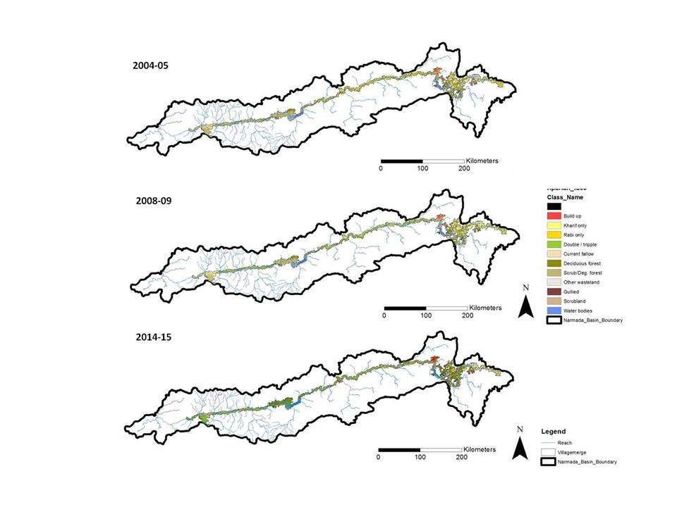
Land use land cover status of years 2004–5, 2008-09 and 2014-15
Land classes studied of Riparian buffer zone of River Narmada
 | Land Cover | Description
1 | Build up | This class describes the land covered with buildings in the rural and urban. It includes commercial, residential, industrial and transportation infrastructures.
2 | Kharif only | The parcels of land which are used only during the kharif cropping season from July –October [during the south-west monsoon]
3 | Rabi only | The parcels of land which are used only during the the Rabi cropping season from October-March (during winter)
4 | Double / triple | The parcels of land which are used for two cropping seasonswith any two combinations from amongst Rabi, Kharif and summer crops [Double cropping land] or during allthree cropping seasons [triple cropping land] (summer cropping season: March to June]
5 | Current fallow | A piece of land that is normally used for farming but that is left with no crops on it for the current season in order to let it recover its fertility [land left without vegetation cover]
6 | Forest | A forest is a large area dominated by trees.
7 | Scrub/Deg. forest | Formerly forested lands severely impacted by intensive and/or repeated disturbance (such as mining, repeated fires or overgrazing) with consequently inhibited or delayed forest regrowth. These include barrens areas, Imperata grasslands, brushlands, and scrublands.
8 | Other wasteland | wasteland is defined as degraded land which can be brought under vegetative cover with reasonable efoort and is currently underutilized and land which is currently deterioriating for lack of appropriate soil and water management on acoount of natural and man made causes.
9 | Gullied | These are first stages of excessive land dissection followed by their networking which leads to suitable development of ravinous land. Areas where all diagnostic soil horizons have been removed by water, resulting in a network of V-shaped or U-shaped channels.
10 | Scrubland | This is a land which is prone to deterioration due to erosion, with scrubs dominating the landscape. They have a tendency of intermixing with cropped areas.
11 | Water bodies | This class of land cover describes the areas either impounded in form of lakes, man-made earth dams or flowing as streams, rivers, canals etc.
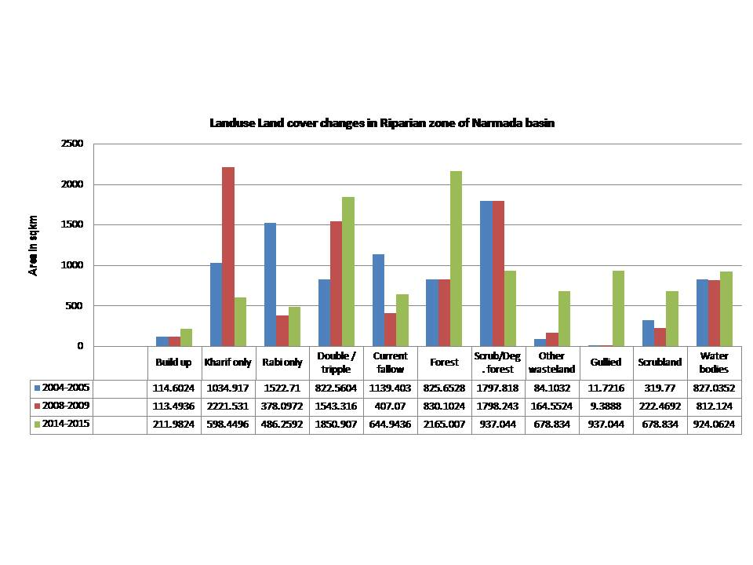
Land cover change in the riparian buffer zone
Land use land cover change in riparian buffer of River Narmada
Land use Land cover | Percent change (2004 to 2008) | Percent change (2008 to 2014) | Change in sq km from 2004 to 2014
Build up | -0.97 | 86.78 | 97.38
Kharif only | 114.66 | -73.06 | -436.47
Rabi only | -75.17 | 28.61 | -1036.45
Double / triple | 87.62 | 19.93 | 1028.35
Current fallow | -64.27 | 58.44 | -494.46
Forest | 0.54 | 160.81 | 1339.36
Scrub/Deg. forest | 0.02 | -47.89 | -860.77
Other wasteland | 95.66 | 312.53 | 594.73
Gullied | -19.9 | 9880.45 | 925.32
Scrubland | -30.43 | 205.14 | 359.06
Water bodies | -1.8 | 13.78 | 97.03

Results and discussion:
LULC in various livelihood zone. The significant land cover occupation or the land cover with maximum area in the various livelihood zones of different parts of the Narmada basin are
I Upper Narmada valley are
1. Current fallow covering an area of 70668130.3 and 49.2 percentage of the land cover in the Eastern Baghelkhand zone where the primary livelihood activities are subsistence based.
2. Deciduous forest covering an area of 1133334109.5 which is 42.9 percentage of total land cover Mahakaushal Maikal Hill Zone where subsistence livelihood predominate.
3. Multiple cropping with an area of 429864407.3 sqkm which is 38.0 percent of total area in Upper Narbada Sub Zone
II Middle Narmada valley
1. Double/triple crop with an area of 315689229.7 covering 59.4 percent in Eastern malwa extension zone quality wheat and pigeonpea production.
2. Degraded / scrub forest Lower an area of 1077965.9 sqkm and 84.4 percent in Bundelkhand Zone low socioeconomic development, low productivity wasteland.

3. Irrigated Intensive agriculture with multiple cropping covering an area of 298270949.2 sqkm or 54.0percent production Central Narbada Sub Zone where horticulture and double / triple cropping predominate.
III Lower Narmada valley
1. Deciduous forest with an area of 459770215.0 covering 26.4 percent in Nimar Plains Zone with major livelihood as cultivation of Cotton, Chilli, Banana and Sugarcane.
2. Degraded / scrub forest with an area of 433403659.3 covering 24.8 percent Nimar Plains Zone - Hot dry Cotton Chilli Banana Sugarcane.
3. Degraded / scrub forest with an area of 91342355.3 covering 59.1 percent in Western Malwa Hill Zone with predominant Bhil tribe.
LULC changes in various zones
The prominent land use change is observed in the following zones can be summarised in the following table. The most significant rise is seen of double triple cropping areas which has increased 3 times original area.
Increased and decreased land cover in various livelihood zones of River Narmada riparian zone
Zone | Livelihood type | Land cover | Percent rise
Central Narbada Sub Zone | Double / triple | Irrigated Intensive agriculture production (horticulture) | 4680.83
Eastern Baghelkhand zone - | Forest, game reserve and energy production | Current fallow | 111.34
Eastern malwa extension zone | quality wheat and pigeonpea production | Built up | 6707.77
Lower Bundelkhand Zone | low socioeconomic development, low productivity wasteland | Deciduous forest | 1056.37
Mahakaushal Maikal Hill Zone Forest | water rich, subsistence tribal zone | Current fallow | 186.47
Malwa Plateau plain zone | Traditional agriculture (spices production) | Deciduous forest | 2088.51
Nimar Plains Zone | Hot dry Cotton Chilli Banana Sugarcane | Gullied | 218547.4
Upper Narbada Sub Zone | Mixed commercial tribal farmers, industrial activities | Deciduous forest | 605.38
Western Malwa Hill Zone | Bhil tribe predominant | Gullied | 1173.67
Zone | Livelihood type | Land cover | Percent fall
Central Narbada Sub Zone | Irrigated Intensive agriculture production (horticulture) | Other wasteland | -96.25
Eastern Baghelkhand zone | Forest, game reserve and energy production | Double / tripple | -91.88
Eastern malwa extension zone | quality wheat and pigeonpea production | Kharif only | -94.95
Mahakaushal Maikal Hill Zone | Forest, water rich, subsistence (millet) | Other wasteland | -98.81
Malwa Plateau plain zone | Traditional agriculture (spices production) | Scrubland | -71.55
Nimar Plains Zone | Hot dry Cotton Chilli Banana Sugarcane | Rabi only | -97.35
Upper Narbada Sub Zone | Mixed commercial tribal farmers, industrial activities | Gullied | -100
Western Malwa Hill Zone | Subsistence | predominant Kharif only | -77.69
The impact of different anthropogenic activities is very severe in the Narmada river ecosystem with changes seen in morphology, fertility, water quality and quantity and forest density and area and on the lifes and livelihoods of people, built and intangible heritage etc. A further increase or stress in the areas can have irreparable damage in the environment of the river.
Interelationship of processes
Matrix of relatiosnhip of processes and impacts
 | Soil erosion |  |  |  | Water pollution |  |  |  |  |  | Flora and Fauna |  |  |  |  |  |  | Changes in micro climate |  |  |  |  | Socio cultural impacts |  |  |  |  |  | Hydrology
Activities | Gully and ravine formation | Soil erosion | Badland formation | Soil fertility | Incresed COD | Incresed BOD | Incresed turbidity | Decresed DO | Increase stream temperature |  | Loss of forest, Riparian fragmentation | Biodiversity loss , | Loss of riparian vegetation, | Changes in flora, faunal density and diversity | changes in fisheries and spawning grounds | Loss of native species |  | Increased air temperatures | Breeding of vectors in reservoirs, | Incresed surface temperature | Reduced humidity |  | Loss of indigenous livelihoods | Submergence of historical sites | Impact on tribal communities, displacement | Loss of indigenous crafts, | Changing culture |  | Reduced ground water flows | Increased run off | Gully erosion | Decrease Infiltration | Depleting ground water levels
Hydropower | 1 | 1 | 1 | 1 | 1 | 1 | 1 | 1 | 1 |  | 1 | 1 | 1 | 1 | 1 | 1 |  | 1 | 1 | 1 | 1 |  | 1 | 1 | 1 | 1 | 1 |  | 1 | 1 | 1 | 1 | 1
Intensive Agriculture | 1 | 1 | 1 | 1 | 1 | 1 | 1 | 1 | 1 |  | 1 | 1 | 1 | 1 | 1 | 1 |  | 1 | 1 | 1 | 1 |  | 1 | 1 | 1 | 1 | 1 |  | 0 | 0 | 1 | 0 | 1
Excessive ground water pumping | 0 | 0 | 1 | 1 | 0 | 0 | 0 | 0 | 0 |  | 1 | 1 | 1 | 1 | 1 | 1 |  | 1 | 0 | 0 | 0 |  | 1 | 1 | 1 | 1 | 1 |  | 0 | 0 | 0 | 1 | 1
Commercial cropping | 1 | 1 | 1 | 1 | 1 | 1 | 1 | 1 | 1 |  | 1 | 1 | 1 | 1 | 1 | 1 |  | 1 | 1 | 1 | 1 |  | 1 | 1 | 1 | 1 | 1 |  | 1 | 1 | 1 | 1 | 1
Irrigation | 1 | 1 | 1 | 1 | 0 | 0 | 0 | 0 | 0 |  | 1 | 1 | 1 | 1 | 1 | 1 |  | 1 | 1 | 1 | 1 |  | 1 | 1 | 1 | 1 | 1 |  | 1 | 1 | 1 | 1 | 1
Intensive Fisheries | 0 | 0 | 0 | 1 | 0 | 0 | 0 | 0 | 0 |  | 1 | 1 | 1 | 1 | 1 | 1 |  | 1 | 1 | 1 | 1 |  | 0 | 0 | 0 | 0 | 0 |  | 1 | 1 | 1 | 1 | 1
Municipal waste discharges | 0 | 0 | 0 | 1 | 1 | 1 | 1 | 1 | 1 |  | 1 | 1 | 1 | 1 | 1 | 1 |  | 1 | 1 | 1 | 1 |  | 0 | 0 | 0 | 0 | 0 |  | 1 | 1 | 1 | 1 | 1
Industrial waste discharges | 0 | 0 | 0 | 1 | 1 | 1 | 1 | 1 | 1 |  | 1 | 1 | 1 | 1 | 1 | 1 |  | 1 | 1 | 1 | 1 |  | 1 | 1 | 1 | 1 | 1 |  | 1 | 1 | 1 | 1 | 1
Increase of impervious surface cover ISC | 1 | 1 | 1 | 1 | 1 | 1 | 1 | 1 | 1 |  | 1 | 1 | 1 | 1 | 1 | 1 |  | 1 | 1 | 1 | 1 |  | 1 | 1 | 1 | 1 | 1 |  | 1 | 1 | 1 | 1 | 1
Channelization, Stabilizing structures, | 1 | 1 | 1 | 1 | 1 | 1 | 1 | 1 | 1 |  | 1 | 1 | 1 | 1 | 1 | 1 |  | 1 | 1 | 1 | 1 |  | 1 | 1 | 1 | 1 | 1 |  | 1 | 1 | 1 | 1 | 1
Increased impervious cover, agriculture and impervious land use, | 1 | 1 | 1 | 1 | 1 | 1 | 1 | 1 | 1 |  | 1 | 1 | 1 | 1 | 1 | 1 |  | 1 | 1 | 1 | 1 |  | 1 | 1 | 1 | 1 | 1 |  | 1 | 1 | 1 | 1 | 1
Sewage discharge | 1 | 1 | 1 | 1 | 1 | 1 | 1 | 1 | 1 |  | 1 | 1 | 1 | 1 | 1 | 1 |  | 1 | 1 | 1 | 1 |  | 1 | 1 | 1 | 1 | 1 |  | 1 | 1 | 1 | 1 | 1
Mining | 1 | 1 | 1 | 1 | 1 | 1 | 1 | 1 | 1 |  | 1 | 1 | 1 | 1 | 1 | 1 |  | 1 | 1 | 1 | 1 |  | 1 | 1 | 1 | 1 | 1 |  | 1 | 1 | 1 | 1 | 1
Felling of forests | 1 | 1 | 1 | 1 | 1 | 1 | 1 | 1 | 1 |  | 1 | 1 | 1 | 1 | 1 | 1 |  | 1 | 1 | 1 | 1 |  | 1 | 1 | 1 | 1 | 1 |  | 1 | 1 | 1 | 1 | 1
Degradation of grasslands, scrublands | 1 | 1 | 1 | 1 | 1 | 1 | 1 | 1 | 1 |  | 1 | 1 | 1 | 1 | 1 | 1 |  | 1 | 1 | 1 | 1 |  | 1 | 1 | 1 | 1 | 1 |  | 1 | 1 | 1 | 1 | 1
@l@
Extent of degradation: Severe environmental degradation of Narmada river ecosystem has happened which can be classified in to following areas:
1. Hydrology :Massive sea water intrusion from the Bay of Khambhat, for upto 40 kilometres eastwards into the Narmada has allegedly “destroyed” 10,000 hectares of agricultural landand affected the livelihoods of fisherfolk.. (Shah, 2016). Severe salinisastion on both the banks upto 400 hectares is see in Rajkot. Waste and effluents discharges have pushed the quality of water down to “B” category, according to Bureau of Indian Standard 2296 norms.A report of the Madhya Pradesh Pollution Control Board (MPPCB) indicates that in Dindori, the quality of water was under ‘C’ category of the BIS’s 2296 norms (1981) (Saxena, 2013). Municipal waste of 19 cities is directly discharged into the river. The major source of pollutants are local anthropogenic activities, agricultural runoff and by industrial effluent. (Sharma Shraddha1, 2011), The 19 cities located on the banks of the river discharge the municipal waste without treating it properly.A number of industries dot the bank of the river which discharges their effluent in the river.
2. Morphology: Siltation occurs in the area below the irrigation canal take-off level (dead storage) as well as above that (live storage). (Ashish Kothari, 1994) Sever soil erosion in edges have led to bank cutting on the erosive edges of the river such as seen in Maheshwar ghats.A significant area is aaffected by Gully erosion. The most commonly described gullies are the ‘hillslope gullies’, which are present in the upland portions of catchments. Gully erosion and the associated soil loss have caused major environmental disasters. Many urban and rural communities have been severely affected, while the sustainability of the total landscape has been threatened. (Padmini Story, 2011) Badlands: Badland forms represent an ever increasing erosive network of channels rendering rendering land unfit for agriculture and other uses.
3. Industrialization: The numerous cotton based industries discharge their waste into the river. The cotton industries heavily pollute the air.
4. Flora and fauna: Degradation of water quality and riparian vegetation.Illegal fishing all year round Loss of fish fauna
Cutting of forests has led to decline in diversity and density of forests. Conversion of grasslands into farmlands have reduced grazing ground of deers and other foragers.
Conclusion:
The central Indian forests located on metamorphic rocks such as dike and Granite, the forest once felled will never regenerate, the barren earth will no longer retain moisture, the river will run dry and the large part of the land will become a wasteland. The protected areas should be increased to protect any further environmental degradation of the river. The degradation which gradual in the last centuries have sevely pacened in the past few deacdes. The valley has seen severe mrphologocal degradation and habitat loss. The results clearly show that LU/LC changes were significant during the period from 2004 to 2014. The increase in wasteland, scrubland and gullied land is alarming and indicates towards degrading landscape of the River. The gullied land is unfit for any purpose and requires conservation as it does not support any livelihood and hence the increase of gullied area is an alarming threat ecosystem of Narmada region and also to the indegenious livelihoods it supports. Scrublands i.e. land which is prone to deterioration due to erosion, with scrubs dominating the landscape are in increase thereby leading to lesser areas with diverse species. The increase in gullied areas indicate towards loss of vegetation cover in steep slopes and valley region. The area of water bodies have increased due to construction of numerous dams in the catchment. Due to availability of new technology for pumping there is a decrease in area of Kharif and Rabi only crops and increase in Double triple cropping Area.
An inclusive management plan which addresses the multiple sector (Silviculture, irrigation, tourism, infrastructure development, urban expansion, waste management etc) is essential to further curtail the degradation of the environment. Looking into the cultural and ecological significance of the rivers, conservation measures like forestation, slope stabilisation need to be taken.

Bibliography
(n.d.).
Anonymous. (2015). Drowning a history in the Narmada valley: A seat of old human settlements and evolution is now under threat. Retrieved April 22, 2017, from COUNTERVIEW.ORG: https://counterview.org/2015/06/15/drowningahistoryinthenarmadavalleyaseatofoldhumansettlementsandevolutionisnowunderthreat/
Ashish Kothari, a. N. (1994). ENVIRONMENTAL IMPACTS OF THE SSP. KALPAVRIKSH.
B.K.Dubey, F. (1967). A study of the Tribal people and tribal areas of Madhya Pradesh. Bhopal.
Badam, G. L. (2007). The Central Narmadā Valley: A Study in Quaternary Palaeontology and Allied Aspects. Bhopal: Indira Gandhi Rashtriya Manav Sangrahalaya.
Baviskar, A. (1995). In the belly of the river. Oxford.
Bhatt, S. K. (2007). Narmada Valley Culture and Civilization. Indore: Academy of Indian Numismatics & Sigillography.
Buch, M. (1991). Forests of Madhya Pradesh. Madhya Pradesh madhyam.
D.S.Deshmukh, U. S. (2011). Geomorphological Analysis and Distribution of Badland around the Confluence of Narmada and SGeomorphological Analysis and Distribution of Badland around the Confluence of Narmada and Sher river, India. European water, 15-36.
Deshdeep-Saxena. (2013). MADHYA PRADESH’S LIFELINE- NARMADA, BATTLES FOR SURVIVAL. Times News Network. Bhopal: Times News Network.
Forsyth, J. (1871). Highlands of Central India. Chapman & Hall.
Gaatha. (2013, July 9). Teer Kaman. Retrieved from Gaatha: http://gaatha.com/teer-kmaan/
Judith, W. (2010). Development and Dispossession in the Narmada Valley. Pearson Education India.
Kothari, A. (1989). Environmental Aspects of the Narmada Valley Project. SAGE.
M.N.Buch. (n.d.). Forests the changing scenario. National center for human settlements.
Mohite1, S. A. (2012). Impact of Land Use Changes on Riparian Habitats in Panchganga River System. Proceeding of International Conference SWRDM-2012.
network, I. r. (2010, 09). Save agriculture in Narmada valley. Retrieved 07 1, 2018, from INDIA WATER PORTAL: http://www.indiawaterportal.org/articles/save-agriculture-narmada-valley
Neuß, J. (n.d.). Narmad?parikram? - Circumambulation of the Narmada River: On the Tradition of a Unique Hindu Pilgrimage.
Padmini Story, S. N. (2011). Ravine Erosion in India.
Poonam Verma, M. R. (2011). Vegetation and Climate of Narmada Hominins.
Romshoo, I. R. (2013). Impact of anthropogenic activities on water quality of Lidder River in Kashmir Himalayas. Environmental Monitoring and Assessment.
Saxena, D. (2013, June 5). Madhya Pradesh’s lifeline- Narmada, battles for survival.
Shah, R. (2016, 7 4). Narmada valley is facing yet another crisis beyond the gigantic dams, which has arisen due to the huge canal network of the Indira Sagar and Omkareshwar canals. . Retrieved 7 1, 2018, from THE WIRE: https://thewire.in/politics/government-inaction-is-turning-the-banks-of-the-narmada-into-salt-pans
Sharma Shraddha1, V. R. (2011). Evaluation of Water Quality of Narmada River with reference to Physcochemical chemical Parameters at Hoshangabad city, MP, India. Research Journal of Chemical Sciences, 40-49.
Sharma, K. (2005). Studies of Pollution On Auatic orgnisms of river Narmada. Varodra: Shodhganaga.
Sonal Tiwari1, N. M. (2018). Monitoring impact of land use &land cover change in livelihood zones along the Narmada River Riparian Buffer Zone, Madhya Pradesh, India. RSAI. Goa.
Unni, K. S. (1996). Ecology of River Narmada. New Delhi: New Apcon.

