(ESI) Engineering hollow microcapsules made of photo-crosslinkable polyelectrolytes containing thymine pendant groups-Suplementary Information-
Mariana P. Serrano
Rodrigo E. Gimenez
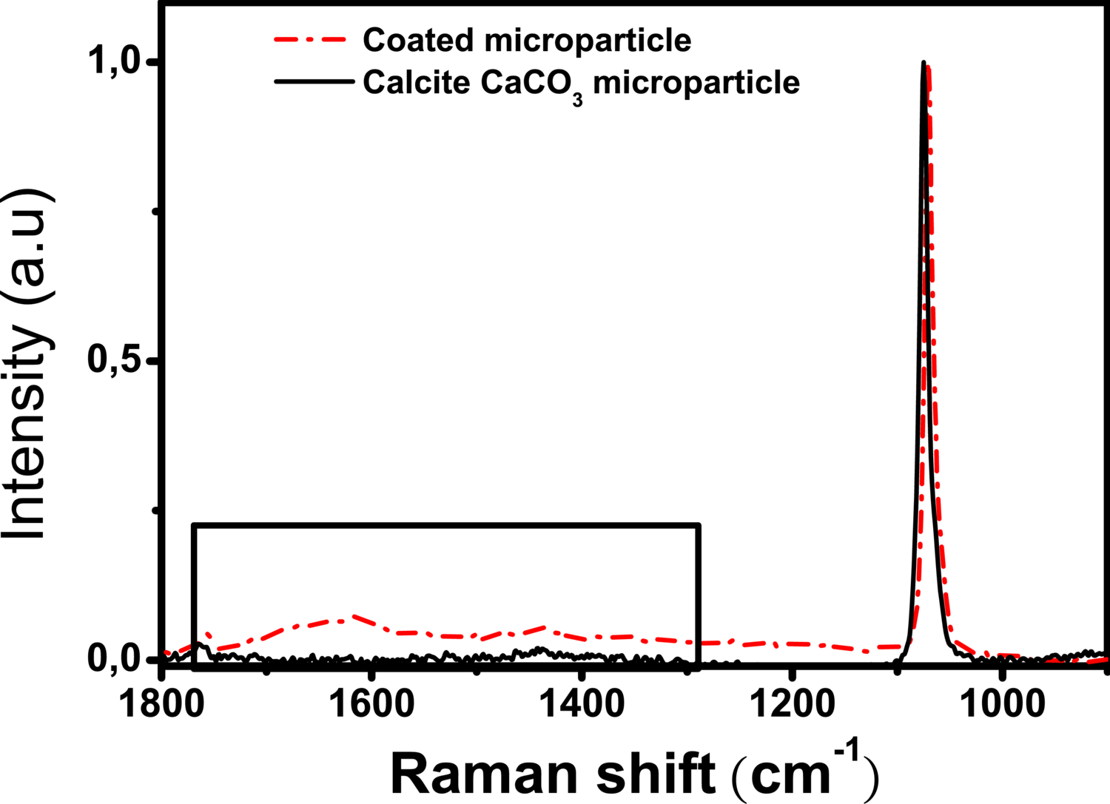
Raman spectra corresponding to calcita morphology of $CaCO_{3}$ microparticles before and after the deposition of 3 bilayers of $VBTVBA_{4}$/$VBTVPS_{4}$ polymers.

Materials

Synthesis of vinylbenzyl thymine (VBT) and vinylbenzyl trielthylammonium (VBA) monomers
For the synthesis of VBT monomer the method of Yang et al. was used (missing citation). Thymine and sodium hydroxide in a 1:1 molar ratio were dissolved in a minimum volume of distilled water and the solution was stirred at room temperature for 2 hours. Dropping the aqueous solution into ethanol the thymine sodium salt crushed out, and in order to eliminate any traces of water the thymine sodium salt was lyophilized for 24 hours. VBC (45 g – 0.296 mol), lyophilized thymine sodium salt (56.56 g – 0.325 mol), inhibitor BHT (60 mg – 0.25 mmol) and 800 mL of distilled DMF were added to a three-neck round bottom flask equipped with a condenser, a nitrogen inlet and a magnetic stirrer. The reaction was carried out at 70 °C for 24 hours under nitrogen atmosphere. The solvent was removed almost completely by rotoevaporation at 35 °C and the unreacted thymine was filtrated with boiling toluene. Filtrated solution was cooled at -5 °C, and after 24 hours the crystallized VBT was collected by filtration and dried under vacuum (yield = 47%).
For the VBA synthesis, the method developed by Zarras et al. was followed (missing citation). 50 mL of VBC and 200 mL of acetone were added into a round bottom flask. While the solution was stirring, 50 mL of triethylamine were added, and the reaction was run at 60 °C with reflux for 1 hour. Then, the heat was turned off and the solution was allowed to stir overnight at room temperature. The precipitated product was filtered and washed with cold acetone (yield = 99 %). Based on 1H NMR spectra (Bruker 300 MHz NMR spectrometer) and melting point results, the monomeric products were deemed pure enough for the synthesis of the polymers.

Synthesis of copolymer VBT:VBA 1:4 and VBT:VPS 1:4
To produce water-soluble polymers, VBT was copolymerized in a free radical process with the cationic monomer VBA and anionic monomer, VPS. The ratio of VBT:VBA and VBT:VPS co-monomers influences the behavior of the polymeric system and varies depending on the application. In the present work, $VBTVBA_{4}$ and $VBTVPS_{4}$ (Figure ???) have been synthesized.

VBT:VPS 1:4 copolymer
VBT was measured into a round bottom flask with 50:50 isopropanol:water as solvent. The solution was stirred and heated to 85 °C to dissolve VBT. Once dissolved, the temperature was lowered to 65 °C, VPS was added according to (1:4) ratio, and the AIBN was added to the flask (1 % by weight of total solids). The solution was held at 65 °C under $N_{2}$ and stirred for 18 hours. The solution was cooled to room temperature, and then rotary evaporated to concentrate the solution. The concentrated solution was poured slowly into acetone while stirring and a white powdery solid crashed out of the acetone/isopropanol/water mix. The powder was filtered and washed with acetone. To verify the absence of unreacted monomers, the precipitated polymer was analyzed by 1H NMR spectroscopy and the typical vinyl group signal at chemical shifts between 5 and 6 ppm was not observed in the spectra.

VBT:VBA 1:4 copolymer
VBT and VBA were added into a round bottom flask according to (1:4) ratio and isopropanol was used as solvent. The solution was stirred and heated to 65 °C. Once at 65 ºC, the initiator AIBN was added to the flask (1 % by weight of total solids) and the solution was held at 65 ºC and stirred for 18 hours. The solution was cooled to room temperature, and then rotaryevaporated to concentrate the solution. The concentrated solution was poured slowly into acetone while stirring and a white powdery solid crashed out of the acetone/isopropanol mix. The powder was filtered and washed with acetone. To verify the absence of unreacted monomers, the precipitated polymer was analyzed by 1H NMR spectroscopy and the typical vinyl group signal at chemical shifts between 5 and 6 ppm was not observed in the spectra.
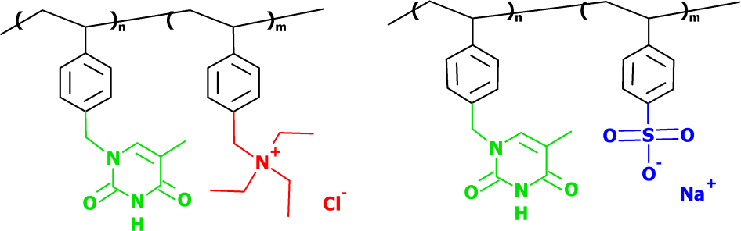
Structure of $VBT_{n}VBA_{m}$ copolymers (left) and $VBT_{n}VPS_{m}$ (right) (n = 1 and m = 4).
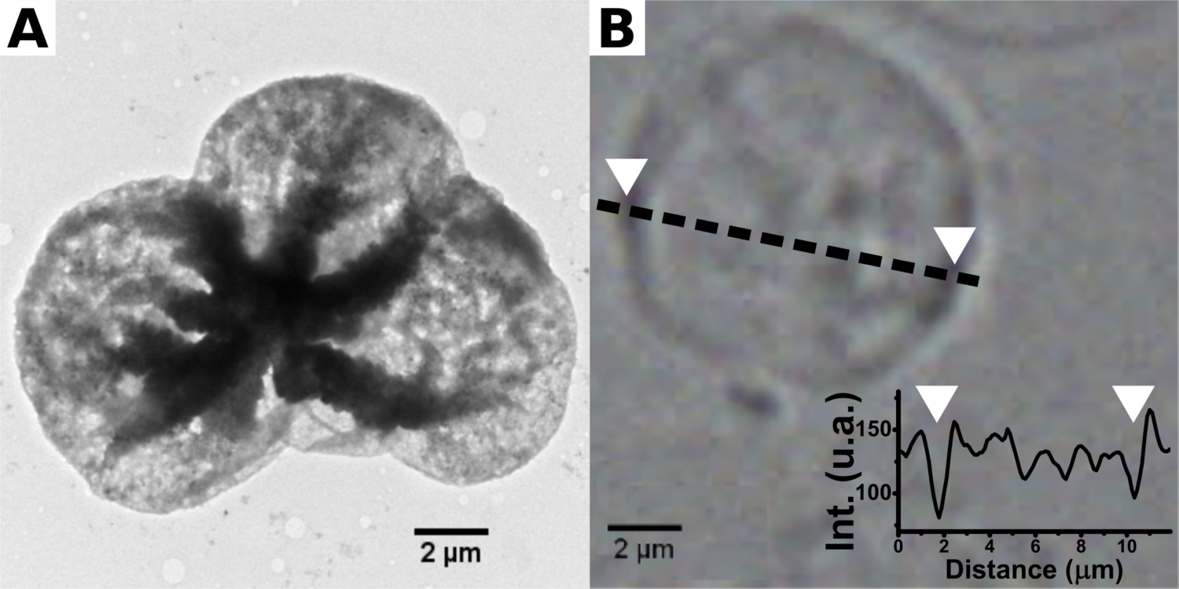
(A) TEM and (B) optical images of hollow microcapsules formed by 3 bilayers of $VBTVBA_{4}$/$VBTVPS_{4}$ polymers after $CaCO_{3}$ removal with EDTA 0.1M.
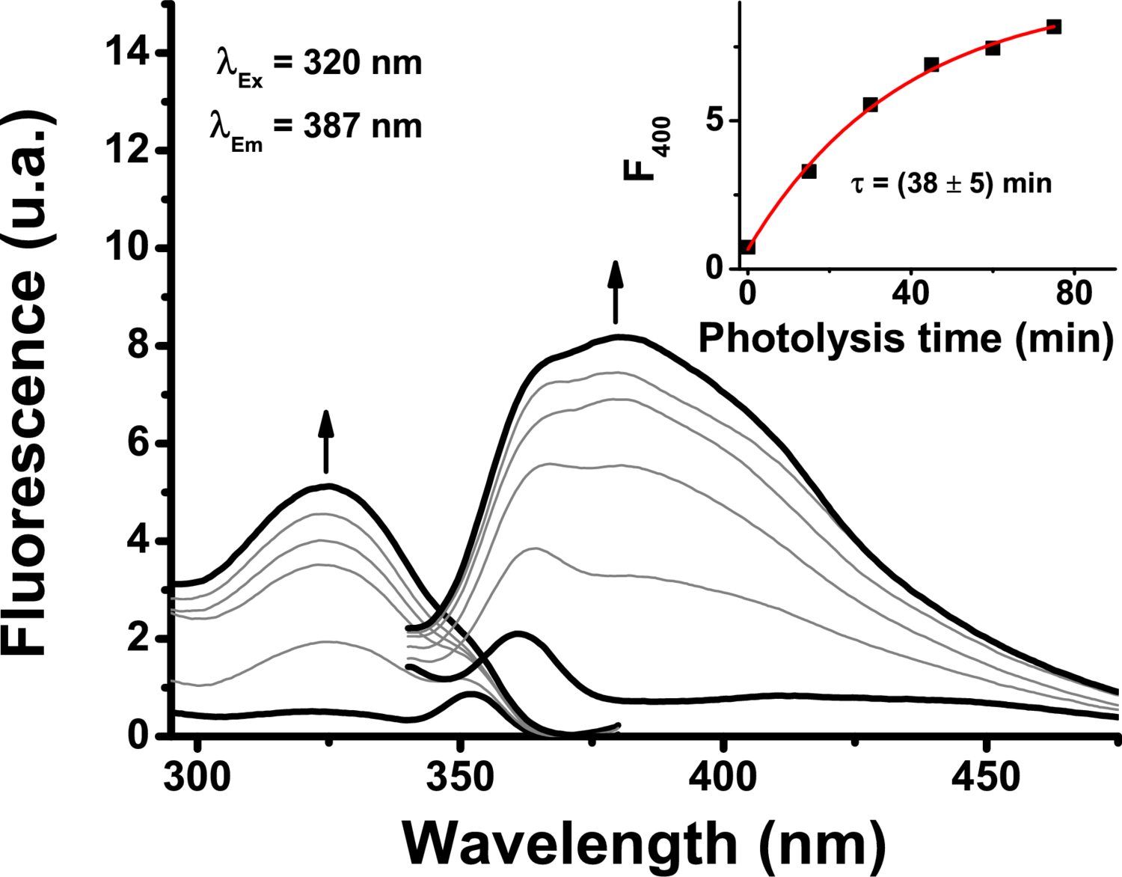
Excitation and emission spectra of $CaCO_{3}$ microparticles coated by by 3 bilayers of $VBTVBA_{4}$/$VBTVPS_{4}$ for different UV irradiation time. $λ_{em}$ = 400 nm and $λ_{exc}$ = 320 nm.
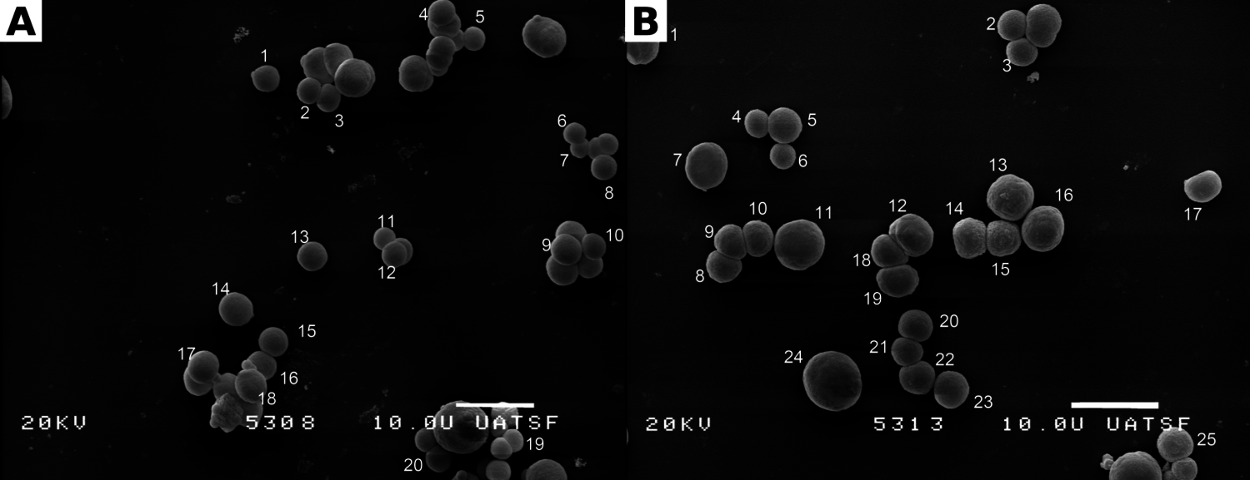
Replace this text with your caption
Student’s double tailed t-test was performed in order to determine if there is a significant increase in particle diameter after coating with 3 bilayers of $VBTVBA_{4}$/$VBTVPS_{4}$. From the size analysis of Figure ??? the data shown in Table ??? was obtained. Since the calculated t value exceeds the critical value for p $<0.001$ ($4.3517>3.551$), the means are significantly different and it can be assured with 99.9 % conficence that there is a $≈1$ m increase in particle diameter after coating.
Mean, standard deviation and number of particles for $CaCO_{3}$ microparticles before and after coating with 3 bilayers of $VBTVBA_{4}$/$VBTVPS_{4}$
 | $CaCO_{3}$ | Coated $CaCO3$
Mean | 3.61 | 4.51
Std. dev | 0.50 | 0.87
n | 20 | 25

References

