Theory Transfers: Multi-sensory Human Bond Communication in Maritime Domain
nor.pys
Norwegian maritime industry faces a major long-term societal challenge with meeting the human-center design needs of the future generation of remoting control. We are currently experiencing an increased need for supporting different stakeholders on land to control unmanned ships at sea. Since the Norwegian government’s official report on innovation in maritime domain brought attention to the rapidly emerging social insights on technology development, we are seeing increased attention directed towards new models for delivering knowledge around technology-based products and services. In line with this, this paper presents a design approach that focuses on effectiveness as the foundation for the design of enabling technologies for the maritime domain. To answer the overarching research questions that concerns constriction of a theoretical design framework, the operationalization of the framework by informing a tailored methodology, and reflection of design outcomes to generate knowledge that can link design and engineering work back to theory. Actor Network Theory and Maurice Merleau-Ponty’s phenomenology of the lived body has been used to construct design framework with theoretical concepts from the Computer-supported cooperative work research field that frame an understanding of effectiveness as the basis for the design. We answer that social computing can emphasizes designing for effectiveness: a design process with supportive analyses of preconditions, participation, and decision making on the design computing devices. Results from the framework building suggest that this design approach can open up opportunities to design long-lasting relationships between people and digital devices they use in their everyday life by designing effectiveness.

Introduction
The internet of things (IoT) is defined as “a dynamic global network infrastructure with self-configuring capabilities based on standard and interoperable communication protocols where physical and virtual things have identities, physical attributes, and virtual personalities and use intelligent interfaces, and are seamlessly integrated into the information network. [1]” As an overlapped area IoT has been discussed in many research fields such as mobile computing, pervasive computing, wireless sensor networks, and cyber-physical systems [2].
Consequently, the development of IoT involves much of computer science, computer engineering, and electrical engineering [1]. All these fields address on underlying technologies such as real-time computing [3], machine learning [4], security [5], [6] and privacy [7], an algorithm for sensor networking [8], big data [9] and others. However, these technical approaches cannot guarantee safe and efficient interactions between humans and IoT platform, so-called Social Internet of Things (SIoT) [2], [10]. Although “human-in-the-loop” as an engineering model can offer opportunities to a broad range of applications including health care [11], smart home [12] and city [13], it is still a challenge on how to bring back human work practices [14] with IoT platform into the loop since its complexity of human behavior.
Recently, Atzori et al.[15] extent that the social internet of things is defined as an IoT where things are capable of establishing social relationships with other objects, automously with respect of humans. In this matter, the structure of the ‘things’ can be shaped as network navigability, so as to effectively perform the discovery of objects and services and to ensure scalability as in human social networks. They argue that a level of trustworthiness can be established for leveraging the degree of interaction among things that are friends. Moreover, the connected ‘things’ through the trustworthiness as social network can be reused to address IoT related issues (intrinsically related to extensive networks of interconnected objects). This approach distinguishes the social world and technical world, hoping that IoT developers can implement a platform to enable end-users to design a technical solution.
Although trustworthiness can be established and ‘things’ can be discovered, the power of interaction among social and technical world which may shape and reshape the structure of IoT platform seems missing. However, it is necessary to unpack this missing box since end-users’ work practices are the fundamental basis for IoT development. Without knowing the work practices of end-users, it may introduce significant price of evaluating and changing the IoT platform towards to meet work practices of end-users [10], [14]. Thus, we present an understanding of how phenomenology of the lived body serves as a design framework to reveal the interaction between humans and technologies to support the design of Social Internet of Things. We assert that SIoT is not only a technical platform for supporting human work. It also a platform that is shaped via human work practices. Through configuring network infrastructures, Phenomenology helps IoT developers to unpack the process of making a useful SIoT platform through indicating how to consider the interaction between human and technologies as safe and effective resources for the development of SIoT.
In this paper, as a backdrop to identifying research questions, section II introduces who is the user during the development of SIoT platform. The discussion is about the usefulness of SIoT platform. Also, SIoT developers themselves are the users in SIoT field. Section IV presents a tale of Phenomenology, and its applies in design research. The research discussed is representative and exploratory rather than complete. The purpose of discussing why SIoT needs theory. The goal of the paper is to highlight how Phenomenology could contribute to SIoT development. Section IV presents a paradigm shift from technical work to the combination of social and technical work with the purpose to understand the materiality in SIoT development. The paper concludes in section V.

An IoT platform is useful to whom
End-users are the users for the IoT platform. They are the people who use and control IoT to accomplish their goals in their work context [2]. Their work behavior can be observed and be modeled regarding analyzing development requirements of IoT platform. End-users might be asked to participate in the testing phases when an IoT platform is established. However, such manner could only make sure that the IoT platform is easy to use within the filtered conditions during the testing period. It is impossible to say that end-users are willing to use [16] this IoT platform in their work context. Therefore, it is important to identify what useful and useless components in an IoT platform are? In line with this question, it is crucial to know that IoT developers themselves are the users as well. How to gain useful local context and common information from the end-user and themselves become important. Therefore, we unpack two important things that IoT should take into account – usefulness, and developers as users.

Usefulness
In an engineering context, where time is, at least sometimes, of the essence, ‘overhead’ can be extremely important. However, there is a possibility that in a context where a task might be less important and thus the time taken might not seem to be significant, suggested that humans were, in fact, subject to the same irritations that they experience with IoT at work. This is interesting in the kinds of complaint about the technology that they voiced. If the above can be thought of, broadly, as easy to use [17] issues, it is essential that we should not miss the idea of usefulness.
If it is true that working with IoT is not always as task-oriented since traditional work routines might be changed somehow due to the IoT technology, then it may turn out to be the case both that usefulness is hard to distinguish and that whether technologies are deemed to be useful may depend on a set of moral and symbolic perspectives as much as practical ones. This challenges developers how to develop IoT platform for collecting of internet of practices of humans [14].

Developers as users
In order to understand how to make useful IoT, it is important to concern with the integration of theories and methodologies to support the combined investigation of machines, humans, and domains of application [18]. Although in the context of computer science ethnography has been adopted within the human-computer interaction community to conduct a study of the workplace and inform the design of computer application [19], developers appear to have limited experience with ethnography [20]. In this manner, end-users are representative of users and developers to some degree do not see themselves are the users as well in the development process. As discussed, ethnographers are unique professionals, and they are good at describing what is and is not important, relevant, interesting, painful, exciting to the users, not to the systems developers. They do not make a priori expectations, judgment, and an intrusive of how users work with technologies but provide a systematic and ongoing data collection and analysis for developers who seek to confirm and disconfirm requirements in the development work [19], [20]. Thus, developers are the users who need help to make implicit explicit from the grounded, real practices of end-users to strengthen the investigations into the human and technology aspects of IoT.

Theories

Phenomenology
Phenomenology concerns experience through the eyes of the first person. Experiences always belong to someone, but how do we subjectively experience a phenomenology and what is the structure of how a phenomenon appears to us? Merleau-Ponty’s use of first person’s perspective [21] tried to changing bodies such an injuries, pain, and suffering helps us contextualize and apply the philosophy as a theory in design context [22]. The first person’s perspective has a natural and vigorous relationship with design practice as it relates our presence and experiences towards our immediate environment and the world around us, which includes everything from people to objects, as well as the relationships between them. The role of embodiment in perception and cognition provides a grounding for understanding interaction through the relationship between the body and the world. It allows researchers to study interaction through a phenomenological lens where people perceive the world through bodily senses and therewith how interpretations, experiences, and intentions revolves around how the human body immerses itself in the world.
However, studying the world through the eyes of conscious experiences carries both a first person and ontological aspects, which Martin Heidgger paid particular attention to in his work. A first person can be labelled as the study of, among other things, structures of conscious experience and what it means that experiences are experienced, it still raises the ontological question of what our experiences, i.e., the nature of the structures of conscious experiences, are [23].
The first person aspect was influenced by and critical of central philosophical figures, both historical and contemporary. Although it is out of the scope to discuss the preceding phenomenology in this paper, it is necessary to mention that the first person as a term can be rooted to Husserl and Heidegger’s critiques of objectivity and objective knowledge that can not properly address important aspects of the world of experiences [24]. This is a shortcoming of natural sciences, further, engineering, since it neglected the animate dimension of the body, i.e., the unique manner in which we experience our bodies as something subjective and categorically different from other people’s experience of embodiment [23]. Heidegger further built an ontological understanding around the very existence of humans in the world to frame concepts, such as subject, object, consciousness, and world into an interconnected and co-existing structure [25].
In line with this, Merleau-Ponty justify how our subjective perspective finds its place in and connects with the world: I can cleary distinguish from myself the world and things, since I certainly do not exist in the way in which things exist [26, p. xiv]. Thus, the perceptual experience involves three elements: the subject, the object, and their relationship. The body represents the subject, the world is the object, and their relationship manifests itself through the consciousness. Of course, we need to consider other types of body, the moving, habitual, intentional, and ill bodies. However, the most fundamental basis for consideration is the relationship between the world and the body – the interactive relationship. Therefore, in order to bring in an extensive understanding for establishing a social internet of things for the maritime domain, we must introduce another theory to bind up individual interactive relationship as a group structure. Thus, the next subsection, we introduce the Actor Network Theory.

Actor network theory
If we understand SIoT is about establishing a useful platform to enable different sensors, physical objects and end-users can work together; then ANT also addresses for better understanding how technology and social can work together for delivering a socio-technical solution for such platform. Actor-network theory is useful because every object in the IoT platform does not work alone. Instead, every object in an IoT platform contributes equally to enable end-users can use the new IoT platform to finish tasks, such as remote control of unmanned ships onshore. ANT thus provides a method for describing how, where, and to what extent technology influences human behavior [27]. Moreover, ANT helps to examine the relations among the end-users, the sensors, and the physical objects and offers a way for engineers to visualize such relations to enable a complex work can be done.
Law [28] defined ANT as follows:
Actor-network theory is a disparate family of material-semiotic tools, sensibilities, and methods of analysis that treat everything in the social and natural worlds as a continuously generated effect of the webs of relations within which they are located. It assumes that nothing has reality or form outside the enactment of those relations. Its studies explore and characterize the webs and the practices that carry them. Like other material-semiotic approaches, the actor-network approach thus describes the enactment of materially and discursively heterogeneous relations that produce and reshuffle all kinds of actors including objects, subjects, human beings, machines, animals, ‘nature,’ ideas, organizations, inequalities, scale and sizes, and geographical arrangements.
Thus, ANT provides a framework and a systematic means for considering all the factors in the social and natural worlds [29]. ANT does not explain why the network exists; it is concerned with the infrastructure of actor networks, how they form and how they can fall apart [30].
ANT combines the so-called generalized symmetry principle, that is, human and nonhuman things should be incorporated into the same conceptual network and be allocated the same amount of agency [31] as well as the interactive relationships. An actor is that which accomplishes or undergoes an act. When we act, we always interact with others. As Law [32] stated, “Interaction is all that there is.” During these interactions, we change the other actors. At the same time, however, the other actors are changing us [33]. We also follow the principle and deal with the cooperation between humans and nonhumans because it is essential for a successful marine operation. ANT considers that not only human beings but also nonhuman entities constantly influence us. Hence, the specific mechanisms at work can be described in detail while allowing the actor to be treated fairly [29]. In this manner, we significantly contribute how to collective the subjects, objects, and their interactive relationships as a whole to define a first person’s perspective on dealing with design to support the relationship between the world and the body.
Additionally, regarding the actor-network, Callon describes how actor-worlds (i.e., a metaphor) function and how the relations between the different actors are organized and structured[34]. Callon [34] explained the following
It is clear that an actor-world may be more, or less, extended, heterogeneous and complex. How shall we describe this range of possibilities and the translations that occur between them? To answer this question, we introduce the notion of actor-network. This concept allows us to describe the dynamics and internal structure of actor worlds.
Based on this explanation, we can understand that the actor-network is the heterogeneous network of human and nonhuman actors. The relationship between them is important; such relationship is not their essential or inherent (Callon, 1986, 1991). ANT assumes that there are no purely human or nonhuman networks. All networks contain elements of both and are heterogeneous and social-technical [37]–[39]. Latour [37] employed to metaphors and advised thinking about nodes, which have as many dimensions as they have connections, instead of thinking about surfaces and the dimensions of these surfaces. For instance, the foundational ANT studies focused on the breakdowns upon which networks become visible. Thus, ANT is concerned with the links that hold and the links that do not hold [40] in network dynamics. Network dynamics assume that actors, human versus nonhuman neutrally, have different and often incompatible interests. The social order or the stability of a network depends on its alignment [41]. Such alignment is based on translation of different interest of actors in a network to define a framework for possible action. The alignment is a necessary process before we get a result of what should be in an actor-network, and it continues until equilibrium has been reached and modified [42].

How theories contribute to IoT
It must be clear for IoT developers that IoT platform is more than the technical-based area that only sensors or physical devices are connected. Also, humans are also connected to the network and play an important to role to coordinate the IoT platform functional in their work context. In most case, developers presume that the “things” on the internet are an object. As defined by the Oxford dictionary, an object is “a material thing that can be seen and touched; a person or thing to which a specified action or feeling is directed [43]”. From both first person and ANT aspects, objects are considered tools used to coordinate the work in everyday life of body where objects are used to realize the work among the collaboration of objects and bodies. As an object, it plays an important role in coordinating work practices [44] and thus is not only about technical but social meanings.
Objects as materials can pre-exist in the technical world. An important investigation is how to bound object via human activities regarding illustrating their work practices that inform design [45]. From a first person perspective, it is a material given by someone’s own experiences. However, in order to make sense such experiences from an ontological level to a wide range of users, we must search for the intra-actions among materials, materials and their locations, and materials and the human mobility patterns associated with different bounding [45]. Regarding design, researchers investigated the role of a particular ecological arrangement of material in performing work [16]. An immutable mobile object needs to be “both plastic enough to adapt to local needs and constraints of the several parties employing them, yet robust enough to maintain a common identity across sites” [46].
As Husserl, Heidegger and Merleau-Ponty’s justify that an object is given meaning by the iterative interaction relationship between the body and the world. In this manner, we should argue that when designing an object, following the interactive relationship is important to bring social context of object use into design and make the digitalization possible. Suchman defines this relationship as the dynamics of object:
The dynamics of computational artifacts extend beyond the interface narrowly defined, to relations of people with each other and the place of computing in their ongoing activities. System design, it follows, must include not only the design of innovative technologies but their artful integration with the rest of the social and material world.
According to this definition, objects consist of more than a physical shape. Artefacts also help users to function in their daily work practices [47]. Moreover, objects are designed to react according to the activities in which they are used, to be incorporated into sophisticated semiotic practices, and to respond to and integrate unfolding events that go beyond function to address social meaning [47].
Thus, it should be clear that ‘things’ in IoT are not only objects to support daily work and collect data. Moreover, social contexts and the work practices in them enable an IoT based work meaningful. In this manner, it will be fruitful to tell the whole story of the relations of thing as the non-material component of human practices in workplace [50]–[52] to make sense of the IoT. Thus, designing social aspect into IoT is about how to unfold the work practices of the body, object, and interactive relations. In that case we must acknowledge that in operations of technologies it is important to know who, where and what is involved in a work and how the work is done. This inquiring requests us to understand ‘things’ as the process of shaping interactive relationships regarding the tasks of each operator and the connections among the various tasks, that is, the interactive relations. This understanding contributes to shifting the focus from the internal opacity [47] of an object to its relations to human practices in a cooperative social context. According to Schmidt and Bansler [47],
We do not need to understand the internal mechanism of an artifact to make rational use of it; nor do we in fact normally do that. One doesn’t need, say, to understand the specifics of the lattice structure of steel alloys causing the operational properties of one’s damascenes kitchen knife: its hardness, its tensile strength, its elasticity. What one needs to understand is its ‘functionality.’ And in the case of machinery, what one needs to know is the dependable regularity of its behavior. That’s all.
According to this, contributing social aspect to IoT development is about how we understand social phenomena and using such resources to make changes and arrangements for the existing algorithm, system structure, as well as the information model. Thus, we believe that such understanding can provide the opportunity to use the ‘things’ to enhance the translation of social theories and related outcomes so that the project audience could shift their focus from the internal mechanism of an object to understanding it as a ‘thing’ and its relations in human practices. This is crucial for the development of IoT.

A maritime case
In this section, we illustrate a maritime case to show how ANT can help with configuring ‘things’ for developers. This could help developers to ensure what is useful in an IoT platform and how to develop sensors in the IoT for safe and efficient work practices with humans.
Norway as a leading nation in maritime domain recently focuses on establish the first remote control center for onboard support of unmanned ships. Ship navigation in the open sea can be nearly autonomy whereas, for some part of a voyage like passing narrow water, it will require supervision, decision-making and full teleoperation onshore ship bridge (see Fig. 1). Traditionally humans operate on the vessels they only need to communicate with traffic service center. However, if humans are moved out from the unmanned vessel but still need to take care of the unmanned vessel regarding safety, humans are not only monitoring information sending back from the unmanned vessel. If necessary, they need to start recovery planning and directly operate ships. This makes huge uncertainties of sensor technologies since we still do not fully understand what information is needed and useful for people who remotely control ships. Therefore, it raises other questions about trust in the systems, information overflow, training humans and their roles in the remote control center, loss of ship senses, and capacity for teamwork and so on.
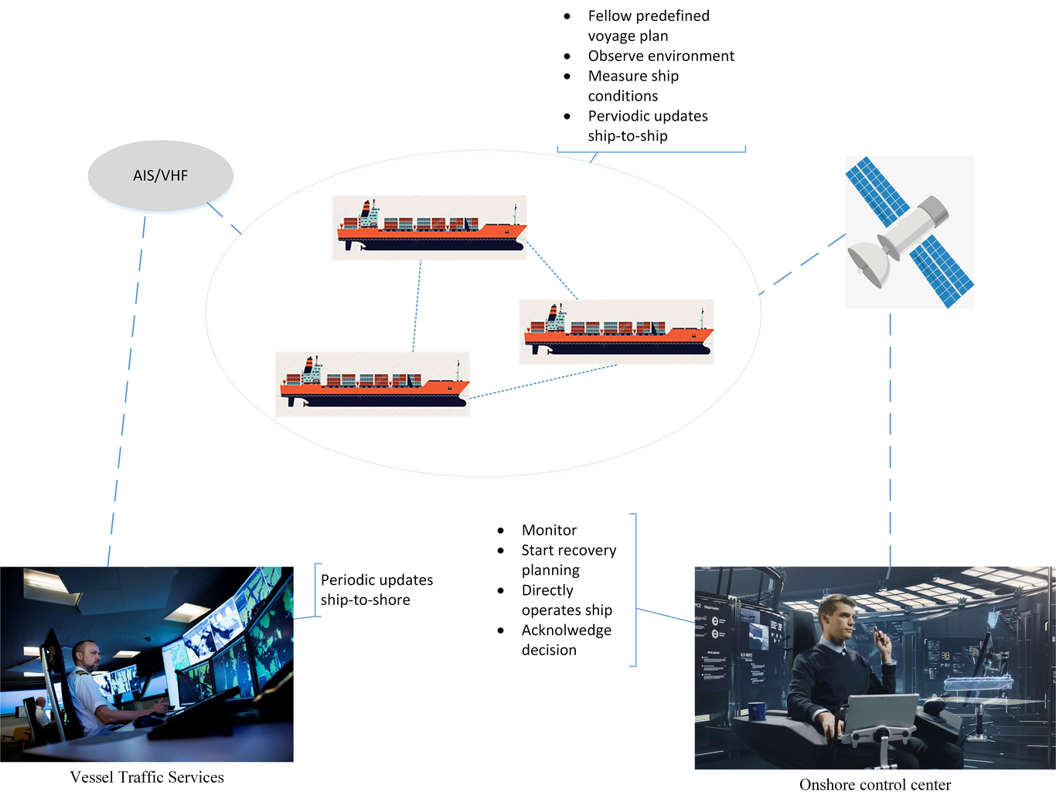
This is a caption
All above concerns might be discussed too much and early until there is a useful remote control center is established. In line with ANT, it is possible to configure and reconfigure what is important information for onshore control.

From human-in-the-loop to actor-in-the-loop
Human-in-the-loop (HITL) is discussed for a long-term [54]. For example, people are involved in a virtuous circle where they train, tune, and test a particular algorithm. First, humans label data – this gives a HITL model a high-quality training data. Developers learn to make decisions from the data. Second, humans tune the model – this can happen in several different ways, but commonly, humans will score data to account for overfitting, to teach a classifier (i.e., algorithm) about edge cases, or new categories in the model’s purview. Lastly, people can test and validate a model by scoring its outputs, especially in places where an algorithm is unconfident about judgment or overly confident about an incorrect decision.
However, there are several flaws in such model. Humans here, as we assume, they are people who develop the IoT platform. They are not the people who experience, live and work with the IoT platform in their daily life. Developers are not and will not be experts in the professional working context wherein domain knowledge are strongly required [55], [56]. Therefore, we must acknowledge that the front-line workers who are using IoT technology should be involved in the development process.
To engage with front-line workers, a development space should be established for allowing fieldwork experts to gain domain knowledge with front-line workers in their daily life [57]. As front-line workers are experts in their work contexts, they knowledge much better what is needed and have a good reason to select necessary technology to support their work practices [58].
Of course, there are differences between developers and front-line workers regarding background, expertise, and experiences. The important thing is to convert their different interests in the development process as a common goal with the IoT platform – the automation of collecting sensors. ANT is a method to deal with the translation of different interests in the development process. In ANT perspective, there is no difference between humans and nonhumans [29]. Hence, both of them are actors in the development process (see Figure 2).

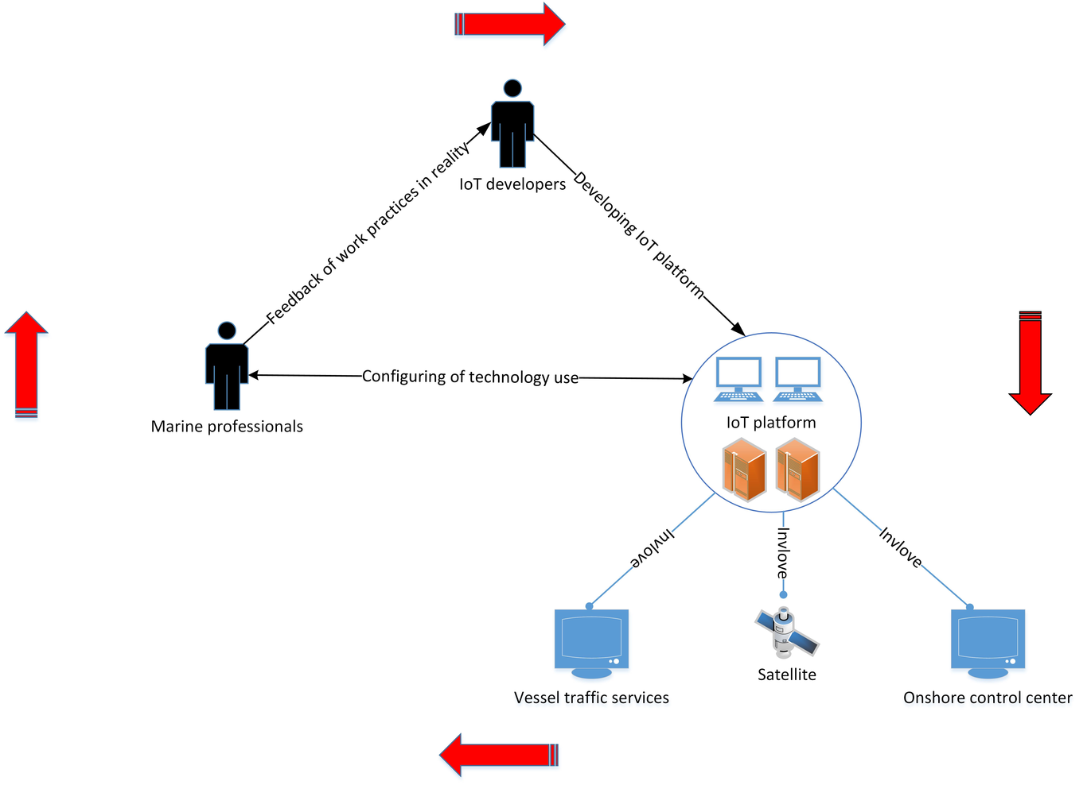
Actors in the loop.
In Fig.1., the HITL model is extended to link the performance of IoT platform with marine professionals. Such link also enables marine professionals to provide feedback to the IoT developers. In ANT aspects, marine professionals, IoT developers and IoT platform (including vessel traffic services, satellite, and onshore control center) are all actors. The feedback of work practices, in reality, can be gained and translated into development process through trained field workers [20], [59]. The work practices of marine professionals can be learned through how they configure technology use regarding their experiences. This is important to bring back their domain knowledge on how an IoT platform should be designed useful to them. In such case, IoT developers as users could benefit how to design a useful IoT platform. Every actor in the loop knows what is important to himself/itself. IoT developers can implement IoT platform with their professional skills. Marine professionals can offer their knowledge and experiences to enable IoT developers to design the IoT platform useful. IoT platform can illustrate errors, performance and special efficacy to marine professionals in their work practices. All these actors play roles to make the loop functional and executable. Although the interests of actors are different, the goal of the loop is straightforward – to enable the IoT platform useful. Hence, it will be easier to identify how to implement such a platform.

Configuring of trust between users
In the maritime domain, the offshore control center is used to remotely control the automation ships at sea. Thus, the trust must be established between actors who are in the loop of unmanned ship system. In 2011, the International Maritime Organisation’s sub-Committee on Radio Communications and Search and Rescue (COMSAR) decided “that the navigator should be kept in the loop as a navigating navigator [60].” It is important to notice that which actors are in the loop and how the trust is established (see Figure 3).

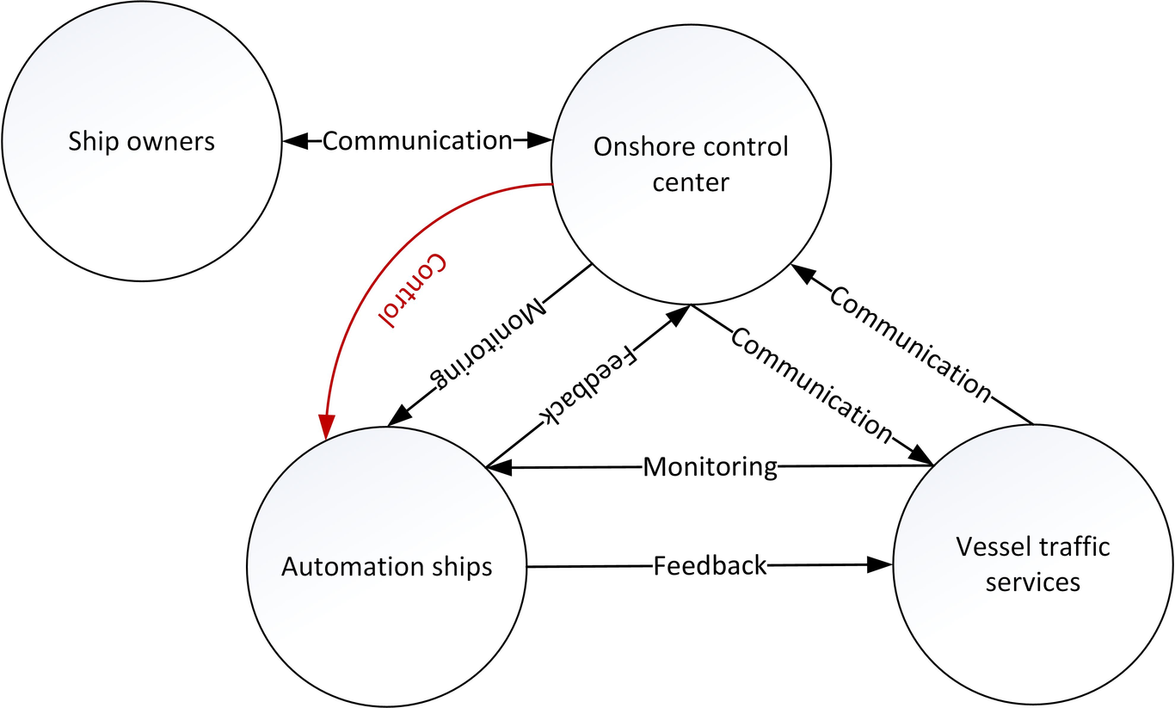
Configuring trust in actors-in-the-loop
Establishing trust is not just a process of how onshore control center should believe the good the automation ships can perform at sea. In his paper <The ‘problem’ of automation: Inappropriate feedback and interaction, not ‘overautimation’>, Norman advises that automation is at an intermediate level of intelligence. It is powerful enough to take over control that which used to be done by people, but not powerful enough to handle all abnormalities [61]. To offer a powerful automation, providing appropriate feedback that occurs among actors is essential. For example, in Figure 3 automation ships could maneuver themselves at sea. However, such auto-maneuvering should provide feedback to the onshore control center as well as enable people in the onshore control center to monitor important information regarding communicate with ship owners and vessel traffic services. Also, automation ships also need to be monitored by the vessel traffic services due to the busy traffic at sea, coastline, and harbor. In this manner, both onshore control center and vessel traffic services may share the same data regarding the automation ships and offer a chance for ship owners to make decisions.
From an ANT point of view, all actors now speak out their concerns regarding the automation. Both vessel traffic services and onshore control center need to monitor the automation ships. Automation ships need to maneuver regarding the planned tasks. Ships owners concern the efficacy of the planned tasks as well as the status of automation ships. However, the actors-in-the-loop has the same goal – the safety of the vessel. Trust is established and configured through the interactions among different actors through several means – monitoring, communication, and feedback. Thus, this dynamic establishing and configuring process enable automation, and human (navigator) shift their roles in the control of automation ships by allowing onshore control center to control the vessel if necessary. This can avoid onshore control center or vessel traffic services lose awareness during the monitoring behavior and mistakenly trust the automation. In such manner, it is important to introduce how to implement the actor-in-the loop when designing an IoT platform.

Implementation of actor-in-the-loop
ANT enables each actor to speak out interest and adjust such an interest to meet the other interests of other actors in the same loop to make the IoT platform useful. As a multidisciplinary field, IoT development is more than pure engineering work. It requests a systematic way to enable academic outcomes, such as methodology, theory, and method from the other field also can contribute to the development process. Thus, the implementation of actor-in-the-loop, therefore, should focus on three important points.
It is important to identify firstly who is an actor in the IoT platform. In this maritime project, the actors as discussed are marine professionals, IoT platforms (including Vessel traffic services, satellite, onshore control center), automation ships, and ship owners. All these actors together established the actors-in-the-loop for enabling the remote control of automation ships successful.
Second, it is important to investigate the interest of each actor. This requests trained field workers to engage with different actors to observe, interview, and note the important issues for the design process of IoT platform. For example, Sharp et al. [20] present the importance of fieldwork that can help developers to identify central requirements for development and control the quality of the software systems. In line with this, we assert that marine professionals can elaborate the most important information for their work practices. With that information, it is not difficult for developers to decide how to choose relevant technology to display information for relevant actors. Further, it is not difficult to decide which sensor should be used. Thus, it is possible to design the onshore control center to remote control the automation ships as a useful and important part of the IoT platform for the automation purpose in the maritime domain.
Third, it is important to investigate the dynamics of actors-in-the-loop. Trust is established through the adjustment of different interests of actors in the loop. However, to bear in mind that each actor has its interest. Thus, it is vital to show up when, where, and how different actors establish trust in the loop of actors to arrange most suitable sensors, technologies, and devices to support such trust in the IoT platform. In this case, the IoT platform becomes not only a collection of hardware and software tools but also has a sense-making process of collection those tools for a useful purpose. In this manner, the development process of IoT platform can be sustainable. That is we might less waste hardware and software in the development process if the people who use the IoT platform refuse or dislike the results which the HITL model provided – or we call it maritime work through an imagination by IoT developers.
To summarize, the development of IoT is a process to develop an information space for the different field to contribute together [62], [63]. This requests several different roles be involved, such as ethnographer, systems developers, project manager, and project owners and so on. Thus, the development process of IoT is a process of sense-making of the sociotechnical solution to support technical work of end-users in their working context. Therefore, it is needed to elaborate how to design artifacts in the IoT platform.

Discussion

Subject, object, and interactive relations in IoT development
A successful IoT development requires a focus on material and nonhuman actors as constituent elements of the social and technical, and in which there is a shift from a focus on ‘epistemology’ (crudely, how is it we can know something) to ‘ontology’ (crudely, what things can exist, or in ANT terms, how are things enacted?). On this score, ANT has been integral to the so-called ‘material turn’ in technology studies.
In tradition, development requirements for IoT platform are based on the work-as-imaged (what we think people do) through developers and requirement specialists. ANT gives an alternative to force us to think about work-as-done (what people do) and collect these pieces of work practices to shape the IoT platform towards as a useful and helpful tool.
If material and nonhuman are artifacts (of course they are), then the social meaning and work practices around those artifacts make the artifact computable and designable [47]. In this matter, the design of IoT platform becomes to investigate how work practices around an artifact connect to other artifacts and make sense of it. Thus, actors can always play in the loop to ensure the social IoT is meaning for the people who use it. It importantly improves the process to use human as subjects for testing and validating purpose [64] but engages the humans who can give voices to the product they are designed for [65]. Moreover, the theory of ANT provides the very idea of the social in IoT has to be interrogated as a construction rather than assumed as an explanan, doing all the explaining in requirement specification in IoT design and implementation.

The combination of social and technical work
HITL has evolved in response to a search for tests that simulation is good. However, it might be too surface to talk about it regarding social studies on science and technology. IoT is an interdisciplinary area. It more than engineering work but also need a full understanding of technology use in social aspects. It is possible to test and validate a HITL model by scoring its outputs. However, it is too early to say that an algorithm is confident for a correct decision.
We must acknowledge how work practices are done with what artifacts for what purposes. This effort go beyond the structure of HITL model and reshape it to scope not only human but also artifact as a network which is non-touchable but can represent the structure of the IoT platform with meaningful social meaning.
In this matter, HITL is about a loop insists of all actors who participate, contribute, and work together for a specific task. This may be the fundamental basis for the IoT development. Through tracing the actors’ roles and attributes in different work practices through time and space, the IoT design and implementation can dynamically support different tasks through time and space.
Schön [66] attributed a situation to the fact that real-world problems present themselves to professionals as messy, indeterminate, and problematic. The challenge, in his view, was not how to solve real-world problems, but how to frame them and construct them. He reasoned that in addition to problems frequently being unique, there are numerous perspectives and ways to interpret and approach the:
Reflecting on the surprising consequences of his efforts to shape the situation in conformity with his initially chosen frame, the inquirer frames new questions and new ends in view. (p. 269)
Researchers draw on a repertoire of knowledge and skills to make sense of problem situations and create candidate concepts and solutions, which are investigated as alternatives. The use of these candidate concepts and solutions depends as much on professional skills and practical experience as on the contingencies of the situation. The solution must match the problem. According to Schön, one is the need to develop meaning-making skills that draw on but are not limited to theoretical and technical knowledge and the other is the need to develop robust, practical inquiry skills so that professionals can understand and resolve unprecedented types of problems not only unprecedented instances of problems.
However, in the field of systems design, the issue is between research and its application [63], architectural research [67], and the use of digital technologies, e.g., in schools [62]. Research and its practice are divided perhaps because the space for action and reflection is not integrated. Design and development require actions that must be sufficiently structured to integrate multiple kinds of collaboration, participation, and construction. In this context, the design study uses paradigms from qualitative and quantitative research to seek an integrated space. In this space, action, and reflection on the use of technology and its design and development should be launched in a double-loop learning process in which researchers and practitioners reflect, act, and offer feedback to each other to make knowledge usable in the field. However, a translator is needed to make this loop work. This paper is a step toward providing a theoretical approach. We assert that this issue will be (or already is) common in the SIoT and its corresponding industrial practices. We claim that researchers must take this responsibility to in facilitating a double loop to produce methodologies for use in society and to reflect on those methodologies for the better support of society.

Section
Nunc a aliquet sem, eget aliquet purus. Vestibulum ac placerat mauris. Proin sed dolor ac justo semper iaculis. Donec varius, nibh sit amet finibus tristique, sapien ante interdum odio, et pretium sapien libero nec massa. In hac habitasse platea dictumst. Donec vel augue ac sapien imperdiet pretium. Maecenas gravida risus id ultricies dignissim. Maecenas gravida felis quis dolor faucibus, sed maximus lorem tristique $e^{iπ}+1=0$

Acknowledgements
Lorem ipsum dolor sit amet, consectetur adipiscing elit. Cras egestas auctor molestie. In hac habitasse platea dictumst. Duis turpis tellus, scelerisque sit amet lectus ut, ultricies cursus enim. Integer fringilla a elit at fringilla. Lorem ipsum dolor sit amet, consectetur adipiscing elit. Nulla congue consequat consectetur. Duis ac mi ultricies, mollis ipsum nec, porta est.

