Template of the memo assignment
Arindam Basu
Instructions: This is a template. I have provided a rough idea or a working script of how to write the memo, so you will find the structure of the memo in here. But use your own ideas to write your own memo on your own topic. This is not a :rigid: structure, rather it is just an indication. It is NOT the best memo out there, as a matter of fact, you should be able to write a better memo. You can either use the Word template I shared on the HLTH214 learn site to write the memo, or you can “fork” this article and write your own stuff and share the article with me. DO NOT EDIT this document. If you want to work directly on Authorea, please let me know, and I will show you how to do it.

Body of the memo
Mr A Councilor
My District
Office of the Environment
Subject: The district needs to frame policies on addressing effects of climate change
Our changing climate patterns, brought about by an increase in the temperature of the globe due to accumulation of greenhouse gases, has health consequences for everyone in the world. I’d like to highlight the global and local issues we have faced in our district and would like to indicate some steps we can take to mitigate the effects of climate change we face.
As early as the turn of the last century (c. 1890s), scientists have warned that an increase in the emission of carbon dioxide and accumulation of carbon dioxide in our atmosphere would increase the surface temperature of the earth. In turn, the scientists claimed that this would trigger melting of the glaciers and rising in the sea levels(Hulme 2009). Indeed, since the 1960s, when the post-industrial revolution era and the impact of the climate change was started to be felt, the pace of climate change has been fast and furious and has put the region of Australasia and Southern Pacific at particular risk of environmental disasters. In particular, the rising levels of ocean, altered salinity of the ocean levels, increased temperature, melting of glaciers, loss of biodiversity and coral reefs, increased frequency of storms and cyclones are some of the environmental factors that threaten not only our region and our country, but also the world in particular with different levels of environmental impacts (Newman 2017) .
As you may know, in 1859, the Irish physicist John Tyndall discovered that carbon dioxide in the atmosphere absorbed the heat and variation in the concentration of carbon dioxide would lead to variation in the gaseous composition of the atmosphere would affect the temperature of the atmosphere (cite). In 1893, the Swedish chemist Svante Arrhenius found that combustion of coal and petroleum was linked with increased temperature of the earth and predicted that increased fossil fuel burning would increase the temperature of earth with consequences (Fleming 2005) . Subsequently, scientists started developing models of what would happen if the global temperature continued to increase. By 1957, it was known that the carbon dioxide concentration of earth’s atmosphere continued to increase and that, the global temperature connected to this increase continued to rise. In 1958, Charles Keeling measured the carbon dioxide concentration in the environment at the Mauna Loa earth station off the coast of Hawaii and found a continuous increase in the carbon dioxide concentration (Harris 2010) (Figure 1)

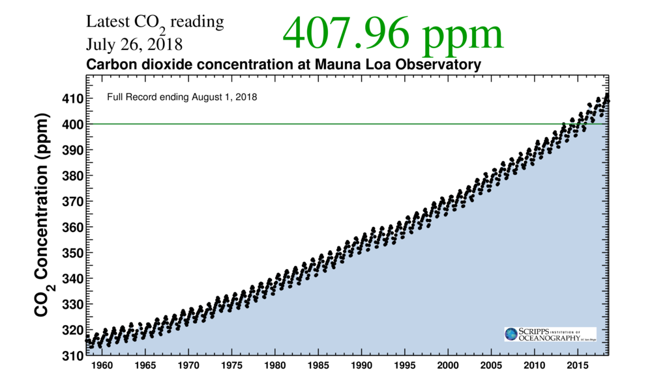
Carbon dioxide concentration in the atmosphere; this is the Keeling curve that shows year-wise annual concentration of carbon dioxide at Mauna Loa observatory in Hawaii. This snapshot is taken from https://scripps.ucsd.edu/programs/keelingcurve/
The rising carbon dioxide from the emission of greenhouse gases have led to increased global temperature and this in turn has resulted in several changes. The glaciers have receded and started melting, the arctic sea ice has been lost, the permafrost has started thawing in parts of the Arctic (Pachauri et al. 2014). In the Southern hemisphere in the Antarctica, the temperature continues to rise; as a result the oceanic volumes have risen; in turn these have resulted in increased frequency of storms and catastrophic cyclones. In the island of Kiribati, due to rise in ocean levels, areas have flooded and the first wave of climate change related refugees have emerged (source: https://www.cbsnews.com/news/climate-refugees-kiribati-cbsn-on-assignment/).
Climate change related events will continue to threaten our biodiversity and the impacts of changes will be felt in our regions as well. In New Zealand, in our district, travel, agriculture, & farming are our main source of economy. Increased temperature has resulted in algal bloom in our lakes and this has resulted in restriction in the use of lakes, leading to loss of tourism (cite). As an island nation in the Pacific, we are open to the storms and natural disasters that can lead to loss of lives. Summers continue to be hot. New Zealand has seen some of the hottest summers in the recent history (Wratt et al. 2004). Heat exhaustion and new patterns of diseases and infections continue to emerge (Patz et al. 2005). Over the next several decades, if the effects of climate change go unmitigated, New Zealand may have to absorb more refugees from other countries. International conflicts cannot be ruled out and will lead to loss of lives. Besides, as tropical climate like situations will prevail, vectors may relocate and we may experience more diseases such as malaria and mosquito or other vector borne diseases as a result of global warming (McMichael, Woodruff, and Hales 2006).
We believe that it is still not too late to respond to the effects of climate change. As New Zealand is a signatory to the Paris accord, all of us who live in New Zealand should share our responsibility to enable New Zealand keep the promise of Paris accord to keep the global temperature within two degree centigrades of the pre-industrial era to avoid what is often referred to as the sixth extinction (Davenport 2015). As we can take individual steps, you, as the leader in our community and in our district, can also enable us to take the steps in the right direction.
We need to be more climate conscious. We should strive to reduce our carbon footprint. At the moment in our districts we lack public transport so that we can reduce our reliance on fossil fuels for our long haul drives to the main city such as Christchurch from smaller towns where many of us live. We need more public transportation and mass rapid transit facilities that are climate friendly. We also need cycleways for shorter commutes. We need awareness to use local produces and boost local businesses so that our reliance on big businesses and grocery chains, their complex supply chain mechanism that adds to fossil fuel burning. We look upon your leadership so that we can become a more climate conscious, environment-friendly society.
Thanking You,
UniversityofCanterbury Student

What to include in the memo?
In the memo:

- Start with the name of the person to whom you will address the memo (this has already been provided) and date the memo.
- Write a subject line (here: “ The district needs to frame policies on addressing effects of climate change ”)
- Write a short introduction to the problem in the first few paragraphs (here, climate change is the problem)
- Add figures, tables, and citations as necessary
- Write a proposed solution to the problem. If you cannot think of a solution, it is OK to write about the problem in depth.
- End the memo with a thanking note, so write something like (“Thanking You” and in the next line your name)
- The last text on the memo will be your Name (use a fictitious name here, do not have to use your real name, that is OK)
- Include the bibliography at the end of the memo.
- Tables and figures must be inserted in the proper place in the text and must be properly titled and labelled.
- Spell check and grammar check your work.
- Put the website URLs directly in the text
- Try to write as non-technically as you can.

Assessment Guide/Rubric

- The memo must look like a memo (a proper address, a title or subject line, an introduction to the problem, a proposed solution, and a call to solution, end with “Thanking You” or a similar thanking quote, and a name of the writer of the memo).
- All facts must be properly cited. Either the student must cite a scholarly source, or a URL, or it should be common knowledge.
- The student must select a topic that is suited to Environmental health, i.e., both an environmental variable and some health consequence should be pointed out.
- Tables must have proper data, headings, and descriptors
- The citation should ideally conform to APA 6th version, but any style is acceptable.
- The paper must be free of grammatical and spelling errors as far as possible.

References
Hulme, Mike. 2009. Why We Disagree about Climate Change: Understanding Controversy, Inaction and Opportunity. Cambridge University Press.
Newman, Todd P. 2017. “Tracking the Release of IPCC AR5 on Twitter: Users, Comments, and Sources Following the Release of the Working Group I Summary for Policymakers”. Public Understanding of Science 26 (7). SAGE Publications Sage UK: London, England: 815–25.
Fleming, James Rodger. 2005. Historical Perspectives on Climate Change. Oxford University Press.
Harris, Daniel C. 2010. “Charles David Keeling and the Story of Atmospheric CO2 Measurements”. ACS Publications.
Pachauri, Rajendra K, Myles R Allen, Vicente R Barros, John Broome, Wolfgang Cramer, Renate Christ, John A Church, et al. 2014. Climate Change 2014: Synthesis Report. Contribution of Working Groups I, II and III to the Fifth Assessment Report of the Intergovernmental Panel on Climate Change. IPCC.
Wratt, D, B Mullan, J Salinger, S Allan, T Morgan, and G Kenny. 2004. “Climate Change Effects and Impacts Assessment. a Guidance Manual for Local Government in New Zealand”.
Patz, Jonathan A, Diarmid Campbell-Lendrum, Tracey Holloway, and Jonathan A Foley. 2005. “Impact of Regional Climate Change on Human Health”. Nature 438 (7066). Nature publishing group: 310.
McMichael, Anthony J, Rosalie E Woodruff, and Simon Hales. 2006. “Climate Change and Human Health: Present and Future Risks”. The Lancet 367 (9513). Elsevier: 859–69.
Davenport, Coral. 2015. “Nations Approve Landmark Climate Accord in Paris”. New York Times 12.

