Solar Energy Harnessing from P(DTP-Ph-NH2)/Cytcohrome C/Thylakoid Membrane Based Photo-bioelectrochemical Fuel Cells
Burak ERTUŞ

In this study, photo-bioelectrochemical fuel cell was constructed for the generation of the electricity by enlightening the electrodes within an aqueous solution. In this purpose, gold electrode was coated with poly 4-(4H-Dithieno [3,2-b:2’,3’-d]pyrol-4-yl) aniline, P(DTP-Ph-NH2) conductive polymer film by using electrochemical polymerization. Then, P(DTP-Ph-NH2) conductive polymer film coated surface was electrochemically modified with cytochrome C which covalently linked onto the surface via bis-aniline functionality of the polymer film and formed crosslinked-structure.The thylakoid membrane was attached on the surface of this electrode by using bissulfosaxinimidyl suberate (BS3) and used as photo-anode in photo-bioelectrochemical fuel cell. The photo-cathode of the photo-bioelectrochemical fuel cell fabrication was followed by the modification of conductive polymer poly[5-(4H-dithieno [3,2-b:2’,3’-d]pyrol-4-yl) naphtalene-1-amine] film coating, glutaraldehyde activation and bilirubin oxidase enzyme immobilization. During the photosynthesis occurring in thylakoid membrane under the light, water was oxidized and separated; while oxygen was released in anode side, the cathode side was reduced the oxygen gas into water via bio-electro-catalytic method. The cytochrome C was used for binding of thylakoid membrane to the electrode surface and play important role for transferring of electrons released as a result of photosynthesis.

Keywords
photo-bioelectrochemical, fuel cell, generating electricity, conductive polymer

Introduction
Photosynthesis is an efficient, sustainable and complex process converting the light energy into chemical energy in fuel cells[1]. In recent years, many studies are carried out on developing the photo-electro-chemical or solar cells mimicking the photosynthesis or implementation of natural photosystems to run the electrochemical cells[2]. Thylakoid membranes and photosystems isolated from plants or cyanobacteria are frequently used as a source for converting the light in to electrical energy. Besides the light conversion, electron transport from reaction centers to the electrode having another important point for the photo-current generation. Efforts have been increased by the researchers to produce enhanced photo-currents using the biological and synthetic materials for the system architecture[3].
Thylakoid membrane is a structure existing in eukaryotic cells and some photosynthetic bacteria and functioning in luminous stages of photosynthesis reactions. Thylakoid membrane has many integral protein complexes functioning in absorbing the light and luminous stage reactions of photosynthesis. Under favor of these protein complexes named Photo-system I (PSI) and Photo-system II (PSII), by using the light energy, the chemical energy (ATP and NADPH) is obtained. The photons reaching the PSI reaction center at different wavelengths raise another electron from here and, under favor of Phylloquinone and Ferrodoxine the electron receivers, it reaches at the NADPH oxidoreductase enzyme. This electron is given to NADP+ molecule and the electron current is ended, and NADPH is formed[4]. As a result of that, the ATP is formed.
In order to satisfy the energy needs in future from solar energy, significant efforts are made in recent years to develop photo-electrochemical cells based on the integration of natural photosynthetic reaction centers. For instance, the photo-currents generated by Photosystem I (PSI) and/or Photosystem II (PSII) when connected to Os complex conducting polymers[5] and hydrogel[6], structures consisting of the integration of multiple surfaces[7] and self-integrated ones[8], p-added silicon[9], bisaniline cross-linked plating nanoparticles[10] and gold nanoparticles[11] have been reported. Many studies that have been carried out on photosynthesis based photo-electrochemical cells have been obtained as a result of extracting the photosystems (PSI and PSII) insulated from thylakoid membrane. The thylakoid membranes, which are used in photo-electrochemical fuelcell systems and can be immobilized via simple methods, allow the electron transfer through various ways. For this reason, they are more advantageous than insulated reaction centers in studies of translating the light into the electrical energy. They can be easily utilized for photo-electrochemical system offering high-efficiency for energy cycle and electricity production[12].
Electrical conductivity of cytochrome C (Cyt C) molecule, which is a molecule that is similar to plastoquinone and plastocynanine conveying electron, has been reported in many studies such as bio-electrocatalitic transformations[13], electrochemical biosensors[14] and biofuel cell production[15]. Under favor of these properties of it, Cyt C can be used as used as active components in the tailoring of biofuel cells. As a functional material the ability to connect proteins[16] to the electrodes allows the production of photo-electrochemical cells that can be formed by using thylakoid membrane. Some of the studies in recent years have shown that Cyt C used in biofuel cell generate the photo-current[17]. Bilirubin oxidase (BOD) is a well known enzyme which oxidizes some natural compounds while reducing O2 directly to H2O. The catalytic activity of BOD is based on the activation of four Cu ions split in the active sites. While one site bind and oxidize the organic compuonds and another site bind and reduce O224. Because of this featured structure it has ability to accept electrons from environment where potentials lower than that of its Cu T1 site[18]. Therefore, BOx is a suitable enzyme for production of biocathodes in biofuel cells applications.
In conductive polymers field that is gradually growing, the syntheses and implementations of conductive polymers having π-conjugated systems have drawn significant attention in recent years. Among the conductive polymers with these π-conjugated systems, the highest level of attention has been drawn by conductive polymers having dithiopenepyrrole (DTP) structure. Dithiophenepyrrole (DTP) is a term referring to the adjacent ring series consisting of two thiophene rings combined to the pyrrole ring. The compounds with p-conjugated systems draw attention of researchers because of their implementations in optic, electronic, and photovoltaic devices, light-emitting diodes, sensors and field-effect transistor properties[18].
Herein, a gold electrode (GE) surface is first coated with poly 4-(4H-Dithieno[3,2-b:2’,3’-d]pyrrole-4-yl)aniline, P(DTP-Ph-NH2) and then Cyt C was cross-linked to bisaniline as a result of electro-polymerization. Finally, thylakoid membranes were cross-linked to the Cyt C via bissulfoaxinimidyl suberate (BS3)(anode). This structure generated high-degree photo-current because of very fast transfer of electrons, which arises as a result of oxidation of water in thylakoid membrane via photosynthesis under the visible light, from thylakoid membrane to electrode. To complete the photo-bio-electrochemical fuel cell, an another gold electrode (used as cathode) is modified by cross-linking the BOx enzyme with poly [5-(4H-dithieno[3,2-b:2’,3’-d] pyrrole-4-yl) naphtalene-1-amine] P(DTP-Naphtyl-NH2). While oxygen will be released as a result of the oxidation of water in the photo-anode of fuel cell, the cathode side will reduce this oxygen gas into water via bio-electrocatalytic method.

Methods

Fabrication of photo-anode for photo-bioelectrochemical fuel cell and photo-current experiments
A P(DTP-Ph-NH2) film covered GE was coated with thioaniline-modified Cyt C via electro-polymerization using 100 mV/s cyclic voltammetry in a potential range of -0.1 V to +1.1 V, performed in 0.1 M phosphate buffer solution. In this electro-polymerization experiment, a graphite electrode (d=5 mm) was used as the auxiliary electrode, and the standard calomel electrode was used as a reference electrode. After the electro-polymerization process, the electrodes were washed with phosphate buffer and treated with 100 μl thylakoid membrane solution. Finally, by treating Cyt C and thylakoid membranes with bis(sulfosuccinimidyl)suberate (BS3) solution (0.001 mg/mL) for 30 minutes, cross-linking between the two materials will occur, and the photo-anode will be completed (Fig. S5).
The photo-current experiments were performed using a solar simulator involving a special photochemical system. This photochemical system consists of 300 W Xe lamp, a monochromator, and a specialized separator. Since the mediator function of the oligoanaline conductive polymeric bridges and Cyt C in the system will accelerate electron transfer, it is believed that high-level photo-current will be obtained when the system is provided with external visible light[5]. In photo-current experiments, the H-type cells presented below were utilized. Examining the system’s kinetics under light in the visible range, the quantum efficiency of the system was computed (Fig. S6).

Fabrication of Cathode Electrode used in the photo-electrochemical fuel cell
Prior to modification gold electrodes were washed with pure water, and then dried at room temperature. Polymerization of 5-(4H-dithiol [3,2-b:2’,3’-d]pirol-4-il)naphtalene-1-amine, DTP-Naphthyl-NH2 monomer onto gold electrodes was then performed using cyclic voltammetry at a scan rate of 10 mV/s in a medium consisting of 5-(4H-dithiol [3,2-b:2’,3’-d]pirol-4-il)naphtalene-1-amine monomer and TBAPF6 (0,1 M)/CH2Cl2. Finally, bilirubin oxidase immobilization was performed in potassium phosphate solution (50 Mm, pH 4.0) containing 2 mg/mL enzyme and 10 µL 1% glutaraldehyde[19] (Fig. S7).

Results and Discussion

Determination of Experimental Variables
In order to understand how photo-current is obtained from a GE/P(DTP-Ph-NH2)/Cyt C/thylakoid membrane electrode, several control experiments were carried out. First, the modified electrode was put into ethanol instead of water, and treated with 6800 W/m2 of light in the visible range of the spectrum, but no any considerable photo-current formation was observed. This experiment revealed that the system is sensitive only to water, and that it generates photo-current through the electron transfer as a result of the photosynthesis-caused oxidation of water. Furthermore, before the whole electrode fabrication, the thylakoid membrane was only immobilized onto the electrode surface and measured the photo-bioelectrochemical activity.

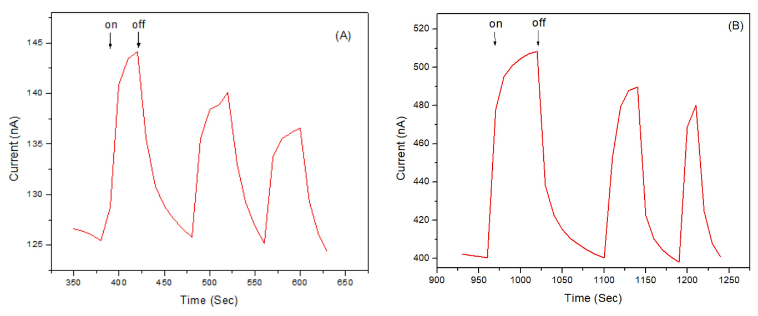
A) The Chronoamperometry (CA) of a thylakoid membrane modified gold electrode (GE) in 10mM pH 7.4 PBS at an applied potential;0V (vs Ag/AgCl) B) The CA of P(DTP-Ph-NH2)/ membrane modified gold electrode in 10mM pH 7.4 PBSat an applied potential; 0V (vs Ag/AgCl).

The Fig. 1A shows the photo-current control experiment of the GE coated with thylakoid membrane and a photo current of 18 nA was observed under the illumination of 6800 w/M2 visible range light in 10mM pH=7.4 PBS. From this result, it was understood that, direct electron transfer obtained as a result of the oxidation of water through photosynthesis without using any mediator or a special system accelerating the electron transfer. All the control experiments were performed at 0 V constant potential, and 500 mg/mL thylakoid membrane.
After the GE was coated with P(DTP-Ph-NH2) conducting polymer by using electro-polymerization method for 40 cycles, 500 mg/ml thylakoid membrane film was immobilized onto the electrode. Then the electrode was immediately put into 10mM pH 7.4 PBS and 6800 w/M² visible light was illuminated to the system, under 0 V constant potential. The amount of photo-current was obtained from the system increased up to 107 nA (Fig. 1B). This shows the enhancement of conductivity was achieved by the P(DTP-Ph-NH2) polymer, which was effective on the transfer of electrons.

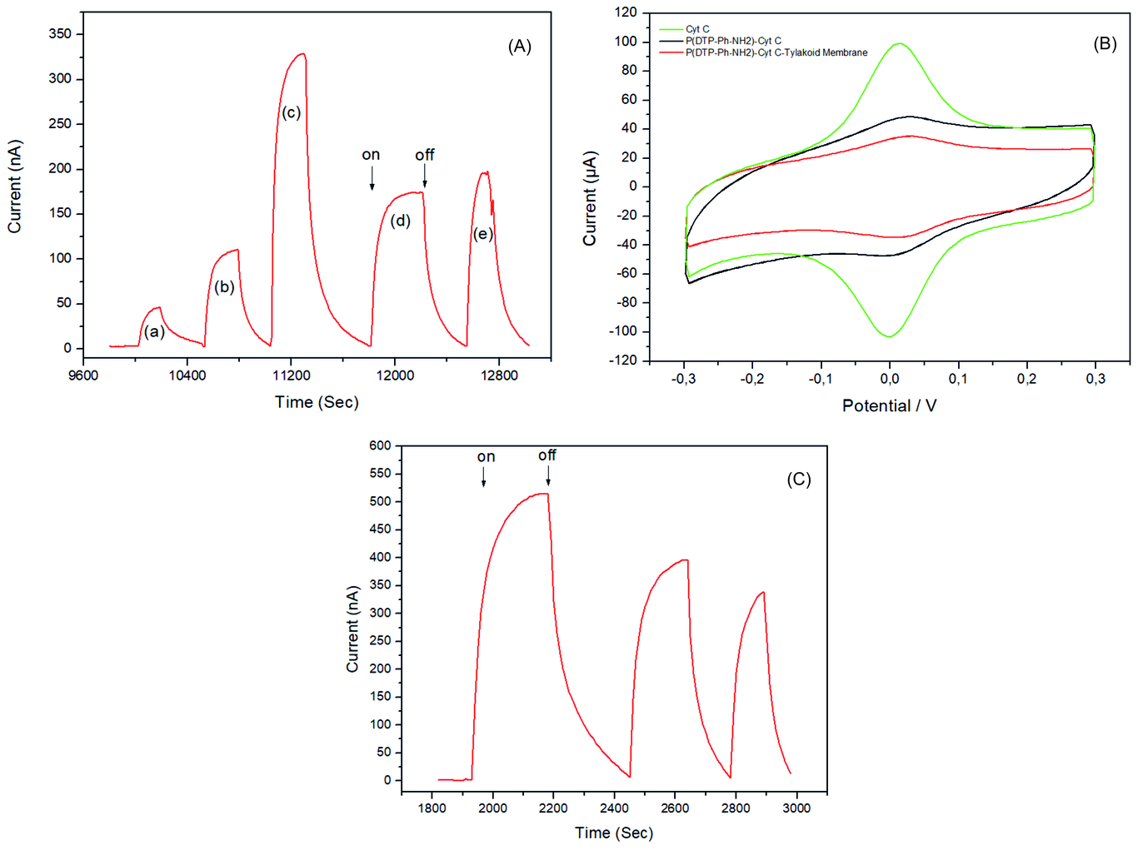
A) CAs of thylakoid membrane modified GE/P(DTP-Ph-NH2) electrodes with different cyclic voltammetry cycles a)20, b) 40, c)60, d)80, e)100 applied for P(DTP-Ph-NH2) polymer coating. B) Cyclic voltammograms (CVs) of Cyt C, P(DTP-Ph-NH2)/Cyt and P(DTP-Ph-NH2)/Cyt C/ thylakoid membrane at a scan rate of 100mV/s in 10mM PBS pH 7.4. C) CA of P(DTP-Ph-NH2)/Cyt C/tilakoid membrane PBS. All CAs were performed upon a cyclic on-off illumination of light at an intensity of 6800 w/M2, applied potential; 0V (vs Ag/AgCl) in 10 mM pH 7.4 PBS.

In order to optimize the P(DTP-Ph-NH2) polymer thickness electrodes were fabricated with polymers having different coating cycles. A significant photo-current of 0.346nA can be clearly observed (highest level of photo-current) from the P(DTP-Ph-NH2) with 60 cycles. When the electropolymerization cycles increase up to 80 and 100 cycles, the decrease in photo-current values were observed. This shows the polymer film has the optimum thickness and conductivity for electron transfer. At the cycles, higher than 60 the polymer film becomes too thick for electron transfer and the sufficient number of electrons cannot be reached to the electrode (Fig. 2A). To increase the photocurrent generation Cyt C was immobilized to the GE/P(DTP-Ph-NH2) electrode before crosslinking the thylakoid membrane by using electropolymerization. The functional properties of the Cyt C,GE/P(DTP-Ph-NH2)/Cyt C and GE/P(DTP-Ph-NH2)/Cyt C/thylakoid membrane have been analyzed by CV. The characteristics of the reversible redox couple Fe+3/Fe2+ in Cyt C molecules well observed (represented with green line) and anodic (Epa) and cathodic (Epc) peak potentials were cleary observed at around 0V, at a scan rate of 100 mV/s. A sharp decrease in the Epc and Epa were observed after modification with polymer (P(DTP-Ph-NH2/Cytc)(shown in black line). A further assembly step continue with thylakoid membrane (shown in red line) caused a decrease in the oxidation and reduction peaks. Formation of the layers have negative effects on the redox potentials of Cyt C, indicating that the blocking the electrical contact with the electrode. However the resulting electrode system, GE/P(DTP-Ph-NH2)/Cyt C/thylakoid membrane, exhibits the sufficient oxidation and reduction peaks means that Cyt C molecules are crosslinked and well oriented in the electrode architecture[20].
After that, to evaluate the influence of Cyt C on the electron transfer pathway CA measurements are performed (shown in Fig. 2C). The use of Cyt C as an electron shuttle between the electrode and thylakoid membrane enhances the amount of obtained photo-current increased up to 550 nA. This result indicates the not all previously immobilized thylakoid membranes are in electrically contact with the electrode before the immobilization of Cyt C. The immobilization of Cyt C molecules increase the amount of thylakoid membranes electrically connected with the electrode[21].
One of the studies on the characterization of the GE modified with P (DTP-Ph-NH2) /Cyt C /Thylakoid Membrane is the study on the optimization of the number of cycles for binding the Cyt C to the polymer film. In this optimization study, after coating the GE with P(DTP-Ph-NH2) polymer by using 40 electro-polymerization cycles, the aniline-functionalized (100 mM) Cyt C was attached on conductive polymer film through oligoanilin bonds by using 20, 30, 40, 50, 60, 70 and 80 electro-polymerization cycles. After binding 500 mg/mL thylakoid membrane, the CA measurement of modified electrodes with P(DTP-Ph-NH2)/Cyt C/thylakoid membrane were performed and different amounts of photo-currents were obtained upon a cyclic on-off illumination of light at an intensity of 6800 w/M2, applied potential; 0V.

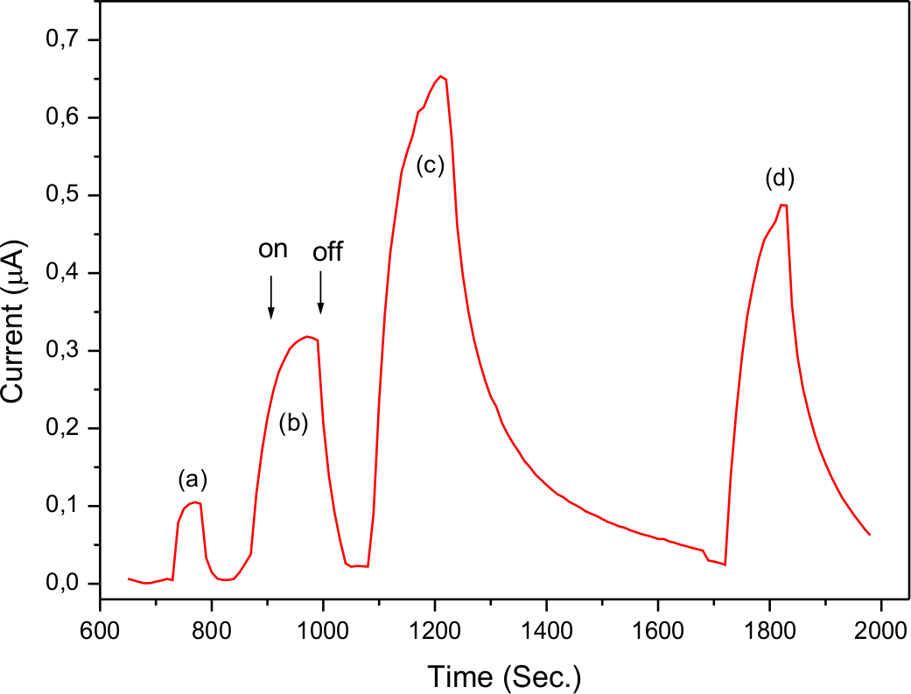
The CAs of thylakoid membrane modified GE/P(DTP-Ph-NH2)/Cyt C electrodes, with different cyclic voltammetry cycles (a) 20, (b) 30, (c) 40, (d) 50, (e) 60, (f) 70, (g) 80 applied for the Cyt C, in 10mM pH 7.4 PBS upon on-off illumination of visible light at an intensity of 6800 W/m2, applied potential; 0V (vs Ag/AgCl).
As the number of electro-polymerization cycles used in order to bind Cyt C onto the polymer film increased, the amount of photo-current observed also increased. These trends continued up to 60 cycles, and after 60 cycles, this increase in photo-current tend to stop. The increase in photo-current until 60 cycles can be explained by the increase in the amount of Cyt C, which consequently induces an increase in electron transfer. In addition the number of Cyt C led to increase the connection of thylakoid membranes with the electrode and this leading to increase photo-current. On the other hand, the reason photo-current reaches a saturation point, even though Cyt C is increased up to 70 and 80 cycles is thought to be related to the rapid increase in complexity of transfer paths in parallel with the increase in number of Cyt C as well as the increase in the number of cycles and consequently the decrease in conductivity and electron transfer speed. In this optimization experiment, the optimum number of cycles to bond Cyt C was determined to be 60 (Fig. 3).
Another characterization study of GE modified with P(DTP-Ph-NH2)/Cyt C /thylakoid membrane structure is the optimization of the amount of thylakoid membranes used in the execution of photosynthesis. In all of the photo-current characterization studies to date, 500 mg/ml thylakoid membrane has been bonded to gold electrodes modified with P(DTP-Ph-NH2)/Cyt C, and photo-current measurements were performed. In this optimization study, the P(DTP-Ph-NH2) polymeric film prepared by using 40 electro-polymerization cycles were obtained first. Then, the aniline-functionalized (100 mM) cytochrome-c solution was bonded to polymer-coated film through oligoaniline bonds using electro-polymerization at 60 cycles. Solutions containing 250, 500, 750 and 1000 mg/ml thylakoid membrane were immobilized on electrodes coated with P(DTP-Ph-NH2)/ Cyt C. Under 0V constant potential, 6800 W/m2 visible range light was applied to the system, and the photo-current measurements were performed in PBS.

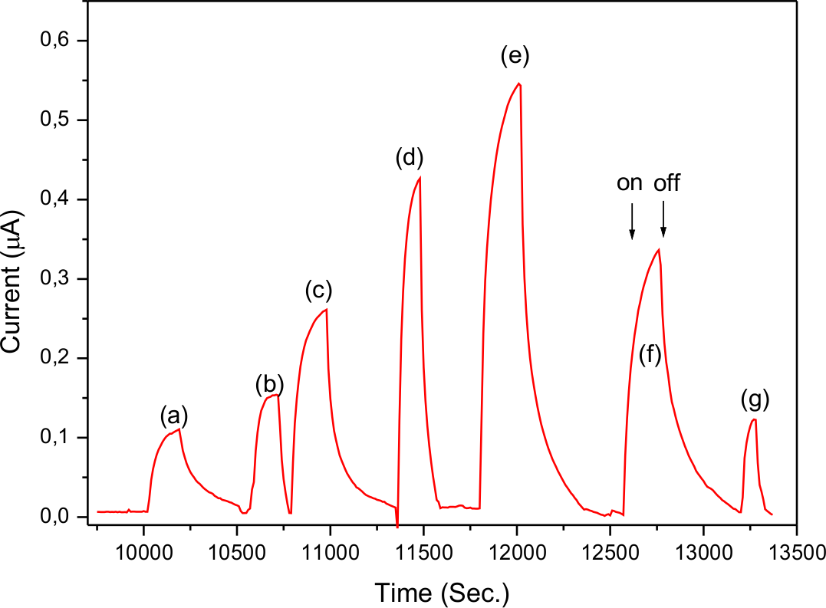
The CAs of different concentration of Thilakoid membrane (a)250 mg/mL, (b)500 mg/mL, (c) 750 mg/mL, (d) 1000 mg/mL) modified P(DTP-Ph-NH2)/ Cyt C electrodes in pH 7.4 PBS upon an on-off illumination of visible light at an intensity of 6800 w/M2, applied potential; 0V (vs Ag/AgCl).
An increase in photo-current was observed up to a concentration of 750 mg/ml. It was observed that the photo-current values decreased after 750 mg/ml. The reason for this was determined to be the increase in thylakoid membrane concentration, which thickened the bio-component surface blocking the transfer towards the electrode of electrons generated as a result of water’s oxidation with photosynthesis (Fig. 4). Thus, 750 mg/ml was determined to be the optimal concentration level of thylakoid membranes to be used for photo-anode design.

Conclusion
In this work, we have exibited the generation of an enhanced photo-current from the novel electrode system based on the construction of a conducting polymer (P(DTP-Ph-NH2)). In the electrode arhitecture layer by layer production method was followed; ploymer, Cyt C, thylakoid membrane and fully crosslinked and stable structure was obtained. CV studies have been performed for the assembly of elctrodes in order to find out the system generates highest photo-current. One of the prominent features of the system is that the materials used such as concducting polymer and Cyt C can be easily monitored by the CV during the assembly of the electrode. CA studies to demonstrate the effect of P (DTP-Ph-NH2) polymer reveal that the photo-current obtained from the electrode using polymer is almost six fold greater than the electrode without using polymer, indicating that the polymer is highly effective in electron transfer. Another distinctive point in achieving enhanced photo-current is that the use of Cyt C in the electrod acrhitecture. Because the results clearly shows that the highest photo-current measured from the electrodes having Cyt C (optimum coating cycle: 60) compared to the other electrodes (without Cyt C). Since Cyt C is a natural protein, it serves a very suitable surface for the attachment of thylakoid membrane. It also functions as an electron-transporting protein because of its unique structure having iron complex. Furthermore, it is understood from the photo-current values that Cyt C actively binds more thylakoid membrane to the electrode surface. On the other hand, O2 is released after photosynthesis in thylakoid membrane quickly converted to water molecules by the BOD enzyme located on the cathode surface, resulting in a cyclic photo-bio-electrochemical fuel cell. This system shows the importance of generation high efficiency from artificial fuel cells; good electrical communication and the use of natural compponents. At the same time, in such bio-hybrid systems, the platform for the development of photo-current (light dependent) well-organized electrodes produces high photo-bio-electrochemical compounds.

Discussion
This should explore the significance of the results of the work, not repeat them. Avoid extensive citations and discussion of published literature. A combined Results and Discussion section is often appropriate. The Results and Discussion should deals with the interpretation of the results in the light of previously published findings.

Acknowledgements
Collate acknowledgements in a separate section at the end of the article before the references. List here those individuals who provided help during the research (e.g., providing language help, writing assistance or proof reading the article, etc.).

