Ambient air quality and the risk of acute myocardial infarction among urban dwellers in Fiji
Josefa B Tabua
University of Canterbury
Arindam Basu
University of Canterbury
Peyman
University of Canterbury
Ambient air pollution isa major environmental health risk factor and globally, it is estimated that at least seven million deaths are attributable to the effects of air pollution on an annual basis. In developing countries in the Western Pacific Region such as Fiji, major sources of air pollution are from the exhaust emissions from motor vehicles, burning of wastes and industrial activities. Countries in this region are also experiencing an intense process of urbanization resulting in the increasing number of vehicles on the road together with a vibrant agricultural practice that often leads to an increased burning of wastes. Despite these known sources of pollution, there is no evidence-based data delineating the relative contribution of these pollution sources in Fiji.
Epidemiological studies have shown that increased emissions from motor vehicles and industrial activities are associated with an increased risk of developing cardiovascular diseases. Cardiovascular disease is quite common in Fiji and in 2016, ischaemic heart disease which includes heart diseases such as angina and myocardial infarction was ranked as the second most cause of all premature deaths in Fiji. To get a basic understanding of how air pollution may affect the cardiovascular health in Fiji, this study will attempt to investigate the association between air pollution and acute myocardial infarction hospitalisation in the city of Lautoka.
Subsequently, a meta-analysis of the literature on the association between air pollution and acute cardiovascular infarction will be conducted and the risk estimates from the selected studies summarized. Values on the criteria pollutants from these selected studies will be obtained and based on the pooled risk estimates and the exposure assessment, a risk assessment of air pollution for heart diseases will then be conducted.

=1

Introduction

Background
Outdoor air pollution is a major environmental health risk affecting everyone in developed and developing countries alike . Recently, a new model on air quality designed by the World Health Organization (WHO) estimates that 92% of the world’s population live in areas that exceed the WHO air quality limits. The World Health Organization (WHO) suggests that the pollution (indoor and outdoor) of the air we breathe is probably the most significant environmental problem that we are facing today and in most instances from human activities such as inefficient modes of transport, household fuel and waste burning, coal-fired power plants, and industrial activities (WHO 2018) . However, there are also natural causes of air pollution such as volcano eruption and wildfires but their occurrence is rare and its effect is often localized as compared to the effects caused by air pollution from human activity (EPC 2017).
The common cause of ambient air pollution are emissions caused by combustion processes from motor vehicles, solid fuel burning and industry. Most of these emissions contain a heterogeneous mixture of pollutants such as particulate matter, ground-level ozone, carbon monoxide, lead, sulphur oxides, nitrogen oxides and is of great concern because of their effects to the environment, animals and humans. These pollutants have been classified by the USEPA as criteria pollutants because their source of emissions is diverse and widespread, therefore, guidelines have been established to regulate their permissible levels.
The harmful effects of ambient air pollution on human health have been consistently documented by many epidemiological studies worldwide, and it has been calculated that globally at least seven million deaths are annually attributable to the effects of air pollution(Mannucci and Franchini 2017). The World Health Organization ranks air pollution as the 13th leading cause of mortality worldwide and recent studies have shown a deeper and more complicated relationship. Exposure to air pollutants can affect human health in various ways, leading to increased mortality and morbidity and in most cases a shortened life expectancy. Health effects of ambient air pollution ranges from increased hospital admissions and emergency rooms visits to increase risk of premature death(WHO 2018). Recent studies have shown that there is growing and evolving epidemiological evidence on the health effects of ambient air pollution(USEPA 2009). The World Health Organization suggests that outdoor ambient air pollution is responsible for some 72% premature deaths worldwide and in 2012, it was estimated that 3 million premature deaths from cardiovascular, respiratory disease and cancers in cities and rural areas were caused by ambient air pollution and in particular exposure to particulate matter of 10 microns (PM₁₀) or less (WHO 2016). From these premature deaths 87% were from low- and middle-income countries with the greatest burden being in those countries in the WHO Western Pacific and South-East Asia regions.
Most of the countries in the Western Pacific Region are developing nations that are experiencing an intense process of urbanization and industrial development, hence, the burden of air pollution-related health effects is large (Mannucci and Franchini 2017). WHO estimates that about 3 billion people in developing nations rely on firewood and charcoal for cooking and other domestic uses, hence, they are continuously exposed to smoke-induced illnesses especially amongst children and the elderly. The latest burden estimates reflect the very significant role air pollution plays in cardiovascular illness and premature deaths – much more so than was previously understood by scientists.
Urbanization leads to increased number of vehicles on road and as a result, increased vehicular exhaust: both agricultural and rapid industrialization leads to burning of wastes and emissions criteria of criteria air pollutants.
The Republic of Fiji is one of the developing nations nestled in the south pacific and the emissions from vehicles, burning of wastes and industrial sources are considered to be major contributors to air pollution in the city of Lautoka; however, there is no evidence-based data delineating the relative contribution of these sources(Isley et al. 2017). General public complaints data indicate that air pollution is a significant community concern for most urban communities in Fiji(of Env 2013). Recent studies by (Isley et al. 2017) on air pollution in urban areas in Fiji have shown that PM_{2.5} are generally within the WHO guidelines but the black carbon (BC) in PM_{2.5} are high compare to population size. Furthermore, the Ministry of Health and Medical Services 2015 annual report states that coronary heart diseases is the leading cause of death in Fiji, hence, health implications of air quality warrants investigation.
This study will attempt to highlight the epidemiological importance of recognizing the effects of ambient (outdoor) air pollution in cities in developing countries and for this research the focus will be on the city of Lautoka in the Republic of Fiji. More so, the study will add to the existing body of knowledge on ambient air pollution within a specific period of time and related health effects on hospital admissions and emergency department visits from cardiovascular illnesses. Specifically, the study will focus on the population being admitted to hospital or visited the emergency department as a result of acute myocardial infarction.

Description of study area
Fiji’s urban population reached 494,252 in 2017, an increase of 69,406 (16.3%) compared to 2007 (FBoS 2017). The count shows that 55.9% of Fiji’s population live in the Urban Areas, an increase of 5.1 percentage points compared to 2007. The population in the urban areas as shown in Fig. 1 is increasing at a rate of 0.6 percent since 2007 and from this urban population the city of Suva accounts for a population of over 87,000 people and is about 175,000 people when including the suburbs (FBoS 2018). Apart from Suva, the city of Lautoka is the second largest city of Fiji. As shown in Fig. 2, the city is located in the west of the island of Viti Levu, 24 kilometres north of the town of Nadi where Fiji’s International airport is located. The city of Lautoka lies in the heart of Fiji’s sugar cane growing region and is also known as the sugar city in Fiji. Lautoka city covers an area of 16 square kilometers, has an estimated population of 52, 500 and is home to Fiji’s largest sugar mill(History, n.d.).

The table show the population distribution in Fiji between 1976 and 2017. Source: Fiji Bureau of Statistics
Census Year | Population | Annual Growth Rate (%) | Median Age (years) | Urban | % | Rural | %
1976 | 588.07 | 2.1 | 17.8 | 218495 | 37.2 | 369573 | 62.8
1986 | 715375 | 2 | 20.6 | 277025 | 38.7 | 438350 | 61.3
1996 | 775077 | 0.8 | 21.2 | 359495 | 46.4 | 415582 | 53.6
2007 | 837271 | 0.7 | 25.1 | 424846 | 50.7 | 412425 | 49.3
2017 | 884887 | 0.6 | 27.5 | 494252 | 55.9 | 390635 | 44.1

The ethnic distribution for the population of Lautoka consists of the indigenous Fijians which accounts for 43%, Indians of Fijian descent accounts for 45% of the population and people from other ethnic background make up the remaining 7%. As the second largest city in Fiji, most industries and commercial enterprises in the Western side of Fiji is located here such as timber milling, pine chips, breweries, oil/ghee refining factory, aerated water & juice factory, concrete industries, soap factory, engineering & steel workshops, flour mills, bakeries etc.

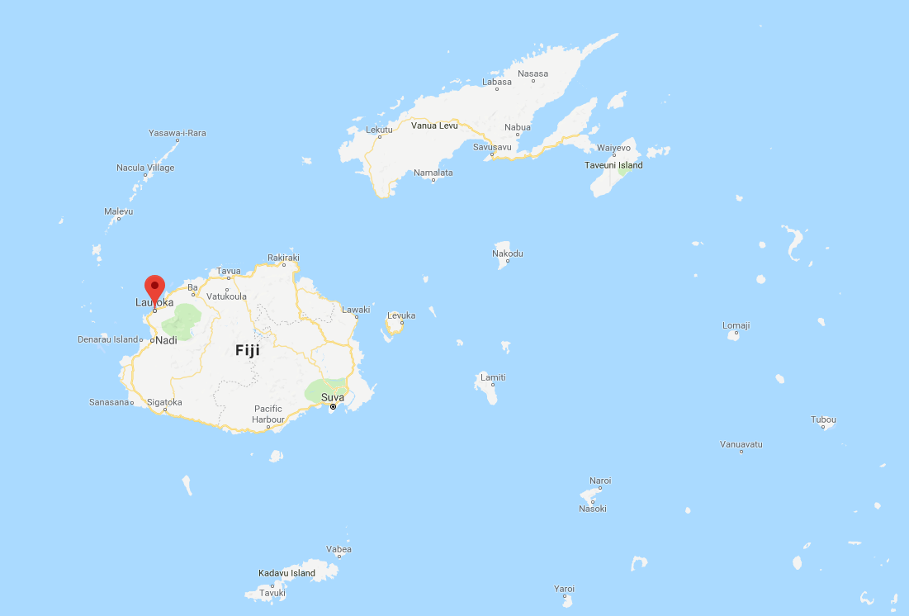
This figure shows the location of the city of Lautoka in Fiji which is located on the west side of the island of Viti Levu Source: Google Maps

Research Question
What is the effect of air pollutants on hea diseases?

Hypothesis
Null hypothesis: The hospital admission rates for those with and without exposure to air pollution is similar.
Alternate hypothesis: Those who are exposed to high level of air pollutants are more likely to get admitted to the hospitals with acute myocardial infarction diagnoses

Aims
The aim of this study is to gather ambient air quality from the city of Lautoka within a three months period and using appropriate statistical methods to compare the air quality data with recently published studies on ambient air pollution and the risk of acute myocardial infarction.

General Objective
To determine the level of air contaminants within the city of Lautoka and the potential effects it may have on the cardiovascular health of its urban population.

Specific Objectives
The specific objectives of this study are as described below:

- To assess the air quality in the city of Lautoka
- To conduct a meta-analysis of the association between air quality and hospital admissions due to acute myocardial infarction in Lautoka
- To predict hospital admissions due to acute myocardial infarction in Lautoka based on air quality data and estimates from the meta-analysis

Literature Review

Brief History of Air Pollution
Before the Industrial Revolution
Air pollution can be traced back to the tribes in early history whereby they lived nomadic lives in order to move away from the stench of animal, vegetable and human waste they generated. These early tribesmen also learned to use fire and this new knowledge was quite important in their daily lives and often its usage would fill the inside of their living quarters with the products of incomplete combustion. Examples of these can still be seen in some of the primitive parts of the world and later on, the invention of chimneys removed the combustion materials and cooking odours from the living spaces.
In the bronze and iron ages, the principal industries associated with the production of air pollution such as dust and fumes were from metallurgy, ceramics and preservation of animal products. These industries were responsible for the baking of clay for pottery and bricks before 4000BC and the production and use of iron before 1000BC. During this period, people relied on charcoal rather than coal or coke as a source of fuel(Vallero 2008). However, the burning wood in fireplaces inside homes created emissions that were smoky and in AD 61 Roman philosopher Seneca mentioned that, “ As soon as I had gotten out of the heavy air of Rome and from the stink of the smoky chimneys thereof, which, being stirred, poured forth whatever pestilential vapors and soot they had enclosed in them, I felt an altercation of my disposition” (Vallero 2008).
Later on in 1157, Eleanor of Aquitaine, the wife of King Henry II of England moved away from Tutbury Castle because she deemed burning wood as unendurable. A hundred and sixty years later the burning of coal was prohibited in London but in 1306 Edward I issued a Royal proclamation authorizing the use of sea coal in furnaces. By 1661, air pollution in London was a huge problem that prompted John Evelyn to advise the parliament and King Charles II on the quality of air in London with possible remedies to control air pollution and these remedies are still relevant in the 21st century (P.J.B. 1956).

The Industrial Revolution
The Western civilization embraced the industrial revolution because it brought prosperity, social changes and it also altered the directions. However, it’s downside was the industrial reliance on coal as an energy source and the severe air pollution that accompanied this(Air Pollution and Health 1999). The harnessing of steam to provide power to move machinery and pump water began in the early years of the 18th century and culminated in 1784 in Watt’s reciprocating engine which was later displaced by the steam turbine in the twentieth century (Fundamentals of Air Pollution 1994). As a consequence of this revolution, there was a lot of pollution from the smoke and ash from the burning of coal in the boiler furnaces of stationary power plants, locomotives’ home heating fireplaces and furnaces. In 1819, Great Britain took the initial steps to address the problem of air pollution and by 1856 laws specifically for London were introduced to reduce the impending problem and deemed the emission of smoke as a public health nuisance (Beaver 1955). In 1880, The United States of America developed municipal ordinances and regulations targeting the emission of black some and ash from industrial, marine and locomotive sources. Despite the introduction of new laws to curb the emission of smoke and ash in major industrialized countries, air pollution was at its worst as the 19th century drew to a close.

The 20th Century
In the early 1900s, there was still a reliance on the use of coal but technological advances such as the replacement of the steam engine with the electric motor was a major breakthrough. Towards the end of the first quarter of this century, the use of coal had been taken over by pulverized coal, oil and gas but each one of them produced its own characteristic emissions to the atmosphere. During this period there was a decrease in ash emissions as oil had replaced the use of coal, and as a consequent, there was a significant increase in the production of automobiles. In addition, the perfection of the motor driven fan together with the invention of the electrostatic precipitator allowed the establishment of large scale gas treating systems and the control of particulates more feasible (Vallero 2008). The period 1925 and 1950 saw the emergence of the present day pollution problems such as the Meuse Valley smog in 1930 which killed sixty people as a result of a combination of air pollution and climatic conditions (Firket 1931). In 1948, an air inversion episode similar to that shown in Fig. 2 ( arrows show airflow in normal conditions on the left and during temperatures inversion on the right. In normal conditions, warm air rises and normal convective patterns persist. During a temperature inversion, the warms air acts as a cap, effectively shutting down convection and trapping smog over a city) and known as the Donora Smog occurred in Donora, Pennsylvenia which resulted in a wall of smog that killed almost forty people and left nearly half of the town’s 14,000 residents experiencing severe respiratory or cardiovascular problems (USEPA 2017). An air inversion is an event in which air stops circulating and is trapped close to the ground. The combination of trapped toxic gasses and early morning mists yields disastrous effects. Another incident was in Poza Rico in Mexico whereby twenty two people were killed and three hundred people hospitalized as a result of an accident release of hydrogen sulfide (H₂S) from a natural gas plant in the city (Yu 2001). The city of Los Angeles also experienced the effects of smog in the 1940s as a result of the influx of cars and industries, combined with a geography that traps fumes.

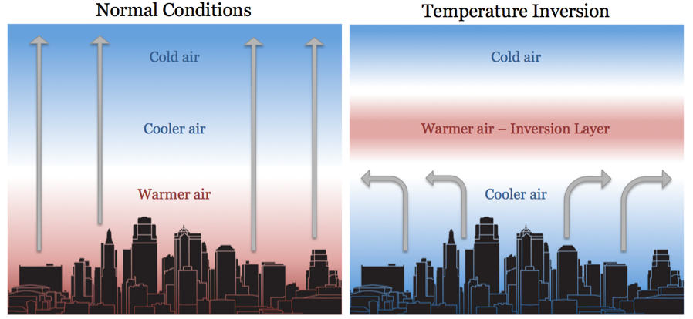
This figure shows what happens during a temperature inversion. Source:understoryweather.com
Towards the end of the first half of this century, major technological advancement and changes were made in major industrial countries like the United States and Great Britain. A good example was in Pittsburgh, Pennsylvania whereby the use of coal and oil as home heating fuel was substituted with the use of natural gas. In addition, was the displacement of steam locomotives and replaced with diesel locomotives. Despite the growing problem of air pollution, no country in the world adopted any air pollution laws to try and mitigate harmful emissions in this period, nevertheless, the state of California adopted the first state air pollution law in the United States.
The period between 1950-1980 was marked with a major pollution disaster in Great Britain in 1952 which was later known as the ‘Great London Smog’. During this period coal was used as the main source for generating power and heating homes in London and it was unfortunate that on this particular day, 5th of December 1952, a high-pressure weather system had stalled over southern England and caused a temperature inversion. For five days, a heavy fog combined with smoke formed from the fumes of vehicle exhaust and power plants created a public health disaster which resulted in an estimated 8,000 to 12,000 deaths(Klein 2012). The impact of the ‘The Great London Smog’ provided the impetus and will for effective air quality regulations which was enacted in the Clean Air Act of 1956. This legislation ensured that the market provided cleaner fuels for homeowners and phasing out coal in most urban areas. In addition, power stations located close to residential areas were closed and height of chimneys was regulated so that pollutants can be blown away by the wind (PopulationMatters, n.d.).
Large cities in almost all countries in Europe including Australia, New Zealand and Japan were experiencing high air pollution levels during this period and as a result, these countries were the first to create national air pollution control legislation. Cities in the United States continued to experience the smog problem; as a result, the first federal air pollution laws came in to effect in 1955 which supported research in air pollution, training and technical assistance (Fundamentals of Air Pollution 1984). Later in 1970, the United States Environmental Protection Agency (USEPA)came into existence and with the mandate of having federal authority and responsibility in the control of air and water pollution and other hazards that may be detrimental to the environment and health.
During this 30 year period, a lot of interest was on air pollution created by automobiles and how to control it, sulfur oxide pollution from flue gases and fuel desulfurization as well as nitrogen oxides produced from combustion (Vallero 2008) . Towards the end of this period, air quality monitoring systems came of age, monitoring systems were available to conduct modelling of atmospheric processes which highlighted the fact that air pollution had become a global concern. In addition, air pollution modelling program also projected that anthropogenic heat and toxic chemicals will become a serious global pollution problem in the future.
Build up of the greenhouse’ gases like carbon dioxide in the atmosphere and chlorofluorocarbons (CFCs) was a concern in the 1970s as it contributed to the depletion of the stratosphere ozone layer and in 1985 CFCs became a major problem after the discovery of the Antarctic ‘ozone hole’ (Elsom 1992). The 1990s saw the emergence of two global environmental crises, the stratospheric ozone depletion and the uncontrolled changes in climate. Central of concern to this crises was the building up of greenhouse gases in the atmosphere and the cooling trends caused by particulate matter and sulphates in the same atmosphere. Subsequently, in the early years of the 21st century, global air pollution has taken on a greater urgency amongst the scientific community and the general public.

Recent Global Ambient Air pollution
Air pollution in the industrialized and developing world has changed drastically since the last century as a consequence of the rapid global population growth (Fenger 2009), moreover, economic development, energy consumption, urbanization, transportation and motorization are other major driving forces of air pollution in major urban cities (Chen and Kan 2008). Nevertheless, the urban environment in the industrialized countries has improved with respect to pollution from sulphur dioxide and soot that is often produced from power and heat production(Fenger 2009). In its 2005 Air Quality Guidelines Global update , the World Health Organization summarized that the PM₁₀ annual average concentrations in European and North American cities were generally lower than 50$μ$g/m³ as shown in Table 2 (WHO 2005). Asia, Africa and Latin America recorded the highest levels of PM₁₀ . SO₂ has substantially declined in the United States and in particular Europe whilst in some Asian cities like Bangkok, Jakarta and New Delhi the low sulfur content in the fuel used there has resulted in the decline in ambient SO₂ levels. Moreover, there has also been a moderate decrease in SO₂ levels in LAtin America and Africa (Chen and Kan 2008).

Ranges of annual average concentrations of PM₁₀ , NO₂, SO₂, and 1 hr average maximum of ozone for different regions
Region | Annual average concentration |  |  | Ozone (1 h maximum concentrations)
 | PM10 | Nitrogen DIoxide | Sulfur dioxide
Africa | 40-150 | 35-65 | 10-100 | 120-300
Asia | 35-220 | 20-75 | Jun-65 | 100-250
Australia/ New Zealand | 28-127 | 11-28 | 3-17 | 120-310
Canada/ United States | 20-60 | 35-70 | Sep-35 | 150-380
Europe | 20-70 | 18-57 | 8-36 | 150-350
Latin America | 30-129 | 30-82 | 40-70 | 200-600
In contrast, (Chen and Kan 2008) suggests that countries in transition have shown that traffic related air pollutants such as NO₂ and SO₃ tend to increase due to the increasing number of motor vehicles. Mega cities such as Beijing, Tokyo, Osaka, New York, Los Angeles and Sao Paulo have recorded NO₂ levels that exceed the WHO air quality criteria of 40$μ$g/m³. Recently, the report ‘State of Global Air/2017’, estimates that for the world’s population (90%) that reside in areas with unhealthy air, 50% of them live in areas where the PM_{2.5} concentrations were above the WHO Interim Target 1 (IT-1 of 35$μ$g/m³) whilst 64% reside in locations exceeding Interim Target 2 (25$μ$g/m³). Almongst the countries that have recorded extreme concentrations (above 75$μ$g/m³) were China, India, Bangladesh and Pakistan as shown in Figure 3. In these countries the sources of this extreme PM_{2.5} concentrations were due to combustion emissions from multiple sources, including household solid fuel use, coal-fired power plants, agricultural and other open burning and transportation and industrial related sources. The lowest concentrations of the annual average population-weighted PM_{2.5} ($≤$8$μ$/m³) were recorded in Finland, Australia, New Zealand, Canada, Brunei Sweden, Greenland and several Caribbean and Pacific Island countries (Institute 2017).

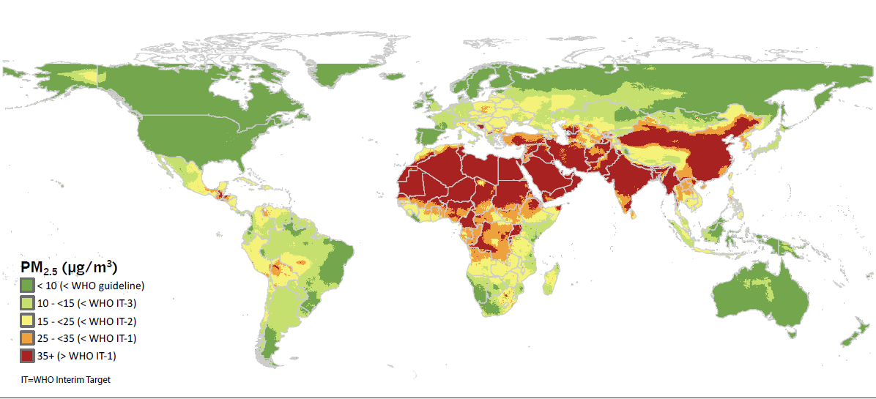
Shows the comparison of Global annual average PM_{2.5} concentrations in 2015 with the WHO Air Quality guidelines. Source: State of Global Air - 2017
Furthermore the report suggests that the global population weighted PM_{2.5} concentrations has increased by 11.2% from 39.7$μ$g/m³ in 1990 to 44.2$μ$g/m³ in 2015 and the rapid increase in the concentrations was significant from the year 2010 onwards as shown in Figure 4. These increases reflects the changes in air pollution levels in some of the most populous countries in the world such as China, India, Bangladesh and those in the European region. The highest increase in PM_{2.5} levels from 2010 to 2015 was experienced by Bangladesh and India whereas countries that are clustered at the bottom of Figure 4 such as the United States, Brazil, Russia, Indonesia and countries in the European Union have seen a slight decrease in PM_{2.5} levels since 1990.
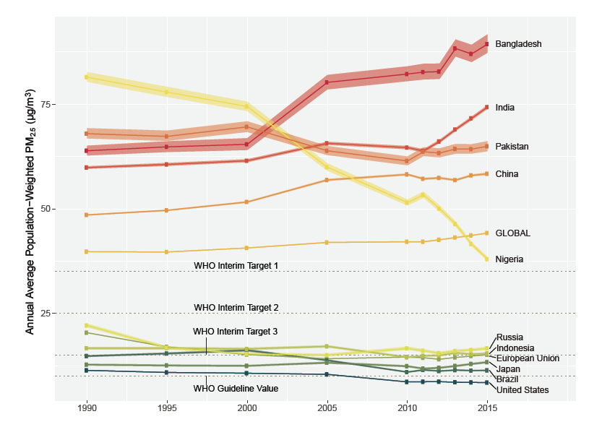
Shows the annual average population weighted PM_{2.5} concentrations in the 10 most populous countries plus European Union
The State of Global Air 2017 report further states that the ozone levels have increased by 7% globally from 1990 to 2015 and is due to a combination of factors. Principal amongst these factors is the increase in emissions of ozone precursors such as nitrogen oxide combined with the warmer temperatures in mid-latitude developing countries such as India, Pakistan, Brazil and Bangladesh. However, the United States and the European Union have noted a decrease in the ozone concentration levels by, 5% and 2% respectively, since 1990 due to air quality management programs that are in place.
The proposed study that will be carried out in the city of Lautoka in Fiji will try to determine the ambient level of criteria pollutants, including particulate matter (PM_{2.5} and PM₁₀) and ozone and make comparisons with the existing WHO air quality guidelines. Such information is critical to ensure that policies are developed and implemented so that necessary air quality improvement steps can be taken if it is warranted.

Air Pollution in Developing Countries
The World Health Organization estimates that ninety-eight percent (98%) of cities in low-income and middle-income countries with more than 100,000 inhabitants do not meet the WHO air quality guidelines. According to a Mr. Marko Tainio an environmental health researcher at the University of Cambridge, " In high-income countries air pollution levels are (in global comparison) lower and getting (slowly) better. In the developing world, especially Asia, concentrations are high and are not improving (in some cases getting even worse). Globally the burden of air pollution is focused on countries like India and China due to combination of high pollution levels and large population” (Post, n.d.).
Modernization has seen a shift from the use of biomass fuel to petroleum products and electricity in developed countries. However, in the developing world households continue to use biomass fuels and according to (Nigel Bruce 2000) poverty is one of the main barriers to the adoption of cleaner fuels and the slow pace of development in many countries suggests that biomass fuels will continue to be used by the poor for many decades. Consequently, women and young children are exposed to high levels of indoor air pollution every day(Gordon et al. 2014).
Majority of households in developing countries use earth ovens and stoves whereby combustion is very incomplete resulting in substantial emissions which may produce high levels of indoor pollution. Indoor concentrations of particles usually exceed guideline levels by a large margin: 24-hour mean PM₁₀ levels are typically in the range 300–3000 mg/m³ and may reach 30 000 mg/m³ or more during periods of cooking (Smith et al. 1994). In comparison, the EPA’s standards for 24-hour average PM₁₀ and PM_{2.5} concentrations are 150 mg/m³ and 35mg/m³ respectively (“NAAQS Table | US EPA”, n.d.). In homes using biomass fuels in developing countries, reports have shown that the mean 24-hour levels of carbon monoxide are in the range 2–50 ppm; during cooking, values of 10–500 ppm. In comparison, the United States Environmental Protection Agency’s 8-hour average carbon monoxide standard is 9ppm mg/m³ (“NAAQS Table | US EPA”, n.d.). These high concentrations of particulate matter and carbon monoxide have shown to be associated with health effects like respiratory illnesses to more adverse effects such as reduced lung function amongst children and exacerbation of chronic obstructive pulmonary disease (Smith 1987).
Even though very limited research has been conducted in the Pacific Island Countries (PICs), it is apparent that these countries share similar air quality concerns such as emissions from transport and burning activities. A recent study in Fiji by (Isley et al. 2017) showed that the ambient PM_{2.5} concentrations in its capital city, Suva, was within the World Health Organization guideline of 10 $μ$m/m³, however, concentrations of black carbon (BC) in Suva were higher than more industrialised cities and comprised of 30% of PM_{2.5} . Whilst the level of PM_{2.5} in the city of Suva are within WHO guidelines Isley et al (2017) suggest that continuous monitoring may show that levels in residential areas of Suva may be close or exceed the WHO guidelines.

Common Air Pollutants and their Sources
The World Health Organization has established that the pollutants with the strongest evidence of health effects are particulate matter (PM), ground-level ozone (O₃), nitrogen dioxide (NO₂),and sulphur dioxide (SO₂) and adverse health consequences can occur as a consequence of short and long-term exposure to these pollutants (WHO 2018). (Chen and Kan 2008) also suggested that these pollutants are commonly used as indicator pollutants for fuel combustion and traffic-related air pollution. In the United States, the USEPA has categorised these four chemicals and two others, namely, carbon monoxide and lead as criteria pollutants because they are basically found all over the United States and can cause harm to human health and the environment.
For the purpose of this study, the following pollutants will be examined:

1. Particulate matter (PM) is also known as particulate pollution and refers to a mixture of solid particles and liquid droplets with some particles such as dust, dirt, soot or smoke are dark enough to be seen by the naked eye. Particulate matter is further categorized into two parts, PM₁₀ and PM_{2.5}. The former are particles with a diameter of 10 micrometres or less and the latter are particles with a diameter of 2.5 micrometres or less. Due to its microscopic solid or liquid droplets, they can be inhaled and penetrate deep into the lungs and some may even end up in the bloodstream (USEPA 2017). Particulate matter is also made up of a variety of components including nitrates, sulphates, organic chemicals, metals, soil and allergens (such as fragments of pollen or mould spores). The main sources of particulate pollution are from motor vehicles, wood burning heaters and industries. Particulate pollution can reach extremely high concentrations during bushfires or dust storms(NSW-Government 2013).
2. Ground-level ozone (O3) is not emitted directly into the air but is created by chemical reactions between oxides of nitrogen (NOx) and volatile organic compounds (VOC) in the presence of sunlight (USEPA 2017). It is composed of three oxygen molecules joined together with the two basic oxygen molecule (O₂) and an additional third atom which makes ozone (O₃) an unstable, highly reactive gas. Ozone is found in the upper atmospheres whereby it filters out damaging ultraviolet radiation from the sun and is also present at ground level. Ground level ozone is the main component of smog and is the product of the interaction between sunlight and emissions from sources such as motor vehicles and industries. It is more readily formed during the summer months and is usually at the highest concentration in the afternoon or early evening. Ozone can travel long distances and accumulate to high concentrations far away from the sources of the original pollutants(NSW-Government 2013).
3. Sulphur dioxide (SO₂) is formed by fossil fuel combustion in industries and power plants and is highly reactive gas with a pungent irritating smell. For all the sulphur oxides (SO_{x}), SO₂ is of greatest concern and is used as the indicator for the larger group of gaseous sulfur oxides. Sulphur dioxide is also released into the atmosphere through natural processes such as decomposition and combustion of organic matter, spray from the sea and volcanic eruptions.
4. Nitrogen Oxide (NO₂) is formed by emissions from cars, trucks, buses, power plants, off-road equipments, industries, unflued gas-heaters and gas stovetops. High concentrations can be found especially near busy roads and indoors where unflued gas-heaters are in use. Other indoor sources can be from cigarette smoke or from cooking with gas. NO₂ also contributes to the formation of ground-level ozone and particulate matter pollution.
5. Carbon-monoxide (CO) is a colorless, odorless gas that can be harmful when inhaled in large amounts. CO is released when something is burned. The greatest sources of CO to outdoor air are cars, trucks and other vehicles or machinery that burn fossil fuels. A variety of items in your home such as unvented kerosene and gas space heaters, leaking chimneys and furnaces, and gas stoves also release CO and can affect air quality indoors (USEPA 2016).

Global Health Effects of Ambient Air Pollution
The Global Burden of Diseases, Injuries, and Risk Factors Study 2015 (GBD 2015) estimated the burden of disease attributable to seventy-nine risk factors in 195 countries from 1990 to 2015. GBD 2015 identified air pollution as a leading cause of global disease burden, especially in low-income and middle-income countries. Ambient particulate matter air pollution (PM2.5), particulate (PM2.5), particulate matter with aerodynamic diameter 2.5μm or smaller)was identified as a leading risk factor for global disease burden with an estimated 2.9 million attributable deaths in the year 2013. An additional 217 000 deaths were attributable to long-term ozone exposure(RiskFactorsCollaborators 2016). According to (Cohen et al. 2017), ambient air pollution contributes substantially to the global burden of disease in 2015. This burden of disease has increased for the past 25 years (1990-2015) due to population ageing, increasing non-communicable rates and the increasing air pollution in low-income and middle-income countries. Moreover, the report on the ‘State of Global Air 2017’, on the global exposure to air pollution and its disease burden as shown in Figure 5 illustrates that the air pollutant PM_{2.5} was the 5th highest ranking risk factor for death in 2015. PM_{2.5} was responsible for 4.2 million deaths from heart disease and stroke, lung cancers and respiratory illnesses. Ground level ozone was ranked as the 33rd risk factor causing deaths and was responsible for an additional 254,000 deaths.
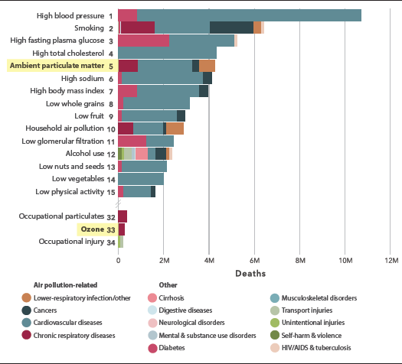
Shows the Global ranking of risk factors for total deaths from all causes for all ages and sexes in 2015
Recent reviews by USEPA and WHO have shown that the long-term exposure to ambient air pollution is responsible for increased mortality and morbidity from respiratory and cardiovascular diseases, lung cancer and shortens life expectancy. In addition, epidemiological studies have shown that airborne particulate matter (PM) is associated not only with respiratory diseases but also with cardiovascular diseases.

Cardiovascular effects of Ambient Air Pollution
The Cardiovascular System
The cardiovascular system is also known as the circulatory system and includes includes the heart, arteries, veins, capillaries and blood. These vital structures are critical in the process of pumping deoxygenated blood to the lungs for gas exchange as well as pumping oxygenated blood to the body’s tissues to support their metabolic functions. The cardiovascular system has three major functions:
- transportation of materials - The cardiovascular system transports blood to almost all of the body’s tissues. The blood delivers essential nutrients and oxygen and removes wastes and carbon dioxide to be processed or removed from the body.
- protection from pathogens - The cardiovascular system protects the body through its white blood cells. White blood cells clean up cellular debris and fight pathogens that have entered the body. Platelets and red blood cells form scabs to seal wounds and prevent pathogens from entering the body and liquids from leaking out. Blood also carries antibodies that provide specific immunity to pathogens that the body has previously been exposed to or has been vaccinated against
- regulation of the body’s homeostasis - The cardiovascular system is instrumental in the body’s ability to maintain homeostatic control of several internal conditions. Blood vessels help maintain a stable body temperature by controlling the blood flow to the surface of the skin. Blood vessels near the skin’s surface open during times of overheating to allow hot blood to dump its heat into the body’s surroundings. In the case of hypothermia, these blood vessels constrict to keep blood flowing only to vital organs in the body’s core. Blood also helps balance the body’s pH due to the presence of bicarbonate ions, which act as a buffer solution. Finally, the albumins in blood plasma help to balance the osmotic concentration of the body’s cells by maintaining an isotonic environment (Innerbody 2018).
How do pollutants enter the cardiovascular system
The most common route for pollutants to enter the cardiovascular system is via inhalation whereby air travels from the upper respiratory tract which includes the nasal cavity, pharynx, glottis and larynx to the lower respiratory tract consisting of the trachea, bronchi, bronchioles and lungs. Of all the pollutants that pass through the respiratory system (refer to Figure 6), particulate matter with an aerodynamic diameter of <2.5 and <0.1$μ$m has the ability to penetrate the lung alveoli (where gas exchange of oxygen and carbon dioxide occurs) and enter the bloodstream whereby it exerts the adverse health effects(Franck et al. 2011). Because of its small aerodynamic diameter (AD) most particulates with an AD range of 2 to 10$μ$m are deposited in the nasal cavities and upper airways. Particulate matter has been recognized as being associated with inducing adverse health effects because it may contain toxic substances that can be transported to the respiratory tract(Lee, Kim, and Lee 2014). In addition, animal studies have shown that particulate matter with an aerodynamic diameter < 2.5$μ$m can have direct health effects when taken up by alveolar macrophages and endothelial cells.

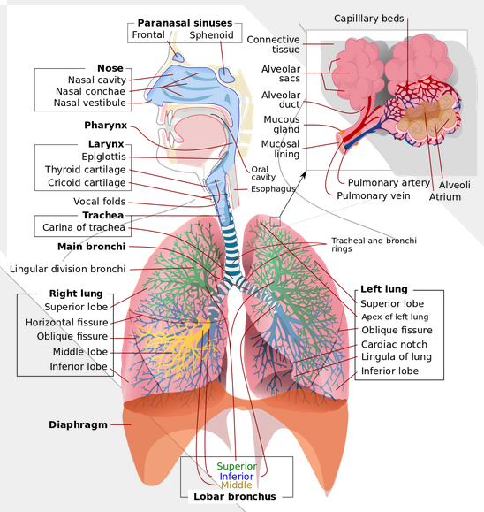
The respiratory system showing the upper and lower respiratory tract as well as the alveoli . Source: US National Library of Medicine
Effect of pollutants on Cardiovascular Health
Recent epidemiological studies have shown that the greatest health threat due to air pollution is cardiovascular disease (Lee, Kim, and Lee 2014). Because of its small size, particulate matter can be inhaled deep into the lungs, with a portion depositing in the alveoli and entering the pulmonary circulation and apparently the systemic circulation(Sun, Hong, and Wold 2010). Inhalation of particulate matter or ultrafine particles (UFPs) triggers inflammatory responses in the lung and increases the release of inflammatory mediators into the blood. This, in turn, can lead to various changes in the cardiovascular system, such as an increase in blood coagulability and the progression of atherosclerotic lesions (Nakane 2011).
In a series of major epidemiological studies, it has been established that air pollution has adverse effects on cardiovascular health(Dockery et al. 1993). Brief exposures to air pollution have been associated with increased cardiovascular-related morbidity and mortality from angina, myocardial infarction, arrhythmia and heart failure and this pathologic link have particular implications for low-income and middle-income countries(Samet et al. 2000). These countries are rapidly developing, hence, air pollution concentrations are continuing to rise. Long-term exposure to air pollution increases the risk of an individual to coronary heart disease and the main arbiter of these health effects seems to be the combustion-derived particulate matter.
In a study by Barnett et al. 2006 on the effects of air pollution on hospitalizations for cardiovascular disease in elderly people in Australia and New Zealand cities, they found that particulate matter (PM₁₀ and PM_{2.5}), NO₂, SO₂ and CO were significantly associated with higher admissions amongst the elderly ($≥$65yrs) than the younger age group (15-64). O₃ was the only pollutant that showed no association. Findings from this study suggests that for a 0.9ppm increase in CO, elderly admissions increased for total cardiovascular disease (2.2%), all cardiac disease (2.8%), cardiac failure (6%), ischemic heart disease (2.3%) and myocardial infarction (2.9%). Their advanced age, frailty and with probably preexisitng heart conditions could be a reason for the vulnerability of the elderly population. Interestingly, these associations were found at concentrations that were below normal air quality health guidelines and the author’s suggest that these guidelines have to be revised and lowered if possible. Lowering these guidelines will lead to improvements in cardiovascular health(Barnett et al. 2006).
Another study by (Liu et al. 2015) on the association between air pollutants and cardiovascular disease mortality in China demonstrated that increases in NO₂ and SO₂ was significantly associated with daily cardiovascular mortality. No significant associations were found for PM₁₀. Moreover, the study suggests that for the elderly (65 years and older), significant associations were found between PM₁₀ and SO₂ with ischemic heart disease mortality.

Ambient Air Pollution and Acute Myocardial Infarction
Acute myocardial infarction is the medical name for a heart attack and is a life-threatening condition that occurs when blood flow to the heart muscle is abruptly cut off, causing tissue damage. This is usually the result of a blockage in one or more of the coronary arteries. A blockage can develop due to a buildup of plaque, a substance mostly made of fat, cholesterol, and cellular waste products.
Epidemiological studies such as that by (Peters et al. 2001)have demonstrated a significant increase in the incidence of adverse myocardial infarction in the immediate periods (hours to days) after exposure to high levels of atmospheric PM_{2.5}. In addition, findings from the study suggests that increasing concentrations of fine particulates in the air may elevate the risk of myocardial infarction after a few hours to a day after exposure. Moreover, even low and moderate PM_{2.5} concentrations were associated with an increased risk of myocardial infarction.
Furthermore, in a meta-analysis study by (Mustafić et al. 2012), the authors systematically reviewed associations between the air pollutants ozone, carbon monoxide, nitrogen dioxide, sulfur dioxide, PM₁₀ and PM_{2.5} levels and the risk of myocardial infarction. The findings from this meta-analysis demonstrated that all the air pollutants i.e. CO, NO₂, SO₂, PM₁₀ and PM_{2.5} , with the exception of ozone were significantly associated with a near-term increase in myocardial risk.

Population and Methods

Study Design
A combination of meta analysis, collection of field data on air quality by measuring criteria pollutants excluding lead and developing a dose-response model of the association between criteria pollutants and the risk of acute myocardial infarction.

Data collection

Air Quality Monitoring
Collection of field data on air quality will be for a period of 3 months and measurements will be taken for the common criteria pollutants (SOx, NOx, PM₁₀, PM_{2.5}, O3, CO). The measurements will be conducted in 3 selected sites in Lautoka (industrial, residential, and commercial (city centre)); measurements will be taken at human breathing height of 1.5m above the ground. The criteria pollutants to be monitored in this study according to (Chen and Kan 2008), are often used as indicator pollutants for fuel combustion and traffic-related air pollution and the study by (Isley et al. 2017) confirms the increasing dependent on fossil fuels, in particular diesel for Pacific Island countries. To provide sufficient data to determine trends in air quality over the 3 months period as well as the background levels of contaminants , the WHO recommended threshhold measurements will be used as shown in Table 3 with the description of the time-averages adopted from the National Environment Standards (NES) provided in Appendix A. The ozone guideline value and measurement time has been adapted from the Ambient Air Quality Guidelines (AAQG) of New Zealand. The equipment of choice to conduct this monitoring measures the air contaminants in part per billion (ppb) and the quick reference conversion table provided in the Guide for Air Quality Monitoring and Data Management 2009 and appended in Appendix B will be utilised to convert the measurements from ppb to $μ$g/m³

Ambient air quality guidelines adopted from the WHO and AAQG guidelines
Contaminant | Guideline value | Time-average
PM_{2.5} | 25µg/m³ | 24-hr mean
PM₁₀ | 50µg/m³ | 24-hr mean
NO₂ | 200µg/m³ | 1-hr mean
SO₂ | 20µg/m³ | 24-hr mean
CO | 30µg/m³ | 1-hr mean
O₃ | 100µg/m³ | 8-hr mean
In addition to measuring the air contaminants, the effect of weather will also be taken into account as it has a profound influence on contaminant dispersion and concentrations. Monitoring organizations in countries such as New Zealand suggest that meteorological effects such as temperature inversions can dramatically increase contaminant levels. Moreover, it would not be possible to gain a clear picture of the air quality in an area without meteorological monitoring, hence, this study will also take some basic meteorological monitoring such as temperature, humidity and pressure at the air quality monitoring sites. The meteorology effect may prove very useful, especially when trying to assess the validity of data.
To ensure that accurate and credible air quality data is obtained from this study, the use of an equipment with high-precision instrumental methods is required in order to understand the ways in which contaminant levels fluctuate over short time periods (hours or days). One of the latest equipment to have such capabilities is the VAISALA Air Quality transmitter (AQT) 400 series which consists of two products the AQT 420 and AQT 410. The AQT 410 measures of the most common urban air pollutants NO₂, SO₂, CO and O₃ whilst the AQT 420 measures particulate matter (PM_{2.5} and PM₁₀). The measurement performance of the AQT 400 series is based on proprietary advanced algorithms that enable parts per billion (ppb) measurements by using electrochemical sensors. The algorithms compensate for the impact of ambient conditions and it is specifically designed for urban areas, road networks or around industrial sites and transportation hubs. Because of its small weight and compact size, it is ideally suited for deployment even in larget air quality networks. The measurement data is sent wirelessly to a web-based database with a gateway solution or through a serial interface.The AQT400 series device has a maintenance and calibration interval of 12-24 months depending on local conditions.
The recommended monitoring sites for this study will include 3 continuous air monitoring stations whereby a) it is typically very close to roads with high traffic use b) close to large point sources of industrial activity and c) a typical residential area. The continuous monitoring method is a high-resolution method that provides continuous records of contaminant levels. They can operate over extended periods (weeks or months) with minimal operator intervention and have a high degree of measurement precision. The 3 sites will be carefully selected after consultation with the Lautoka City council to ensure that the monitoring equipment is safe and is not vulnerable to vandalism. Monitoring will be conducted Also, the site has to be accessible and other factors such as restricted air flows in the vicinity of the sample inlet and changes around the monitoring site will be considered prior to setting up the equipment.

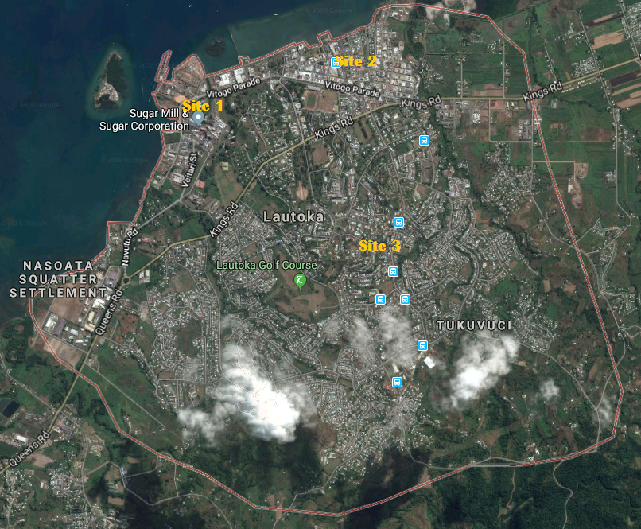
Shows the 3 sites for the air quality monitoring
Figure 7 above shows the proposed 3 air quality monitoring sites within the city of Lautoka. Each site represents a specific area of activity and is described in Table 4 below

Shows the features of the selected sites for this air quality monitoring
Site | Zone | Features | Possible emissions
1 | Industrial | Sugar mill, local and international ports, distilley, pine chip storage facility, metal facbrication workshops | sulfur dioxide, nitrogen dioxide, particulate matter, carbon monoxide
2 | City centre | Bus station, high traffic used roads, high daily volume of vehicles | Particulate matter, nitrogen dioxide, carbon moxoide
3 | Residential | relatively high population residential, wood burning, low traffic use, | Particulate matter, carbon monoxide

Data Management

Air Quality Data acquisition
The VAISALA Air Quality Transmitter AQT 400 series like most modern continuous air quality monitoring instruments contains its own data acquisition system as well as provision for digital output of data to an external data logger. Hence, utilising the instruments data acquisition system it is possible to transfer data to a laptop to collect and store monitoring data. Data can then be imported into Microsoft Excel spreadsheet for temporary storage purposes.

Air Quality data storage, archiving and retrieval
All data will be stored in a central database and will be regularly backed up. Each monitoring site and the parameter will be assigned a unique identifier that enables easy retrieval. It is preferable to store data in such a way that incoming data is appended to the archive file so it can be viewed as a continuous data set. Two parallel data sets will be maintained: one that preserves raw data in its original form and the other that has been quality assured and will be available for further analysis. Keeping a raw data set archived means that the data can be revisited and re-analysed if any problems arise with the original quality assurance process.

Daily data checks
The main advantage of regular data transfer by telemetry is that the data can be checked at least once a day so that instrument faults, systems failures, data spikes, human error, power failures, interference or other disturbances can be readily identified and promptly remedied to minimise instrument breakdown and data loss. Daily data checks is recommended for each site and notes of events that may affect results such as bushfires, dust storms, roadworks, fireworks, etc. will be recorded.

Data Analysis
Using the software analysis tool R-studio, the following analysis is recommended to sufficiently provide the desired results:

Time Series Regression
Time series regression is a Trend analysis method which looks at how a potential driver of change has developed over time, and how it is likely to develop in the future. It does not predict what the future will look like, however, it becomes a powerful tool for strategic planning by creating plausible, detailed pictures of what the future might look like (OECD, n.d.). Trend detection is considered a key aspect of understanding the state of air quality based on past data(Blanchard 1999). Statistical methods for trend analysis of environmental data can be classified into parametric and non-parametric tests. Hence, Time series linear regression(a parametric method) is chosen due to its simplicity and straightforwardness of interpretation. In addition, parametric tests tend to be more powerful than nonparametric tests and they have an ability to quantify the magnitude of a trend(OECD, n.d.). Time series regression will be employed to describe and analyse the trend of the air quality data.

Systematic Review and Meta-analysis
This technique is used to combine the results of a number of different reports into one report to create a single, more precise estimate of an effect. Benefits of conducting a meta-analysis include overcoming the dangers of bias, decisions of achieving the final aggregate sizes are always transparent and they give more precise estimates of the size of any effects uncovered (Lalkhen and McCluskey 2008). The required steps for the meta-analysis are described below:

1. Using the PICO (population, exposure, comparison and outcomes) framework the research question for the matter analysis will be, “Compared with lower levels of exposure to air pollutants, what is the risk of acute myocardial infarction related hospitalisation for people who are exposed to higher level of air pollutants?”
2. A systematic review of literature will primarily use the Embase and Medline databases to search for relevant studies using the Boolean logic and fuzzy logic (Tuttle et al. 2009) search principles. The eligibility criteria for the literature search will focus on studies analyzing the associations of exposure to 1 or more air pollutants with acute myocardial infarction hospital admissions and emergency department visits. The relevant studies should involve the general populace and be in any study design. Studies have to be in the English language and had to be published within the last 10 years. Key words to this search include air pollution, acute myocardial infarction, effect size, realative risk, etc. Particulars of this search strategy are shown in Appendix E whereby a total of 152 relevant studies were found. However, this number may be reduced after removing duplicated studies and other studies that do not fit the elements descibed in the research question for the meta-analysis.
3. The following scheme (exclusion criteria) will then be employed in order to go through the list of retrieved abstracts and titles of the studies from step 2 and to retrieve their full texts.
a. The article is published in a foreign language and cannot be translated
b. The article is irrelevant to the study question
c. The article does not have the relevant population
d. The article is a duplicate of another study
e. The article does not discuss the outcome that is of interest to this research
f. The article does not have a relevant comparison group
4. The full texts from the studies identified in step 3 will be thoroughly read and then decide whether to further exclude them OR, using their reference lists, other studies can be identified and in this way, iteratively, build a database of studies to be included in the meta-analysis.
5. This step involves abstracting information from individual studies included in the meta-analysis. This will include information on authors, years of study, the population studied, the sample size, study type, the effect size or point estimate, the 95% confidence interval and the p-value
6. From the information you collected in step 5, a forest plot will be used to graphically display the distribution of the effect size of the different studies.
7. In this step, the information obtained from step 5 will be used to first test the heterogeneity of the studies. Testing the heterogeneity of the studies involves using a variation of chi-square test based on a pooled estimate, the effect estimate of each individual study, and the number of studies. This test is referred to as Q statistic and the associated p-value noted, and further evaluated at 0.05 for the null hypothesis. The null hypothesis will be that, “ the results of the studies are similar to each other or that there is no difference between the results of the studies included in the meta-analysis“. The alternative hypothesis is that ”the results of the studies differ from each other”. If the p-value rejects the null hypothesis, then the studies are heterogeneous; if the p-value fails to reject the null hypothesis, then the conclusion will be that the studies are homogeneous. If the studies are homogeneous, the results of the study will be pooled together and two types of estimates reported: (1) fixed effects estimate based on the assumption that the studies that have been included in the research form an exhaustive set of studies; and (2) a random effect estimate where it will be assumed that the set of studies being included in the analysis form a ‘sample’ or random sample of studies of ‘all possible studies’.
8. This step requires to carry out a pooled estimate as mentioned in step 7 and report the effect estimate.
9. In this step, I will test for publication bias. Publication bias refers to a bias that occurs due to the fact that smaller studies and those with “equivocal estimates” (that is estimates that are inconclusive or those studies with negative estimates) are less likely to be published and therefore less likely to be captured in this meta-analysis than those studies that are large and have significant findings. Plotting the variance of the study estimates (variance of the effect estimate of a study is a function of its sample size) and the effect estimate itself, itself, will show that the cloud of points may define a funnel. The base of the funnel will be formed by studies that are small in size (hence large variance) and the effect estimates will vary all around the point estimate; the apex or peak of the funnel will be formed by those studies that are large sized (hence low variance) and all the estimates will be clouded around the point estimate estimate obtained in the meta-analysis. If part of the funnel is missing, then that indicates that there was publication bias. This is referred to as the funnel plot. There are other tests, such as “Egger’s Test” that can statistically report the extent of publication bias. Eggers test is a formalized statistical tests for assessing funnel plot asymmetry . In addition, Eggers test plots the regression line between precision of the studies (independent variable) and the standardized effect (dependent variable). When there isn’t publication bias the regression line originates in the Y-axis zero. If it is much futher away from zero, this suggests further evidence of publication bias (Molina 2012). There is not much to be done to remedy publication bias other than searching for ‘fugitive literature’ and contacting the research groups and others who can have studies that are small and remained unpublished or obtain the raw data from different sources.
10. In this final step I will test for meta-regression or subgroup analyses. In this analysis, I will subgroup the data and analyse them separately using a regression model. I will test if the estimates are different for those in developing versus developed countries, and also for those with different types of source apportionment. Source apportionment refers to the phenomenon that different sources will contribute differently to air pollution. For example, do sources such as vehicle exhausts lead to higher admission rates than say coal burning plants? Is the association between PM10 and hospital admissions different for developing countries than for developed countries?

Linear Regression and Modelling
Linear regression is suitable to use when a time series data suggest a simple linear increasing or decreasing trend on a plot of data against time (Gilbert 1988). The overall idea of regression is first to examine whether a set of predictor variables (criteria pollutants) is good enough to predict an outcome (risk of acute myocardial infarction) and secondly, to identify which of the variables are significant predictors of the outcome variable. Also, regression examines in what way in terms of magnitude does the predictor variables impact the outcome variable (StatisticsSolutions 2013). In addition, I will need to set up a model using this regression method to impute hospital admission rates due to acute myocardial infarction and the pollution data

Ethical considerations
The Lautoka City Council will have to give its consent to allow the placement of air quality monitoring equipment in the selected sites within the city. In this regard, an information sheet (please refer to Appendix C) that gives an insight into the details and particulars of the study will be provided to them. Once the information sheet has been sighted and signed by the Latuka City Council, a consent form (please refer to Appendix D) outlining information confidentiality and sharing will be given to them for their perusal and final consent. This process will be followed should the need arise to mount the monitoring equipments in private or commercial properties.

Workplan
The Gantt Chart shown below indicates the different stages of the Thesis development and the timelines to complete each stage.
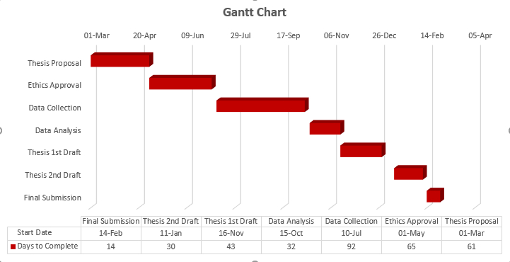
Shows the workplan with activities and the duration to complete each activity

Budget
The table provided below shows the breakdown of the minimum final requirements that will be needed to conduct this research in the city of Lautoka

Shows the budgetary requirements for the study
Budget Item | per unit cost | Costing details | Sub Total | Rationale
Accommodation | $65 | 8 nights | $520 | The site for my study is the city of Lautoka and is 215.8km away from where I reside which is in Suva. I will be spending at least 8 nights spread out through the 3 months study period
Travelling cost | $36 (return) | for 8 weeks | $288 | The city of Lautoka is about a 3hrs 45 mins bus ride from Suva and I will be travelling once a week via the cheapest mode of transport which is the Pacific Transport Ltd bus
Meals | $20 | 8 days | $160
Personnel Salary | $20 | 8 | $160 | I will be engaging an assistant to help in the setting up of the air pollution monitoring equipment as well as assist in the daily checks of the equipment
Gift vouchers | $150 |  | $150 | For individuals who will provide relevant and critical information through interviews
Recharge cards | $10 | per week | $120 | For daily communication with my assistant as well as contacting potential
Grand Total |  |  | $1398

Outline of Chapters

Chapter 1: Introduction
Initially, this chapter will provide a brief background on air pollution as well as the associated cardiovascular effects from a global and regional perspective. It will also include the objectives of the study as well as a description of the study area and the air quality monitoring sites.

Chapter 2: Characteristics of Air Pollution
Air pollutants (PM₁₀, PM_{2.5}, SO₂, NO₂, O₃) in terms of their chemical composition, reaction properties, emission sources and movement in the environment will be discussed in this chapter. This should provide an in-depth understanding of how these pollutants are released into the environment and their behaviour thereafter.

Chapter 3: Pollutants and Acute Myocardial Infarction
This chapter will provide insights from global, regional and local perspectives on pollutant effect on cardiovascular health

Chapter 4: Methods
This chapter will detail the procedures taken to acquire the air quality data and selected health studies. Information will include steps for monitoring, data management, the systematic review, meta-analysis and methods for Statistical Analysis of trend data

Chapter 5: Results and Discussions
This chapter will provide the results after the analysis from all the air quality monitoring sites. Each pollutant will be analysed and presented separately in order to provide a better understanding of each pollutant level at each site.

Chapter 6: Findings
This chapter will provide a tabulated summary of the concentration trend for each air pollutant at each air monitoring station for the period of record analyzed. In addition, this chapter will also show the outcome of the meta-analysis in a

References
WHO. 2018. “Ambient Air Quality”. http://www.who.int/phe/health_topics/outdoorair/en/. http://www.who.int/phe/health_topics/outdoorair/en/.
EPC. 2017. “What Is Air Pollution | Environmental Pollution Centers”. https://www.environmentalpollutioncenters.org/air/. https://www.environmentalpollutioncenters.org/air/.
Mannucci, Pier, and Massimo Franchini. 2017. “Health Effects of Ambient Air Pollution in Developing Countries”. International Journal of Environmental Research and Public Health 14 (12). MDPI AG: 1048. doi:10.3390/ijerph14091048.
WHO. 2018. “Ambient Air Pollution: Health Impacts”. http://www.who.int/airpollution/ambient/health-impacts/en/. http://www.who.int/airpollution/ambient/health-impacts/en/.
USEPA. 2009. “Integrated Science Assessment (ISA) for Particulate Matter (Final Report, Dec 2009) | Risk Assessment Portal | US EPA”. http://cfpub.epa.gov/ncea/risk/recordisplay.cfm?deid=216546. http://cfpub.epa.gov/ncea/risk/recordisplay.cfm?deid=216546.
WHO. 2016. “Ambient (Outdoor) Air Quality and Health”. http://www.who.int/mediacentre/factsheets/fs313/en/. http://www.who.int/mediacentre/factsheets/fs313/en/.
Isley, C.F., P.F. Nelson, M.P. Taylor, F.S. Mani, M. Maata, A. Atanacio, E. Stelcer, and D.D. Cohen. 2017. “PM 2.5 and Aerosol Black Carbon in Suva Fiji”. Atmospheric Environment 150 (February). Elsevier BV: 55–66. doi:10.1016/j.atmosenv.2016.11.041.
of Env, Dept. 2013. “Sources of Air Pollution (Fiji)”. https://doefiji.wordpress.com/2013/10/22/air-pollution/. https://doefiji.wordpress.com/2013/10/22/air-pollution/.
FBoS. 2017. “CENSUS 2017 - Fiji Bureau of Statistics”. http://www.statsfiji.gov.fj/census. http://www.statsfiji.gov.fj/census.
———. 2018. “Fiji Bureau of Statistics - Fiji Bureau of Statistics” 1. http://www.statsfiji.gov.fj/. http://www.statsfiji.gov.fj/.
History, City. n.d. “City History | My Lautoka City Council”. http://www.mylautokacity.org/city-history/. http://www.mylautokacity.org/city-history/.
Vallero, Daniel. 2008. Fundamentals of Air Pollution. Academic Press. https://books.google.com/books/about/Fundamentals_of_Air_Pollution.html?id=4AV2Wds_NZAC.
Vallero, Daniel A. 2008. “Air Quality”. In Fundamentals of Air Pollution, 263–95. Elsevier. doi:10.1016/b978-012373615-4/50009-1.
P.J.B. 1956. “Smoake”. Tubercle 37 (5). Elsevier BV: 364–66. doi:10.1016/s0041-3879(56)80085-8.
1999. Academic Press. https://books.google.com/books/about/Air_Pollution_and_Health.html?id=WcfbxeoaliwC.
1994. Academic Press Ltd, London. https://books.google.com/books/about/Fundamentals_of_Air_Pollution.html?id=pfEkBQAAQBAJ.
Beaver, Hugh. 1955. “Air Pollution: the Problems of Administration”. Journal (Royal Society of Health) 75 (5). SAGE Publications: 341–45. doi:10.1177/146642405507500506.
Firket, J. 1931. “Bull. Acad. R. Med. Belg.” 11.
USEPA. 2017. “History of Air Pollution”. https://www.epa.gov/air-research/history-air-pollution. https://www.epa.gov/air-research/history-air-pollution.
Yu, MIng-Ho. 2001. Environmental Toxicology. Lewis Publishers. https://books.google.com/books/about/Environmental_Toxicology.html?id=eg4J_G0v0xgC.
Klein, Christopher. 2012. “The Great Smog of 1952”. History. https://www.history.com/news/the-killer-fog-that-blanketed-london-60-years-ago. http://www.history.com/news/the-killer-fog-that-blanketed-london-60-years-ago.
PopulationMatters. n.d. “Air Pollution and Population Density”. https://www.populationmatters.org/documents/air_pollution_and_population_density.pdf. https://www.populationmatters.org/documents/air_pollution_and_population_density.pdf.
1984. Academic Press, INC.
Elsom, Derek M. 1992. Atmospheric Pollution: a Global Problem.. Ed. 2.. Blackwell Publishers. http://agris.fao.org/agris-search/search.do?recordID=GB19940093553.
Fenger, Jes. 2009. “Air Pollution in the Last 50 Years – From Local to Global”. Elsevier 43,Issue 1. https://www.sciencedirect.com/science/article/pii/S1352231008008960. https://www.sciencedirect.com/science/article/pii/S1352231008008960.
Chen, Bingheng, and Haidong Kan. 2008. “Air Pollution and Population Health: a Global Challenge”. Environmental Health and Preventive Medicine 13 (2). Springer Nature: 94–101. doi:10.1007/s12199-007-0018-5.
Fenger, Jes. 2009. “Air Pollution in the Last 50 Years From Local to Global”. Atmospheric Environment 43 (1). Elsevier BV: 13–22. doi:10.1016/j.atmosenv.2008.09.061.
WHO. 2005. “Air Quality Guidelines Global Update 2005”. http://www.euro.who.int/__data/assets/pdf_file/0005/78638/E90038.pdf. http://www.euro.who.int/__data/assets/pdf_file/0005/78638/E90038.pdf.
Institute, Health Effects. 2017. “State of Global Air 2017: A Special Report on Global Exposure to Air Pollution and Its Disease Burden | Climate & Clean Air Coalition”. http://www.ccacoalition.org/en/resources/state-global-air-2017-special-report-global-exposure-air-pollution-and-its-disease-burden. http://www.ccacoalition.org/en/resources/state-global-air-2017-special-report-global-exposure-air-pollution-and-its-disease-burden.
Post, Washington. n.d. “WHO: Global Air Pollution Is Worsening, and Poor Countries Are Being Hit the Hardest”. https://www.washingtonpost.com/news/energy-environment/wp/2016/05/12/who-global-air-pollution-is-worsening-and-poor-countries-are-being-hit-the-hardest/?utm_term=.4fa57d44940f. https://www.washingtonpost.com/news/energy-environment/wp/2016/05/12/who-global-air-pollution-is-worsening-and-poor-countries-are-being-hit-the-hardest/.
Nigel Bruce, Rogelio Perez-Padilla & Rachel Albalak. 2000. “Indoor Air Pollution in Developing Countries: a Major Environmental and Public Health Challenge”. Bulletin of the World Health Organization 78(9). http://www.who.int/bulletin/archives/78(9)1078.pdf. http://www.who.int/bulletin/archives/78(9)1078.pdf.
Gordon, Stephen B, Nigel G Bruce, Jonathan Grigg, Patricia L Hibberd, Om P Kurmi, Kin-bong Hubert Lam, Kevin Mortimer, et al. 2014. “Respiratory Risks from Household Air Pollution in Low and Middle Income Countries”. The Lancet Respiratory Medicine 2 (10). Elsevier BV: 823–60. doi:10.1016/s2213-2600(14)70168-7.
Smith, Kirk R., Michael G. Apte, Ma Yuqing, Wathana Wongsekiarttirat, and Ashwini Kulkarni. 1994. “Air Pollution and the Energy Ladder in Asian Cities”. Energy 19 (5). Elsevier BV: 587–600. doi:10.1016/0360-5442(94)90054-x.
n.d. https://www.epa.gov/criteria-air-pollutants/naaqs-table. https://www.epa.gov/criteria-air-pollutants/naaqs-table.
Smith, Kirk R. 1987. “Health Effects”. In Biofuels Air Pollution, and Health, 199–229. Springer US. doi:10.1007/978-1-4613-0891-1_6.
Isley, C.F., P.F. Nelson, M.P. Taylor, M. Mazaheri, L. Morawska, A.J. Atanacio, E. Stelcer, D.D. Cohen, and Anthony L. Morrison. 2017. “Airborne Ultrafine Particles in a Pacific Island Country: Characteristics Sources and Implications for Human Exposure”. Environmental Pollution 231 (December). Elsevier BV: 367–78. doi:10.1016/j.envpol.2017.08.021.
WHO. 2018. “Ambient Air Pollution: Pollutants”. http://www.who.int/airpollution/ambient/pollutants/en/. http://www.who.int/airpollution/ambient/pollutants/en/.
USEPA. 2017. “Particulate Matter (PM) Basics | US EPA”. https://www.epa.gov/pm-pollution/particulate-matter-pm-basics#PM. https://www.epa.gov/pm-pollution/particulate-matter-pm-basics.
NSW-Government. 2013. “Particulate Matter”. http://www.health.nsw.gov.au/environment/air/Pages/particulate-matter.aspx. http://www.health.nsw.gov.au/environment/air/Pages/particulate-matter.aspx.
USEPA. 2017. “Ozone Pollution | US EPA”. https://www.epa.gov/ozone-pollution. https://www.epa.gov/ozone-pollution.
NSW-Government. 2013. “Ozone (O3)”. http://www.health.nsw.gov.au/environment/air/Pages/ozone.aspx. http://www.health.nsw.gov.au/environment/air/Pages/ozone.aspx.
USEPA. 2016. “Basic Information about Carbon Monoxide (CO) Outdoor Air Pollution | US EPA”. https://www.epa.gov/co-pollution/basic-information-about-carbon-monoxide-co-outdoor-air-pollution#What%20is%20CO. https://www.epa.gov/co-pollution/basic-information-about-carbon-monoxide-co-outdoor-air-pollution.
RiskFactorsCollaborators, GBD 2015. 2016. “Global, Regional, and National Comparative Risk Assessment of 79 Behavioural, Environmental and Occupational, and Metabolic Risks or Clusters of Ri... - PubMed - NCBI”. Lancet 388: 1659–724. https://www.ncbi.nlm.nih.gov/pubmed/27733284. https://www.ncbi.nlm.nih.gov/pubmed/27733284.
Cohen, Aaron J, Michael Brauer, Richard Burnett, H Ross Anderson, Joseph Frostad, Kara Estep, Kalpana Balakrishnan, et al. 2017. “Estimates and 25-Year Trends of the Global Burden of Disease Attributable to Ambient Air Pollution: an Analysis of Data from the Global Burden of Diseases Study 2015”. The Lancet 389 (10082). Elsevier BV: 1907–18. doi:10.1016/s0140-6736(17)30505-6.
Innerbody. 2018. “Cardiovascular System - Human Veins, Arteries, Heart”. http://www.innerbody.com/image/cardov.html. http://www.innerbody.com/image/cardov.html.
Franck, Ulrich, Siad Odeh, Alfred Wiedensohler, Birgit Wehner, and Olf Herbarth. 2011. “The Effect of Particle Size on Cardiovascular Disorders The Smaller the Worse”. Science of The Total Environment 409 (20). Elsevier BV: 4217–21. doi:10.1016/j.scitotenv.2011.05.049.
Lee, Byeong-Jae, Bumseok Kim, and Kyuhong Lee. 2014. “Air Pollution Exposure and Cardiovascular Disease”. Toxicological Research 30 (2). The Korean Society of Toxicology: 71–75. doi:10.5487/tr.2014.30.2.071.
Sun, Q., X. Hong, and L. E. Wold. 2010. “Cardiovascular Effects of Ambient Particulate Air Pollution Exposure”. Circulation 121 (25). Ovid Technologies (Wolters Kluwer Health): 2755–65. doi:10.1161/circulationaha.109.893461.
Nakane, Hideo. 2011. “Translocation of Particles Deposited in the Respiratory System: a Systematic Review and Statistical Analysis”. Environmental Health and Preventive Medicine 17 (4). Springer Nature: 263–74. doi:10.1007/s12199-011-0252-8.
Dockery, Douglas W., C. Arden Pope, Xiping Xu, John D. Spengler, James H. Ware, Martha E. Fay, Benjamin G. Ferris, and Frank E. Speizer. 1993. “An Association between Air Pollution and Mortality in Six U.S. Cities”. New England Journal of Medicine 329 (24). New England Journal of Medicine (NEJM/MMS): 1753–59. doi:10.1056/nejm199312093292401.
Samet, Jonathan M., Francesca Dominici, Frank C. Curriero, Ivan Coursac, and Scott L. Zeger. 2000. “Fine Particulate Air Pollution and Mortality in 20 U.S. Cities 19871994”. New England Journal of Medicine 343 (24). New England Journal of Medicine (NEJM/MMS): 1742–49. doi:10.1056/nejm200012143432401.
Barnett, Adrian G., Gail M. Williams, Joel Schwartz, Trudi L. Best, Anne H. Neller, Anna L. Petroeschevsky, and Rod W. Simpson. 2006. “The Effects of Air Pollution on Hospitalizations for Cardiovascular Disease in Elderly People in Australian and New Zealand Cities”. Environmental Health Perspectives 114 (7). Environmental Health Perspectives: 1018–23. doi:10.1289/ehp.8674.
Liu, Yisi, Xi Chen, Shuqiong Huang, Liqiao Tian, Yuanan Lu, Yan Mei, Meng Ren, Na Li, Li Liu, and Hao Xiang. 2015. “Association between Air Pollutants and Cardiovascular Disease Mortality in Wuhan China”. International Journal of Environmental Research and Public Health 12 (4). MDPI AG: 3506–16. doi:10.3390/ijerph120403506.
Peters, A., D. W. Dockery, J. E. Muller, and M. A. Mittleman. 2001. “Increased Particulate Air Pollution and the Triggering of Myocardial Infarction”. Circulation 103 (23). Ovid Technologies (Wolters Kluwer Health): 2810–15. doi:10.1161/01.cir.103.23.2810.
Mustafić, Hazrije, Patricia Jabre, Christophe Caussin, Mohammad H. Murad, Sylvie Escolano, Muriel Tafflet, Marie-Cécile Périer, et al. 2012. “Main Air Pollutants and Myocardial Infarction”. JAMA 307 (7). American Medical Association (AMA): 713. doi:10.1001/jama.2012.126.
OECD. n.d. “Trend Analysis as a Method”. https://www.oecd.org/site/schoolingfortomorrowknowledgebase/futuresthinking/trends/trendanalysisasamethod.htm. https://www.oecd.org/site/schoolingfortomorrowknowledgebase/futuresthinking/trends/trendanalysisasamethod.htm.
Blanchard, Charles L. 1999. “METHODS FORATTRIBUTINGAMBIENTAIRPOLLUTANTS TOEMISSIONSOURCES”. Annual Review of Energy and the Environment 24 (1). Annual Reviews: 329–65. doi:10.1146/annurev.energy.24.1.329.
Lalkhen, Abdul Ghaaliq, and Anthony McCluskey. 2008. “Statistics V: Introduction to Clinical Trials and Systematic Reviews”. Continuing Education in Anaesthesia Critical Care & Pain 8 (4). Elsevier BV: 143–46. doi:10.1093/bjaceaccp/mkn023.
Tuttle, Brandi D., Megan von Isenburg, Connie Schardt, and Anne Powers. 2009. “PubMed Instruction for Medical Students: Searching for a Better Way”. Medical Reference Services Quarterly 28 (3). Informa UK Limited: 199–210. doi:10.1080/02763860903069839.
Molina, Manuel. 2012. “Egger’s Test - Science without Sense…Double Nonsense”. http://www.cienciasinseso.com/en/tag/eggers-test/. http://www.cienciasinseso.com/en/tag/eggers-test/.
Gilbert, R. O. 1988. “Statistical Methods for Environmental Pollution Monitoring.”. Biometrics 44 (1). JSTOR: 319. doi:10.2307/2531935.
StatisticsSolutions. 2013. “What Is Linear Regression? - Statistics Solutions”. https://www.statisticssolutions.com/what-is-linear-regression/. https://www.statisticssolutions.com/what-is-linear-regression/.
“Ambient (Outdoor) Air Quality and Health”. n.d. http://www.who.int/mediacentre/factsheets/fs313/en/. http://www.who.int/mediacentre/factsheets/fs313/en/.
Vilches, Patricia, and Kimberly Gauderman. 2004. “Womens Lives in Colonial Quito: Gender Law, and Economy in Spanish America”. The Sixteenth Century Journal 35 (4). JSTOR: 1246. doi:10.2307/20477230.
Marchwinska-Wyrwal, E., G. Dziubanek, I. Hajok, M. Rusin, K. Oleksiuk, and M. Kubasiak. 2011. “Impact of Air Pollution on Public Health”. In The Impact of Air Pollution on Health Economy, Environment and Agricultural Sources. InTech. doi:10.5772/17906.
WHO, 2016. n.d. Ambient (Outdoor) Air Quality and Health. http://www.who.int/mediacentre/factsheets/fs313/en/. http://www.who.int/mediacentre/factsheets/fs313/en/.
Wong, T. W., T. S. Lau, T. S. Yu, A. Neller, S. L. Wong, W. Tam, and S. W. Pang. 1999. “Air Pollution and Hospital Admissions for Respiratory and Cardiovascular Diseases in Hong Kong”. Occupational and Environmental Medicine 56 (10). BMJ: 679–83. doi:10.1136/oem.56.10.679.
Centers, Environmental Pollution. 2017. “What Is Air Pollution | Environmental Pollution Centers”. https://www.environmentalpollutioncenters.org/air/. https://www.environmentalpollutioncenters.org/air/.
Isley, C.F., P.F. Nelson, M.P. Taylor, E. Stelcer, A.J. Atanacio, D.D. Cohen, F.S. Mani, and M. Maata. 2018. “Reducing Mortality Risk by Targeting Specific Air Pollution Sources: Suva Fiji”. Science of The Total Environment 612 (January). Elsevier BV: 450–61. doi:10.1016/j.scitotenv.2017.08.225.
Isley C.F., Nelson P.F., and Taylor M.P. 2016. “Managing Air Quality in Suva, Fiji | Isley | European Journal of Sustainable Development”. European Journal of Sustainable Development. https://ecsdev.org/ojs/index.php/ejsd/article/view/401. https://ecsdev.org/ojs/index.php/ejsd/article/view/401.
DOE(Fiji). 2013. “SOurces of Air Pollution”. https://doefiji.wordpress.com/2013/10/22/air-pollution/. https://doefiji.wordpress.com/2013/10/22/air-pollution/.
Mannucci. 2017. “Health Effects of Ambient Air Pollution in Developing Countries. - PubMed - NCBI”. https://www.ncbi.nlm.nih.gov/pubmed/28895888. https://www.ncbi.nlm.nih.gov/pubmed/28895888.
Shores, Fiji, and Marina. 2018. “The Climate of Fiji – FIJI Shores and Marinas”. https://www.fijimarinas.com/climate-weather-fiji/. https://www.fijimarinas.com/climate-weather-fiji/.
VALLERO, DANIEL A. 2008. “The Physics of the Atmosphere”. In Fundamentals of Air Pollution, 123–53. Elsevier. doi:10.1016/b978-012373615-4/50006-6.
D, Vallero. 2008. Fundamentals of Air Pollution. Academic Press. https://books.google.com/books/about/Fundamentals_of_Air_Pollution.html?id=4AV2Wds_NZAC.
Dennis, Brady, and Chris Mooney. 2016. “WHO: Global Air Pollution Is Worsening, and Poor Countries Are Being Hit the Hardest”. https://www.washingtonpost.com/news/energy-environment/wp/2016/05/12/who-global-air-pollution-is-worsening-and-poor-countries-are-being-hit-the-hardest/?utm_term=.0f2e64ed1c24. https://www.washingtonpost.com/news/energy-environment/wp/2016/05/12/who-global-air-pollution-is-worsening-and-poor-countries-are-being-hit-the-hardest/.
Matters, Population. 2017. “Air Pollution and Population Density”. https://www.populationmatters.org/documents/air_pollution_and_population_density.pdf. https://www.populationmatters.org/documents/air_pollution_and_population_density.pdf.
———. n.d. “Air Pollution and Population Density”. https://www.populationmatters.org/documents/air_pollution_and_population_density.pdf. https://www.populationmatters.org/documents/air_pollution_and_population_density.pdf.
“Air Pollution and Population Density”. n.d. https://www.populationmatters.org/documents/air_pollution_and_population_density.pdf. https://www.populationmatters.org/documents/air_pollution_and_population_density.pdf.
M, Cohen AJ & Braver. 2015. “Global Regional and National Comparative Risk Assessment of 79 Behavioural, Environmental and Occupational and Metabolic Risks or Clusters of Risks in 188 Countries, 19902013: a Systematic Analysis for the Global Burden of Disease Study 2013”. Lancet 388 (2016), pp. 1659-1724 (7). Springer Nature: 329–29. doi:10.1038/sj.bdj.2015.751.
“Particulate Matter (PM) Basics | US EPA”. n.d. https://www.epa.gov/pm-pollution/particulate-matter-pm-basics#PM. https://www.epa.gov/pm-pollution/particulate-matter-pm-basics.
Healthline. n.d. “Acute Myocardial Infarction: Causes, Symptoms, and Treatment”. https://www.healthline.com/health/acute-myocardial-infarction#prevention. https://www.healthline.com/health/acute-myocardial-infarction.
“Basic Information about Carbon Monoxide (CO) Outdoor Air Pollution | US EPA”. n.d. https://www.epa.gov/co-pollution/basic-information-about-carbon-monoxide-co-outdoor-air-pollution#What%20is%20CO. https://www.epa.gov/co-pollution/basic-information-about-carbon-monoxide-co-outdoor-air-pollution.

