Report: Exploratory analisys of HF Radar Data and Mohid Operational Model algong the Tagus River
Mariangel garcia
HF Radar observation are well known to be an important source of information to study hydrodynamics near the shore. The Tagus River is a complex system influenced mainly by wind and tides, in this report the main focus is to explore the quality of the observation available in real time specifically a comparison
This are a very very DRAFT preliminary results

Introduction
introduction to Mohid, history, some applications, data assimilation importance of data assimilation, improvement on DA for Mohid, our approach. Previews analysis was reported by (Rodrigues 2015)

The HF Radar Data
The HF radar data is provided by the Sistema de Monitorização Operacional de Correntes Costeiras, it has a large source of data base,
Land-based high-frequency (HF)coastal radars are an important means of acquiring oceanographic information. The “SeaSonde” radar of the “Coastal Ocean Dynamics Application Radar” (CODAR) is a variant of this type of technology. This monitoring system is composed of two stations, one of which is currently installed in the São Julião da Barra Fort (JLSM) and another in the Cape Espichel lighthouse (EPSM), which allows the measurement of surface currents and sea agitation in an area up to 70 km from the coast. Its operation is based on Doppler variation and back-diffusion of the transmitted signal. Each station measures the Doppler variation and the intensity of the backscattered signal along each azimuth every 5 ° (000 - 005 - 010 - 015 - … ..), providing a component of the vector. In the Hydrographic Institute, the central computer joins the two components, one of each station, obtaining the final vector. After integrating the two components obtained in the stations, this is the final result where we have the intensity of the current represented in two ways (length and color of the arrow) and its direction (arrow direction).

Exploratory analysis at one particular frame
The very first step was to make sure the data was imported properly. Figure ??? represent the raw data published by the Hidrografico, resolution of the data come aroun 1.4 km and Figure ??? is a representation of the same data for purpose of validation indicating the location of the two monitoring system . The observations are available with frequency of every hour, for the validation purpose, May 3, 2018 for this first analysis.
Mohid provide a tool to download the data automatically, also an R Script was developed to download the same files. It can besse from booth plot that the HF
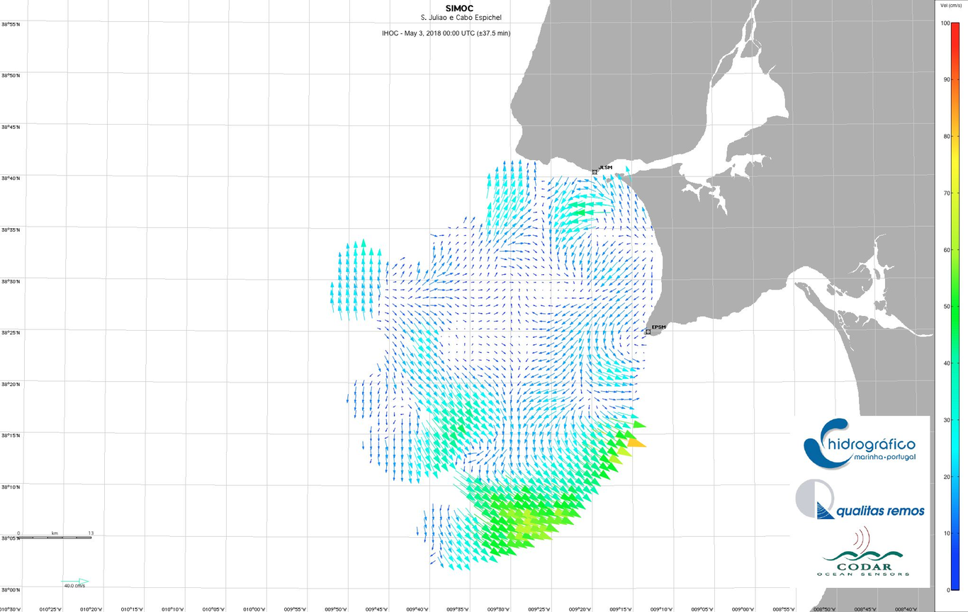
HF Radar data from
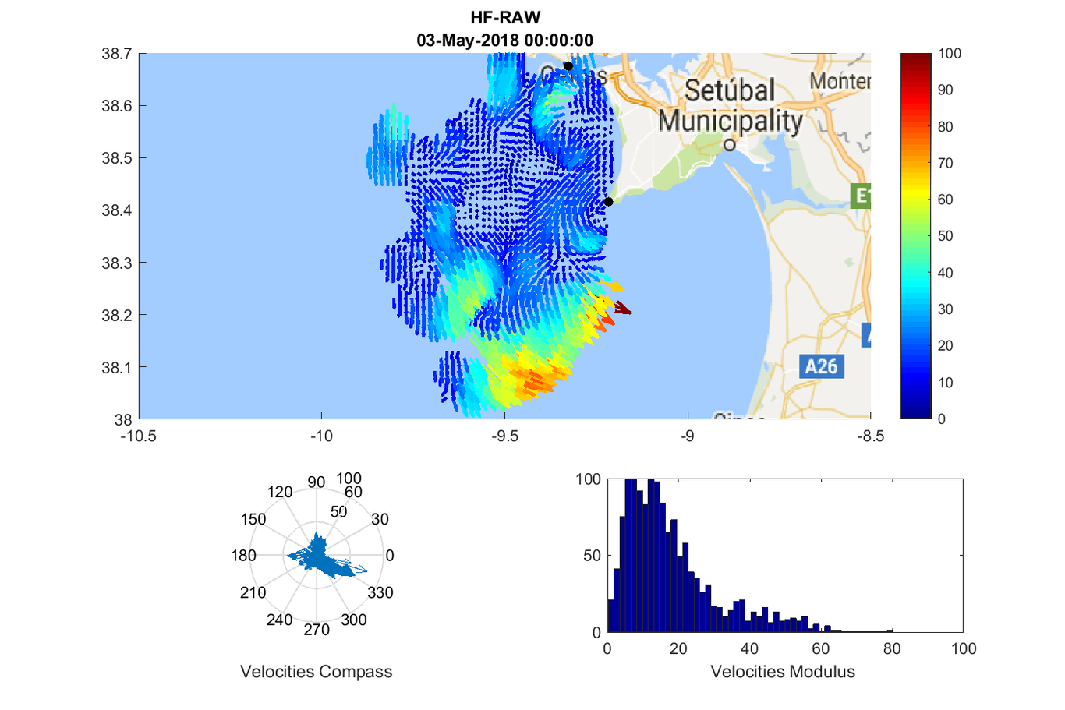
This is a caption

Mohid Operational System
To be able to compare HF Radar data and avoid issue at the boundary the domains

Study Region

HF Radar Data

Mohid Operatioanl System

Analisys

References

Thesis and a few publications for boundary conditions:
Leitão P C (2003). Integração de escalas e de processos na modelação no ambiente marinho. PhD thesis. Technical University of Lisbon, Portugal. (In Portuguese) [Download]
Leitão P, Coelho H, Santos A, Neves R. Modelling the main features of the Algarve coastal circulation during July 2004: A downscaling approach. Journal of Atmospheric & Ocean Science. 2005; 10(4): 421-462.

Riflet G, Juliano M, Fernandes L, Leitão PC, Neves R. Operational ocean forecasting of the Portuguese waters. Mercator-Ocean Quarterly Newsletter. 2008; 30: 20–32.

For data assimilation
Canas A (2009). Modelling and data assimilation techniques for operational hydrodynamic forecast in Tagus Estuary. PhD thesis. Technical University of Lisbon, Portugal. [Download]
Canas Â, dos Santos A, Leitão P. Implementation and validation of a SFEK data assimilation application for an hydrodynamic model of the Tagus Estuary. XI International Symposium on Oceanography of the Bay of Biscay. 2-4 April 2008, San Sebastian, Spain. Revista de Investigacion Marina, 3, 159-160.

NOTES:
The MyCoast project is 32 months long and the iFADO project is 48 months long. The main work region of are in the first case the waters around the Tagus and Sado Estuaries (Greater Lisbon area) and in the second case the Western Iberia region. Our assimilation method is commonly using relaxation to other solutions as we are not currently doing some assimilation of data in our models. Usually, we perform nudging in the boundary with larger model solutions such as CMEMS and then let the rest of the model free. Our source code is available at: https://github.com/Mohid-Water-Modelling-System/Mohid.
And we have a wiki where we have been trying to put together the information of the model however it still needs to be further completed to serve as the model manual. This is the assimilation page http://wiki.mohid.com/index.php?title=Module_Assimilation. If you want we could provide you with username and password so while you are doing some revision you could help to complete the information. Some conceptual information can be found in Paulo Chambel
For data assimilation, MOHID has little experience, some details are on this docs and they are related to the Module
ModuleSequentialAssimilation
Jorge Palma

In MARETEC we are running both in Linux and Windows systems, more commonly in the latter as it’s easier to pass models from one machine to another and also cause it’s a big sector of our users however we probably will have to operate some applications in LINUX machines in the near future. Regarding the problems you found while compiling in LINUX, I’m adding Jorge Palma to the conversation, he prepared the installation guide so he is the person that can probably aid you more with those doubts. I do also agree that we should be able to compile the code in other fortran compilers (in windows and linux) so we may find more bugs and allowing the users to compile the open source code with open source tools. Do you have any experience in compiling in Windows systems?

This is a caption

References
Rodrigues, J. 2015. “The Tagus Estuarine Plume Variability: Impact in Coastal Circulation and Hydrography”. MSc dissertation, Universidade de Aveiro. http://www.nmec.eu/images/teses/TESE{_}FINAL{_}jgrr.pdf.

