Scholarly Article Template
Maheshwaran
The aim of this research is to study and enhance the applications of most profitable technology in cloud computing ever “Virtualization”. Back then, a 15 years before, nobody knows about the tht technology named cloud computing exists. But now, every technologies such as personal computer, mobile phone, tablet pc, even televisions rely on cloud computing. Cloud computing helps greatly in reducing costs, scalability and flexibility in computer services. Virtualization is the technology that helps cloud computing to emerge in a large profitable level. Using virtualization (such as server, network and storage virtualization technologies) , the resource cost is reduced in great level.

Introduction

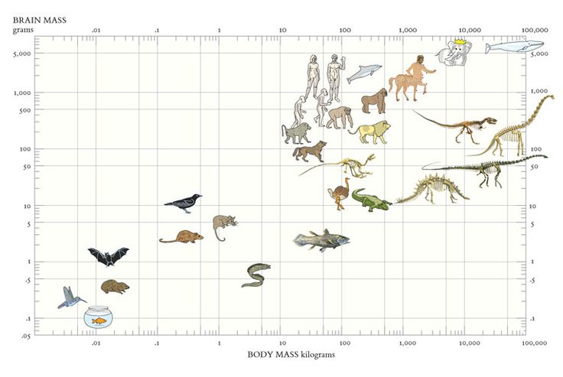
Pellentesque suscipit risus massa, non vestibulum libero euismod feugiat. In hac habitasse platea dictumst. Maecenas rutrum lobortis lobortis. Vestibulum convallis porttitor sem ac ultricies.
Mauris nec massa leo. Mauris ac diam auctor nisl imperdiet porta. Sed sit amet neque eget nisi dictum placerat. Duis sit amet pellentesque odio. Cras scelerisque sem a consectetur vehicula. Aliquam interdum luctus fringilla. Nunc sollicitudin, lorem in semper viverra, dui nisi sodales sem, ut condimentum erat leo eget arcu. Donec pharetra aliquam metus, non pulvinar tellus interdum a. Mauris a ante pharetra, mollis enim in, eleifend erat. Pellentesque suscipit risus massa, non vestibulum libero euismod feugiat. In hac habitasse platea dictumst. Maecenas rutrum lobortis lobortis. Vestibulum convallis porttitor sem ac ultricies. Mauris volutpat fringilla nisl blandit semper. Proin nec iaculis sem. Aenean neque ipsum, pretium a faucibus non, tincidunt ut sapien (Zhou et al. 1988; Boyer 1998) .
Nunc a aliquet sem, eget aliquet purus. Vestibulum ac placerat mauris. Proin sed dolor ac justo semper iaculis. Donec varius, nibh sit amet finibus tristique, sapien ante interdum odio, et pretium sapien libero nec massa. In hac habitasse platea dictumst. Donec vel augue ac sapien imperdiet pretium. Maecenas gravida risus id ultricies dignissim. Maecenas gravida felis quis dolor faucibus, sed maximus lorem tristique. Nam hendrerit quam quis ante porta posuere. Fusce finibus maximus orci at porttitor. Nulla tempor ex a porttitor consequat. Quisque quis tempor eros. Donec nisi mauris, sollicitudin in dapibus eu, interdum ultricies quam Fig ???.

Section
Nunc a aliquet sem, eget aliquet purus. Vestibulum ac placerat mauris. Proin sed dolor ac justo semper iaculis. Donec varius, nibh sit amet finibus tristique, sapien ante interdum odio, et pretium sapien libero nec massa. In hac habitasse platea dictumst. Donec vel augue ac sapien imperdiet pretium. Maecenas gravida risus id ultricies dignissim. Maecenas gravida felis quis dolor faucibus, sed maximus lorem tristique $e^{iπ}+1=0$

Acknowledgements
Lorem ipsum dolor sit amet, consectetur adipiscing elit. Cras egestas auctor molestie. In hac habitasse platea dictumst. Duis turpis tellus, scelerisque sit amet lectus ut, ultricies cursus enim. Integer fringilla a elit at fringilla. Lorem ipsum dolor sit amet, consectetur adipiscing elit. Nulla congue consequat consectetur. Duis ac mi ultricies, mollis ipsum nec, porta est.

References
Zhou, Junmei, Zhixiong Xue, Ziyun Du, Teri Melese, and Paul D. Boyer. 1988. “Relationship of Tightly Bound ADP and ATP to Control and Catalysis by Chloroplast ATP Synthase”. Biochemistry 27 (14). American Chemical Society (ACS): 5129–35. doi:10.1021/bi00414a027.
Boyer, Paul D. 1998. “Energy Life, and ATP (Nobel Lecture)”. Angewandte Chemie International Edition 37 (17). Wiley-Blackwell: 2296–2307. doi:10.1002/(sici)1521-3773(19980918)37:17<2296::aid-anie2296>3.0.co;2-w.

