SYSTEM DEVELOPMENT LIFE CYCLE : MY WORDS
anis
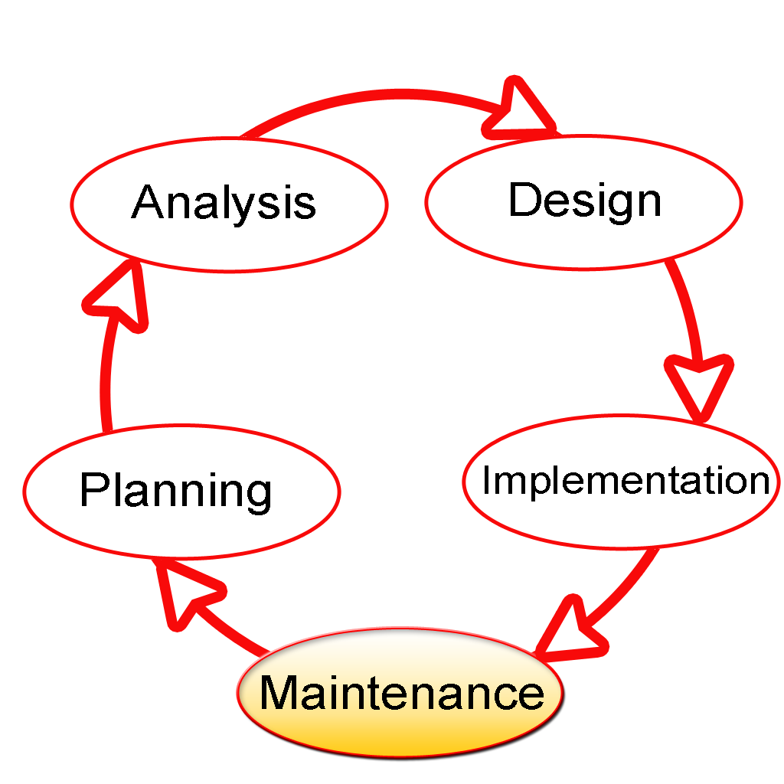
system development life cycle is the system that explain of planning, creating testing and deploying or using of information system. The system development life cycle concept applies to hardware or software or both. There are a few type of system development life cycle such as planning, analysis, design, implementation and maintenance which is known as phases.
from this phase of system development life cycle, I would like to give my words on last phase which is maintenance phase. maintenance phase is occurs after the create the product or after finish its operation. Maintenance programming can incorporate programming updates, repairs, and repaired the programming if have an error. Almost as soon as the system is operational, end users begin to request changes in it. those changes generate system maintenance activities which is could be grouped into 3 type. Firstly, corrective maintenance in response to systems errors, adaptive maintenance due to changes in the business environment and perfective maintenance to enhance the system.
programming applications should be upgraded with new systems the customer deploys. It is important to provide extra testing of the software or version upgrades. During the maintenance phase, errors or defects may exist, which would require repairs during extra testing of the software. Monitoring the performance of the software is also needed in this phase. Every request for change requires retracing the system development life cycle steps make the system is in sense which is always in some stage of system development life cycle. Each system has a predetermined operational life span, but it is actual life span depends on its perceived utility. there are several factors for decreasing the operational life of certain systems. Rapid technological change is one factor especially for system based on processing speed and expandability. Another common factor is the cost of maintaining a system. iF THE MAINTENANCE COST OF SYSTEM IS HIGH, the becomes suspect

