Staph Paper
Arif Nadiadi
Since the advent of penicillin, antibiotics have become widely used as a treatment for most bacterial diseases. However, the increased use of them as a treatment has led the evolution of antibiotic resistance to proliferate across many species of bacteria, and the need for a greater variety of antibiotics has increased. This study stands to show the change in antibiotic resistance over the past 18 years, and see how mechanisms of action may affect this change. Data was collected by students who isolated and grew Staphylococcus in a lab setting. The bacteria was then plated and five different antibiotic discs were placed to measure antibiotic sensitivity. Overall, a change in resistance to antibiotics was not observed for any of the five antibiotics used, although resistance did fluctuate between each year. In the context of this study, the data may suggest that Staphylococcus has not been affected by antibiotic use, and continues to be sensitive to a variety of antibiotics. Yet, this contrasts what is expected and known about antibiotic resistance, especially with the identification of Methicillin-resistant Staphylococcus aureus (MRSA). As all data was student collected, it is difficult to control for confounding variables created by each student, and as such the results of this study should be regarded with great scrutiny.

Introduction:
Antibiotic use has proliferated greatly over the course of the last 80 years, and has become a common treatment for a great number of bacterial infections. Unfortunately, the advent of antibiotic use has also led to the rapid increase in antibiotic resistant bacteria due to their great use and misuse (Barbosa and Levy 2000). Resistance to antibiotics can develop through various processes, and in the case of antibiotic use, is most likely attributed to the random chance that a bacteria has gained the ability to survive in antibiotics through mutation and gene exchange (Levy 1998). When a viable bacteria is able to grow in an environment with antibiotics, it gains a fitness advantage that quickly allows it to spread and outperform other members of its species that lack the ability. Treating an infection with antibiotics causes all susceptible bacteria to die or stop growing, as a result, the only bacteria left will be those that are not affected by the particular mechanism of action of the antibiotic, as well as any that have the ability to resist the mechanism, allowing unchecked growth of surviving bacteria. In this manner, antibiotic use serves as a method of contributing to its own ineffectiveness, and the propagation of bacteria with innate resistance.
The breadth of the diversity found within the kingdom of bacteria has led to the necessity of multiple multiple types of antibiotics with various mechanisms of actions. One of the most common antibiotics, penicillin, is an example of a beta-lactam antibiotic. Beta-lactam antibiotics work by inhibiting cell wall synthesis, a core component of all bacterial cells that when interrupted causes cells to lyse (Tomasz 1979). This method has been found to be very effective and today we find that most antibiotics in use are found in the class of beta-lactam antibiotics. However, another mechanism of action common today is through the inhibition of protein translation. For example, tetracycline antibiotics function by binding to the A site found on the small ribosomal subunit, this serves to stop mRNA from binding to the same location and stops all growth and reproduction of the cell (Connell et al. 2003). While we see resistance develop to all types of antibiotics, it is not well studied on how quickly resistance develops to each type of antibiotic. This study serves to discover if antibiotic resistance develops at different rates in response to antibiotics with different mechanisms of action. It is believed that more complex mechanisms of action will likely require a more complex change to confer resistance, and as a result it will likely be seen that bacteria will gain resistance to beta-lactam antibiotics more quickly than antibiotics targeting ribosomal translation.

Methods:
15 years of resistance data was recorded by students at the University of Colorado Boulder through participation in a microbiology lab course. The target test bacteria were those of the genus Staphylococcus as they are commonly found as part of the human microbiome, as well as contain species known to be antibiotic resistant such as Methicillin-resistant Staphylococcus aureus (MRSA). Students began isolation by swabbing their own nose and skin and inoculating m-Staphylococcus broth, a medium with a high salt concentration (7.5% NaCl) and manitol to inhibit growth of other bacteria and promote growth of Staphylococcus aureus. Turbidity analysis indicated growth in the broth and bacteria in the culture were plated on Vogel-Johnson media in order to differentiate for Staphylococcus aureus and isolate colonies. Isolated colonies were then inoculated into trypticase soy agar slants (TSA) and trypticase soy broth (TSB) for further analysis. From TSB, blood agar plates were streaked to determine β-hemolysis and to differentiate S. aureus from S. epidermidis and S. saprophyticus. To further differentiate S. aureus from S. epidermidis and S. saprophyticus, DNase test agar was streaked from TSA slants, where clear zones indicate organisms with the capability to cleave DNA, such as S. aureus. Catalase and latex test were also performed for further differentiation of isolated colonies, and once bacterial species was determined another TSB was inoculated. After identification, antibiotic sensitivity tests were performed on isolated colonies. Once isolated colonies were identified, Mueller Hinton Agar plates were inoculated from final TSB. Utilizing the Kirby-Bauer method, antibiotic discs of penicillin G, oxacillin, cephalothin, vancomycin, tetracycline, and erythromycin were added to the plates and allowed to grow for 24 hours. To measure antibiotic sensitivity, zones of inhibition were measured and sensitivity was ranked to be resistant, intermediate, or sensitive. Penicillin G, cephalothin, oxacillin, and vancomycin were grouped as beta-lactam antibiotics, while tetracycline and erythromycin made a second group of antibiotics that target ribosomal activity.
In order to analyze data, the mean resistance for each antibiotic was recorded for each year by assigning a value of 1 for resistance, 2 for intermediate, and 3 for sensitive. A mean value then gives a quantitative value of how sensitive or resistant the bacteria was to a specific antibiotic that year. In this manner, a value closer to one indicated a high antibiotic resistance, while a value closer to three shows a high sensitivity towards an antibiotic. A linear regression analysis was run with year (2003-2018) as the explanatory variable for antibiotic resistance to determine a trend in how resistance has changed over time, no data was recorded in 2005, 2006, and 2009. A test was run for each antibiotic separately to follow each trend individually as well as to separate mechanisms of action. Due to the results observed in the output of each linear regression, further analysis to determine differences between each antibiotic was not completed.

Results:
P-values for each slope calculated are reported as follows: penicillin G =0.302, cephalothin=0.224, oxacillin=0.442, vancomycin=0.276, erythromycin=0.945, and tetracycline=0.810. With such high p-values, the analysis suggests that the slopes for each antibiotic all approximated zero, and there was no significant change in antibiotic resistance over the course of 15 years as seen in figure 1 which shows the mean antibiotic sensitivity for each antibiotic each year. 2018 contained an outlier for the antibiotic, vancomycin, this point was kept in through analysis as it did not significantly change the output. Through visual analysis, it was observed that Staphylococcus was highly resistant to penicillin while approximately similarly sensitive to the other five antibiotics.
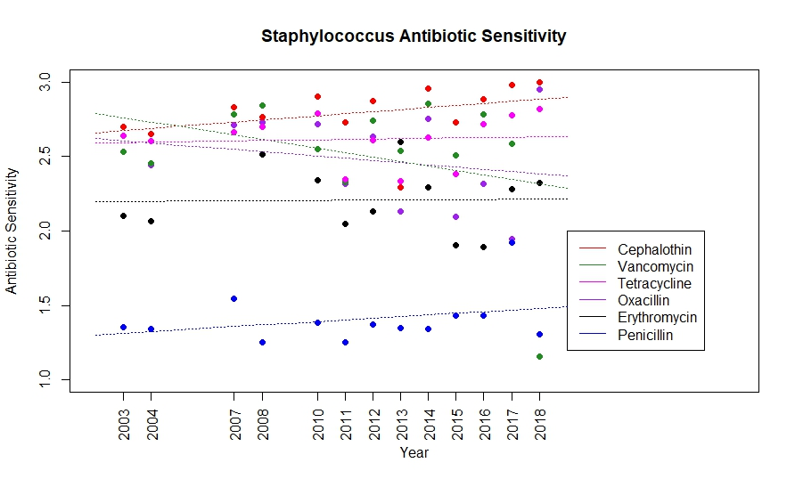
Shows the mean antibiotic sensitivity of each antibiotic at each year. A value of 1 indicates high resistance to an antibiotic while a value of 3 indicates high sensitivity to it. Includes trend line from linear regression output. No antibiotic trend line was found to be significantly different from zero.

Discussion:
Analysis of this data showed no significant trend towards an increase or decrease in antibiotic resistance over the course of 15 years. Linear regression found all slopes to approximate zero, which indicates that these Staphylococcus species have not significantly changed in their resistance to the six antibiotics tested. These results contrast previous findings of many studies that have found antibiotic resistance to increase over time, not only in Staphylococcus, but also in other microbial communities such as soil (Ghosh and LaPara 2007; Ridley et al. 1970; Guillemot et al. 1998; McGowan 1983). While many studies support an increase in antibiotic resistance in bacteria over time due to the use of antibiotics, this study may fail to support this claim for various reasons.
15 years of data lends itself for well supported results, however, the collection method of this data allows for great variability and error. Student collection allowed for a lot of data to be gathered in short periods of time, however, individual collection contributed to differences between each sample. Mistakes and differences will stem from each individual performing methods and recording data in different ways, introducing many confounding variables. Furthermore, this study did not account for differences due to each Staphylococcus species isolated, which may show different trends individually.
In addition, mechanism of action cannot be shown to attribute to differences in the rate of antibiotic resistance being gained. All antibiotics, of both types studied, did not show any change in antibiotic resistance, which suggests that there are no significant differences that can be associated with the mechanism of action for an antibiotic. However, it has already been shown that the data gathered do not seem to hold reliable in drawing conclusions. As a result, it cannot be said with certainty that an antibiotics mechanism of action does not affect the rate at which Staphylococcus gain antibiotic resistance. In conclusion, this study does not serve as a good indication of the trends of antibiotic resistance in Staphylococcus. Further research would be required to create an effective experiment that tests for accurate changes in resistance. If a study can measure significant changes in antibiotic resistance, it would be notable to record differences due to the type of antibiotic. These differences may allow for a better understanding of the rate that antibiotic resistance increases, and which antibiotics may contribute to faster changes.

References
Barbosa, Teresa M., and Stuart B. Levy. 2000. “The Impact of Antibiotic Use on Resistance Development and Persistence”. Drug Resistance Updates 3 (5). Elsevier BV: 303–11. doi:10.1054/drup.2000.0167.
Levy, Stuart B. 1998. “The Challenge of Antibiotic Resistance”. Scientific American 278 (3). Springer Nature: 46–53. doi:10.1038/scientificamerican0398-46.
Tomasz, A. 1979. “The Mechanism of the Irreversible Antimicrobial Effects of Penicillins: How the Beta-Lactam Antibiotics Kill and Lyse Bacteria”. Annual Review of Microbiology 33 (1). Annual Reviews: 113–37. doi:10.1146/annurev.mi.33.100179.000553.
Connell, S. R., D. M. Tracz, K. H. Nierhaus, and D. E. Taylor. 2003. “Ribosomal Protection Proteins and Their Mechanism of Tetracycline Resistance”. Antimicrobial Agents and Chemotherapy 47 (12). American Society for Microbiology: 3675–81. doi:10.1128/aac.47.12.3675-3681.2003.
Ghosh, Sudeshna, and Timothy M LaPara. 2007. “The Effects of Subtherapeutic Antibiotic Use in Farm Animals on the Proliferation and Persistence of Antibiotic Resistance among Soil Bacteria”. The ISME Journal 1 (3). Springer Nature: 191–203. doi:10.1038/ismej.2007.31.
Ridley, Mark, Dinah Barrie, R. Lynn, and K.C. Stead. 1970. “ANTIBIOTIC-RESISTANT STAPHYLOCOCCUS AUREUS AND HOSPITAL ANTIBIOTIC POLICIES”. The Lancet 295 (7640). Elsevier BV: 230–33. doi:10.1016/s0140-6736(70)90585-4.
Guillemot, D, C Carbon, B Balkau, P Geslin, H Lecoeur, F Vauzelle-Kervroëdan, G Bouvenot, and E Eschwége. 1998. “Low Dosage and Long Treatment Duration of Beta-Lactam: Risk Factors for Carriage of Penicillin-Resistant Streptococcus Pneumoniae.”. JAMA 279: 365–70.
McGowan, JE Jr. 1983. “Antimicrobial Resistance in Hospital Organisms and Its Relation to Antibiotic Use.”. Rev Infect Dis 5: 1033–48.

