Prevalence of vancomycin-resistance in MRSA isolates
Claire Mastrangelo
ABSTRACT
The incidence and mortality of antibiotic resistant infections is increasing worldwide. In the United States Methicillin-resistant Staphylococcus aureus (MRSA) is particularly concerning. Many studies focus on nosocomial MRSA infections however the incidence of community acquired MRSA is increasing. In this study we examine the prevalence of vancomycin resistance in MRSA isolates from a general population of college students. We found that of MRSA isolates, 46% were either fully or intermediately resistant to vancomycin compared to methicillin sensitive strains of which just 14.2% were resistant to vancomycin.
INTRODUCTION
Antibiotic resistant infections cost an estimated $35 billion annually in both direct healthcare costs and lost productivity in the United States, as well as causing more than 23,000 deaths. Methicillin Resistant Stapholoccocus aureus (MRSA) infections pose a significant healthcare risk with an estimated 80,000 cases and 11,000 deaths per year in the U.S. (CDC 2016).
Methicillin is a $β$-lactam antibiotic that limits bacterial growth by blocking peptidoglycan cross-linking and thus preventing cell wall synthesis (Madigan 2018). It was traditionally used as a treatment for S. aureus that was resistant to other antibiotics however MRSA is becoming increasingly more prevalent (Rai et al. 2016). Vancomycin is currently listed as the most effective treatment for several types of MRSA according to the guidelines supported by the infectious disease society of America (Liu et al. 2011). Similarly to methicillin, vancomycin targets peptidoglycan synthesis however it falls into the class of polypeptide antibiotics. Vancomycin-resistant S. aureus is becoming an increasing concern. Bacteria tend to carry antibiotic resistance genes on plasmids which can be transferred to other bacteria via horizontal gene transfer (Madigan 2018). Are S. aureus that are resistant to Methicillin also resistant to vancomycin? With the increase use of vancomycin in treating MRSA infections we hypothesize that there will be a positive association between resistance to methicillin and resistance to vancomycin.
METHODS
We isolated S. aureus from the nose and hands of college students from 2003-2018. The samples were initially grown in m Staphylococcus broth. Samples exhibiting growth were then plated on Vogel-Johnson Medium to further select for Staphylococcus bacteria and positive isolates were then used to inoculated Tripticase soy agar (TSA) slats and Tripticase soy broth (TSB). After 24 hours, Catalase and latex tests were run on samples from the TSA slants. The TSB sample was diluted to McFarland standard and plated on a blood agar plate with furazolidone, bacitracin, and novobiocin antibiotic disks. Finally, samples determined to be S. aureus were plated from the TSB culture onto TSA with vancomycin and oxacillin disks. Zones of inhibition were measured 24 hours later and samples were categorized as sensitive, intermediate, or resistant based on the diameter. Because methicillin is no longer available, oxacillin, a similar $β$-lactam drug, was used to determine sensitivity to methicillin.
Bacteria can exhibit varying levels of resistance, making it challenging to quantify and categorize resistant versus susceptible. Here were used the diameter of the zone of inhibition to determine if a sample was sensitive, intermediate, or resistant. In order to run a linear model, sensitive bacteria were assigned a value of 0, intermediate 0.5, and resistant 1.
RESULTS
There is a positive association between resistance to oxacillin and resistance to vancomycin in Stapholoccuss aureus, with susceptible bacteria assigned to 0, intermediate 0.5, and resistant 1. The linear model shows a positive effect (B1=0.28$\frac{+}{−}$0.08) of oxacillin resistance on vancomycin resistance. We can refute the null hypothesis that there is not effect of methicillin resistance on vancomycin resistance based on the small p-value (<0.001) and the confidence interval that does not cross 0.
Of the 140 isolates determined to be MRSA, 55 were also resistant to vancomycin (39%) and 10 were intermediately affected by vancomycin (7%). Conversely, only 58 (12.2%) and 9 (2.2%) of the 407 methicillin sensitive isolates were resistant and intermediately resistant to vancomycin respectively.

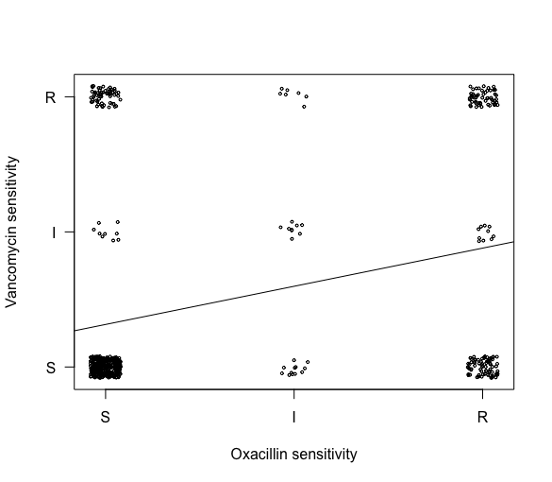
Shows the association between resistance to oxacillin (similar to methicillin) and resistance to vancomycin for isolates of S. aureus. S indicates sensitive isolates, I intermediate, and R resistant. The trend line indicates the results of the linear model (B1=0.28$\frac{+}{−}$0.08, p-value < 0.001).
Fig. 1 shows the association between resistance to oxacillin (similar to methicillin) and resistance to vancomycin for isolates of S. aureus. The trend line indicates the results of the linear model (B1=0.28$\frac{+}{−}$0.08)
DISCUSSION
There is an association between resistance to vancomycin and resistance to oxacillin in the samples isolated. This trend has also been observed across studies in nosocomial infections (Hasan, Acharjee, and Noor 2016). The high prevalence of MRSA isolates demonstrating full or intermediate resistance to vancomycin (46%) is concerning. Though these samples were primarily taken from young, healthy individuals, the incidence of community acquired MRSA is increasing. These strains may easily be transmitted to other individuals or become pathogenic if their current host becomes immunocompromised (CDC 2013). Individuals infected with MRSA that is resistant to vancomycin will be more costly and difficult to treat, and are at increased risk of death.
It is also interesting that vancomycin resistance is more common in MRSA than in methicillin-sensitive isolates. This indicates that there is some selective pressure that makes vancomycin resistance more advantageous in MRSA than in methicillin-sensitive isolates. This study emphasizes the need for alternative treatments for MRSA and VRSA including new antibiotic targets.
Future studies including extensive metadata for samples may offer insight into why some individuals are more likely to harbor multi-drug resistant (MDR) S. aureus than others. Because bacteria are able to share plasmids via horizontal gene transfer, it may also be beneficial to examine how the microbiome of an individual influences the prevalence of MDR S. aureus. Information about why some people are more likely to be colonized with MDR S. aureus may also provide ways to prevent drug-resistant S. aureus infection in individuals who are at risk.

References
Rai, M., K. Kon, A. Gade, A. Ingle, D. Nagaonkar, P. Paralikar, and S.S. da Silva. 2016. “Antibiotic Resistance”. In Antibiotic Resistance, 121–43. Elsevier. doi:10.1016/b978-0-12-803642-6.00006-x.
Liu, Catherine, Arnold Bayer, Sara E. Cosgrove, Robert S. Daum, Scott K. Fridkin, Rachel J. Gorwitz, Sheldon L. Kaplan, et al. 2011. “Clinical Practice Guidelines by the Infectious Diseases Society of America for the Treatment of Methicillin-Resistant Staphylococcus Aureus Infections in Adults and Children: Executive Summary”. Clinical Infectious Diseases 52 (3). Oxford University Press (OUP): 285–92. doi:10.1093/cid/cir034.
Hasan, Rashedul, Mrityunjoy Acharjee, and Rashed Noor. 2016. “Prevalence of Vancomycin Resistant Staphylococcus Aureus (VRSA) in Methicillin Resistant S. Aureus (MRSA) Strains Isolated from Burn Wound Infections”. Tzu Chi Medical Journal 28 (2). Medknow: 49–53. doi:10.1016/j.tcmj.2016.03.002.

