Application and Improvement of SE in Zuidosk Project
Barrak Alfares
This paper will discuss the experience of using an SE process in the Zuidosk Project. It will also discuss the extent to which SE is implemented and problems faced. An analysis is done to see where team members found difficulty dealing with SE process. Recommendations will be suggested to improve the SE process. Team members were in a learning process and did not yet possess all the SE knowledge and skills required.

1.Introduction
This brief individual paper will state how much Systems Engineering was applied and how it could be improved in Zuidasdok Project. This paper uses a literature review and empirical part, and it is based on my experience in collaborative design and systems engineering principles provided and discussed in class.
By using a questionnaire and submitted reports, it is possible to assess the amount of system engineering applied.
To gather empirical data a questionnaire was used to assess the situation of the design team in relation to the problems and issues faced during this project. All team members did a questionnaire that was cross-referenced with the main problems and ranked on repetition of keywords.
A theoretical part of SE is discussed in comparison to the actual methods used for this project. Recommendations and assessments are done side by side following the SE process.
This paper is divided into sections. First SE process will be discussed and compared to what has been implemented in the project (2. SE Process). Second, The method used for gathering data and the structure of the questionnaire (3. Method). Third, The results of the questionnaire and an analysis (4. Results and Data Analysis) and lastly a conclusion (5. Conclusions)

2. SE Process
The definition of systems engineering goes back to a few limited sources. Between these three repetitive names: INCOSE, Charles S. Wasson and Alexander Kossiakoff. Alexander Kossiakoff defines it best stating that “ The function of systems engineering is to guide the engineering of complex systems “(Kossiakoff, A. 2011).

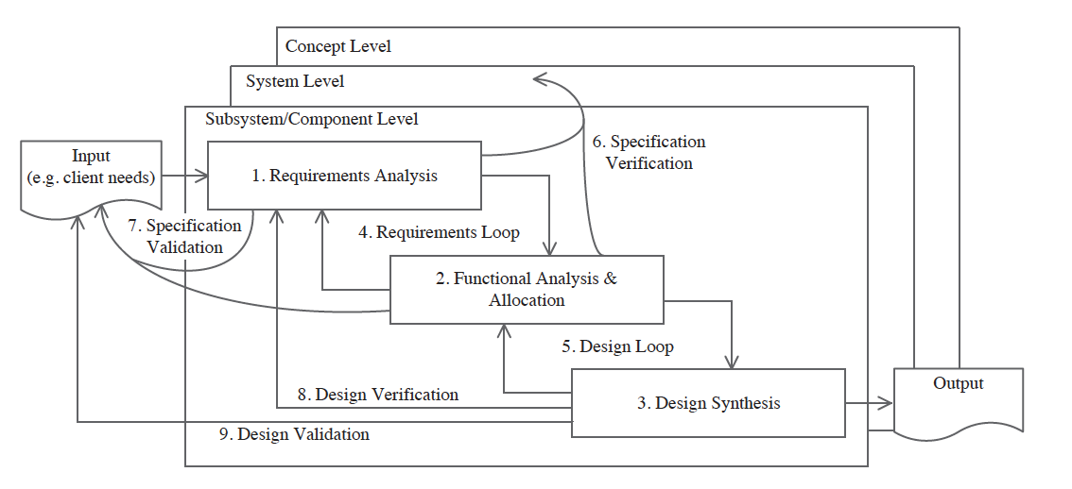
SE Process (Graaf, R. et al 2017, USA. 2001)
Systems engineering is an integrated design methodology. It starts off with requirement analysis from different stakeholders then build these requirements into functions. These functions are then organized into objects then transformed into design solutions while satisfying all the requirements. This is the team’s SE methodology. The following paragraphs will go into detail of the steps implemented in this approach, starting with a behavioral setting, that talks about the preconditions that were applied for this project.
Behavior:
Our team is comprised of a mix of students with and without work experience. Most of their undergraduate years in engineering studies involved being trained over and over again in an educational environment, which is different from the systems engineering process. Team members were in a learning process and did not yet possess all the SE knowledge and skills required. Therefore to flourish, there has to be a shift in mind and behavior.
Readings are given in class about SE, however just as an overview. More in-depth readings are needed to have a better sense of this framework. As a concept it is fully understood, However, there has to be a behavior shift from traditional ways to Systems Engineering process to do this correctly.
An interesting video played during class about Ringlemens effect; which describes the propensity of team members to use fewer efforts when they are part of a group. This is only true if there is an alignment of goals, therefore, each member contributes less to a group. If the tasks were done individually then efforts would increase (Kravitz et al. 1986).
This process loss as described in class could be due to motivation, where members were less motivated and even worse don’t understand the SE process, which was the case. , as described in class, could be due to motivation, where members where less motivated and even worse don’t understand the SE process, as was the case. Another reason could be accountability, the whole consortium had a total of 21 members, and their actions could have little impact on the project and while believing in the efforts of their colleague. This is an inversely related aspect, where the fewer the members the more they will contribute. This is an important point because as you follow along with the SE process these two behavior concepts keep on resurfacing.
Requirement Analysis (RA) : Problem Definition

To solve a problem one should first understand it. This falls entirely on the systems engineer to analyze and document all the requirement and specifications in order to easily grasp the concept and satisfy the needs of the system.
The requirements analysis phase starts with the input data gathered from interviews with the client and stakeholders, then translating these demands and needs into measurable requirements. Inputs from interviews were recorded, documented and discussed among team members. These requirements define what this system should do and simultaneously gauge its performance. The Clients and Stakeholders were analyzed and ranked based on their influence and interest using a Power Interest Grid. Their decisions will shape the outcome of the project. This will help determine which requirement has priority over the other, and whom to satisfy their needs first.
Additionally, a verification and validation plan (V&V) should be used to check if these requirements have been met. (Farnham, R., & Aslaksen, E. W. (2015) Unfortunately, the V&V plan was not devised at the beginning of the project. It was not planned until our third interview with the Client. When we were told that our concept phase was completely wrong because no other options were made that a verification process is needed with evidence to prove the verification of the requirement has been met. The requirements were organized using a numbering system, making it easily traceable to their identity number.
During this framework, the team used a requirement list. This list is comprised of a number of requirements, which are organized in an upper level and lower level, to reflect a requirements breakdown structure (RBS). Also, the requirements were done to meet the SMART standards as closely as possible. This could be a problem because having requirements that don’t follow the SMART standard makes it difficult for the design team and well as other members to come up with neutral solutions.
There are two different types of requirements that contribute to Zuidasdok Project: operational and functional. (Kossiakoff, A. 2011) Operational requirements are taken as an overview of the whole system. It relates to the purpose of the system and describes how will it operate. Operational requirements were not considered nor discussed during our time. As a team, the focus was mostly on the functional requirements and its effects on the design. Operational requirements somewhat relate to all the requirements. The tasks of the system are written in an action-oriented way by focusing on the function’s requirements (Kossiakoff, A. 2011, ). One automatically takes into account the operational requirements.
Functional Analysis and Allocation: Functional Definition
Now that the requirements have been completed, the team transitions into functional analysis and allocation phase. The main focus here is deriving functions from the requirements. These functions are solution neutral, which expresses how the system works and models the functionality of the system(Graaf, R. et al. 2016).
The project team determines the task that the system should perform. These tasks are derived from the requirements in the requirement analysis phase. These tasks are then rephrased into functions. These functions should be described in “solution neutral” way to increase creativity (). Refer to Appendix C for an example used in the FAST diagram. These functions are phrased in a verb/noun format. The group here did not expand the functions. There was no basic functions and support functions. Fast diagrams were needed to understand “how and why” the system will function. By breaking these functions into small items they are easier to manage. Therefore, it can easily be connected to objects. Connecting the functions into the object will result in an object tree (Appendix D object tree). The functional analysis and allocation phase could be improved. This is done by introducing a system verification, after deriving the functions. Not all functions were described in the appropriate ways, which had to be redone again, causing loss of efforts and time.

Requirements Loop:
The requirement loop starts after completing the functional analysis. Several iterations have been done, because the functional analysis brought new possibilities, thus affecting the requirements(Graaf et al. 2017). This triggers another round of requirements analysis. Going back and forth between these two states is what the group did for the design. These loops were not documented and it was done verbally. This puts the team at a disadvantage because this situation has no history. As the team progressed through the SE process, there was a point where the team had to go back and do drastic changes. Lack of documentation caused problematic differences between the groups. These difference were overcome when the team redid the whole requirements list and functions. Here the team has succeeded in aligning the functions to the requirements.
Design Synthesis:
After the requirement loop was completed, the team transitioned into the design synthesis phase, where all previous activities of requirements and functional analysis converge resulted in design solutions. These design solutions were matched to the needs of the client and stakeholder and only one design solution is picked by the team. This final solution is traceable in which it meets all requirements, functions, and object. The object here matches its function and requirements.

Design Loop

The design loop starts after completing the design synthesis where a definite alignment between functions and requirements exist. Several iterations have been done, because the design synthesis brought new possibilities, therefore affecting the requirements (Graaf et al. 2016). This triggers another round of requirements analysis. Going back and forth between these two states is what the group did for the design. These loops were not documented and it was done verbally. This puts the team at a disadvantage because this situation has no history. As the team progressed through the SE process, drastic changes had to be done. There was a point where the team has to go back and do drastic changes. Due to the lack of documentation, problems between the groups arose. This step caused problematic differences between the groups. These difference were overcome when the team redid the whole requirements list and functions.
Verification & Validation

Verification and validations is an essential part of the SE process. It determines if all the information used connects to one another. In addition, it satisfies the client and stakeholder. It makes sure that the solution meets the system requirements. It confirms the solution has met with the system requirements(Wasson, C. S. 2015). The verification list has a direct relationship to the requirements list sheet (refer to Appendix B). Any changes made to the requirements will trigger a verification check.
The verification process is a series of questions, who is responsible for the requirements? What level of detail is it? What are the methods used for the verification (Marking in design, expert’s opinion, calculation, benchmark, and simulation)? Has it been completed? And if so provide the evidence.
The final step of SE is the validation of the results. In this step the managers met with the client and stakeholders, to make sure the requirements, functions, and objects have met his expectations (Beasley, R. 2017). A validation report is needed to confirm the status of the process in order to transition to the next phase. However, this was not done. It would have been more professional to incorporate a report by means of traceability. The method used was only done to document the changes (appendix A). The Project was done in 3 phases. These phases reflect the level of details mimicking an actual project. Appendix B displays the requirements and verification list where all the requirements have been organized in a numerical system. These numbers are considered identities and also used for traceability and object relation. For example, identity 1.1 is the first level of detail and 1.1.1 is the second level of detail and so on.

3. Method
To analyze the how much SE was applied to the project a questionnaire was used. Appendix D lists the questions and applicant answers. There are six questions that were addressed to the members of the design group (Andrea, David, Dimitris, Jorge, Tim, and Oskar). The questions are the following:
What were the problems of the group?
This is a general question. The reason behind it is to have an overview of the problems relative to the group as a whole. All team members have answered this question and their answers have some overlap. This will help to find similarities when comparing the answers.
What are some problems with your part and how did you go about solving them?
This question is directed for the individual. The members have all been assigned a role, and these roles have responsibilities that the members need to fulfill. Having a project of this caliber and complexity caused the team members to be faced with serious problems and hurdles that needed to be solved and overcomes respectively. And that is the second part of the question if the team member was able to overcome and solve these problems.
What would you do differently about your work?
The team has gained tremendous experience going through and completing the project in an SE format. By asking this question, the members can reflect back on their work and respond well knowing what exactly was expected of them. Thus giving an alternative path or way of working, that could help them reach the objective of their tasks.
What position would you choose if you were to redo this project? Why?
This question was posed to see if there were any members who regret choosing their roles. During the first meeting, the selection of roles was on a call out basis.
What would your advice be for a group doing this next year?
Now that the team has gone through this experience. Their advice should reflect upon their mistakes.
Anything you what to add?
This questionnaire question is used as a precautionary measure. In other words, if there is some topic, problem, or anything unrelated to the SE process and a member would like to include, this question gives that possibility.
This questionnaire was used as input for the analysis of the issues and problems associated with this project. These issues are listed in the following table. The level of importance reflect the occurrences of the members with that problem. A score 7/6/5 means that most if not all members have encountered this problem. A 4/3 describes the 3 or 4 members have faced this problem during the SE process. And lastly, a score of 2/1 has few members subjected to these issues.

4. Results
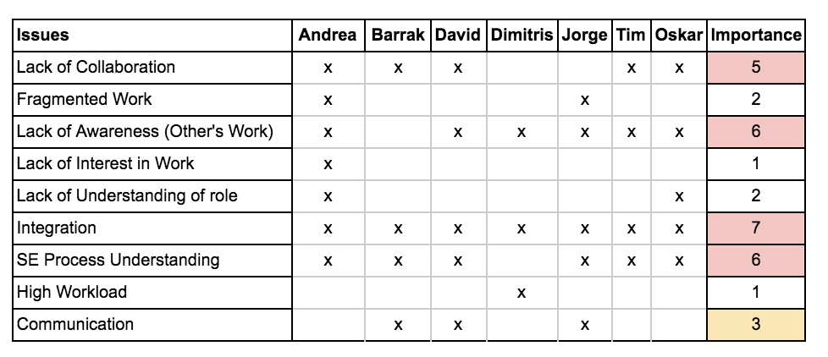
Table of Analysis
Data Analysis

Reflecting back to our experience in SE process, all team members were working independently on their assigned task and responsibility. It is safe to say that indeed there is an interest in their work. It is confirmed that is is also a high workload, however, that is to be experienced by all team members. Fig. 2 states that only one member addressed this as a problem. All team members are aware of and understand their roles and responsibilities and I was surprised to see that two members mentioned the opposite. This means that some members were not doing their job well if not at all. This could lead to fragmented work which does not fit the report for the client. This affects the quality needed for better integration.
Communication is essential for this project and having a score 3/7 is relatively high. The design team has used all means of communication: Whats Up app, Google Drive, Emails, Face to Face meetings, and Phone Calls. Yet as stated in the table above this wasn’t enough. This pulls in the next threat, the lack of collaboration having a 5/7 score. Tasks were done independently, then presented to the group, then to the consortium. Clearly, this process undermines collaboration and when this happens a lack of awareness of the team and others works follow suit.
Lastly, most students had problems grasping the SE process having a score of 6/7. That is the main part of the project, on paper it is understood however to turn these into actions is the problem. This leads to next problem integration, having a score 7/7. All steps taken from start to completion had integration issues because actions and functions feed the phase and the next step. Members were very much dependant on their colleges when it comes to the requirements, object trees, function, and design.

5. Conclusion
Integration plays a big role in systems engineering. It joins together all the necessary requirements, functions, and objects into a design that could be presented to the client and stakeholders. And most importantly it is time and effort consuming (refer to table). One of the comments from the professor states that the integration period for the project plan should be twice in terms of duration compared to the other functions of the SE process. Therefore integration should always be at the forefront when it comes to the SE process
The SE process was the main objective of this course and ironically during the project it wasn’t. The reason being is old habits and behaviors. There has to be a behavior shift from traditional ways to Systems Engineering process to do this correctly. () It takes several tries to transition from the theoretical process of SE to actual functional model.
Collaboration does not happen in a state of solitude. A project is successful if all parties consolidate and act as one. For this to happen the team has to be aware of other members work and help them if needed. This will greatly affect the quality of work and improve the communication between team members and the consortium. This will also reduce process loss.
To prevent process loss the teams (design, construction, and installation) should have been broken down into an even smaller group. This will make team members contribute more to the project by making them feel more important. Another way to reduce process loss would be to explicitly define the roles and tasks to that particular entity, making him/her responsible
Limitations :

There are two limitations for this project. First, the team members are students that have no past experiences with SE. They are trained in an academic environment which is very different from the SE process. Therefore this implementation of the SE process will not be optimized. Second, data was gathered from only the design team which accounts only third of the consortium. This will lead to a blinkered view of what the problems are. Including the whole consortium would give a winder and better understanding of the problems faced however, this would take much time and effort.

References
Farnham, R., & Aslaksen, E. W. (2009). Applying systems engineering in infrastructure projects. Paper presented at the INCOSE Spring conference Nothingham, UK.
Alsem, D., Kamerman, J., Leeuwen, C., Ruijven, L., Toom, T., & Vos, M. (n.d.). (Netherlands, Rijkswaterstaat).
Aslaksen, E. W. (2005). Systems Engineering and the Construction Industry.
Beasley, R. (2017). Realizing the Value of Systems Engineering. INCOSE International Symposium,27(1), 1100-1113. doi:10.1002/j.2334-5837.2017.00415.x
Farnham, R., & Aslaksen, E. W. (2015). Applying Systems Engineering to Infrastructure Projects. Complex Systems Design & Management.
Graaf, R. S., Vromen, R. M., & Boes, J. (. (2017). Applying systems engineering in the civil engineering industry: An analysis of systems engineering projects of a Dutch water board. Civil Engineering and Environmental Systems,34(2), 144-161. doi:10.1080/10286608.2017.1362399
Graaf, R. S. (2014). Basisboek systems engineering in de bouw: Een methodische totaalaanpak van het bouwproces. Nederland: Brave New Books.
Graaf, R. D., Voordijk, H., & Heuvel, L. V. (2016). Implementing Systems Engineering in Civil Engineering Consulting Firm: An Evaluation. Systems Engineering,19(1), 44-58. doi:10.1002/sys.21336
Kossiakoff, A. (2011). Systems engineering: Principles and practice. Hoboken, NJ: Wiley-Interscience.
Kravitz, D. A., & Martin, B. (1986). Ringelmann rediscovered: The original article. Journal of Personality and Social Psychology,50(5), 936-941. doi:10.1037//0022-3514.50.5.936
USA. (2001). Systems Engineering Fundamentals. FORT BELVOIR, VA: DEFENSE ACQUISITION UNIVERSITY PRESS.
Wasson, C. S. (2015). System Analysis, Design, and Development Concepts, Principles, and Practices. Somerset: John Wiley & Sons, Incorporated.
Appendix A Documented Meetings for Design Team

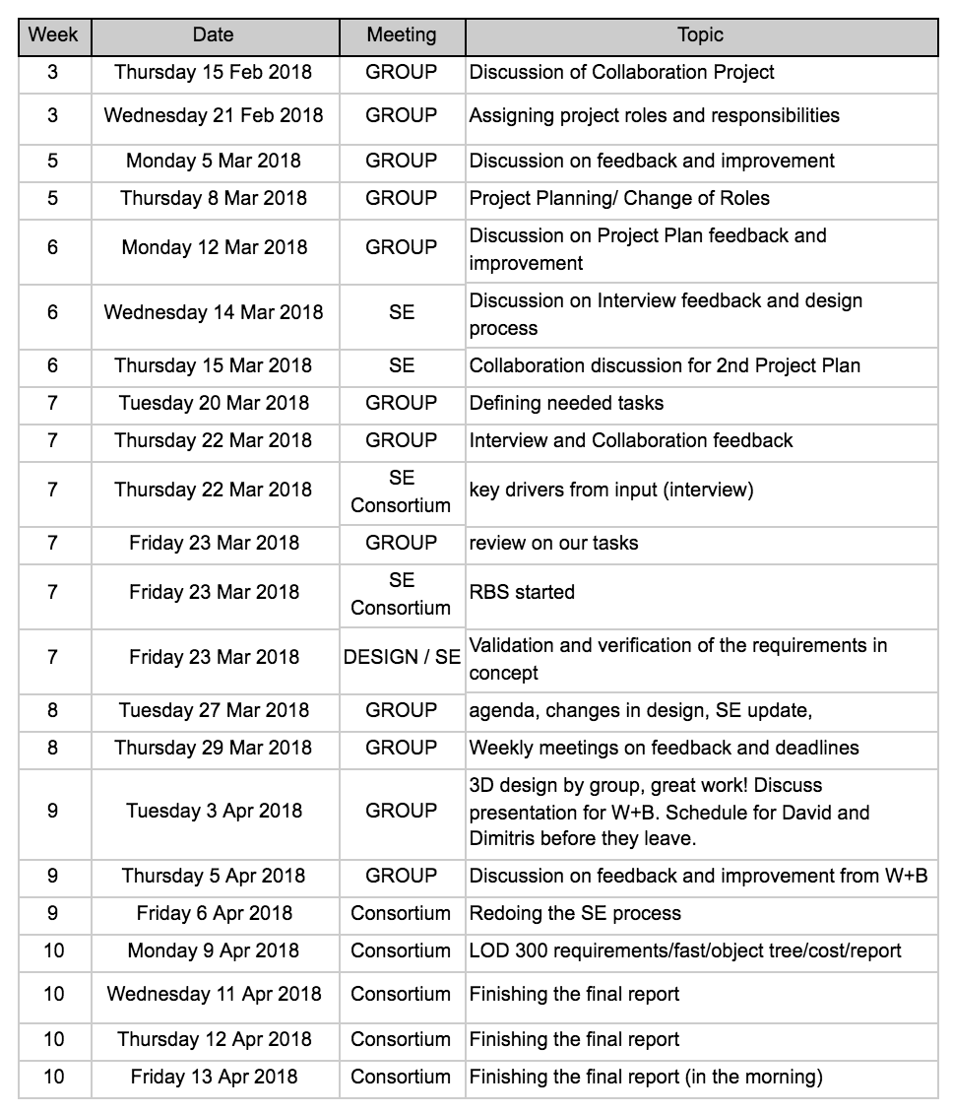
Appendix B: Requirements and Verification List

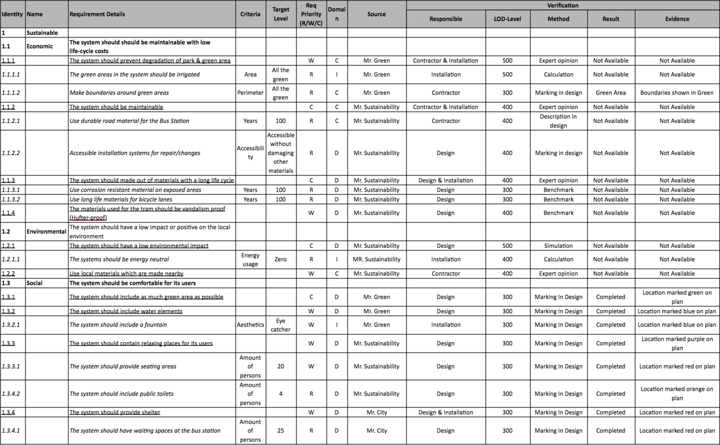
Appendix C FAST Diagram

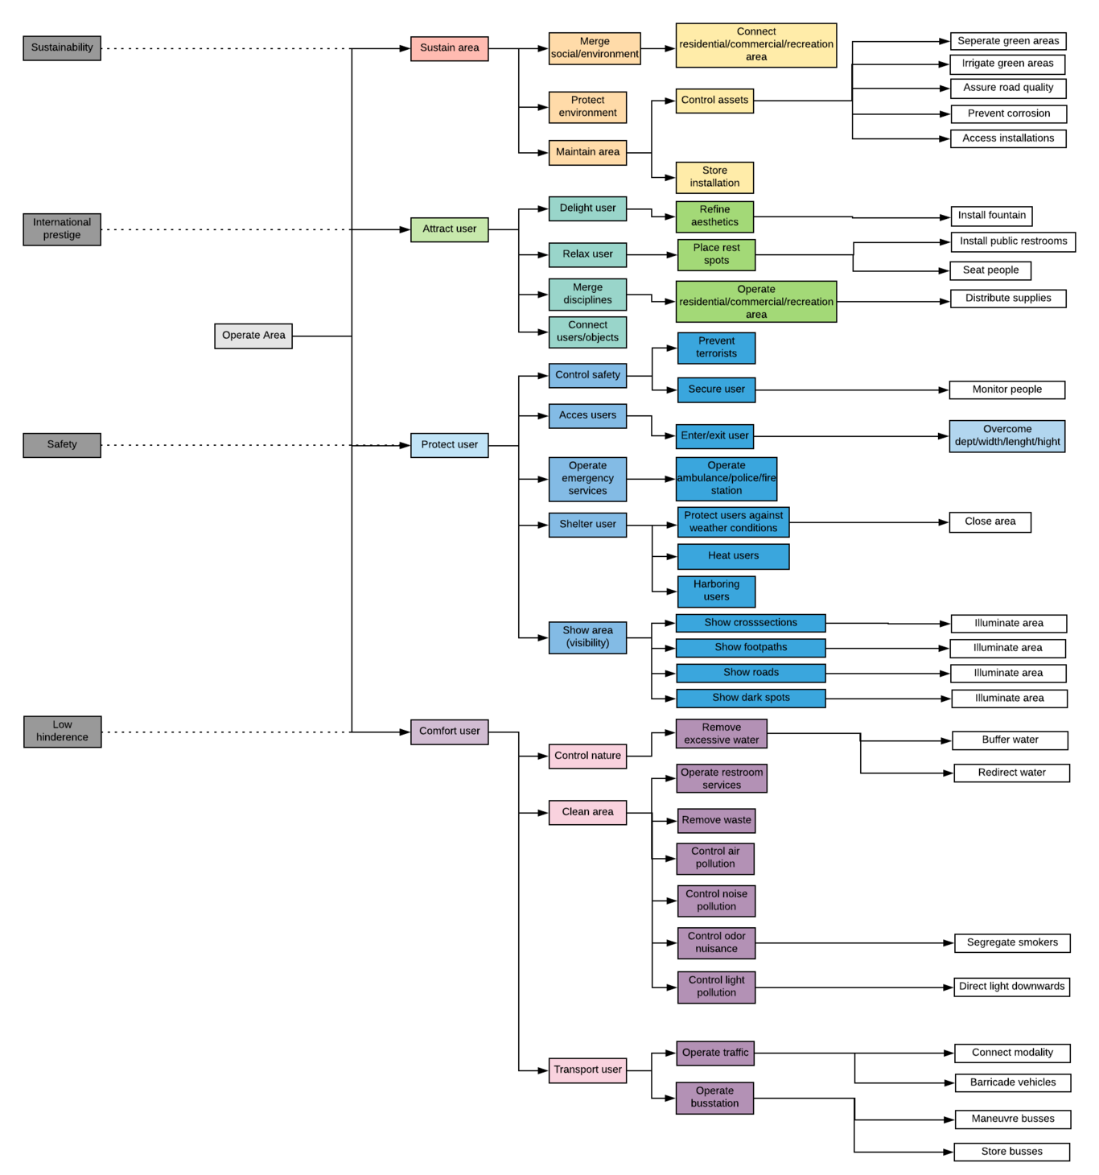
Appendix D Object Tree Diagram

