Volumes of Solids of Revolution & Solids with known cross-sections (Beyond BC- Shell Method)
Naksha Roy
Kate Slinchenkova
Abstract content goes here

Volumes of Solids of Revolution & Solids with Known Cross-Sections (including Multi-Variable)

Riemann Sums and the Definition of a Definite Integral

Approximation of Area under Functions:
Some History:

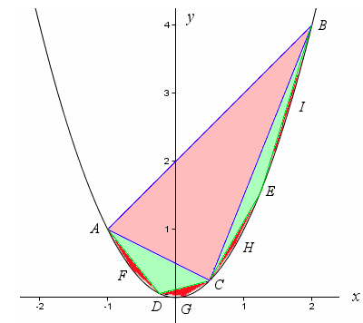
The first person to work on finding the area within or under a curve was Archimedes. He applied it to optimize space (which often helped dispute conflicts regarding trade). He used triangles in order to approximate the areas. As shown here, a parabola can be split into triangles, each becoming smaller (or its area approaching zero).
Riemann Sums:
Although Archimedes was the first to use geometry in order to approximate the area under a curve, Bernhard Riemann (A German Mathematician) was the first to come up with a proof for the integrals we use today.
He stated that by creating approximations with the areas of rectangles, we could break up the domain of the function to such a degree that it would almost be the function itself. Depending on the nature of the function, the Riemann sum would give either and over or under-approximation of the area under the function.
Left Rectangular Approximation:
$L_{n}=Δx\left[f\left(x_{0}\right)+f\left(x_{1}\right)+f\left(x_{2}\right)+...+f\left(x_{n−1}\right)\right]$
Right Rectangular Approximation:
$R_{n}=Δx\left[f\left(x_{1}\right)+f\left(x_{2}\right)+f\left(x_{3}\right)+...+f\left(x_{n}\right)\right]$
Midpoint Rectangular Approximation:
$M_{n}=Δx\left[f\left(\frac{x_{0}+x_{1}}{2}\right)+f\left(\frac{x_{1}+x_{2}}{2}\right)+f\left(\frac{x_{2}+x_{3}}{2}\right)+...+f\left(\frac{x_{n−1}+x_{n}}{2}\right)\right]$
Trapezoidal Approximation:
$T_{n}=Δx\left[\frac{\left(f\left(x_{0}\right)+2f\left(x_{1}\right)+2f\left(x_{2}\right)+...+2f\left(x_{n−1}\right)+f\left(x_{n}\right)\right)}{2}\right]$
To summarize the use of Riemann Sums:
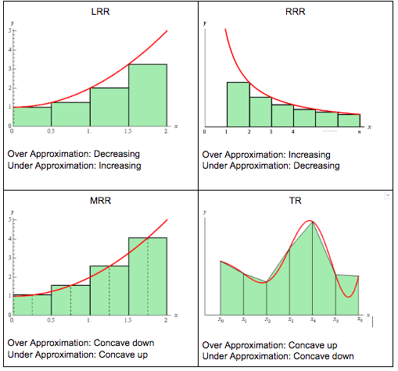
Summary of Riemann Sums
However, if all of these approximations are over or underestimates, how do we get the exact area? No matter how small the change in x is, the Riemann sums will never give the exact area under a function. The key is to use limits…
The Riemann integral is the limit of the Riemann sums as Δx approaches zero (or the number of sums approaches infinity).

Volume of a Solid (with known Cross Sections)
When given a solid with a known cross sections, the volume of the solid is formed by the sum of all the cross sections. The area of the cross section can be found using the given information in the problem. For example, if the problem says that a solid is formed by the base bound by the function f)x) and has rectangular cross sections perpendicular to the x axis with the height being twice the base, then we know that the area of the cross section is equal to $2{\left(f\left(x\right)\right)}^{2}$. If we add up the areas using a definite integral of the area of the cross section, we would get the volume of the solid.

Volume of a solid (Complex Cross Sections)In
A solid with Complex Cross Section is a solid whose cross sections are generally shapes such as triangles or semicircles. In order to find the volume of these solids, the areas of the cross sections need to be related to the function that binds the base. For example, if the cross sections are equaliteral triangles with the base bound by $f\left(x\right)$, the area of the cross section would be equal to $\frac{\sqrt{3}{\left(f\left(x\right)\right)}^{2}}{4}$. Therefore, the Volume of this solid would be equal to $\int_{a}^{b}{\frac{\sqrt{3}{\left(f\left(x\right)\right)}^{2}}{4}}dx$.
In the case of a solid with a semicircular cross section, the same logic is followed and we use the area of a semicircle in order to calculate the volume. Interestingly, a solid with a semicircular cross section comes very close to being a solid of revolution. In fact, it is one half the Volume of it. How do we find the volume of a Solid of Revolution though?

Solids of Revolution (Disk and Washer Method)
One way to find the volume of a solid of revolution is by “slicing” it. This will result in circular cross-sections. The area of each of these circles is equal to $πr^{2}$ where the radius is usually the function value.

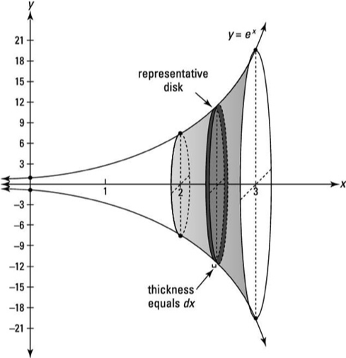
Now, if we add an infinite amount of these heightless areas we get the Volume of the solid of revolution. To do this we use the definite Integral:
$V=π\int_{a}^{b}{{\left(f\left(x\right)\right)}^{2}}dx$
However, what if there is another function that creates a whole in the solid of revolution. In this case, the second function would create create a solid on the inside that would also have circular cross sections. As a result, the volume of the new solid of revolution si found using the Washer Method and can be written as such:
$V=π\int_{a}^{b}{\left({\left(f\left(x\right)\right)}^{2}−{\left(g\left(x\right)\right)}^{2}\right)}dx, f\left(x\right)>g\left(x\right)$
If the function is not rotated about an axis, the radius of the function in the integral needs to be adjusted in order to accurately reflect the solid of revolution formed. This can be done by either subtracting the function from the line value that the function is rotated about or subtracting the line value from the function (depending on the location of each).

Solids of Revolution (Shell Method)
Similarly to the Disk Method, the Shell Method uses known Areas which when added create the volume of the solid. However, in this case, the solid of revolution is “peeled” and the Volume is found by adding up the surface areas of the cylinders that form the solid. Similar to the Disk Method, as the number of “shells”, or cylinders, approaches infinity - we get the exact volume of the Solid of Revolution. Derived from the formula for the surface area of a cylinder (not including the bases), the following formulas are born:
$V=2π\int_{a}^{b}{\left(Radius\right)}\left(Height\right)dx = 2π\int_{a}^{b}{\left(x\right)}\left(y\left(x\right)\right)dx$
$V=2π\int_{c}^{d}{\left(Radius\right)}\left(Height\right)dy=2π\int_{c}^{d}{\left(y\right)}\left(x\left(y\right)\right)dy$
It is interesting to note that there is no equivalent of a Washer Method for the Shell Method because is not necessary - if there is a “hole” inside the solid, inegration using the shell method just avoid the interval where there is a hole.
It is also important to note that if the function was not rotated around a line that is adjacent to the function, the radius or height need to be adjusted to reflect the true radius (since it is no longer just a value y or x).

Multi-Variable Aspect
So far, we have only seen the use of a single integral to find the volumes of solids in the x & y planes. However, multiple integrals can be used to find volume of a 3-dimensional solid formed in the x, y, and z planes. Let’s first take a look at how to solve multiple integrals.

How to Solve Multiple Definite Integrals:
We know how to solve a single definite integral, an example of which is shown below.
$\int_{0}^{2}{x^{2}}dx$ = ${\left[\frac{x^{3}}{3}\right]}_{{}_{x=0}}^{{}^{x=2}}$ = $\frac{2^{3}}{3}−\frac{0^{3}}{3}= \frac{8}{3}$$\frac{2^{3}}{3}−\frac{0^{3}}{3}= \frac{8}{3}$
Now, what if we had to integrate the equation $xy+x^{2}y^{3}$ ? This is when we would use a double integral.

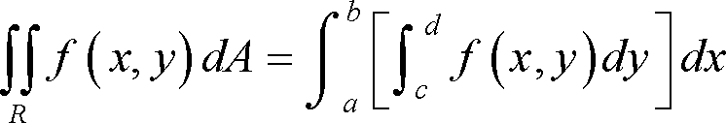
R = $\left[a,b\right]×\left[c,d\right]$
Let’s look at an example of how we would evaluate a double integral:
Evaluate $\int_{0}^{2}{\int_{1}^{3}{\left(xy+x^{2}y^{3}\right)}}dx dy$
Step 1: The inner most integral ($\int_{1}^{3}{}$, in this case) corresponds to the leftmost dx/dy. We want to break this up so that dy is placed before dx and the integral with bounds that corresponds to the dy is placed innermost. In this case, dy corresponds to $\int_{0}^{2}{}$, so we will rewrite the integral.
$\int_{1}^{3}{\int_{0}^{2}{\left(xy+x^{2}y^{3}\right)}}dy dx$
Step 2: Now, we treat x as a constant and integrate the first part, which is $\int_{0}^{2}{\left(xy+x^{2}y^{3}\right)}dy$ as if it were just a function of y, and integrate.
$\int_{1}^{3}{\int_{0}^{2}{\left(xy+x^{2}y^{3}\right)}}dy dx = \int_{1}^{3}{\left({\left|\frac{xy^{2}}{2}+\frac{x^{2}y^{4}}{4}\right|}_{{}_{y=0}}^{{}^{y=2}}\right)}dx$
${\left|\frac{xy^{2}}{2}+\frac{x^{2}y^{4}}{4}\right|}_{{}_{y=0}}^{{}^{y=2}} = \left(\frac{2^{2}x}{2}+\frac{x^{2}y^{4}}{4}−\left(x⋅\frac{0^{2}}{2}+x^{2}⋅\frac{0^{4}}{4}\right)\right)=2x+4x^{2}$
Step 3: Now that we have solved the first part of the double integral, we have our integrand, which is $2x+4x^{2}$, for the next step only in terms of x.
We can now finish calculating the integral.
$\int_{1}^{3}{\left(2x+4x^{2}\right)}dx = {\left|x^{2}+\frac{4x^{3}}{3}\right|}_{{}_{x=1}}^{{}^{x=3} } = 3^{2}+\frac{4{\left(3\right)}^{3}}{3}−\left(1^{2}+\frac{4{\left(1\right)}^{3}}{3}\right)$
$=9+36−1−\frac{4}{3}$
$= 44−\frac{4}{3}$
$=\frac{128}{3}$
And, here we have our nicely solved double integral.

“It’s what you learn after you know it all that counts” - John Wooden, former basketball player.
We have learned to solve double integrals with variables x & y, so we will use this knowledge to explore something more advanced: Volumes of 3-dimensional solids. 3-dimensional makes it clear to us that, in this case, three dimensions or planes will be looked at$−$x, y, and z.
A triple integral can be represented in the form below:

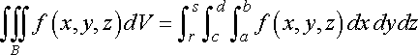
Before moving on to 3D solids, let’s look at how to solve a triple integral.
Evaluate
$$\iiint_{B}{8}xyz dx dy dz$$
$B = \left[2,3\right]×\left[1,2\right]×\left[0,1\right]$
Step 1: We need to rewrite the integral with the bounds given. Although, as shown previously, the first $\left[a,b\right]$ is put as the bounds of the innermost integral, order actually does not matter as long as you are consistent with the dx, dy, and dz. In this case, $\left[2,3\right]$ corresponds to dx, $\left[1,2\right]$ corresponds to dy, and $\left[0,1\right]$ corresponds to dz.
$\int_{0}^{1}{\int_{1}^{2}{\int_{2}^{38}{x}}}yz dxdydz$ *Notice that since $\left[2,3\right]$ was used as bounds of innermost integral, dx is put first.

Step 2. Solve integral for either x, y, or z depending on whether you put dx, dy, or dz first. Since we put dx first here, we will solve the integral for x first and treat y and z as if they were constants.
$\int_{0}^{1}{\int_{1}^{2}{{\left|4x^{2}yz\right|}_{x=2}^{x=3}}} dydz = \int_{0}^{1}{\int_{1}^{2}{\left(4{\left(3\right)}^{2}yz −4{\left(2\right)}^{2}yz\right)}}dydz$
$=\int_{0}^{1}{\int_{1}^{220}{y}}z dydz$
Step 3. Now solve the integral for y since now dy is before dz. Treat z as a constant.
$\int_{0}^{1}{{\left|10y^{2}z\right|}_{y=1}^{y=2}} dz = \int_{0}^{1}{\left(10{\left(2\right)}^{2}z−10{\left(1\right)}^{2}z\right)} dz$
$=\int_{0}^{130}{z} dz$
Step 4. Finally, simply solve the integral for z to arrive at an answer.
${\left|15z^{2} \right|}_{z=0}^{z=1} =15{\left(1\right)}^{2}−15{\left(0\right)}^{2}$
=15
Our answer for the integral above is 15.

What We’ve Been Waiting for: Volumes of 3D Solids
With our knowledge of solving triple integrals, we’re finally ready to solve for volumes of 3-dimensional solids.
Let there be a tetrahedron enclosed by 2x+y+z = 4 and the coordinate planes.
Below is a graph of the “base” of this tetrahedron, with x-intercept of 2 and y-intercept of 4.

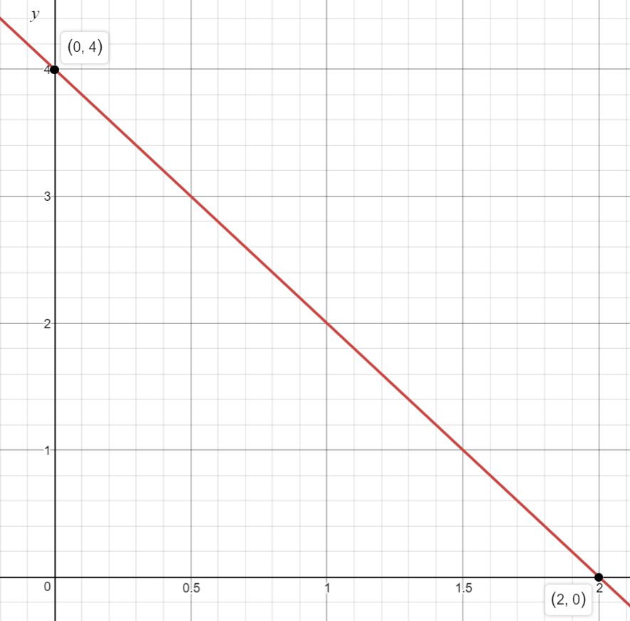
Below is the “full picture” of the tetrahedron. Because we’re concerned with the region between sides of the tetrahedron and the coordinate planes, we can consider the front side to be “missing”. The three parts intersecting the coordinate planes and forming three 3 regions are what we’re finding the volume of.

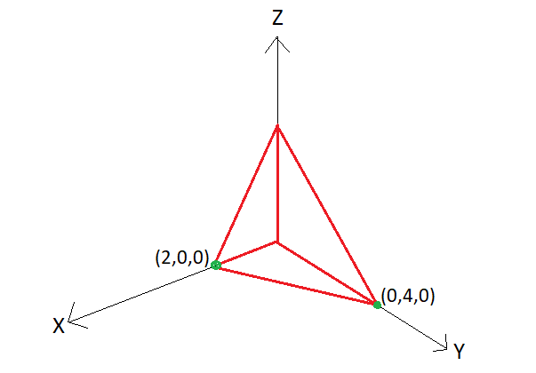
Step 1. In order to set up our triple integral, we need to first determine the limits of integration for x, y, and z. As we see in the graphs shown above, x is always between 0 and 2, with 0 being the lower bound and 2 being the upper bound of integration. Notice that the limits for y is 0 to 4, however, the value of y is dependent on the value of z. Therefore, we have to set z as 0 in the equation 2x + y + z = 4 to get that y = 4- 2x. Finally, we know that z is dependent on both x and y, and therefore we write the given equation of tetrahedron to get z = 4 - 2x - y. Therefore, our limits of integration are:
x $\left[0,2\right]$
y $\left[0,4−2x\right]$
z $\left[0,4−2x−y\right]$
Step 2. Our order of integration depends on the number of variables present in the limits of integrations for each variable (x,y, & z). We will integrate first with respect to the variable that has the greatest number of variables in its limit of integration and integrate last with respect to the variable that has the least number of variables in its limit of integration. In this case, we’ll integrate with respect to z first and with respect to x last.
$\int_{0}^{2}{\int_{0}^{4−2x}{\int_{0}^{4−2x−y}{1}}} dzdydx$
Step 3. Integrate with respect to z as if x & y were constants.
$\int_{0}^{2}{\int_{0}^{4−2x}{{\left|z\right|}_{z=0}^{z=4−2x−y}}} dydx =\int_{0}^{2}{\int_{0}^{4−2x}{\left(4−2x−y−0\right)}}dydx$
Step 4. Integrate with respect to y.
$\int_{0}^{2}{\int_{0}^{4−2x}{\left(4−2x−y\right)}}dydx = \int_{0}^{2}{{\left|4y−2xy−\frac{y^{2}}{2}\right|}_{y=0}^{y=4−2x}} dx$
$=\int_{0}^{24}{\left(4−2x\right)}−2x\left(4−2x\right)−\frac{{\left(4−2x\right)}^{2}}{2}−\left(4\left(0\right) −2x\left(0\right)−\frac{{\left(0\right)}^{2}}{2}\right) dx$
$=\int_{0}^{2}{\left(16 −16x+4x^{2}−8+8x−2x^{2}\right)} dx$
$=\int_{0}^{2}{\left(8−8x+2x^{2}\right)}dx$
Step 5. Finally, integrate with respect to x to obtain the volume of the solid.
$=\int_{0}^{2}{\left(8−8x+2x^{2}\right)}dx = {\left|8x−4x^{2}+\frac{2}{3}x^{3}\right|}_{x=0}^{x=2}$
$=8\left(2\right)−4{\left(2\right)}^{2}+\frac{2}{3}{\left(2\right)}^{3}−\left(8\left(0\right)−4{\left(0\right)}^{2}+\frac{2}{3}{\left(0\right)}^{3}\right)$
$=\frac{16}{3}$
The volume of the tetrahedron enclosed by 2x + y +z =4 and the coordinate planes is $\frac{16}{3}$

Questions

Multiple Choice
1.The base of a solid is the region in the first quadrant bounded by the line $x=−2y+6$ and the coordinate axes. What is the volume of the solid if every cross section perpendicular to the y-axis is a square?
a.15.75 b.36 c. 18 d. 72 e. None of these
2. Identify the definite integral that computes the volume of the solid generated by revolving the region bounded by the graph of $y=x^{3}$ , and the line $y=x$ , between $x=0$ and $x=1$about the line $x=4$.
a. $π\int_{0}^{1}{\left(y^{\frac{2}{3}}−y^{2}\right)}dy$ b. $π\int_{0}^{1}{{\left(y^{\frac{1}{3}}−y\right)}^{2}}dy$
c. $2π\int_{0}^{1}{\left(4−x^{2}\right)}\left(4−x^{6}\right)dx$ d. $π\int_{0}^{1}{\left({\left(4−y\right)}^{2}{\left(4−y^{\frac{1}{3}}\right)}^{2}\right)}dy$
e. None of the above
3. The region R is enclosed by the curves $y=4x$ and $y=x^{2}$. Find the volume of the solid obtained by rotating R about the line $y=−2$.
a. 529.044 b. 402.124 c. 480.035 d. 562.973 e. 856.398
4. A solid is generated with the region in the first quadrant bounded by the graph of y = 1 + $\sin^{2}x$, the line x= $\frac{π}{2}$, the x-axis, and the y-axis is revolved about the x-axis. Its volume is found by evaluating which of the following integrals?
a. $π\int_{0}^{\frac{π}{2}}{{\left(1+\sin^{2}x\right)}^{2}} dx$ b. $π\int_{0}^{1}{{\left(1+\sin^{2}x\right)}^{2}} dx$
c. $2π\int_{0}^{\frac{π}{2}}{\left(1+\sin^{4}x\right)}dx$ d. $π\int_{0}^{\frac{π}{2}}{\left(1+\sin^{2}x\right)} dx$
5. Consider the solid of revolution formed by revolving the area bounded by the curve y = 1/x, the x-axis, the line x=1 and the line x=a, (a>1) about the x-axis . The integral representing the volume of solid is
a. $π\int_{1}^{a}{\frac{dx}{x}}$ b. $2π\int_{1}^{a}{\frac{dx}{x}}$
c. $2π\int_{1}^{a}{\frac{dy}{y}}$ d. $π\int_{1}^{a}{\frac{dx}{\sqrt{x}}}$
6. Find the volume of the tetrahedron bounded by the plane passing through the points A(1,0,0), B(0,2,0), C(0,0,3) and the coordinate planes Oxy, Oxz, Oyz.
a. 2/3 b. 1
c. 2 d. 1/2

Short Response
1. Find the volume of the solid of revolution found when the region bound by y=cos(x), y=$e^{x−2}$ , the y-axis, and the x-axis is rotated around
a) The y-axis
b) The x-axis
c) The line x=4
2. Find the volume of the solid with semicircular cross sections bounded by the x axis and y=sin(x).
3. Find the volume of the solid formed when the region bounded by $y=64−x^{3}$ and the x and y-axis is rotated about a)y-axis and b)x-axis.
4. Let R be the region in the first quadrant bound by the graphs of $y=\frac{1}{\left(x−1\right)}$, $y=ln\left(x\right)$, and the x-axis. Find the volume of the solid formed when R is rotated about the x axis
5. Find the volume of the solid tetrahedron enclosed by 2x + 3y + z = 6 and the coordinate planes. (NO CALCULATOR)
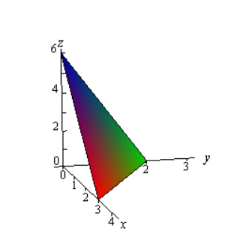
6. Find the volume of the tetrahedron bounded by the planes x + y + z = 5, x = 0, y = 0, z = 0.

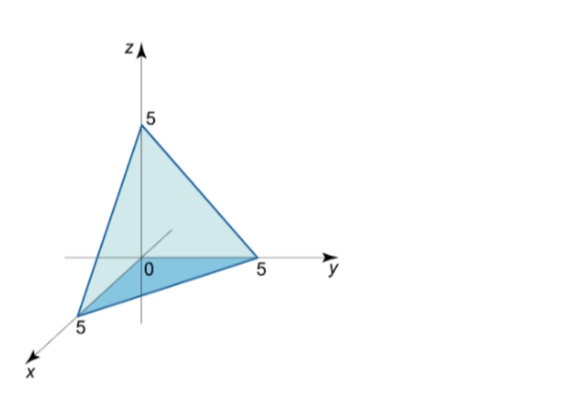

Solutions for Multiple Choice
1. The base of a solid is the region in the first quadrant bounded by the line $x=−2y+6$ and the coordinate axes. What is the volume of the solid if every cross section perpendicular to the y-axis is a square?
a.15.75 b.36 c. 18 d. 72 e. None of these
Answer: B
$V=\int_{0}^{3}{{\left(−2y+6\right)}^{2}}dy = 36$
2. Identify the definite integral that computes the volume of the solid generated by revolving the region bounded by the graph of $y=x^{3}$ , and the line $y=x$ , between $x=0$ and $x=1$about the line $x=4$.
a. $π\int_{0}^{1}{\left(y^{\frac{2}{3}}−y^{2}\right)}dy$ b. $π\int_{0}^{1}{{\left(y^{\frac{1}{3}}−y\right)}^{2}}dy$
c. $2π\int_{0}^{1}{\left(4−x^{2}\right)}\left(4−x^{6}\right)dx$ d. $π\int_{0}^{1}{\left({\left(4−y\right)}^{2}{\left(4−y^{\frac{1}{3}}\right)}^{2}\right)}dy$
e. None of the above
3. The region R is enclosed by the curves $y=4x$ and $y=x^{2}$. Find the volume of the solid obtained by rotating R about the line $y=−2$.
a. 529.044 b. 402.124 c. 480.035 d. 562.973 e. 856.398
Answer: D
$V=π\int_{0}^{4}{\left({\left(4x+2\right)}^{2}−{\left(x^{2}+2\right)}^{2}\right)}dx = 179.2π = 562.973$
4. A solid is generated with the region in the first quadrant bounded by the graph of y = 1 + $\sin^{2}x$, the line x= $\frac{π}{2}$, the x-axis, and the y-axis is revolved about the x-axis. Its volume is found by evaluating which of the following integrals?
a. $π\int_{0}^{\frac{π}{2}}{{\left(1+\sin^{2}x\right)}^{2}} dx$ b. $π\int_{0}^{1}{{\left(1+\sin^{2}x\right)}^{2}} dx$
c. $2π\int_{0}^{\frac{π}{2}}{\left(1+\sin^{4}x\right)}dx$ d. $π\int_{0}^{\frac{π}{2}}{\left(1+\sin^{2}x\right)} dx$
Choice A is correct.
The limits of integration are $\left[0,\frac{π}{2}\right]$ and the volume should be written as $π\int_{0}^{\frac{π}{2}}{{\left(f\left(x\right)\right)}^{2}}dx$ (Disk Method). Since f(x) = $1+\sin^{2}x$, ${\left(f\left(x\right)\right)}^{2} = {\left(1+\sin^{2}x\right)}^{2}$. Therefore, the answer is $π\int_{0}^{\frac{π}{2}}{{\left(1+\sin^{2}x\right)}^{2}} dx$.
5. Consider the solid of revolution formed by revolving the area bounded by the curve y = 1/x, the x-axis, the line x=1 and the line x=a, (a>1) about the x-axis . The integral representing the volume of solid is
a. $π\int_{1}^{a}{\frac{dx}{x}}$ b. $2π\int_{1}^{a}{\frac{dx}{x}}$
c. $2π\int_{1}^{a}{\frac{dy}{y}}$ d. $π\int_{1}^{a}{\frac{dx}{x^{2}}}$
Choice D is correct.
The limits of integration are $\left[1,a\right]$ and the volume should be written as $π\int_{1}^{a}{{\left(f\left(x\right)\right)}^{2}} dx$ (Disk Method). Since f(x) is 1/x, ${\left(f\left(x\right)\right)}^{2 }=\frac{1}{x^{2}}$. Therefore, the answer is $π\int_{1}^{a}{\frac{dx}{x^{2}}}$.
6. Find the volume of the tetrahedron bounded by the plane passing through the points A(1,0,0), B(0,2,0), C(0,0,3) and the coordinate planes Oxy, Oxz, Oyz.
a. 2/3 b. 1
c. 2 d. 1/2
Choice B is correct
$\int_{0}^{1}{\int_{0}^{2−2x}{\int_{0}^{3−3x−\frac{3}{2}y}{d}}}zdydx$
$=\int_{0}^{1}{\int_{0}^{2−2x}{{\left|z\right|}_{z=0}^{z=3−2x−\frac{3}{2}y}}} dydx =\int_{0}^{1}{\int_{0}^{2−2x}{\left(3−3x−\frac{3}{2}y\right)}} dydx$
$=\int_{0}^{1}{{\left|3y−3xy−\frac{3}{4}y^{2}\right|}_{y=0}^{y=2−2x}} dx$
$=\int_{0}^{1}{\left(6−12x+6x^{2}−3+6x−3x^{2}\right)} dx = 3\int_{0}^{1}{\left(1−2x+x^{2}\right)} dx$
$=3{\left|x−x^{2}+\frac{x^{3}}{3}\right|}_{x=0}^{x=1} = 3\left(1−1^{2}+\frac{1^{3}}{3}\right)$
$=1$

Solutions for Short Response
1. Find the volume of the solid of revolution found when the region bound by y=cos(x), y=$e^{x−2}$ , the y-axis, and the x-axis is rotated around
a) The y-axis
$V=2π\int_{a}^{b}{x}\left(y\left(x\right)\right)dx=2π\int_{0}^{1.136}{x}\left(cos\left(x\right)−e^{x−2}\right)dx= .259$
b) The x-axis
$V=π\int_{0}^{1.136}{\left({\left(cosx\right)}^{2}−{\left(e^{x−2}\right)}^{2}\right)}dx = 2.134$
c) The line x=4
$V=2π\int_{0}^{1.136}{\left(4−x\right)}\left({\left(cosx\right)}^{2}−{\left(e^{x−2}\right)}^{2}\right)dx = 2.224$
2. Find the volume of the solid with semicircular cross sections bounded by the x axis and y=sin(x).
V$V=π\left(\frac{1}{2}\right)\left(\int_{0}^{\frac{π}{2}}{{\left(\frac{d}{2}\right)}^{2}}dx\right) = π\left(\frac{1}{2}\right)\left(\int_{0}^{\frac{π}{2}}{{\left(\frac{sin\left(x\right)}{2}\right)}^{2}}dx\right)$
$=π\left(\frac{1}{2}\right)\left(\frac{1}{4}\right)\int_{0}^{\frac{π}{2}}{\sin^{2}}\left(x\right)dx = π\left(\frac{1}{8}\right)\left(−\frac{1}{2}sin\left(x\right)cos\left(x\right)+\int_{0}^{\frac{π}{2}}{d}x\right)$
$=π\left(\frac{1}{8}\right)\left(−\frac{1}{2}sin\left(x\right)cos\left(x\right) +x\right) = \frac{π^{2}}{16}$
3. Find the volume of the solid formed when the region bounded by $y=64−x^{3}$ and the x and y-axis is rotated about
a) y-axis
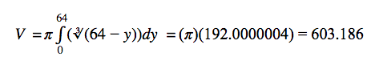
b) x-axis
$V = π\int_{0}^{4}{\left(64−x^{3}\right)}dx = 192π = 603.186$
4. Let R be the region in the first quadrant bound by the graphs of $y=\frac{1}{\left(x−1\right)}$, $y=ln\left(x\right)$, and the x-axis. Find the volume of the solid formed when R is rotated about the x axis.
First Step: Find the points of intersection.

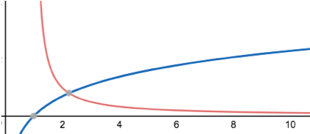
Blue =$ln\left(x\right)$ Red = $\frac{1}{x−1}$
$\frac{1}{x−1}=ln\left(x\right)$ at x= 2.240, ln(x) = 0 at x=1, and $\frac{1}{x−1}$ does not cross the x axis. Therefore, we treat it as a Type I Improper Integral while finding the volume of the solid.
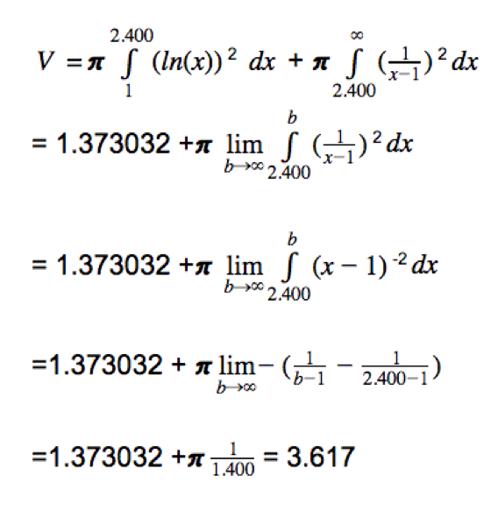
5. Find the volume of the solid tetrahedron enclosed by 2x + 3y + z = 6 and the coordinate planes.

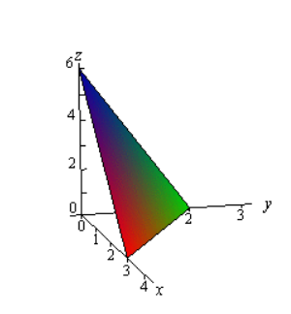
Step 1. Limits Integration for each variable
x is always between 0 & 3. so, x: $\left[0,3\right]$
y is dependent on the value of x, so if we set z as 0, y: $\left[0,2−\frac{2}{3}x\right]$
z is dependent on the values of x & y, so z: $\left[0, 6−2x−3y\right]$
Step 2. Since the limits of integration for z has the most variables, we have to integrate with respect to z first, y second, and x third. Our triple integral will be:
$\int_{0}^{3}{\int_{0}^{2−\frac{2}{3}x}{\int_{0}^{6−2x−3y}{d}}}zdydx$
Step 3. Integrate with respect to z, then y, and finally x.
$\int_{0}^{3}{\int_{0}^{2−\frac{2}{3}x}{{\left|z\right|}_{z=0}^{z=6−2x−3y}}} dydx = \int_{0}^{3}{\int_{0}^{2−\frac{2}{3}x}{\left(6−2x−3y−0\right)}} dydx$
$=\int_{0}^{3}{\int_{0}^{2−\frac{2}{3}x}{\left(6−2x−3y\right)}} dydx = \int_{0}^{3}{{\left|6y−2xy−\frac{3y^{2}}{2}\right|}_{y=0}^{y=2−\frac{2}{3}x}} dx$
$=\int_{0}^{3}{\left(6\left(2−\frac{2}{3}x\right)−2x\left(2−\frac{2}{3}x\right)−\frac{3{\left(2−\frac{2}{3}x\right)}^{2}}{2}−\left(6\left(0\right)−2x\left(0\right)−\frac{3{\left(0\right)}^{2}}{2}\right)\right)}dx$
$=\int_{0}^{3}{\left(\frac{2}{3}x^{2}−4x+6\right)}dx ={\left|\frac{2}{9}x^{3}−2x^{2}+6x\right|}_{x=0}^{x=3}$
$=\frac{2}{9}{\left(3\right)}^{3}−2{\left(3\right)}^{2}+6\left(3\right)−\left(\frac{2}{9}{\left(0\right)}^{3}−2{\left(0\right)}^{2}+6\left(0\right)\right)$
$=6−18+18$
$=6$
The volume of the solid tetrahedron enclosed by 2x + 3y + z = 6 and the coordinate planes is 6.
6. Find the volume of the tetrahedron bounded by the planes x + y + z = 5, x = 0, y = 0, z = 0.
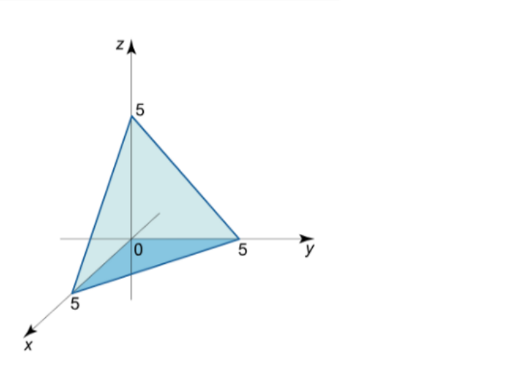
Step 1. Limits Integration for each variable
x is always between 0 & 5. so, x: $\left[0,5\right]$
y is dependent on the value of x, so if we set z as 0, y: $\left[0,5−x\right]$
z is dependent on the values of x & y, so z: $\left[0, 5−x−y\right]$
Step 2. Since the limits of integration for z has the most variables, we have to integrate with respect to z first, y second, and x third. Our triple integral will be:
$\int_{0}^{5}{\int_{0}^{5−x}{\int_{0}^{5−x−y}{d}}}zdydx$
Step 3. Integrate with respect to z, then y, and finally x.
$\int_{0}^{5}{\int_{0}^{5−x}{{\left|z\right|}_{z=0}^{z=5−x−y}}} dydx = \int_{0}^{5}{\int_{0}^{5−x}{\left(5−x−y−0\right)}} dydx$
$=\int_{0}^{5}{\int_{0}^{5−x}{\left(5−x−y\right)}} dydx = \int_{0}^{5}{{\left|5y−xy−\frac{y^{2}}{2}\right|}_{y=0}^{y=5−x}} dx$
$=\int_{0}^{5}{\left(5\left(5−x\right)−x\left(5−x\right)−\frac{{\left(5−x\right)}^{2}}{2}−\left(5\left(0\right)−x\left(0\right)−\frac{{\left(0\right)}^{2}}{2}\right)\right)}dx$
$=\frac{1}{2}\int_{0}^{5}{\left(25−10x+x^{2}\right)}dx ={\left|\frac{1}{2}\left(25x−\frac{10x^{2}}{2}+\frac{x^{3}}{3}\right)\right|}_{x=0}^{x=5}$
$=\frac{1}{2}\left(125−5\left(25\right)+\frac{125}{3}\right)$
$=\frac{125}{6}$
The volume of the solid tetrahedron enclosed by x+y+z = 5, x=0, y=0, and z=0 is $\frac{125}{6}$.

Citations
http://tutorial.math.lamar.edu/Classes/CalcIII/TripleIntegrals.aspx
https://ocw.mit.edu/courses/mathematics/18-02-multivariable-calculus-fall-2007/video-lectures/lecture-25-triple-integrals/
https://www.math24.net/calculation-volumes-triple-integrals/
https://www.intmath.com/blog/mathematics/archimedes-and-the-area-of-a-parabolic-segment-1652

