High-resolution mass spectrometric in vitro and in vivo metabolite profiling of novel synthetic cannabinoids, APINAC and its fluorined analogue
S.A. Appolonova
K.M. Shestakova
D.A. Burmykin
M.V. Ovcharov
F. Tagliaro
S.A. Savchuk
Background: The data are reported for an in vivo and in vitro metabolism study of two novel synthetic cannabinoids, N-(1-adamantyl)-1-pentyl-1H-indazole- 3-carboxylate (APINAC) and its fluorinated analog N-(1-adamantyl)-1-(5-fluoropentyl)-1H-indazole-3-carboxylate (5F-APINAC), which are active ingredients of smoking mixtures sold in Russia since 2016. Despite increasing prevalence, no human metabolism data are currently available, making it challenging for forensic laboratories to confirm intake of APINAC or 5F-APINAC.
Methods: The cannabinoids were incubated with human liver microsomes (HLMs). The formed metabolites were characterized by liquid chromatography – triple quadrupole mass spectrometry and high-resolution mass spectrometry with electrospray ionization in positive ion mode.
Results: It was found that HLMs produce mono-, di-, and trihydroxylated metabolites, as well as N-desalkyl metabolites, which can be further hydroxylated; the amide bond resisted the metabolic cleavage. For 5F-APICA, a series of oxidative defluorination products formed as well. For in vivo confirmation of the formed in vitro metabolites, spot urine samples from drug users were analyzed with the created method. It was shown that for the detection of APICA abuse, the preferred metabolites are the di- and tri-hydroxylated species, while in case of 5F-APICA, a monohydroxy metabolite is a better target. The N-despentyl (desfluoropentyl) hydroxyadamantyl metabolite also provides good retrospectivity to confirm the administra- tion of any of these cannabinoids.
Conclusions: We have characterized APINAC and 5F-APINAC in vitro metabolism with human hepatocytes and in vivo metabolism using of rat urine and high- resolution mass spectrometry, and we recommend characteristic major metabolites for clinical and forensic laboratories to identify APINAC and 5F-APINAC intake and link observed adverse events to these novel synthetic cannabinoids

Introduction
Lorem ipsum dolor sit amet, consectetur adipiscing elit [1]. Cras egestas auctor molestie. In hac habitasse platea dictumst. Duis turpis tellus, scelerisque sit amet lectus ut, ultricies cursus enim. Integer fringilla a elit at fringilla. Lorem ipsum dolor sit amet, consectetur adipiscing elit. Nulla congue consequat consectetur. Duis ac mi ultricies, mollis ipsum nec, porta est. ${}_{12}^{4}C_{2}^{5+}$

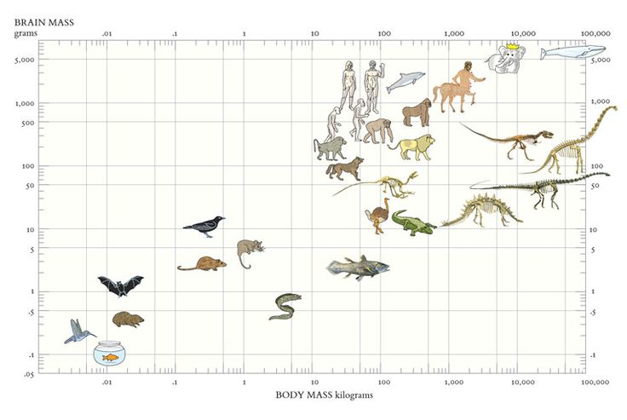
Pellentesque suscipit risus massa, non vestibulum libero euismod feugiat. In hac habitasse platea dictumst. Maecenas rutrum lobortis lobortis. Vestibulum convallis porttitor sem ac ultricies.
Mauris nec massa leo. Mauris ac diam auctor nisl imperdiet porta. Sed sit amet neque eget nisi dictum placerat. Duis sit amet pellentesque odio. Cras scelerisque sem a consectetur vehicula. Aliquam interdum luctus fringilla. Nunc sollicitudin, lorem in semper viverra, dui nisi sodales sem, ut condimentum erat leo eget arcu. Donec pharetra aliquam metus, non pulvinar tellus interdum a. Mauris a ante pharetra, mollis enim in, eleifend erat. Pellentesque suscipit risus massa, non vestibulum libero euismod feugiat. In hac habitasse platea dictumst. Maecenas rutrum lobortis lobortis. Vestibulum convallis porttitor sem ac ultricies. Mauris volutpat fringilla nisl blandit semper. Proin nec iaculis sem. Aenean neque ipsum, pretium a faucibus non, tincidunt ut sapien [2]; [3] .
Nunc a aliquet sem, eget aliquet purus. Vestibulum ac placerat mauris. Proin sed dolor ac justo semper iaculis. Donec varius, nibh sit amet finibus tristique, sapien ante interdum odio, et pretium sapien libero nec massa. In hac habitasse platea dictumst. Donec vel augue ac sapien imperdiet pretium. Maecenas gravida risus id ultricies dignissim. Maecenas gravida felis quis dolor faucibus, sed maximus lorem tristique. Nam hendrerit quam quis ante porta posuere. Fusce finibus maximus orci at porttitor. Nulla tempor ex a porttitor consequat. Quisque quis tempor eros. Donec nisi mauris, sollicitudin in dapibus eu, interdum ultricies quam Fig ???.

Section
Nunc a aliquet sem, eget aliquet purus. Vestibulum ac placerat mauris. Proin sed dolor ac justo semper iaculis. Donec varius, nibh sit amet finibus tristique, sapien ante interdum odio, et pretium sapien libero nec massa. In hac habitasse platea dictumst. Donec vel augue ac sapien imperdiet pretium. Maecenas gravida risus id ultricies dignissim. Maecenas gravida felis quis dolor faucibus, sed maximus lorem tristique $e^{iπ}+1=0$

Acknowledgements
Lorem ipsum dolor sit amet, consectetur adipiscing elit. Cras egestas auctor molestie. In hac habitasse platea dictumst. Duis turpis tellus, scelerisque sit amet lectus ut, ultricies cursus enim. Integer fringilla a elit at fringilla. Lorem ipsum dolor sit amet, consectetur adipiscing elit. Nulla congue consequat consectetur. Duis ac mi ultricies, mollis ipsum nec, porta est.

References
1. Zinszer K, Morrison K, Verma A, Brownstein JS (2017) Spatial Determinants of Ebola Virus Disease Risk for the West African Epidemic.. PLoS Curr 9:
2. Zhou J, Xue Z, Du Z, et al. (1988) Relationship of tightly bound ADP and ATP to control and catalysis by chloroplast ATP synthase. Biochemistry 27:5129–5135. doi: 10.1021/bi00414a027
3. Boyer PD (1998) Energy Life, and ATP (Nobel Lecture). Angewandte Chemie International Edition 37:2296–2307. doi: 10.1002/(sici)1521-3773(19980918)37:17<2296::aid-anie2296>3.0.co;2-w

