Biosensors and Bioelectronics
Komal Garde
saravamu
komu.garde
This paper reports on a minimal growth factor and clinical translation friendly methodology using micromachined penetrating nanoelectrodes to differentiate Adipose-Derived Stem Cells (ADSCs) into neuronal lineage. An electrical stimulus is delivered via penetrating nanoelectrodes to differentiate ADSCs toward neuronal lineage with minimal use of conventional growth factors, genetic manipulators, cytokines or other chemical reagents. The paper also reports on the time dynamics of cell penetration process using the nanoelectrodes

Keywords
Nanoelectrodes, electrical stimulation, stem cells

Introduction
Adipose-derived stem cells (ADSCs) have gained increasing attention in the recent times, for regenerative medicine and tissue engineering applications due to their high proliferative capacity, multi-lineage potential and ease in harvesting compared to other stem cells [1]. Similarly, penetrating nanoelectrodes that can interface or assess the interior of the cell, without causing cell damage are increasingly being used as biosensors and for cell interrogation studies [2, 3]. In this work, for the first time, we show that (a) silicon nanopillars/nanoelectrodes of optimized size and shape can penetrate ADSCs without any loss of cellular function and (b) electrical stimulus can be applied through the penetrating electrodes to differentiate ADSCs into neuronal lineages. ADSCs are generally differentiated into neurons by using growth factors, genetic manipulators, cytokines and/or other chemical reagents [4]. However, there are many issues associated with the use of chemical reagents, including problems in translational studies, cell toxicity and induced cell stress [5]. On the other hand, endogenous electrical stimulus, which plays many important roles in physiological processes, can modulate or control biological processes including cell migration, orientation, and differentiation [6].

Materials and Methods

Nanopillars design and fabrication
The nanoelectrodes (nanopillars/nanofins) were designed to overcome the trade-offs between electrode impedance and electrode size. Compared to conventional 3 x 3 array of 150nm diameter nanowire electrodes [2. 3], the current nanoelectrodes were designed to reduce electrode impedance by a factor of 20 due to a large capacitance and small charge transfer resistance, while maintaining minimal cell damage. The fabrication of nanoelectrodes or nanopillars starts on single crystal silicon wafer followed by a series of lithographic patterning, deposition and etching steps, as shown in Fig. 1. The dimensions of the nanopillars were tuned to give desired height, width, and thickness at the tip. The density of the nanopillars was varied between 4.8x10³ and 8.3x10³ pillars/cm², and the tip dimension ranged from 100nm x 100nm to 100nm x 7.5µm. The height of the nanopillars was maintained at a constant height.
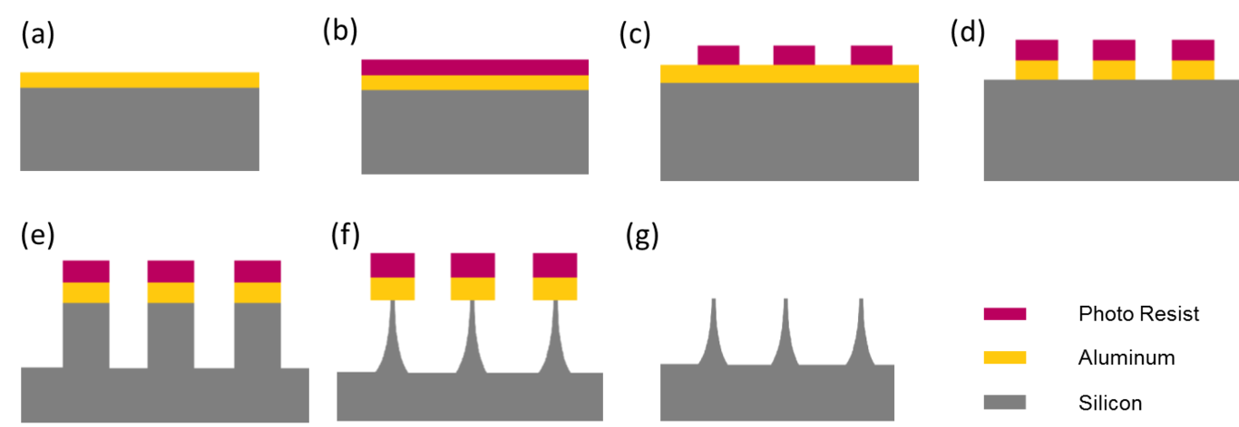
Process flow of nano electrode fabrication. (a) Deposition of aluminium (b)Spin photoresist (c) Expose and develop photoresist (d) Aluminium wet etch (e) Anisotropic etch (f) Isotropic etch (g) Lift off
The fabrication sequence is described below. First, a p-type 4-inch wafer was RCA cleaned and then a layer of aluminum or gold was deposited (Fig.1a). This was followed by lithographic patterning (Fig. 1c) and removal of undesired metal (Fig. 1d). Each 4-inch Si wafer has about 13 nanopillar arrays. Next, silicon is dry etched on Lam Rainbow 4400 Reactive Ion Etch System. Silicon etching was carried in two steps. The anisotropic vertical etch (Fig. 1e) was followed by isotropic etch to get the desired undercutting effect. For anisotropic etch, SF₆ and RFB were used at low pressure (Fig. 1e), while for isotropic etch, SF6 and high RFB were used at high pressure (Fig. 1f). Next, photoresist and metal were etched (Fig. 1g). Finally, a thin layer of Au was deposited for electrode stimulation studies (Not shown in Fig 1).

Cell culture
The precise placement of cells on the nanoelectrodes is a challenging process. After surface functionalization with silane coupling (uncoated Si) or thiol chemistry (Au nanoelectrodes), cells are cultured on the nanoelectrodes. Three different cells were tested on the silicon nanopillar arrays. First, NIH 3T3 cells were cultured in Dulbecco’s modified Eagle’s medium (DMEM) containing 10% Fetal Bovine Serum (FBS) and 1% antibiotic/antimycotic. 3T3 cells were seeded at a density of 5,000 cells/cm2.
Next, PC12 cells were grown in RPMI supplemented with 10% heat activated horse serum, 5% calf serum and 1% penicillin and streptomycin. After PC12 cells were seeded at a density of 10,000 cells/cm2 on the nanopillars, differentiation was carried out using nerve growth factor (NGF) alone or NGF along with electrical stimulation.
Finally, Adipose-derived stem cells (ADSCs) were cultured in DMEM/Ham’s F-12 medium with 10% FBS and 1% Penstrap. For neurogenic differentiation of ADSC, (a) the stromal media was replaced by pre-induction medium (DMEM, 20% FBS, and 1nM beta-mercaptoethanol) for up to
24 hours followed by induction medium (DMEM/2% DMSO/200uM BHA) for up to two weeks or (2) a regime electrical stimulation protocol (as described below) was used to facilitate conventional induction medium based differentiation.

Electrical stimulation protocol
For cell differentiation, the DC stimuli were optimized. The pulsed DC stimuli were in the range of 100 mV/cm field strength with monophasic 100 ms square pulse and 1 Hz frequency.

Immunofluorescence staining
Cells were fixed with 4% paraformaldehyde in PBS for 15 min, washed thrice with PBS solution, and subsequently permeabilized in 0.25% Triton X solution for 15 minutes. Before staining, all the samples were blocked using 1% BSA in PBS for one hour. The samples were then incubated with
Actin green and DAPI to visualize actin and nuclei respectively. To validate the differentiation process, gene expression markers and morphological changes were monitored.

Electron Microscopy
Cells were fixed overnight at 4ºC using a fixative solution that comprises 25% of 0.4M cacodylate buffer, 12.5% of 16% formaldehyde, 10% of 25% glutaraldehyde and the rest being water. The cells are then washed thrice with water and dehydrated using increasing concentration of acetonitrile. The samples are then mounted on stubs using carbon tape and sputter-coated with 5nm of gold-palladium.

Electrical Stimulation
Various ES parameters in combination with chemical induction were studied. For ES, 5mm x 5mm array of nanofins were used after coating them with gold. ADSC cells were seeded on to of the nanofins at an initial seeding density of 30,000cells/cm2 with the help of a 10mm cloning cylinder. Parameters ranging from 50mV to 500mV were studied

Results
A. Nanopillars fabrication
Arrays of 5mm x 5mm were fabricated, as described in the experimental methods section. Optimized fabrication methodology allowed for tunable geometry with control over nanopillar density, tip diameter, height as shown in Table 1. The density of the pillars was controlled using appropriate mask patterning, while the height of the pillars was controlled in the RIE. The tip diameter was controlled within few tens of nanometers by an optimized combination of anisotropic and isotropic etch. The sharpness of tip is crucial to increase the probability of cell penetration.
Table 1. Variation in Nanoelectrode
 | Nanopillar - 1 | Nanopillar/fin - 2 | Nanopillar/fin - 3
Tip dimension | ~100nm x 100nm | ~100nm x 3µm | ~100nm x7.5µm
Height | ~5-6 µm | ~5-6 µm | ~5-6 µm
Interpillar distance | ~11 x 11 µm | ~15 x 11 µm | ~19 x 11 µm
Density | 8.3x10³pillar/cm² | 6.6x10³pillar/cm² | 4.8x10³pillar/cm²
Table 1 describes the three different nanopillar or fin configurations. SEM images of the different configurations are shown in Fig. 2. The difference between the nanopillars and nanofins are that nanopillars have the same tip width and breadth while nanofins have different tip width and breadth. The advantage of the nanofin configuration over nanopillars is that nanofins have reduced interfacial impedance and reduced electrode resistance.
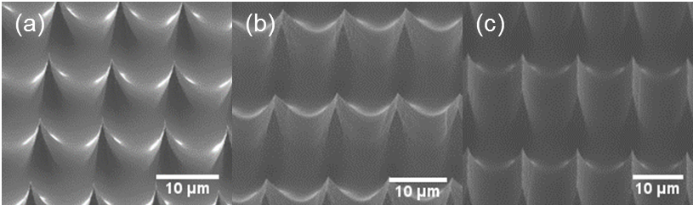
SEM micrographs of silicon nanoelectrodes. (a)Nanopillar-1 (b)Nanofin-2 (c)Nanofin-3
B. Confocal imaging studies
To better understand how cells respond to the nanopillars, high-resolution confocal microscopy was used to image NIH 3T3 cell cytoplasm while the cells grew on the nanopillars. The spacing between the nanopillars is critical for better cell- pillar interaction. If the pillars were dense then it resulted in “bed of nails” effect on cells and cells remained suspended on the top of the pillar and did not conform around the pillars. We chose an optimized spacing of over 10µm for efficient cell penetration. Fig. 3 shows the interaction of NIH 3T3 cells on the pillars. The images clearly depict the cytoplasm exclusion effect (dark squares/rectangles) where the nanopillars are present. The images also show that cells were penetrated completely by the nanopillars. The presence of cytoplasmic exclusion effect may mean – (a) cell membrane penetration on the nanopillars or (b) wrapping of cell membrane tightly around the nanopillar without membrane penetration. To address this question and better understand the cell membrane conformation on the nanopillars, particularly whether nanopillars can penetrate the cell membrane, SEM imaging was done.

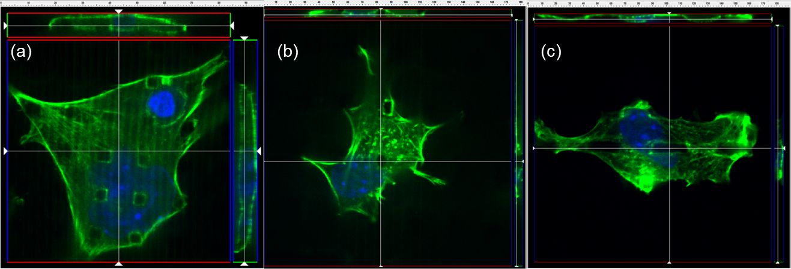
Confocal images of cells cultured on (a)Nanopillar-1 (b)Nanofin-2 (c)Nanofin-3
C. SEM studies
Fig. 4 shows the dynamics of the cell penetration process over time, recorded at 5 minutes to 5 hours using SEM imaging. These images provide information, although limited, of possible cell membrane deformation around the nanopillars or conform on the nanopillars. The images clearly show the NIH 3T3 cell-nanopillar interface at different time points. Here, the nanopillars are 100-200 nm in tip diameter, 5-6 µm high at a density of 8x10³ nanopillars/cm². The sphere-shaped cells first settle onto the nanopillars (~5min), then gradually continue to adhere to the substrate which leads to cell spreading (30 min), followed by increase cell-pillar contact area (2 and 5 hours).
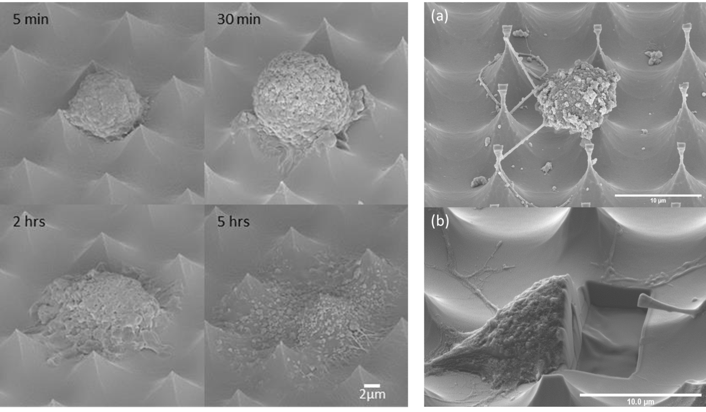
Dynamics of cell penetration process over time (left image). (a)Differentiated cells penetrated by nanopillars (b) Image of cells on nanopillars after FIB milling of one half of the electrode-cell interface.
Fig. 4a and 4b show the fixed SEM images of differentiated PC12 cells being penetrated by the nanopillars without any loss of cellular function. It is interesting to observe that the PC12 neurite outgrowth grasping onto the nanopillars. Additionally, it is evident from Fig. 6b that the nanopillars are clearly assessing the interior of the cells’ cytosol. This image was taken after focused ion milling (FIB) milling of one half of the electrode-cell interface. The cross-section image shows clearly that the cell has surrounded the nanopillars. The FIB-SEM results shown here are consistent with the confocal images, which showed cell membrane deformation around the nanopillars.
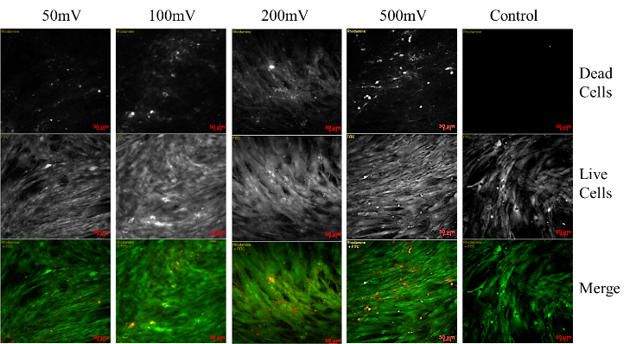
Live/Dead assay for various ES parameters
Figure 5 shows a confluent monolayer of viable cells in all the four groups and the control. This indicates that the majority of ADSCs were alive, with a mild reduction in cell viability in 200mV and 500mV. Based on these preliminary studies we chose 100mV/cm of DC ES for 15min per day for this experiment. In comparison to non-stimulated cells grown on plain silicon substrates, the stimulated cells showed slightly higher proliferation and hence a dense growth over a period of 3 days. The obtained results confirmed that electrical stimulation of ADSCs led to no significant cell viability loss.
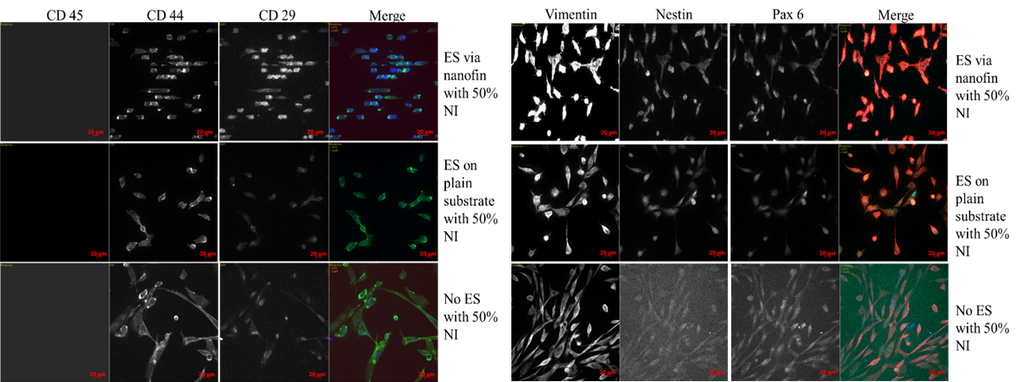
ADSCs stained for ADSC(left) and NSC(right) markers for cells undergoing both NI (50%) and ES (5 days, 100mV for 15min/day)
The influence of electrical stimulation on neurogenic differentiation of human ADSCs was investigated after 3-5 days and compared to controls. Electrical stimulation was also carried out using 50% neural induction media (with and without the use of nanofins). The combined effect of both electrical and chemical stimulus was not significant. However initial morphological changes are observed in figure 6 for all three conditions.

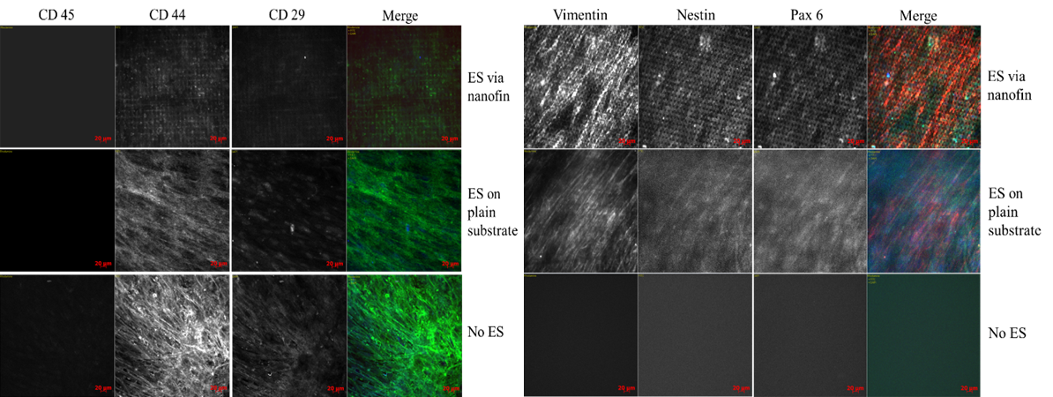
ADSCs stained for ADSC (left) and NSC (right) markers for cells undergoing only ES (5 days, 100mV for 15min/day)
Figure 7 shows results of ADSCs undergoing transformation using only electrical stimulation. Electrical stimulation was performed using both nanofins and plain substrates. Although cells on plain substrate yielded a more confluent layer as compared to cells growing on nanofins, the cells receiving electrical stimulation via nanofins showed higher expression of NSC markers.

Discussion
In summary, this paper reports on the development of an optimized nanoelectrode that has the potential to penetrate ADSCs without any loss of cellular function, where electrical stimulus can be applied through the penetrating electrodes to differentiate ADSCs into neuronal lineages. The nanofin design compared to nanopillars gave larger electrode surface area and thereby reduced the interfacial impedance and electrode resistance. Our preliminary studies show that electrical stimulation can greatly reduce the use of growth factor for cell differentiation with early expression of neural markers - Nestin and PAX6. In future, we hope to achieve an optimized DC electrical stimuli protocol that may differentiate ADSCs without the use of growth factors.
We have demonstrated that DC ES promotes Vimentin, Nestin and Pax 6 expression in human ADSCs already at 5 days.
Future studies should look into finding the optimum parameters at which ES is not only most effective but can differentiate ADSC into desired cell type down the neural lineage.

Acknowledgements
This work was performed at the Joint School of Nanoscience and Nanoengineering, a member of Southeastern Nanotechnology Infrastructure Corridor (SENIC) and National Nanotechnology Coordinated Infrastructure (NNCI), which is supported by the National Science Foundation (ECCS-1542174).

