Assessing the vulnerability of marine life to climate change in the Pacific Region

Jonatha Giddens

Donald Kobayashi

mark.nelson

Our changing climate poses growing challenges for the effective management of marine life, ocean ecosystems, and the human communities that depend upon them. Which species are most vulnerable to climate change and where should science and management focus efforts to reduce these risks? To address these questions, the NOAA Fisheries Climate Science Strategy called for vulnerability assessments in each of NOAA’s ocean regions. The Pacific Islands Vulnerability Assessment (PIVA) project assessed the vulnerability of 83 marine taxa to the impacts of climate change. In a Rapid Vulnerability Assessment framework, this project utilized expert knowledge, literature review, and climate projection models to synthesize the best available science towards answering these questions. Here we: (1) provide a relative climate vulnerability ranking across species; (2) identify key attributes and factors that drive this vulnerability; and (3) identify key data gaps in understanding and mitigating climate change impacts to living marine resources. The invertebrate group ranked as most vulnerable and pelagic and coastal group ranked as least vulnerable. Sea surface temperature, ocean acidification, and oxygen concentration were the three main exposure drivers of vulnerability. This project ultimately advances our understanding of the research needs and the management options to both sustain marine life and seafood security in the Pacific Ocean and beyond.

# Introduction

Climate change is occurring now, affecting our oceans and the species that depend upon it, including ourselves (Morley et al. 2018; Kleisner et al. 2016; Pinsky and Byler 2015; Pinsky et al. 2013) . Due to increasing sea surface temperatures and ocean acidification, decreasing oxygen concentration, and increased pollution, marine life now faces a range of stressors which negatively impact ecosystems and fisheries (Popova et al. 2016; Pandolfi et al. 2011; Morley et al. 2018). What is not clear is which species are most vulnerable to climate change and where science and management should focus efforts to reduce these risks (Marzloff et al. 2016).

Our knowledge of climate change impacts to ocean ecosystems has been disparate, with studies focused on model species, or single-pressure impacts (Holsman et al. 2017). A synthesis of knowledge is needed to move past single-species, to an ecosystem-based approach to management (EBM) (Levin and Lubchenco 2008). By amassing climate change science across a range of species and environmental variables in a region, we can use the best available science now to anticipate which species are most vulnerable, and why (Holsman et al. 2017). This information is critically needed in order to prioritize ocean ecosystem management and research in an rapidly changing world  (on Climate Change, n.d.). IPCC 2014

To assess climate vulnerability in an EBM context, Rapid Vulnerability Assessments (RVAs) is one method for evaluating multiple impacts to ecosystems. RVAs can be used as a tool to gather existing knowledge through expert opinion and literature search, and thus to bring the best available science into a usable format for timely, science-based management, and to direct future research to fill knowledge gaps (Holsman et al. 2017).

An RVA methodology to assess the vulnerability of marine life to climate change was first developed and implemented in the New England/mid Atlantic region (Morrison et al. 2016)Hare et al. 2016) and in 2015, the US National Oceanic and Atmospheric Administration (NOAA) Fisheries Climate Science Strategy called for a RVA to be deployed in each region (New England/Mid-Atlantic, Southeast, West Coast, Alaska, and Pacific Islands) (Link et al. 2015; (Busch et al. 2016). The Pacific Islands Vulnerability Assessment (PIVA) project implemented this practical and efficient tool and utilized expert knowledge, literature review, and climate projection models to assess the relative vulnerability of 83 marine species following (Hare et al. 2016).

Here we (1) provide a relative climate vulnerability ranking across species; (2) identify key attributes and factors that drive this vulnerability; and (3) identify key data gaps in understanding and mitigating climate change impacts to living marine resources.

# Methods

### Taxonomic scope:

This assessment focused on 83 species from 6 functional groups (Fig ???. ) and 33 families (Fig ???.) across a wide range of geographies spanning US fishery management jurisdictions in the Central, West, and South Pacific Ocean ([Supplementary Materials 1 - Species List](https://drive.google.com/open?id=1wfxlDgoVA4F9A0DnjytO8ItXpbr6l_LF)). These species were selected based on regional expert opinion, as well as commercial and recreational catch records for their importance as food-fish, or cultural and conservation importance. The final selection of taxa also took into account representation and balance of key taxa representing important ecosystem function.

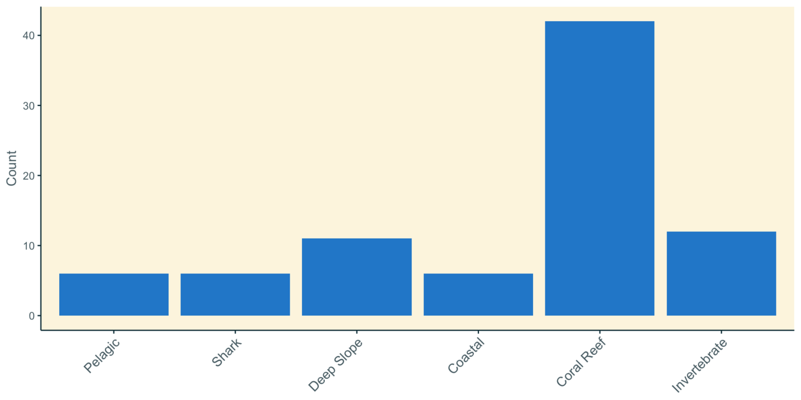

???

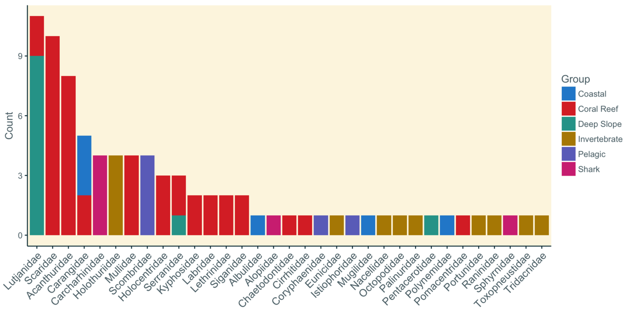

Fig ???. Histogram of fish and invertebrate families included in the Pacific Islands Vulnerability Assessment (PIVA)

Climate change vulnerability, as defined here,  is composed of both exposure variables and sensitivity attributes.

### Exposure

The term exposure as used in our rapid  vulnerability assessment measures how much a species is likely to experience a change in climate from some physical variable in its environment. Exposure variables were chosen specifically for the Pacific region and our taxa of interest, and they include:  temperature (surface, bottom), salinity (surface, bottom), ocean acidification (pH), mixed layer depth, precipitation, currents (magnitude, NS, EW), windstress (magnitude, NS, EW), surface oxygen, sea level rise, wave height, chlorophyll, and  productivity. These were selected based on local expert knowledge from a scientific of NOAA Pacific Islands Fisheries Science Center staff as the most relevant and available variables that would affect species in the Pacific Islands region. The exposure variable was tabulated into a binary relevance matrix for each taxa. The majority of these exposure variables were available in a global gridded format, facilitating the spatial matchup of exposure variables to the known distributions for particular species. Exploratory work on only examining an expert-derived subset (n=6) of exposure variables for each species was also undertaken for comparative purposes.

The standardized anomaly for exposure variables available in gridded format was visualized as the spatial overlap in a species’ current distribution and the expected climate change in that region of the ocean. To obtain this measure, species distribution maps were obtained from online sources (OBIS; fishbase.net; sealifebase.net). The exposure variable global grids were then subset to species-specific regions using these distribution maps. These global grids of modeled exposure variables  were obtained  from  the NOAA Earth System Research Laboratory Climate Change Web Portal at <https://www.esrl.noaa.gov/psd/ipcc/ocn/> (ensemble, RCP 8.5, 0.5 degree grids) where standardized anomalies of future climate change were calculated relative to historical values. This standardized anomaly represents the difference in the mean climate in the future time period (2006-2055) compared to the historical reference period (1956-2005), standardized by the de-trended interannual standard deviation for the historical reference period (1956-2005). In short, this represents, on a pixel by pixel basis, the projected amount of climate change in units of standard deviation. This particular standard deviation is reflective of the inherent variability of any particular exposure variable at this point in space (0.5 degree pixel) yet excluding the variability associated with any interannual trend. The latter point is critical since the standardized anomaly is intended to represent the nature of a large-scale interannual trend. The standardized anomaly was further examined with respect to the amount of change projected to occur and the historical pattern of variability (CV) in the 1956-2005 reference period, since these two components enter into the standardized anomaly calculation. This exercise was useful to better understand how the standardized anomaly value can be driven by both patterns of absolute change in an exposure variable and by patterns of historical variability, or lack thereof. It should be noted that downscaled data products were not pursued for this exercise since most of the taxa considered have large geographic ranges covering many degrees of latitude and longitude, and additionally there was need for consistent data products (e.g. ESRL climate data portal <https://www.esrl.noaa.gov/psd/ipcc/ocn/>) across all of the NOAA NMFS climate vulnerability assessments already undertaken and currently ongoing.

Pacific-wide exposure was considered in our final analysis; however spatial subsets of each exposure variable and taxa were created to better characterize the regional variability in exposure for the wide-ranging taxa. Four such subsets were created to examine exposure in the Hawaiian Archipelago, American Samoa Archipelago, Mariana Islands Archipelago (including Guam and Saipan), and a portion of the Pacific Basin that encompassed the Pacific Remote Island Areas (PRIAs) of Baker Island, Howland Island, Jarvis Island, Johnston Atoll, Kingman Reef, Palmyra Atoll, and Wake Island. The spatial domain for each of these subsets including the larger Pacific-wide domain examined are presented in Table 1. Note that exposure variable scoring tabulations did not take place over these entire spatial domains, but only where the spatial domain intersected the known distribution for a particular taxa. Individual summary visualizations were created for each of the spatial domain, taxa, and exposure variable combinations. Each summary included a pair of histograms which summarized exposure tabulations with respect to signage of projected perturbations relative to baseline (negative for decreases, positive for increases) and overall exposure combining positive and negative under the assumption that both types of perturbations could be assessed together (e.g. a large decrease or a large increase could be equally deleterious). The average exposure score was also calculated and included on the visualization.

Table 1. Table of geographic regions included in the assessment and their spatial extent

|  |  |  |  |  |
| --- | --- | --- | --- | --- |
| Spatial Domain | Eastern extent | Western extent | Southern extent | Northern extent |
| Pacific | 90°E | 60°W | 60°S | 60°N |
| American Samoa Archipelago | 180°E | 160°W | 20°S | 8°S |
| Hawaiian Archipelago | 172°E | 145°W | 11°N | 36°N |
| Mariana Archipelago | 132°E | 158°E | 10°N | 25°N |
| Pacific Remote Island Areas | 154°E | 152°W | 5°S | 27°N |

The count of geographic pixels within the distribution for a species that fell into the negative or positive anomalies (in bins of low, moderate, high, and very high) were tabulated following the bin definition from Hare et al. (2016). Mean ranking is a summary of the climate variable over the spatial domain of taxa of interest. This approach provides an objective scoring to the exposures for all of the combinations of taxa, spatial domain, and exposure variables, taking into account the spatial variability in the standardized anomaly across the range of each taxa. Exposure variables which were not available with globally gridded data products (e.g., wave height, sea level) are addressed in narrative form using best available scientific information (e.g., <https://cmgwindwave.usgsportals.net> for modeled wave height data, and <https://podaac.jpl.nasa.gov/dataset/RECON_SEA_LEVEL_OST_L4_V1> for sea level height). The gridding, subsetting, tabulating, and visualizations of exposure variables were accomplished with automated shell scripts using subroutines in the free software package Generic Mapping Tools (Wessel et al. 2013). The code to perform these steps is available by the authors upon request.

### Sensitivity

Sensitivity is a biological trait-based variable, and was informed by extensive literature review and expert opinion. Twelve sensitivity attributes were considered: habitat specificity, prey specificity, complexity in reproduction, sensitivity to OA, early life history survival and settlement requirements, dispersal of early life stages, sensitivity to temperature, population growth rate, stock size/status, adult mobility, spawning cycle, and ‘other stressors’. These 12 attributes are consistent within VAs across all NOAA regions ([Supplementary Materials 2 - Sensitivity Attribute Definitions](https://drive.google.com/open?id=1KhL1xTk_0vyVRmGx48csUqevZc4Dt1cy)). Expert opinion was solicited during a 3-day facilitated workshop in March 2018 to score each species’ sensitivity attribute (Hare et al 2016). Expert scorers were aided by compiled Species Profiles ( [Supplementary Materials 4 - Species Profiles](https://drive.google.com/open?id=1unJutE52ZlzIHkJdAjDS9Vwvf5YrpaJc)) which summarized existing literature on the sensitivity attributes for each species. Experts scored sensitivity individually first, and then were engaged in discussion and allowed to modify scores based on the information from the group. Each species was assessed by five experts to obtain a robust distribution of scores.

### Vulnerability

Vulnerability to climate change for each of the taxa was informed by a synthesis of the exposure and sensitivity scores using a bootstrapping approach. Bootstrapping is a computer-intensive statistical technique to characterize uncertainty with no assumptions about the type of underlying distribution (e.g. normal distribution). The bootstrapping process consisted of resampling the tallies (with replacement) for each exposure factor and sensitivity attribute, then recalculating the component scores and vulnerability ranking for each species.  This was done 1,000 times and the results were tabulated and charted into bubble plots.  The bootstrap analysis was able to demonstrate the uncertainty in our point estimates of the vulnerability rankings and better illuminate issues that arise from using thresholds in the scoring process. The bootstrapping analysis was performed in the statistical programming language R and allowed the incorporation of variability in attribute scores to supplement the point estimates of vulnerability. Bubble plot visualizations of this variability were also created in R. The code to perform these steps is available by the authors upon request.

# Results

All species ranked Very High in the overall exposure component of vulnerability when all exposure variables were considered together. These high rankings were driven by three dominant factors which are: (1) oxygen concentration, which is expected to decrease across the Pacific; (2) rise in sea surface temperature; and (3) increase in ocean acidification (surface pH).  Exposure score values should be considered for both the projected absolute change in a particular variable as well as how the historical variability can influence the standardized anomaly. For example, with exposure variables that exhibit very little historical variability a very slight offset in absolute value projected for the future can translate to a relatively large standardized anomaly when dividing by a very small historical standard deviation. The high exposure scores for ocean acidification (surface pH) and surface oxygen should be noted with the caveat that the projected changes for the future are relatively slight for all taxa considered. Across all taxa the maximum projected changes in value for surface pH and surface oxygen are -1.37% and -2.26%, respectively. Some exposure variables such as current velocity and precipitation exhibit substantial historical variability which tends to dampen the exposure score for these variables even when quite high changes in magnitude are anticipated. Some exposure variables such as surface pH, surface oxygen, salinity (both surface and bottom), and surface temperature all have a relatively smooth spatial signals across the Pacific and the differential taxa-specific exposures that would be expected, commensurate with unique spatial distributions, are not clearly apparent. Other exposure variables such as mixed layer depth, bottom temperature, productivity, and chlorophyll exhibit the expected relationship of higher exposure scores with higher negative or positive perturbations relative to historical values. This contrast in scoring results highlights the importance of a taxa-specific matching of distributions and exposure fields, which this vulnerability exercise accomplished as an improvement over the established protocol. Distributions in this exercise ranged from archipelagic endemics to circumglobal making it difficult for experts to glean scoring information from simple exposure variable maps. The automated subsetting and tabulation of exposure fields therefore allowed an objective exposure scoring to take place.

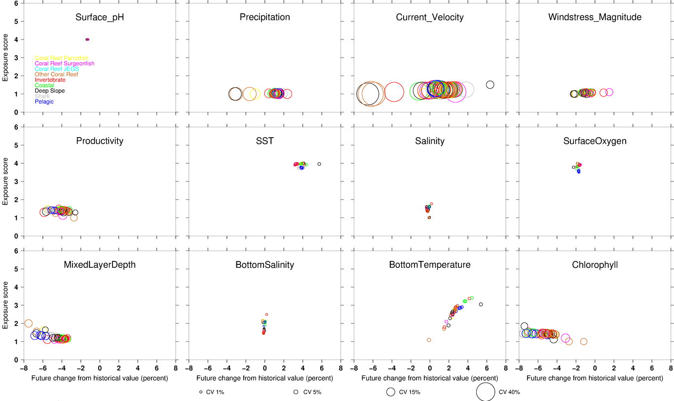

Fig. 3. Exposure scores for 12 variables. Color codes are for each species group, and size of bubble represents the magnitude of exposure.

Exposure scores also relate closely to the spatial domain examined over the distributional range of a particular taxa. For example a sequence of bottom temperature exposure summaries are presented for Scalloped Hammerhead shark (*Sphyrna lewini)*. The overall Pacific exposure shows a mixed result of scores for this variable (Figure ???), which can then be further understood by examination of the four subset domains (Figures ???). Note that some scores for this exposure variable are both positive and negative, indicating that temperature perturbations can be both increasing and decreasing relative to baseline reference levels. In this example, most areas within the distributional range for this taxa are projected to warm in the future, but some areas will experience very little change or even experience some moderate cooling. These bidirectional effects are combined in the upper right panels of the exposure visualizations, with the star on the x-axis representing the average score on a low, moderate, high, very high scale combining both positive and negative scores. In this example we can see that the overall exposure score for Scalloped Hammerhead shark in the Pacific is likely between moderate and high, considering all areas of distribution for this taxa.

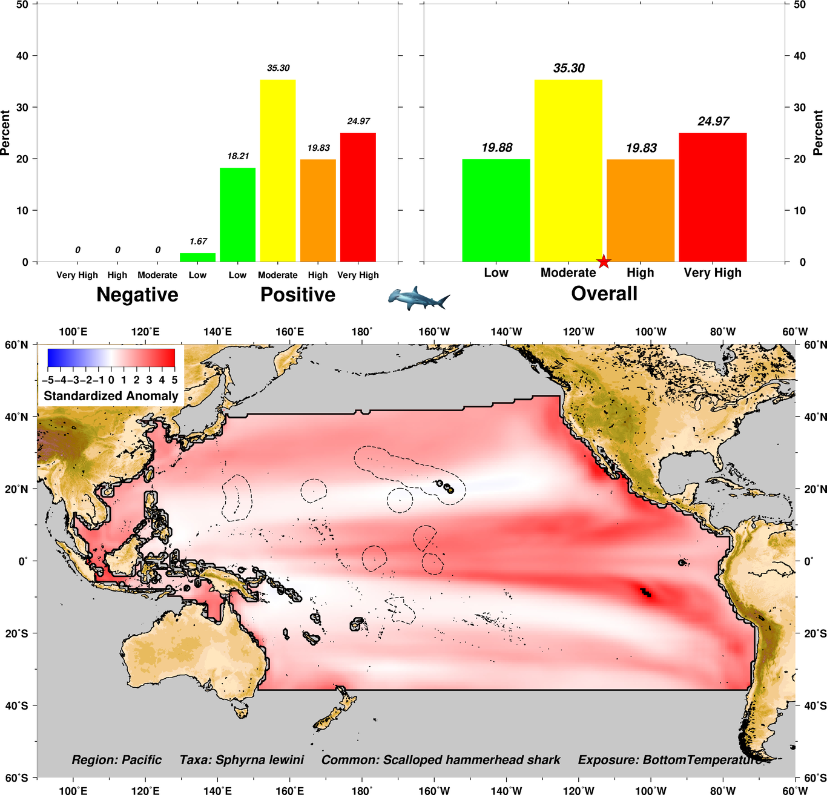

Fig. 4. Bottom temperature exposure summaries for Scalloped Hammerhead shark over the Pacific region.

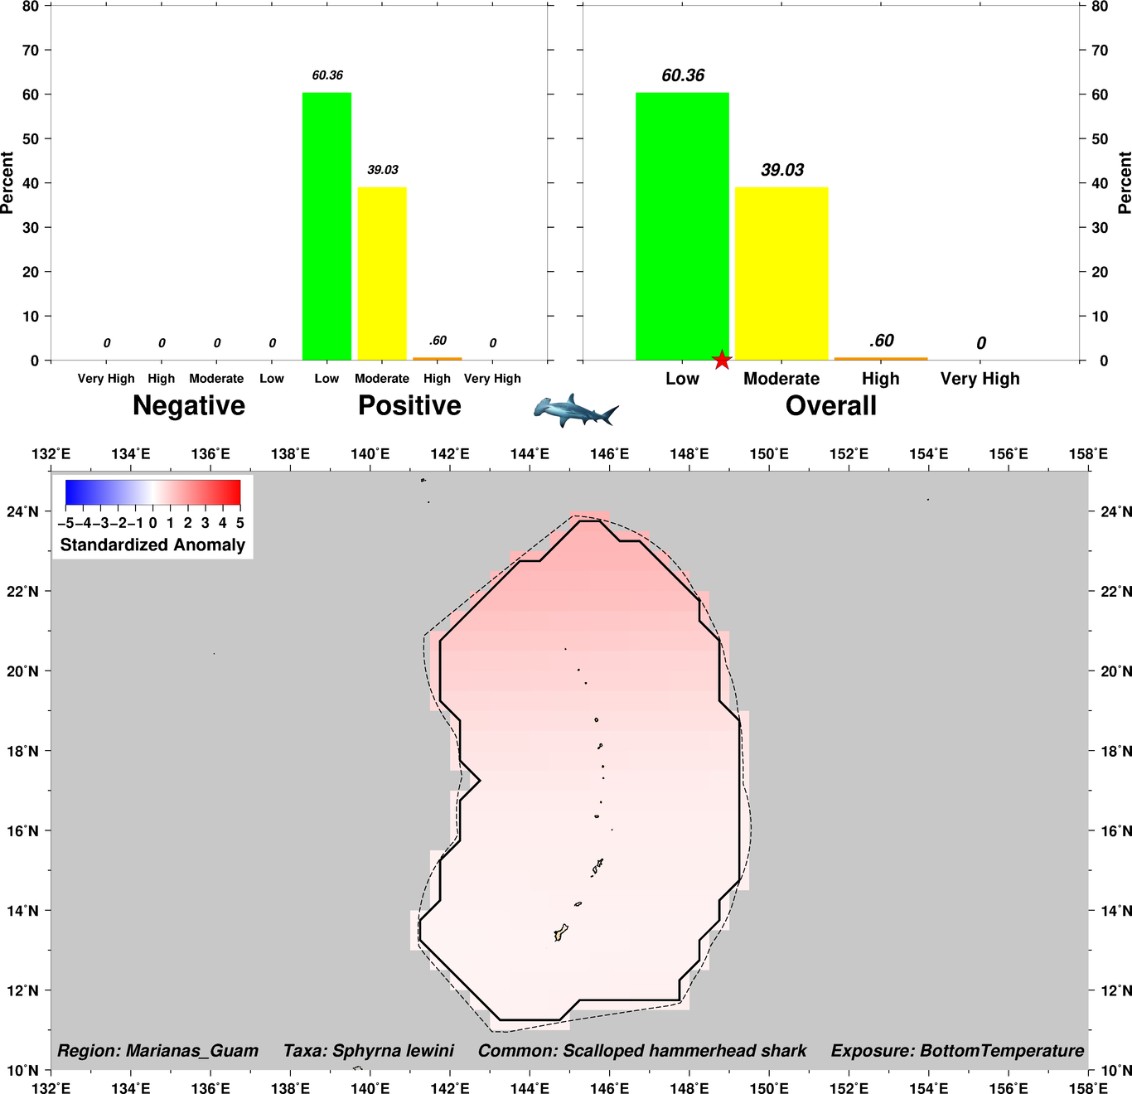

Fig. 5. Bottom temperature exposure scores for Scalloped Hammerhead shark in the Mariana Archipelago

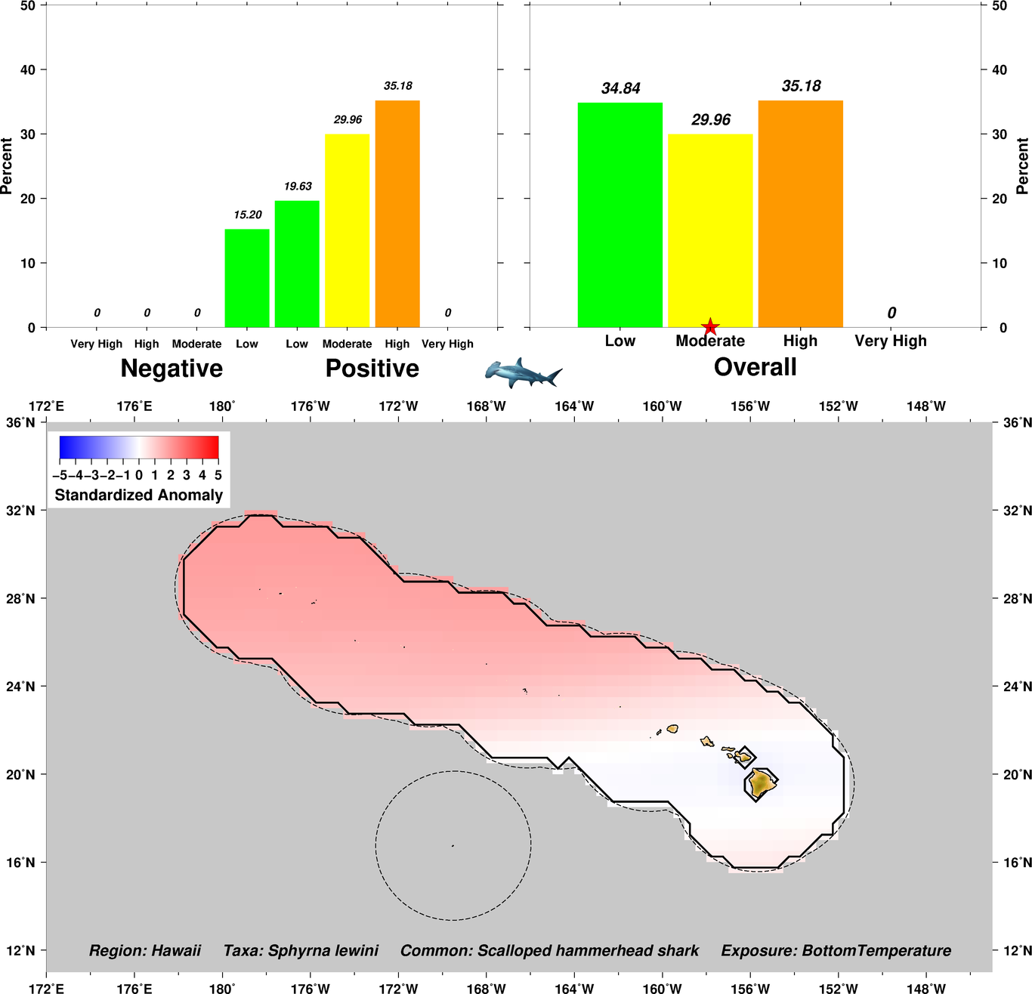

Fig. 6. Bottom temperature exposure scores for Scalloped Hammerhead shark in the Hawaiian Archipelago

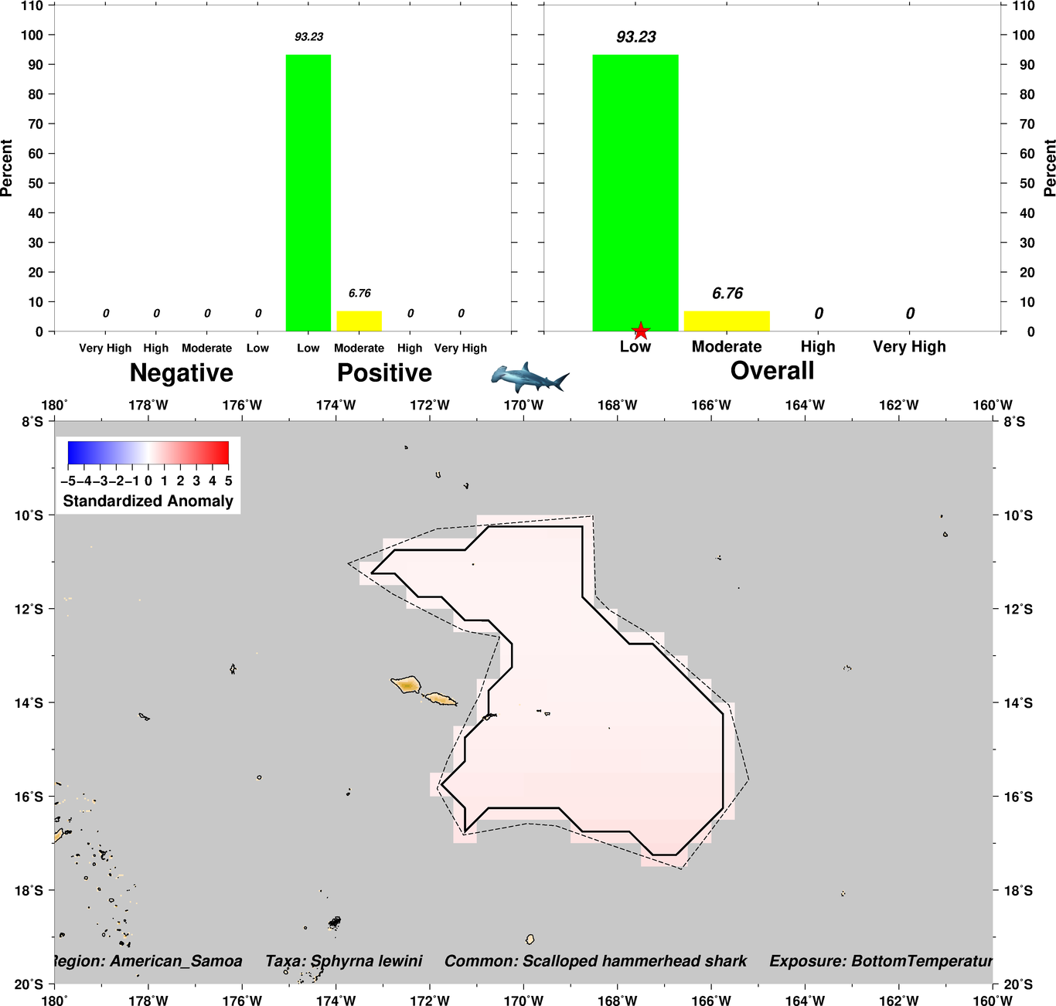

Fig. 7. Bottom temperature exposure scores for Scalloped Hammerhead shark in the American Samoa Archipelago

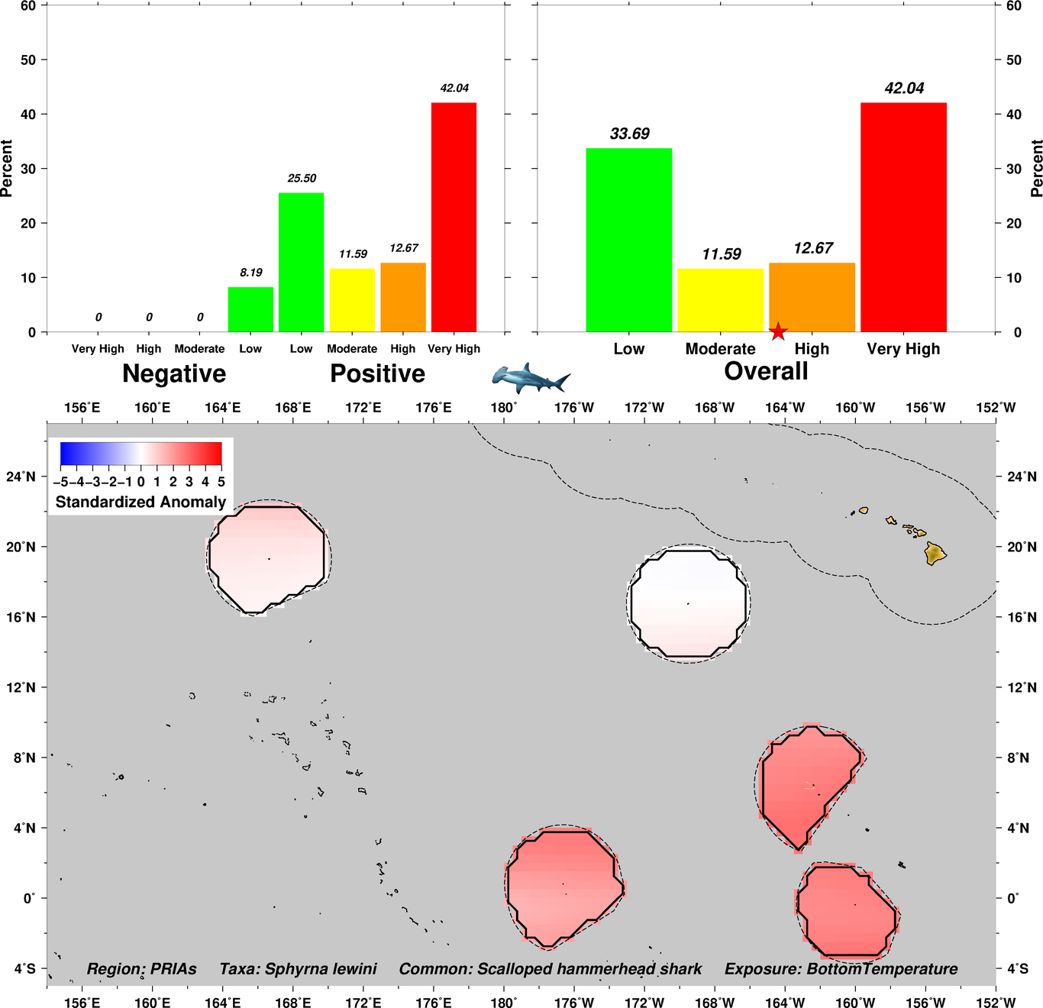

Fig. 8. Bottom temperature exposure scores for Scalloped Hammerhead shark in the Pacific Remote Island Areas

Biological sensitivity point estimate means ranged between Low and Very High ([Supplementary Materials 3 - Species Narratives](https://drive.google.com/drive/folders/1FbNLLvKfUzl5fxRZfmVigvUfhDOT52dN?usp=sharing)). Functional groups that encompassed larger bodied species generally shared similar sensitivity scores, whereas the groups with smaller and site attached species were more differentiated in scores.

## Pelagic:

Biological sensitivity ranged from Low to Moderate for pelagic species (Fig .  ???

The slender armored and striped marlin ranked higher in sensitivity because of their low stock size score  ([Supplementary Materials 3 - Species Narratives](https://drive.google.com/drive/folders/1FbNLLvKfUzl5fxRZfmVigvUfhDOT52dN?usp=sharing))

???

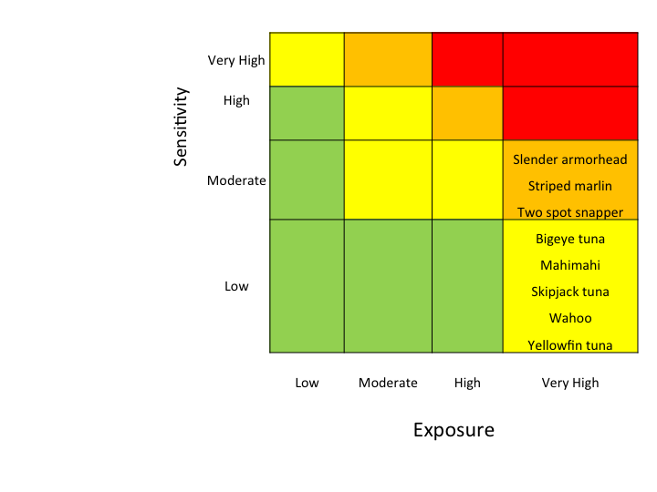

???Pelagic vulnerability scores composed of sensitivity and exposure variables ???

## Sharks:

For sharks, sensitivity ranged from Low to High. The Oceanic White Tip (*Carcharhinus longimanus*), Scalloped Hammerhead (*Sphyrna lewini*), and Silky Shark (*Carcharhinus falciformis*) were ranked higher in overall sensitivity because both population growth rate and stock size status were of concern ([Supplementary Materials 3 - Species Narratives](https://drive.google.com/drive/folders/1FbNLLvKfUzl5fxRZfmVigvUfhDOT52dN?usp=sharing)).

Fig ??????

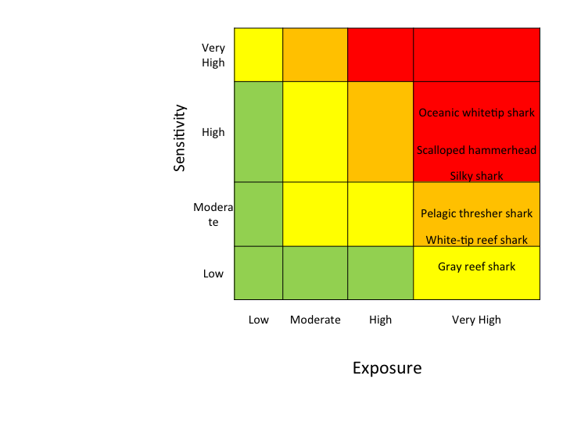

??? Sharks vulnerability scores composed of sensitivity and exposure variables

## Deep slope:

For deep slope species, sensitivity ranged from Low to Moderate, with the Deep-Water Red Snapper (*Etelis carbunculus*), Hawaiian Grouper (*Hyporthodus quernus*), and Slender Aromorhead (*Pentaceros wheeleri*)being most sensitive in the group. These higher scores were due in part to temperature sensitivity and low population growth rate for Hawaiian Grouper, and to concern of small stock size for the Slender Armorhead. Most sensitivity attributes ranked High for Deep-Water Red Snapper (*Etelis carbunculus*) ([Supplementary Materials 3 - Species Narratives](https://drive.google.com/drive/folders/1FbNLLvKfUzl5fxRZfmVigvUfhDOT52dN?usp=sharing)).

Fig ???.

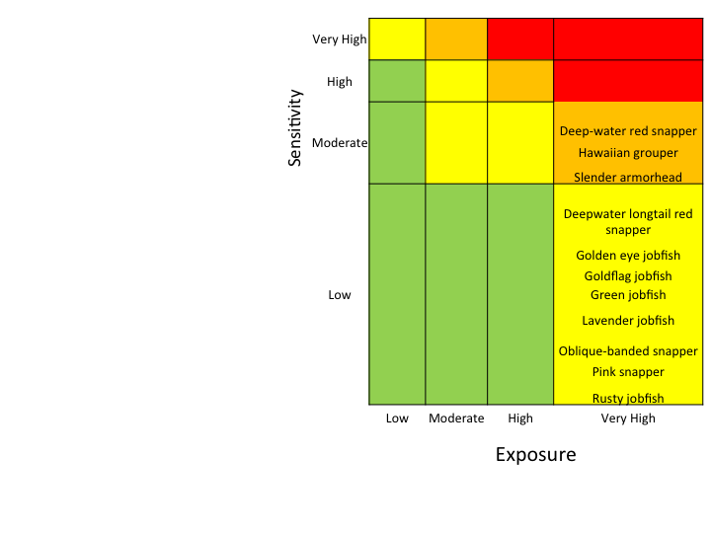

Fig 11. Deep slope vulnerability scores composed of sensitivity and exposure variables

## Coastal:

All coastal species ranked Low in overall sensitivity.  This group was made up of only six species, and their component sensitivities all ranged from Low to Moderate, with only Bonefish (*Albula glossodonta*), Threadfin (*Polydactylus sexfilis*), and Greater Amberjack (*Seriola dumerilii*) sensitivity attributes falling in the Very High category for any component score ([Supplementary Materials 3 - Species Narratives](https://drive.google.com/drive/folders/1FbNLLvKfUzl5fxRZfmVigvUfhDOT52dN?usp=sharing)).

Fig ???.

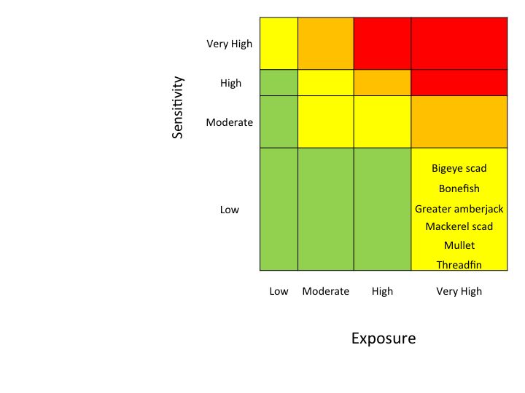

??? Fig. 12. Coastal vulnerability scores composed of sensitivity and exposure variables

## Coral reef Jack, Emperors, Groupers, and Snappers (JEGS):

Coral reef JEGS sensitivity ranged from Low to Moderate, with most species falling in the Low category. The Black-tip Grouper (*Epinephelus fasciatus*) and the Whitesaddle Goatfish (*Parupeneus porphyreus*) stood out as more sensitive because of complexity in reproduction, specialized early life history requirements, and sensitivity to temperature for the Whitesaddle Goatfish ([Supplementary Materials 3 - Species Narratives](https://drive.google.com/drive/folders/1FbNLLvKfUzl5fxRZfmVigvUfhDOT52dN?usp=sharing)).

Fig ???.

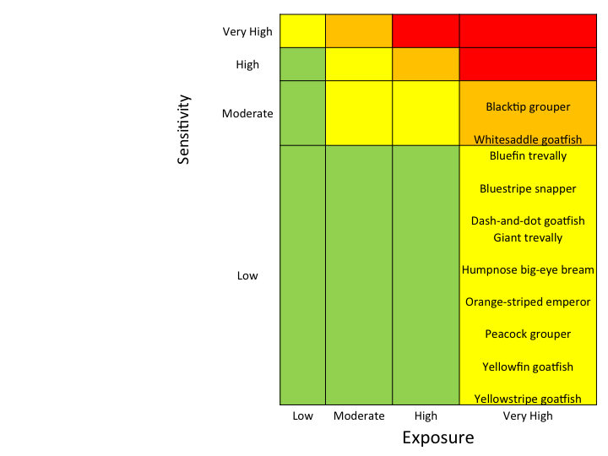

Fig. 13. Coral reef Jack, Emperors, Groupers, and Snappers vulnerability scores composed of sensitivity and exposure variables

## Coral reef parrotfish:

Sensitivity ranged from Low to Moderate for coral reef parrotfish. Of these, only two species ranked Moderate. The Bumphead Parrotfish (*Bolbometopon muricatum*) stood out with greater sensitivity because of habitat specificity, early life history requirements, sensitivity to OA, and low stock size. The Steephead Parrotfish (*Chlorurus microrhinos*) ranked moderate in sensitivity because of habitat specificity, early life history requirements, and complexity in reproductive strategy ([Supplementary Materials 3 - Species Narratives](https://drive.google.com/drive/folders/1FbNLLvKfUzl5fxRZfmVigvUfhDOT52dN?usp=sharing)).

Fig ???.

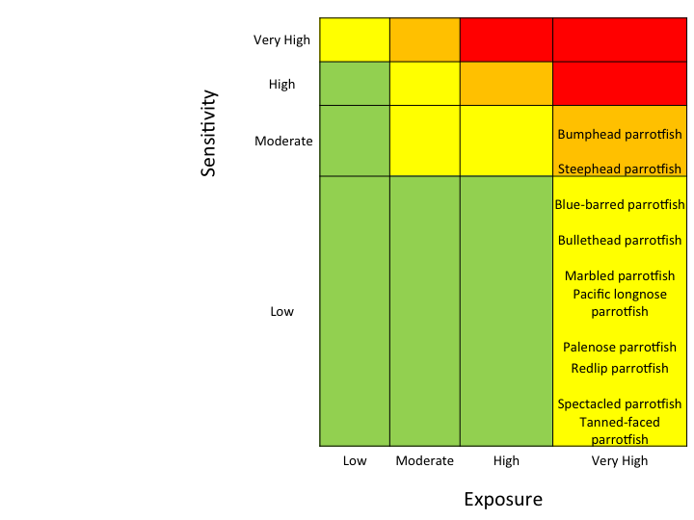

Fig. 14. Coral reef parrotfish vulnerability score composed of sensitivity and exposure variables

## Coral reef surgeonfish:

Coral reef surgeonfish sensitivities ranged from Low to Moderate almost distributed evenly between the two categories ([Supplementary Materials 3 - Species Narratives](https://drive.google.com/drive/folders/1FbNLLvKfUzl5fxRZfmVigvUfhDOT52dN?usp=sharing)).

Fig ???.

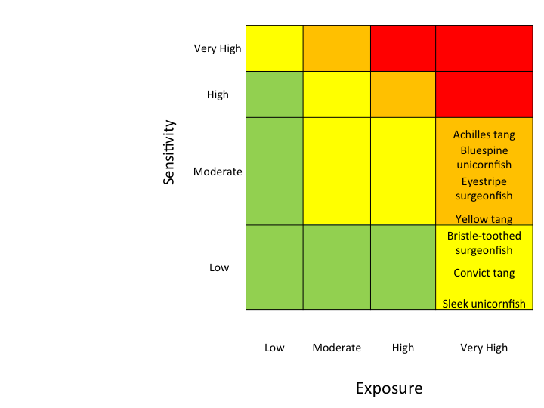

Fig. 15. Coral reef surgeonfish vulnerability scores composed of sensitivity and exposure variables

## Other coral reef fish:

For other coral reef fish, sensitivities ranged from Low to High. The Arceye Hawkfish (*Paracirrhites arcatus*) and the Ornate Butterflyfish (*Chaetodon ornatissimus*) scored the highest in vulnerability. For Arceye Hawkfish, habitat specificity and adult mobility were the two most sensitive attributes. For the Ornate Butterflyfish, prey sensitivity and sensitivity to OA  stood out as higher concern ([Supplementary Materials 3 - Species Narratives](https://drive.google.com/drive/folders/1FbNLLvKfUzl5fxRZfmVigvUfhDOT52dN?usp=sharing)).

Fig ???.

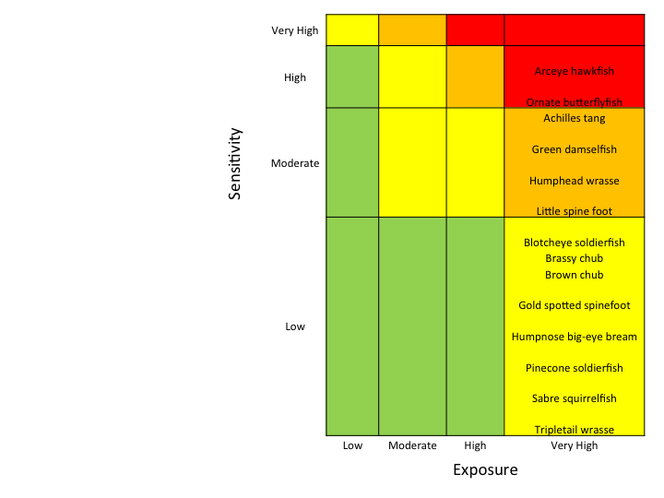

Fig. 16. Other coral reef fish vulnerability scores composed of sensitivity and exposure variables

## Invertebrates:

The group that scored the highest in biological sensitivities were the invertebrates. One species, the endemic Hawaiian Yellow-foot Limpet (*Cellana sandwicensis*), ranked Very High. This was due to a very high sensitivity score in every attribute except population growth rate. Five species were ranked high in vulnerability, with the remainder of the taxa falling in the Low or Moderate category.  The Blue Octopus (*Octopus cyanea*) and the Samoan Crab (*Scylla serrata*) ranked the lowest in vulnerability ([Supplementary Materials 3 - Species Narratives](https://drive.google.com/drive/folders/1FbNLLvKfUzl5fxRZfmVigvUfhDOT52dN?usp=sharing)).

Fig ???.

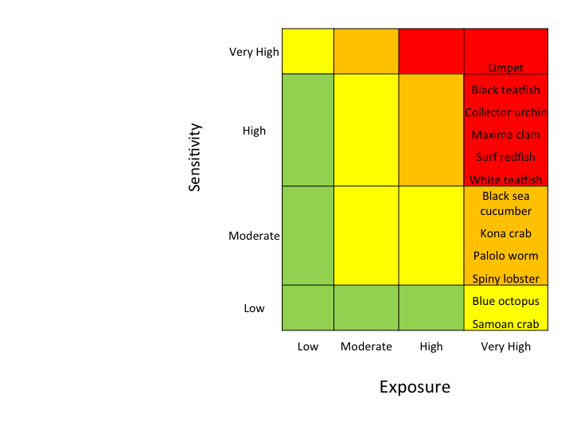

Fig. 17. Invertebrates vulnerability scores composed of sensitivity and exposure variables

## Summary:

Functional groups separated out from each other in terms of vulnerability scores, with invertebrates scoring the highest, and pelagic and coastal groups scoring the lowest in vulnerability (Figures 9-17). Within-group differences were evident as well (Fig ???.) For invertebrates, taxa were more evenly distributed between Moderate to Very High vulnerability rankings, whereas for the coastal group, all species fell within the Moderate category.

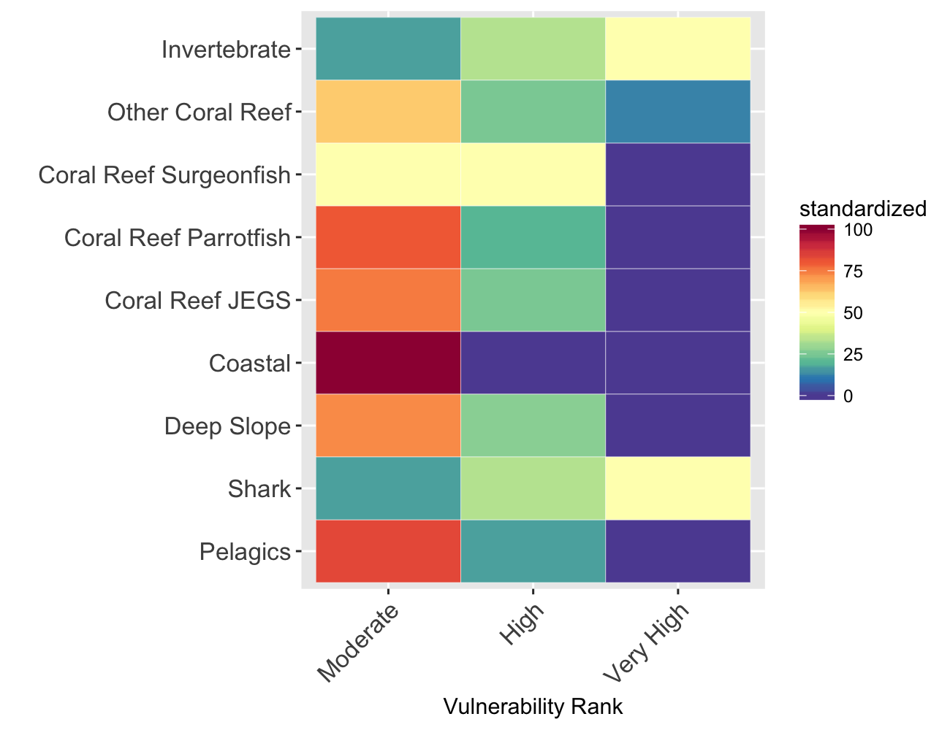

Fig. 18. Summary of standardized  vulnerability scores across taxa

## Bootstrap sensitivity scores

Results of bootstrapped sensitivity scores showed a slight change in the distribution of overall vulnerability scores, where a greater number of species across four functional groups scored Very High in overall vulnerability. (Fig. ???

Fig. 19. Bootstrapped sensitivity scores for all 83 taxa 

Fig. 19. Bootstrapped sensitivity scores for all 83 taxa

# 

# Discussion

The climate change vulnerabilities for 83 taxa in the Pacific showed a broad pattern across functional groups. The larger-bodied and more wide-ranging (pelagic and coastal) species ranked least, while the smaller-bodied and more site attached species (small coral reef and invertebrates) ranked highest in vulnerability.

## Drivers of vulnerability:

### Large, wide-ranging species:

In general, the vertical expansion of the oxygen minimum zone with climate change could be the biggest habitat threat for pelagic species (Schmidtko, Stramma, and Visbeck 2017). One exception to this generalization may be bigeye tuna, that as adults are relatively tolerant of low oxygen concentrations (Bernal 2011). Secondly, rising sea surface temperatures is a threat to pelagic species (Henson et al. 2017). For example, skipjack tuna may already inhabit the high extreme of their temperature threshold (Lehodey et al. 2012).

In contrast, coastal mackerel scad may experience an increase in population growth rate and abundance (Stobberup and Erzini 2006) given the projected increase in nutrient runoff in coastal areas with climate change (Bell et al. 2013).

### Mid-sized species:

The sensitivity scores of many coral reef fish ranged between Low to Moderate. This is  surprisingly low, given that  many coral reef species depend on a biogenic habitat that is itself threatened by climate change (Pratchett et al. 2011). There are direct physiological effects of not only temperature, but also OA on coral reef fish, which include impaired hearing and olfaction in reef fish (Munday et al. 2012). These senses are particularly important for navigation and homing during early life stages when the larvae settle from the plankton as new recruits to a coral reef habitat (Castro et al. 2017).

In particular, the bumphead parrotfish have very specific recruitment requirements and so emerge as a more sensitive species (Muñoz et al. 2014). They recruit to acroporid coral in shallow lagoon areas, areas that are particularly affected by climate change (Bonin 2011).

### Small, site attached species:

Invertebrates face a slew of unique challenges to climate change. In particular, given their small home range sizes and limited adult mobility, they are more susceptible to impacts that occur in a particular region.

In Hawaii, the Yellow-foot Limpet, or *opihi*as it is locally known, isranked the highest in vulnerability. Not only is it endemic with a very small distribution limited to the Hawaiian archipelago, it also has a particular habitat requirement of open Crustose Coraline Algae (CCA) relying on a co-occuring  grazer at the right densities to create habitable space for the *opihi* (BIRD et al. 2007).  This species of *Cellana* is also the most desired for human consumption.

More generally, the less-mobile invertebrates are more likely to experience the Allee effect at low population numbers, which could negate or slow recovery (Allee 1923). For example, in a field experiment where a sea cucumber (*Actinopyga*m*auritiana)* was fished to near complete depletion, it took nine years to recover to pre-disturbance abundances (Trianni and Bryan 2004).

In contrast, theSamoan crabcoulddo well in disturbed habitats. This species was identified as a potential “winner” in climate change scenarios given its quick acclimation to Hawaii after introduction (Alberts-Hubatsch et al. 2015), and its low sensitivity rankings.  This species is relatively mobile compared to other invertebrates and is not specialized in most aspects of its life-history.

## Methodology considerations

There were a few distinct characteristics that set the Pacific Islands Vulnerability Assessment apart from the original VA developed in the US North East. In the latter region, biological sensitivities were ranked High to Very High. In the Northeast US, many of the species considered are managed stocks, with detailed assessments of stock status and data on life history parameters available. In the Pacific Islands region, many coral reef and invertebrate species are not quantitatively assessed and managed. The low vulnerability scores for species in the Pacific region may reflect uncertainty in sensitivity attributes, rather than actual biological coping mechanisms of the species.

Further, some coral reef species, such as surgeonfish do not fit well into standard categories, making it difficult to interpret sensitivity from life history attributes. For example, the reproductive schedule of many surgeonfish trade output for long life, where there are mass recruitments at odd times, making it difficult to assess population growth rate in a standard way (Montgomery 2003). The square growth curve and odd life history parameters are particularly challenging to fit into a standardized assessment (Claisse et al. 2009).

Secondly, coral reef fish have added complexity in reproduction in that some species are hermaphrodites (Fischer 1980). The expression of one gender or another is dependent on habitat quality as well as population density  (Choat and Robertson 1975)(Robertson and Justines 1982). This flexibility in reproduction could be advantageous rather than the opposite, but in this methodology, complexity in reproduction is taken as an indicator of increased sensitivity to climate change.

Finally, the biological sensitivity attributes were developed for finfish. Here, the invertebrate species were particularly difficult to assess. The life history for invertebrates can change dramatically among locations. For example, for the sea cumbers, asexual reproduction occurs in some, but not all locations (Dolmatov 2014). Likewise, the spawning cycle can be different across locations (Drumm and Loneragan 2005).

Exposure variables were scored under the assumption that perturbations to baseline conditions are equally deleterious whether the departures were negative or positive. While the scoring provides a flexible framework to incorporate potential nonlinear responses, it remains difficult to know how a particular taxa may cope with excess amounts of something that is normally beneficial and desirable. For example, oxygen concentration may fall into this category whereby positive anomalies of oxygen could be beneficial yet realizing that at some point (albeit unlikely to occur naturally) oxygen toxicity could become an issue. For purposes of this exercise, high levels of oxygen were scored similarly to low levels of oxygen. Until the specific dose-response functions are fully mapped out for each taxa, these types of assumptions remain in the scoring process and should be carefully treated. Fortunately, situations such as this did not manifest in our results nor drive any taxa’s overall vulnerability to climate change projections.

Because certain sensitivity attributes could be closely related, and could thus potentially skew results, and because some attributes have very little information available for the Pacific region or for particular taxa so that their scores could potentially be less meaningful, experts who participated in the panel suggested selecting the top six attributes for each species that are most relevant as a way to explore modifying the methodology to customize it to our region. Thus, further research will include reexamining the sensitivity attributes for the Pacific Islands to determine which of the twelve originally developed are most meaningful for this unique location. This may reduce uncertainty and better assess the relative vulnerability rankings of species within the Pacific region. Further developments could show both analysis on the one hand for consistency with other vulnerability exercises around the country, and on the other, to highlight a potential improvement, particularly when a wide variety of taxa are being considered such as with PIVA.

## Data needs moving forward:

Many species were difficult to assess given unknowns in their biology and trophic ecology. In particular for fin-fish, the early life history and larval stage proved the most challenging to assess given unknowns about these requirements. The invertebrate group were particularly challenging to asses, given the uncertainty in basic knowledge about their life-history and distribution. Finally, the role of adaptation and the the ability of species to increase fitness apace with climate change was a question that emerged that we need to address to better understand the vulnerability of marine life to climate change.

# Acknowledgements

Roger Griffis, Michael Seki, Evan Howell,  Frank Parrish, Rusty Brainard, Jeff Hare, Melanie Abecassis, Mark Hixon, Rob Toonen, Howard Choat, Charles Birkeland, Marlowe Sabater, Ivor Williams, Michael Trianni, Phoebe Woodworth-Jefcoats, Jacob Asher, Bruce Mundy, Mark Fitchett, Johanna Wren, Joseph O’Malley, Melanie Hutchinson.  This work was supported with funding from NOAA Office of Science and Technology, NOAA Pacific Islands Fisheries Science Center, and the Joint Institute of Marine and Atmospheric Research at the University of Hawaii, Manoa.

# References

Morley, JW, RL Selden, RJ Latour, TL Frölicher, RJ Seagraves, and ML Pinsky. 2018. “Projecting Shifts in Thermal Habitat for 686 Species on the North American Continental Shelf.”. *PLoS One* 13: e0196127.

Kleisner, KM, MJ Fogarty, S McGee, A Barnett, P Fratantoni, J Greene, JA Hare, et al. 2016. “The Effects of Sub-Regional Climate Velocity on the Distribution and Spatial Extent of Marine Species Assemblages.”. *PLoS One* 11: e0149220.

Pinsky, ML, and D Byler. 2015. “Fishing, Fast Growth and Climate Variability Increase the Risk of Collapse.”. *Proc Biol Sci* 282: 20151053.

Pinsky, ML, B Worm, MJ Fogarty, JL Sarmiento, and SA Levin. 2013. “Marine Taxa Track Local Climate Velocities.”. *Science* 341: 1239–42.

Popova, E, A Yool, V Byfield, K Cochrane, AC Coward, SS Salim, MA Gasalla, et al. 2016. “From Global to Regional and Back Again: Common Climate Stressors of Marine Ecosystems Relevant for Adaptation across Five Ocean Warming Hotspots.”. *Glob Chang Biol* 22: 2038–53.

Pandolfi, JM, SR Connolly, DJ Marshall, and AL Cohen. 2011. “Projecting Coral Reef Futures under Global Warming and Ocean Acidification.”. *Science* 333: 418–22.

Marzloff, MP, J Melbourne-Thomas, KG Hamon, E Hoshino, S Jennings, Putten IE van, and GT Pecl. 2016. “Modelling Marine Community Responses to Climate-Driven Species Redistribution to Guide Monitoring and Adaptive Ecosystem-Based Management.”. *Glob Chang Biol* 22: 2462–74.

Levin, Simon A., and Jane Lubchenco. 2008. “Resilience Robustness, and Marine Ecosystem-Based Management”. *BioScience* 58 (1). Oxford University Press (OUP): 27–32. doi:10.1641/b580107.

on Climate Change, Intergovernmental Panel. n.d. “Drivers Trends and Mitigation”. In *Climate Change 2014 Mitigation of Climate Change*, 351–412. Cambridge University Press. doi:10.1017/cbo9781107415416.011.

Holsman, Kirstin, Jameal Samhouri, Geoffrey Cook, Elliott Hazen, Erik Olsen, Maria Dillard, Stephen Kasperski, et al. 2017. “An Ecosystem-Based Approach to Marine Risk Assessment”. *Ecosystem Health and Sustainability* 3 (1). Informa UK Limited: e01256. doi:10.1002/ehs2.1256.

Morrison, Wendy E., Mark W. Nelson, Roger B. Griffis, and Jonathan A. Hare. 2016. “Methodology for Assessing the Vulnerability of Marine and Anadromous Fish Stocks in a Changing Climate”. *Fisheries* 41 (7). Wiley: 407–9. doi:10.1080/03632415.2016.1182507.

Busch, D. Shallin, Roger Griffis, Jason Link, Karen Abrams, Jason Baker, Russell E. Brainard, Michael Ford, et al. 2016. “Climate Science Strategy of the US National Marine Fisheries Service”. *Marine Policy* 74 (December). Elsevier BV: 58–67. doi:10.1016/j.marpol.2016.09.001.

Hare, JA, WE Morrison, MW Nelson, MM Stachura, EJ Teeters, RB Griffis, MA Alexander, et al. 2016. “A Vulnerability Assessment of Fish and Invertebrates to Climate Change on the Northeast U.S. Continental Shelf.”. *PLoS One* 11: e0146756.

Wessel, Paul, Walter H. F. Smith, Remko Scharroo, Joaquim Luis, and Florian Wobbe. 2013. “Generic Mapping Tools: Improved Version Released”. *Eos Transactions American Geophysical Union* 94 (45). American Geophysical Union (AGU): 409–10. doi:10.1002/2013eo450001.

Schmidtko, S, L Stramma, and M Visbeck. 2017. “Decline in Global Oceanic Oxygen Content during the Past Five Decades.”. *Nature* 542: 335–39.

Bernal, Diego. 2011. “Fishes of the Open Ocean: A Natural History and Illustrated Guide. By Julian Pepperell$\Mathsemicolon$ Illustrated by Guy Harvey. Chicago (Illinois): University of Chicago Press. 35.00. Vi + 266 p.$\Mathsemicolon$ Ill.$\Mathsemicolon$ Index. ISBN: 978-0-226-65539-0. 2010.”. *The Quarterly Review of Biology* 86 (1). University of Chicago Press: 61–62. doi:10.1086/658456.

Henson, Stephanie A., Claudie Beaulieu, Tatiana Ilyina, Jasmin G. John, Matthew Long, Roland Séférian, Jerry Tjiputra, and Jorge L. Sarmiento. 2017. “Rapid Emergence of Climate Change in Environmental Drivers of Marine Ecosystems”. *Nature Communications* 8 (March). Springer Nature: 14682. doi:10.1038/ncomms14682.

Lehodey, Patrick, Inna Senina, Beatriz Calmettes, John Hampton, and Simon Nicol. 2012. “Modelling the Impact of Climate Change on Pacific Skipjack Tuna Population and Fisheries”. *Climatic Change* 119 (1). Springer Nature: 95–109. doi:10.1007/s10584-012-0595-1.

Stobberup, Kim A., and Karim Erzini. 2006. “Assessing Mackerel Scad Decapterus Macarellus, in Cape Verde: Using a Bayesian Approach to Biomass Dynamic Modelling in a Data-Limited Situation”. *Fisheries Research* 82 (1-3). Elsevier BV: 194–203. doi:10.1016/j.fishres.2006.06.005.

Bell, Johann D., Alexandre Ganachaud, Peter C. Gehrke, Shane P. Griffiths, Alistair J. Hobday, Ove Hoegh-Guldberg, Johanna E. Johnson, et al. 2013. “Mixed Responses of Tropical Pacific Fisheries and Aquaculture to Climate Change”. *Nature Climate Change* 3 (6). Springer Nature: 591–99. doi:10.1038/nclimate1838.

Pratchett, Morgan S., Andrew S. Hoey, Shaun K. Wilson, Vanessa Messmer, and Nicholas A.J. Graham. 2011. “Changes in Biodiversity and Functioning of Reef Fish Assemblages Following Coral Bleaching and Coral Loss”. *Diversity* 3 (3). MDPI AG: 424–52. doi:10.3390/d3030424.

Munday, Philip L., Morgan S. Pratchett, Danielle L. Dixson, Jennifer M. Donelson, Geoff G. K. Endo, Adam D. Reynolds, and Richard Knuckey. 2012. “Elevated CO2 Affects the Behavior of an Ecologically and Economically Important Coral Reef Fish”. *Marine Biology* 160 (8). Springer Nature: 2137–44. doi:10.1007/s00227-012-2111-6.

Castro, JM, MC Amorim, AP Oliveira, EJ Gonçalves, PL Munday, SD Simpson, and AM Faria. 2017. “Painted Goby Larvae under High-CO2 Fail to Recognize Reef Sounds.”. *PLoS One* 12: e0170838.

Muñoz, RC, BJ Zgliczynski, BZ Teer, and JL Laughlin. 2014. “Spawning Aggregation Behavior and Reproductive Ecology of the Giant Bumphead Parrotfish, Bolbometopon Muricatum, in a Remote Marine Reserve.”. *PeerJ* 2: e681.

Bonin, M. C. 2011. “Specializing on Vulnerable Habitat: Acropora Selectivity among Damselfish Recruits and the Risk of Bleaching-Induced Habitat Loss”. *Coral Reefs* 31 (1). Springer Nature: 287–97. doi:10.1007/s00338-011-0843-2.

BIRD, CHRISTOPHER E., BRENDEN S. HOLLAND, BRIAN W. BOWEN, and ROBERT J. TOONEN. 2007. “Contrasting Phylogeography in Three Endemic Hawaiian Limpets (Cellana Spp.) with Similar Life Histories”. *Molecular Ecology* 16 (15). Wiley: 3173–86. doi:10.1111/j.1365-294x.2007.03385.x.

Allee, W. C. 1923. “Studies in Marine Ecology: The Effect of Temperature in Limiting the Geographical Range of Invertebrates of the Woods Hole Littoral”. *Ecology* 4 (4). Wiley: 341–54. doi:10.2307/1929181.

Trianni, Michael S., and Patrick G. Bryan. 2004. “Survey and Estimates of Commercially Viable Populations of the Sea Cucumber Actinopyga Mauritiana (Echinodermata: Holothuroidea) on Tinian Island, Commonwealth of the Northern Mariana Islands”. *Pacific Science* 58 (1). Johns Hopkins University Press: 91–98. doi:10.1353/psc.2004.0009.

Alberts-Hubatsch, Hilke, Shing Yip Lee, Jan-Olaf Meynecke, Karen Diele, Inga Nordhaus, and Matthias Wolff. 2015. “Life-History Movement, and Habitat Use of Scylla Serrata (Decapoda, Portunidae): Current Knowledge and Future Challenges”. *Hydrobiologia* 763 (1). Springer Nature: 5–21. doi:10.1007/s10750-015-2393-z.

Montgomery, W Linn. 2003. “Surgeonfishes of the World. Bishop Museum Bulletin in Zoology Volume 4.By John E  Randall. Honolulu (Hawai’i): Mutual Publishing$\Mathsemicolon$ Honolulu (Hawai’i): Bishop Museum Press. 18.95. x + 123 p$\Mathsemicolon$ Ill.$\Mathsemicolon$ IndexCommon and Scientific Names of Fishes. ISBN: 1566475619. 2001.”. *The Quarterly Review of Biology* 78 (4). University of Chicago Press: 492–92. doi:10.1086/382429.

Claisse, JT, M Kienzle, ME Bushnell, DJ Shafer, and JD Parrish. 2009. “Habitat- and Sex-Specific Life History Patterns of Yellow Tang Zebrasoma Flavescens in Hawaii USA”. *Marine Ecology Progress Series* 389 (September). Inter-Research Science Center: 245–55. doi:10.3354/meps08114.

Fischer, Eric A. 1980. “The Relationship between Mating System and Simultaneous Hermaphroditism in the Coral Reef Fish Hypoplectrus Nigricans (Serranidae)”. *Animal Behaviour* 28 (2). Elsevier BV: 620–33. doi:10.1016/s0003-3472(80)80070-4.

Choat, J. H., and D. R. Robertson. 1975. “Protogynous Hermaphroditism in Fishes of the Family Scaridae”. In *Intersexuality in the Animal Kingdom*, 263–83. Springer Berlin Heidelberg. doi:10.1007/978-3-642-66069-6_26.

Robertson, D. R Ross, and Gustavo Justines. 1982. “Protogynous Hermaphroditism and Gonochorism in Four Caribbean Reef Gobies”. *Environmental Biology of Fishes* 7 (2). Springer Nature: 137–42. doi:10.1007/bf00001783.

Dolmatov, Igor Yu. 2014. “Asexual Reproduction in Holothurians”. *The Scientific World Journal* 2014. Hindawi Limited: 1–13. doi:10.1155/2014/527234.

Drumm, Darrin J., and Neil R. Loneragan. 2005. “Reproductive Biology OfHolothuria Leucospilotain the Cook Islands and the Implications of Traditional Fishing of Gonads on the Population”. *New Zealand Journal of Marine and Freshwater Research* 39 (1). Informa UK Limited: 141–56. doi:10.1080/00288330.2005.9517297.