Effect of Policy Anticipation on Milk Supply Response: Evidence from EU Quota Elimination
Shuwei

Policy
Between 1984 and 2015, the European Union (EU) dairy sector has been subject to country specific production quotas. This restriction was officially eliminated in 2015 and this quota elimination policy was announced and confirmed in 2008. Dairy farms have seven years to adjust and prepare for quota removal. Fig. ??? presents the timeline of policy changes.
- In 1984, each dairy farm was assigned quota based on the milk production, the amount of milk sold each year can not exceed quota;
- Quota trade: before 2007, quota trade were highly regulated and mostly attached to land. From 2007, quota trade were more flexible, but still not competitive market due to restriction on trade amount and price regulation;
- In 2008, quota removal in 2015 was announced and confirmed;
- “Soft-landing” policy: quota for each farm was increased 1% annually from 2009;
- Penalty: If a dairy farm sells more milk than the quota assigned, he may be subject to a penalty for the exceeding part, the penalty value is fixed per unit milk. The farm only need to pay the penalty only when the whole country’s milk production exceeds the aggregated quota;
- In 2015, milk quota was officially eliminated.
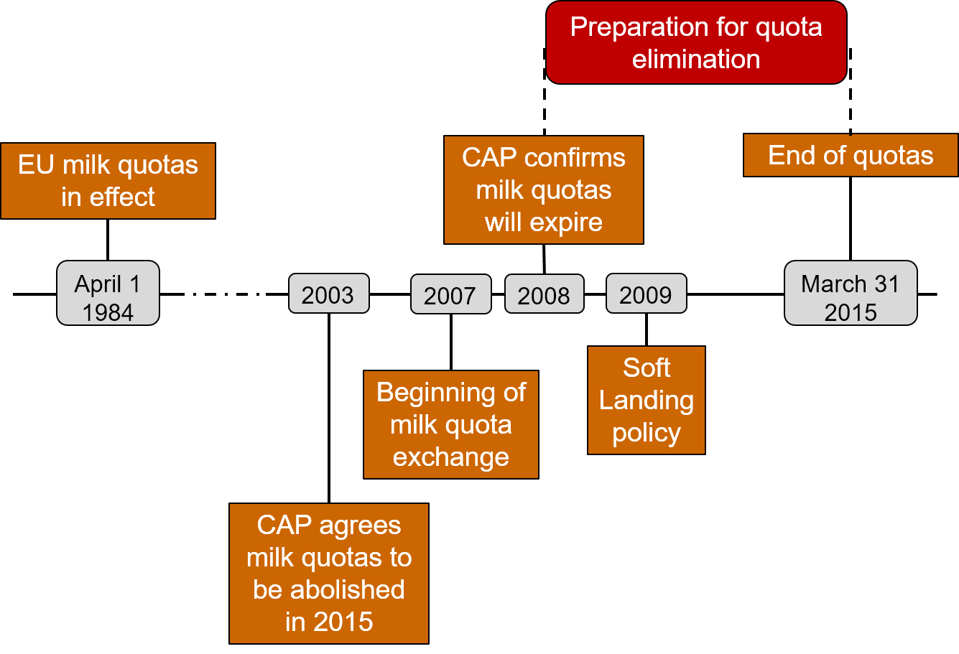
Time Line of Milk Quota Regulation

Research Questions
Dairy farms anticipate quota elimination and thus may adjust production decisions ahead of the policy taking effect. The policy anticipation has effect on farm dynamics in response to the policy change.
- Does the policy anticipation have effect on farm dynamics in response to the policy change, such as herd size, milk supply and quota adjustment?
- If so, are there heterogeneous effects on farms with different productivity level?

Model
We develop a dynamic model to analyze the heterogeneous supply responses of dairy farms in anticipation of production quota elimination. The farms in the industry are distinguished by productivity levels. We focus on two policies: herd size and quota amount. We investigate how these policy choices respond to the timing of policy implication: whether the quota removal is anticipated by the farm. Assume farms are price-taker for milk, quota and cow sales.
States | $c_{t}$ | Herd size
 | $q_{t}$ | Quota
 | $p_{t}^{m}$ | Milk price
 | $p_{t}^{c}$ | Cow price
 | $p_{t}^{q}$ | Quota price
Controls | $y_{t}$ | Milk yield per cow
Technology | $Y_{t}=c_{t}y_{t}$ | Milk production
 | $C(Y_{t},ω_{i})=h(\frac{Y_{t}}{exp(ω_{t})})^{α}$ | Cost of milk production
 | $x_{t+1}=μ_{x}+ρ_{x}x_{t}+ξ_{t}^{x}$, | AR(1) process of milk, cow, quota prices, and productivity
 | and $ξ^{x}∼N(0,σ_{x}^{2})$ | for $x=p^{m},p^{c},p^{q}$, $ω_{t}$
Parameters | $h$, $α$ | Parameters for milk cost function
 | $μ_{x},ρ_{x},ξ_{t}^{x}$ | Prices parameters
 | $β$ | Discount factor
 | $d$ | Cow death rate
 | $p^{s}$ | Penalty of exceeding quota
Milk profit function:
$$\begin{matrix}π\left(c_{t},q_{t},y_{t},p_{t}^{m},p_{t}^{s},ω_{t}\right) & =R(c_{t},q_{t},y_{t},p_{t}^{m},p_{t}^{s})−C(c_{t},y_{t},ω_{t}) \\ & =p_{t}^{m}c_{t}y_{t}−p_{t}^{s}Max\left\{\begin{matrix}(c_{t}y_{t}−q_{t}),0\end{matrix}\right\}−h(\frac{c_{t}y_{t}}{exp(ω_{t})})^{α}\end{matrix}$$
Value function:
$$\begin{matrix}V\left(c_{t},q_{t},X_{t}\right) & =Max_{c_{t},q_{t}}\left\{\begin{matrix}π\left(c_{t},q_{t},X_{t}\right)+p_{t}^{c}Δc_{t}+p_{t}^{q}Δq_{t}+βE\left[\begin{matrix}V\left(c_{t+1},q_{t+1},X_{t+1}\right)\end{matrix}\right]\end{matrix}\right\} \\ s.t. & c_{t+1}=\sqrt{1.5}(1−d)c_{t}−Δc_{t} \\ & q_{t+1}=q_{t}−Δq_{t} \\ & Δc_{t}≥0 \\ & ∣\begin{matrix}Δq_{t}\end{matrix}∣≤80,000\end{matrix}$$

Transition Path
We first calculate two stationary states with and without quota restriction. Then we analyze the transition dynamics between two stationary states and compare differences between with and without policy anticipation. Fig. ??? presents comparison of three transition paths. (This figure pattern is what I’d like to generate, but I know there are some problems now and the figure is not correct.)
- Period 0-7: subject to quota;
- Period 8-20: quota removed;
- Red line: farms didn’t know quota removal until period 8 when policy suddenly implemented;
- Blue line: At period 1, farms are informed with quota removal in period 8;
- Yellow line: Farms know future removal in period 1, in addition, available quota increases 1% each period until final removal.
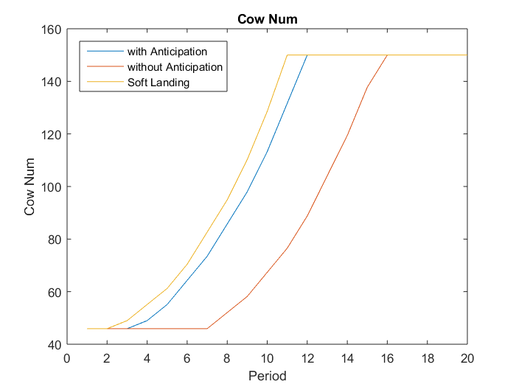
Equilibrium Herd Size Over Time

Questions
I’d like to have your advice about the research question and modeling. Specifically, I have the following questions in mind:
- Production function estimation: Now milk production is specified as cow number times production per cow. I’d like to use Cobb-Douglas production function, where inputs are cow number, labor, capital, material and land. In this set up, capital and land need to be viewed as state variable, but they are not of interest. Is there a way to simplify production function, so that I can focus on cow number as state variable?
- Model Algorithm: I calculated two stationary states by infinite horizon value function iteration. The transition path is calculated using finite horizon. However, I’m not sure if I model the anticipation effect correctly and would like to have your advice about it.
- Computation: Now I haven’t done grid search for all exogenous variables and the grids are very small, but the running time on my laptop is already very long. I’d like to have your advice about computation details.

