Assessment of the predicting compression index of soft soils from Brazilian coast by empirical correlations and artificial neural networks
AMANDIO FILHO
This paper discusses the prediction of compression index (CC) on Brazilian coast soft soils by empirical correlations and artificial neural networks. The data from 295 standard consolidation (or oedometer) tests and the corresponding index properties performed on cohesive soils from different deposits of Brazilian coast are investigated herein. The predictions of alternative new empirical linear correlations relating CC with soil index properties for the investigated soft soils are compared with those of previous published CC empirical correlations. This paper also illustrates the use of artificial neural network (ANN) for CC predictions. The empirical correlations and ANNs performances evaluated through statistical techniques that include: (i) the root mean square error (RMSE), (ii) the ratio of the estimated measured compression index (K), (iii) the ranking index (RI) and (iv) the ranking distance (RD). The results indicate ANN as a potential alternative to empirical correlations for CC prediction of soft soils from Brazilian coast.

1. Introduction
The amount of consolidation settlements of structures founded on a soft cohesive soil depends on its compression index (Cc), which is defined as the change in void ratio per 10-fold increase in consolidation pressure, determined through consolidation tests on undisturbed or remolded soil samples. Empirical relationships between Cc and soil index properties are of practical importance especially during preliminary investigation of suitability of a foundation site during planning stages.
The consolidation settlement of fine-grained soils depends on the fabric of the soil, the water absorption capacity of the clay sized particles, the existing stress state, the pre-consolidation pressure of the soil sample, and to some extent the compressibility of the soil grains (Ozer et al.). For this reason, empirical correlations have been proposed to estimate the compression index from Atterberg limits (such as the liquid limit determined by the Casagrande method (LLCUP) and the plasticity index (PI)) which reflects the relative amount of clay sized particles and their mineralogy, the initial void ratio (e0) as an indication of the existing stress state and the pre-consolidation pressure, and the natural water content (wn) as a measure of the water attracted to the clay particles and free water present within the voids.
Many researchers have published empirical correlations linking various parameters to soil compression index around the world (e.g. Terzaghi and Peck , Azzouz et al., Oh and Chai , Ozer et al. , Kalantary and Kordnaeij , McCabe et al. and Kootahi and Moradi ) and for Brazilian soft soils (Castello and Polido, Futai et al. , Silva , Bicalho et al. , Coutinho and Bello , Higashi and Baroni and Almeida ). Empirical correlations may not apply to soils elsewhere without consideration of soil origin, and the multiplicity of existing empirical correlations indicates the need of evaluation criteria for their use.
The artificial neural networks (ANNs) technique has been used in geotechnical engineering for prediction of engineering properties of soils based on previously known index properties of these soils. The work of Rumelhart et al. () on the backpropagation algorithm is a milestone in the use of ANN in civil engineering studies. Further studies on the application of neural networks in geotechnical engineering can be found in Goh (), who used ANN in hydraulic conductivity research in clays; Najjar et al. () used ANN to control soil compaction, in which they estimated the values of the optimal water content and the corresponding maximum dry density of the soil; Isik () used ANN in predicting soil expansion index (Cs).In Brazil, studies led by Diminsky () represent important research on the potential use of neural networks in geotechnical engineering, with publication of studies with ANN in the prediction of load capacity, as well as modeling of the stress-strain soil behavior.
Artificial neural networks were used in the estimation of soils settlement by Nawari et al. (), Nejad et al. () and Benali et al. (). Studies on the compression index prediction by ANNs were subject in several papers (Kolay et al. , Ozer et al. , Park and Lee , Kalantary and Kordnaeij and Kurnaz et al. ).
This research assesses the validity of some empirical correlations between Cc and index properties for soft soils from Brazilian coast. These correlations use simple or multiple variables to predict Cc from properties such as plasticity index (PI), natural water content (wn), initial void ratio (e0) and liquid limit determined by the Casagrande method (LLCUP). New empirical correlations for soft soils from Brazilian Coast are proposed using the least squares regression and residual analysis test techniques. In addition, this research illustrates the use of ANNs in the estimation of the compression index to overcome limitations of single and multi-variable empirical correlations obtained from regression analysis.

2. Test Soil Database Development
The results of standard consolidation (or oedometer) tests and the corresponding index properties of 295 soft soils from different deposits of the Brazilian coast are investigated in this paper (see Fig. The data set includes soft soils samples from six Brazilian states, distanced up to 3000 km from each other: Espírito Santo (ES), Santa Catarina (SC), Pernambuco (PE), Rio de Janeiro (RJ), Rio Grande do Sul (RS) and São Paulo (SP). The standard oedometer tests were performed according to ABNT NBR-12007 (ABNT ).
Castello and Polido (1988) suggested that marine clays from the Brazilian coast, except for different organic matter contents, appear to have an unique genesis. In the conformation of the deposits of soft clays of the Brazilian coast, prevails the presence of sedimentary associations in the flattened regions, dating from the Tertiary and Quaternary periods, formed by the deposition of sediments predominantly of fluvial-marine origin under influence of sea level and climate variation, as well as fluvial-lagoon sediments and colluvium sediments (Martin et al.).

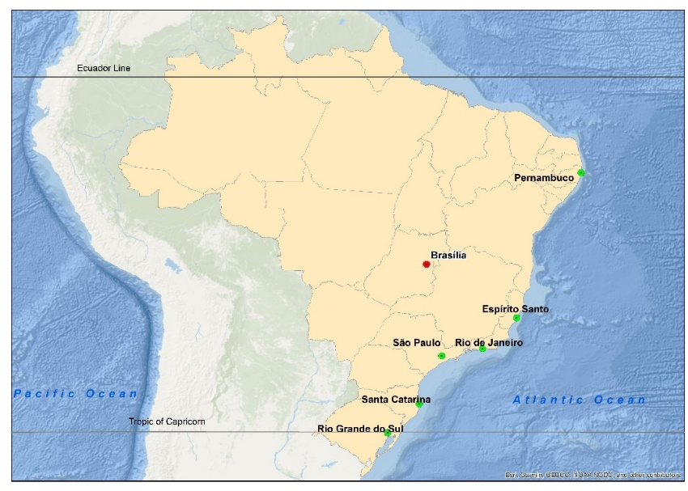
Location of the different investigatedsoil samples of Brazilian coast.

The index properties investigated are: plasticity index (PI), natural water content (wn), initial void ratio (e0) and liquid limit determined by the Casagrande method (LLCUP).
Measurement process data may contain inaccuracies due to systematic bias or outliers. Therefore, adjustments have been used for a selection of investigated experimental data. Initially from known grain specific gravity (Gs), initial void ratio (e0) and water content (wn) of each sample, the saturation degrees (S) of the soil samples have been calculated by:

$S.e_{0}=G_{S}.w_{n}$
The consolidation tests were performed on saturated samples (S = 1) and the calculated degrees of saturation (S) values were mostly within a range of 100% +/- 8%. The values outside this range have been removed from the analysis, due to the data inconsistency.
Statistical techniques were applied for identification and exclusion of systematic bias or outliers. Linear regression graphs of C_{C} versus each one of the variables of interest were plotted (Fig. shows C_{C} versus LL_{CUP}) and a confidence interval of 95% have been used.

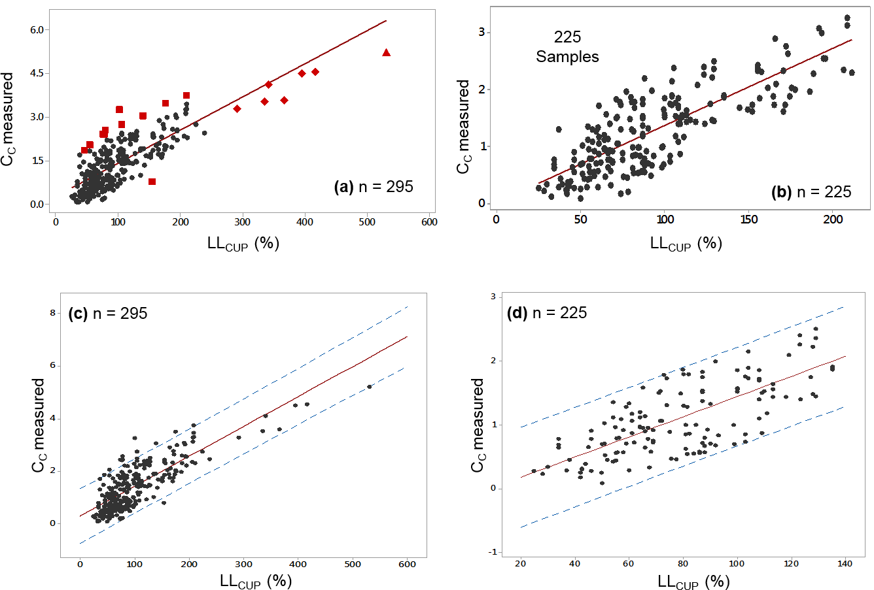
Compression index linear regression by LL_{CUP} (a) before and (b) after the removing the outliers by LL_{CUP.} Confidence interval (95%) (c) before and (d) after the removing the outliers by.
A statistical description data summary after outliers exclusion is presented in Table . Fig. shows Cc distribution histogram. The total of 70 soil samples were removed from the data set, remaining 225 soil samples from which the analyzes of this research are carried out. The outliers exclusion allowed a reduction of the SD values of the evaluated index properties, due to the removals of soil samples with high values of LLCUP and wn.

LL_{CUP} liquide limit (%), PIasticity index (%), w_{n} natural water content (%), e₀ inicial void ratio, C_{C} comprssion index, SD standard deviation.
Variable | Minimum | Maximum | Mean | SD
LL_{CUP} | 25.0 | 211.0 | 94.46 | 43.18
PI | 4.0 | 136.1 | 54.92 | 29.55
w_{n} | 29.0 | 221.34 | 97.5 | 41.53
e₀ | 0.73 | 5.66 | 2.54 | 1.03
C_{c} | 0.09 | 3.27 | 1.3 | 0.71
LLCUP liquid limit (%),PI plasticity index (%), wn natural water content (%),
e0 initial void ratio, Cc compression index, SD standard deviation.

