18.4 Micro-structure noise
Faraz Khaleghi
In this exercise we are gonna check micro-structure properties and perform a self-consistency check on our process

Introduction
We have two process: $x\left(t\right)=−x\left(t\right)dt + \sqrt{2}dw$ $y\left(t\right)=x\left(t\right)+σζ\left(t\right)$ we have x(t=0)=0, dt=0.01 for ${10}^{6}$ data points, $σ$=0.2 and $ζ$(t) is uncorrelated zero mean, unit variance Gaussian noise. Our time series amplitude will be between 4 and -4. So I have one hundred bins over the range of -3 to 3. $α$
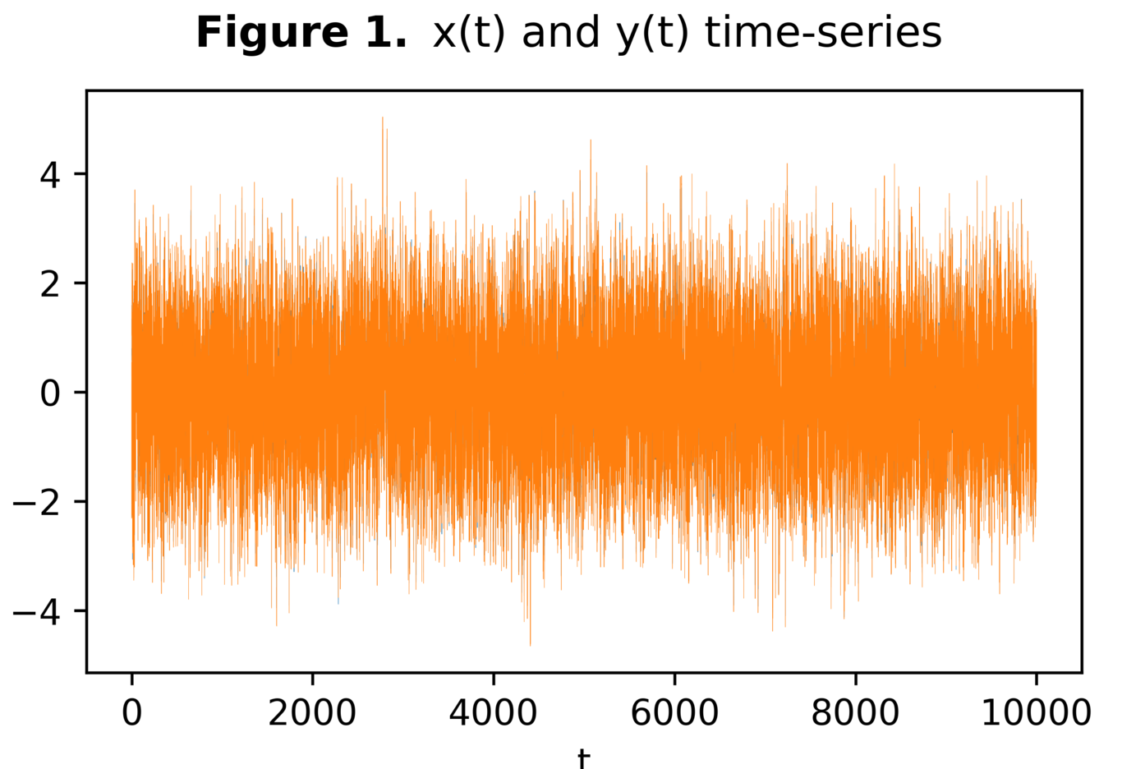

(a) Kramers-Moyal coefficients for y and estimate $σ$
I have estimated the Kramers-Moyal coefficients the normal way and with the equation, $K^{\left(2\right)}\left(y, τ\right)=K^{\left(2\right)}\left(x, τ\right) + γ_{2}\left(y\right)$ and also, $γ_{2}\left(y\right) = 2<η^{2}> =2σ^{2}$ we can estimate $σ$ as seen in the figure below:
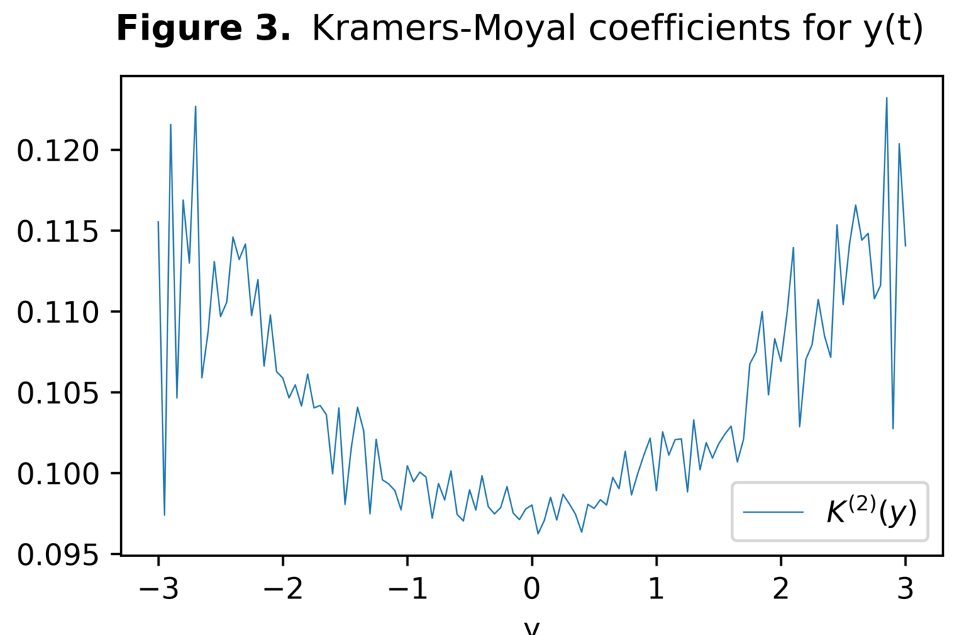
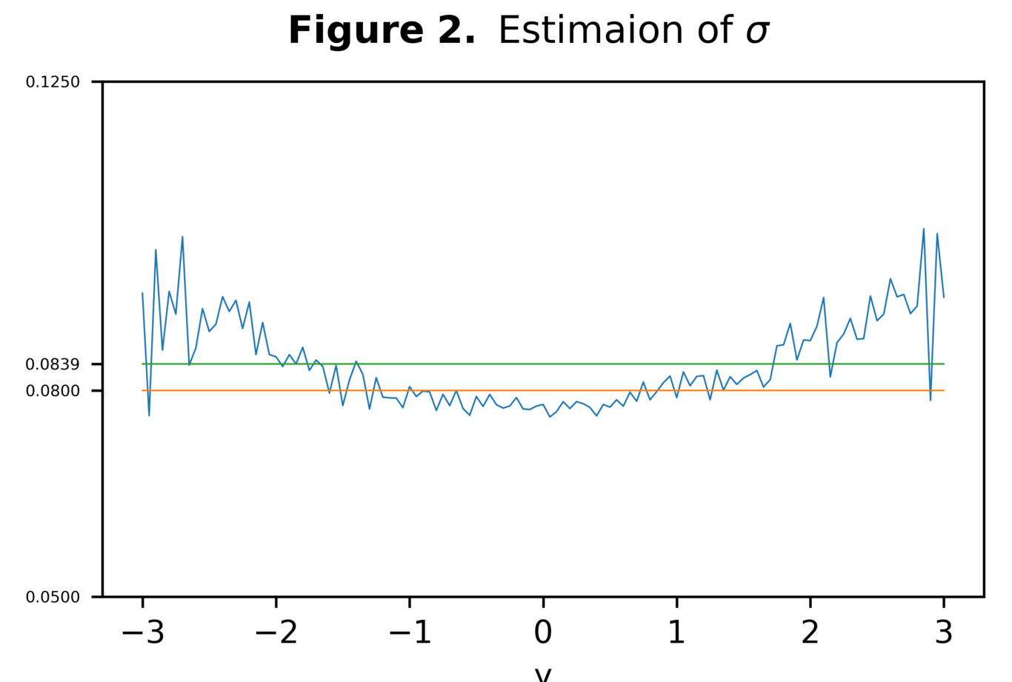

(b) Drift and diffusion coefficients of x(t)
We will estimate these coefficients the classic way again. Here are some figures confirming the precision of the estimated coefficients:
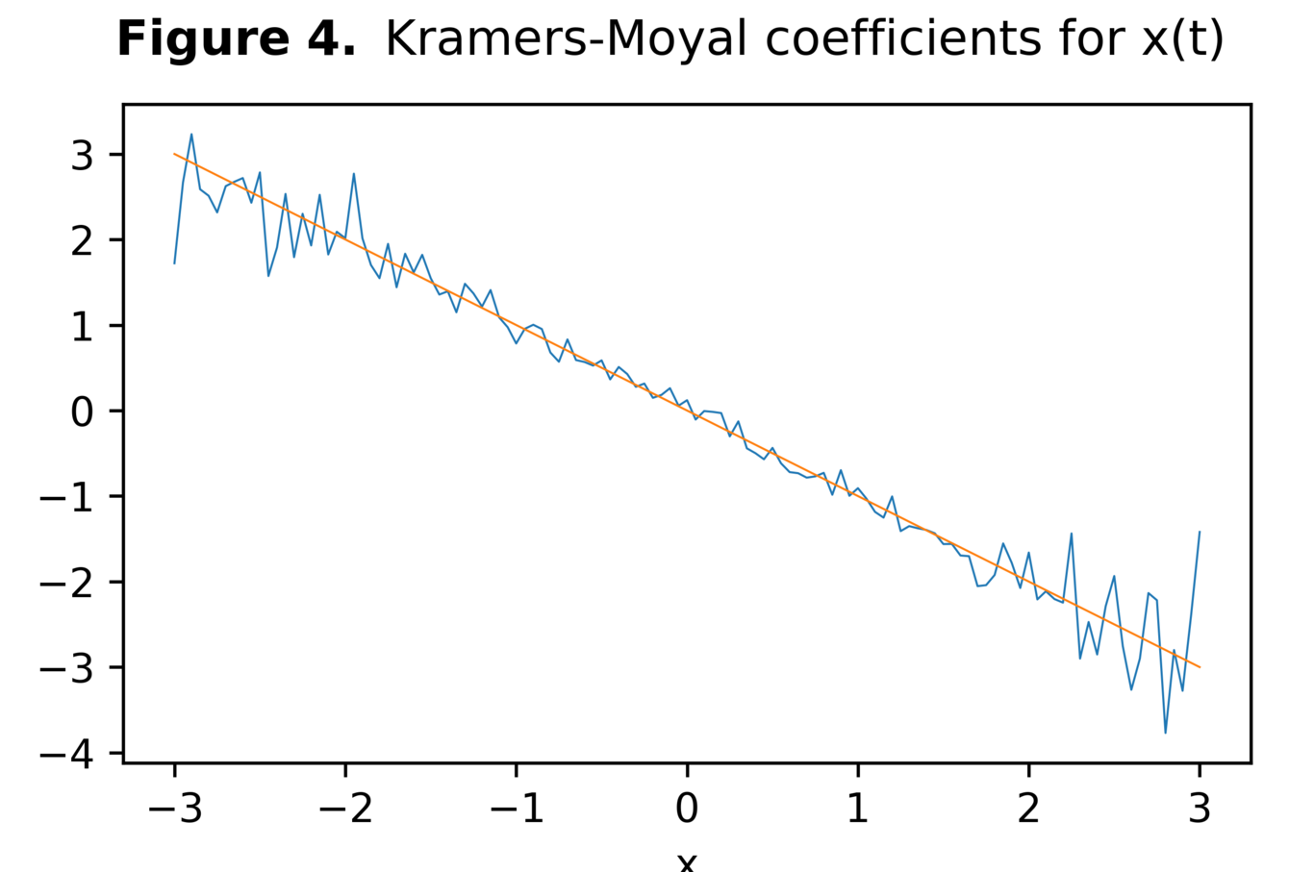
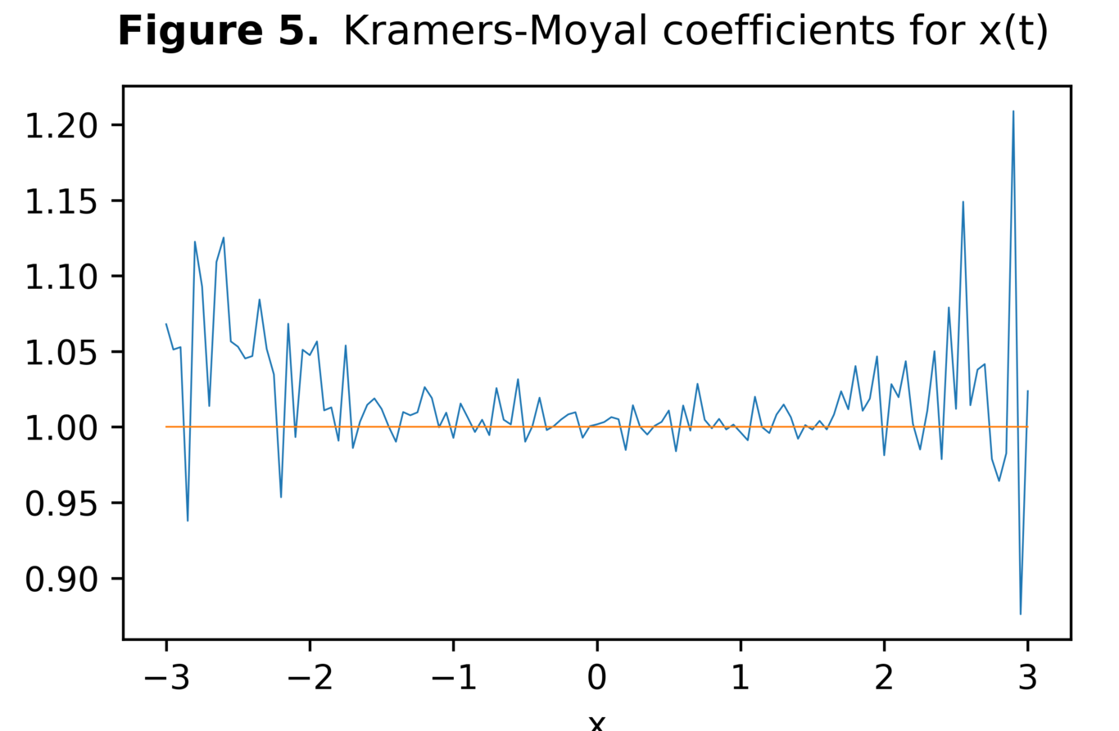

$K^{\left(2\right)}\left(y, τ\right)$ plot
In the figure below we see the dependence of the first Kramers-Moyal coefficient for process y(t) to $τ$, confirming the existence of micro-structure noise:
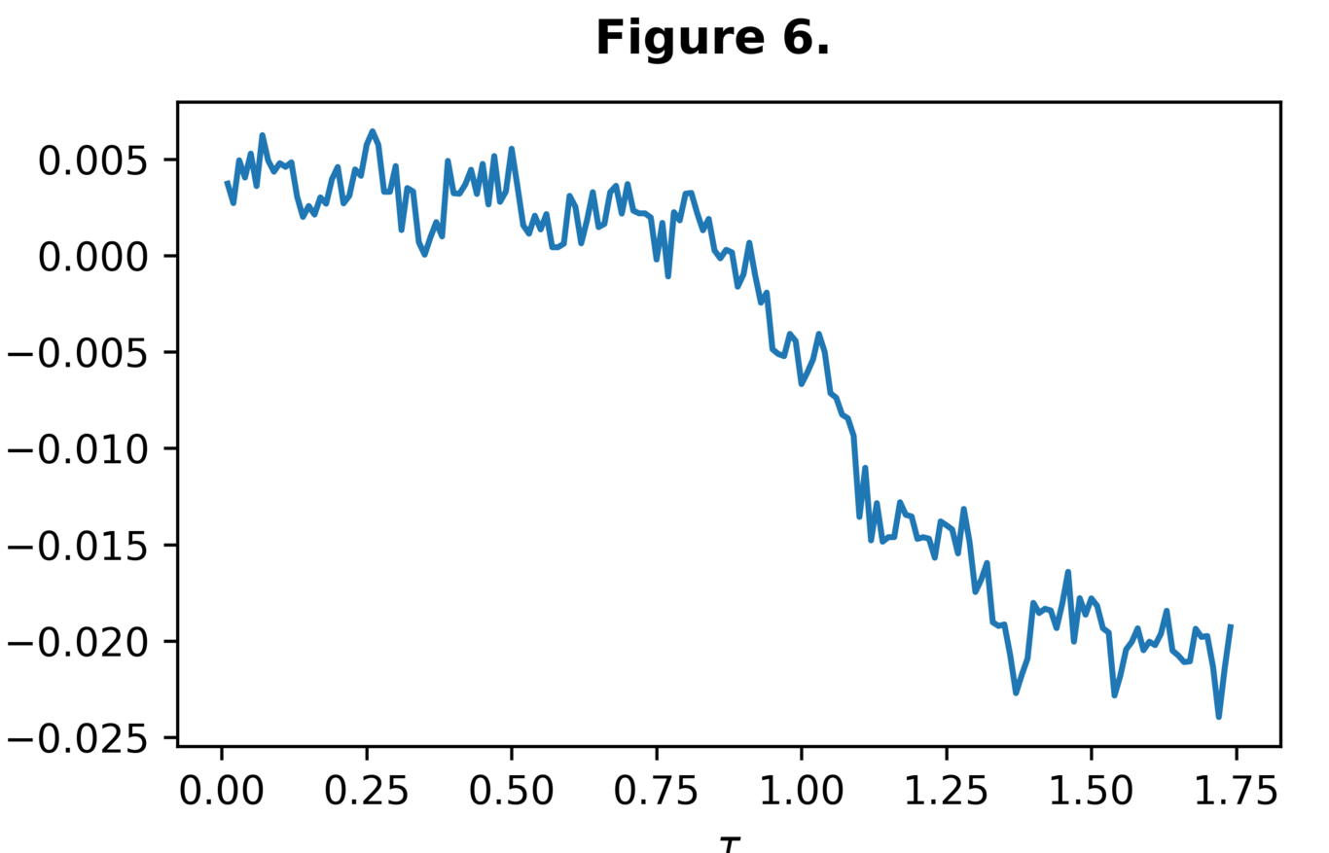

Code
The python code file is attached to the zip file and here we have a summary of it:
dt = 0.01
final_t = 10000
t_steps = int(final_t/dt)
t = np.arange(t_steps)*dt
x = np.zeros(t_steps)
y = np.zeros(t_steps)
sigma = 0.2
for i in tqdm(range(0, t_steps-1)):
x[i+1] = x[i] - x[i]*dt + np.sqrt(2)*np.random.normal(loc=0.0, scale=1.0)*np.sqrt(dt)
y[i] = x[i] + sigma*np.random.normal(loc=0.0, scale=1.0)
def K(n, x, start, end, binsize, *args, **kwargs):
''' returns Kramers-Moyal coefficients for different bins
default for tau is dt
'''
binrange = [int(start/binsize), int(end/binsize)]
bincount = (binrange[1] - binrange[0]) + 1
global bins
bins = np.linspace(start, end, num=bincount)
K = []
if 'tau' in kwargs:
tau = kwargs['tau']
elif len(args) > 0:
tau = args[0]
else:
tau = dt
for i in range(binrange[0], binrange[1]+1):
Bin = []
for j in range(x.size-int(tau/dt)):
if ((x[j] < float(i)*binsize + binsize/2) & (x[j] > float(i)*binsize - binsize/2)):
Bin.append(x[j+int(tau/dt)] - x[j])
Bin = np.array(Bin)
K.append(np.mean(Bin**n))
K = np.array(K)
return K
K_2x = K(n=2, x=x, start=-3, end=3, binsize=0.05, tau=0.01)
K_2y = K(n=2, x=y, start=-3, end=3, binsize=0.05, tau=0.01)
K_1x = K(n=1, x=x, start=-3, end=3, binsize=0.05, tau=0.01)

