A Comparison of Wet-Based and Dry-Based EEG Capabilities in detecting P300 waveforms for Brain-Computer Interface Applications
Alessia Cacace
Toby P. Breckon
Jason D. Connolly*
This study compares a dry-electroencephalography (EEG) approach that does not require external shielding. This makes it amenable for a clinical EEG-based brain-computer interface (BCI) platform. A BCI forges a command relationship between the brain and a computer. We provide a direct side-by-side reference comparison of the dry-EEG methodology with a reference 64-channel wet-EEG approach. As the P300 is a robust dual polarity waveform, spanning the signal space, it works well with clinical-based BCI studies. In this study, six subjects perform a P300 auditory oddball stimulation task while we monitor the P300 with either the dry- or the wet-EEG approach. The results demonstrate the efficacy of the dry approach and we report that the approach produced all P300 components. Dry-EEG therefore performs similar to wet-EEG while providing for a less invasive, shorter set-up time and usability outside of cage shielding, all vital for everyday, home-based clinical BCI applications. Key differences for BCI researchers and future users of the approach are mentioned such that their signal processing analyses can be adjusted. Given that we induce all three primary P300 components, we conclude that this dry-EEG approach represents a highly viable P300 BCI option.

Introduction
Here we compare a relatively novel dry-electroencephalogram (EEG) approach with a “standard” wet-EEG approach via quantification of the P300 components. Elecroencephalography is a non-invasive (harmless) brain imaging approach to record and display brain activity via the use of electrodes placed on the scalp, and with high temporal precision and limited spatial resolution. For standard wet-EEG approaches to work effectively, such approaches rely on conductive electrolytic gel between the scalp and the electrodes to maximise conductivity. Recently, dry-EEG has been developed for BCI by applying pre-amplified eletrodes that do not require the use of external conductive mediums and result in a shorter set-up time and a more comfortable user experience - and therefore could be brought into the home for patient therapies for Spinal Cord Injury (SCI) or late stage Motor Neurone Disease (MND). Although the particular dry-EEG approach we examine here has already been utilised, for example, in a mobile environment (Chi et al. 2012; Chi et al. 2013; Mullen et al. 2015), with synchronous Steady State Visual Evoked Potentials (Lin, Wang, and Jung 2013; Lin et al. 2014), with asynchronous Motor Imagery EEG (Lisi et al. 2016) and during sleep (Onton, Kang, and Coleman 2016) whether or not it is comparable to wet-EEG-based P300 detection remains an open question. This is because experimenters need to be made aware of any vital relative spatial, timing and amplitude differences to adjust their signal processing strategies. An extremely critical application of the P300 component relates to implemention in a clinical P300 BCI platform (Hoffmann et al. 2008; Serby, Yom-Tov, and Inbar 2005; Guan, Thulasidas, and Wu, n.d.). It is vital that the present comparison be made to ascertain whether or not such an implementation is feasible.
The P300 is both an endogenous (’automatic’, P3a component) and also attention-related (P3b component) brain-induced physiological response and therefore has seen extremely widespread use across psychology, cognitive neuroscience and BCI (computer science; engineering). The P300 occurs in all subjects provided only that the subjects attend to the experimental task. Upon presentation of a recurring stimulus (baseline condition) interleaved by another, less frequent, odd stimulus (odd condition), subjects show occurrence of the component when the odd stimulus is presented. Providing that the subject is aware enough to follow the instructions and to convey attention to the stimulus, the P300 will reliably occur (Farwell and Donchin 1988). In other words, the P300 is very robust, is amenable to patient use and will inform the experimenter with regard to the target selected by the subjects thus lending itself to BCI application(s); for example, virtual keyboard word processors, brain-controlled 2-D cursor movement on a computer screen, computer icon selection and wheelchair control for communication for those living with SCI or MND (Serby, Yom-Tov, and Inbar 2005; Guan, Thulasidas, and Wu, n.d.). The P300 waveform is characterized by: 1) a distinct negative amplitude; and then 2) a distinct positive-amplitude deflection in voltage. The P300 has been utilized in an extremely vast number of wet-EEG experimental studies, e.g. (Polich 2007; Squires, Squires, and Hillyard 1975; Piccione et al. 2006; Picton 1992). The first example of an oddball P300 paradigm to specifically investigate the P300 wave is (Squires, Squires, and Hillyard 1975). Results of the baseline condition demonstrate the presence of N1 and P2, sensory evoked potentials representing a pre-attentive stimulus detection, recurring at the latency of 80-100 and 140-190 milliseconds, respectively, and with no presence of the P300 wave. P3a typically locates to a relatively greater extent in the frontal lobe (Knight 1984). Additionally, whereas P3a occurs when subjects do not actively engage in a specific task, P3b will only occur if subjects actively focus or attend to the experiment (Squires, Squires, and Hillyard 1975). This suggests a more physiological nature of the first P3a component over a more distinct task-related nature of the later P3b component. An extremely significant application of the P300 component relates to utilizing this waveform within a BCI platform (Hoffmann et al. 2008; Serby, Yom-Tov, and Inbar 2005; Sellers, Kubler, and Donchin 2006). Fig. 1 demonstrates that the dry-EEG approach used in this study is compliant with the 10-20 EEG reference standard, an internationally recognised approach to denote the location of the electrodes on the scalp / brain tissue (as adapted from (Mullen et al. 2015)).
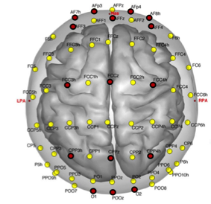
64-channel sensor montage for the dry-EEG approach, coregistration with the MNI “Colin27” brain. Average sensor locations are obtained by averaging 3-D digitized (ELPOS, Zebris, Medical GmbH) electrode locations from ten individuals. Electrode labels are assigned based on the nearest neighbour mapping to the standard 10/5 montage. Nas, LPA and RPA denote nasion and left/right preauricular fiducials. *Only the 16 sensors shown in red were included in the present hardware configuration. Only 16 sensors were used to make the approach as cost-effective as possible and therefore amenable to potential clinical use.
The P300 component has been under use for decades to develop BCI suitable for patients that have low or no residual control over voluntary movements, such as high-level SCI or late-stage MND (Hoffmann et al. 2008; Serby, Yom-Tov, and Inbar 2005). Upon inducing the component as a neural signature of a chosen target, the subject selects a certain item in a group of other non-target items, for example, letters for spelling. This then enables the subject to spell sequentially his/her own words and provides for an enhancement in their degree of independence for those living with SCI or MND.One inherent limitation to many of these applications is that of being bound to an unnatural environment - the “static” and experimentally-shielded wet-EEG laboratory. The wet-EEG equipment imposes some specific requirements to obtain optimal (or even useable) signal quality. Electrolytic gel, a shielded room (or Faraday cage), preparation of the skin, and a tethered connection to the scalp mounted apparatus that are part of the set-up imposes a limit to what and where BCI based on the common wet-EEG can be applied.

The Dry, Mobile and Wireless EEG approach: a New Frontier?
A new technical development that circumvents all of the aforementioned problems has emerged over the past several years: the advent of dry-, mobile- and wireless-EEG approaches. These technical modifications provide for a reduction in the preparation time as well as representing a less invasive procedure (as no preparation of the scalp is required) and the potential for home-based therapy. The use of dry electrodes can also substantially increase the duration of the BCI session, as the drying up or leaking of the electrolytic gel is no longer an issue (Gargiulo et al. 2010). Another problem arises with regard to the bridging of the electrodes that typically occurs when the electrolytic gel spreads between close electrodes thus mildly “shorting” them to one another from an electrical stand point and thereby distorting the BCI signals (Alschuler et al. 2014). These technical hurdles can all be overcome via the use of relatively novel dry-EEG approaches. If these same dry-EEG approaches are indeed as sensitive and reliable as wet-EEG approaches, then such approaches could improve the feasibility of EEG based BCI for the end user (in this case the SCI or MND patient) and/or the primary caregiver(s) both via ease of use and taking them out of the laboratory setting and into the home. Wireless approaches also add certain novel options to the application of EEG approaches. With the correct amplification and careful internal signal shielding (or shielding that is inherent to the EEG cap itself), dry-EEG recordings can now be collected outdoors which would be useful for brain-controlled wheelchair navigation. In one particular study that provides support for this idea, Debener (Debener et al. 2012) use an in-house built non-commercial dry and mobile-EEG platform to assess an auditory oddball task while subjects are naturally walking outdoors and following a particular route. No specific instruction is given except the request to mentally keep count of the relatively rare (odd) auditory tone. The experimental results demonstrate that high quality data can be obtained even in such an everyday environment. Amplification and adequate artifact correction can also aid in minimizing movement related noise in mobile EEG approaches (Gwin et al. 2010). Nevertheless, we still need to know how these signals directly compare directly to wet-EEG such that the appropriate signal processing adjustments can be made or truly optimised. Brain areas active during spatial navigation, obstacle avoidance, attention allocation and many more can be investigated in everyday environments and, again, non-invasively (harmlessly). Such experimental environments could also play a key role to develop BCI that will be more comparable to a natural environment as well as being specifically designed for a mobile individual - as opposed to those BCI platforms that acquire information / carry out experiments in the common static laboratory-based setting (Lin et al. 2014). Experiments like the one performed by Iturrate (Galán et al. 2008) could now be used to not only virtually but to physically navigate a patient wheelchair through an everyday environment, thus restoring some of the freedom lost by the patient due to b neurological damage. A study by Cao et al. (Cao et al. 2014) employs a hybrid BCI with both motor imagery (MI) and steady-state visually evoked potentials (SSVEP) and the authors fuse these to enable subjects to control both the direction and speed of their wheelchair. Motor imagery represents the active rehearsal of an internal representation of a motor action (Decety 1996) and steady-tate visually evoked potentials (SSVEP) represent the electrical (brain cell) physiological responses that occur when looking at or attending to a visual stimulus of a specific, typically visual-based, flicker frequency (Vialatte et al. 2010). It is clear that the development of these approaches has a very important target clinical setting and this is owing to the need to overcome the limitations of the relatively cumbersome wet- and static-EEG approaches. Given that the classic wet- and static-EEG technique provides for an extremely well-established and accepted platform both in terms of reliability and fidelity of recording, wet-EEG constitutes the suitable approach to examine the efficacy of novel dry-EEG approaches and to examine whether or not the quality of the recordings is of a sufficient scientific standard. Yet comparing such EEG approaches poses other major challenges: the components of EEG recordings tend to vary not only across different subjects and tasks but also within the same subject when recorded on different days or under different experimental conditions (Sellers, Kubler, and Donchin 2006). In other words, EEG is nonstationary (Kaplan et al. 2005). Here we present results for one commercial device for dry-, wireless- and mobile-EEG. The dry-EEG hardware used here consists of 16 sensors and a communication link that additionally provides for wireless recording. We compare a dry-EEG approach developed by Cognionics Inc. (San Diego, USA) HD-72 model (Fig 2) with a 64 channel wet-EEG set-up by ANT Neuro (Enschede, Netherlands) to investigate the quality and reliability of the recordings of the former approach.To test the dry-EEG approach, we opt for the serial method (sequential testing across the two approaches) while wearing the dry- or the wet-EEG approach and across the same subjects. This is owing to the fact that we need to record from the same sensor (dry-EEG) or electrode (wet-EEG) for the oddball task to quantify the P300 waveform. The experimental task we employ is the classic auditory oddball paradigm (SEGALOWITZ and BARNES 1993; İŞOĞLU-ALKAÇ et al. 2007). The auditory (sound) paradigm is highly reliable with regard to inducing the P300 waveform. We use only 16 channels because the cost is more reasonable for clinical application - approximately in line with the cost of an electric wheelchair - while still maintaining adequate skull coverage. We report that the P300 was comparable across the two approaches but with important differences. Specifically, there is a latency difference in the relative onset of the 3 primary components (N1, P3a and P3b) upon which the vast majority of prior EEG BCI studies rely (Chi et al. 2012; Farwell and Donchin 1988; Hoffmann et al. 2008; Serby, Yom-Tov, and Inbar 2005). Furthermore, the N1 is more negative-going and the Pz topography is relatively more frontally situated for the P3a as compared to the wet-EEG approach.
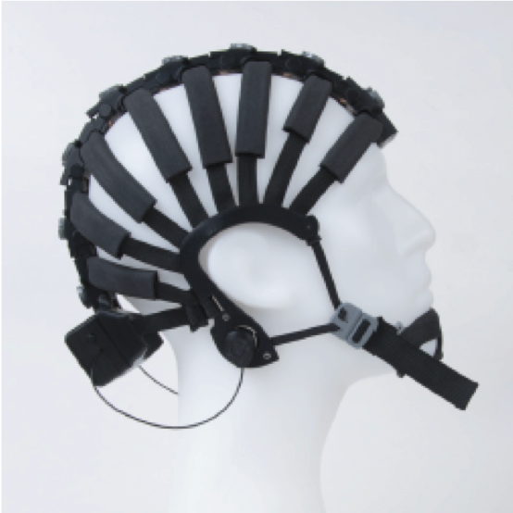
The dry-EEG system HD-72 model developed by Cognionics Inc. (San Diego, USA).

Experimental Section
In this section we describe the nature of our subject sample of six participants and define the two EEG approaches that we compare. We detail the specifics of auditory stimuli and the experimental procedure we use to elicit the oddball effect.

Subjects
We examine six healthy subjects (3 males and 3 females) for the two experiments (mean age: 27.6 years, s2= 8.18; range: 22-43). Exclusion criteria include past psychiatric disorders such as Major Depressive Disorder, Schizophrenia and Dementia as all are reported to affect the normal characteristics of the P300 [45]. Subjects report to have no known psychiatric history and to have well preserved auditory, visual and cognitive function. To exclude any age-related hearing impairment (Frisina 2009), subjects over the age of 45 did not participate in the present study. We also obtain Handedness information via completion of the Edinburgh Handedness Inventory (Oldfield 1971). Subject information is summarized in Table I.
Sex, age, handedness and the channels we exclude for all subjects we include in the present analyses
Subject | Sex | Age | Handedness | Excluded Channels
1 | M | 31 | Right | P4-Oz-O2
2 | M | 22 | Left | O1-O2-P4
3 | F | 23 | Right | None
4 | F | 23 | Right | None
5 | M | 43 | Right | C3
6 | F | 24 | Right | O1-P3-Pz

Evaluation systems
The Cognionics Inc. conductive coating material on the sensors is biocompatible and resistant to water corrosion as skin sweat from the scalp can arise during recording – especially important factors within a mobile environment. For these reasons, most metals are unsuitable, for these would require application of gel to maximize conductivity or might undergo oxidation and induce allergic reaction (Gargiulo et al. 2010). Owing to the higher electrode impedances that relates to the lack of skin preparation and gel use (Gargiulo et al. 2010; Alschuler et al. 2014; Debener et al. 2012), dry electrodes require in-situ amplification to ensure high levels of Information Transfer Rate (ITR or bits/s), an evaluation measurement in BCI that represents the precise amount of information transferred over time (Wolpaw et al. 1998). Additionally, the electrodes of this system have in-situ active shielding and noise cancellation and these provide for reasonable, low-noise recordings also ensuring adequate signal-to-noise ratio (SNR) is maintained during the recording sessions. The dry-EEG system excludes artefact and noise beyond 50/60Hz - as this range originates mainly from external electrical noise and movement related noise (or motion artefact). The system we test here has 4 drypad sensors along the frontal pole (or toward the front of the brain) in the region of the subject’s forehead (F8, Fp2, Fp1 and F7 according to the 10-20 universal reference system standard). The 12 flex sensors (or the sensors that pass through the hair) are located over the relevant areas in positions F4, Fz, F3, C4, Cz, C3, P4, Pz, P3, O2, Oz and O1. The even numbers correspond to the right side (hemisphere) of the brain while the odd numbers correspond to the left side (hemisphere of the brain) (Fig 1). The reference site is set on the bilateral mastoid bones and the sampling rate is set to 500 Hz. The reference wet-EEG system we use has 64 channels and mounts on customized WaveGuard caps, with electrode positions also in accordance with the 10-20 reference standard. The latter system uses standard passive wet-EEG electrodes that have no inner amplification or shielding and these connect to an amplifier located inside a shielded recording room. The sampling rate of the ANT Neuro system is also 500 Hz.

Experimental conditions
We test the subjects across two sessions while using either the dry- or the wet-EEG approach and with the identical experimental task. We also test subjects at the same time of day in order to control for the physiological oscillation of the P300 (Polich 2004) and on separate days for dry- and wet-EEG to avoid habituation to the task on the same testing day (Pan, Takeshita, and Morimoto 2000; Debener et al. 2005). However, the chinrest and shielded room are only used when testing with the wet-EEG and head movement is relatively unrestrained with dry-EEG In the session with the dry-EEG approach, the room is unshielded, and other electronic devices are present. This configuration was used to ensure higher ecological validity in the potential clinical, home-based use of the dry-EEG system. Stimuli presentation and data acquisition occur on separate computers: one computer runs the stimuli program to preserve presentation timing and a second computer to receive the wireless signal from the device and to run proprietary data acquisition software. The data acquisition software provides for our direct observation of the raw dry-EEG data, channel selection and the impedance spectrum to assist initial set-up and data quality assessment. For all of the sessions, impedance values - defined as the measurement of adequate contact between the EEG sensors and the scalp - are checked prior to the onset of the experiment and we ensure that these are lower than 20 $Ω$ (considering the relatively higher impedance of dry-EEG sensors), and we lower these impedance values by applying very slight pressure to the backs of the sensors for a few seconds, wiggling the sensors left or right, and/or slightly tightening the cap to allow the sensors to better adhere to the scalp. In the wet-EEG approach condition, subjects are sat in a chair in a shielded room and we use one screen and two speakers necessary for presentation of the auditory tones within the testing environment. Subjects heads are stable via a chin-rest and further instructions are given with regard to inhibiting all unnecessary and natural movements. For every session, impedance values are checked to be between 0-10 k $Ω$ according to the wet-EEG approach guidelines (Ferree et al. 2001; Kappenman and Luck 2010) and we lower these same impedance values via preparation of the skin with blunt needles. We then apply electrolytic gel.

Stimuli
We deliver two audio stimuli tones via the same speaker set-up for both conditions. One tone we define as “standard” has a frequency of 2460 Hz whereas the other we define as “deviant” (i.e. oddball) is set to a frequency of 2495 Hz. Presentation of the two tones is set to be completely pseudorandom across all trials and subjects. To obtain an oddball paradigm, the probability of occurrence of the deviant tone is set at 25% of the 200 overall trials (or 50 trials) with a complementary 75% occurrence of the standard tone (or 150 trials). Also, the first four trials are set to run the standard tone to enable the subjects to easily identify the frequent (standard) over the infrequent (deviant or oddball) tone from the outset of the experiment. Tones are present at a rate of one every 1000ms and each tone is present for 500ms.

Experimental procedure and analysis
We instruct subjects to internally count the less frequent, or deviant, higher pitched tone and to report this value back to the experimenter via a verbal report once the experimental session is complete. All the subjects report the correct number of odd stimuli and this demonstrates a high level of compliance and focus throughout the task across both experimental dry- and wet-EEG set-ups. We carry out data analysis for both the dry- and wet-EEG approaches via BESA Research software (Besa, Grafelfing, Germany) and maintain the same analyses procedure for the datasets of both the dry- and wet-EEG approaches. We also apply an on-line artefact correction for eyeblinks and bandpass filter the datasets (1.6 Hz - 40 Hz) for both dry- and wet-EEG approaches to exclude high frequency noise not originating from brain activity. We include all channels in the analysis for the wet-EEG approach and certain channels are excluded in the datasets obtained from the dry-EEG approach owing to the relatively higher level of external noise as detected during the recordings (Table 1). A re-referencing is required for the data obtained through the wet-EEG approach and reference points are set to be the average across the two mastoid bones - identical to the dry-EEG experiment. Baseline correction is -100ms to 0ms for both approaches and epochs and we extract at different time points for the two conditions while maintaining the same range across the two approaches. This difference is owing to the 48ms latency difference across the dry- and wet-EEG approaches. The epochs we extract for the wet approach are at 200-250ms for an early component (P3a) and at 320-400ms for a later component (P3b). For the dry-EEG experiment, we extract epochs at 150-200ms and 250-330ms for the P3a and the P3b component, respectively. Channel(s) exclusion and the different number of electrodes across the two set-ups are not a major issue in the present study as the channel focus of our auditory analysis is Cz, at the vertex (or top) of the skull for both the dry- and the wet-EEG approaches (refer to Fig. 1 and 3).

Results and Discussion
In this section we evaluate results for the mean amplitude of the early and late components of the P300 waveform in the two conditions defined as standard and deviant (oddball). We also investigate differences between the two EEG approaches we use here to report the occurrence of the different components.
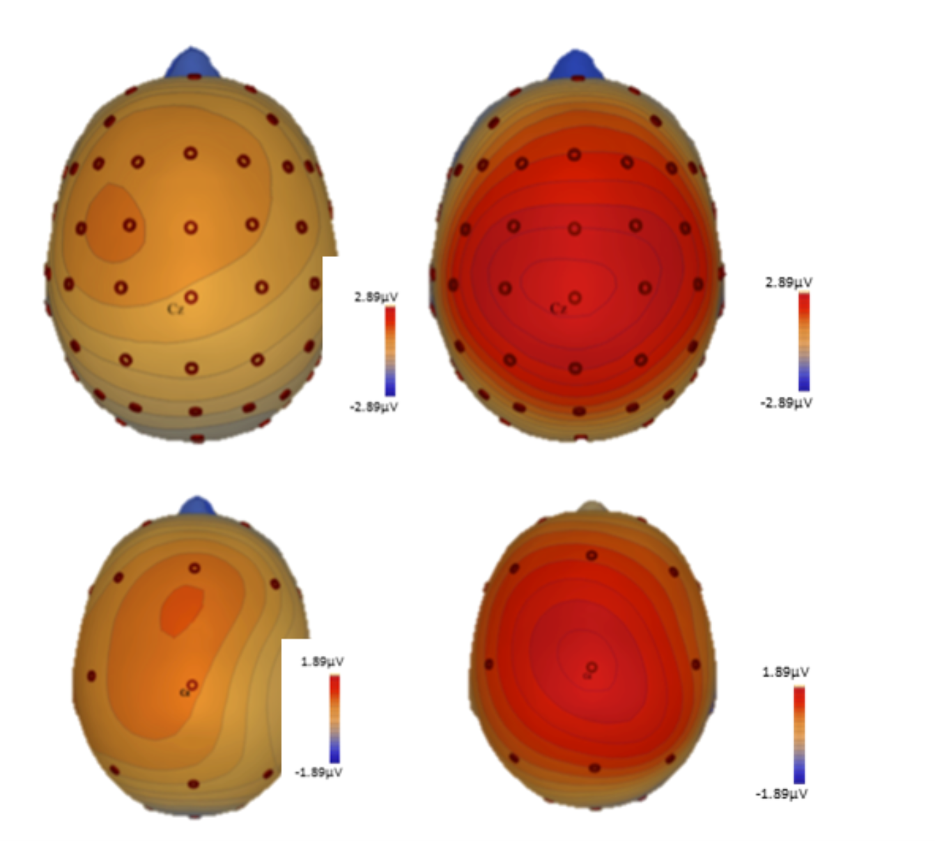
Topographic images that depict the scalp localizations for the auditory oddball task for the wet- (top panels) and the dry-EEG approaches (bottom panels) - note that the peaks at the Cz sensor for the P3a (left panel) and the P3b (right panel) components. Critically, the P3a component (left bottom panel) for the dry approach is relatively more frontal-situated (toward the nose) as compared to the wet EEG approach which instead situated at the very top or apex of the brain (right top panel). The P3b occurs over the Cz electrode at the top / apex and mid-line of the brain (top and bottom right panels) for both the dry- and the we-EEG approaches.

Between conditions
For every subject, we extract both the early P3a and late P3b components of the P300. After averaging these across subjects, we then compare the mean amplitude of the P3a and P3b components for the standard and deviant (oddball) condition. Paired sample t-tests - where t is the value used in estimating the population mean from a sampling distribution of sample means - are carried out to compare the mean amplitudes of the standard and the deviant stimuli with both approaches to examine the fidelity of the dry-EEG approach to detect the oddball effect. As one would predict, when using the wet-EEG approach, a highly significant difference is reported across the standard (µ= -0.63; s2= 0.44) and the deviant tone (µ= -0.12; s2= 1.00) of the P3b or late component, t(5)=8.28, p<0.001. However, we report a non-significant difference when comparing the mean amplitudes of the standard (µ= 1.42; s2= 1.00) and deviant (oddball) tone (µ= 2.32; s2= 1.22) for the first earlier component, or P3a, t(5)=-1.203, p=0.254. We report highly similar results for the dry-EEG approach. There is a significant difference between the standard (µ= -0.48; s2= 0.79) and deviant (µ= 0.83; s2= 0.71) condition in the later component or P3b component, t(5)=6.19, p=0.003. There is no significant difference between standard (µ= 0.42; s2= 0.71) and deviant (µ= 0.86; s2= 3.21) in the earlier component or P3a component, t(5)=1.321, p=0.213. Inspection of the timecourse plots demonstrates the prominent early occurrence of the same negative-amplitude component, or N1, and the two later positive-amplitude components, P3a and P3b and across both approaches we examine here. Independent plots that compare the waveforms of the deviant and standard conditions for the two components are depicted in Fig. 4 (wet-EEG) and Fig. 5 (dry-EEG).
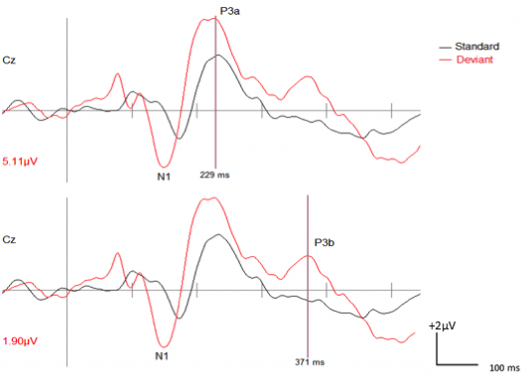
The P300 waveforms for the wet-EEG approach. This figure depicts the waveforms that the N1, P3a (top) and the P3b (bottom) components for the Cz channel across the two conditions we examine in the auditory oddball task. Mean amplitudes of the deviant (oddball) condition are in red. The latency, displayed in black, is 229ms for the P3a and 371ms for the P3b components.
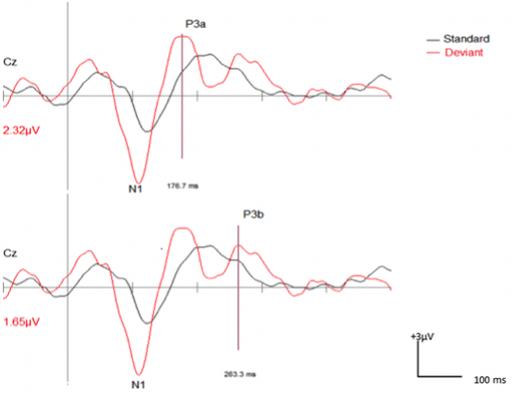
P300 waveforms for the dry-EEG approach. This figure depicts the N1, P3a (top) and the P3b (bottom) components for the Cz channel across the two conditions we examine in the auditory oddball task. Mean amplitudes of the deviant (oddball) condition are in red. The latency, displayed in black, is 176.7ms for the P3a and 263ms for the P3b components.

Comparison across conditions
Effect sizes are calculated for both dry- and wet-EEG approaches by subtracting mean amplitude values of standard and deviant (oddball) conditions and a paired sample t-test is performed to ultimately compare the results across the two approaches. When analyzing the earlier P3a component, no difference is reported between effect sizes of the wet-EEG approach (µ= -0.90; s2= 1.41) and the dry-EEG approach (µ= -0.43; s2= 2.80); t(5)=-0.403, p=0.704. Similarly, there is no significant difference between the effect sizes of the wet-EEG approach (µ= -0.50; s2= 1.08) and the dry-EEG approach (µ= -1.32; s2= 0.57) for the later P3b component; t(5)=1.258, p=0.264. A direct temporal (time) comparison of the waveform shapes obtained through the two approaches is reported in Fig. 6.
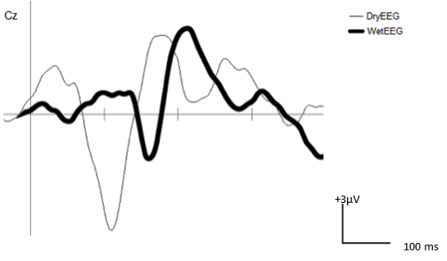
Deviant waveshapes across the dry- and wet-EEG approaches. The data demonstrate the P300 for the deviant (oddball) condition as registered with the dry-EEG (thin line) and the wet-EEG approach (bold line) and the clear evidence for the N1, P3a and P3b components. We report a ~48ms latency difference across the two approaches, with the dry approach exhibiting the relatively shorted onset of the N1, P3a and P3b. The N1 peak occurs at ~120ms and ~170ms for the dry- and wet-EEG approaches, respectively. The dry-EEG N1 also has a relatively more negative amplitude peak value as compared to the wet-EEG approach.

Discussion
The present results provide evidence for the successful utilization of the dry-EEG approach to reliably detect the the different electrophysiological (brain cell or neuronal)-based primary components of the P300 EEG waveform (the N1, P3a and P3b). The shape of the waveforms and the scalp distributions we report in the present study correspond to those of several early wet-EEG studies (Polich 2007; Frisina 2009; Polich 2004). However, the comparison of the waveforms of the deviant (odd) condition obtained by the reference wet-EEG approach and the relatively novel dry-EEG approach in Fig. 6 demonstrate a very obvious timing difference in detecting the three key components (N1, P3a, and P3b). For both approaches, the statistical tests demonstrate a significant difference in the amplitudes of the waves across the two conditions (or, for the deviant (oddball) as compared to the standard auditory tone). Critically, Fig. 6 shows a very substantial latency difference in the onset of each of the three components with an overall earlier occurrence in the onset of the P3a and P3b with the dry-EEG approach (176.7ms; 263.3ms) as compared to the wet approach (229ms; 371ms) – a difference of vast timing difference of 48ms across the two dry- and wet-EEG approaches (based on the N1 component). Notably, variations of the latency of the P300 are linked to several factors including the nature of the stimuli and the task and individual differences [10]. In particular, the P300 latency is reported to increase according with the difficulty of detection and evaluation of the odd from the standard stimulus (Picton and Hillyard 1974) and factors such as age (Emmerson et al. 1989) and mental fatigue (Kaseda et al. 1998). Given the wet-EEG approach is always tested several weeks after the dry-EEG approach – the latency difference reported here cannot be argued to be the result of mental fatigue across the sequential testing days of the two approaches.Yet there are also other key differences: 1) a greater effect size is reported for the P3a component when using the dry-EEG as compared to the wet-EEG approach; 2) for the P3b component, a greater effect size is reported when using the wet- as compared to the dry-EEG approach. It is crucial to point out that the experimental conditions we employ across the two approaches differ quite dramatically from one another (refer to Methods). The chinrest and shielded room are only used when testing with the wet-EEG and head movement is relatively unrestrained with dry-EEG; 3) the N1 component is more negative-amplitude for the dry- as compared to the wet-EEG approach; and 4) the P3a component is topographically more frontal situated (or toward the nose) for the dry-EEG as compared to the wet-EEG approach.The aim of the present study is to investigate the fidelity of the dry-EEG approach in a relatively less constrained research environment – one in which head movement is unrestrained – and this can be much more informative with regard to the specific possible uses of this particular commercially-available dry- and mobile-EEG approach for future clinical purposes. In an everyday home environment the head must be free to move. Our analyses provides support for the idea that the dry-EEG approach is accurate enough to detect an oddball effect in the six subjects tested and with only a total of 200 trials per subject - and yet this approach still produces P300 waveforms. Moreover, it is worthwhile to note that none of the subjects report any pain and a substantial reduction in discomfort when using the dry-EEG approach and describe the electrodes as being “hardly noticeable”. In contrast, although bearable, the scrubbing procedure of the wet-EEG is reported to be “generally unpleasant” by the majority of these same subjects. The dry-EEG headset is very straightforward to set-up ( 5 minutes set-up time) and can be easily adjusted to different head sizes/shapes. The wet-EEG approach typically takes between 15 - 20 minutes to set-up and requires the additional blunted needle preparation (preparation of the skin). These considerations become particularly important when considering the practical usability of the dry- and mobile-EEG approach for potential long-term domestic clinical application(s) – and would perhaps even enable set-up by home-based caregivers.The latency difference is critical for BCI applications using sliding windows for data analysis (van Gerven et al. 2009). A sliding window is a approach for controlling transmitted data packets between two network computers in which highly reliable and sequential delivery is required. The fact that the P3a is relatively more anteriorly situated (or toward the nose) in the frontal lobe is also critical for proper electrode selection and placement/data collection for the above BCI applications. Finally, the N1 component is much more negative-amplitude for dry-EEG as compared to the wet-EEG. This is also important for the detection thresholds used for P300 brain-computer applications. For all of these reasons, we are of the opinion that the differences observed in the present experiment are as noteworthy as the similarities and need to be disseminated to all those working with this particular approach – and also to those of using other dry- or wet/dry- electrode EEG approaches on-market (e.g. g.Sahara ; Emotiv EPOC; QUASAR; Biosemi; B-Alert, e.g. (Nijboer et al. 2015; Grummett et al. 2015; Edlinger, Krausz, and Guger 2012; Melnik et al. 2017)).

Conclusions
This study compares a dry-EEG approach with a standard wet-EEG approach for dry-EEG suitable for clinical therapies for SCI and MND. We demonstrate that dry-EEG quantifies expected areas of EEG similarity and divergence between the two methodologies on exemplar reference systems and could therefore constitute a viable option for future BCI research. In the present study, we report a difference of 2.79 µV in the amplitude of the early P3a component and a 0.25 µV difference in the amplitude of the P3b component between the two approaches (Fig. 4). Additionally, a difference of 52.3ms and 107.7ms is found in the timing of the P3a and P3b components respectively (Fig. 4). The application of the established wet-EEG approaches for this purpose has been limited by the specific set-up requirements needed for the correct use of the approach and their inherent immobility. Although necessary in a dedicated research environment, the shielded room, cables and a tethered connection to the scalp mounted apparatus, electrolytic gels and skin preparation diminish the usability of wet-EEG approaches in everyday or clinical applications. Dry, pre-amplified electrodes can overcome these limitations, and such dry-EEG technology clearly extend well beyond the boundary of the laboratory environment and into a domestic environment. All three primary P300 components are present using this dry-EEG approach. Future experiments will test this approach with P300- and SSVEP-based spellers and robotic actuator deployment to establish its suitability for effective BCI utilization in SCI and MND.
The authors declare no conflict of interest.

References
Chi, Yu Mike, Yu-Te Wang, Yijun Wang, Christoph Maier, Tzyy-Ping Jung, and Gert Cauwenberghs. 2012. “Dry and Noncontact EEG Sensors for Mobile BrainComputer Interfaces”. IEEE Transactions on Neural Systems and Rehabilitation Engineering 20 (2). Institute of Electrical and Electronics Engineers (IEEE): 228–35. doi:10.1109/tnsre.2011.2174652.
Chi, Yu M., Yijun Wang, Yu-Te Wang, Tzyy-Ping Jung, Trevor Kerth, and Yuchen Cao. 2013. “A Practical Mobile Dry EEG System for Human Computer Interfaces”. In Foundations of Augmented Cognition, 649–55. Springer Berlin Heidelberg. doi:10.1007/978-3-642-39454-6_69.
Mullen, Tim R., Christian A. E. Kothe, Yu Mike Chi, Alejandro Ojeda, Trevor Kerth, Scott Makeig, Tzyy-Ping Jung, and Gert Cauwenberghs. 2015. “Real-Time Neuroimaging and Cognitive Monitoring Using Wearable Dry EEG”. IEEE Transactions on Biomedical Engineering 62 (11). Institute of Electrical and Electronics Engineers (IEEE): 2553–67. doi:10.1109/tbme.2015.2481482.
Lin, Yuan-Pin, Yijun Wang, and Tzyy-Ping Jung. 2013. “A Mobile SSVEP-Based Brain-Computer Interface for Freely Moving Humans: The Robustness of Canonical Correlation Analysis to Motion Artifacts”. In 2013 35th Annual International Conference of the IEEE Engineering in Medicine and Biology Society (EMBC). IEEE. doi:10.1109/embc.2013.6609759.
Lin, Yuan-Pin, Yijun Wang, Chun-Shu Wei, and Tzyy-Ping Jung. 2014. “Assessing the Quality of Steady-State Visual-Evoked Potentials for Moving Humans Using a Mobile Electroencephalogram Headset”. Frontiers in Human Neuroscience 8 (March). Frontiers Media SA. doi:10.3389/fnhum.2014.00182.
Lisi, Giuseppe, Masashi Hamaya, Tomoyuki Noda, and Jun Morimoto. 2016. “Dry-Wireless EEG and Asynchronous Adaptive Feature Extraction towards a Plug-and-Play Co-Adaptive Brain Robot Interface”. In 2016 IEEE International Conference on Robotics and Automation (ICRA). IEEE. doi:10.1109/icra.2016.7487227.
Onton, Julie A., Dae Y. Kang, and Todd P. Coleman. 2016. “Visualization of Whole-Night Sleep EEG From 2-Channel Mobile Recording Device Reveals Distinct Deep Sleep Stages with Differential Electrodermal Activity”. Frontiers in Human Neuroscience 10 (November). Frontiers Media SA. doi:10.3389/fnhum.2016.00605.
Hoffmann, Ulrich, Jean-Marc Vesin, Touradj Ebrahimi, and Karin Diserens. 2008. “An Efficient P300-Based BrainComputer Interface for Disabled Subjects”. Journal of Neuroscience Methods 167 (1). Elsevier BV: 115–25. doi:10.1016/j.jneumeth.2007.03.005.
Serby, H., E. Yom-Tov, and G.F. Inbar. 2005. “An Improved P300-Based Brain-Computer Interface”. IEEE Transactions on Neural Systems and Rehabilitation Engineering 13 (1). Institute of Electrical and Electronics Engineers (IEEE): 89–98. doi:10.1109/tnsre.2004.841878.
Guan, Cuntai, M. Thulasidas, and Jiankang Wu. n.d. “High Performance p300 Speller for Brain-Computer Interface”. In IEEE International Workshop on Biomedical Circuits and Systems 2004.. IEEE. doi:10.1109/biocas.2004.1454155.
Farwell, L.A., and E. Donchin. 1988. “Talking off the Top of Your Head: toward a Mental Prosthesis Utilizing Event-Related Brain Potentials”. Electroencephalography and Clinical Neurophysiology 70 (6). Elsevier BV: 510–23. doi:10.1016/0013-4694(88)90149-6.
Polich, John. 2007. “Updating P300: An Integrative Theory of P3a and P3b”. Clinical Neurophysiology 118 (10). Elsevier BV: 2128–48. doi:10.1016/j.clinph.2007.04.019.
Squires, Nancy K, Kenneth C Squires, and Steven A Hillyard. 1975. “Two Varieties of Long-Latency Positive Waves Evoked by Unpredictable Auditory Stimuli in Man”. Electroencephalography and Clinical Neurophysiology 38 (4). Elsevier BV: 387–401. doi:10.1016/0013-4694(75)90263-1.
Piccione, F., F. Giorgi, P. Tonin, K. Priftis, S. Giove, S. Silvoni, G. Palmas, and F. Beverina. 2006. “P300-Based Brain Computer Interface: Reliability and Performance in Healthy and Paralysed Participants”. Clinical Neurophysiology 117 (3). Elsevier BV: 531–37. doi:10.1016/j.clinph.2005.07.024.
Picton, Terence W. 1992. “The P300 Wave of the Human Event-Related Potential”. Journal of Clinical Neurophysiology 9 (4). Ovid Technologies (Wolters Kluwer Health): 456–79. doi:10.1097/00004691-199210000-00002.
Knight, Robert T. 1984. “Decreased Response to Novel Stimuli after Prefrontal Lesions in Man”. Electroencephalography and Clinical Neurophysiology/Evoked Potentials Section 59 (1). Elsevier BV: 9–20. doi:10.1016/0168-5597(84)90016-9.
Sellers, Kubler, and Donchin. 2006. “BrainComputer Interface Research at the University of South Florida Cognitive Psychophysiology Laboratory: The P300 Speller”. IEEE Transactions on Neural Systems and Rehabilitation Engineering 14 (2). Institute of Electrical and Electronics Engineers (IEEE): 221–24. doi:10.1109/tnsre.2006.875580.
Gargiulo, Gaetano, Rafael A. Calvo, Paolo Bifulco, Mario Cesarelli, Craig Jin, Armin Mohamed, and André van Schaik. 2010. “A New EEG Recording System for Passive Dry Electrodes”. Clinical Neurophysiology 121 (5). Elsevier BV: 686–93. doi:10.1016/j.clinph.2009.12.025.
Alschuler, Daniel M., Craig E. Tenke, Gerard E. Bruder, and Jürgen Kayser. 2014. “Identifying Electrode Bridging from Electrical Distance Distributions: A Survey of Publicly-Available EEG Data Using a New Method”. Clinical Neurophysiology 125 (3). Elsevier BV: 484–90. doi:10.1016/j.clinph.2013.08.024.
Debener, Stefan, Falk Minow, Reiner Emkes, Katharina Gandras, and Maarten de Vos. 2012. “How about Taking a Low-Cost Small, and Wireless EEG for a Walk?”. Psychophysiology 49 (11). Wiley: 1617–21. doi:10.1111/j.1469-8986.2012.01471.x.
Gwin, Joseph T., Klaus Gramann, Scott Makeig, and Daniel P. Ferris. 2010. “Removal of Movement Artifact From High-Density EEG Recorded During Walking and Running”. Journal of Neurophysiology 103 (6). American Physiological Society: 3526–34. doi:10.1152/jn.00105.2010.
Galán, F., M. Nuttin, E. Lew, P.W. Ferrez, G. Vanacker, J. Philips, and J. del R. Millán. 2008. “A Brain-Actuated Wheelchair: Asynchronous and Non-Invasive BrainComputer Interfaces for Continuous Control of Robots”. Clinical Neurophysiology 119 (9). Elsevier BV: 2159–69. doi:10.1016/j.clinph.2008.06.001.
Cao, Lei, Jie Li, Hongfei Ji, and Changjun Jiang. 2014. “A Hybrid Brain Computer Interface System Based on the Neurophysiological Protocol and Brain-Actuated Switch for Wheelchair Control”. Journal of Neuroscience Methods 229 (May). Elsevier BV: 33–43. doi:10.1016/j.jneumeth.2014.03.011.
Decety, Jean. 1996. “The Neurophysiological Basis of Motor Imagery”. Behavioural Brain Research 77 (1-2). Elsevier BV: 45–52. doi:10.1016/0166-4328(95)00225-1.
Vialatte, François-Benoît, Monique Maurice, Justin Dauwels, and Andrzej Cichocki. 2010. “Steady-State Visually Evoked Potentials: Focus on Essential Paradigms and Future Perspectives”. Progress in Neurobiology 90 (4). Elsevier BV: 418–38. doi:10.1016/j.pneurobio.2009.11.005.
Kaplan, Alexander Ya., Andrew A. Fingelkurts, Alexander A. Fingelkurts, Sergei V. Borisov, and Boris S. Darkhovsky. 2005. “Nonstationary Nature of the Brain Activity as Revealed by EEG/MEG: Methodological Practical and Conceptual Challenges”. Signal Processing 85 (11). Elsevier BV: 2190–2212. doi:10.1016/j.sigpro.2005.07.010.
SEGALOWITZ, SIDNEY J., and KERRY L. BARNES. 1993. “The Reliability of ERP Components in the Auditory Oddball Paradigm”. Psychophysiology 30 (5). Wiley: 451–59. doi:10.1111/j.1469-8986.1993.tb02068.x.
İŞOĞLU-ALKAÇ, ÜMMÜHAN, KARINA KEDZIOR, SACİT KARAMÜRSEL, and NUMAN ERMUTLU. 2007. “EVENT-RELATED POTENTIALS DURING AUDITORY ODDBALL AND COMBINED AUDITORY ODDBALLVISUAL PARADIGMS”. International Journal of Neuroscience 117 (4). Informa UK Limited: 487–506. doi:10.1080/00207450600773509.
Frisina, Robert D. 2009. “Age-Related Hearing Loss”. Annals of the New York Academy of Sciences 1170 (1). Wiley: 708–17. doi:10.1111/j.1749-6632.2009.03931.x.
Oldfield, R.C. 1971. “The Assessment and Analysis of Handedness: The Edinburgh Inventory”. Neuropsychologia 9 (1). Elsevier BV: 97–113. doi:10.1016/0028-3932(71)90067-4.
Wolpaw, J.R., H. Ramoser, D.J. McFarland, and G. Pfurtscheller. 1998. “EEG-Based Communication: Improved Accuracy by Response Verification”. IEEE Transactions on Rehabilitation Engineering 6 (3). Institute of Electrical and Electronics Engineers (IEEE): 326–33. doi:10.1109/86.712231.
Polich, John. 2004. “Clinical Application of the P300 Event-Related Brain Potential”. Physical Medicine and Rehabilitation Clinics of North America 15 (1). Elsevier BV: 133–61. doi:10.1016/s1047-9651(03)00109-8.
Pan, Jingbo, Tatsuya Takeshita, and Kanehisa Morimoto. 2000. “P300 Habituation from Auditory Single-Stimulus and Oddball Paradigms”. International Journal of Psychophysiology 37 (2). Elsevier BV: 149–53. doi:10.1016/s0167-8760(00)00086-6.
Debener, Stefan, Scott Makeig, Arnaud Delorme, and Andreas K. Engel. 2005. “What Is Novel in the Novelty Oddball Paradigm? Functional Significance of the Novelty P3 Event-Related Potential as Revealed by Independent Component Analysis”. Cognitive Brain Research 22 (3). Elsevier BV: 309–21. doi:10.1016/j.cogbrainres.2004.09.006.
Ferree, Thomas C, Phan Luu, Gerald S Russell, and Don M Tucker. 2001. “Scalp Electrode Impedance Infection Risk, and EEG Data Quality”. Clinical Neurophysiology 112 (3). Elsevier BV: 536–44. doi:10.1016/s1388-2457(00)00533-2.
Kappenman, Emily S., and Steven J. Luck. 2010. “The Effects of Electrode Impedance on Data Quality and Statistical Significance in ERP Recordings”. Psychophysiology, March. Wiley. doi:10.1111/j.1469-8986.2010.01009.x.
Picton, T.W., and S.A. Hillyard. 1974. “Human Auditory Evoked Potentials. II: Effects of Attention”. Electroencephalography and Clinical Neurophysiology 36 (January). Elsevier BV: 191–200. doi:10.1016/0013-4694(74)90156-4.
Emmerson, Rita Y., Robert E. Dustman, Donald E. Shearer, and Charles W. Turner. 1989. “P3 Latency and Symbol Digit Performance Correlations in Aging”. Experimental Aging Research 15 (3). Informa UK Limited: 151–59. doi:10.1080/03610738908259769.
Kaseda, Yumiko, ChunHui Jiang, Katsumi Kurokawa, Yasuyo Mimori, and Shigenobu Nakamura. 1998. “Objective Evaluation of Fatigue by Event-Related Potentials”. Journal of the Neurological Sciences 158 (1). Elsevier BV: 96–100. doi:10.1016/s0022-510x(98)00100-2.
van Gerven, Marcel, Jason Farquhar, Rebecca Schaefer, Rutger Vlek, Jeroen Geuze, Anton Nijholt, Nick Ramsey, et al. 2009. “The BrainComputer Interface Cycle”. Journal of Neural Engineering 6 (4). IOP Publishing: 041001. doi:10.1088/1741-2560/6/4/041001.
Nijboer, Femke, Bram van de Laar, Steven Gerritsen, Anton Nijholt, and Mannes Poel. 2015. “Usability of Three Electroencephalogram Headsets for BrainComputer Interfaces: A Within Subject Comparison”. Interacting with Computers 27 (5). Oxford University Press (OUP): 500–511. doi:10.1093/iwc/iwv023.
Grummett, T S, R E Leibbrandt, T W Lewis, D DeLosAngeles, D M W Powers, J O Willoughby, K J Pope, and S P Fitzgibbon. 2015. “Measurement of Neural Signals from Inexpensive Wireless and Dry EEG Systems”. Physiological Measurement 36 (7). IOP Publishing: 1469–84. doi:10.1088/0967-3334/36/7/1469.
Edlinger, Gunter, Gunther Krausz, and Christoph Guger. 2012. “A Dry Electrode Concept for SMR P300 and SSVEP Based BCIs”. In 2012 ICME International Conference on Complex Medical Engineering (CME). IEEE. doi:10.1109/iccme.2012.6275712.
Melnik, Andrew, Petr Legkov, Krzysztof Izdebski, Silke M. Kärcher, W. David Hairston, Daniel P. Ferris, and Peter König. 2017. “Systems Subjects, Sessions: To What Extent Do These Factors Influence EEG Data?”. Frontiers in Human Neuroscience 11 (March). Frontiers Media SA. doi:10.3389/fnhum.2017.00150.

