Emerging technologies
Magdalena

Emerging technologies
Grażyna Paliwoda-Pękosz¹
¹Uniwersytet Ekonomiczny w Krakowie
January 12, 2019
Sources:
https://en.wikipedia.org/wiki/Internet_of_things https://en.wikipedia.org/wiki/3D_printing https://en.wikipedia.org/wiki/Self-driving_car
Fig.1 https://en.wikipedia.org/wiki/Internet_of_things#/media/File:Internet_of_Things.jpg
Fig.2 https://en.wikipedia.org/wiki/Internet_of_things#/media/File:Internet_of_Things.svg
Fig.3 https://en.wikipedia.org/wiki/3D_printing#/media/File:MakerBot_ThingOMatic_Bre_Pettis.jpg
Fig.4 https://en.wikipedia.org/wiki/3D_printing#/media/File:84530877_FillingSys_(9415669149).jpg
Fig.5 https://upload.wikimedia.org/wikipedia/commons/b/ba/3D_selfie_in_1_20_scale_in_my_palm_after_one_spray_of_clear_satin_acrylic_varnish_IMG_4751_FRD.jpg
Fig.6 https://en.wikipedia.org/wiki/3D_printing#/media/File:HCC_3D_printed_turbine_view_1.jpg
Fig.7 https://en.wikipedia.org/wiki/Self-driving_car
Fig.8 https://www.google.com/search?q=cloud+computing&client=firefox-b&source=lnms&tbm=isch&sa=X&ved=0ahUKEwjx7_eh9JjgAhV8TBUIHZBnDS0Q_AUIDigB&biw=1366&bih=632#imgrc=kVq-s8XcIgLJNM
Fig.9 https://www.google.com/search?q=cloud+computing&client=firefox-b&source=lnms&tbm=isch&sa=X&ved=0ahUKEwjx7_eh9JjgAhV8TBUIHZBnDS0Q_AUIDigB&biw=1366&bih=632#imgrc=2-sDmok_f3QvOM
Table ??? (Wang, 2018)
Table ??? (Own study)

Internet of things

Outline
The Internet of things (IoT) is the network of physical devices, vehicles, home appliances, and other items embedded with electronics, software, sensors, actuators, and connectivity which enables these things to connect, collect and exchange data. IoT involves extending Internet connectivity beyond standard devices, such as desktops, laptops, smartphones and tablets, to any range of traditionally dumb or non-internet-enabled physical devices and everyday objects. Embedded with technology, these devices can communicate and interact over the Internet, and they can be remotely monitored and controlled. With the arrival of driverless vehicles, a branch of IoT, i.e. the Internet of Vehicle starts to gain more attention.

History
The definition of the Internet of things has evolved due to convergence of multiple technologies, real-time analytics, machine learning, commodity sensors, and embedded systems. Traditional fields of embedded systems, wireless sensor networks, control systems, automation (including home and building automation), and others all contribute to enabling the Internet of things.
The concept of a network of smart devices was discussed as early as 1982, with a modified Coke machine at Carnegie Mellon University becoming the first Internet-connected appliance, able to report its inventory and whether newly loaded drinks were cold. Mark Weiser’s 1991 paper on ubiquitous computing, “The Computer of the 21st Century”, as well as academic venues such as UbiComp and PerCom produced the contemporary vision of IoT. In 1994, Reza Raji described the concept in IEEE Spectrum as “[moving] small packets of data to a large set of nodes, so as to integrate and automate everything from home appliances to entire factories”. Between 1993 and 1997, several companies proposed solutions like Microsoft’s at Work or Novell’s NEST. The field gained momentum when Bill Joy envisioned Device to Device (D2D) communication as part of his “Six Webs” framework, presented at the World Economic Forum at Davos in 1999.
The term “Internet of things” was likely coined by Kevin Ashton of Procter & Gamble, later MIT’s Auto-ID Center, in 1999, though he prefers the phrase “Internet for things”. At that point, he viewed Radio-frequency identification (RFID) as essential to the Internet of things, which would allow computers to manage all individual things.
A research article mentioning the Internet of things was submitted to the conference for Nordic Researchers in Logistics, Norway, in June 2002, which was preceded by an article published in Finnish in January 2002. The implementation described there was developed by Kary Främling and his team at Helsinki University of Technology and more closely matches the modern one, i.e. an information system infrastructure for implementing smart, connected objects (Fig. ???).
Defining the Internet of things as “simply the point in time when more ‘things or objects’ were connected to the Internet than people”, Cisco Systems estimated that IoT was “born” between 2008 and 2009, with the things/people ratio growing from 0.08 in 2003 to 1.84 in 2010.

Applications

Consumer applications
Smart home
IoT devices are a part of the larger concept of home automation, which can include lighting, heating and air conditioning, media and security systems. Long term benefits could include energy savings by automatically ensuring lights and electronics are turned off.
A smart home or automated home could be based on a platform or hubs that control smart devices and appliances. For instance, using Apple’s HomeKit, manufacturers can get their home products and accessories be controlled by an application in iOS devices such as the iPhone and the Apple Watch. This could be a dedicated app or iOS native applications such as Siri. This can be demonstrated in the case of Lenovo’s Smart Home Essentials, which is a line of smart home devices that are controlled through Apple’s Home app or Siri without the need for a Wi-Fi bridge. There are also dedicated smart home hubs that are offered as standalone platforms to connect different smart home products and these include the Amazon Echo, Apple’s HomePod, and Samsung’s SmartThings Hub.
Elder care
One key application of smart home is to provide assistance for those with disabilities and elderly individuals. These home systems use assistive technology to accommodate an owner’s specific disabilities. Voice control can assist users with sight and mobility limitations while alert systems can be connected directly to cochlear implants worn by hearing impaired users. They can also be equipped with
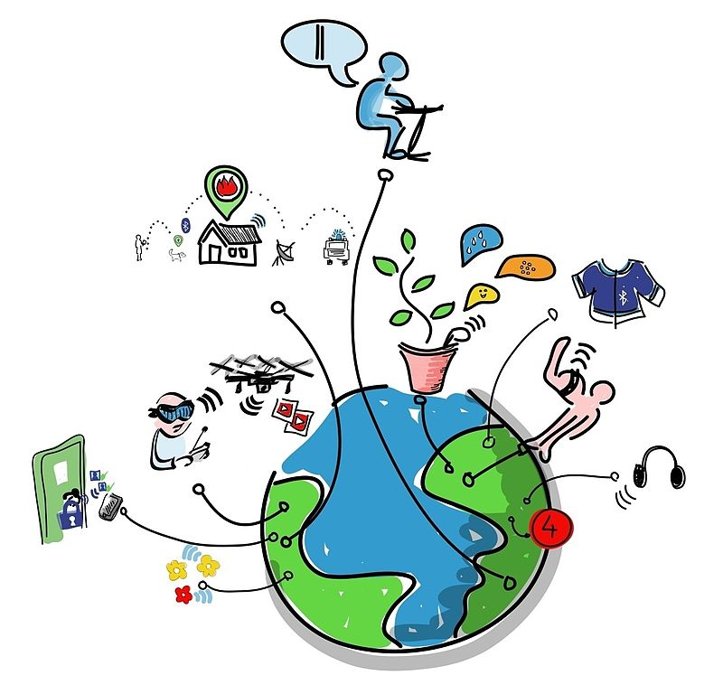
Firgure 1: Internet of Things.
additional safety features. These features can include sensors that monitor for medical emergencies such as falls or seizures. Smart home technology applied in this way can provide users with more freedom and a higher quality of life.

Commercial applications
Medical and healthcare
The Internet of Medical Things (also called the internet of health things) is an application of the IoT for medical and health related purposes, data collection and analysis for research, and monitoring. This ‘Smart Healthcare’, as it can also be called, led to the creation of a digitized healthcare system, connecting available medical resources and healthcare services.
IoT devices can be used to enable remote health monitoring and emergency notification systems. These health monitoring devices can range from blood pressure and heart rate monitors to advanced devices capable of monitoring specialized implants, such as pacemakers, Fitbit electronic wristbands, or advanced hearing aids. Some hospitals have begun implementing “smart beds” that can detect when they are occupied and when a patient is attempting to get up. It can also adjust itself to ensure appropriate pressure and support is applied to the patient without the manual interaction of nurses. A 2015 Goldman Sachs report indicated that healthcare IoT devices “can save the United States more than $300 billion in annual healthcare expenditures by increasing revenue and decreasing cost.” Moreover, the use of mobile devices to support medical follow-up led to the creation of ‘m-health’, used “to analyze, capture, transmit and store health statistics from multiple resources, including sensors and other biomedical acquisition systems”.
Specialized sensors can also be equipped within living spaces to monitor the health and general well-being of senior citizens, while also ensuring that proper treatment is being administered and assisting people regain lost mobility via therapy as well. These sensors create a network of intelligent sensors that are able to collect, process, transfer and analyse valuable information in different environments, such as connecting in-home monitoring devices to hospital-based systems. Other consumer devices to encourage healthy living, such as connected scales or wearable heart monitors, are also a possibility with the IoT. End-to-end health monitoring IoT platforms are also available for antenatal and chronic patients, helping one manage health vitals and recurring medication requirements.
As of 2018 IoMT was not only being applied in the clinical laboratory industry, but also in the healthcare and health insurance industries. IoMT in the healthcare industry is now permitting doctors, patients and others involved (i.e. guardians of patients, nurses, families, etc.) to be part of a system, where patient records are saved in a database, allowing doctors and the rest of the medical staff to have access to the patient’s information. Moreover, IoT-based systems are patient-centered, which involves being flexible to the patient’s medical conditions. IoMT in the insurance industry provides access to better and new types of dynamic information. This includes sensor-based solutions such as biosensors, wearables, connected health devices and mobile apps to track customer behaviour. This can lead to more accurate underwriting and new pricing models.
Transportation
The IoT can assist in the integration of communications, control, and information processing across various transportation systems. Application of the IoT extends to all aspects of transportation systems (i.e. the vehicle, the infrastructure, and the driver or user). Dynamic interaction between these components of a transport system enables inter and intra vehicular communication, smart traffic control, smart parking, electronic toll collection systems, logistic and fleet management, vehicle control, and safety and road assistance. In Logistics and Fleet Management for example, The IoT platform can continuously monitor the location and conditions of cargo and assets via wireless sensors and send specific alerts when management exceptions occur (delays, damages, thefts, etc.). If combined with Machine Learning then it also helps in reducing traffic accidents by introducing drowsiness alerts to drivers and providing self driven cars too.
Building and home automation
IoT devices can be used to monitor and control the mechanical, electrical and electronic systems used in various types of buildings (e.g., public and private, industrial, institutions, or residential) in home automation and building automation systems. In this context, three main areas are being covered in literature:
The integration of the Internet with building energy management systems in order to create energy efficient and IOT driven “smart buildings”.
The possible means of real-time monitoring for reducing energy consumption and monitoring occupant behaviors.
The integration of smart devices in the built environment and how they might to know who to be used in future applications.

Industrial app,lications
Manufacturing
The IoT can realize the seamless integration of various manufacturing devices equipped with sensing, identification, processing, communication, actuation, and networking capabilities. Based on such a highly integrated smart cyberphysical space, it opens the door to create whole new business and market opportunities for manufacturing. Network control and management of manufacturing equipment, asset and situation management, or manufacturing process control bring the IoT within the realm of industrial applications and smart manufacturing as well. The IoT intelligent systems enable rapid manufacturing of new products, dynamic response to product demands, and real-time optimization of manufacturing production and supply chain networks, by networking machinery, sensors and control systems together.
Digital control systems to automate process controls, operator tools and service information systems to optimize plant safety and security are within the purview of the IoT. But it also extends itself to asset management via predictive maintenance, statistical evaluation, and measurements to maximize reliability. Smart industrial management systems can also be integrated with the Smart Grid, thereby enabling real-time energy optimization. Measurements, automated controls, plant optimization, health and safety management, and other functions are provided by a large number of networked sensors.
The term industrial Internet of things (IIoT) is often encountered in the manufacturing industries, referring to the industrial subset of the IoT. IIoT in manufacturing could generate so much business value that it will eventually lead to the fourth industrial revolution, so the so-called Industry 4.0. It is estimated that in the future, successful companies will be able to increase their revenue through Internet of things by creating new business models and improve productivity, exploit analytics for innovation, and transform workforce. The potential of growth by implementing IIoT may generate $12 trillion of global GDP by 2030.
Agriculture
There are numerous IoT applications in farming such as collecting data on temperature, rainfall, humidity, wind speed, pest infestation, and soil content. This data can be used to automate farming techniques, take informed decisions to improve quality and quantity, minimize risk and waste, and reduce effort required to manage crops. For example, farmers can now monitor soil temperature and moisture from afar, and even apply IoT-acquired data to precision fertilization programs.
In August 2018, Toyota Tsusho began a partnership with Microsoft to create fish farming tools using the Microsoft Azure application suite for IoT technologies related to water management. Developed in part by researchers from Kindai University, the water pump mechanisms use artificial intelligence to count the number of fish on a conveyor belt, analyze the number of fish, and deduce the effectiveness of water flow from the data the fish provide. The specific computer programs used in the process fall under the Azure Machine Learning and the Azure IoT Hub platforms.

Infrastructure applications
Monitoring and controlling operations of sustainable urban and rural infrastructures like bridges, railway tracks and on- and offshore wind-farms is a key application of the IoT. The IoT infrastructure can be used for monitoring any events or changes in structural conditions that can compromise safety and increase risk. IoT can benefit the construction industry by cost saving, time reduction, better quality workday, paperless workflow and increase in productivity. It can help in taking faster decisions and save money with Real-Time Data Analytics. It can also be used for scheduling repair and maintenance activities in an efficient manner, by coordinating tasks between different service providers and users of these facilities. IoT devices can also be used to control critical infrastructure like bridges to provide access to ships. Usage of IoT devices for monitoring and operating infrastructure is likely to improve incident management and emergency response coordination, and quality of service, up-times and reduce costs of operation in all infrastructure related areas. Even areas such as waste management can benefit from automation and optimization that could be brought in by the IoT.
Metropolitan scale deployments
There are several planned or ongoing large-scale deployments of the IoT, to enable better management of cities and systems. For example, Songdo, South Korea, the first of its kind fully equipped and wired smart city, is gradually being built, with approximately 70 percent of the business district completed as of June 2018. Much of the city is planned to be wired and automated, with little or no human intervention.
Another application is a currently undergoing project in Santander, Spain. For this deployment, two approaches have been adopted. This city of 180,000 inhabitants has already seen 18,000 downloads of its city smartphone app. The app is connected to 10,000 sensors that enable services like parking search, environmental monitoring, digital city agenda, and more. City context information is used in this deployment so as to benefit merchants through a spark deals mechanism based on city behavior that aims at maximizing the impact of each notification.
Other examples of large-scale deployments underway include the Sino-Singapore Guangzhou Knowledge City; work on improving air and water quality, reducing noise pollution, and increasing transportation efficiency in San Jose, California; and smart traffic management in western Singapore. French company, Sigfox, commenced building an ultra-narrowband wireless data network in the San Francisco Bay Area in 2014, the first business to achieve such a deployment in the U.S. It subsequently announced it would set up a total of 4000 base stations to cover a total of 30 cities in the U.S. by the end of 2016, making it the largest IoT network coverage provider in the country thus far.
Another example of a large deployment is the one completed by New York Waterways in New York City to connect all the city’s vessels and be able to monitor them live 24/7. The network was designed and engineered by Fluidmesh Networks, a Chicago-based company developing wireless networks for critical applications. The NYWW network is currently providing coverage on the Hudson River, East River, and Upper New York Bay. With the wireless network in place, NY Waterway is able to take control of its fleet and passengers in a way that was not previously possible. New applications can include security, energy and fleet management, digital signage, public Wi-Fi, paperless ticketing and others.
Energy management
Significant numbers of energy-consuming devices (e.g. switches, power outlets, bulbs, televisions, etc.) already integrate Internet connectivity, which can allow them to communicate with utilities to balance power generation and energy usage and optimize energy consumption as a whole. These devices allow for remote control by users, or central management via a cloud-based interface, and enable functions like scheduling (e.g., remotely powering on or off heating systems, controlling ovens, changing lighting conditions etc.). The smart grid is a utility-side IoT application; systems gather and act on energy and power-related information to improve the efficiency of the production and distribution of electricity. Using advanced metering infrastructure (AMI) Internet-connected devices, electric utilities not only collect data from end-users, but also manage distribution automation devices like transformers. Environmental monitoring
Environmental monitoring applications of the IoT typically use sensors to assist in environmental protection by monitoring air or water quality, atmospheric or soil conditions, and can even include areas like monitoring the movements of wildlife and their habitats. Development of resource-constrained devices connected to the Internet also means that other applications like earthquake or tsunami early-warning systems can also be used by emergency services to provide more effective aid. IoT devices in this application typically span a large geographic area and can also be mobile. It has been argued that the standardization IoT brings to wireless sensing will revolutionize this area.

Trends and characteristics
The IoT’s major significant trend in recent years is the explosive growth of devices connected and controlled by the Internet. The wide range of applications for IoT technology mean that the specifics can be very different from one device to the next but there are basic characteristics shared by most. IoT creates opportunities for more direct integration of the physical world into computer-based systems, resulting in efficiency improvements, economic benefits, and reduced human exertions.
The number of IoT devices increased 31% year-over-year to 8.4 billion in the year 2017 and it is estimated that there will be 30 billion devices by 2020. The global market value of IoT is projected to reach $7.1 trillion by 2020 (Fig. ???).

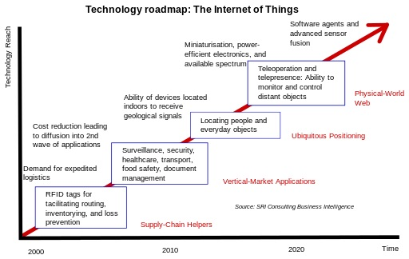
Figure 2: Technology roadmap: Internet of Things.
Intelligence
Ambient intelligence and autonomous control are not part of the original concept of the Internet of things. Ambient intelligence and autonomous control do not necessarily require Internet structures, either. However, there is a shift in research (by companies such as Intel) to integrate the concepts of IoT and autonomous control, with initial outcomes towards this direction considering objects as the driving force for autonomous IoT.
In the future, the Internet of Things may be a non-deterministic and open network in which auto-organized or intelligent entities (web services, SOA components) and virtual objects (avatars) will be interoperable and able to act independently (pursuing their own objectives or shared ones) depending on the context, circumstances or environments. Autonomous behavior through the collection and reasoning of context information as well as the object’s ability to detect changes in the environment (faults affecting sensors) and introduce suitable mitigation measures constitutes a major research trend, clearly needed to provide credibility to the IoT technology. Modern IoT products and solutions in the marketplace use a variety of different technologies to support such context-aware automation, but more sophisticated forms of intelligence are requested to permit sensor units and intelligent cyber-physical systems to be deployed in real environments.
Architecture
Tier 1 of the IIoT architecture consists of networked things, typically sensors and actuators, from the IIoT equipment, which use protocols such as Modbus, Zigbee, or proprietary protocols, to connect to an Edge Gateway. Tier 2 includes sensor data aggregation systems called Edge Gateways that provide functionality, such as pre-processing of the data, securing connectivity to cloud, using systems such as WebSockets, the event hub, and, even in some cases, edge analytics or fog computing. Tier 3 includes the cloud application built for IIoT using the microservices architecture, which are usually polyglot and inherently secure in nature using HTTPS/OAuth. Tier 3 also includes storage of sensor data using various database systems, such as time series databases or asset stores using backend data storage systems such as Cassandra or Postgres. In addition to the data storage, we analyze the data using various analytics, predictive or threshold-based or regression-based, to get more insights on the IIoT equipment.
Building on the Internet of things, the web of things is an architecture for the application layer of the Internet of things looking at the convergence of data from IoT devices into Web applications to create innovative use-cases. In order to program and control the flow of information in the Internet of things, a predicted architectural direction is being called BPM Everywhere which is a blending of traditional process management with process mining and special capabilities to automate the control of large numbers of coordinated devices.
The Internet of things requires huge scalability in the network space to handle the surge of devices. IETF 6LoWPAN would be used to connect devices to IP networks. With billions of devices being added to the Internet space, IPv6 will play a major role in handling the network layer scalability. IETF’s Constrained Application Protocol, ZeroMQ, and MQTT would provide lightweight data transport.
Complexity
In semi-open or closed loops (i.e. value chains, whenever a global finality can be settled) IoT will often be considered and studied as a complex system due to the huge number of different links, interactions between autonomous actors, and its capacity to integrate new actors. At the overall stage (full open loop) it will likely be seen as a chaotic environment (since systems always have finality). As a practical approach, not all elements in the Internet of things run in a global, public space. Subsystems are often implemented to mitigate the risks of privacy, control and reliability. For example, domestic robotics (domotics) running inside a smart home might only share data within and be available via a local network. Managing and controlling high dynamic ad hoc IoT things/devices network is a tough task with the traditional networks architecture, Software Defined Networking (SDN) provides the agile dynamic solution that can cope with the special requirements of the diversity of innovative IoT applications.
Size considerations
The Internet of things would encode 50 to 100 trillion objects, and be able to follow the movement of those objects. Human beings in surveyed urban environments are each surrounded by 1000 to 5000 trackable objects. In 2015 there were already 83 million smart devices in people‘s homes. This number is about to grow up to 193 million devices in 2020 and will for sure go on growing in the near future. The figure of online capable devices grew 31% from 2016 to 8.4 billion in 2017.
Space considerations
In the Internet of things, the precise geographic location of a thing—and also the precise geographic dimensions of a thing—will be critical. Therefore, facts about a thing, such as its location in time and space, have been less critical to track because the person processing the information can decide whether or not that information was important to the action being taken, and if so, add the missing information (or decide to not take the action). (Note that some things in the Internet of things will be sensors, and sensor location is usually important.) The GeoWeb and Digital Earth are promising applications that become possible when things can become organized and connected by location. However, the challenges that remain include the constraints of variable spatial scales, the need to handle massive amounts of data, and an indexing for fast search and neighbor operations. In the Internet of things, if things are able to take actions on their own initiative, this human-centric mediation role is eliminated. Thus, the time-space context that we as humans take for granted must be given a central role in this information ecosystem. Just as standards play a key role in the Internet and the Web, geospatial standards will play a key role in the Internet of things.
A solution to “basket of remotes”
Many IoT devices have a potential to take a piece of this market. Jean-Louis Gassée (Apple initial alumni team, and BeOS co-founder) has addressed this topic in an article on Monday Note, where he predicts that the most likely problem will be what he calls the “basket of remotes” problem, where we’ll have hundreds of applications to interface with hundreds of devices that don’t share protocols for speaking with one another. For improved user interaction, some technology leaders are joining forces to create standards for communication between devices to solve this problem. Others are turning to the concept of predictive interaction of devices, “where collected data is used to predict and trigger actions on the specific devices” while making them work together.

Frameworks
IoT frameworks might help support the interaction between “things” and allow for more complex structures like distributed computing and the development of distributed applications. Currently, some IoT frameworks seem to focus on real-time data logging solutions, offering some basis to work with many “things” and have them interact. Future developments might lead to specific software-development environments to create the software to work with the hardware used in the Internet of things. Companies are developing technology platforms to provide this type of functionality for the Internet of things. Newer platforms are being developed, which add more intelligence.
REST is a scalable architecture that allows things to communicate over Hypertext Transfer Protocol and is easily adopted for IoT applications to provide communication from a thing to a central web server.

3D printing

Outline
3D printing is any of various processes in which material is joined or solidified under computer control to create a three-dimensional object, with material being added together (such as liquid molecules or powder grains being fused together). 3D printing is used in both rapid prototyping and additive manufacturing. Objects can be of almost any shape or geometry and typically are produced using digital model data from a 3D model or another electronic data source such as an Additive Manufacturing File (AMF) file (usually in sequential layers). There are many different technologies, like stereolithography (SLA) or fused deposit modeling (FDM). Thus, unlike material removed from a stock in the conventional machining process, 3D printing or Additive Manufacturing builds a three-dimensional object from a computer-aided design (CAD) model or AMF file, usually by successively adding material layer by layer.
The term “3D printing” originally referred to a process that deposits a binder material onto a powder bed with inkjet printer heads layer by layer. More recently, the term is being used in popular vernacular to encompass a wider variety of additive manufacturing techniques. United States and global technical standards use the official term additive manufacturing for this broader sense (Fig. ???).

Terminology
The umbrella term additive manufacturing (AM) gained wide currency in the 2000s, inspired by the theme of material being added together (in any of various ways). In contrast, the term subtractive manufacturing appeared as a retronym for the large family of machining processes with material removal as their common theme. The term 3D printing still referred only to the polymer technologies in most minds, and the term AM was likelier to be used in metalworking and end use part production contexts than among polymer, inkjet, or stereolithography enthusiasts.
By the early 2010s, the terms 3D printing and additive manufacturing evolved senses in which they were alternate umbrella terms for additive technologies, one being used in popular vernacular by consumer-maker communities and the media, and the other used more formally by industrial end-use part producers, machine manufacturers, and global technical standards organizations. Until recently, the term 3D printing has been associated with machines low-end in price or in capability. Both terms reflect that the technologies share the theme of material addition or joining throughout a 3D work envelope under automated control. Peter Zelinski, the editor-in-chief of Additive Manufacturing magazine, pointed out in 2017 that the terms are still often synonymous in casual usage but that some manufacturing industry experts are increasingly making a sense distinction whereby Additive Manufacturing comprises 3D printing plus other technologies or other aspects of a manufacturing process.
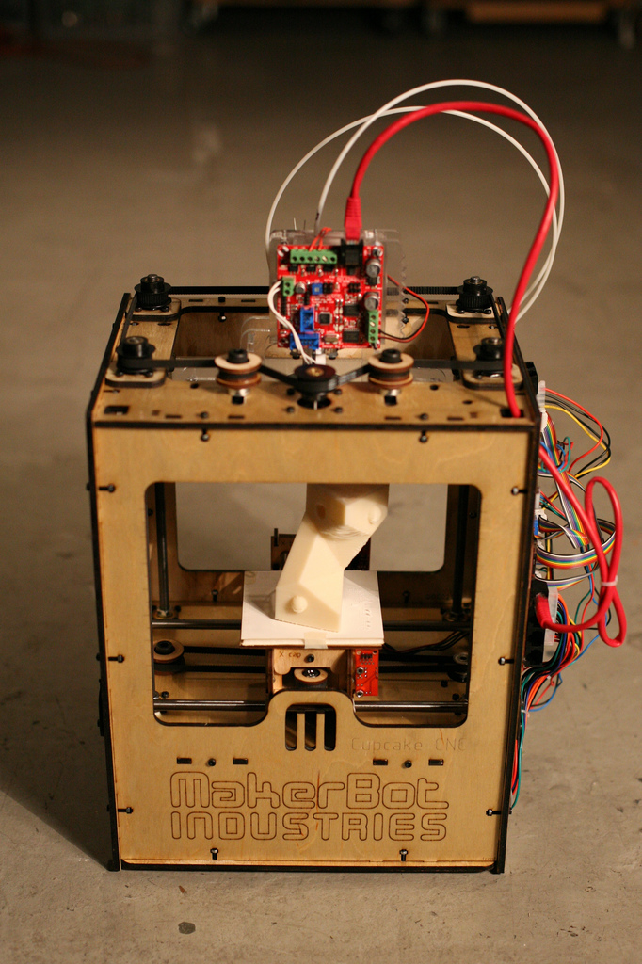
Figure 3: A makerBot three-dimensional printer.
Other terms that have been used as synonyms or hypernyms have included desktop manufacturing, rapid manufacturing (as the logical production-level successor to rapid prototyping), and on-demand manufacturing (which echoes on-demand printing in the 2D sense of printing). That such application of the adjectives rapid and on-demand to the noun manufacturing was novel in the 2000s reveals the prevailing mental model of the long industrial era in which almost all production manufacturing involved long lead times for laborious tooling development. Today, the term subtractive has not replaced the term machining, instead complementing it when a term that covers any removal method is needed. Agile tooling is the use of modular means to design tooling that is produced by additive manufacturing or 3D printing methods to enable quick prototyping and responses to tooling and fixture needs. Agile tooling uses a cost effective and high quality method to quickly respond to customer and market needs, and it can be used in hydro-forming, stamping, injection molding and other manufacturing processes.

History
1981
Early additive manufacturing equipment and materials were developed in the 1980s. In 1981, Hideo Kodama of Nagoya Municipal Industrial Research Institute invented two additive methods for fabricating three-dimensional plastic models with photo-hardening thermoset polymer, where the UV exposure area is controlled by a mask pattern or a scanning fiber transmitter.
1984
On 16 July 1984, Alain Le Méhauté, Olivier de Witte, and Jean Claude André filed their patent for the stereolithography process. The application of the French inventors was abandoned by the French General Electric Company (now Alcatel-Alsthom) and CILAS (The Laser Consortium). The claimed reason was “for lack of business perspective”.
Three weeks later in 1984, Chuck Hull of 3D Systems Corporation filed his own patent for a stereolithography fabrication system, in which layers are added by curing photopolymers with ultraviolet light lasers. Hull defined the process as a “system for generating three-dimensional objects by creating a cross-sectional pattern of the object to be formed,”. Hull’s contribution was the STL (Stereolithography) file format and the digital slicing and infill strategies common to many processes today.
1988
The technology used by most 3D printers to date—especially hobbyist and consumer-oriented models—is fused deposition modeling, a special application of plastic extrusion, developed in 1988 by S. Scott Crump and commercialized by his company Stratasys, which marketed its first FDM machine in 1992.
AM processes for metal sintering or melting (such as selective laser sintering, direct metal laser sintering, and selective laser melting) usually went by their own individual names in the 1980s and 1990s. At the time, all metalworking was done by processes that we now call non-additive (casting, fabrication, stamping, and machining); although plenty of automation was applied to those technologies (such as by robot welding and CNC), the idea of a tool or head moving through a 3D work envelope transforming a mass of raw material into a desired shape with a toolpath was associated in metalworking only with processes that removed metal (rather than adding it), such as CNC milling, CNC EDM, and many others. But the automated techniques that added metal, which would later be called additive manufacturing, were beginning to challenge that assumption. By the mid-1990s, new techniques for material deposition were developed at Stanford and Carnegie Mellon University, including microcasting and sprayed materials. Sacrificial and support materials had also become more common, enabling new object geometries.
1993
The term 3D printing originally referred to a powder bed process employing standard and custom inkjet print heads, developed at MIT in 1993 and commercialized by Soligen Technologies, Extrude Hone Corporation, and Z Corporation.
The year 1993 also saw the start of a company called Solidscape, introducing a high-precision polymer jet fabrication system with soluble support structures, (categorized as a “dot-on-dot” technique).
1995
In 1995 the Fraunhofer Institute developed the selective laser melting process.
2009
Fused Deposition Modeling (FDM) printing process patents expired in 2009. As the various additive processes matured, it became clear that soon metal removal would no longer be the only metalworking process done through a tool or head moving through a 3D work envelope transforming a mass of raw material into a desired shape layer by layer. The 2010s were the first decade in which metal end use parts such as engine brackets and large nuts would be grown (either before or instead of machining) in job production rather than obligately being machined from bar stock or plate. It is still the case that casting, fabrication, stamping, and machining are more prevalent than additive manufacturing in metalworking, but AM is now beginning to make significant inroads, and with the advantages of design for additive manufacturing, it is clear to engineers that much more is to come.
As technology matured, several authors had begun to speculate that 3D printing could aid in sustainable development in the developing world.
2013
NASA employees Samantha Snabes and Matthew Fiedler create first prototype of large-format, affordable 3D printer, Gigabot, and launch 3D printing company re:3D.
2018
re:3D develops a system that uses plastic pellets that can be made by grinding up waste plastic.

General principles
Modeling
3D printable models may be created with a computer-aided design (CAD) package, via a 3D scanner, or by a plain digital camera and photogrammetry software. 3D printed models created with CAD result in reduced errors and can be corrected before printing, allowing verification in the design of the object before it is printed. The manual modeling process of preparing geometric data for 3D computer graphics is similar to plastic arts such as sculpting. 3D scanning is a process of collecting digital data on the shape and appearance of a real object, creating a digital model based on it.
CAD model used for 3D printing.
Printing
Before printing a 3D model from an STL file, it must first be examined for errors. Most CAD applications (Fig. ???) produce errors in output STL files of the following types:
- holes,
- faces normal,
- self-intersections,
- noise shells,
- manifold errors.
A step in the STL generation known as “repair” fixes such problems in the original model. Generally STLs that have been produced from a model obtained through 3D scanning often have more of these errors. This is due to how 3D scanning works-as it is often by point to point acquisition, reconstruction will include errors in most cases.
Once completed, the STL file needs to be processed by a piece of software called a “slicer,” which converts the model into a series of thin layers and produces a G-code file containing instructions tailored to a specific type of 3D printer (FDM printers). This G-code file can then be printed with 3D printing client software (which loads the G-code, and uses it to instruct the 3D printer during the 3D printing process).
Printer resolution describes layer thickness and X–Y resolution in dots per inch (dpi) or micrometers (µm). Typical layer thickness is around 100 µm (250 DPI), although some machines can print layers as thin as 16
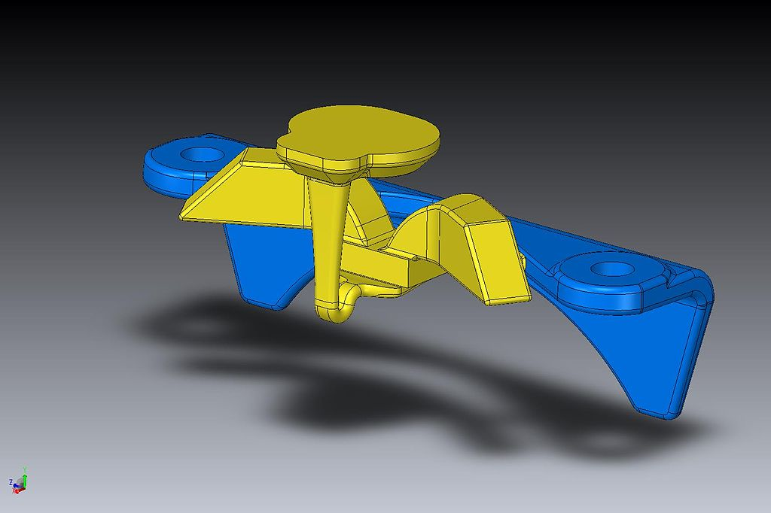
Figure 4: CAD model used for 3D printing.
µm (1,600 DPI). X–Y resolution is comparable to that of laser printers. The particles (3D dots) are around 50 to 100 µm (510 to 250 DPI) in diameter. For that printer resolution, specifying a mesh resolution of 0.01–0.03 mm and a chord length ? 0.016 mm generate an optimal STL output file for a given model input file. Specifying higher resolution results in larger files without increase in print quality.
Construction of a model with contemporary methods can take anywhere from several hours to several days, depending on the method used and the size and complexity of the model. Additive systems can typically reduce this time to a few hours, although it varies widely depending on the type of machine used and the size and number of models being produced simultaneously.
Traditional techniques like injection moulding can be less expensive for manufacturing polymer products in high quantities, but additive manufacturing can be faster, more flexible and less expensive when producing relatively small quantities of parts. 3D printers give designers and concept development teams the ability to produce parts and concept models using a desktop size printer.
Seemingly paradoxic, more complex objects can be cheaper for 3D printing production than less complex objects.
Finishing
Though the printer-produced resolution is sufficient for many applications, printing a slightly oversized version of the desired object in standard resolution and then removing material with a higher-resolution subtractive process can achieve greater precision.
The layered structure of all Additive Manufacturing processes leads inevitably to a strain-stepping effect on part surfaces which are curved or tilted in respect to the building platform. The effects strongly depend on the orientation of a part surface inside the building process.
Some printable polymers such as ABS, allow the surface finish to be smoothed and improved using chemical vapor processes based on acetone or similar solvents.
Some additive manufacturing techniques are capable of using multiple materials in the course of constructing parts. These techniques are able to print in multiple colors and color combinations simultaneously, and would not necessarily require painting.
Some printing techniques require internal supports to be built for overhanging features during construction. These supports must be mechanically removed or dissolved upon completion of the print.
All of the commercialized metal 3D printers involve cutting the metal component off the metal substrate after deposition. A new process for the GMAW 3D printing allows for substrate surface modifications to remove aluminum or steel.

Processes and printers
A large number of additive processes are available. The main differences between processes are in the way layers are deposited to create parts and in the materials that are used. Each method has its own advantages and drawbacks, which is why some companies offer a choice of powder and polymer for the material used to build the object. Others sometimes use standard, off-the-shelf business paper as the build material to produce a durable prototype. The main considerations in choosing a machine are generally speed, costs of the 3D printer, of the printed prototype, choice and cost of the materials, and color capabilities. Printers that work directly with metals are generally expensive. However less expensive printers can be used to make a mold, which is then used to make metal parts.
ISO/ASTM52900-15 defines seven categories of Additive Manufacturing (AM) processes within its meaning: binder jetting, directed energy deposition, material extrusion, material jetting, powder bed fusion, sheet lamination, and vat photopolymerization.
Some methods melt or soften the material to produce the layers. In Fused filament fabrication, also known as Fused deposition modeling (FDM), the model or part is produced by extruding small beads or streams of material which harden immediately to form layers. A filament of thermoplastic, metal wire, or other material is fed into an extrusion nozzle head (3D printer extruder), which heats the material and turns the flow on and off. FDM is somewhat restricted in the variation of shapes that may be fabricated. Another technique fuses parts of the layer and then moves upward in the working area, adding another layer of granules and repeating the process until the piece has built up. This process uses the unfused media to support overhangs and thin walls in the part being produced, which reduces the need for temporary auxiliary supports for the piece.
Laser sintering techniques include selective laser sintering, with both metals and polymers, and direct metal laser sintering. Selective laser melting does not use sintering for the fusion of powder granules but will completely melt the powder using a high-energy laser to create fully dense materials in a layer-wise method that has mechanical properties similar to those of conventional manufactured metals. Electron beam melting is a similar type of additive manufacturing technology for metal parts (e.g. titanium alloys). EBM manufactures parts by melting metal powder layer by layer with an electron beam in a high vacuum. Another method consists of an inkjet 3D printing system, which creates the model one layer at a time by spreading a layer of powder (plaster, or resins) and printing a binder in the cross-section of the part using an inkjet-like process. With laminated object manufacturing, thin layers are cut to shape and joined together.
Schematic representation of Stereolithography; a light-emitting device a) (laser or DLP) selectively illuminate the transparent bottom c) of a tank b) filled with a liquid photo-polymerizing resin; the solidified resin d) is progressively dragged up by a lifting platform e)
Other methods cure liquid materials using different sophisticated technologies, such as stereolithography. Photopolymerization is primarily used in stereolithography to produce a solid part from a liquid. Inkjet printer systems like the Objet PolyJet system spray photopolymer materials onto a build tray in ultra-thin layers (between 16 and 30 µm) until the part is completed. Each photopolymer layer is cured with UV light after it is jetted, producing fully cured models that can be handled and used immediately, without post-curing. Ultra-small features can be made with the 3D micro-fabrication technique used in multiphoton photopolymerisation. Due to the nonlinear nature of photo excitation, the gel is cured to a solid only in the places where the laser was focused while the remaining gel is then washed away. Feature sizes of under 100 nm are easily produced, as well as complex structures with moving and interlocked parts. Yet another approach uses a synthetic resin that is solidified using LEDs.
In Mask-image-projection-based stereolithography, a 3D digital model is sliced by a set of horizontal planes. Each slice is converted into a two-dimensional mask image. The mask image is then projected onto a photocurable liquid resin surface and light is projected onto the resin to cure it in the shape of the layer. Continuous liquid interface production begins with a pool of liquid photopolymer resin. Part of the pool bottom is transparent to ultraviolet light (the “window”), which causes the resin to solidify. The object rises slowly enough to allow resin to flow under and maintain contact with the bottom of the object. In powder-fed directed-energy deposition, a high-power laser is used to melt metal powder supplied to the focus of the laser beam. The powder fed directed energy process is similar to Selective Laser Sintering, but the metal powder is applied only where material is being added to the part at that moment.
As of December 2017, additive manufacturing systems were on the market that ranged from $99 to $500,000 in price and were employed in industries including aerospace, architecture, automotive, defense, and medical replacements, among many others. For example, General Electric uses the high-end model to build parts for turbines. Many of these systems are used for rapid prototyping, before mass production methods are employed. Higher education has proven to be a major buyer of desktop and professional 3D printers which industry experts generally view as a positive indicator. Libraries around the world have also become locations to house smaller 3D printers for educational and community access. Several projects and companies are making efforts to develop affordable 3D printers for home desktop use. Much of this work has been driven by and targeted at DIY/Maker/enthusiast/early adopter communities, with additional ties to the academic and hacker communities.

Applications
In the current scenario, 3D printing or Additive Manufacturing has been used in manufacturing, medical, industry and sociocultural sectors which facilitate 3D printing or Additive Manufacturing to become successful commercial technology (Fig. ??????). The earliest application of additive manufacturing was on the toolroom end of the manufacturing spectrum. For example, rapid prototyping was one of the earliest additive variants, and its mission was to reduce the lead time and cost of developing prototypes of new parts and devices, which was earlier only done with subtractive toolroom methods such as CNC milling, turning, and precision grinding. In the 2010s, additive manufacturing entered production to a much greater extent.
Additive manufacturing of food is being developed by squeezing out food, layer by layer, into three-dimensional objects. A large variety of foods are appropriate candidates, such as chocolate and candy, and flat foods such as crackers, pasta, and pizza.
3D printing has entered the world of clothing, with fashion designers experimenting with 3D-printed bikinis, shoes, and dresses. In commercial production Nike is using 3D printing to prototype and manufacture the 2012 Vapor Laser Talon football shoe for players of American football, and New Balance is 3D manufacturing custom-fit shoes for athletes. 3D printing has come to the point where companies are printing consumer grade eyewear with on-demand custom fit and styling (although they cannot print the lenses). On-demand customization of glasses is possible with rapid prototyping.
Vanessa Friedman, fashion director and chief fashion critic at The New York Times, says 3D printing will have a significant value for fashion companies down the road, especially if it transforms into a print-it-yourself tool for shoppers. “There’s real sense that this is not going to happen anytime soon,” she says, “but it will happen, and it will create dramatic change in how we think both about intellectual property and how things are in the supply chain.” She adds: “Certainly some of the fabrications that brands can use will be dramatically changed by technology.”
In cars, trucks, and aircraft (Fig. ???), Additive Manufacturing is beginning to transform both (1) unibody and
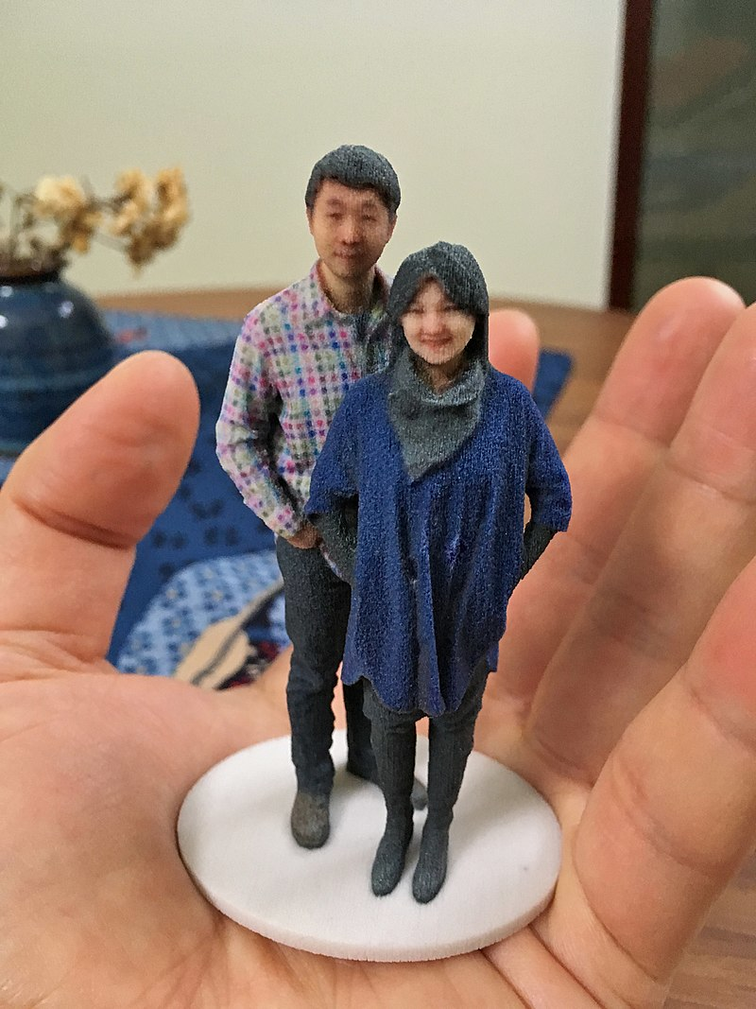
Figure 5: A 3D selfie in 1:20 scale printed by Shapeways using gypsum-based printing.
fuselage design and production and (2) powertrain design and production. For example:
- in early 2014, Swedish supercar manufacturer Koenigsegg announced the One:1, a supercar that utilizes many components that were 3D printed. Urbee is the name of the first car in the world car mounted using the technology 3D printing (its bodywork and car windows were “printed”),
- in 2014, Local Motors debuted Strati, a functioning vehicle that was entirely 3D Printed using ABS plastic and carbon fiber, except the powertrain. In May 2015 Airbus announced that its new Airbus A350 XWB included over 1000 components manufactured by 3D printing,
- in 2015, a Royal Air Force Eurofighter Typhoon fighter jet flew with printed parts. The United States Air Force has begun to work with 3D printers, and the Israeli Air Force has also purchased a 3D printer to print spare parts,
- in 2017, GE Aviation revealed that it had used design for additive manufacturing to create a helicopter engine with 16 parts instead of 900, with great potential impact on reducing the complexity of supply chains.
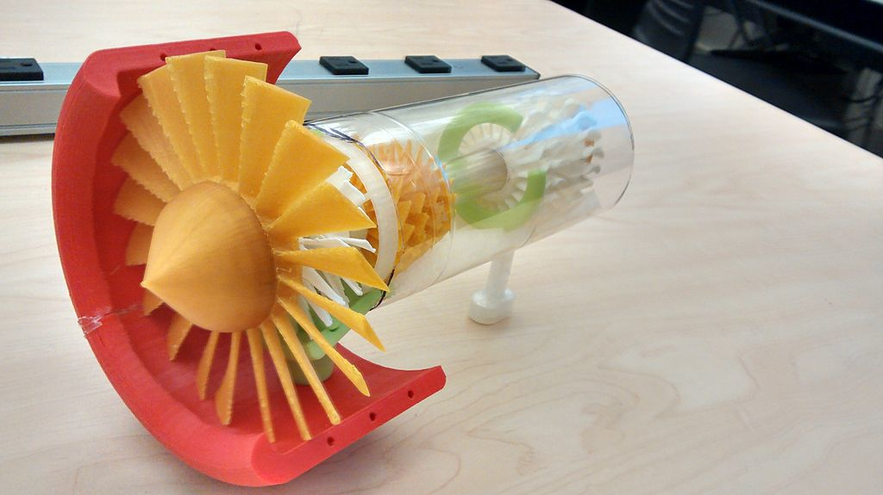
Figure 6: A Jet Engine turbine printed from the Howard Community College Makerbot.
AM’s impact on firearms involves two dimensions: new manufacturing methods for established companies, and new possibilities for the making of do-it-yourself firearms. In 2012, the US-based group Defense Distributed disclosed plans to design a working plastic 3D printed firearm “that could be downloaded and reproduced by anybody with a 3D printer.” After Defense Distributed released their plans, questions were raised regarding the effects that 3D printing and widespread consumer-level CNC machining may have on gun control effectiveness.
Surgical uses of 3D printing-centric therapies have a history beginning in the mid-1990s with anatomical modeling for bony reconstructive surgery planning. Patient-matched implants were a natural extension of this work, leading to truly personalized implants that fit one unique individual. Virtual planning of surgery and guidance using 3D printed, personalized instruments have been applied to many areas of surgery including total joint replacement and craniomaxillofacial reconstruction with great success. One example of this is the bioresorbable trachial splint to treat newborns with tracheobronchomalacia developed at the University of Michigan. The use of additive manufacturing for serialized production of orthopedic implants (metals) is also increasing due to the ability to efficiently create porous surface structures that facilitate osseointegration. The hearing aid and dental industries are expected to be the biggest area of future development using the custom 3D printing technology.
In March 2014, surgeons in Swansea used 3D printed parts to rebuild the face of a motorcyclist who had been seriously injured in a road accident. In May 2018, 3D printing has been used for the kidney transplant to save a three-year-old boy. As of 2012, 3D bio-printing technology has been studied by biotechnology firms and academia for possible use in tissue engineering applications in which organs and body parts are built using inkjet printing techniques. In this process, layers of living cells are deposited onto a gel medium or sugar matrix and slowly built up to form three-dimensional structures including vascular systems. Recently, a heart-on-chip has been created which matches properties of cells.
In 2018, 3D printing technology was used for the first time to create a matrix for cell immobilization in fermentation. Propionic acid production by Propionibacterium acidipropionici immobilized on 3D-printed nylon beads was chosen as a model study. It was shown that those 3D-printed beads were capable to promote high density cell attachment and propionic acid production, which could be adapted to other fermentation bioprocesses.
In 2005, academic journals had begun to report on the possible artistic applications of 3D printing technology. As of 2017, domestic 3D printing was reaching a consumer audience beyond hobbyists and enthusiasts. Off the shelf machines were increasingly capable of producing practical household applications, for example, ornamental objects. Some practical examples include a working clock and gears printed for home woodworking machines among other purposes. Web sites associated with home
3D printing tended to include backscratchers, coat hooks, door knobs, etc.
3D printing, and open source 3D printers in particular, are the latest technology making inroads into the classroom. Some authors have claimed that 3D printers offer an unprecedented “revolution” in STEM education. The evidence for such claims comes from both the low cost ability for rapid prototyping in the classroom by students, but also the fabrication of low-cost high-quality scientific equipment from open hardware designs forming open-source labs. Future applications for 3D printing might include creating open-source scientific equipment.
In the last several years 3D printing has been intensively used by in the cultural heritage field for preservation, restoration and dissemination purposes. Many Europeans and North American Museums have purchased 3D printers and actively recreate missing pieces of their relics. The Metropolitan Museum of Art and the British Museum have started using their 3D printers to create museum souvenirs that are available in the museum shops. Other museums, like the National Museum of Military History and Varna Historical Museum, have gone further and sell through the online platform Threeding digital models of their artifacts, created using Artec 3D scanners, in 3D printing friendly file format, which everyone can 3D print at home.
3D printed soft actuators is a growing application of 3D printing technology which has found its place in the 3D printing applications. These soft actuators are being developed to deal with soft structures and organs especially in biomedical sectors and where the interaction between human and robot is inevitable. The majority of the existing soft actuators are fabricated by conventional methods that require manual fabrication of devices, post processing/assembly, and lengthy iterations until maturity in the fabrication is achieved. To avoid the tedious and time-consuming aspects of the current fabrication processes, researchers are exploring an appropriate manufacturing approach for effective fabrication of soft actuators. Thus, 3D printed soft actuators are introduced to revolutionize the design and fabrication of soft actuators with custom geometrical, functional, and control properties in a faster and inexpensive approach. They also enable incorporation of all actuator components into a single structure eliminating the need to use external joints, adhesives, and fasteners.

Legal aspects

Intellectual property
3D printing has existed for decades within certain manufacturing industries where many legal regimes, including patents, industrial design rights, copyright, and trademark may apply. However, there is not much jurisprudence to say how these laws will apply if 3D printers become mainstream and individuals or hobbyist communities begin manufacturing items for personal use, for non-profit distribution, or for sale.
Any of the mentioned legal regimes may prohibit the distribution of the designs used in 3D printing, or the distribution or sale of the printed item. To be allowed to do these things, where an active intellectual property was involved, a person would have to contact the owner and ask for a license, which may come with conditions and a price. However, many patent, design and copyright laws contain a standard limitation or exception for ‘private’, ‘non-commercial’ use of inventions, designs or works of art protected under intellectual property (IP). That standard limitation or exception may leave such private, non-commercial uses outside the scope of IP rights.
Patents cover inventions including processes, machines, manufactures, and compositions of matter and have a finite duration which varies between countries, but generally 20 years from the date of application. Therefore, if a type of wheel is patented, printing, using, or selling such a wheel could be an infringement of the patent.
Copyright covers an expression in a tangible, fixed medium and often lasts for the life of the author plus 70 years thereafter. If someone makes a statue, they may have copyright on the look of that statue, so if someone sees that statue, they cannot then distribute designs to print an identical or similar statue.
When a feature has both artistic (copyrightable) and functional (patentable) merits, when the question has appeared in US court, the courts have often held the feature is not copyrightable unless it can be separated from the functional aspects of the item. In other countries the law and the courts may apply a different approach allowing, for example, the design of a useful device to be registered (as a whole) as an industrial design on the understanding that, in case of unauthorized copying, only the non-functional features may be claimed under design law whereas any technical features could only be claimed if covered by a valid patent.

Gun legislation and administration
The US Department of Homeland Security and the Joint Regional Intelligence Center released a memo stating that “significant advances in three-dimensional (3D) printing capabilities, availability of free digital 3D printable files for firearms components, and difficulty regulating file sharing may present public safety risks from unqualified gun seekers who obtain or manufacture 3D printed guns” and that “proposed legislation to ban 3D printing of weapons may deter, but cannot completely prevent, their production. Even if the practice is prohibited by new legislation, online distribution of these 3D printable files will be as difficult to control as any other illegally traded music, movie or software files.”
Attempting to restrict the distribution of gun plans via the Internet has been likened to the futility of preventing the widespread distribution of DeCSS, which enabled DVD ripping. After the US government had Defense Distributed take down the plans, they were still widely available via the Pirate Bay and other file sharing sites. Downloads of the plans from the UK, Germany, Spain, and Brazil were heavy. Some US legislators have proposed regulations on 3D printers to prevent them from being used for printing guns. 3D printing advocates have suggested that such regulations would be futile, could cripple the 3D printing industry, and could infringe on free speech rights, with early pioneer of 3D printing Professor Hod Lipson suggesting that gunpowder could be controlled instead.
Internationally, where gun controls are generally stricter than in the United States, some commentators have said the impact may be more strongly felt since alternative firearms are not as easily obtainable. Officials in the United Kingdom have noted that producing a 3D printed gun would be illegal under their gun control laws. Europol stated that criminals have access to other sources of weapons but noted that as technology improves, the risks of an effect would increase.

Aerospace regulation
In the United States, the FAA has anticipated a desire to use additive manufacturing techniques and has been considering how best to regulate this process. The FAA has jurisdiction over such fabrication because all aircraft parts must be made under FAA production approval or under other FAA regulatory categories. In December 2016, the FAA approved the production of a 3D printed fuel nozzle for the GE LEAP engine. Aviation attorney Jason Dickstein has suggested that additive manufacturing is merely a production method, and should be regulated like any other production method. He has suggested that the FAA’s focus should be on guidance to explain compliance, rather than on changing the existing rules, and that existing regulations and guidance permit a company “to develop a robust quality system that adequately reflects regulatory needs for quality assurance.”

Health and safety
Research on the health and safety concerns of 3D printing is new and in development due to the recent proliferation of 3D printing devices. In 2017 the European Agency for Safety and Health at Work has published a discussion paper on the processes and materials involved in 3D printing, potential implications of this technology for occupational safety and health and avenues for controlling potential hazards. Most concerns involve gas and material exposures, in particular nanomaterials, material handling, static electricity, moving parts and pressures.
A National Institute for Occupational Safety and Health (NIOSH) study noted particle emissions from a fused filament peaked a few minutes after printing started and returned to baseline levels 100 minutes after printing ended. Emissions from fused filament printers can include a large number of ultrafine particles and volatile organic compounds (VOCs).
The toxicity from emissions varies by source material due to differences in size, chemical properties, and quantity of emitted particles. Excessive exposure to VOCs can lead to irritation of the eyes, nose, and throat, headache, loss of coordination, and nausea and some of the chemical emissions of fused filament printers have also been linked to asthma. Based on animal studies, carbon nanotubes and carbon nanofibers sometimes used in fused filament printing can cause pulmonary effects including inflammation, granulomas, and pulmonary fibrosis when at the nanoparticle size.
As of March 2018, the US Government has set 3D printer emission standards for only a limited number of compounds. Furthermore, the few established standards address factory conditions, not home or other environments in which the printers are likely to be used.
Carbon nanoparticle emissions and processes using powder metals are highly combustible and raise the risk of dust explosions. At least one case of severe injury was noted from an explosion involved in metal powders used for fused filament printing. Other general health and safety concerns include the hot surface of UV lamps and print head blocks, high voltage, ultraviolet radiation from UV lamps, and potential for mechanical injury from moving parts.
The problems noted in the NIOSH report were reduced by using manufacturer-supplied covers and full enclosures, using proper ventilation, keeping workers away from the printer, using respirators, turning off the printer if it jammed, and using lower emission printers and filaments. At least one case of severe injury was noted from an explosion involved in metal powders used for fused filament. Personal protective equipment has been found to be the least desirable control method with a recommendation that it only be used to add further protection in combination with approved emissions protection.
Hazards to health and safety also exist from post-processing activities done to finish parts after they have been printed. These post-processing activities can include chemical baths, sanding, polishing, or vapor exposure to refine surface finish, as well as general subtractive manufacturing techniques such as drilling, milling, or turning to modify the printed geometry. Any technique that removes material from the printed part has the potential to generate particles that can be inhaled or cause eye injury if proper personal protective equipment is not used, such as respirators or safety glasses. Caustic baths are often used to dissolve support material used by some 3D printers that allows them to print more complex shapes. These baths require personal protective equipment to prevent injury to exposed skin.
Although no occupational exposure limits specific to 3D printer emissions exist, certain source materials used in 3D printing, such as carbon nanofiber and carbon nanotubes, have established occupational exposure limits at the nanoparticle size.
Since 3-D imaging creates items by fusing materials together, there runs the risk of layer separation in some devices made using 3-D Imaging. For example, in January 2013, the US medical device company, DePuy, recalled their knee and hip replacement systems. The devices were made from layers of metal, and shavings had come loose – potentially harming the patient.

Impact
Additive manufacturing, starting with today’s infancy period, requires manufacturing firms to be flexible, ever-improving users of all available technologies to remain competitive. Advocates of additive manufacturing also predict that this arc of technological development will counter globalization, as end users will do much of their own manufacturing rather than engage in trade to buy products from other people and corporations. The real integration of the newer additive technologies into commercial production, however, is more a matter of complementing traditional subtractive methods rather than displacing them entirely.
The futurologist Jeremy Rifkin claimed that 3D printing signals the beginning of a third industrial revolution, succeeding the production line assembly that dominated manufacturing starting in the late 19th century.
Since the 1950s, a number of writers and social commentators have speculated in some depth about the social and cultural changes that might result from the advent of commercially affordable additive manufacturing technology. Amongst the more notable ideas to have emerged from these inquiries has been the suggestion that, as more and more 3D printers start to enter people’s homes, the conventional relationship between the home and the workplace might get further eroded. Likewise, it has also been suggested that, as it becomes easier for businesses to transmit designs for new objects around the globe, so the need for high-speed freight services might also become less. Finally, given the ease with which certain objects can now be replicated, it remains to be seen whether changes will be made to current copyright legislation so as to protect intellectual property rights with the new technology widely available.
As 3D printers became more accessible to consumers, online social platforms have developed to support the community. This includes websites that allow users to access information such as how to build a 3D printer, as well as social forums that discuss how to improve 3D print quality and discuss 3D printing news, as well as social media websites that are dedicated to share 3D models. RepRap is a wiki based website that was created to hold all information on 3d printing, and has developed into a community that aims to bring 3D printing to everyone. Furthermore, there are other sites such as Pinshape, Thingiverse and MyMiniFactory, which were created initially to allow users to post 3D files for anyone to print, allowing for decreased transaction cost of sharing 3D files. These websites have allowed greater social interaction between users, creating communities dedicated to 3D printing.
Some call attention to the conjunction of Commons-based peer production with 3D printing and other low-cost manufacturing techniques. The self-reinforced fantasy of a system of eternal growth can be overcome with the development of economies of scope, and here, society can play an important role contributing to the raising of the whole productive structure to a higher plateau of more sustainable and customized productivity. Further, it is true that many issues, problems, and threats arise due to the democratization of the means of production, and especially regarding the physical ones. For instance, the recyclability of advanced nanomaterials is still questioned; weapons manufacturing could become easier; not to mention the implications for counterfeiting and on IP. It might be maintained that in contrast to the industrial paradigm whose competitive dynamics were about economies of scale, Commons-based peer production 3D printing could develop economies of scope. While the advantages of scale rest on cheap global transportation, the economies of scope share infrastructure costs (intangible and tangible productive resources), taking advantage of the capabilities of the fabrication tools. And following Neil Gershenfeld in that “some of the least developed parts of the world need some of the most advanced technologies,” Commons-based peer production and 3D printing may offer the necessary tools for thinking globally but acting locally in response to certain needs.
Larry Summers wrote about the “devastating consequences” of 3D printing and other technologies (robots, artificial intelligence, etc.) for those who perform routine tasks. In his view, “already there are more American men on disability insurance than doing production work in manufacturing. And the trends are all in the wrong direction, particularly for the less skilled, as the capacity of capital embodying artificial intelligence to replace white-collar as well as blue-collar work will increase rapidly in the years ahead.” Summers recommends more vigorous cooperative efforts to address the “myriad devices” (e.g., tax havens, bank secrecy, money laundering, and regulatory arbitrage) enabling the holders of great wealth to “avoid paying” income and estate taxes, and to make it more difficult to accumulate great fortunes without requiring “great social contributions” in return, including: more vigorous enforcement of anti-monopoly laws, reductions in “excessive” protection for intellectual property, greater encouragement of profit-sharing schemes that may benefit workers and give them a stake in wealth accumulation, strengthening of collective bargaining arrangements, improvements in corporate governance, strengthening of financial regulation to eliminate subsidies to financial activity, easing of land-use restrictions that may cause the real estate of the rich to keep rising in value, better training for young people and retraining for displaced workers, and increased public and private investment in infrastructure development—e.g., in energy production and transportation.
Michael Spence wrote that “Now comes a … powerful, wave of digital technology that is replacing labor in increasingly complex tasks. This process of labor substitution and disintermediation has been underway for some time in service sectors—think of ATMs, online banking, enterprise resource planning, customer relationship management, mobile payment systems, and much more. This revolution is spreading to the production of goods, where robots and 3D printing are displacing labor.” In his view, the vast majority of the cost of digital technologies comes at the start, in the design of hardware (e.g. 3D printers) and, more important, in creating the software that enables machines to carry out various tasks. “Once this is achieved, the marginal cost of the hardware is relatively low (and declines as scale rises), and the marginal cost of replicating the software is essentially zero. With a huge potential global market to amortize the upfront fixed costs of design and testing, the incentives to invest [in digital technologies] are compelling.”
Spence believes that, unlike prior digital technologies, which drove firms to deploy underutilized pools of valuable labor around the world, the motivating force in the current wave of digital technologies “is cost reduction via the replacement of labor.” For example, as the cost of 3D printing technology declines, it is “easy to imagine” that production may become “extremely” local and customized. Moreover, production may occur in response to actual demand, not anticipated or forecast demand. Spence believes that labor, no matter how inexpensive, will become a less important asset for growth and employment expansion, with labor-intensive, process-oriented manufacturing becoming less effective, and that re-localization will appear in both developed and developing countries. In his view, production will not disappear, but it will be less labor-intensive, and all countries will eventually need to rebuild their growth models around digital technologies and the human capital supporting their deployment and expansion. Spence writes that “the world we are entering is one in which the most powerful global flows will be ideas and digital capital, not goods, services, and traditional capital. Adapting to this will require shifts in mindsets, policies, investments (especially in human capital), and quite possibly models of employment and distribution.”
Naomi Wu regards the usage of 3D printing in the Chinese classroom (where rote memorization is standard) to teach design principles and creativity as the most exciting recent development of the technology, and more generally regards 3D printing as being the next desktop publishing revolution.

Self-driving car

Outline
A self-driving car (also known as an autonomous car or a driverless car) is a vehicle that is capable of sensing its environment and moving with little or no human input.
Autonomous cars combine a variety of sensors to perceive their surroundings, such as radar, computer vision, Lidar, sonar, GPS, odometry and inertial measurement units. Advanced control systems interpret sensory information to identify appropriate navigation paths, as well as obstacles and relevant signage.
Potential benefits include reduced costs, increased safety, increased mobility, increased customer satisfaction and reduced crime. Safety benefits include a reduction in traffic collisions, resulting injuries and related costs, including for insurance. Automated cars are predicted to increase traffic flow; provide enhanced mobility for children, the elderly, disabled, and the poor; relieve travelers from driving and navigation chores; lower fuel consumption; significantly reduce needs for parking space; reduce crime; and facilitate business models for transportation as a service, especially via the sharing economy.
Problems include safety, technology, liability, desire by individuals to control their cars, legal framework and government regulations; risk of loss of privacy and security concerns, such as hackers or terrorism; concern about the resulting loss of driving-related jobs in the road transport industry; and risk of increased suburbanization as travel becomes more convenient.

History
General Motors’ Firebird II of the 1950s was described as having an “electronic brain” that allowed it to move into a lane with a metal conductor and follow it along.
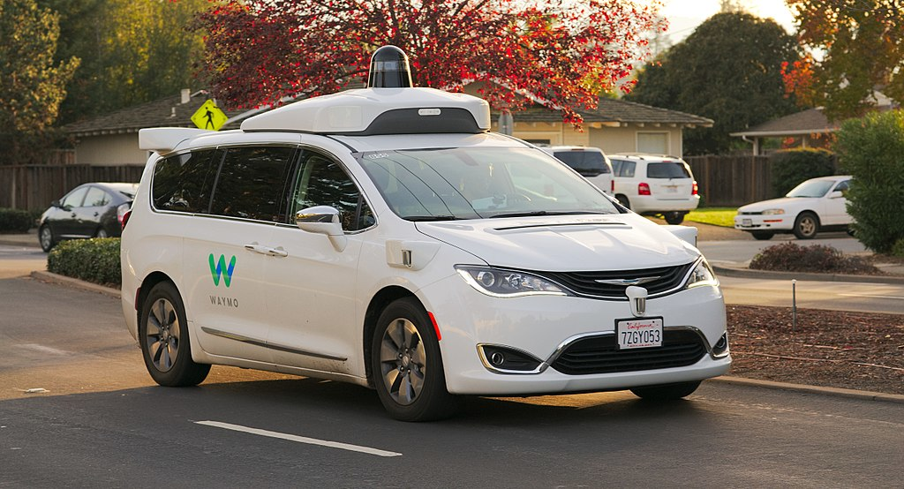
Figure 7: Waymo Chrysler Pacifica Hybrid undergoing testing in the San Francisco Bay Area.
Experiments have been conducted on automating driving since at least the 1920s; trials began in the 1950s. The first truly automated car was developed in 1977, by Japan’s Tsukuba Mechanical Engineering Laboratory. The vehicle tracked white street markers, which were interpreted by two cameras on the vehicle, using an analog computer for signal processing. The vehicle reached speeds up to 30 kilometres per hour (19 mph), with the support of an elevated rail.
Autonomous prototype cars appeared in the 1980s, with Carnegie Mellon University’s Navlab and ALV projects funded by DARPA starting in 1984 and Mercedes-Benz and Bundeswehr University Munich’s EUREKA Prometheus Project in 1987. By 1985, the ALV had demonstrated self-driving speeds on two-lane roads of 31 kilometers per hour (19 mph) with obstacle avoidance added in 1986 and off-road driving in day and nighttime conditions by 1987. From the 1960s through the second DARPA Grand Challenge in 2005, automated vehicle research in the U.S. was primarily funded by DARPA, the US Army and the U.S. Navy yielding incremental advances in speeds, driving competence in more complex conditions, controls and sensor systems. Companies and research organizations have developed prototypes.
The U.S. allocated $650 million in 1991 for research on the National Automated Highway System, which demonstrated automated driving through a combination of automation, embedded in the highway with automated technology in vehicles and cooperative networking between the vehicles and with the highway infrastructure. The program concluded with a successful demonstration in 1997 but without clear direction or funding to implement the system on a larger scale. Partly funded by the National Automated Highway System and DARPA, the Carnegie Mellon University Navlab drove 4,584 kilometers (2,848 mi) across America in 1995, 4,501 kilometers (2,797 mi) or 98% of it autonomously. Navlab’s record achievement stood unmatched for two decades until 2015 when Delphi improved it by piloting an Audi, augmented with Delphi technology, over 5,472 kilometers (3,400 mi) through 15 states while remaining in self-driving mode 99% of the time. In 2015, the US states of Nevada, Florida, California, Virginia, and Michigan, together with Washington, D.C., allowed the testing of automated cars on public roads.
In 2017, Audi stated that its latest A8 would be automated at speeds of up to 60 kilometres per hour (37 mph) using its “Audi AI.” The driver would not have to do safety checks such as frequently gripping the steering wheel. The Audi A8 was claimed to be the first production car to reach level 3 automated driving, and Audi would be the first manufacturer to use laser scanners in addition to cameras and ultrasonic sensors for their system.
In November 2017, Waymo announced that it had begun testing driverless cars without a safety driver in the driver position; however, there is still an employee in the car. In July 2018, Waymo announced that its test vehicles had traveled in automated mode for over 8,000,000 miles (13,000,000 km), increasing by 1,000,000 miles (1,600,000 kilometers) per month (Fig. ???).

Terminology
There is some inconsistency in terminology used in the self-driving car industry. Various organizations have proposed to define an accurate and consistent vocabulary. Such confusion has been documented in SAE J3016 which states that “Some vernacular usages associate autonomous specifically with full driving automation (level 5), while other usages apply it to all levels of driving automation, and some state legislation has defined it to correspond approximately to any ADS at or above level 3 (or to any vehicle equipped with such an ADS).”

Words definition and safety considerations
Modern vehicles provide partly automated features such as keeping the car within its lane, speed controls or emergency braking. Nonetheless, differences remain between a fully autonomous self-driving car on one hand and driver assistance technologies on the other hand. According to the BBC, confusion between those concepts leads to deaths.
Association of British Insurers considers the usage of the word autonomous in marketing for modern cars to be dangerous, because car ads make motorists think ‘autonomous’ and ‘autopilot’ means a vehicle can drive itself, when they still rely on the driver to ensure safety. Technology alone still is not able to drive the car.
When some car makers suggest or claim vehicles are self-driving, when they are only partly automated, drivers risk becoming excessively confident, leading to crashes, while fully self-driving cars are still a long way off in the UK.

Autonomous vs. automated
Autonomous means self-governing. Many historical projects related to vehicle automation have been automated (made automatic) subject to a heavy reliance on artificial aids in their environment, such as magnetic strips. Autonomous control implies satisfactory performance under significant uncertainties in the environment and the ability to compensate for system failures without external intervention.
One approach is to implement communication networks both in the immediate vicinity (for collision avoidance) and farther away (for congestion management). Such outside influences in the decision process reduce an individual vehicle’s autonomy, while still not requiring human intervention.
Wood et al. (2012) wrote, “This Article generally uses the term ‘autonomous,’ instead of the term ‘automated.’ ” The term “autonomous” was chosen “because it is the term that is currently in more widespread use (and thus is more familiar to the general public). However, the latter term is arguably more accurate. ‘Automated’ connotes control or operation by a machine, while ‘autonomous’ connotes acting alone or independently. Most of the vehicle concepts (that we are currently aware of) have a person in the driver’s seat, utilize a communication connection to the Cloud or other vehicles, and do not independently select either destinations or routes for reaching them. Thus, the term ‘automated’ would more accurately describe these vehicle concepts.” As of 2017, most commercial projects focused on automated vehicles that did not communicate with other vehicles or with an enveloping management regime.
Put in the words of one Nissan engineer, “A truly autonomous car would be one where you request it to take you to work and it decides to go to the beach instead.”
EuroNCAP defines autonomous in “Autonomous Emergency Braking” as: “the system acts independently of the driver to avoid or mitigate the accident.” which implies the autonomous system is not the driver.

Autonomous versus cooperative
To make a car travel without any driver embedded within the vehicle some system makers used a remote driver.
But according to SAE J3016, some driving automation systems may indeed be autonomous if they perform all of their functions independently and self-sufficiently, but if they depend on communication and/or cooperation with outside entities, they should be considered cooperative rather than autonomous.

Self-driving car
Techemergence says.
“Self-driving” is a rather vague term with a vague meaning
—?Techemergence
PC mag definition is: A computer-controlled car that drives itself. Also called an “autonomous vehicle” and “driverless car,” self-driving cars date back to the 1939 New York World’s Fair when General Motors predicted the development of self-driving, radio-controlled electric cars.
UCSUSA definition is: Self-driving vehicles are cars or trucks in which human drivers are never required to take control to safely operate the vehicle. Also known as autonomous or “driverless” cars, they combine sensors and software to control, navigate, and drive the vehicle. Currently, there are no legally operating, fully-autonomous vehicles in the United States.
NHTSA definition is: These self-driving vehicles ultimately will integrate onto U.S. roadways by progressing through six levels of driver assistance technology advancements in the coming years. This includes everything from no automation (where a fully engaged driver is required at all times), to full autonomy (where an automated vehicle operates independently, without a human driver).

Classification
A classification system based on six different levels (ranging from fully manual to fully automated systems) was published in 2014 by SAE International, an automotive standardization body, as J3016, Taxonomy and Definitions for Terms Related to On-Road Motor Vehicle Automated Driving Systems. This classification system is based on the amount of driver intervention and attentiveness required, rather than the vehicle capabilities, although these are very loosely related. In the United States in 2013, the National Highway Traffic Safety Administration (NHTSA) released a formal classification system, but abandoned this system in favor of the SAE standard in 2016. Also in 2016, SAE updated its classification, called J3016_201609.

Levels of driving automation
In SAE’s automation level definitions, “driving mode” means “a type of driving scenario with characteristic dynamic driving task requirements (e.g., expressway merging, high speed cruising, low speed traffic jam, closed-campus operations, etc.)”
Level 0: Automated system issues warnings and may momentarily intervene but has no sustained vehicle control.
Level 1 (“hands on”): The driver and the automated system share control of the vehicle. Examples are Adaptive Cruise Control (ACC), where the driver controls steering and the automated system controls speed; and Parking Assistance, where steering is automated while speed is under manual control. The driver must be ready to retake full control at any time. Lane Keeping Assistance (LKA) Type II is a further example of level 1 self-driving.
Level 2 (“hands off”): The automated system takes full control of the vehicle (accelerating, braking, and steering). The driver must monitor the driving and be prepared to intervene immediately at any time if the automated system fails to respond properly. The shorthand “hands off” is not meant to be taken literally. In fact, contact between hand and wheel is often mandatory during SAE 2 driving, to confirm that the driver is ready to intervene.
Level 3 (“eyes off”): The driver can safely turn their attention away from the driving tasks, e.g. the driver can text or watch a movie. The vehicle will handle situations that call for an immediate response, like emergency braking. The driver must still be prepared to intervene within some limited time, specified by the manufacturer, when called upon by the vehicle to do so. As an example, the 2018 Audi A8 Luxury Sedan was the first commercial car to claim to be capable of level 3 self-driving. This particular car has a so-called Traffic Jam Pilot. When activated by the human driver, the car takes full control of all aspects of driving in slow-moving traffic at up to 60 kilometers per hour (37 mph). The function works only on highways with a physical barrier separating one stream of traffic from oncoming traffic.
Level 4 (“mind off”): As level 3, but no driver attention is ever required for safety, i.e. the driver may safely go to sleep or leave the driver’s seat. Self-driving is supported only in limited spatial areas (geofenced) or under special circumstances, like traffic jams. Outside of these areas or circumstances, the vehicle must be able to safely abort the trip, i.e. park the car, if the driver does not retake control.
Level 5 (“steering wheel optional”): No human intervention is required at all. An example would be a robotic taxi.
In the formal SAE definition below, note in particular what happens in the shift from SAE 2 to SAE 3: the human driver no longer has to monitor the environment. This is the final aspect of the “dynamic driving task” that is now passed over from the human to the automated system. At SAE 3, the human driver still has the responsibility to intervene when asked to do so by the automated system. At SAE 4 the human driver is relieved of that responsibility and at SAE 5 the automated system will never need to ask for an intervention.

Legal definition
In the district of Columbia (DC) code, “Autonomous vehicle” means a vehicle capable of navigating District roadways and interpreting traffic-control devices without a driver actively operating any of the vehicle’s control systems. The term “autonomous vehicle” excludes a motor vehicle enabled with active safety systems or driver- assistance systems, including systems to provide electronic blind-spot assistance, crash avoidance, emergency braking, parking assistance, adaptive cruise control, lane-keep assistance, lane-departure warning, or traffic-jam and queuing assistance, unless the system alone or in combination with other systems enables the vehicle on which the technology is installed to drive without active control or monitoring by a human operator.
In the same district code, it is considered that:
An autonomous vehicle may operate on a public roadway; provided, that the vehicle:
- Has a manual override feature that allows a driver to assume control of the autonomous vehicle at any time;
- Has a driver seated in the control seat of the vehicle while in operation who is prepared to take control of the autonomous vehicle at any moment; and
- Is capable of operating in compliance with the District’s applicable traffic laws and motor vehicle laws and traffic control devices.

Technical challenges
The challenge for driverless car designers is to produce control systems capable of analyzing sensory data in order to provide accurate detection of other vehicles and the road ahead. Modern self-driving cars generally use Bayesian simultaneous localization and mapping (SLAM) algorithms, which fuse data from multiple sensors and an off-line map into current location estimates and map updates. Waymo has developed a variant of SLAM with detection and tracking of other moving objects (DATMO), which also handles obstacles such as cars and pedestrians. Simpler systems may use roadside real-time locating system (RTLS) technologies to aid localization. Typical sensors include Lidar, stereo vision, GPS and IMU. Udacity is developing an open-source software stack. Control systems on automated cars may use Sensor Fusion, which is an approach that integrates information from a variety of sensors on the car to produce a more consistent, accurate, and useful view of the environment.
Driverless vehicles require some form of machine vision for the purpose of visual object recognition. Automated cars are being developed with deep neural networks, a type of deep learning architecture with many computational stages, or levels, in which neurons are simulated from the environment that activate the network. The neural network depends on an extensive amount of data extracted from real-life driving scenarios, enabling the neural network to “learn” how to execute the best course of action.
In May 2018, researchers from MIT announced that they had built an automated car that can navigate unmapped roads. Researchers at their Computer Science and Artificial Intelligence Laboratory (CSAIL) have developed a new system, called MapLite, which allows self-driving cars to drive on roads that they have never been on before, without using 3D maps. The system combines the GPS position of the vehicle, a “sparse topological map” such as OpenStreetMap, (i.e. having 2D features of the roads only), and a series of sensors that observe the road conditions.

Human factor challenges
Alongside the many technical challenges that autonomous cars face, there exist many human and social factors that may impede upon the wider uptake of the technology. As things become more automated, the human users need to have trust in the automation, which can be a challenge in itself.

Testing
Testing vehicles with varying degrees of automation can be done physically, in closed environments, on public roads (where permitted, typically with a license or permit or adhering to a specific set of operating principles) or virtually, i.e. in computer simulations. When driven on public roads, automated vehicles require a person to monitor their proper operation and “take over” when needed. Apple is currently testing self-driven cars, and has increased the number of test vehicles from 3 to 27 in January 2018, and to 45 in March 2018.
One way to assess the progress of automated vehicles is to compute the average distance driven between “disengagements”, when the automated system is turned off, typically by a human driver. In 2017, Waymo reported 63 disengagements over 352,545 miles (567,366 km) of testing, or 5,596 miles (9,006 km) on average, the highest among companies reporting such figures. Waymo also traveled more distance in total than any other. Their 2017 rate of 0.18 disengagements per 1,000 miles (1,600 km) was an improvement from 0.2 disengagements per 1,000 miles (1,600 km) in 2016 and 0.8 in 2015. In March, 2017, Uber reported an average of 0.67 miles (1.08 km) per disengagement. In the final three months of 2017, Cruise Automation (now owned by GM) averaged 5,224 miles (8,407 km) per disruption over 62,689 miles (100,888 km). In July 2018, the first electric driverless racing car “Robocar” completed 1.8 kilometers track, using its navigation system and artificial intelligence (Table 1).

Table 1: Self-driving car testing results.
Maker | Distance between disengagements | Distance
BMW | 638 miles (1027 km) | 638 miles (1027 km)
Bosch | 0.68 miles (1.09 km) | 983 miles (1582 km)
Delphi Automotive Systems | 14.9 miles (24.0 km) | 2658 miles (4278 km)
Ford | 196.6 miles (316.4 km) | 590 miles (950 km)
General Motors | 54.7 miles (88.0 km) | 8156 miles (13126 km)
Mercedes Benz | 2 miles (3.2 km) | 673 miles (1083 km)
Nissan | 263.3 miles (423.7 km) | 6056 miles (9746 km)
Tesla | 2.9 miles (4.7 km) | 550 miles (890 km)
Waymo | 5127.9 miles (8252.6 km) | 635868 miles (1023330 km)

Fields of application

Automated trucks
Several companies are said to be testing automated technology in semi trucks. Otto, a self-driving trucking company that was acquired by Uber in August 2016, demonstrated their trucks on the highway before being acquired. In May 2017, San Francisco-based startup Embark announced a partnership with truck manufacturer Peterbilt to test and deploy automated technology in Peterbilt’s vehicles. Waymo has also said to be testing automated technology in trucks, however no timeline has been given for the project.
In March 2018, Starsky Robotics, the San Francisco-based automated truck company, completed a 7-mile (11 km) fully driverless trip in Florida without a single human in the truck. Starsky Robotics became the first player in the self-driving truck game to drive in fully automated mode on a public road without a person in the cab. In Europe, the truck Platooning is considered with the Safe Road Trains for the Environment approach.Vehicular automation also covers other kinds of vehicles such as Buses, Trains, Trucks. Lockheed Martin with funding from the U.S. Army developed an automated truck convoying system that uses a lead truck operated by a human driver with a number of trucks following autonomously. Developed as part of the Army’s Autonomous Mobility Applique System (AMAS), the system consists of an automated driving package that has been installed on more than nine types of vehicles and has completed more than 55,000 hours of driving at speeds up to 64 kilometres per hour (40 mph) as of 2014. As of 2017 the Army was planning to field 100-200 trucks as part of a rapid-fielding program.

Transport systems
In Europe, cities in Belgium, France, Italy and the UK are planning to operate transport systems for automated cars, and Germany, the Netherlands, and Spain have allowed public testing in traffic. In 2015, the UK launched public trials of the LUTZ Pathfinder automated pod in Milton Keynes. Beginning in summer 2015, the French government allowed PSA Peugeot-Citroen to make trials in real conditions in the Paris area. The experiments were planned to be extended to other cities such as Bordeaux and Strasbourg by 2016. The alliance between French companies THALES and Valeo (provider of the first self-parking car system that equips Audi and Mercedes premi) is testing its own system. New Zealand is planning to use automated vehicles for public transport in Tauranga and Christchurch.
In China, Baidu and King Long produce automated minibus, a vehicle with 14 seats, but without driving seat. With 100 vehicles produced, 2018 will be the first year with commercial automated service in China. Those minibuses should be at level 4, that is driverless in closed roads.

Potential advantages

Safety
Driving safety experts predict that once driverless technology has been fully developed, traffic collisions (and resulting deaths and injuries and costs), caused by human error, such as delayed reaction time, tailgating, rubbernecking, and other forms of distracted or aggressive driving should be substantially reduced. Consulting firm McKinsey & Company estimated that widespread use of autonomous vehicles could “eliminate 90% of all auto accidents in the United States, prevent up to US$190 billion in damages and health-costs annually and save thousands of lives.”
According to motorist website “TheDrive.com” operated by Time magazine, none of the driving safety experts they were able to contact were able to rank driving under an autopilot system at the time (2017) as having achieved a greater level of safety than traditional fully hands-on driving, so the degree to which these benefits asserted by proponents will manifest in practice cannot be assessed. Confounding factors that could reduce the net effect on safety may include unexpected interactions between humans and partly or fully automated vehicles, or between different types of vehicle system; complications at the boundaries of functionality at each automation level (such as handover when the vehicle reaches the limit of its capacity); the effect of the bugs and flaws that inevitably occur in complex interdependent software systems; sensor or data shortcomings; and successful compromise by malicious interveners.

Welfare
Automated cars could reduce labor costs; relieve travelers from driving and navigation chores, thereby replacing behind-the-wheel commuting hours with more time for leisure or work; and also would lift constraints on occupant ability to drive, distracted and texting while driving, intoxicated, prone to seizures, or otherwise impaired. For the young, the elderly, people with disabilities, and low-income citizens, automated cars could provide enhanced mobility. The removal of the steering wheel—along with the remaining driver interface and the requirement for any occupant to assume a forward-facing position—would give the interior of the cabin greater ergonomic flexibility. Large vehicles, such as motorhomes, would attain appreciably enhanced ease of use.

Traffic
Additional advantages could include higher speed limits; smoother rides; and increased roadway capacity; and minimized traffic congestion, due to decreased need for safety gaps and higher speeds. Currently, maximum controlled-access highway throughput or capacity according to the U.S. Highway Capacity Manual is about 2,200 passenger vehicles per hour per lane, with about 5% of the available road space is taken up by cars. One study estimated that automated cars could increase capacity by 273% (~8,200 cars per hour per lane). The study also estimated that with 100% connected vehicles using vehicle-to-vehicle communication, capacity could reach 12,000 passenger vehicles per hour (up 445% from 2,200 pc/h per lane) traveling safely at 120 km/h (75 mph) with a following gap of about 6 m (20 ft) of each other. Currently, at highway speeds drivers keep between 40 to 50 m (130 to 160 ft) away from the car in front. These increases in highway capacity could have a significant impact in traffic congestion, particularly in urban areas, and even effectively end highway congestion in some places. The ability for authorities to manage traffic flow would increase, given the extra data and driving behavior predictability combined with less need for traffic police and even road signage.

Lower costs
Safer driving is expected to reduce the costs of vehicle insurance. Reduced traffic congestion and the improvements in traffic flow due to widespread use of automated cars will also translate into better fuel efficiency. Additionally, self-driving cars will be able to accelerate and brake more efficiently, meaning higher fuel economy from reducing wasted energy typically associated with inefficient changes to speed (energy typically lost due to friction, in the form of heat and sound).

Parking space
Manually driven vehicles are reported to be used only 4-5% time, and being parked and unused for the remaining 95-96% of the time. Autonomous vehicles could, on the other hand, be used continuously after it has reached its destination. This could dramatically reduce the need for parking space. For example, in Los Angeles, 14% of the land is used for parking alone, equivalent to some 17,020,594 square meters. This combined with the potential reduced need for road space due to improved traffic flow, could free up tremendous amounts of land in urban areas, which could then be used for parks, recreational areas, buildings, among other uses; making cities more livable.

Related effects
By reducing the (labor and other) cost of mobility as a service, automated cars could reduce the number of cars that are individually owned, replaced by taxi/pooling and other car sharing services. This would also dramatically reduce the size of the automotive production industry, with corresponding environmental and economic effects. Assuming the increased efficiency is not fully offset by increases in demand, more efficient traffic flow could free roadway space for other uses such as better support for pedestrians and cyclists.
The vehicles’ increased awareness could aid the police by reporting on illegal passenger behavior, while possibly enabling other crimes, such as deliberately crashing into another vehicle or a pedestrian. However, this may also lead to much expanded mass surveillance if there is wide access granted to third parties to the large data sets generated. The future of passenger rail transport in the era of automated cars is not clear.

Potential limits or obstacles
The sort of hoped-for potential benefits from increased vehicle automation described may be limited by foreseeable challenges, such as disputes over liability (will each company operating a vehicle accept that they are its “driver” and thus responsible for what their car does, or will some try to project this liability onto others who are not in control?), the time needed to turn over the existing stock of vehicles from non-automated to automated, and thus a long period of humans and autonomous vehicles sharing the roads, resistance by individuals to having to forfeit control of their cars, concerns about the safety of driverless in practice, and the implementation of a legal framework and consistent global government regulations for self-driving cars. Other obstacles could include de-skilling and lower levels of driver experience for dealing with potentially dangerous situations and anomalies, ethical problems where an automated vehicle’s software is forced during an unavoidable crash to choose between multiple harmful courses of action (‘the trolley problem’), concerns about making large numbers of people currently employed as drivers unemployed (at the same time as many other alternate blue collar occupations may be undermined by automation), the potential for more intrusive mass surveillance of location, association and travel as a result of police and intelligence agency access to large data sets generated by sensors and pattern-recognition AI (making anonymous travel difficult), and possibly insufficient understanding of verbal sounds, gestures and non-verbal cues by police, other drivers or pedestrians.
Possible technological obstacles for automated cars are:
- artificial Intelligence is still not able to function properly in chaotic inner-city environments,
- a car’s computer could potentially be compromised, as could a communication system between cars,
- susceptibility of the car’s sensing and navigation systems to different types of weather (such as snow) or deliberate interference, including jamming and spoofing,
- avoidance of large animals requires recognition and tracking, and Volvo found that software suited to caribou, deer, and elk was ineffective with kangaroos,
- autonomous cars may require very high-quality specialized maps to operate properly. Where these maps may be out of date, they would need to be able to fall back to reasonable behaviors,
- competition for the radio spectrum desired for the car’s communication,
- field programmability for the systems will require careful evaluation of product development and the component supply chain,
- current road infrastructure may need changes for automated cars to function optimally,
- discrepancy between people’s beliefs of the necessary government intervention may cause a delay in accepting automated cars on the road. Whether the public desires no change in existing laws, federal regulation, or another solution; the framework of regulation will likely result in differences of opinion,
- employment - Companies working on the technology have an increasing recruitment problem in that the available talent pool has not grown with demand. As such, education and training by third party organizations such as providers of online courses and self-taught community-driven projects such as DIY Robocars and Formula Pi have quickly grown in popularity, while university level extra-curricular programmers such as Formula Student Driverless have bolstered graduate experience. Industry is steadily increasing freely available information sources, such as code, datasets and glossaries to widen the recruitment pool.

Potential disadvantages
A direct impact of widespread adoption of automated vehicles is the loss of driving-related jobs in the road transport industry. There could be resistance from professional drivers and unions who are threatened by job losses. In addition, there could be job losses in public transit services and crash repair shops. The automobile insurance industry might suffer as the technology makes certain aspects of these occupations obsolete. A frequently cited paper by Michael Osborne and Carl Benedikt Frey found that automated cars would make many jobs redundant.
Privacy could be an issue when having the vehicle’s location and position integrated into an interface in which other people have access to. In addition, there is the risk of automotive hacking through the sharing of information through V2V (Vehicle to Vehicle) and V2I (Vehicle to Infrastructure) protocols. There is also the risk of terrorist attacks. Self-driving cars could potentially be loaded with explosives and used as bombs.
The lack of stressful driving, more productive time during the trip, and the potential savings in travel time and cost could become an incentive to live far away from cities, where land is cheaper, and work in the city’s core, thus increasing travel distances and inducing more urban sprawl, more fuel consumption and an increase in the carbon footprint of urban travel. There is also the risk that traffic congestion might increase, rather than decrease. Appropriate public policies and regulations, such as zoning, pricing, and urban design are required to avoid the negative impacts of increased suburbanization and longer distance travel.
Some believe that once automation in vehicles reaches higher levels and becomes reliable, drivers will pay less attention to the road. Research shows that drivers in automated cars react later when they have to intervene in a critical situation, compared to if they were driving manually. Depending on the capabilities of automated vehicles and the frequency with which human intervention is needed, this may counteract any increase in safety, as compared to all-human driving, that may be delivered by other factors.
Ethical and moral reasoning come into consideration when programming the software that decides what action the car takes in an unavoidable crash; whether the automated car will crash into a bus, potentially killing people inside; or swerve elsewhere, potentially killing its own passengers or nearby pedestrians. A question that programmers of AI systems find difficult to answer (as do ordinary people, and ethicists) is “what decision should the car make that causes the ‘smallest’ damage to people’s lives?”
The ethics of automated vehicles are still being articulated, and may lead to controversy. They may also require closer consideration of the variability, context-dependency, complexity and non-deterministic nature of human ethics. Different human drivers make various ethical decisions when driving, such as avoiding harm to themselves, or putting themselves at risk to protect others. These decisions range from rare extremes such as self-sacrifice or criminal negligence, to routine decisions good enough to keep the traffic flowing but bad enough to cause accidents, road rage and stress.
Human thought and reaction time may sometimes be too slow to detect the risk of an upcoming fatal crash, think through the ethical implications of the available options, or take an action to implement an ethical choice. Whether a particular automated vehicle’s capacity to correctly detect an upcoming risk, analyze the options or choose a ‘good’ option from among bad choices would be as good or better than a particular human’s may be difficult to predict or assess. This difficulty may be in part because the level of automated vehicle system understanding of the ethical issues at play in a given road scenario, sensed for an instant from out of a continuous stream of synthetic physical predictions of the near future, and dependent on layers of pattern recognition and situational intelligence, may be opaque to human inspection because of its origins in probabilistic machine learning rather than a simple, plain English ‘human values’ logic of parsable rules. The depth of understanding, predictive power and ethical sophistication needed will be hard to implement, and even harder to test or assess.
The scale of this challenge may have other effects. There may be few entities able to marshal the resources and AI capacity necessary to meet it, as well as the capital necessary to take an automated vehicle system to market and sustain it operationally for the life of a vehicle, and the legal and ‘government affairs’ capacity to deal with the potential for liability for a significant proportion of traffic accidents. This may have the effect of narrowing the number of different system operators, and eroding the presently quite diverse global vehicle market down to a small number of system suppliers.

Cloud computing
The evolution of cloud computing over the past few years is potentially one of the major advances in the history of computing. However, if cloud computing is to achieve its potential, there needs to be a clear understanding of the various issues involved, both from the perspectives of the providers and the consumers of the technology. While a lot of research is currently taking place in the technology itself, there is an equally urgent need for understanding the business-related issues surrounding cloud computing. In this article, we identify the strengths, weaknesses, opportunities and threats for the cloud computing industry. We then identify the various issues that will affect the different stakeholders of cloud computing. We also issue a set of recommendations for the practitioners who will provide and manage this technology. For IS researchers, we outline the different areas of research that need attention so that we are in a position to advice the industry in the years to come. Finally, we outline some of the key issues facing governmental agencies who, due to the unique nature of the technology, will have to become intimately involved in the regulation of cloud computing.

Cloud computing characteristics and benefits
Cloud computing is a general term for the delivery of hosted services over the internet. Cloud computing enables companies to consume a compute resource, such as a virtual machine (VM), storage or an application, as a utility - just like electricity - rather than having to build and maintain computing infrastructures in house.
Cloud computing boasts several attractive benefits for businesses and end users. Five of the main benefits of cloud computing are:
- self-service provisioning: end users can spin up compute resources for almost any type of workload on demand. This eliminates the traditional need for IT administrators to provision and manage compute resources,
- elasticity: companies can scale up as computing needs increase and scale down again as demands decrease. This eliminates the need for massive investments in local infrastructure, which may or may not remain active
- pay per use: compute resources are measured at a granular level, enabling users to pay only for the resources and workloads they use,
- workload resilience: cloud service providers often implement redundant resources to ensure resilient storage and to keep users’ important workloads running – often across multiple global regions,
- migration flexibility: organizations can move certain workloads to or from the cloud - or to different cloud platforms - as desired or automatically for better cost savings or to use new services as they emerge.

Cloud computing deployment models
Cloud computing services can be private, public or hybrid.
Private cloud services are delivered from a business’s data center to internal users. This model offers the versatility and convenience of the cloud, while preserving the management, control and security common to local data centers. Internal users may or may not be billed for services through IT chargeback.
Common private cloud technologies and vendors include VMware and OpenStack. In the public cloud model, a third-party cloud service provider delivers the cloud service over the internet. Public cloud services are sold on demand, typically by the minute or hour, though long-term commitments are available for many services. Customers only pay for the CPU cycles, storage or bandwidth they consume.
Leading public cloud service providers include Amazon Web Services (AWS), Microsoft Azure, IBM and Google Cloud Platorm.
A hybrid cloud is a combination of public cloud services and an on-premises private cloud, with orchestration and automation between the two. Companies can run mission-critical workloads or sensitive applications on the private cloud and use the public cloud to handle workload bursts or spikes in demand. The goal of a hybrid cloud is to create a unified, automated, scalable environment that takes advantage of all that a public cloud infrastructure can provide, while still maintaining control over mission-critical data.
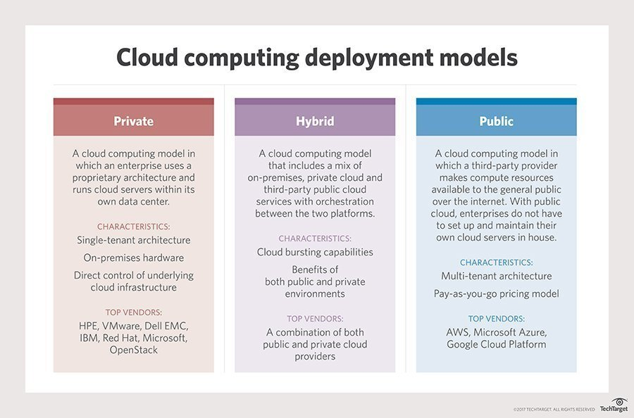
Figure 8: Main cloud deployment models.
In addition, organizations are increasingly embracing a multicloud model, or the use of multiple infrastructure-as-a-service providers. This enables applications to migrate between different cloud providers or to even operate concurrently across two or more cloud providers.
Organizations adopt multicloud for various reasons. For example, they could do so to minimize the risk of a cloud service outage or to take advantage of more competitive pricing from a particular provider.
Multicloud implementation and application development can be a challenge because of the differences between cloud providers’ services and application program interfaces (APIs). Multicloud deployments should become easier, however, as providers’ services and APIs converge and become more homogeneous through industry initiatives such as the Open Cloud Computing Interface.

Types of cloud computing services
Although cloud computing has changed over time, it has been divided into three broad service categories: infrastructure as a service (IaaS), platform as a service (PaaS) and software as a service (Saas).
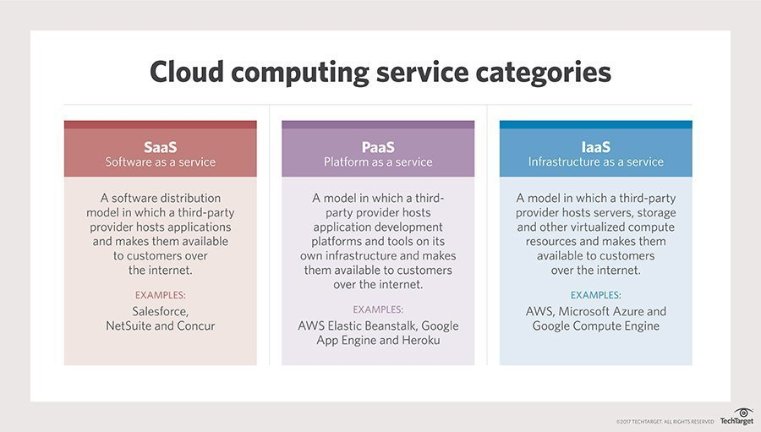
Figuer 9: Cloud servisce a categories.
IaaS providers, such as AWS, supply a virtual server instance and storage, as well as APIs that enable users to migrate workloads to a VM. Users have an allocated storage capacity and can start, stop, access and configure the VM and storage as desired. IaaS providers offer small, medium, large, extra-large and memory- or compute-optimized instances, in addition to customized instances, for various workload needs.
In the PaaS model, cloud providers host development tools on their infrastructures. Users access these tools over the internet using APIs, web portals or gateway software. PaaS is used for general software development, and many PaaS providers host the software after it’s developed. Common PaaS providers include Salesforce’s Force.com, AWS Elastic Beanstalk and Google App Engine.
SaaS is a distribution model that delivers software applications over the internet; these applications are often called web services. Users can access SaaS applications and services from any location using a computer or mobile device that has internet access. One common example of a SaaS application is Microsoft Office 365 for productivity and email services.

Emerging cloud technologies and services
Cloud providers are competitive, and they constantly expand their services to differentiate themselves. This has led public IaaS providers to offer far more than common compute and storage instances.
For example, serverless, or event-driven computing is a cloud service that executes specific functions, such as image processing and database updates. Traditional cloud deployments require users to establish a compute instance and load code into that instance. Then, the user decides how long to run – and pay for – that instance.
With serverless computing, developers simply create code, and the cloud provider loads and executes that code in response to real-world events, so users don’t have to worry about the server or instance aspect of the cloud deployment. Users only pay for the number of transactions that the function executes. AWS Lambda, Google Cloud Functions and Azure Functions are examples of serverless computing services.
Public cloud computing also lends itself well to big data processing, which demands enormous compute resources for relatively short durations. Cloud providers have responded with big data services, including Google BigQuery for large-scale data warehousing and Microsoft Azure Data Lake Analytics for processing huge data sets.
Another crop of emerging cloud technologies and services relates to artificial intelligence (AI) and machine learning. These technologies build machine understanding, enable systems to mimic human understanding and respond to changes in data to benefit the business. Amazon Machine Learning, Amazon Lex, Amazon Polly, Google Cloud Machine Learning Engine and Google Cloud Speech API are examples of these services.

Cloud computing security
Security remains a primary concern for businesses contemplating cloud adoption – especially public cloud adoption. Public cloud service providers share their underlying hardware infrastructure between numerous customers, as public cloud is a multi-tenant environment. This environment demands copious isolation between logical compute resources. At the same time, access to public cloud storage and compute resources is guarded by account login credentials.
Many organizations bound by complex regulatory obligations and governance standards are still hesitant to place data or workloads in the public cloud for fear of outages, loss or theft. However, this resistance is fading, as logical isolation has proven reliable, and the addition of data encyption and various identity and access management tools has improved security within the public cloud.

A brief history of cloud computing
Cloud computing traces its origins back to the 1960s, when the computer industry recognized the potential benefits of delivering computing as a service or a utility. However, early computing lacked the connectivity and bandwidth needed to implement computing as a utility. It wasn’t until the broad availability of internet bandwidth in the late 1990s that computing as a service became practical.
Grid and Cloud Computing Simulation Tools

Table 2: Cloud computing providers comparison.
CLOUD PROVIDER | CLOUD TYPE | PROVIDED SERVICES | COSTS
AMAZON | public | IaaS, PaaS, Saas | per hour, storage usage, data transfer
MICROSOFT | public | IaaS, PaaS, Saas | subscription, storage usage, data transfer, CPU usage
SALESFORCE | private and public | PaaS, SaaS | registration, unlimited resource usage

References
Brian Wang. Uber’ self-driving system was still 400 times worse [than] Waymo in 2018 on key distance
intervention metric. NextBigFuture.com, 2018.

