Motion of a Triple Rod Pendulum
Harman
Nick Nelson
A Lagrangian approach to the triple pendulum is utilized to derive the equations of motion. Linearization of the Lagrangian near its stable equilibrium yields tractable equations of motion. The system’s behavior is characterized by solving the matrix equation for its eigenfrequencies and eigenvectors. A python program, provided by Dr. Nelson, is utilized to model and plot the system behavior near its eigenfrequencies. A driving frequency near the eigenfrequency results in the system rapidly increasing in amplitude because of resonance. The steady-state solution of the system near its eigenfrequency results in beats. The beat frequency increases as the driving frequency deviates from the eigenfrequency slightly.

Introduction
The triple pendulum is a holonomic system with 3 degrees of freedom. It consists of 3 identical point masses of mass m joined by massless rigid rods of length L. The rods have friction-less pivots allowing them freely rotate in the plane. It is one of simplest systems that exhibits chaos. I, Harman Khinda, utilize the Langrangian approach, to investigate and characterize the triple pendulum. First the system’s kinetic, T, and potential energy, U, are constructed.
Linearization allows for a tractable solution to the resulting eigenvalue problem. A driving term of the form $Asin(ωt)$ is added, and Python is utilized to plot the systems behavior. We will utilize the full nonlinear equations of motion and plot them over a range times and driving frequencies near the system’s normal modes.
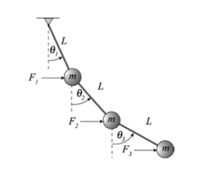
The famous triple Rod penudlum

Derivation
$L=T−U$
The Cartesian coordinates of the three masses are:
$$\begin{matrix}x_{1}=Lsin(θ_{1}) \\ x_{2}=x_{1}+Lsin(θ_{2}) \\ x_{3}=x_{2}+Lsin(θ_{3}) \\ \\ y_{1}=Lcos(θ_{1}) \\ y_{2}=x_{1}+Lcos(θ_{2}) \\ y_{3}=x_{2}+Lcos(θ_{3})\end{matrix}$$
By inspection the potential energy is:
$$U=mgL(1−cos(θ_{1}))+mgL((1−cos(θ_{1}))+(1−cos(θ_{2}))$$
$$+mgL((1−cos(θ_{1}))+(1−cos(θ_{2}))+(1−cos(θ_{3})))$$
$$g≡9.8$$
The stable equilibrium occurs is when the pendulum completely vertical, $θ_{i}=0$. Substituting in a small angle approximation , $1−cos(θ_{1})≈\frac{θ^{2}}{2}$, allows us to linearize the equation, with respect to force, around the stable equilibrium. This is when the pendulum is completely vertical, by inspection the linearized potential energy is:
$$U=mgL[(\frac{θ_{1}^{2}}{2})+(\frac{θ_{1}^{2}}{2}+\frac{θ_{2}^{2}}{2})+(\frac{θ_{1}^{2}}{2}+\frac{θ_{2}^{2}}{2}+\frac{θ_{3}^{2}}{2})]=mgl[3(\frac{θ_{1}^{2}}{2})+2(\frac{θ_{2}^{2}}{2})+1(\frac{θ_{3}^{2}}{2})]$$
The kinetic energy is first written in Cartesian and then the re-expressed in our natural coordinates, $θ_{i}$ :
$$\begin{matrix}T=\frac{1}{2}m(\overset{̇}{x_{1}^{2}}+\overset{̇}{y_{1}^{2}}+\overset{̇}{x_{2}^{2}}+\overset{̇}{y_{2}^{2}}+\overset{̇}{x_{3}^{2}}+\overset{̇}{y_{3}^{2}}) \\ =\frac{1}{2}mL^{2}[3{\overset{̇}{θ_{1}}}^{2}+2{\overset{̇}{θ_{2}}}^{2}+{\overset{̇}{θ_{3}}}^{2}+4cos(θ_{1}−θ_{2})\overset{̇}{θ_{1}}\overset{̇}{θ_{2}} \\ +2cos(θ_{1}−θ_{2})\overset{̇}{θ_{1}}\overset{̇}{θ_{2}}++2cos(θ_{2}−θ_{3})\overset{̇}{θ_{2}}\overset{̇}{θ_{3}}]\end{matrix}$$
To linearize T we can just set $cos(θ_{i}−θ_{j})=1$
$$\begin{matrix}T=\frac{1}{2}mL^{2}[3{\overset{̇}{θ_{1}}}^{2}+2{\overset{̇}{θ_{2}}}^{2}+{\overset{̇}{θ_{3}}}^{2}+4\overset{̇}{θ_{1}}\overset{̇}{θ_{2}}+2\overset{̇}{θ_{1}}\overset{̇}{θ_{2}}++2\overset{̇}{θ_{2}}\overset{̇}{θ_{3}}]\end{matrix}$$
$$\begin{matrix}L=\frac{1}{2}mL^{2}[3{\overset{̇}{θ_{1}}}^{2}+2{\overset{̇}{θ_{2}}}^{2}+{\overset{̇}{θ_{3}}}^{2}+4cos(θ_{1}−θ_{2})\overset{̇}{θ_{1}}\overset{̇}{θ_{2}}+2cos(θ_{1}−θ_{2})\overset{̇}{θ_{1}}\overset{̇}{θ_{2}}++2cos(θ_{2}−θ_{3})\overset{̇}{θ_{2}}\overset{̇}{θ_{3}}] \\ −mgL[3(1−cos(θ_{1}))+2(1−cos(θ_{2}))+(1−cos(θ_{3})] \\ ≈\frac{1}{2}mL^{2}[3{\overset{̇}{θ_{1}}}^{2}+2{\overset{̇}{θ_{2}}}^{2}+{\overset{̇}{θ_{3}}}^{2}+4\overset{̇}{θ_{1}}\overset{̇}{θ_{2}}+2\overset{̇}{θ_{1}}\overset{̇}{θ_{2}}++2\overset{̇}{θ_{2}}\overset{̇}{θ_{3}}]−mgL[3(\frac{θ_{1}^{2}}{2})+2(\frac{θ_{2}^{2}}{2})+1(\frac{θ_{3}^{2}}{2})]\end{matrix}$$
The 3 Euler-Lagrange equations are:
$$\frac{∂L}{∂θ_{1}}=\frac{∂}{∂t}\frac{∂L}{∂\overset{̇}{θ_{1}}}$$
$$\frac{∂L}{∂θ_{2}}=\frac{∂}{∂t}\frac{∂L}{∂\overset{̇}{θ_{2}}}$$
$$\frac{∂L}{∂θ_{3}}=\frac{∂}{∂t}\frac{∂L}{∂\overset{̇}{θ_{3}}}$$
Our next step could be to construct the $M$ and $K$ matrices. They are the generalized mass and generalized spring coefficient matrices. The matrices must satisfy this generalized harmonic matrix equation: $M\overset{̈}{Φ_{2}}=−KΦ$ equation. We could get the matrix elements directly from $T$ and $U$ we constructed earlier. Both the M and K matrices are symmetric and their values come from T and U respectively. For M the diagonal elements will be those of the form $a*{\overset{̇}{θ_{i}}}^{2}$ and the off diagonal ones will be those with cross terms looking of the form $a*\overset{̇}{θ_{i}}\overset{̇}{θ_{j}}$, where $a$ is the value entered in the matrix. These are to be put in their corresponding elements of the matrix, $M_{(i=j,j=i)}$, $M_{(i,j)}$ and $M_{(j,i)}$. The K matrix, which gets it’s values from U, will have only diagonal terms of the from $2aθ_{i}^{2}$ where $2a$ is the value entered in the matrix.

$M\overset{̈}{Φ_{2}}=−KΦ$
Thus by inspection the M matrix is:
$$M=mL^{2}\left(\begin{matrix}3 & 2 & 1 \\ 2 & 2 & 1 \\ 1 & 1 & 1\end{matrix}\right)$$
Playing the same game with the K matrix, yields:
$$K=mgl\left(\begin{matrix}3 & 0 & 0 \\ 0 & 2 & 0 \\ 0 & 0 & 1\end{matrix}\right)$$
Next we plug these matrices into our matrix equation. We utilize an ansatze of the form $Φ=\overset{⃗}{B}e^{(iωt)}$ where $\overset{⃗}{B}$ is a 3-n column vector, $\overset{⃗}{B}=<b_{1},b_{2},b_{3}>$, containing complex elements containing whose phase in the complex phase is the phase shift and amplitude the magnitude. Plugging the ansatze into the matrix-vector equation and then dividing out by $\overset{⃗}{B}e^{(iωt)}$ yields:
$$K=−ω^{2}M$$
$$K−ω^{2}M=0$$
Next non-dimensionalize K by dividing by $mgl$ on both sides. We also define the new variables: $ω_{0}^{2}≡\frac{g}{L}$ and $ω_{n}=\frac{ω^{2}}{ω_{0}^{2}}$.
$$\frac{1}{mgL}K−\frac{1}{m}ω_{n}M=0$$
Since these are square, non-singular matrices, the determinate of the left side must be zero for there to be a nontrivial solution. We are assured there is a solution since K is a diagonal matrix.
$$det(\frac{1}{gL}K−ω_{n}M)=0$$
$$=det\left(\begin{matrix}3−3ω_{n} & −2ω_{n} & −ω_{n} \\ −2ω_{n} & 2−2ω_{n} & −ω_{n} \\ −ω_{n} & −ω_{n} & 1−ω_{n}\end{matrix}\right)$$
Plugging this into Mathematica and using NSolve yields three eigenfrequinces:
$$ω_{n}=.415775,2.29428,6.28995$$
Expressing $ω^{2}$ terms of $ω_{0}^{2}$:
$$ω^{2}=.415775ω_{0}^{2},2.29428ω_{0}^{2},6.28995ω_{0}^{2}$$
To find the eigenvectors we plug the eigenfrequencies into our matrix-vector equation:
$$(K−ω^{2}M)\overset{⃗}{B}=0$$
$$=\left(\begin{matrix}3−3ω^{2} & −2ω^{2} & −ω^{2} \\ −2ω^{2} & 2−2ω^{2} & −ω^{2} \\ −ω^{2} & −ω^{2} & 1−ω^{2}\end{matrix}\right)\left[\begin{matrix}b_{1} \\ b_{2} \\ b_{3}\end{matrix}\right]$$
Setting $b_{1}=1$ and then row-reducing yields 3 eigenvectors:
$\overset{⃗}{B}$ = $<1,1.2921,1.6312>,<1,.35286,−.23981>,<1,−1.6450,.76690>$
Eigenvectors we are contain information about each normal mode behavior; and all modes can be re-written as a linear combination of these 3 eigenvectors. In the first normal mode all the masses are oscillating in phase. The bottom has the largest amplitude, the middle swings less than it and the top the least. In the second normal mode, the top two masses are in phase and the bottom is out of phase. The top mass is oscillating with the largest amplitude, a lot less amplitude for the middle mass and even less for the bottom mass. In the third normal mode the middle oscillating with the highest amplitude and the top and bottom are oscillating out of phase from it. The top mass has a lower amplitude and the bottom mass the lowest amplitude.
Setting $L=.1$, $A=1$ and setting the driving frequency to eigenfrequencies and plotting yields:
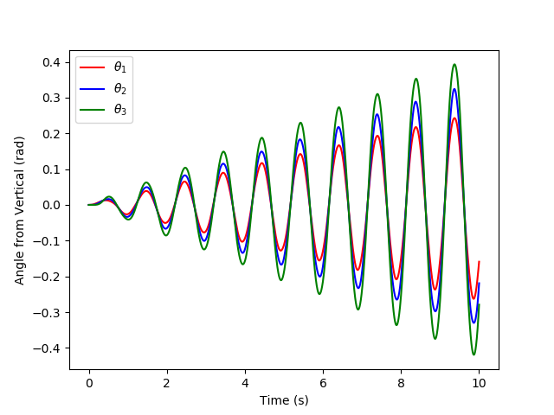
ω1^2 = 415775ω0^2
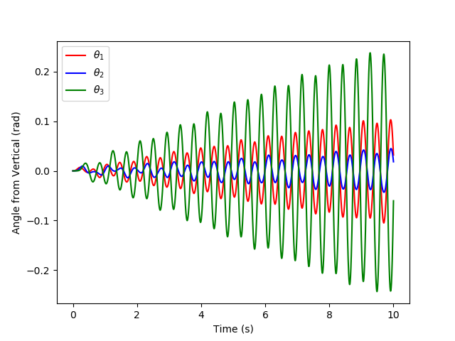
ω2^2 = 2.29428ω0^2
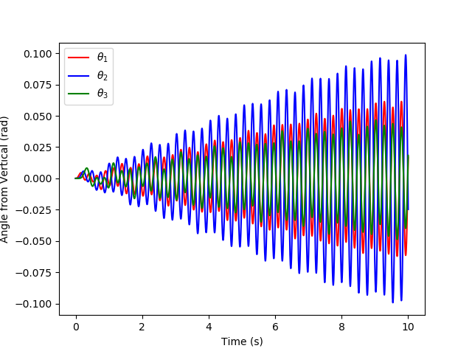
ω3^2 = 6.28995ω0^2
It can be seen that at normal modes the system’s amplitude quickly increases because it is experiencing resonance. The system’s behavior is also more smooth and the oscillation is more sinusiodial than when the system is driven further from it’s normal mode. Choosing the first eigenfrequency, $ω_{1}=(.415775ω_{0}^{2})^{.5}$ for further investigation; the following plots show the systems behavior as the driving frequency ranges from .5 $ω_{1}$ to 1.5 $ω_{1}$.
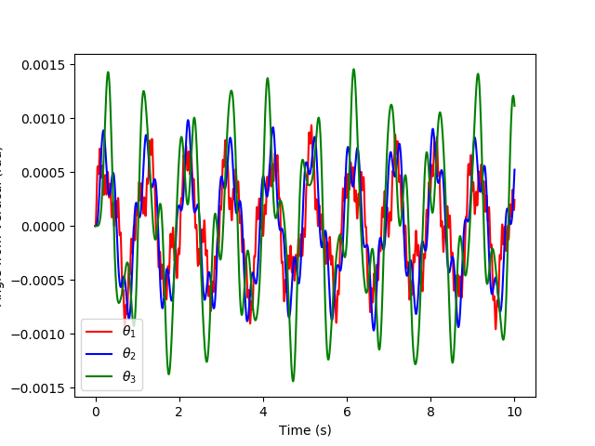
1.5ω1 very jagged
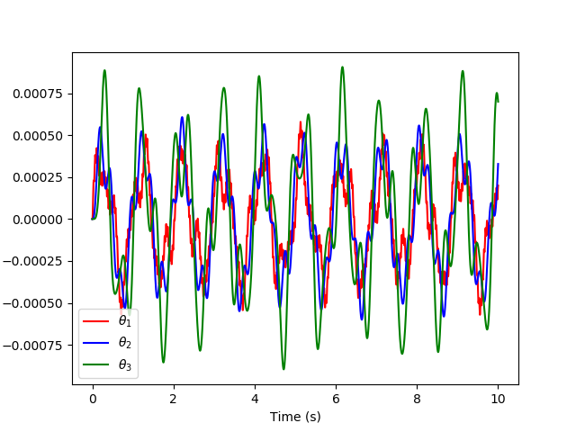
.80ω1
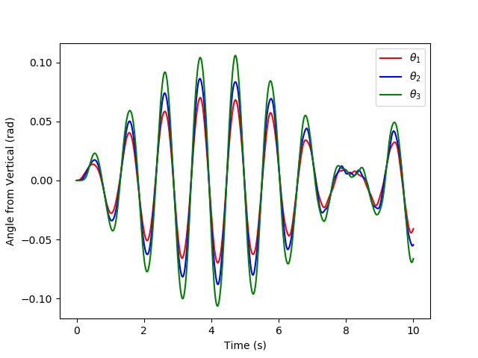
.88ω1
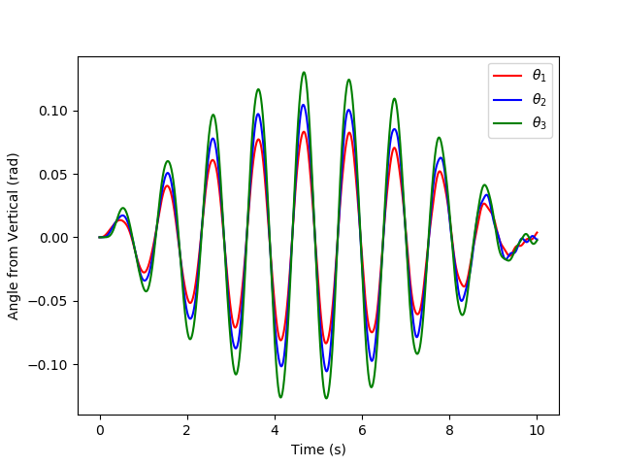
.90ω1
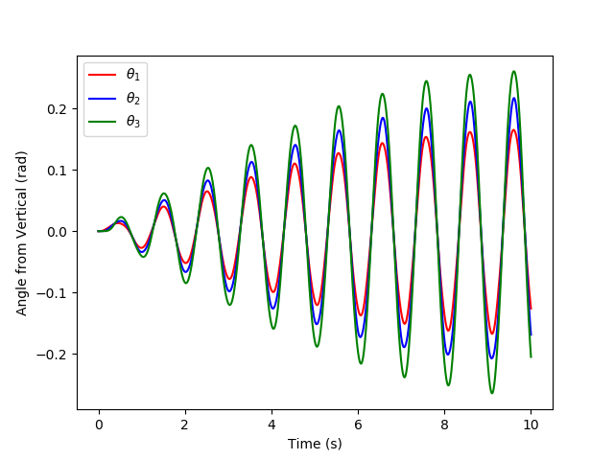
.95ω1
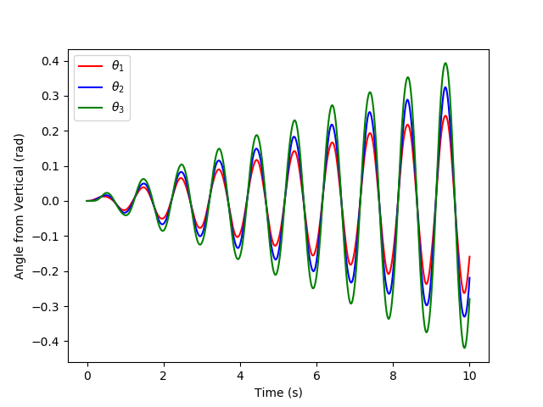
ω1
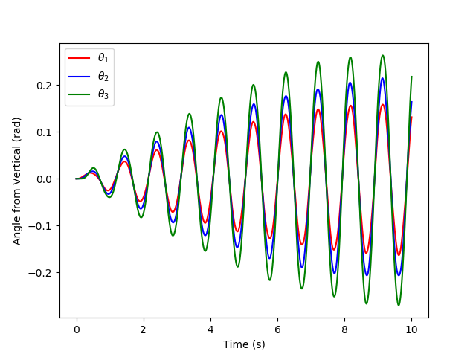
1.05ω1
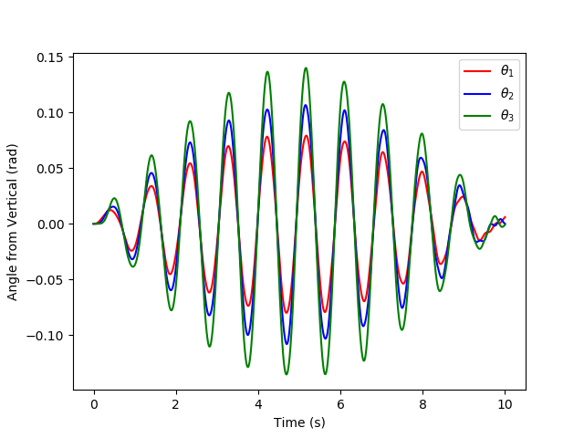
1.1ω1
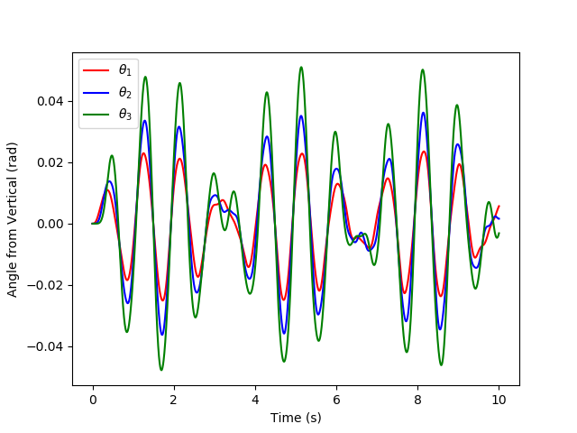
1.3ω1
You can see near the eigenfrequency the system is experiencing resonance and has a relatively high amplitude, while away from the normal frequency the system is at relatively low amplitudes. To investigate the steady state solution of the system we choose $ω_{1}$, $.95ω_{1}$ and $1.05ω_{1}$ and plot them from range $t=$ 0 to 100. The plots show that the system’s steady state behavior, is a beat pattern. You can see at 5 percent difference relative above or below $ω1$ results in the period of these transitions decreasing by relatively the same amount in each case. To investigate how amplitude effects the system’s behavior at normal modes we will set the driving frequency to $ω_{1}$ and plot the systems steady state behavior at large amplitude, $A=3,5,6$.
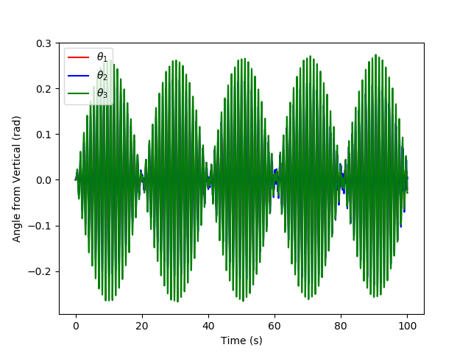
.95ω1 from t = 0 to 100
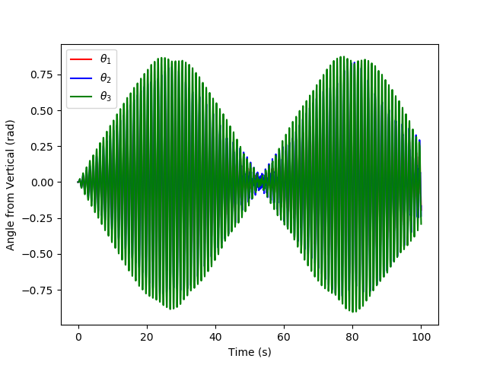
ω1 from t = 0 to 100
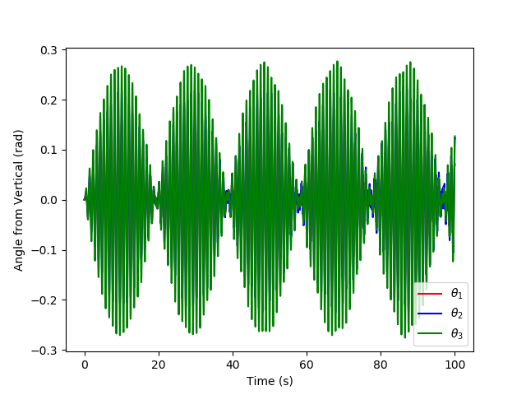
1.05ω1 from t = 0 to 100
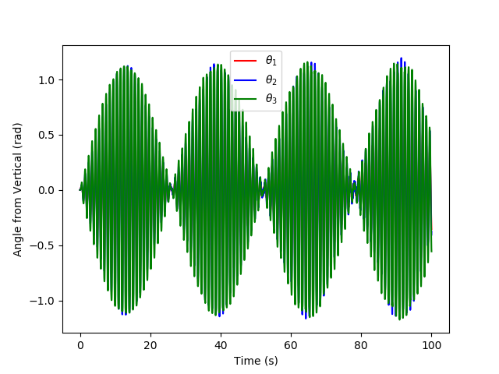
A = 3
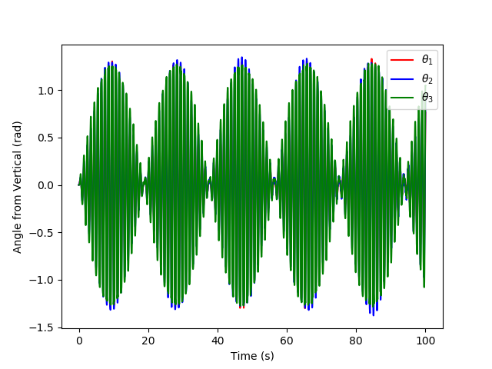
A = 5
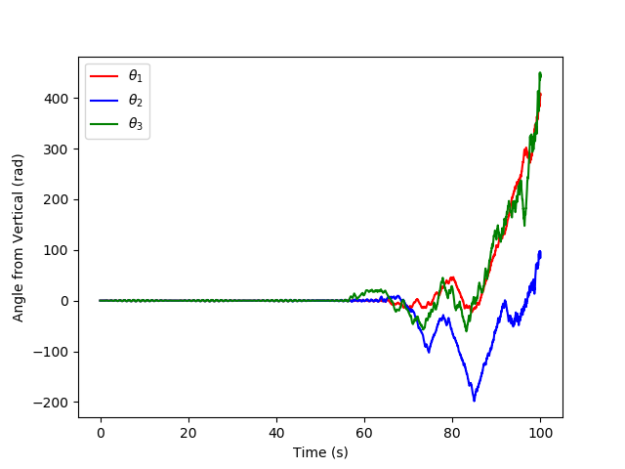
A = 6
It can be seen that increasing the driving frequency increases the beat frequency. At A=6 the pendulum goes in a runaway rotation frenzy; in this regime it’s unlikely that the small angle aproximation is holding.

Conclusion
In conclusion, the Langrangian approach combined with linearizing T and U, was utilized to find the M and K matrices. Mathematica NSolve function was used to solve the resulting eigenvalue problem. Setting the driving frequency near the eigenfrequencies leads the system to experience resonance. Investigating the long-term steady state solution of our system near $ω_{1}$ uncovers a beat behavior. A 5 percent relative change above or below $ω_{1}$ causes the period of these beats to decrease. Choosing $ω_{1}$ and increasing the driving amplitude also decreases the beat period.

