Homework 4
Sam Smith
kkeshava
lanluan
Instructor: Ben Kravitz (bkravitz@iu.edu)
Due Monday, April 8, 2019
Question 1. Using the simple climate model we discussed in class, answer the following questions:
- Set all forcing values (orange boxes in row 26) to 1. There are six parameters that can be varied: $H_{mix},T_{0},s,κ$ (kappa), $H_{deep},$ and $Td0$. Describe what each of these does in terms of global mean temperature.
- Set all forcing values to 1 and all default parameters (D16:D21) to their default values (the red values in B16:B21). Now vary equilibrium climate sensitivity (D18). What value results in the best match of the model to historical observations? Does this value of climate sensitivity fit with what you know from the literature? Why or why not?
- Set all forcing values to 1, all model parameters except equilibrium climate sensitivity to their default values, and equilibrium climate sensitivity to the value you found in part (b). Now vary the volcanic forcing factor to get the model to best match observed temperatures. What might this tell you about how much cooling there was after the 1991 eruption of Mt. Pinatubo?
- How might you vary solar forcing to represent the influence of Milankovitch cycles on the seasonal cycle of the model? Are there particular orbital forcing parameters that better enable you to match the historical temperature record?
References:
https://crudata.uea.ac.uk/~timo/teaching/simple_climate_model_exercises.pdf
https://crudata.uea.ac.uk/~timo/teaching/outcome_simple_climate_model_exercises.pdf
Soden et al. (2002), doi:10.1126/science.296.5568.727
Canty et al. (2013), doi:10.5194/acp-13-3997-2013
Sherwood et al. (2014), doi:10.1038/nature12829
http://forecast.uchicago.edu/Projects/orbit.html
(a) $H_{mix}$ - The mixed layer depth seems to have an inversely proportional relationship with global mean temperature. A deeper mixed layer results in a lower global mean temperature anomaly while a shallow mixed layer results in an increase in global mean temperature anomaly.
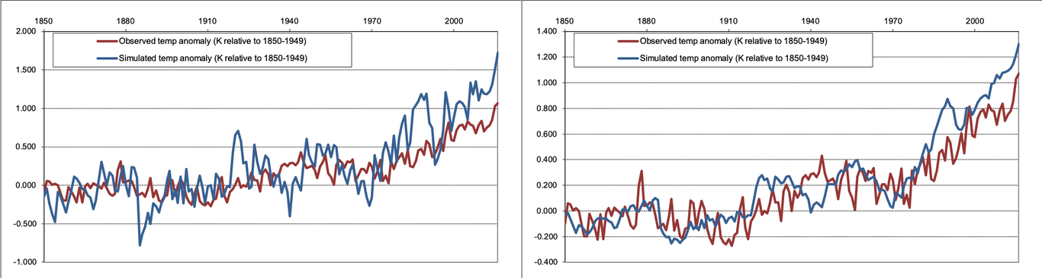
Temperature anomalies for Hmix = 20 m (left) and Hmix = 200 m(right)
$T_{0}$ - The surface/mixed layer temperature anomaly at the start of the simulation does not seem to affect the global mean temperature change as much. This could be due to the fact that the mixed layer does exactly what it sounds like and gets well mixed as a result of radiative forcing from the doubled CO2.
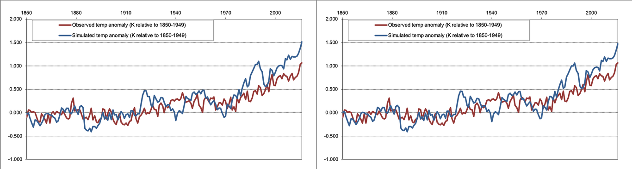
Temperature anomalies for T0 = -5K (left) and T0 = 5K m(right)
$S$ – The equilibrium climate sensitivity results in the model having a really low to no temperature anomaly in a global mean sense while a higher sensitivity results in a really warm atmosphere. The result is quite simple since climate sensitivity is the amount of warming we get for a CO2 scenario.
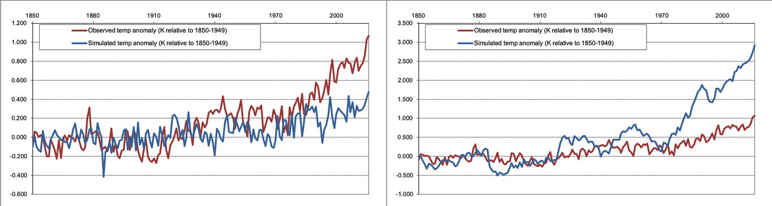
Temperature anomalies for s = 0.5 m (left) and s = 10 m(right)
$κ$ – The diffusivity between the mixed layer and deep ocean layer seems to have a big impact on the global mean temperature change based on the results of this model. The better the diffusivity, the better the exchange of heat fluxes between the mixed layer and the deep ocean and as a result, the overall increase of the global mean temperature is quite low.
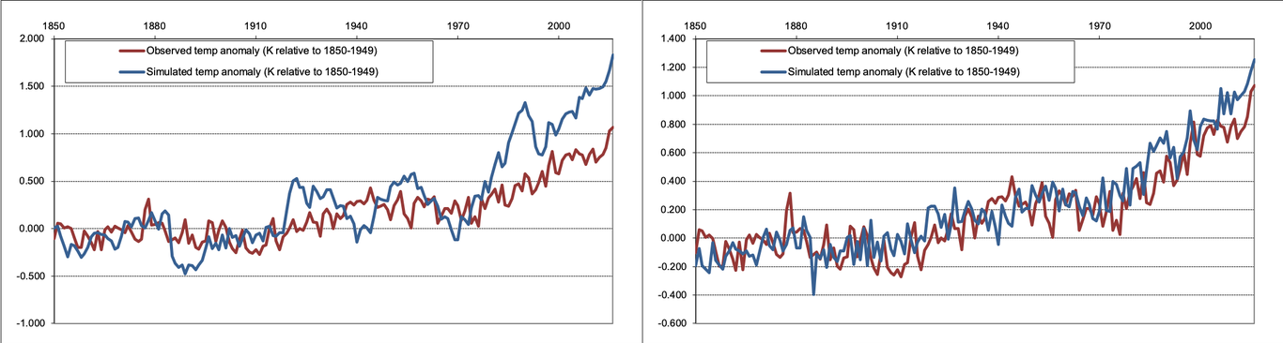
Temperature anomalies for Kappa = 0.1 K/Q2xCO2 (left) and Kappa = 5 K/Q2xCO2(right)
$H_{deep}$ - The shallower the deep ocean is, the global mean temperature has a slightly lower positive anomaly compared to a deeper deep ocean which can be understood from an ocean heat content perspective in that a shallower deep ocean cannot take up as much heat compared to a deeper deep ocean.
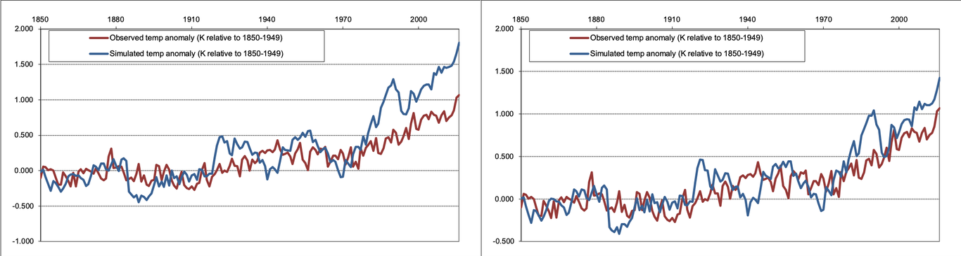
Temperature anomalies for Hdeep = 100 m (left) and Hdeep = 1000 m(right)
$T_{d0}$ – A negative deep ocean temperature anomaly at the start of the simulation seems to result in a positive global mean temperature anomaly while a positive deep ocean temperature anomaly at the start of the simulation seems to result also in a positive but weaker global mean temperature anomaly compared to a negative deep ocean temperature anomaly at the start of the simulation.
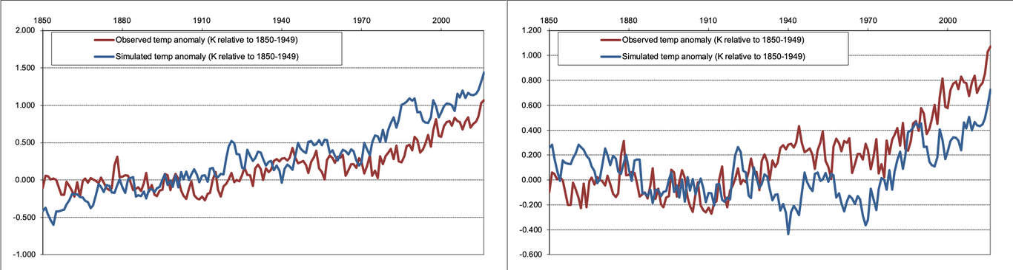
Temperature anomalies for Td0 = -10 K (left) and Td0 = 10 K(right)
(b) Sherwood et al. (2014) mention the climate sensitivity from models span from 1.5 to 5 degrees. In the simple climate model, the closest pattern between model and historical observations is when setting the equilibrium climate sensitivity to 1.5. This value falls in the range in the model results from Sherwood et al. (2014) which means the simple climate model is on a similar track as other models. However, the pattern between the simple climate model and the historical record are quite different with equilibrium climate sensitivity equals to 1.5. Also, when increasing the equilibrium climate sensitivity, the difference between the simple climate model and the historical record becomes larger. Because this is a simple climate model, there is no complicated parameterization as the model used in Sherwood et al. (2014). Also, as mentioned in Sherwood et al. (2014), low clouds play an important role in influencing the climate sensitivity. This is also not included in the simple climate model.
(c) To best fit observed temperature trends with a sensitivity of $1.5K$, we used a volcanic forcing factor of $.5$, which is outside the suggested range for this parameter. From the simple climate model result, the temperature anomaly in 1991 is $0.422K$, in 1992 is $0.553K$, in 1993 is $0.340K$, and in 1994 is $0.378K$. The temperature anomaly increases after 1994. According to Stefan–Boltzmann law $ΔR=σ{ΔT}^{4}$. The global mean reference temperature for the model (from GISS data from 1951-1980) is about $286.88K$. Thus, the average global radiative forcing of the volcano between 1992 and 1993 is about
$ΔR_{total}=σΔ(T^{4})=(5.67×{10}^{−8})((286.88+0.553)^{4}−(286.88+0.340)^{4})$
$ΔR_{total}=1.146Wm^{−2}$
In comparison, the model uses a value of $.5×3.025Wm^{−}2=1.513Wm^{−}2$. These are in reasonable agreement for the approximations involved, suggesting that the efficacy of the climate system to volcanic forcing for this model with this configuration is relatively low compared to what we expect. This tells us the model is likely too sensitive to volcanic forcing with its current configuration.
(d) As far as we can tell, there is no seasonal cycle One of the ways that the effects of the Milankovitch cycles can be included is by varying the sinusoidal forcing by setting the approximate periods for the different components of the Milankovitch cycles. However, given the simplicity of the model and the lack of provision for setting orbital parameters that vary every year, the model is as such not very good at representing the effects of the Milankovitch cycles.
Question 2. Write a review of (Malavelle et al. 2017), following the guidelines provided on the course webpage on how to write a review.
References:
Malavelle et al. (2017), doi:10.1038/nature22974
How to conduct peer review (course webpage)
(Malavelle et al. 2017) present a case study of the impacts of the 2014-2015 Holuhraun eruption on cloud microphysical properties in and around the Norwegian and Greenland Seas using an observational and model-based perspective. The authors contend that volcanically-introduced aerosols do affect cloud microphysical properties by demonstrating the lack of other possible causes for the changes in cloud properties and the significance of those changes compared to natural variability. They find evidence of the so-called “first” aerosol indirect effect (cloud albedo effect), but not the second (cloud lifetime effect).
The volcanic eruption case used in this study is highly representative with a high emission rate of sulfur dioxide into the atmosphere and it adds more confidence in this study.
Overall, the authors argument for the existence of the first aerosol indirect effect is effective. They painstakingly demonstrate that the changes in the cloud droplet effective radius are only attributable to volcanic sulfate aerosols and not due to natural variability or anthropogenic sources. In doing so, they rely on both standard satellite retrievals of cloud microphysical properties and models which reasonably reproduce those observations. However, the reviewers find the lack of evidence for the second aerosol indirect effect to be less convincing; we suggest that the authors go too far in suggesting that the lack of evidence in their case study should be used as a benchmark for evaluating the response of models. Since the strength of the authors’ conclusions is not a scientific judgment but rather a philosophical one, and since the scientific work presented here is exceedingly thorough, we recommend acceptance without revision, leaving debate about the strength of their conclusions to the broader scientific community.
As previously mentioned, the paper rigorously demonstrates evidence for the first aerosol indirect effect through satellite and model data. They also report little evidence for the second aerosol indirect effect, but the strength of this conclusion is weaker than what the authors suggest for three reasons. First, the authors demonstrate that changes in cloud liquid water path (LWP) are not significantly different from natural variability at 95% confidence, but this does not imply that there is no second indirect effect. Rather, an examination of the MODIS satellite data indicates there are large areas of anomalous LWP downwind of the eruption, suggesting that a signal may be present but that attribution suffers from a low signal-to-noise ratio. Second, the authors note that models which predict a response in line with observations may not be doing so for any physical reason; they rightly contend that the model response would likely be different with a higher (cloud-resolving) resolution where fewer processes are parameterized. They observe that the agreement between a model and observations at the coarse resolutions of their simulations may well be fortuitous. Subsequently, we suspect that the model-based results should be taken with some consideration as to their limitations. Finally, we note the large uncertainties ( 50%) involved in estimating the properties of the SO${}_{2}$ plume from satellite data, which serves as the backbone for all of the modeled simulations. This adds further uncertainty to the modeled results beyond internal uncertainties about the model’s ability to realistically simulate the aerosolcloud interactions.
In addition, by showing regional liquid water path and liquid cloud effective radius anomalies and the zonal mean state, it helps the reader to get a broad image of their responses. In this paper, we can see many places with methods, figures and discussions put in the supplementary document and they help to make the paper more concrete and the statement stronger. However, more cases are needed in the future study to support the findings in this paper.
Overall, while we agree the authors present thorough and convincing evidence for the first aerosol indirect effect, and even for a much-reduced magnitude for the second indirect effect, the second indirect effect may prove to be important for anthropogenic emissions which provide both a larger signal and a longer one, and models which do not capture this effect may or may not be correct. Additionally, it is possible that the second indirect effect is significant depending on the type of cloud, the location of the eruption, the season, etc. but did not appear in data for this particular eruption. We agree with the authors’ conclusions that further simulation of the Holuhraun eruption is necessary, particularly at higher resolutions, to further constrain the aerosol cloud interactions shown in models.

References
Malavelle, F. F., and others, 2017: Strong constraints on aerosol–cloud interactions from volcanic eruptions. Nature, 546, 485–491, doi:10.1038/nature22974. https://doi.org/10.1038%2Fnature22974.

