The Lorenz Equations
Brendon
The Lorenz equations were first derived by Edward Lorenz in 1963 from a simplified model of weather patterns. The reason for their significance is that they were one of the first incontrovertible examples of deterministic chaos, the occurrence of apparently random motion even though their is no randomness built into the equation.

Introduction
Eq. ??? The Lorenz equations are commonly expressed as 3 coupled non-linear differential equations
$$\frac{dx}{dt}=σ\left(y−x\right) ,\frac{dy}{dt}=x\left(ρ−z\right)−y ,\frac{dz}{dt}=xy−βz ,$$
x is proportional to the intensity of motion, y is proportional to the temperature difference between the ascending and descending currents, and z is proportional to the distortion of the vertical temperature profile from linearity. The parameter is called the Prandtl number, which is the ratio of momentum and thermal. is called the Rayleigh number and determines whether the heat transfer is primarily in the form of conduction or convection and is a geometric factor.

Changing Inital Conditions
Example 1: The first example of showing how this system is chaotic is to change the initial conditions.
Explanation: When we set the initial conditions to be [0,5,0], we see that the graph changes over time with no pattern symbolizing that the system of equations are acting chaotic.
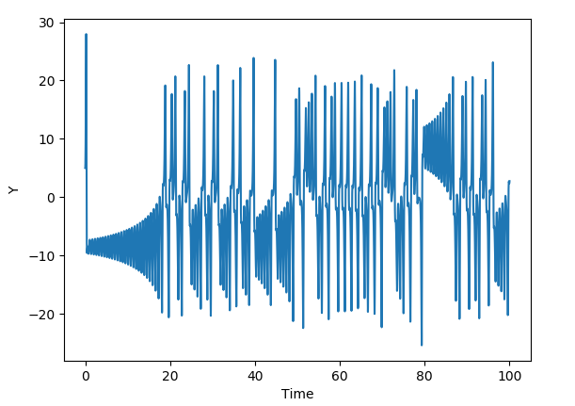
This graph is of Y vs. Time with initial conditions of x = 0, y = 5, and z = 0. The parameters are fixed at $\left(σ\right)$ = 10, $\left(β\right)$ = 8/3, and $\left(ρ\right)$ = 28.

Lyapunov Exponent
Example 2: Another way to show chaos is to graph the Lyapunov Exponent vs. Distance from Equilibrium.
Explanation: The Lyapunov Exponent measures stability and/or is a quantity that characterizes the rate of separation of infinitesimally close trajectories.
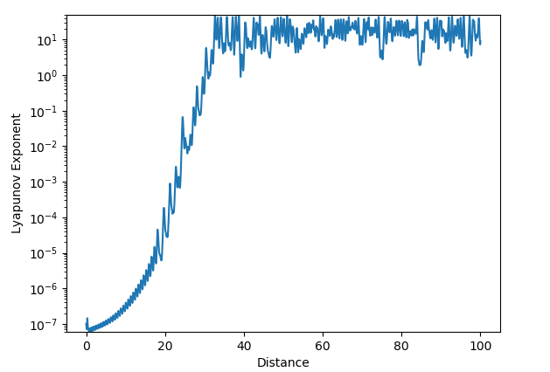
This is a graph of the Lyapunov Exponent vs. the Distance from Equilibrium for the two different initial conditions [0,5,0] and [0,5,1e^-7].
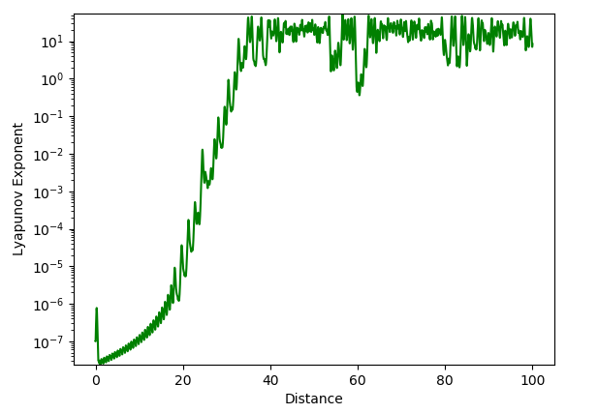
This is a graph showing the Lyapunov Exponent vs. Distance from Equilibrium with the initial conditions now being [0,5,0] and [0, 5+1e^-7 ,0].
Analysis: When calculating the Lyapunov Exponent I predicted that changing the initial conditions by the same amount but for a different variable would get the same results, because you are adding up the squared difference between each coordinate. However, to my surprise the graph shows that it will produce two different results. My hypothesis for these results are that due to the unique coupling of each variable, changing one coordinate by the same amount as another will give different values for the Lyapunov Exponent.
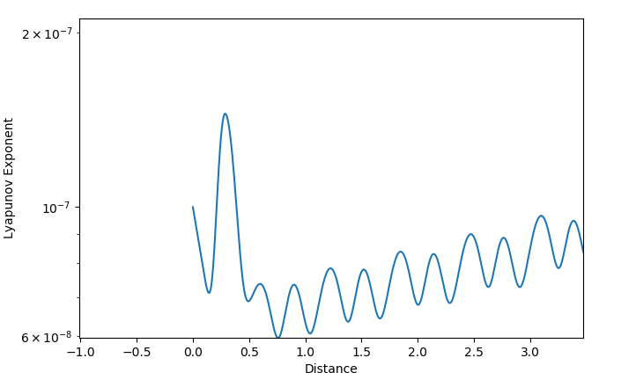
ZOOMED IN: Fig. 2
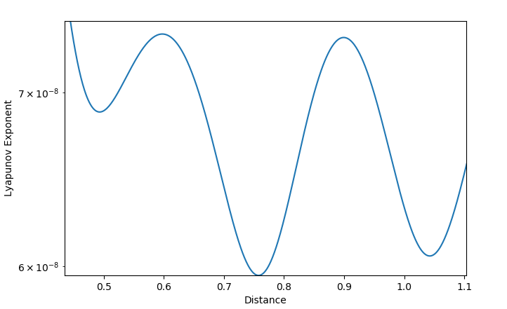
ZOOMED IN AGAIN: Fig. 2
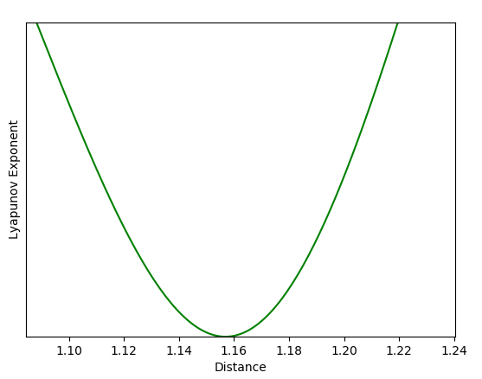
ZOOMED IN: Fig. 3
Analysis: Something interesting occurs in both of these graphs of the Lyapunov Exponent and the Distance from Equilibrium. When zoomed in we see that the Lyapunov Exponent becomes zero once, but happens at different distances.

Changing Parameters
Example 3: Another way to show that these system of equations is chaotic is to change the parameters $\left(σ\right)$, $\left(β\right)$, and $\left(ρ\right)$.
Explanation: When changing the parameters of the Lorentz equations we again see that the results show a chaotic system.
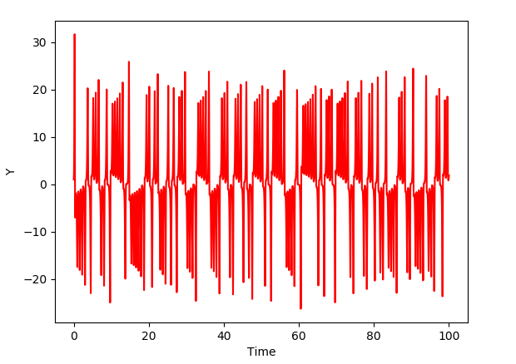
This is graph is Y vs. Time with initial conditions fixed at x = 0, y = 1, and z = 0. The parameters for this graph is $\left(σ\right)$ = 24, $\left(β\right)$ = 5/2, and $\left(ρ\right)$ = 32.

Strange Attractor
Example 4: We modify the program to produce a plot of z against x which gives us a picture of the“strange attractor” of the Lorenz equations which is a lopsided butterfly.
Explanation: The plot of the strange attractor shows chaos in the system, because this lopsided butterfly never repeats itself.
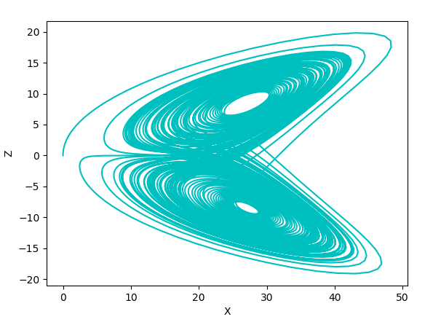
This is a graph of X vs. Z and is the famous “strange attractor” of the Lorenz equations which resembles a lopsided butterfly shaped plot that never repeats itself.

Conclusion
We have shown that the Lorenz equations due in fact produce a chaotic system. The series of equations never reach a steady state and is, therefore, an example of deterministic chaos. The Lorenz equation, like other chaotic systems, are sensitive to the initial conditions which means that two initial states no matter how close will end up diverging.

References
Bourke, P. (1997, April). The Lorenz Attractor in 3D. Retrieved April 18, 2019, from http://paulbourke.net/fractals/lorenz/
Mcgehee. (2008). The Lorenz Equations. Retrieved April 18, 2019, from http://www.users.math.umn.edu/~mcgehee/Seminars/ClimateChange/presentations/20081007.pdf

