The Observed Synoptic scale precipitation relationship between Western Equatorial Africa and Eastern Equatorial Africa
Godwin Ayesiga
Christopher E. Holloway
Charles JR. Williams
Gui-Ying Yang
Samantha Ferrett
An improvement to subseasonal (i.e. days to weeks) rainfall prediction across Equatorial Africa is an important area of current research because most countries there are highly dependent on rain-fed agriculture, with millions of livelihoods at risk in the event of an unexpected harvest failure. This study examines 16 years of daily precipitation anomalies to investigate the relationship in precipitation between Western Equatorial Africa (WEA) and Eastern Equatorial Africa (EEA). Using lead/lag correlation and spatio-temporal correlation patterns over various sub-regions, a synoptic-scale relationship in precipitation is presented between WEA and EEA in which precipitation over EEA lags precipitation over WEA by 1-2 days. In addition, central WEA and sub-regions in the Sudan highlands display a synoptic-timescale precipitation contrast, suggesting a weak precipitation dipole. Consistent with the known heterogeneity characteristic of Equatorial Africa’s precipitation, our findings suggest that the 1-2 day precipitation relationship is dependent upon the sub-region under investigation.

Furthermore, our results indicate a coherent synoptic-timescale eastward/northeastward propagating signal with a speed of approximately 12 m s⁻¹. Composite and correlation analyses of precipitation anomalies and a novel equatorial wave dataset show an apparent connection between eastward/northeastward propagating wet anomalies and Kelvin wave lower-tropospheric convergence. This suggests that Convectively Coupled Kelvin Waves (CCKWs) play a role in modulating the 1-2 day convection and precipitation oscillation between EEA and WEA. These results imply that monitoring the propagation characteristics of CCKWs may be important in synoptic-timescale forecasting over Equatorial Africa.
Keywords — Western Equatorial Africa, Eastern Equatorial Africa, Precipitation, Kelvin wave

Introduction
Short-to-medium-range convective rainfall variability has a direct influence on rain-fed agricultural productivity because it determines the amount of available soil moisture (Black et al., 2016) as well as the frequency of replenishing surface and underground water for production (Taylor et al., 2019). However, extreme precipitation events are likely to cause destructive flooding and landslides; therefore, to minimise loss of life and livelihoods, it is important to develop robust forecasting systems for various timescales (Ongoma et al., 2018). In most countries in Equatorial Africa, however, the reliability of short-term forecasts depends on experts’ ability to extrapolate the prevailing conditions as well as interpretation of forecast maps from global forecast centres (Graham et al., 2015). This implies that the methods used to generate reliable forecasts with sufficient lead time are still rudimentary. Due to the multi-spatial and temporal interaction of key drivers of convection and precipitation variability, building reliable and accurate forecast systems for Equatorial Africa (defined here as 15ºS – 15ºN, 8ºE – 51ºE) is one challenge the present scientific community is facing.
The rainfall characteristics in Equatorial Africa are strongly influenced by the north-south migration of the Inter-Tropical Convergence Zone (ITCZ). Given that the ITCZ crosses the equator twice in a year, most areas in Equatorial Africa experience a bimodal rainfall cycle. Within each season, the interaction between large-scale tropical drivers, regional and local precipitation processes, and a complex topography makes precipitation variability profoundly heterogeneous (Nicholson, 2011) and complex to forecast. Because of this heterogeneity of precipitation over Equatorial Africa, previous studies have delineated their areas of study into smaller sub-regions (Indeje et al., 2000; Pohl and Camberlin, 2006; Dezfuli, 2011). This study takes a unique approach of objectively identifying small sub-regions that are characterised by similar daily precipitation variability.
Precipitation in Equatorial Africa is dominated by convective systems of various spatial and temporal scales. A large proportion of tropical precipitation (and convection) is strongly controlled by large-scale tropical disturbances (Kiladis et al., 2009). Despite the suggested vital role of large-scale tropical disturbances in modulating convective activity and precipitation in Equatorial Africa, relatively few studies have been done to enhance our understanding of how the local precipitation regime responds to large-scale forcing.
One of the major steps in improving short-to-medium-range forecasting is enhancing our knowledge on the role of synoptic scale disturbances in modulating convective activity and associated precipitation. The major synoptic-scale disturbances in the tropics include Kelvin waves (Gill, 1980), Equatorial Rossby waves (ERWs), Eastward and Westward Inertio-Gravity waves (EIGs and WIGs), Mixed Rossby-gravity waves (MRGs) (Matsuno, 1966; Wheeler and Kiladis, 1999) and easterly waves (Reed et al., 1977). These synoptic-scale disturbances influence convection and precipitation by significantly perturbing the basic state of atmospheric fields such as pressure, temperature and wind. The resulting latent heat released by the deep convection associated with the perturbed fields can cause the generation of new equatorial waves (Lindzen, 2003). As a wave propagates, it interacts with convection through, for example, enhancing low-level moisture flux (Mekonnen et al., 2008; Sinclaire et al., 2015), and this may cause a variation in its speed of propagation. Previous studies such as Wheeler et al. (2004), Ventrice et al. (2012), Mekonnen et al. (2016), and Schlueter et al. (2019) have suggested that these waves strongly modulate convective activity and precipitation in Equatorial Africa. An opportunity to exploit the source of synoptic-scale weather predictability lies partly in how well we understand the behaviour of these synoptic-scale weather systems in both observations (Nguyen and Duvel, 2008; Sinclaire et al., 2015; Schlueter et al., 2019) and weather and climate models.
Much has been documented on the role of synoptic-scale tropical disturbances in influencing precipitation and convection in West Africa significantly north of the Equator (i.e. 9ºN – 20ºN) (see, for example, (Duvel, 1990; Mounier et al., 2006; Mekonnen et al., 2008; Janicot et al., 2009; Ventrice et al., 2012; Yang et al., 2018; Schlueter et al., 2019)) but our knowledge of the role of synoptic-scale disturbances in influencing convection and precipitation variability within a few degrees about the equator remains limited. Additionally, the few studies that did focus on the role of these large-scale disturbances concentrated exclusively on either WEA (Sinclaire et al., 2015; Nguyen and Duvel, 2008) or EEA (e.g (Pohl and Camberlin, 2006), and thus our knowledge on how WEA and EEA interact is incomplete. Of the literature that does focus on this interaction, Pohl et al. (2006) suggested that eastward propagating synoptic-scale dynamical disturbances trigger convective activity as they travel through Equatorial Africa. Also, Sinclaire et al. (2015) investigated synoptic Kelvin waves in the Congo basin and found that, during March-June, the eastward propagating CCKWs favour initiation of synoptic-scale convective systems. However, the role of synoptic-scale dynamical systems in influencing precipitation and convection relationships between WEA and EEA has not been thoroughly investigated.
A particular study on this interaction came from Mekonnen et al. (2016), who examined 22-years of cloud brightness temperature to investigate convective activity interaction between the Congo Basin and Eastern Africa during boreal summer. Their findings suggested a dipole synoptic-scale convective activity interaction between the Congo Basin and Eastern Africa, and they observed that CCKWs modulate a coherent eastward/northeastward propagating convective signal that oscillates between enhanced and suppressed states with a periodicity of 3–4 days. They found that low-level westerly and southwesterly anomalous winds are linked to enhanced convection over East Africa, while northeasterly wind anomalies show a connection to suppressed convection over East Africa. The current study therefore builds on Mekonnen et al. (2016) by examining: actual observed daily precipitation (rather than an indirect measure of convective activity); from a number of datasets; for the whole year (rather than certain seasons only); and on a higher spatial resolution.
The rest of this manuscript is organised as follows. Section 2 describes the datasets analysed, followed by Section 3 describing the methodology. In Section 4 the results are presented and finally Section 5 summarises and concludes.

Data

Tropical Rainfall Measuring Mission (TRMM)
The Tropical Rainfall Measuring Mission (TRMM) daily precipitation dataset has a latitudinal coverage that spans 50ºS - 50ºN, and is produced at a resolution of 0.25º x 0.25º, as described in Huffman et al. (2007) . The 3B42 version 7 of the daily TRMM estimates is computed by accumulating eight 3-hourly TRMM 3B42 records obtained by merging precipitation estimates from multiple satellites (Huffman et al. 2007), and ground-based observations are used for bias correction of the final product over regions where they are available. The validation of TRMM daily estimates over various regions has been conducted by several studies (Dinku et al., 2007; Gebremicael et al., 2019).

Global Precipitation Climatology Project (GPCP-1DD)
The Global Precipitation Climatology Project (GPCP-1DD) is a 1º x 1º global daily precipitation product produced by merging various satellite estimates and rain gauge observations (Huffman et al., 2001). The microwave estimates are generated from the Special Sensor Microwave Imager (SSM/I) on board the Defence Meteorological Satellite Program, and the Infrared (IR) data uses the Geostationary Operational Environmental (GOES) Precipitation Index (GPI) which relates cold cloud top temperature to precipitation rate (Huffman 2001). Precipitation estimates are then computed using the Threshold-Matched Precipitation Index (TMPI) that is applied on the SSM/I data to isolate raining pixels in the IR data (Huffman 2001). The rain gauge precipitation observations are indirectly used when the GPCP-1DD accumulations are scaled to match the GPCP monthly product. This particular dataset has been validated over EEA (Dinku 2007) and this makes it ideal for the current study, which uses the 1DD daily estimates for the period 1997 - 2012.

ERA-Interim
ERA-Interim (ERA-I) is a global atmospheric reanalysis dataset that was produced by the European Centre for Medium-Range Weather Forecasts (ECMWF), available on a spatial resolution of 0.7º x 0.7º and a 6-hour temporal resolution at 37 pressure levels (see (Dee et al., 2011) for full description of ERA-I). The current study uses the daily averaged fields for the period of 1998 - 2013.

Equatorial Wave dataset
The equatorial wave dataset is produced using dynamical fields in ERA-I. The dataset has a spatial resolution of 1º x 1º and a 6-hour temporal resolution at 10 pressure levels for the entire 24ºS - 24ºN latitudinal belt, and includes equatorial waves with zonal wavenumbers k=2-40 and a period of 2-30 days: for full details, see (Yang et al., 2003). Identification of the different types of equatorial waves is done by projecting the dynamical fields onto various equatorial wave modes using their meridional structures, described by parabolic cylinder functions in y and sinusoidal variations in x; prior to projecting the dynamical field data onto the equatorial structure, the data are filtered in a specified wavenumber and frequency domain to separate into eastward and westward propagating components using space-time spectral analysis (Yang et al. 2003). One aspect that makes this dataset unique is that the data are projected onto each pressure level independently, allowing the data to reveal the vertical structure rather than having to assume dispersion relations, and it is worth noting that equatorial waves are identified based on their dynamical structure (Yang et al. 2003), making it appropriate for the current study. Because the equatorial dataset does not use Outgoing Longwave Radiation (OLR) to identify the waves, it has no information about precipitation, thus the relationship between this dataset and precipitation is independent of the technique used to generate it. This dataset is available from 1997 - 2018, however this study uses the daily averaged data for the period 1998 - 2013.

Methodology

Empirical Orthogonal Teleconnection (EOT)
The influence of oscillatory modes of tropical convection and precipitation variability is location specific and seasonally dependent (Pohl 2006, Sinclaire 2015). In this study, we subdivide the entire domain (15ºS – 15ºN, 0º – 51ºE) into smaller sub-regions with relatively similar daily precipitation variability, using the Empirical Orthogonal Teleconnection (EOT) technique (Smith, 2004). Prior to performing the EOT on the daily precipitation dataset, the annual cycle was removed by subtracting a 30-day running mean of the daily 16-year rainfall climatology from each year used in the study. Since the interest here is to understand high frequency convection and precipitation variability, the influence of low frequency modes of variability was also removed by subtracting the 100-day simple moving average from the time series at every grid-point in the domain. Finally, any long-term trend over the 16-year period was removed using linear regression. The remaining anomalies were then subjected to the EOT algorithm.
The purpose of this technique is to objectively identify sub-regions exhibiting similar daily precipitation characteristics, and the technique produces modes which are orthogonal in either space or time. Here, we use the modified EOT approach as described in Smith (2004) . The modified version of the EOT technique is based on a global integral as opposed to that which is based on global variance as described in (Van den Dool et al., 2000).
The procedure starts by searching for a base point whose timeseries is best correlated to the area average timeseries of the domain. The base point timeseries is then correlated with the timeseries of every grid-point in the entire domain. The first sub-region is obtained by identifying the longitude-latitude box that completely encloses the contiguous grid-points whose correlation coefficients between the grid point timeseries and the base point timeseries exceed 0.2. The variance explained by the first base point is then subtracted from every grid point in the domain, thus creating a new dataset (the residual). The process was repeated for higher order sub-regions. It should be noted that the order of the sub-region is not indicative of the relative percentage of the total variance explained, and for the purposes here the major interest is finding sub-regions of spatial co-variance rather than quantifying variances explained. Since the order in which the sub-regions are identified is not physically important, the identified sub-regions were renamed: for example, W1 represents sub-region 1 in WEA and E1 represents sub-region 1 in EEA. A more detailed description of the modified EOT approach can be found in Smith (2004) and (Stephan et al., 2017). The use of the EOT algorithm enabled an objective identification of sub-regions of similar daily precipitation variability. The dimensions of the various sub-regions identified are the only outputs of the EOT analysis used in subsequent analysis.

Correlation and Composite Analysis
Correlation analysis is used for all pairs of sub-regions over various lead/lag days in order to identify propagating signals. The bootstrapping technique is used to test for the statistical significance of the correlation coefficient between the area averaged timeseries of a pair of sub-regions. For brevity, the timeseries for the sub-region in WEA is referred to as A and that of the sub-region in EEA as B here. The bootstrapping is done by holding A in its original order, and then, to preserve the original synoptic-timescale autocorrelation of B, it is divided into blocks of 100 days. A total of 1000 samples of B are constructed by randomly drawing the blocks with replacement and stitching the sampled blocks together so that each sample is the same size as B. Time-series A is then correlated with every sample and the 95th percentile of the absolute value of these correlation coefficients is determined. If the absolute value of a particular correlation coefficient is greater than this 95th percentile, it is considered to be statistically significant at the 95% confidence level.
Composites are performed on events days that were selected by considering a pair of sub-regions. So, for a given pair of sub-regions, an “event” is defined as an occurrence of precipitation in excess of a threshold over a sub-region in WEA which is followed, two days later, by a precipitation occurrence above the corresponding paired sub-region’s threshold recorded over EEA given that the previous day’s precipitation record in the EEA sub-region was below the threshold. The thresholds were determined by calculating the 66.7th percentile for each particular sub-region. The area averaged timeseries of the anomalies of each sub-region were used to compute the threshold for each sub-region. All the days with zero area averaged raw precipitation amount were removed before computing the thresholds.

Results

Identification of sub-regions
Daily TRMM anomalies for a 16-year period were subjected to the EOT and a total of 32 sub-regions were identified. The robustness (in terms of the identified sub-regions’ location) of using TRMM daily anomalies was tested by subjecting 15 years of GPCP daily anomalies to the same EOT. Figure 1 shows an example of the sub-regions identified using TRMM daily anomalies. Those identified using the GPCP dataset were generally in similar locations as those shown in Figure 1 (not shown), so the fact that the sub-regions identified using two independent data sets were generally in similar locations provided confidence in the results. In this study, the 29ºE longitude was considered to divide Equatorial Africa (15ºS – 15ºN, 8º – 51ºE) into WEA and EEA. The sub-regions over the oceans and those whose base-points were located on the 29ºE longitude were disregarded. Ultimately, a total of 17 sub-regions in WEA and 8 in EEA were considered for further analysis. An example of these sub-regions is shown in Figure 1, and all other sub-regions not in this figure are indicated in Figure S1.

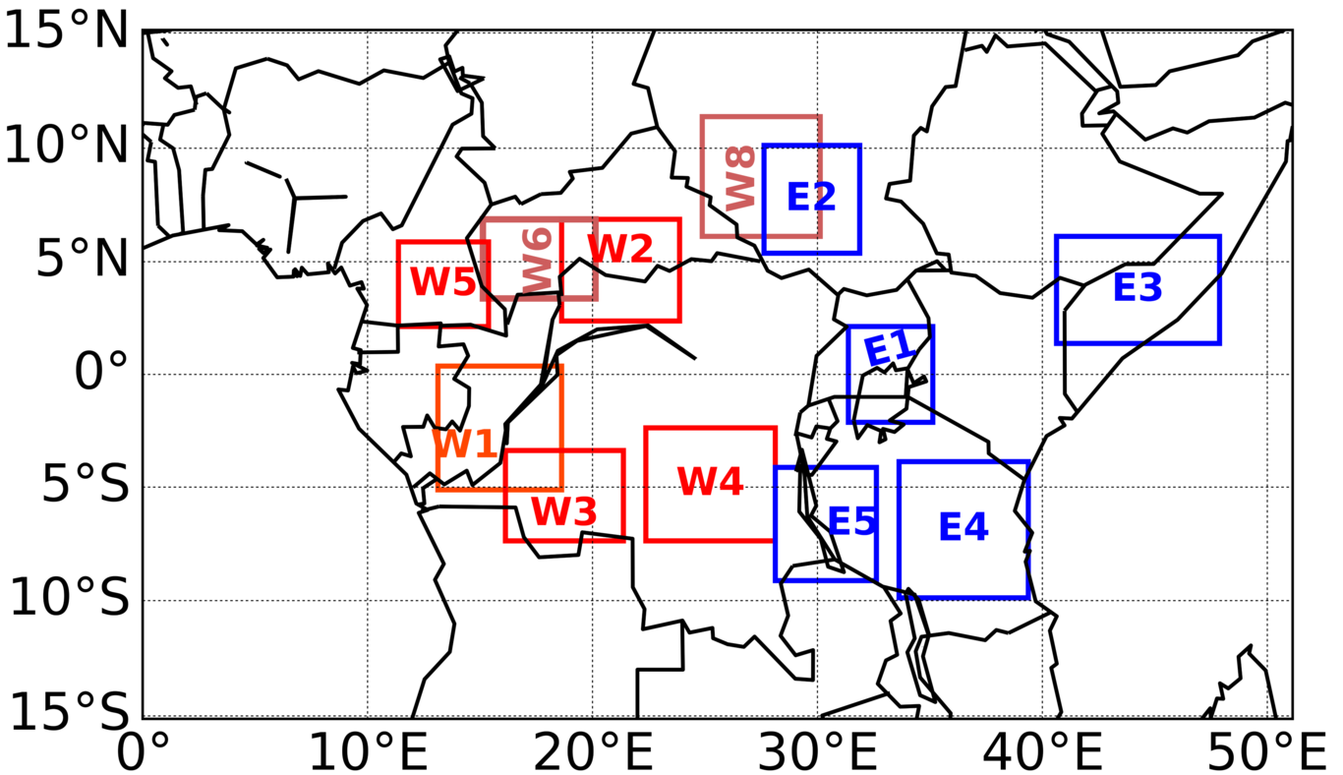
Example of sub-regions identified by subjecting 16-years of daily TRMM anomalies to an EOT. The letter “W” attached to the number in the red sub-regions indicates that the sub-region is located in Western Equatorial Africa and “E” likewise for EEA. Since the order in which these sub-regions were identified does not matter, they were renamed for clarity.

Lead/lag correlation
Correlation coefficients between the area average timeseries of TRMM rainfall anomalies of each sub-region in EEA with every sub-region in WEA for lead/lag -5 to +5 days over the entire 16 years were calculated. Since there were 17 sub-regions identified in WEA and 8 sub-regions in EEA, there is a total of 136 different pairs of timeseries on which lead/lag correlation coefficients were calculated. Sub-regions E1 and E2 indicated the strongest correlation coefficients when correlated with the various sub-regions in WEA. Figure 2 shows peak correlation coefficients at lag +1–2 days followed by a local minimum on lag +3–4 days. E1 (in Fig. 2a) shows a peak correlation with W1-3 around ~ lag +1-2 (for W3 there is also positive peak at lag -3 day). In comparison with Figure 2a, there is a peak correlation coefficient on both sides of lag 0 in Figure 2b. This indicates an oscillation of with a period of few days.
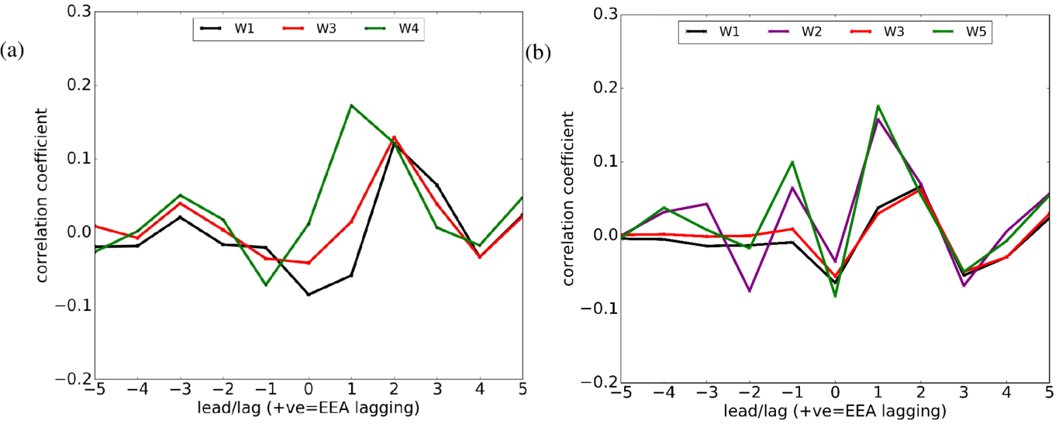
Lead/lag correlation coefficients of 16-year daily TRMM precipitation anomalies for (a) E1 versus W1, W3 and W4 (b) E2 versus W1, W2, W3 and W5. A positive lag implies that EEA is lagging. Only pairs of sub-regions whose maximum correlation coefficient is statistically significant at the 95% level are shown.
The precipitation anomalies were also divided into four seasons consisting of March-May (MAM), June -August (JJA), September-November (SON) and December-February (DJF), and lead/lag correlation coefficients over the various sub-regions were recalculated. The peak of the correlation coefficients was seen at similar lead/lag days as shown in Table 1 and Table 2.

Further analysis on the peak correlation coefficients seen in Figure 2 is done by identifying the strongest correlation at each lag day and the associated pair of sub-regions. Figure_ED shows shows the pair of sub-regions that is characterised by the strongest correlation coefficient at various lag days. It can be seen in this figure that sub-region E1 indicates the strongest correlation coefficient at lag day +2 with 47% of the sub-regions in WEA and likewise 12% at lag day +1. Furthermore, compared to all the other sub-regions in WEA, Figure_ED shows the strongest correlation coefficient between E1 and W3 at lag day +2. Subsequent work looks at E1 in more detail because it indicated the highest number of sub-regions in WEA with which it exhibits the strongest correlation coefficient. Emphasis is placed on E1 and W3 as these sub-regions further show the strongest correlation coefficient. From Figure_ED, E2 and E5 indicates strongest correlation coefficients at lag day +1 with 30% of the sub-regions in WEA. Over the continuum of lag days 0 to +4, Figure_ED suggests that the strongest correlation are seen on lag day+1 and +2.
Table 1 and Table 2 show example results obtained by correlating area average timeseries for E1 and E2 with every sub-region in WEA respectively. In the subsequent sections, a discussion of why E2 warranted further analysis is given.

The lead/lag correlation coefficients and the corresponding lead/lag between sub-region E1 and various sub-regions in WEA. The correlation coefficients are statistically significant at the 95% level.
E1 vs | min corr | lag @ min corr | max corr | lag @ max corr
W1 | -0.085 | 0 | 0.120 | 2
W2 | -0.094 | 0 | 0.049 | 1
W3 | -0.042 | 0 | 0.129 | 2
W4 | -0.072 | -1 | 0.172 | 1
W5 | -0.111 | 0 | 0.091 | 2
W6 | -0.044 | 0 | 0.061 | 2
W7 | -0.095 | 0 | 0.093 | 3
W8 | -0.084 | 1 | 0.068 | 3
W9 | -0.030 | 0 | 0.064 | 1
W10 | -0.129 | -1 | 0.133 | 1
W11 | -0.094 | 1 | 0.088 | 2
W12 | -0.036 | 0 | 0.085 | 2
W13 | -0.025 | 0 | 0.050 | 2
W14 | -0.063 | 0 | 0.109 | 2
W15 | -0.125 | -1 | 0.151 | 1
W16 | -0.063 | 0 | 0.101 | 2
W17 | -0.090 | 1 | 0.055 | 3
The lead/lag correlation coefficients and the corresponding lead/lag between sub-region E2 and various sub-regions in WEA. The correlation coefficients are statistically significant at 95% level.
E2 vs | min corr | lag @ min corr | max corr | lag @ max corr
W1 | -0.064 | 0 | 0.067 | 2
W2 | -0.074 | -2 | 0.158 | 1
W3 | -0.055 | 0 | 0.063 | 2
W4 | -0.043 | 3 | 0.061 | 1
W5 | -0.107 | 0 | 0.123 | 1
W6 | -0.082 | 0 | 0.176 | 1
W7 | -0.024 | -1 | 0.029 | 2
W8 | -0.152 | -2 | 0.78 | 0
W9 | -0.061 | 0 | 0.098 | 1
W10 | -0.073 | 3 | 0.10 | 1
W11 | -0.068 | 0 | 0.079 | 2
W12 | -0.024 | 3 | 0.046 | 2
W13 | -0.056 | 0 | 0.154 | 1
W14 | -0.069 | 0 | 0.081 | 2
W15 | -0.045 | 3 | 0.069 | 1
W16 | -0.041 | 0 | 0.044 | 2
W17 | -0.028 | 0 | 0.077 | 2
In Table 1 the strongest positive correlation coefficients are seen on lag day +1 (i.e. E1 versus W4), and the positive correlation coefficients on lag day +2 (i.e. E1 versus W1, E1 versus W3) are generally weaker than those on lag day +1. This suggests a weakening of the signal from lag day +1 into lag day +2. The strongest negative correlation coefficients for some regions seen on lag day 0 in Table 1 and Table 2 suggest a contrasting relationship between the different pairs of sub-regions. From Table 1, it can be seen that the magnitude of the correlation coefficients is generally below 0.2. This is unsurprising given the nature of daily precipitation variability.
Results in Table 2 indicate that the strongest correlation occurs between W8 and E2 (coefficient of 0.78) at day 0. Note that this pair of sub-regions indicate the strongest negative correlation of -0.152 at lag day -2. These strong correlation coefficients are a consequence of the overlap between the two sub-regions (see Figure 1), but they also highlight a synoptic-timescale oscillation with a period of a few days.
To further understand the precipitation connection highlighted by the peak correlation coefficient seen on lag day +1 and lag day +2 in Figure 2, the entire period (regardless of the season) was used to calculate a spatio-temporal correlation coefficients pattern for lag 0, +1, +2, +3 and +4 over all the sub-regions in WEA. It is seen in Table 1 and Figure1 that W3 (7.4ºS–3.4ºS, 16.1ºE–21.4ºE) with E1 (2.1ºS –2.1ºN, 31.4ºE–35.1ºE) indicates the strongest significant correlation coefficient at lag +2 days. The spatio-temporal correlation coefficient pattern between W3’s area average time-series and every grid point is shown in Figure 3. This figure shows strongest negative correlation coefficients on day +1 when the eastward/northeastward propagating signal progresses from W3 and propagates to a region with approximate centroid, 5ºS, 25ºE (over W4) and then on day +2 when the positive strongest correlation coefficient advances to further east to a region with approximate centroid, 3ºN, 33ºE (over E1 ). By day +3 (and also day +4; not shown), the signal becomes weak and almost non-existent, suggesting a short lived signal. The pattern seen in Figure 3 suggests a coherent eastward propagating signal with a synoptic spatial and temporal scale.
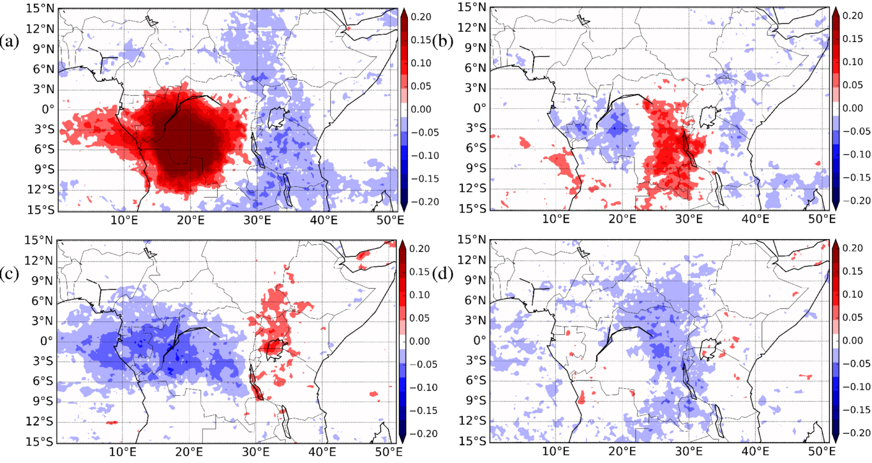
Correlation coefficients between area average time series based on 16-years of TRMM daily precipitation anomalies over W3 and every grid point in the domain for (a) day 0 (b) day +1, (c) day +2, (d) day +3. Only correlation coefficients that are statistically significant at 5% level are shown.
Figure 3 also suggests that, while it is expected that on day +3 the eastward propagating coherent signal would shift further east (close to the western shore of the Indian Ocean), this is not the case. This result is consistent, however, with the findings in (Liebmann et al., 2009) (see their Figure 1), and there are several possible reasons for this behaviour, discussed below.
The area average timeseries over all the sub-regions in EEA (e.g E1, E2, E3, E4, E5, E6, E7 and E8) was correlated with every grid point in the domain at lead/lag days 0, -1, -2, and -3. Figure 4 shows the spatio-temporal distribution of the correlation coefficients for E1 (Figure 4a-d) and E2 (Figure 4e-h) for lag day 0, -1, -2, and -3. There is a clear difference in the structure of the correlation patterns over lag days -1, -2, and day -3. For E1, it is seen in Figure 4 that there is no switch in polarity of the local sub-region correlation signal over all lag days. However, E2 indicates a change in the polarity of the local signal over the four lag days. The correlation coefficient pattern seen in Figure 4e-h may be interpreted to mean that when wet anomalies dominate the sub-region E2 (Highlands in South Sudan), dry anomalies occur in central WEA (e.g over sub-regions W1, W5, W6) and vice versa, suggesting a weak precipitation dipole. Here, the word "dipole” is used to refer to behaviour leading to a two-pole (positive-negative) spatial structure of the signal on day 0 which is also similarly present on an earlier or later lag day, and where a similar structure with reversed polarity is present between those two days. On day lag -3 (Figure 4h), the structure of the signal resembles that seen on day 0 (Figure 4e), though the signal is weak in Figure 4h. However, the correlation pattern seen in Figure 4d does not show any resemblance to that in Figure 4a. The coefficient pattern seen in Figure 4e-h therefore suggests a precipitation dipole. This result is consistent with the findings of (Mekonnen and Thorncroft, 2016), who found a dipole in convective activity during July-August-September (JAS) season between the Congo Basin and Eastern Africa.
To test whether the unique behaviour of E2 was due to its location off the equator, a similar spatio-temporal correlation analysis over sub-region E5 (9.1ºS – 4.1ºS, 28.1º – 32.6ºE) was performed, since both E2 and E5 are located approximately along the same longitudinal band and distance from the equator. The structure of the correlation coefficient pattern over E5 for lag 0, -1, -2, and -3 was similar to that of E1 (see Figure 4a-d) and not that of E2. This suggests that the behaviour of E2 is not due simply to its location being off the equator.
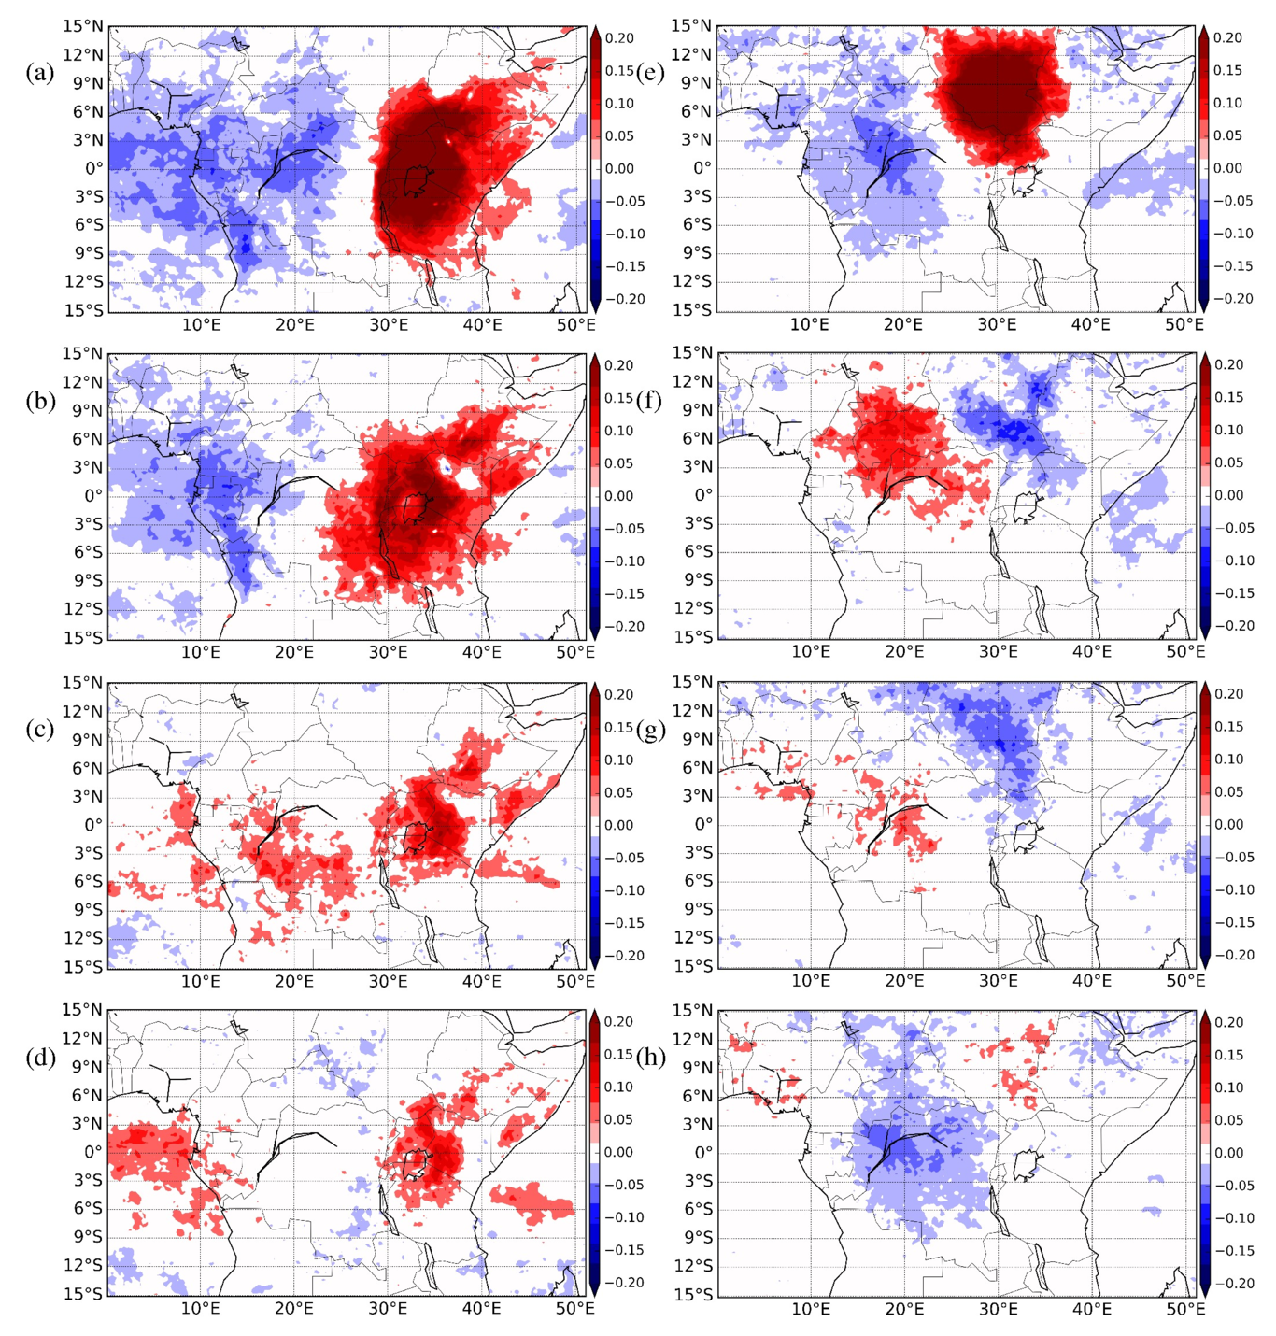
Correlation coefficients between area average time series based on 16-years of TRMM daily precipitation anomalies over E1 and every grid point in the domain for lag day (a) 0, (b) -1, (c) -2, and (d) -3 and similarly over E2 for lag day (e) 0, (f) -1, (g) -2, and (h) -3 . Only correlation coefficients that are statistically significant at 95% are shaded
Figure 4 shows a clear difference in the spatio-temporal correlation patterns between E1 and E2. Spatio-temporal correlation patterns for the other E sub-regions (e.g. E3, E4) were similar to that for E1, thus not shown. The contrasting correlation pattern between Figure 4a-d and Figure 4e-h suggests that the sub-region E2 has a unique behaviour. This is apparent on comparing Figure 4b with Figure 4f, and Figure 4d with Figure 4h. The interpretation made here is that for all sub-regions in EEA, except E2, a “local” influence within EEA persists for a longer timescale than the influence from WEA. Also, this result suggests that precipitation over several sub-regions in EEA is not mainly controlled by the eastward propagating signal seen in Figure 2.
To further assess the relationship between precipitation in a sub-region and the driving circulation at every grid-point, area averaged precipitation anomalies in W1, W3 and W5 were correlated with 850hPa zonal wind anomalies for the entire period, regardless of the season. Results indicate a coherent eastward/northeastward propagation signal as seen in Figures 3 and 4 (not shown), discussed further below.
The signal seen in Figure 3 and 4e-h therefore highlights a synoptic -timescale eastward/northeastward propagating system. In light of this result, the documented large-scale tropical disturbances that might be associated with the large-scale coherent signal seen in Figure 3 and 4e-h are briefly reviewed. The Madden Julian Oscillation (MJO) is an eastward propagating mode of intra-seasonal variability that modulates convective activity and precipitation in Equatorial Africa (Berhane and Zaitchik, 2014; Pohl and Camberlin, 2006) and propagates through Equatorial Africa with a speed of about 5 m s⁻¹ (Geerts and Wheeler, 1998; Zaitchik, 2017). This implies that the MJO is a slower mode compared with the ~12 m s⁻¹ eastward propagating signal seen in Figures 3 and 4. An ERW is a westward propagating mode (Wheeler and Kiladis, 1999), and thus is also discounted from being associated with the signal in Figures 3 and 4. EIGs are equally weak over Equatorial Africa (Kiladis et al. 2009), and thus are less likely to responsible for the signal seen in the aforementioned figures. On the other hand, a Kelvin wave propagates eastward through Equatorial Africa with a speed of between 11 m s⁻¹ and 15 m s⁻¹ (Mekonnen et al., 2008; Baranowski et al., 2016) . Therefore, it is highly likely that the synoptic-scale signal in the current study is that of a CCKW.
Figure 5a shows a time-longitude plot of TRMM daily precipitation anomalies and the 850 hPa Kelvin wave divergence field (see section 2.4) for April 2004, as an example. The period shown here was selected because it includes several “event days” (see section 5 below) that were indicated by several different pairs of near-equatorial sub-regions suggesting that on these dates there was an eastward propagation of wet anomalies. It is apparent from Figure 5a that eastward propagating wet anomalies coincide with the Kelvin wave low-level convergence, while dry anomalies coincide with Kelvin wave low-level divergence. The relationship between precipitation in various sub-regions in WEA and Kelvin wave divergence field over lag day -3 to day +4 was also analysed. As an example, Figure 5b shows the lagged correlation coefficients between area averaged precipitation anomalies in W3 and grid-point Kelvin wave divergence at 850 hPa for the entire 16-year period over lag day -3 to day +4. In agreement with Figure 5a, 5b reveals a signal of a Kelvin wave that progresses into WEA from the Atlantic Ocean and progresses into EEA with a phase speed of ~10 m s⁻¹. The pattern seen in Figure 5b is in agreement with results by Mekonnen et al. (2008) that suggested that CCKWs propagate into Africa from the Atlantic Ocean.
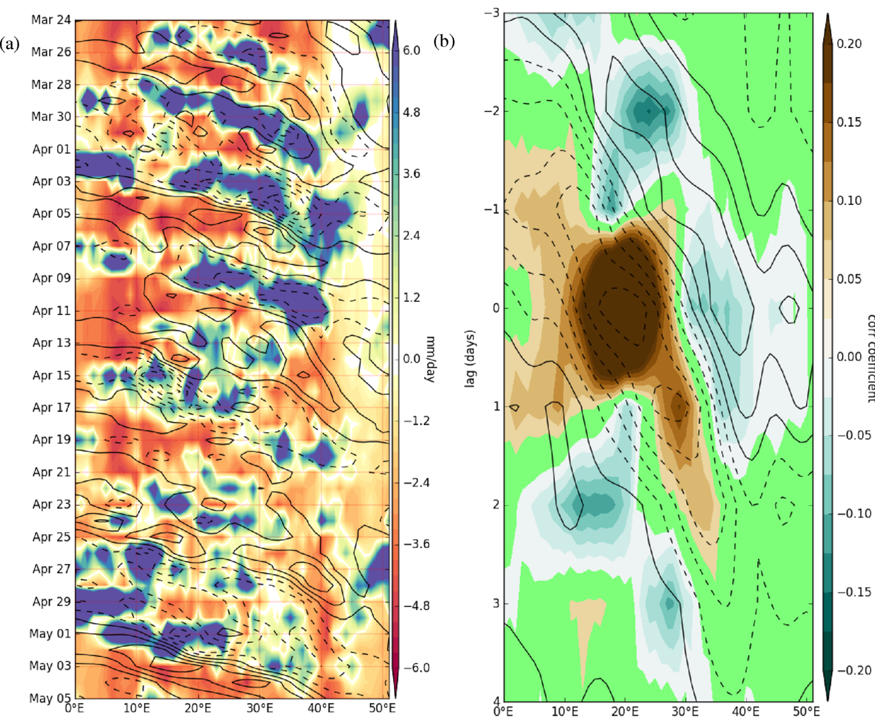
Time-longitude section for daily precipitation anomalies for 24 March to 5 May 2004 (shaded) where the contour lines show Kelvin wave divergence (dashed lines negative) at 850 hPa and both divergence and precipitation are averaged between 7ºS and 3ºN. Contour line internval is 9.3x10-7s⁻¹. (b) Contour lines show the lagged correlation coefficient between 16-years of daily precipitation anomalies over W3 and grid point 850 hPa Kelvin wave divergence (dashed lines negative) and shading shows the auto-lagged correlation of precipitation over W3 and grid point precipitation averaged over 7ºS and 3ºN.

Isolation of event time indices
A meaningful way of understanding the eastward/northeastward propagating signal seen in Figures 3 and 4 is to undertake a basic count of the number of days (or “events”, see section 3.2) when precipitation exhibits eastward propagation.
Figure 6 shows the number of events between W3 and E1. Similarly, the number of events for all the various pairs of sub-regions were counted. Between W3 and E1, the approach identified 87 events during December-January-February (DJF) while between W1 and E1, a total number of 103 events for the boreal spring (March-April-May) were identified. This averages about 6 events per MAM and about 5 events per DJF. In assessing the interannual synoptic-scale variability of precipitation over the Congo basin, (Sinclaire et al., 2015) suggested that 6 - 7 convectively coupled equatorial Kelvin waves propagate through the Congo basin during March - June. Mekonnen et al. (2008) performed a count of the number of CCKWs that started west of 10ºE and propagated through tropical Africa east of 20ºE during boreal summer, finding that 5 - 6 CCKWs events propagated eastward in the 3-month period but with a profound year-to-year variability. It is likely that the events seen in the present study correspond to the days when the passage of the CCKWs modulate convection and precipitation over Equatorial Africa.
In Figure 6, June-July-August (JJA) shows the least number of events when compared to other seasons. This could be because during these months, EEA is generally dry. Additionally, Figure 6 highlights that these events are characterised by a large season-to-season variability. Because seasonal precipitation over Equatorial Africa is strongly modulated by the ITCZ, Figure 6 suggests that the synoptic-scale system that modulates these precipitation events is associated with the ITCZ.
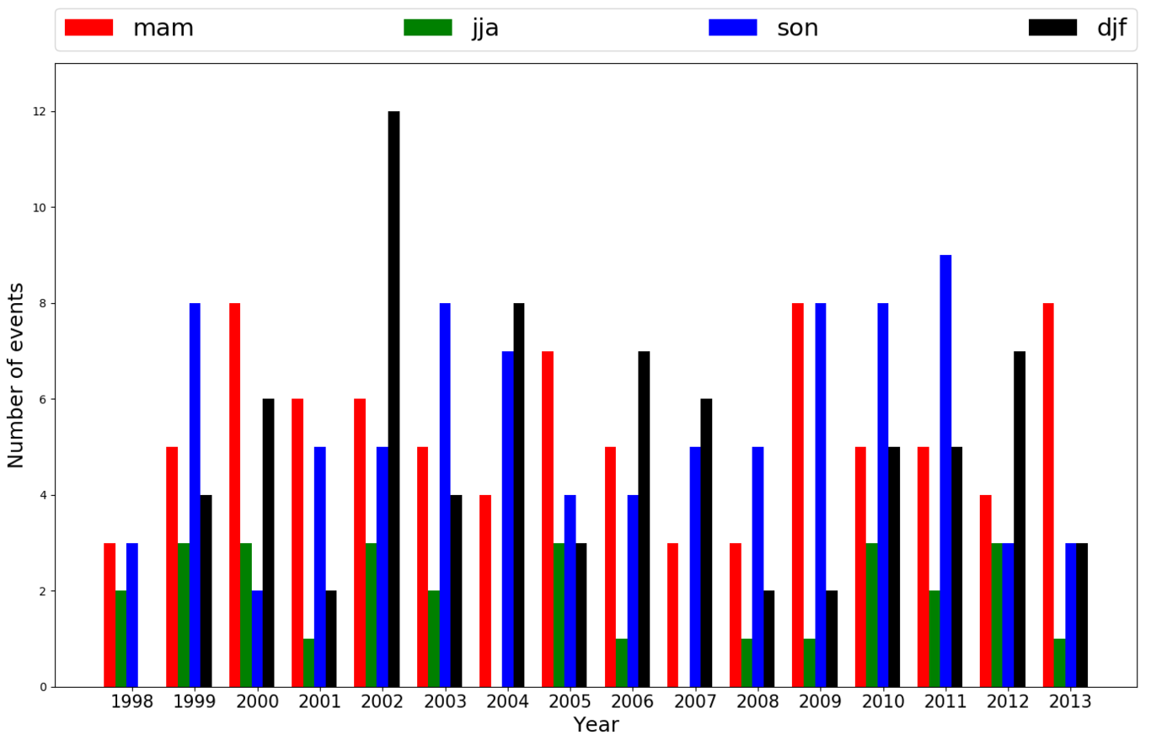
Season-to-season variability in the number of events for W3 and E1

Composite Analysis
Finally, the composite method is used here to investigate the average structure, characteristics and wind regime associated with the precipitation relationship between WEA and EEA. The composite is calculated by taking an average over event days. Composite analysis has been used in previous studies to investigate the characteristics of propagating features in the tropics. For example, (Wheeler and Hendon, 2004) and (Roundy, 2008) used the compositing technique by taking an average of the anomalous observations to study the propagation characteristics of the MJO and analyse the role of convectively coupled Kelvin waves in the Indian Ocean. In this study, a similar composite technique is used to calculate composites for precipitation anomalies and dynamical fields. Because previous studies have indicated that the circulation patterns associated with precipitation variability in the different seasons varies remarkably (Pohl and Camberlin, 2006), composites based on Equatorial Africa’s known wet seasons are calculated. The events were first categorised by season and a composite was calculated only when the total number of events in a given season (over 16 year period) exceed 60. In calculating a composite, day 0 corresponds to the day when wet anomalies exceeded the threshold in the sub-region in WEA, and negatively/positively lagged composites are computed to explore the propagation characteristics of the wet anomalies.
Figure 7 (based on sub-region W3 and E1) shows composites of precipitation anomalies and 850 hPa Kelvin wave divergence for boreal spring (Figure 7a-d) and boreal autumn season (Figure 7e-h) over lag day 0 to day +3. It can be seen that wet anomalies propagate eastward together with Kelvin wave convergence (dashed contours), while dry anomalies coincide with Kelvin wave divergence (solid contours). In addition, Figure 7 shows that Kelvin wave slows down in EEA. The composites of events over various seasons for different sub-regions indicated a similar structure as that seen in Figure 7 (not shown). This Figure is consistent with Figure 6 and 3 and further highlights the role of CCKWs in modulating the 2-day precipitation connection between WEA and EEA.
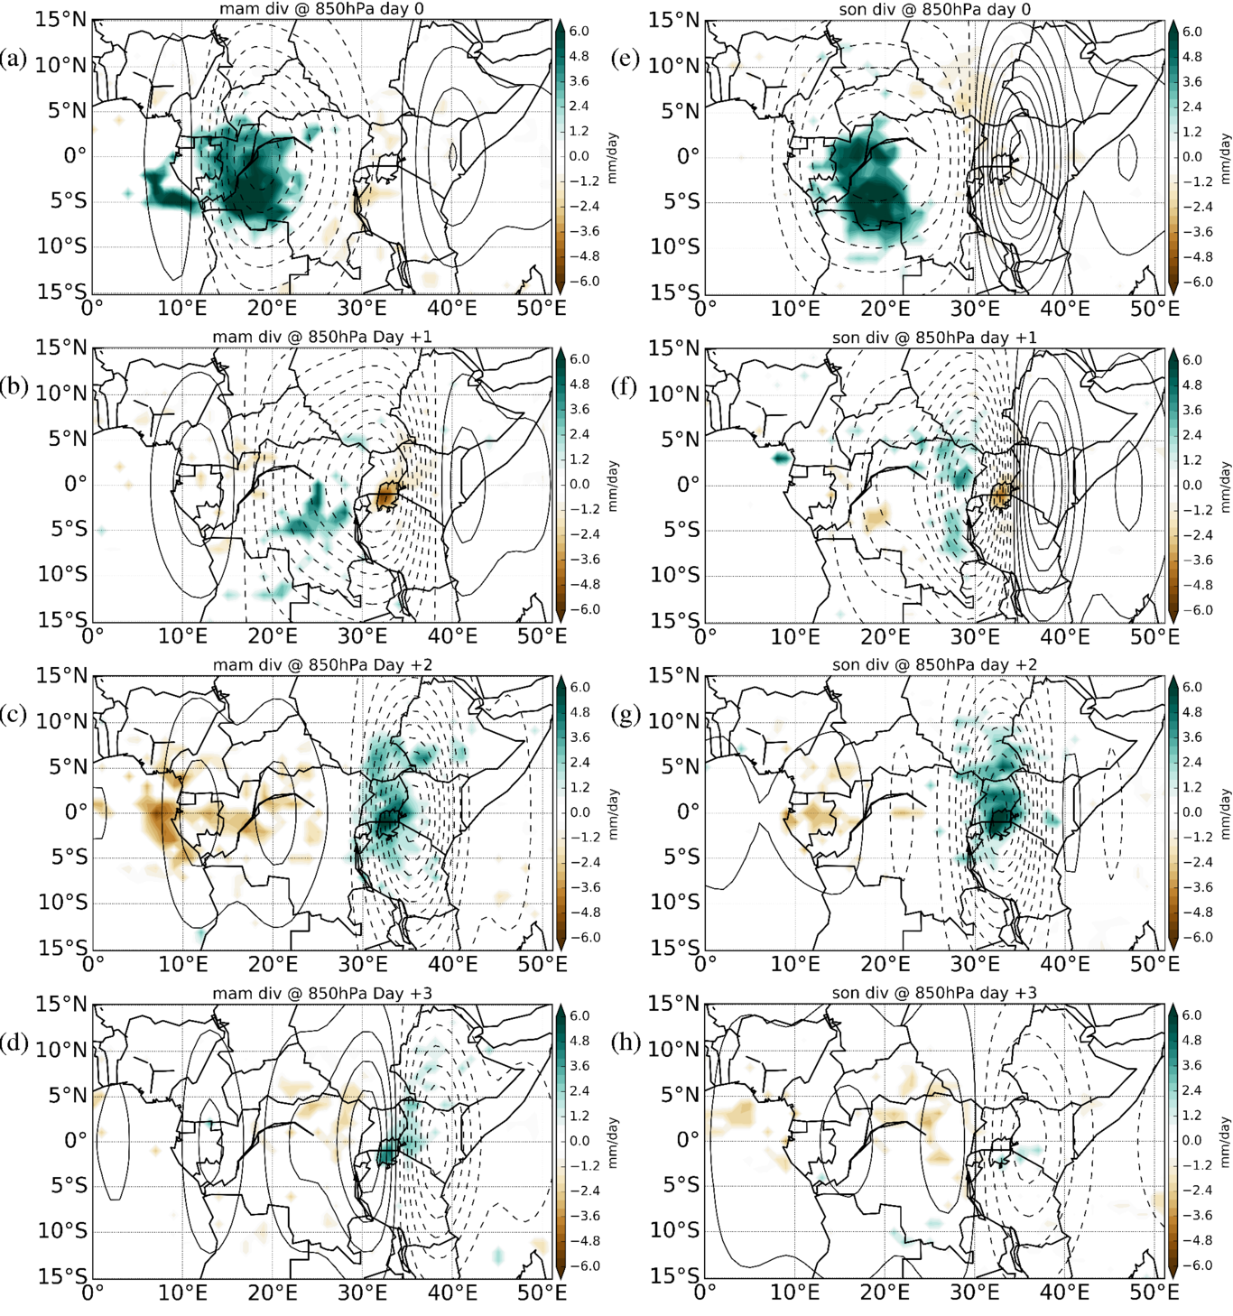
Lagged composite of events for (a, b, c, d) MAM and (e, f, g, h) SON for lag day 0, +1, +2, and +3, respectively. Precipitation anomalies that are statistically significant at the 95% confidence level are shaded. The contour lines show the 850 hPa Kelvin wave divergence (dashed lines negative). Contour line interval is 1.1x10⁻⁷s⁻¹.
Composites of the mean sea level pressure in all the seasons indicate that on day -2 and day -1, positive mean sea level pressure anomalies dominate the Atlantic Ocean while negative mean sea level pressure anomalies dominate the Indian Ocean (not shown). The positive mean pressure anomalies are seen to shift eastward on day 0, +1, +2, +3 and day +4. The orientation of the West-East pressure gradient is an indication of a travelling large-scale tropical disturbance.
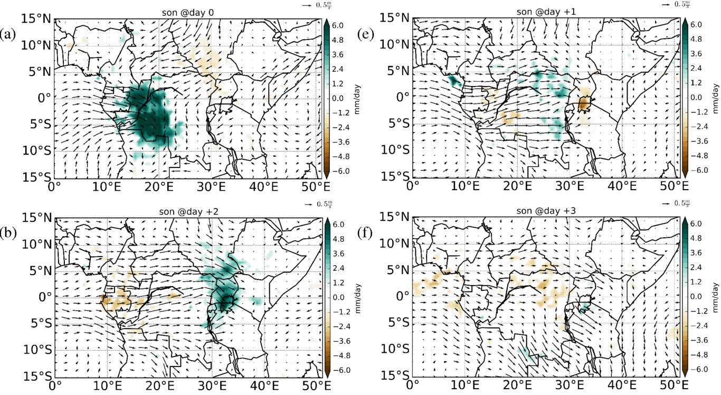
Composite of SON daily TRMM precipitation anomalies (shaded) and SON 850 hPa wind anomalies (vectors) on (a) day 0, (b) day +1, (c) day +2 and (d) day +3. Only precipitation anomalies that are statistically significant at the 95% level are shown. The wind vectors are plotted regardless of statistical significance.
Figure 8 shows a composite of SON daily precipitation anomalies and 850 hPa horizontal wind anomalies. First, it is evident in all the panels that there is low-level convergence into the region of strong wet anomalies. Second, this figure shows a wave-like signature. The trailing end of dry anomalies (at about 32ºE) in Figure 8e is dominated by wet anomalies and to the west of this, dry anomalies are seen, while further west (at about 9ºE) weak wet anomalies can be seen. This shows a “dry-wet-dry-wet” pattern, which further highlighting the role of a convectively coupled wave in modulating the 1-2 day precipitation linkage between WEA and EEA.
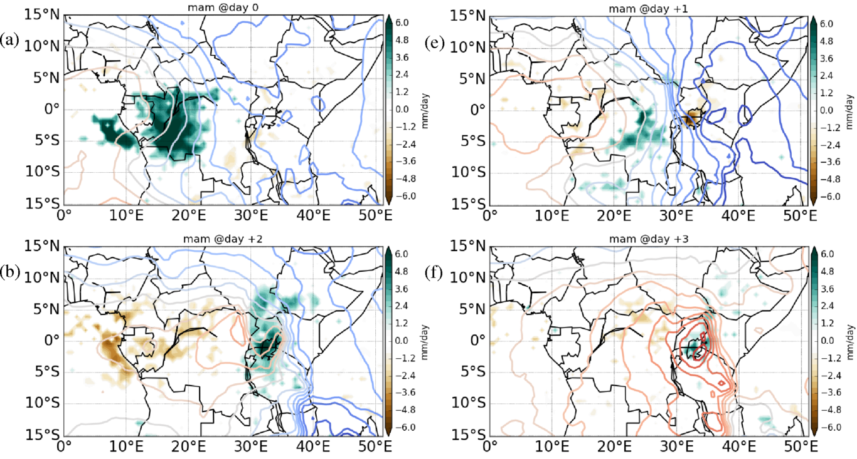
Composite of MAM daily TRMM precipitation anomalies (shaded) and MAM 850hPa geopotential height anomalies (contour lines) for (a) day 0, (b) day +1, (c) day +2 and (d) day +3. Only precipitation anomalies that are statistically significant at the 95% level are shown, and warm-coloured contours indicate positive geopotential height anomalies while cool-coloured contours correspond to negative anomalies. Contour line interval is 5.0x10⁻¹ geopotential metres (gpm).
Figure 9 shows a composite of MAM daily precipitation anomalies and 850hPa geopotential height anomalies. Positive geopotential height anomalies are seen to advance eastward in coherence with the wet anomalies from lag day 0 to lag day +3. It can be seen in Figure 9 that generally, the positive geopotential anomalies are in phase with the low level westerly wind anomalies in Figure 8. Figure 9 provides further evidence of a Kelvin wave.
Given that previous work has suggested that the MJO influences precipitation over sub-regions in EEA (e.g (Pohl 2006) ), it can be speculated that the MJO may have a role in the propagation of wet anomalies from WEA onto EEA. Consequently, we investigated whether the events identified in Section 5 occur in a preferred MJO phase using the Real-time Multivariate MJO Index; RMM1 and RMM2 (Wheeler and Hendon, 2004) . Our results indicate that the 2-day precipitation relationship may not be dependent on MJO activity, since no particular MJO phase is favourable for the occurrence of the events (not shown).

Summary
This study examines daily precipitation anomalies, ERA-I dynamical fields and a novel equatorial wave dataset. The aim of the study was to investigate the relationship in precipitation between Western Equatorial Africa (WEA) and Eastern Equatorial Africa (EEA) by considering small sub-regions in the domain of interest. The study started by identifying the sub-regions that exhibited similar daily precipitation characteristics using an EOT analysis. In doing so, the daily precipitation anomalies were used to objectively identify sub-regions of similar daily precipitation characteristics, rather than relying on a subjective identification.
Lead/lag correlation coefficients were calculated, as well as spatio-temporal correlation coefficient patterns between time-series averaged over a sub-region and grid -point timeseries. The lead/lag correlation analysis shows statistically significant peak correlation coefficient on day +1 to day +2, suggesting that precipitation over EEA lags that in WEA by 1-2 days. It is also seen that the lag at which the correlation coefficient peaked is contingent upon the distance between the sub-regions. For sub-regions that are far apart (e.g. W1 and E1), the correlation coefficient peaked at day +2 while for the sub-regions that were close to one another (e.g. W4 and E1), the correlation coefficient peaked on day +1. This suggests a coherently propagating synoptic-scale system.
Consistent with the results of the lead/lag correlations between the various sub-regions, the spatio-temporal correlation coefficient patterns have revealed a coherent eastward/northeastward propagating signal. The propagation structure of the coherent eastward/northeastward signal (with an estimated speed of about 12 m s-1) suggests a role of a large-scale disturbance in modulating the precipitation relationship between WEA and EEA. Furthermore, the contrasting signal shown in the patterns between the Highlands in South Sudan (E2) and Central WEA has highlighted a weak precipitation dipole. This result lends support to the findings in Mekonnen et al. (2016), who proposed a dipole relationship in convective activity between East Africa and the Congo Basin.
The structure of the spatio-temporal correlation patterns for the other sub-regions (not shown) over lag day 0, -1, -2, and -3 suggest that while precipitation over EEA has a 1-2 day relationship with precipitation over WEA, precipitation over several sub-regions in EEA is also influenced by various features not necessarily propagating from WEA but rather persisting within EEA. This is consistent with earlier studies that have suggested the “localness”’ of precipitation over EEA (e.g Nicholson 2011).
The identification of events in the various seasons allowed a further investigation as to the driver modulating the 1-2 day precipitation connection. Using a novel Equatorial wave dataset, the collocation of wet anomalies and Kelvin Wave convergence was evident in a time-longitude plot (Fig. 5) and composites (Fig. 7, 8). As shown in Wheeler et al. (2015), it is also seen that anomalous westerly flow and wet anomalies in Figure 8 are in phase with the positive geopotential height anomalies in Figure 9. This suggests that CCKWs play a role in modulating the 1-2 day precipitation connection between WEA and EEA in most seasons, more particularly during March-April-May and September-October-November. This is consistent with findings in Zipser et al. (2006), who found an apparent occurrence of intense convection in all seasons over WEA. Our results have therefore highlighted the importance of considering the role of CCKWs in synoptic-timescale forecasting, particularly over EEA. Ongoing work is investigating this precipitation relationship in convection-permitting model simulations using the Pan-African Convection-Permitting Regional Climate Simulation from the Met Office Unified Model (CP4-Africa).

Supplementary Material

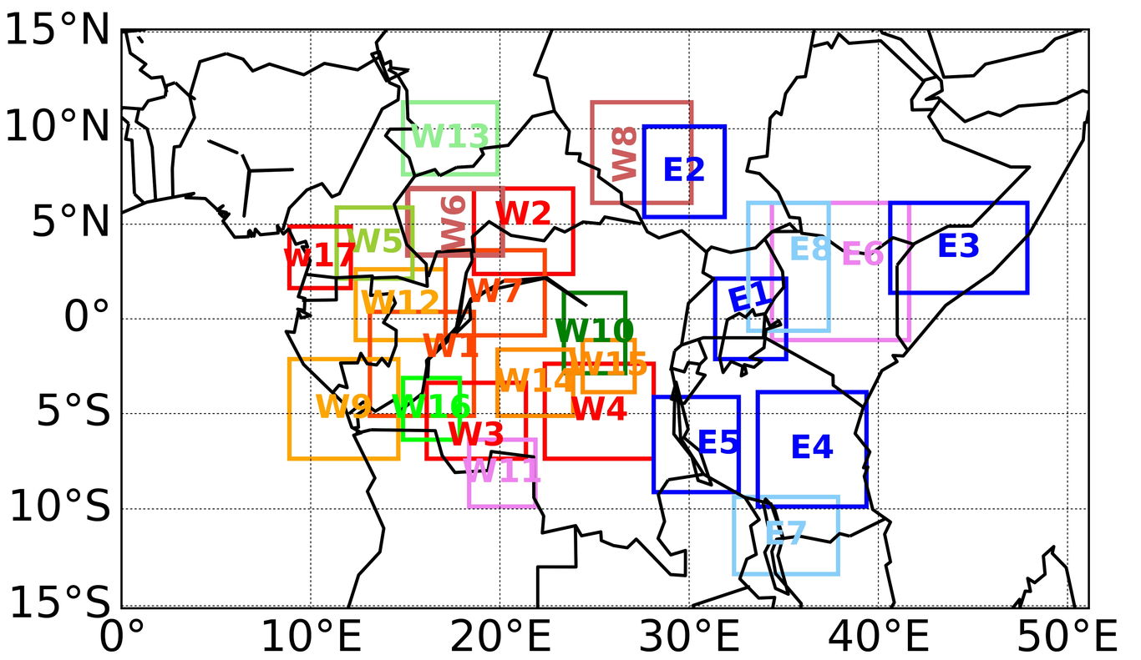
The sub-regions identified by subjecting 16-years of daily TRMM anomalies to an Empirical Orthogonal Teleconnection algorithm as described in section 3. The sub-regions over the Oceans and those whose base-points were along the 29º E (boundary to delineate WEA from EEA) were disregarded. The letter “W” attached to the number indicates that the sub-region is located in Western Equatorial Africa and “E” likewise for EEA. Since the order in which these sub-regions were identified does not matter, they were renamed for clarity.

References
Baranowski, D.B., Flatau, M.K., Flatau, P.J., Matthews, A.J., 2016. Impact of atmospheric convectively coupled equatorial Kelvin waves on upper ocean variability. Journal of Geophysical Research: Atmospheres 121, 2045–2059.
Berhane, F., Zaitchik, B., 2014. Modulation of daily precipitation over East Africa by the Madden–Julian oscillation. Journal of Climate 27, 6016–6034.
Black, E., Tarnavsky, E., Maidment, R., Greatrex, H., Mookerjee, A., Quaife, T., Brown, M., 2016. The use of remotely sensed rainfall for managing drought risk: A case study of weather index insurance in Zambia. Remote Sensing 8, 342.
Dee, D.P., Uppala, S.M., Simmons, A.J., Berrisford, P., Poli, P., Kobayashi, S., Andrae, U., Balmaseda, M.A., Balsamo, G., Bauer, d P., others, 2011. The ERA-Interim reanalysis: Configuration and performance of the data assimilation system. Quarterly Journal of the royal meteorological society 137, 553–597.
Dezfuli, A.K., 2011. Spatio-temporal variability of seasonal rainfall in western equatorial Africa. Theoretical and applied climatology 104, 57–69.
Dinku, T., Ceccato, P., Grover-Kopec, E., Lemma, M., Connor, S.J., Ropelewski, C.F., 2007. Validation of satellite rainfall products over East Africa’s complex topography. International Journal of Remote Sensing 28, 1503–1526.
Duvel, J.P., 1990. Convection over tropical Africa and the Atlantic Ocean during northern summer. Part II: Modulation by easterly waves. Monthly Weather Review 118, 1855–1868.
Gebremicael, T.G., Mohamed, Y.A., Zaag, P.van der, Gebremedhin, A., Gebremeskel, G., Yazew, E., Kifle, M., 2019. Evaluation of multiple satellite rainfall products over the rugged topography of the Tekeze-Atbara basin in Ethiopia. International Journal of Remote Sensing 40, 4326–4345.
Geerts, B., Wheeler, M., 1998. The Madden-Julian oscillation. Naval Maritime Forecast Center/Joint Typhoon Warning Center (NMFC/JTWC), Pearl Harbor.
Gill, A.E., 1980. Some simple solutions for heat-induced tropical circulation. Quarterly Journal of the Royal Meteorological Society 106, 447–462.
Graham, R., Visman, E., Wade, S., Amato, R., Bain, C., Janes, T., Leathes, B., Lumbroso, D., Cornforth, R., Boyd, E., others, 2015. Scoping, options analysis and design of a ‘Climate Information and Services Programme’for Africa (CIASA): literature review.
Huffman, G.J., Adler, R.F., Morrissey, M.M., Bolvin, D.T., Curtis, S., Joyce, R., McGavock, B., Susskind, J., 2001. Global precipitation at one-degree daily resolution from multisatellite observations. Journal of hydrometeorology 2, 36–50.
Indeje, M., Semazzi, F.H.M., Ogallo, L.J., 2000. ENSO signals in East African rainfall seasons. International Journal of Climatology: A Journal of the Royal Meteorological Society 20, 19–46.
Janicot, S., Mounier, F., Hall, N.M.J., Leroux, S., Sultan, B., Kiladis, G.N., 2009. Dynamics of the West African monsoon. Part IV: Analysis of 25–90-day variability of convection and the role of the Indian monsoon. Journal of Climate 22, 1541–1565.
Kiladis, G.N., Wheeler, M.C., Haertel, P.T., Straub, K.H., Roundy, P.E., 2009. Convectively coupled equatorial waves. Reviews of Geophysics 47.
Liebmann, B., Kiladis, G.N., Carvalho, L.M.V., Jones, C., Vera, C.S., Bladé, I., Allured, D., 2009. Origin of convectively coupled Kelvin waves over South America. Journal of Climate 22, 300–315.
Lindzen, R.S., 2003. The interaction of waves and convection in the tropics. Journal of the atmospheric sciences 60, 3009–3020.
Matsuno, T., 1966. Quasi-geostrophic motions in the equatorial area. Journal of the Meteorological Society of Japan. Ser. II 44, 25–43.
Mekonnen, A., Thorncroft, C.D., 2016. On mechanisms that determine synoptic time scale convection over East Africa. International Journal of Climatology 36, 4045–4057.
Mekonnen, A., Thorncroft, C.D., Aiyyer, A.R., Kiladis, G.N., 2008. Convectively coupled Kelvin waves over tropical Africa during the boreal summer: Structure and variability. Journal of Climate 21, 6649–6667.
Mounier, F., Kiladis, G.N., Janicot, S., 2006. West african monsoon dynamics: evidence of convectively coupled Kelvin waves.
Nguyen, H., Duvel, J.-P., 2008. Synoptic wave perturbations and convective systems over equatorial Africa. Journal of Climate 21, 6372–6388.
Nicholson, S.E., 2011. Dryland climatology. Cambridge University Press.
Ongoma, V., Chen, H., Omony, G.W., 2018. Variability of extreme weather events over the equatorial East Africa, a case study of rainfall in Kenya and Uganda. Theoretical and applied climatology 131, 295–308.
Pohl, B., Camberlin, P., 2006. Influence of the Madden–Julian oscillation on East African rainfall: II. March–May season extremes and interannual variability. Quarterly Journal of the Royal Meteorological Society: A journal of the atmospheric sciences, applied meteorology and physical oceanography 132, 2541–2558.
Reed, R.J., Norquist, D.C., Recker, E.E., 1977. The structure and properties of African wave disturbances as observed during Phase III of GATE. Monthly Weather Review 105, 317–333.
Roundy, P.E., 2008. Analysis of convectively coupled Kelvin waves in the Indian Ocean MJO. Journal of the Atmospheric Sciences 65, 1342–1359.
Schlueter, A., Fink, A.H., Knippertz, P., Vogel, P., 2019. A systematic comparison of tropical waves over northern Africa. Part I: Influence on rainfall. Journal of Climate 32, 1501–1523.
Sinclaire, Z., Lenouo, A., Tchawoua, C., Janicot, S., 2015. Synoptic Kelvin type perturbation waves over Congo basin over the period 1979–2010. Journal of Atmospheric and Solar-Terrestrial Physics 130, 43–56.
Smith, I., 2004. An assessment of recent trends in Australian rainfall. Australian Meteorological Magazine 53, 163–173.
Stephan, C.C., Klingaman, N.P., Vidale, P.L., Turner, A.G., Demory, M.-E., Guo, L., 2017. A comprehensive analysis of coherent rainfall patterns in China and potential drivers. Part I: Interannual variability. Climate Dynamics 1–20.
Taylor, R.G., Favreau, G., Scanlon, B.R., Villholth, K.G., 2019. Topical Collection: Determining groundwater sustainability from long-term piezometry in Sub-Saharan Africa. Hydrogeology Journal 27, 443–446.
Van den Dool, H.M., Saha, S., Johansson, .A., 2000. Empirical orthogonal teleconnections. Journal of Climate 13, 1421–1435.
Ventrice, M.J., Thorncroft, C.D., Janiga, M.A., 2012. Atlantic tropical cyclogenesis: A three-way interaction between an African easterly wave, diurnally varying convection, and a convectively coupled atmospheric Kelvin wave. Monthly Weather Review 140, 1108–1124.
Wheeler, M., Kiladis, G.N., 1999. Convectively coupled equatorial waves: Analysis of clouds and temperature in the wavenumber–frequency domain. Journal of the Atmospheric Sciences 56, 374–399.
Wheeler, M.C., Hendon, H.H., 2004. An all-season real-time multivariate MJO index: Development of an index for monitoring and prediction. Monthly Weather Review 132, 1917–1932.
Yang, G.-Y., Hoskins, B., Slingo, J., 2003. Convectively coupled equatorial waves: A new methodology for identifying wave structures in observational data. Journal of the atmospheric sciences 60, 1637–1654.
Yang, G.-Y., Methven, J., Woolnough, S., Hodges, K., Hoskins, B., 2018. Linking African easterly wave activity with equatorial waves and the influence of Rossby waves from the Southern Hemisphere. Journal of the Atmospheric Sciences 75, 1783–1809.
Zaitchik, B.F., 2017. Madden-Julian Oscillation impacts on tropical African precipitation. Atmospheric Research 184, 88–102.

