Nonlinear inversion approaches to study the Bouger gravity anomaly of Covington pluton
Anuradha Mahanama
This study has done with a set of Bouguer gravity anomaly data along with the geographic locations of Covington Pluton which located in the Mississippi Embayment area. Three different types of nonlinear inversion algorithms; Monte Carlo method, Newton’s method and Simulate Aneling method have applied to find the estimates for the source depth and the density contrast of the pluton. The forward model assumed that there is a spherical mass excess in the pluton that gives a positive Bouguer gravity anomaly at the surface. According to the results of the three inversion approaches, the simulated aneling method gave us reasonable estimates compared to the other two methods. Results from the simulated aneling suggest the source depth of the Covington pluton should be lower as 2.5 km and density contrast close to 250 kgm⁻³.
1 Introduction
2 Data & Data correction
3 Theory
3.1 Bouger gravity anomaly
4 Methodology
4.1 Monte Carlo method
4.2 Newton’s method
4.3 Simulated Annealing method
5 Results
6 Discussion & Conclusion
7 Acknowledgment

1 Introduction
In Central and Eastern Unites states, the New Madrid area becomes the most seismically active region due to the area covered by Tertiary and Cretaceous sedimentary rocks with unconsolidated Quaternary sediments ^{1,2}. So, the potential-field geophysics has played a major role in interpreting the geologic framework of the Mississippi Embayment region. Potential- field studies have revealed the ancient rift system and buried plutons as a major factor of the distribution of seismicity ³. One of the few studies in the Mississippi Embayment area has focused on the detailed gravity and ground-magnetic data that collected over the Reelfoot scrap to investigate the small- amplitude, short-wavelength anomalies that caused by shallow sources ⁴.
Several detailed gravity profiles in the Reelfoot graben reveal unexpected local variation in gravity values and distinguish small-amplitude anomalies characterized by sudden changes in gradient ⁴. They suggest these anomalies may be caused by either shallow igneous intrusions (where the anomalies correlate with small gravity anomalies) or post-unconformity faulting. They have filtered the gravity data to improve short-wavelength features reveal the locations of density contrasts that correspond to observed subsurface faults cutting the Cretaceous unconformity ^{1,4}.
There were several plutons discovered using both gravity and magnetic surveys; Bloomfield, Paragould, Malden, and Covington are few of them located in the North Mississippi Embayment and surrounding regions ⁴. The Covington Pluton is one of the most pronounced plutonic masses seen in potential studies in the New Madrid seismic region which located at 35⁰35’N and 89⁰35’W (fig.1)⁵. Based on the location of hypocenters and earthquake focal mechanisms, there is no evidence that stress concentration correlated with the mass excess of the pluton is the cause of seismicity near the pluton. The seismicity is probably along zones of weakness independent of the pluton ⁴. The Covington pluton is widespread more than 50 km wide, slightly blocky high on the unfiltered gravity. On the filtered gravity maps, this broad high part divided into two to three isolated anomalies; the central high most closely follows the gravity anomaly of the Covington pluton, a tiny anomaly extended in both east-west and northeast-southwest directions ^{5,4}.
One such anomaly has been drilled: a well near the Covington pluton in southwestern Tennessee confronted nepheline syenite directly beneath Upper Cretaceous sedimentary rocks. The age of the pluton has claimed as post-Ordovician and pre-Late Cretaceous and depth estimated as shallower as 2 to 4km deep along with a width of 40 to 50 km ⁴. Due to the presence of the pluton in such shallow depth, there is a mass excess in the Covington area that gives a positive gravity anomaly. This study is mainly focused on determining the accurate source depth and the density contrast of the Covington pluton region using Bouguer gravity anomaly data. To estimate accurate parameters, three Nonlinear inversion methods; Newton’s method, Monte Carlo method, and Simulated Annealing method has used with the support of a forward model and other required geological parameters.
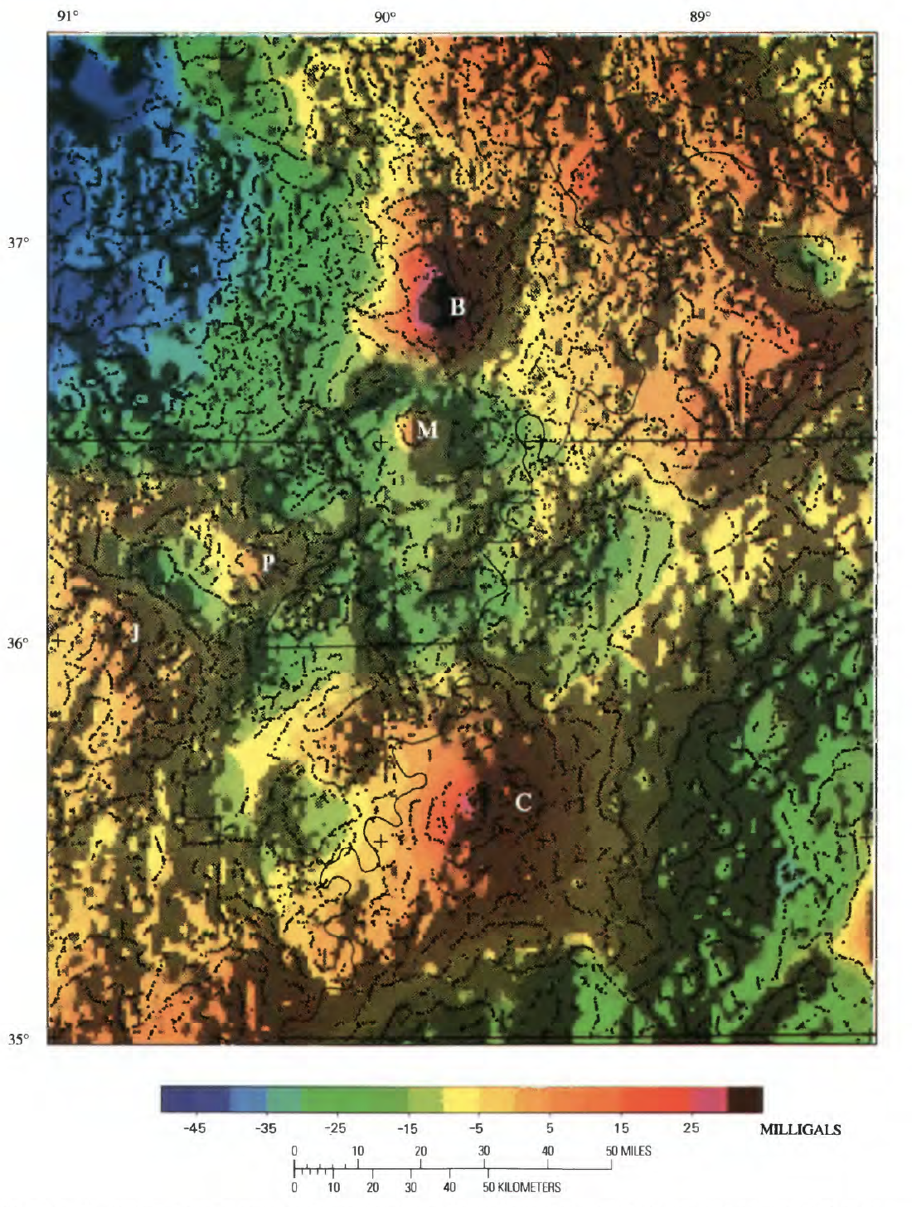
Map of Bouguer gravity of the northern Mississippi Embayment. Illumination is from the west. The Contour interval is 5 mGal. Dots indicate positions of maximum horizontal gravity gradient (density boundaries). B, Bloomfield pluton; C, Covington pluton; J, Jonesboro pluton; M, Maiden pluton; P, Paragould pluton. State boundaries are shown as solid lines ⁴.

2 Data & Data corrections
The Bouguer gravity anomaly data was downloaded for the Covington pluton region from the National Center for Environmental Information (NOAA) (fig. 2). The Bouguer gravity map of the New Madrid region was composed of several data sets that incorporate more than 14,800 gravity stations. The average station spacing is around 2 km with several gaps along the Mississippi River and over wildlife refuges and lakes ^{4,6}. The data have been corrected to free-air gravity values using standard formulas. Bouguer and terrain corrections were fitted to the free-air value at each station to determine the full Bouguer gravity anomalies using a standard reduction density of 2.67 g/cm3⁶. The data have been edited to remove single-station anomalies and then gridded using a 1-km interval. All observed gravity values were referenced to the IGSN71 datum as specified by and were then reduced to create Bouguer anomaly values using standard formulas. The accuracy of the measurements is around 0.2 mGal ^{4,6}.
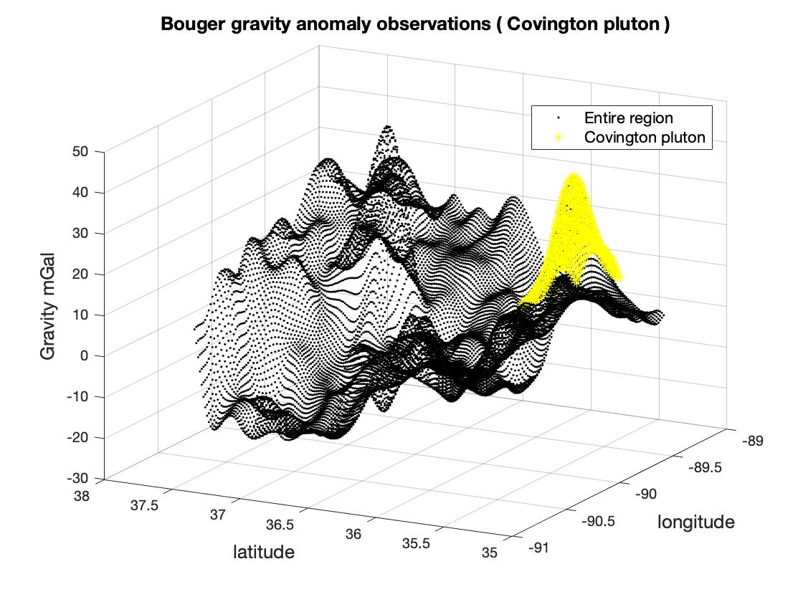
Bouguer gravity anomaly data for the New Madrid region. The Yellow color area is the Covington pluton used for this study.

3 Theory

3.1 Bouger gravity anomaly
Bouger gravity anomaly is a discrepancy between the corrected, measured gravity, and the theoretical gravity. It arises as the density of the Earth’s interior is not homogeneous as assumed. Bouguer gravity anomaly is one of the most common types of gravity anomalies. It (DgB) is defined by Equation (01) where g_{m} and g_{n} are the measured and theoretical gravity respectively, and Dg_{F,} DgBP, Dg_{t}, and Dg_{tide} are the free-air, Bouguer plate, terrain, and tide corrections respectively ⁷.
Equation 01:

$Δg_{B}=g_{m}+(Δg_{F}−Δg_{BP}+Δg_{J}+Δg_{tide})−g_{n}$
Due to the simplicity, we assume that there is an amount of excess mass with a spherical shape, the effect of a roughly equidimensional ore body is quite similar to that of a sphere, so our model is not entirely inappropriate. Because we calculate Bouguer anomalies in terms of density variations, we speak in terms of the density contrast when considering the gravity effects of models. The density contrast is the density of the model minus the density of the remaining material. Which we assume to be homogeneous. Derivation of an equation for the gravity effect of a sphere is relatively straight forward because the effect is the same as if all the mass is concentrated at the sphere’s center. Because we deal with the vertical component of gravimeters we need to consider only the vertical component. The gravity anomaly data (fig. 3), g, can be generated by using the Equation (02), where a is the radius of the buried sphere, Dr is the density contrast, G is Newton’s universal gravity constant, Z_{S} is the depth of the sphere center, and r is the distance of the sphere center from the reference point. ‘r’ can be expressed by Equation (03), where, x, y, and z are the longitudes latitudes and depth of the observed locations respectively.
Equation 02:
$g=3/4πa^{3}DrGZ_{s}/r^{3}$
Equation 03:
$r = \sqrt{x^{2}+y^{2}+z_{s}^{2}}$
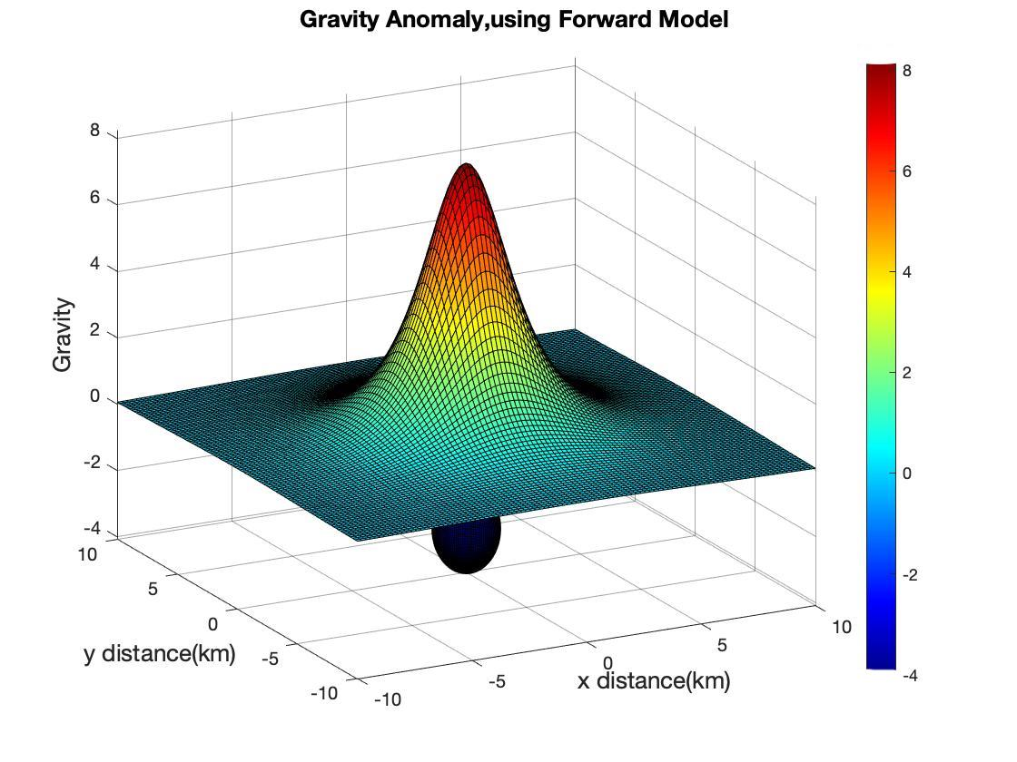
Illustration of the gravity anomaly due to a buried spherical excess mass using forward model

4 Methodology
To compute the estimates for the source depth and the density contrast of the igneous intrusion, three nonlinear approaches were used with the help of the above-mentioned forward model (Equation 02). For all three approaches, 5000m used as the radius (a) of the sphere and 6.67 X 10⁻¹¹kg⁻¹s⁻²m³ as the Universal gravitational constant (G). Bouguer gravity anomaly data has converted to ms⁻² and the geographic coordinates converted to XY, before using in the inversions.

4.1 Monte Carlo method
Monte Carlo method is a nonlinear approach that we can use to find estimates for a single parameter or multiple parameters of a function. As the initial step, we did a grid search to compute the error function for a large grid of trial solutions. For the grid of solutions, I used trial values from 2000km to 7000km for the depth estimations and 200kgm⁻³ to 2000kgm⁻³ for the density contrast estimations. Then, each trial solution has randomly generated independently of previous ones. Estimations for the two parameters were drawn comparing the errors after a number of iterations.

4.2 Newton’s method
In Newton’s method, we start with the same approach as the Monte Carlo method by making an error function using a large grid of trial solutions. Then, the nonlinear inversion problem has solved using the information on the shape of the error. We used the derivatives of error at each trial solution to find the shape of the error. Using Taylor’s theorem, and keeping its first three terms, we obtained a parabolic approximation and find the estimates for the parameters⁸.

4.3 Simulated Annealing method
This is a nonlinear inversion method that combines the best features from both Newton and Monte Carlo methods. This method samples the entire model space and uses local information to direct the sequence of trial solutions as Newton’s method ⁹. The initial approach is the same as the above mentioned two methods. The simulated annealing method starts with a trial solution m(p) with corresponding error Em(p). Then, a test solution m* with corresponding error E(m*) generated which falls neighboring to m(p). Condition to accept the test solutions as the new trial solution m(p+1) will be, when E(m*) < Em(p) or sometimes accepted even when E(m*)> Em(p). To decide the second case, a test parameter (t) should be calculated. A random number r that is evenly distributed on the interval [0, 1] is generated and the solution m* is accepted if t>r. When T is large, the parameter approaches to unity, and m* is almost always accepted, despite the value of the error. When T is small, the parameter t is close to zero, and m* is almost never accepted. This matches to the directed search case, as then the only solutions that decrease the error is accepted ^{10,8}.
Equation 04:
$t=exp[−E(m*)/T)]/exp[−E(m(p)/T)]=exp[−[E(m*)−Em(p)]/T]$

5 Results
After giving 2000 iterations to the Monte Carlo inversion approach we got estimates for the model parameters for the density contrast as 6567 kgm⁻³ and 26.5 km as the source depth of the Covington pluton (fig.4a, 4b). The estimates had a minimum error of 0.2 X 10⁻⁴ with a similar distribution for the predicted and observed gravity anomaly (fig.4c).
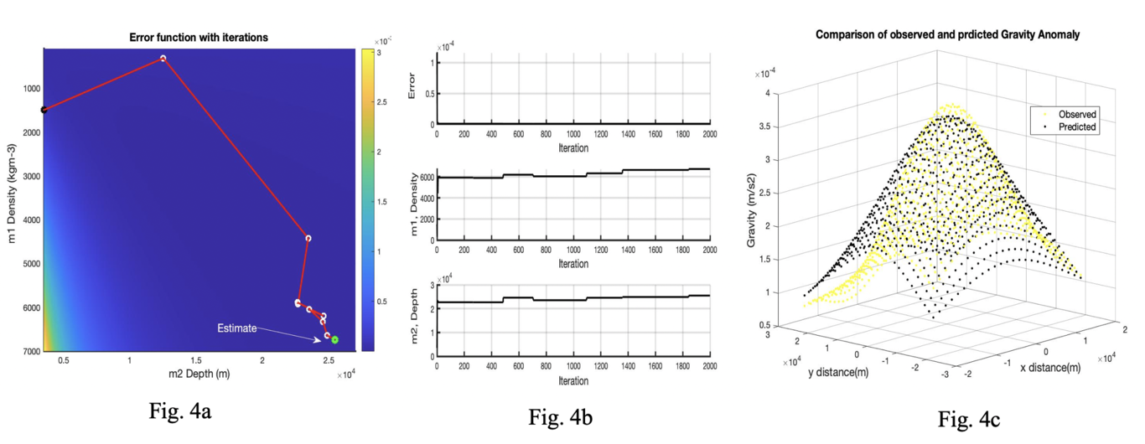
Results from the Monte Carlo method, a) Visualization of the error function and final estimated parameters (green circle), b) Plot of the error and m1, m2 estimation changes with iteration number, c) comparison of observed gravity anomaly and predicted gravity anomaly
Using Newton’s method approach with an initial estimate of 1500 kgm⁻³ and 3km, we got estimates for the model parameters for the density contrast as 6827 kgm⁻³ and 24.7 km as the source depth of the Covington pluton (fig.5a, 5b). We reached the estimates after four iterations with a minimum error of 0.5 X 10⁻³ (fig. 6a), the distribution for the predicted and observed gravity anomaly had a similar distribution (fig.6b).
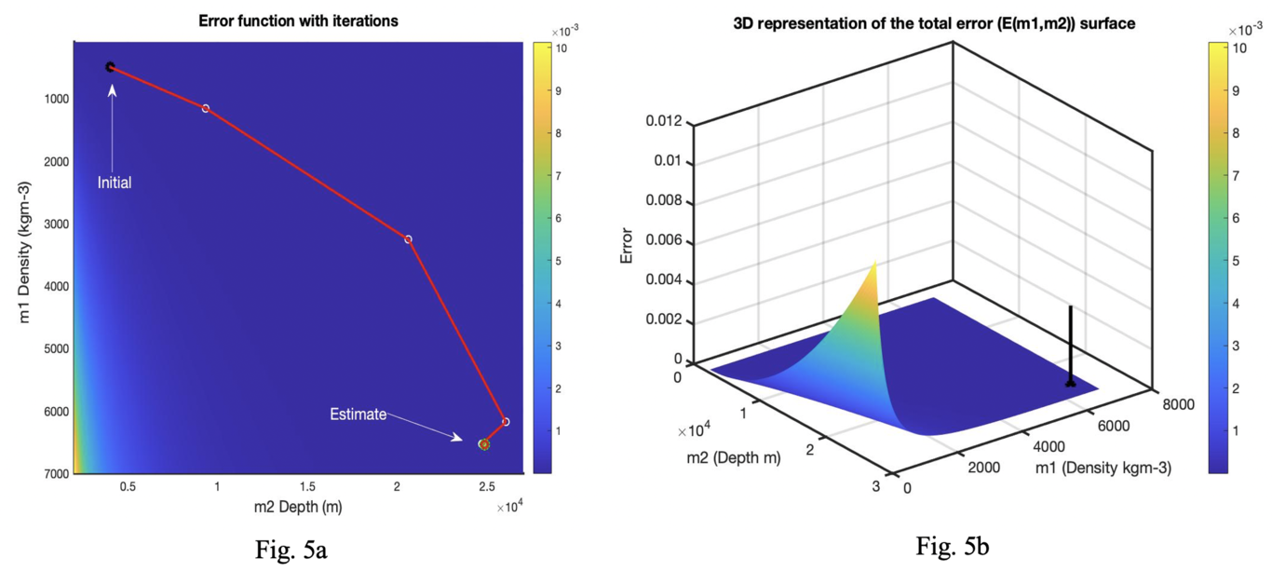
Results from the Newton’s method, a) Visualization of error function, initial model parameters (black circle), and final estimated parameters (green circle), b) 3D representation of the error function and estimated parameters (black line)
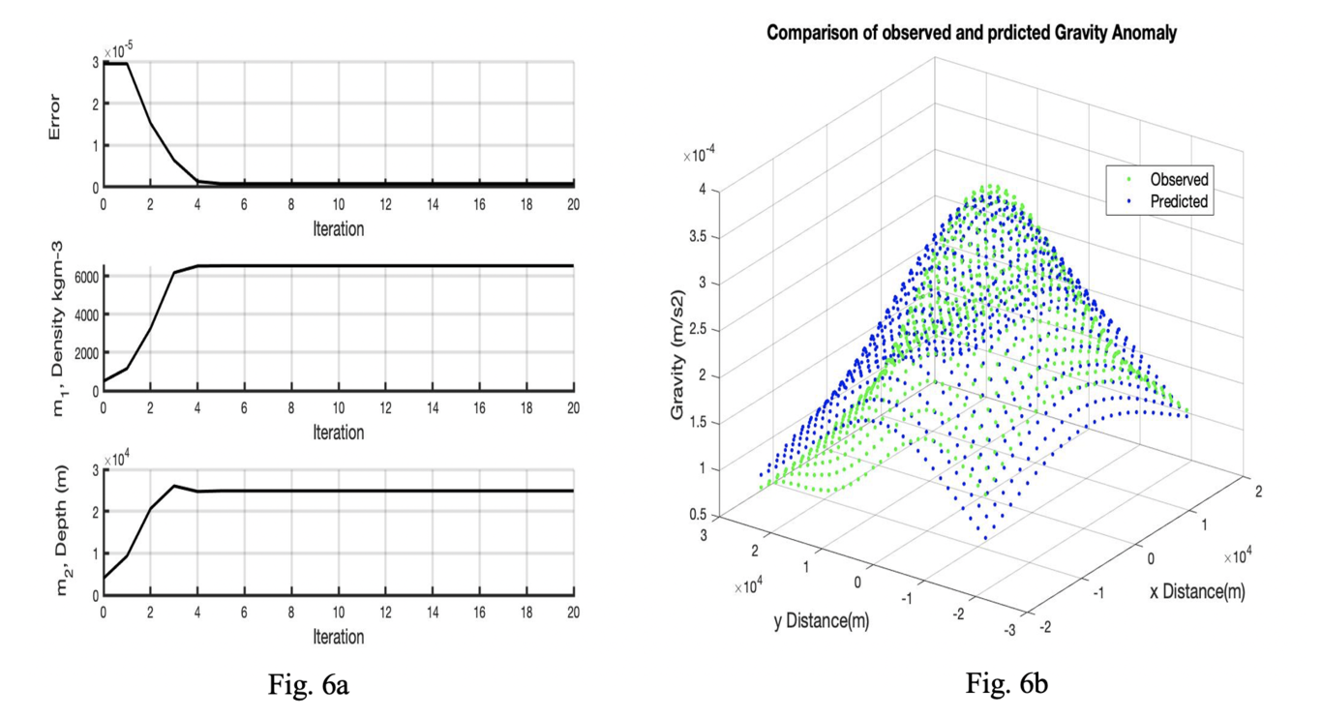
Results from Newton’s method, a) Plot of the error and two estimation changes with iteration number, b) comparison of observed gravity anomaly and predicted gravity anomaly
Using the Simulated Annealing method with 400 fixed iterations, we got estimates for the model parameters as 227 kgm-3 for the density contrast and 2.47 km as the source depth of the Covington pluton (fig.7). We reached the estimates after four iterations with a minimum error of 1 X 10-4 (fig. 8a), the distribution for the predicted and observed gravity anomaly had two different distribution patterns (fig.8b).
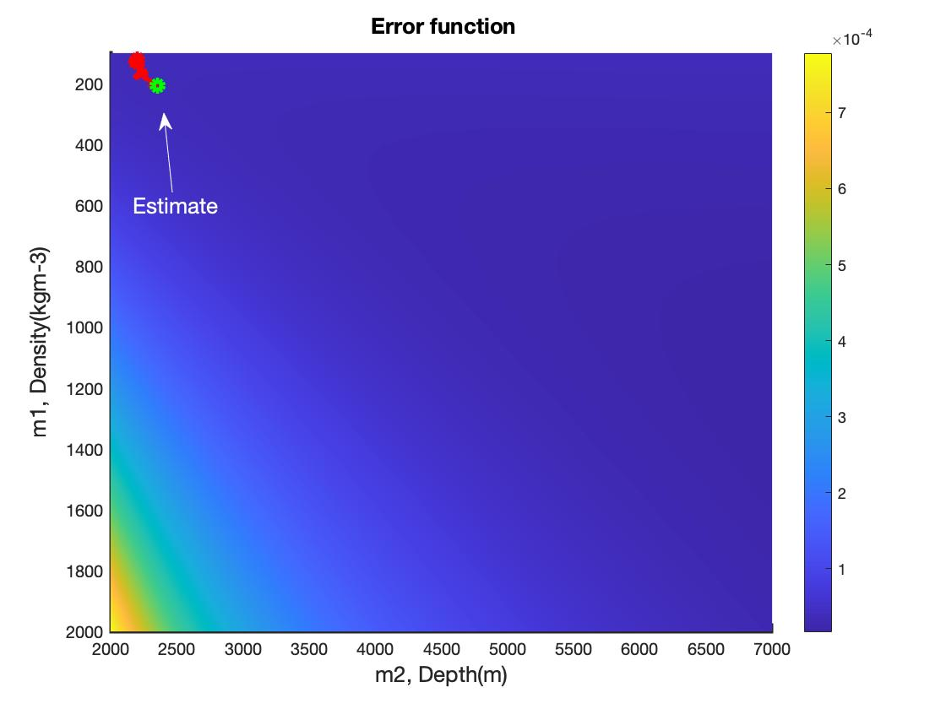
Results of the Simulated Annealing method. Visualization of the error function, initial model parameters(black circle), and final estimated parameters (green circle).
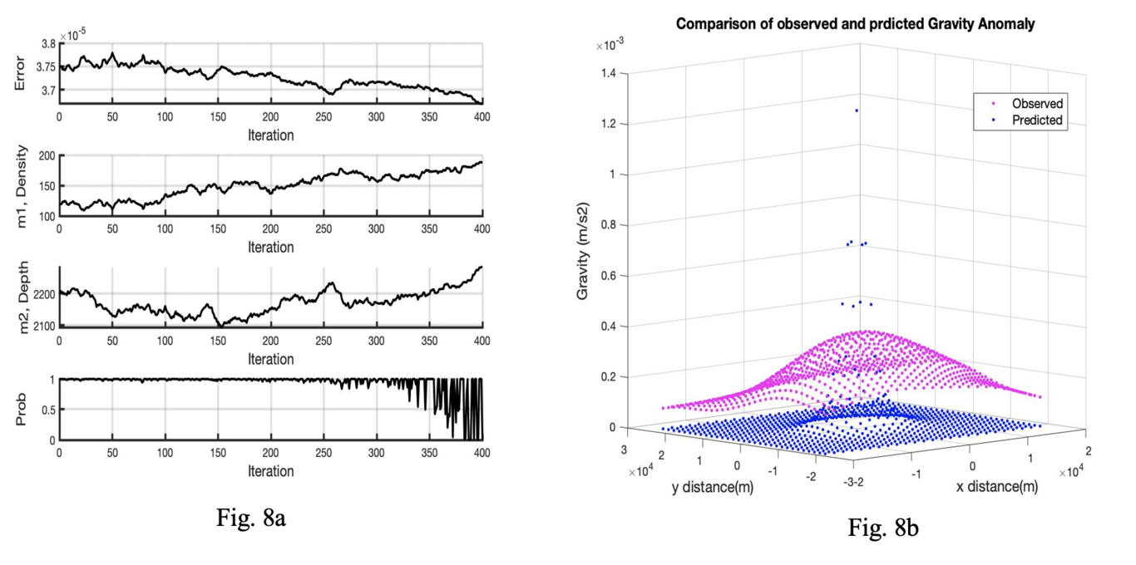
This is a Results from the Simulated Annealing method, a) Plot of the error, two estimation changes with iteration number and probability variation, b) comparison of observed gravity anomaly and predicted gravity anomaly

6 Discussion & Conclusion
Using the observations from 715 gravimeter recordings and applying three different types of nonlinear inversion methods, Monte Carlo and Newton’s method gave comparable results for both model parameters and Simulated Annealing had distinct estimations for the model parameters. According to the prior studies, the depth of the Covington pluton should be shallower with a range of 2 to 5km. Moreover, the density contrast should be around 500 kgm⁻³. Results of the Monte Carlo method and Newton’s method gave almost similar results for the source depth around 24 km and density contrast around 6,500 kgm⁻³ which seems to be higher considering the previous studies. However, simulated annealing results gave us reasonable values for both source depth and density contrast as 2.47 km and 227 kgm⁻³.
The Monte Carlo method is an undirected approach and the whole model space is randomly sampled. If we provide a certain number of trial solutions, the global minimum of the error will be calculated out of that range. Unfortunately, I think the number of trial solutions maybe not enough to find a better solution for this problem and we need to give a higher number for better estimates. Even though we had a good fit with predictions and observations gravity anomalies, the results of the estimates are not that accurate. In contrast, Newton’s method is completely a directed approach but still, it can fit a local minimum except reaching the global minimum of the error and I think that is the reason we got a largely deviated estimates for the model parameters. The simulated annealing method is equipped with a combination of both strength nesses of Newton’s method and Monte Carlo method and the estimated model parameters seem more accurate. Still, to obtain the best estimates the inversion should run for a large number of times and get a set of estimates to find a distribution of estimates and should come up with values from the distribution.
As a conclusion, the source depth of the Covington pluton should be around 2-4 km and the density contrast of the rocks in that region should be lower as 250 kgm⁻³. The simulated annealing method looks a better approach for this study and Newton’s method and the Monte Carlo method should be improved to get accurate estimates. With a facility of a forward model and a widespread of accurate observations of Bouguer gravity anomalies, the nonlinear inversion methods seem a better approach to find estimates for the subsurface materials like igneous intrusions. The inversions can be used along with the reflection, refraction, and resistivity methods for accurate estimates for analyzing subsurface materials without disturbing the surface. If we have a better idea about the shape, the spread of the subsurface materials, and more accurate gravity anomaly observations, I believe we can find more precise estimates for the source depths and density contrasts for studies like this.

7 Acknowledgment
I am very grateful to Dr. Christodoulos Kyriakopoulos for his continuous support throughout the ‘Inverse Methods in Geophysics’ course. It was a hard time for all of us but still, you gave enormous support to finish this project at a higher level. I also want to thank all of my CERI friends for their feedback and guidance.

References
1.Braile, L. W., Hinze, W. J., Keller, G. R., Lidiak, E. G. & Sexton, J. L. Tectonic development of the New Madrid rift complex Mississippi embayment, North America. Tectonophysics 131, 1–21 (1986).
2.Braile, L. W., Keller, G. R., Hinze, W. J. & Lidiak, E. G. An Ancient Rift Complex and its relation to contemporary seismicity in the New Madrid Seismic Zone. Tectonics 1, 225–237 (1982).
3.Csontos, R., Arsdale, R. V., Cox, R. & Waldron, B. Reelfoot rift and its impact on Quaternary deformation in the central Mississippi River valley. Geosphere 4, 145 (2008).
4.Langenheim, V. E. Gravity of the New Madrid Seismic Zone: A Preliminary Study, Issue 1538. (1995).
5.Ravat, D. N., Braile, L. W. & Hinze, W. J. Earthquakes and Plutons in the Midcontinent - Evidence From the Bloomfield Pluton New Madrid Rift Complex. Seismological Research Letters 58, 41–52 (1987).
6.Applied Geophysics by Telford Geldart Sheriff - AbeBooks.
7.Nozaki, K. The generalized Bouguer anomaly. Earth Planets and Space 58, 287–303 (2006).
8.Geophysical Data Analysis.
9.Hirata, N. & Matsuura, M. Maximum-likelihood estimation of hypocenter with origin time eliminated using nonlinear inversion technique. Physics of the Earth and Planetary Interiors 47, 50–61 (1987).
10.Sen, M. K. & Stoffa, P. L. Nonlinear one-dimensional seismic waveform inversion using simulated annealing. GEOPHYSICS 56, 1624–1638 (1991).

