The Optimum Conditions of the Barlat-Lian Yield Criteria to Investigate the Formability of FCC and BCC Materials
Roya Darabi
Hamed Deilami Azodi
Mostafa Habibi
This paper presents the optimum exponent of Barlat-Lian (1989) yield function which defines the yield surface shape for different materials under plane stress condition. The predictions of the optimum exponents of Barlat-Lian (1989) yield function are derived and then compared with the experimental data for these materials to allow a better representation of the plastic behavior of the orthotropic sheet metals. The results show that contrary to what it was supposed to be up to now the optimum exponent of Barlat-Lian could be have different values for verity of face and body centered cubic types of materials case by case.
Nomenclature:
$σ_{i}$ | Principal stress components | $t$ | Thickness of sheet
$f$ | Yield function | $R_{G}$ | Initial surface roughness
$a$ | Barlat-Lian yield exponent | $k$ | Grain size coefficient
$r_{0}$ , $r_{90}$ | Anisotropy coefﬁcients at $0$and $90$from rolling direction | $\overset{\overline{}}{ε}$ | Effective strain
$r$ | Normal anisotropy coefﬁcient | $d_{0}$ | Grain size
$ε_{i}$ | Principal strain component | $h_{0}$ | Initial coefﬁcient of heterogeneity
dγ | Proportionality factor | $h$ | Coefﬁcient of heterogeneity
Conflict of Interest: The authors declare that they have no conflict of interest
Introduction
In order to achieve the safe formability against occurred defects throughout forming process, forming limit diagram (FLD) commonly is used. The FLD is a plot of the major strains versus the minor strain which is obtained at the onset of localized necking condition (Nguyen et al., 2009). This curve defines the maximum permissible major strain with respect to the minor strain above which failure may be occurred in the deformed sheet (Darabi et al., 2017; Alipour et al., 2019; Habibi et al., 2018a; Al-Ghamdi and Hussain, 2016; Ahmed et al., 2010; Cui et al., 2019; Habibi et al., 2018b). The plasticity plays a fundamental role in designing metal products and controlling the process. In plasticity, yield functions are critical because they provide the yielding point of the material and also when used within an associated flow rule scheme, they describe the plastic flow of the metal accurately (Otorabad et al., 2018; Cardoso and Adetoro, 2017; Bae et al., 2017; Khalatbari et al., 2015; Hosseini et al., 2018; Babaei and Darvizeh, 2011). The FLD concept was introduced by Keeler (Ghazanfari et al., 2016; Keeler, 1968) and Goodwin (Habibi et al., 2016; Goodwin, 1968) for the first time in 1968. Based on geometric imperfection, another well-known methodology was proposed by Marciniak and Kuczynski (M-K) (Marciniak and Kuczyński, 1967; Habibi et al., 2017), which was studied and used extensively in prediction of sheet metal forming. They developed another approach for localized necking prediction. The latter is based on the introduction of an initial imperfection, which ultimately triggers the occurrence of localized necking. Hill (Hill, 1952) was one of the pioneers in developing the yield functions for plastic anisotropy. Barlat and Lian (Barlat and Lian, 1989) extended the proposed isotropic approach by Hosford (Hosford, 1972) to planar anisotropy by using stress tensor invariants (including shear stress terms). They attributed the amount of 6 to body center cubic (BCC) and 8 to face centered cubic (FCC) as exponent of yield criteria (Banabic, 2010). Besides Hill’s quadratic yield model, many other anisotropic yield models have been developed. For example, the famous plane stress yield function, Yld2000-2d, was proposed by Barlat et al. (Barlat et al. , 2003) to describe the anisotropic plastic deformation of sheet metals. The Yld2000-2d yield function involves eight parameters which can be determined by the yield stresses and r-values along 0°, 45°, and 90°, and the equibiaxial tension direction (Wang et al., 2019; Dick et al. ,2016). To provide more accurate predictions, yield locus expressions with more coefficients have been introduced, which necessitate more material tests for calibration. For example, the Yld2004-18p (Yoon et al., 2006) yield function includes 18 parameters; the criterion BBC2008 (Comsa et al., 2008) needs 16 or 24 parameters; and the CPB06 (Plunkett et al. , 2008) yield locus may contain 28 anisotropy coefficients.
In this study, a precise procedure in getting the best exponent in Barlat-Lian yield criterion is exhibited by approaching from the theoretical viewpoints. The ability of this yield criterion to represent the plastic behavior for different sheet metals is investigated.
Mathematical Formulation
Barlat-Lian Theory
In 1989, Barlat-Lian published a new generalization of Hosford’s criterion [10] for materials exhibiting planar anisotropy by introducing the following yield function. Eq. 1 shows the Barlat-Lian yield function. Here f is yield function while $k_{1}$ and$k_{2}$ are invariants of the stress tensor while $a$ is an integer exponent of Barlat-Lian yield criterion (Eq.1); this exponent is 8 for FCC and 6 for BCC materials (Hosford, 1979). Where $k_{1}$ and $k_{2}$ coefficients are obtained from Eq.2 & 3 while $σ_{1}$ and $σ_{2}$ are principle stresses and $\overset{\overline{}}{σ}$ is the effective stress.
$f={\left|k_{1}+k_{2}\right|}^{a}+{\left|k_{1}−k_{2}\right|}^{a}+\frac{c}{2−c}{\left|2k_{2}\right|}^{a}=\frac{c}{2−c}\overset{\overline{}}{σ^{a}}$ | (1)
$k_{1}=\frac{σ_{1}+u*σ_{2}}{2}$ | (2)
$k_{2}=\frac{σ_{1}−u*σ_{2}}{2}$ | (3)
The coefficients $u$ and $c$ can be determined as Eq. 4, 5. The$r_{0}$ and $r_{90}$ are anisotropy coefficients.
In order to evaluate these parameters, samples at 0°, 45°, and 90° with respect to the rolling direction have to be machined from the metal blank and tested under uniaxial tensile conditions and can be derived$r=\frac{ε_{w}}{ε_{t}}$ while the strains in the width and thickness are $ε_{w}$ and $ε_{t}$respectively.
$c=2*\sqrt{\frac{r_{0}}{1+r_{0}}*\frac{r_{90}}{1+r_{90}}}$ | (4)
$u=\sqrt{\frac{r_{0}}{1+r_{0}}*\frac{1+r_{90}}{r_{90}}}$ | (5)
For planar isotropy ($r_{0} =r_{90} =r$), the coefficient ($u=1$) and parameters c is as follows:
$c=\frac{2*r}{1+r}$ | (6)
Where dγ is the plastic multiplier and $f$ is the plastic potential defined by the yield criterion. The flow rule can be written as Eq.7:
$dε_{i}=dγ\frac{∂f}{{∂σ}_{i}}$ | (7)
Using Barlat-Lian yield criterion, the effective strain increment-effective stress ration is expressed as:
$\frac{{dε}_{1}}{sign\left(σ_{1}\right){\left|σ_{1}\right|}^{a−1}+sign(σ_{1}+uσ_{2})\frac{c}{2−c}{\left|σ_{1}−uσ_{2}\right|}^{a−1}}=\frac{{dε}_{2}}{sign\left(uσ_{2}\right)u{\left|{uσ}_{2}\right|}^{a−1}−sign(σ_{1}+uσ_{2})\frac{cu}{2−c}{\left|σ_{1}−uσ_{2}\right|}^{a−1}}=\frac{−{dε}_{3}}{sign\left(σ_{1}\right){\left|σ_{1}\right|}^{a−1}+sign\left(uσ_{2}\right)u{\left|uσ_{2}\right|}^{a−1}+\frac{c}{2−c}sign(σ_{1}−uσ_{2}){\left|σ_{1}−uσ_{2}\right|}^{a−1}}=\frac{d\overset{\overline{}}{ε}}{\frac{2}{2−c}{\overset{\overline{}}{σ}}^{a−1}}$ | (8)
Marciniak and Kuczynski (M-K) Model
Plastic instability (Marzani et al., 2012; Banichuk et al., 2013) in sheets is investigated by Marciniak and Kuczynski. The existence of an initial imperfection has been assumed by M-K model, a groove through the entire material due to surface roughness, which leads a locally weak area. In this study, the plane stress condition is supposed, and the roll direction is also taken as a principal direction of strain. In the M-K model, the homogeneous and inhomogeneous zones have referred as ”A,” and ”B” respectively. This model for a metal sheet under biaxial tension is shown in Fig 1.
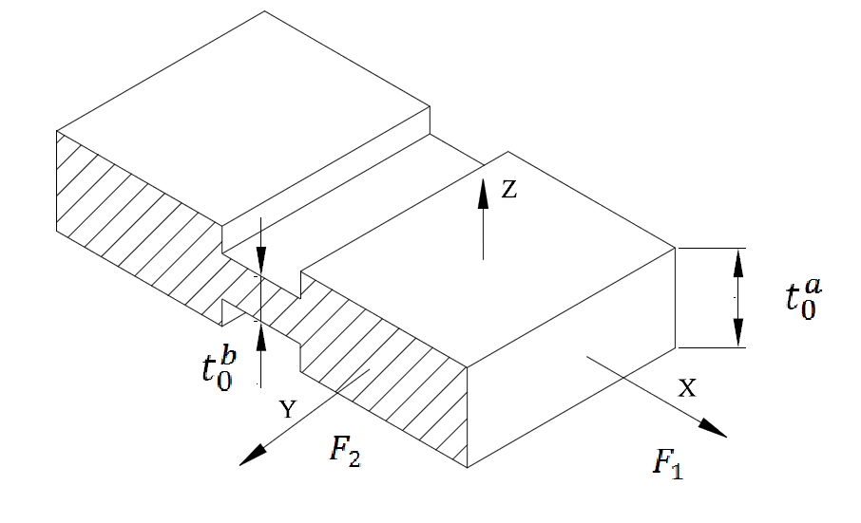
Fig. 1. Barlat-Lian model
The coefficient of initial heterogeneity in the general framework of M-K model is expressed as Eq. 9:
$h_{0}=\frac{t_{0}^{B}}{t_{0}^{A}}$ | (9)
Where $t_{0}^{A}$ and $t_{0}^{B}$ are the initial thickness of homogenous and inhomogeneous regions, respectively. The thickness of both regions changes during metal forming process which is defined as Eq. 10:
$t^{A or B}=t_{0}^{A or B} exp(ε_{3}^{A or B})$ | (10)
Where $ε_{3}^{A}$ and $ε_{3}^{B}$ are the thickness strains. Also, the initial thickness of heterogeneous area ($t_{0}^{B})$ can be explained based on the homogenous region ($t_{0}^{A})$ as follow:
$t_{0}^{B}=t_{0}^{A}−2(R_{G}+kd_{0}{\overset{\overline{}}{ε}}^{B})$ | (11)
Here $R_{G}$ is the initial surface roughness, $k$ is the coefficient of grain size, $d_{0}$is the grain size and${\overset{\overline{}}{ε}}^{B}$ is the effective strain in the inhomogeneous region(Barlat and Lian, 1989; Gronostajski and Zimniak, 1992; Assempour and Nurcheshmeh, 2003). Hence, the coefficient of heterogeneity can be defined as:
$h=h_{0}e^{(ε_{3}^{B}−ε_{3}^{A})}$ | (12)
The compatibility requirement between the regions “A” and “B” yields to equality of strains at direction “2” as Eq.13:
${dε}_{2}^{B}={dε}_{2}^{A}$ | (13)
Both safe (A) and defected (B) zones are loaded by a similar force (F₁). This equilibrium condition is expressed as below:
$F_{1}^{A}= F_{1}^{B}$ | (14)
For the Incompressibility material, the volume is constant and the deformation defines the relations between strains. Eq. 15 shows the volume strains are constant in this relation.
${dε}_{1}+{dε}_{2}+{dε}_{3}=0$ | (15)
It has been assumed that the localization occurs in the groove when a critical strain reaches in the homogeneous region based on M-K model. Then, the values of strain increments in two regions of homogeneous and heterogeneous are compared with specific amount (e.g.,$\frac{{{dε}_{1}}^{B}}{{{dε}_{1}}^{A}}≥N (N≥10)$) and the material major and minor strain limits are obtained for the forming limit diagrams (Hashemi and Karajibani, 2018).
Identification Procedure
In experimental procedure, two type of stainless steel including AISI 321, 430 and copper, aluminum alloys including 7075-T6 and 3003-H24 (Dariani and Azodi, 2003) and carbon steel St-12 (Sadough et al., 1999) were used. Stretching the metallic sheet samples was done by a hemispherical punch to obtain the FLD. The punch-stretch apparatus sheets were prepared according to (Shakeri et al., 2000). The tensile testing is performed at a crosshead speed 5 mm/min. The initial circular grids were printed on surface of sheets with 3 mm diameters in order to measure the minor and major diameters of ovals after notching and deforming which illustrate the FLD. The strains were measured directly from specimens by using a profile projector. The scheme of hemispherical punch and its setup are shown in Fig.2 before and after sheet forming process.
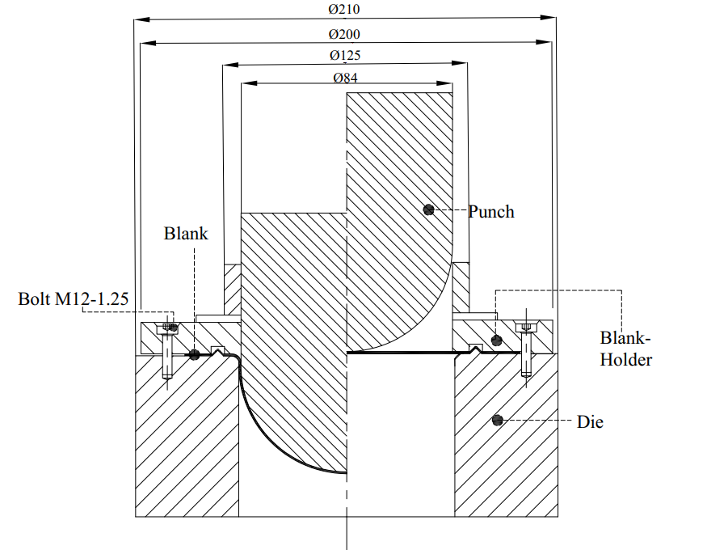
Fig. 2 scheme of hemispherical punch and its dimensions
Fig.3 shows the circular and rectangular specimens with various widths. Table 1 shows the properties of used materials.
Samples (a) | 1 | 2 | 3 | 4 | 5 | 6 | 7 | 8 | 9
(a) | Samples (a) 1 2 3 4 5 6 7 8 9 L (mm) 25 25 30 30 40 40 45 45 45 R (mm) 2.5 5 2.5 5 5 10 2.5 5 10
&
Samples (a) | 1 | 2 | 3 | 4 | 5 | 6 | 7 | 8 | 9
L (mm) | 25 | 25 | 30 | 30 | 40 | 40 | 45 | 45 | 45
R (mm) | 2.5 | 5 | 2.5 | 5 | 5 | 10 | 2.5 | 5 | 10
(b)
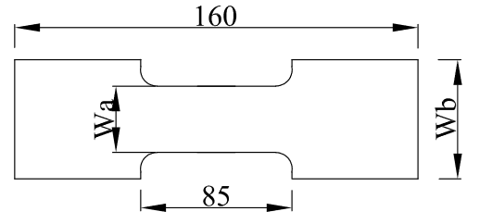
&
(b)
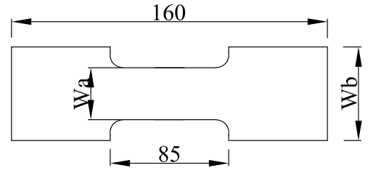
&
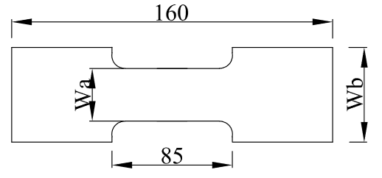
Samples (b) | 10 | 11 | 12 | 13 | 14 | 15 | 16 | 17
L (mm) | 20 | 30 | 40 | 50 | 60 | 70 | 80 | 90
R (mm) | 25 | 35 | 45 | _ | _ | _ | _ | _
&
Samples (b) | 10 | 11 | 12 | 13 | 14 | 15 | 16 | 17
L (mm) | 20 | 30 | 40 | 50 | 60 | 70 | 80 | 90
R (mm) | 25 | 35 | 45 | _ | _ | _ | _ | _
&
Samples (b) | 10 | 11 | 12 | 13 | 14 | 15 | 16 | 17
L (mm) | 20 | 30 | 40 | 50 | 60 | 70 | 80 | 90
R (mm) | 25 | 35 | 45 | _ | _ | _ | _ | _
(c)
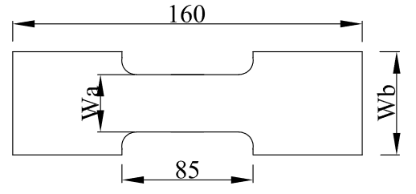
&
(c)
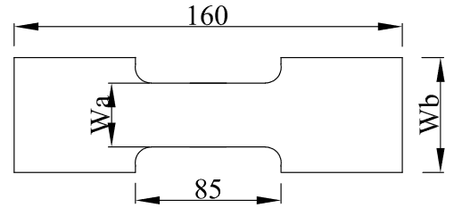
&
(c)
Material | $m$ | $n$ | $r$ | $d_{0}(mm)$ | $R(mm)$
AISI 321 (Dariani and Azodi, 2003) | 0.012 | 0.29 | 0.84 | 0.025 | 0.005
AISI 430 (Dariani and Azodi, 2003) | 0.009 | 0.23 | 1.04 | 0.028 | 0.005
AA 7075-T6 (Dariani and Azodi, 2003) | 0 | 0.09 | 0.75 | 0.05 | 0.0055
AA 3003-H24 (Dariani and Azodi, 2003) | 0.003 | 0.08 | 0.715 | 0.044 | 0.0055
Copper (Dariani and Azodi, 2003) | 0.005 | 0.36 | 0.73 | 0.035 | 0.0055
St 12 (Sadough et al., 1999) | 0.01 | 0.3 | 1.21 | 0.025 | 0.006
Comparison with Experiments
The curved fitting of experimental values are obtained with Matlab software and evaluating of different powers of Barlat-Lian yield criteria can be estimated with comparison between experimental and achieved numerical strains of different powers of Barlat-Lian yield criteria. The R-square is expressed in Eqs.16,17 and 18.Where SSE and SST are the sum of squared errors of our regression model and the sum of squared errors of our baseline model respectively. The $R^{2}$ factor gives the overall predictive capabilities of the obtained model and Minimum differences are the best fitted values. Root Mean Squared Error (RMSE) is also known as the fit standard error and the standard error of the regression and closer to 0 indicates a better fit (Eq.19).
$R^{2}=\frac{SSE}{SST}$ | (16)
$SSE=\sum_{i=1}^{n}{{\left(y_{i}−{\overset{\overset{ˇ}{}}{y}}_{i}\right)}^{2}}$ | (17)
$SST=\sum_{i=1}^{n}{{\left(y_{i}−{\overset{\overline{}}{y}}_{i}\right)}^{2}}$ | (18)
$RMSE=\frac{SSE}{number of independent pieces of information}$ | (19)
Results and Discussion
Fig 4 shows the forming limit diagrams for different expotent of Barlat-Lian which is applied for AA3003-H24 and the table 2 demonstrates that a=5.9 may have the best fitting with experimental results. Aluminum is F.C.C material and the predefined exponent is 8 but the results show that the best power amount is 5.9.
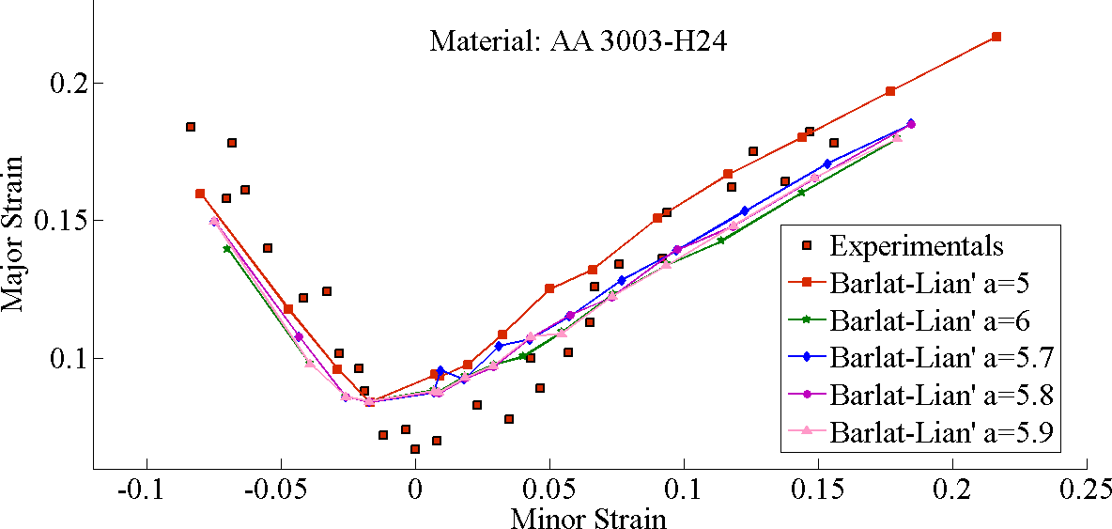
Fig. 4 Forming limit diagrams of AA3003-H24 sheet (Experimental data from Dariani and Azodi, 2003)
Table 2. RMSE for different powers
St 12 | a=4 | a=4.5 | a=4.8 | a=4.9 | a=5 | a=6 | a=8
RMSE | 0.703829 | 0.581941 | 0.565814 | 0.618761 | 0.634552 | 1.089167 | 1.273228
The numerical results are achieved to investigate the best fitting curve for AA7075-T6 in comparison with experimental data based on Fig.5 and the table 3 shows that a=6.6 can present the least RMSE value. Although AA7075-T6 is face centered cubic (F.C.C), amount of archived Barlat-lian power is 6.6.
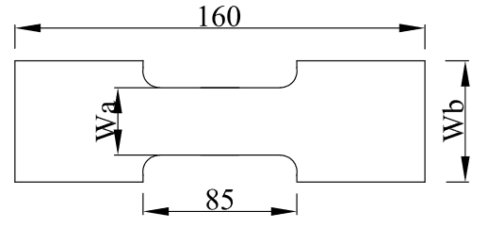
Fig. 5 Forming limit diagrams of AA7075-T6 sheet (Experimental data from Dariani and Azodi, 2003)
Table 3. RMSE for different powers
St 12 | a=4 | a=4.5 | a=4.8 | a=4.9 | a=5 | a=6 | a=8
RMSE | 0.703829 | 0.581941 | 0.565814 | 0.618761 | 0.634552 | 1.089167 | 1.273228
Another tests and numerical approaches have been done to determine the best power of Barlat Lian yield criteria for AISI 321 in Fig.6 . It can be seen the best fitting results are derived from a=4.6 as it is shown in table 4. AISI 321 is titanium (Ti)-stabilized austenitic stainless steel and has B.C.C structure. It has been assumed in all stainless steel, a=6 otherwise in this study obtained a is 4.6.
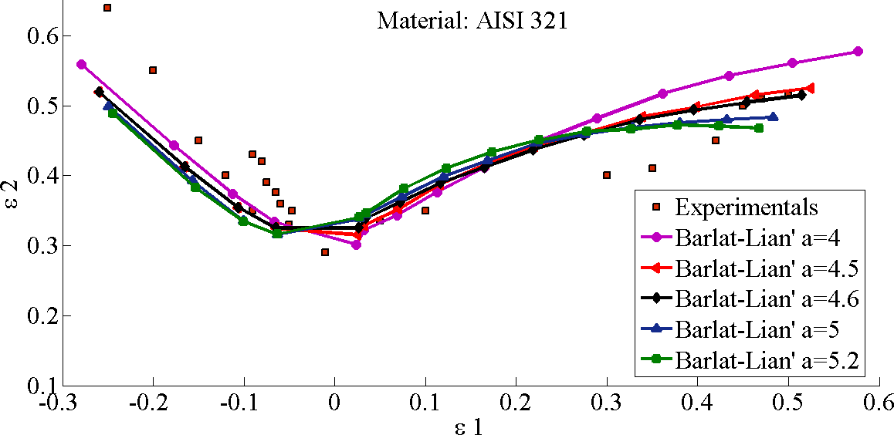
Fig. 6 Forming limit diagrams of stainless steel AISI 321 sheet (Experimental data from Dariani and Azodi, 2003)
Table 4. RMSE for different powers
St 12 | a=4 | a=4.5 | a=4.8 | a=4.9 | a=5 | a=6 | a=8
RMSE | 0.703829 | 0.581941 | 0.565814 | 0.618761 | 0.634552 | 1.089167 | 1.273228
Figure 7 and table 5 show the results of numerical and experimental method to obtain the best exponent of Barlat-Lian for AISI 430. AISI 430 has the B.C.C structure and Contrary to previous assumptions $a=6.5$has the least square in regression.
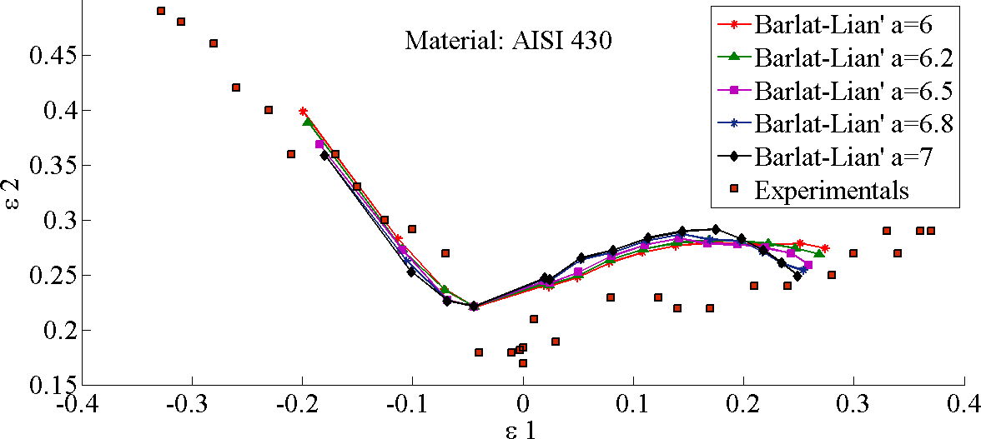
Fig. 7 Forming limit diagrams of stainless steel AISI 430 sheet (Experimental data from Dariani and Azodi, 2003)
Table 5. RMSE for different powers
St 12 | a=4 | a=4.5 | a=4.8 | a=4.9 | a=5 | a=6 | a=8
RMSE | 0.703829 | 0.581941 | 0.565814 | 0.618761 | 0.634552 | 1.089167 | 1.273228
Copper was studied to derive the best exponent of Barlat-Lian. It can be seen that the best power is a=6.5 in table 6, while Fig 7 shows that most of left sided is not covered by numerical results. So the r squares have the large amount in comparison with other materials in this study. Cu is F.C.C material and $a=6.5$ can cover experimental results sufficiently although it had been assumed that this amount is 8 for Copper.
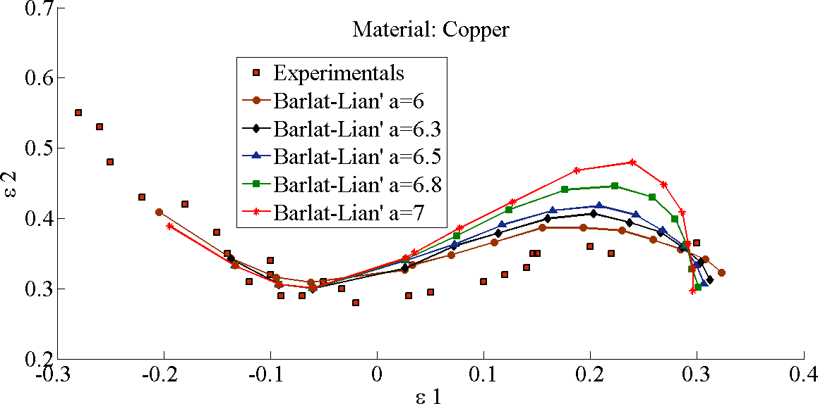
Fig. 7 Forming limit diagrams of Copper sheet (Experimental data from Dariani and Azodi, 2003)
Table 6. RMSE for different powers
St 12 | a=4 | a=4.5 | a=4.8 | a=4.9 | a=5 | a=6 | a=8
RMSE | 0.703829 | 0.581941 | 0.565814 | 0.618761 | 0.634552 | 1.089167 | 1.273228
Figure 8 and Table 7 represent the best achieved amount of Barlat-Lian exponent for St 12. The investigation shows that a=4.8 is the best curve fitted value. St 12 is low carbon steel and has the FCC structure and archived Barlat-Lian exponent is different by assumption$a=8$.
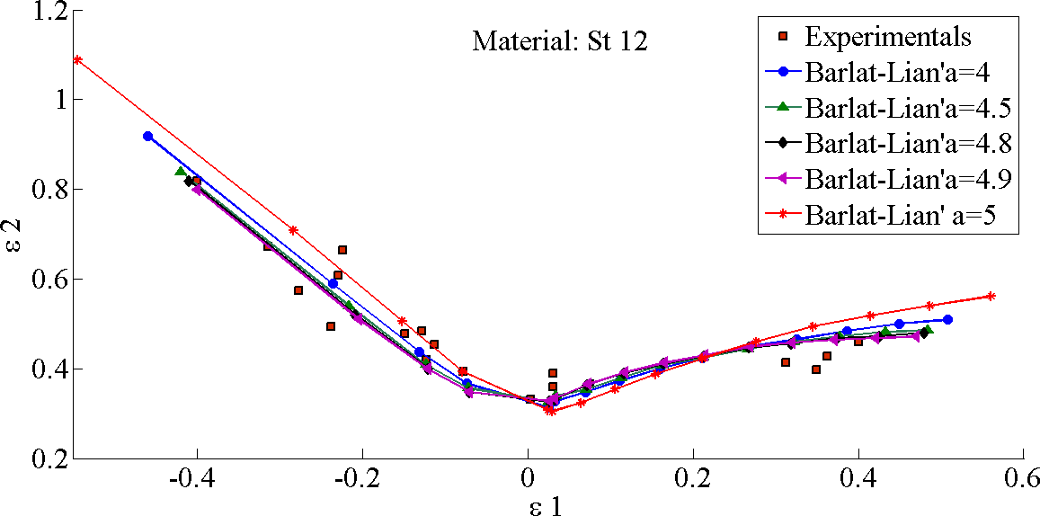
Fig. 8 St 12 Forming limit diagrams of St-12 sheet (Experimental data from Sadough et al., 1999)
Table 7. RMSE for different powers
St 12 | a=4 | a=4.5 | a=4.8 | a=4.9 | a=5 | a=6 | a=8
RMSE | 0.703829 | 0.581941 | 0.565814 | 0.618761 | 0.634552 | 1.089167 | 1.273228
Table 8 shows the best power of Barlat-Lian for different materials.
Table 8 the best power of Barlat-Lian for different materials.
Material | AA3003-H24 | AA7075-T6 | AISI 321 | AISI 430 | Copper | St 12
Best power | 5.9 | 6.7 | 4.6 | 6.5 | 6.5 | 4.8
Conclusions:
- Evaluation of r-squares for considered materials shows that the FLD of Aluminum alloys can be predicted well by Barlat-Lian yield criteria though FLD of stainless steels whether low or high carbon, associated with this yield criteria have less accuracy. The derived FLD of Copper has the highest amount of RMSE that comes from less compatibility of this yield theory for this material.
- For the aluminum alloys including AA3003-H24 and AA7075-T6, the exponent of Barlat-Lian are 5.9 and 6.6 respectively. The assumption presented this amount for FCC material like aluminum equals 8.
- The investigated Stainless steel including AISI 321 and AISI 430 demonstrate better power of Barlat-Lian yield criteria are 4.6 and 6.5 respectively however the theory assumed this amount for B.CC material equals 6.
- Although Copper is F.C.C material and anticipates this power 8, the achieved exponent is 6.5.
- For Low carbon stainless steel like St 12 with F.C.C structure, the exponent of Barlat-Lian hypothesis is 4.8.
References
Ahmed E, Reisgen U, Schleser M, et al. (2010) On formability of tailor laser welded blanks of DP/TRIP steel sheets. Science and Technology of Welding and Joining 15: 337-342.
Al-Ghamdi K and Hussain G. (2016) SPIF of Cu/steel clad sheet: annealing effect on bond force and formability.Materials and Manufacturing Processes 31: 758-763.
Alipour M, Torabi MA, Sareban M, et al. (2019) Finite element and experimental method for analyzing the effects of martensite morphologies on the formability of DP steels.Mechanics Based Design of Structures and Machines : 1-17.
Assempour A and Nurcheshmeh M. (2003) The influence of material properties on the shape and level of the forming limit diagram. SAE Technical Paper.
Babaei H and Darvizeh A. (2011) Investigation into the response of fully clamped circular steel, copper, and aluminum plates subjected to shock loading. Mechanics Based Design of Structures and Machines 39: 507-526.
Bae S-G, Noh GH, Hong SS, et al. (2017) Effect of temperature on mechanical properties and formability of coatings for pre-coated metal. Molecular Crystals and Liquid Crystals 659: 23-27.
Banabic D. (2010) Sheet metal forming processes: constitutive modelling and numerical simulation : Springer Science & Business Media.
Banichuk N, Kurki M, Neittaanmäki P, et al. (2013) Optimization and analysis of processes with moving materials subjected to fatigue fracture and instability. Mechanics Based Design of Structures and Machines 41: 146-167.
Barlat F and Lian K. (1989) Plastic behavior and stretchability of sheet metals. Part I: A yield function for orthotropic sheets under plane stress conditions.International journal of Plasticity 5: 51-66.
Cardoso R and Adetoro O. (2017) A generalisation of the Hill’s quadratic yield function for planar plastic anisotropy to consider loading direction. International Journal of Mechanical Sciences 128: 253-268.
Cui X, Zhang S, Zhang C, et al. (2019) The impact of powder oxygen content on formability of 12CrNi2 alloy steel fabricated by laser melting deposition. Powder Metallurgy : 1-10.
Darabi R, Azodi HD and Bagherzadeh S. (2017) Investigation into the effect of material properties and arrangement of each layer on the formability of bimetallic sheets.Journal of Manufacturing Processes 29: 133-148.
Dariani B and Azodi H. (2003) Finding the optimum Hill index in the determination of the forming limit diagram. Proceedings of the Institution of Mechanical Engineers, Part B: Journal of Engineering Manufacture 217: 1677-1683.
Ghazanfari A, Assempuor A, Habibi M, et al. (2016) Investigation on the effective range of the through thickness shear stress on forming limit diagram using a modified Marciniak–Kuczynski model. Modares Mechanical Engineering 16: 137-143.
Goodwin GM. (1968) Application of strain analysis to sheet metal forming problems in the press shop.SAE Transactions : 380-387.
Gronostajski J and Zimniak Z. (1992) Theoretical simulation of sheet behaviour in forming processes.Journal of Materials Processing Technology 31: 57-63.
Habibi M, Ghazanfari A, Assempour A, et al. (2017) Determination of forming limit diagram using two modified finite element models. Mechanical Engineering 48.
Habibi M, Hashemi R, Ghazanfari A, et al. (2018a) Forming limit diagrams by including the M–K model in finite element simulation considering the effect of bending. Proceedings of the Institution of Mechanical Engineers, Part L: Journal of Materials: Design and Applications 232: 625-636.
Habibi M, Hashemi R, Sadeghi E, et al. (2016) Enhancing the mechanical properties and formability of low carbon steel with dual-phase microstructures. Journal of Materials Engineering and Performance 25: 382-389.
Habibi M, Hashemi R, Tafti MF, et al. (2018b) Experimental investigation of mechanical properties, formability and forming limit diagrams for tailor-welded blanks produced by friction stir welding. Journal of Manufacturing Processes 31: 310-323.
Hashemi R and Karajibani E. (2018) Forming limit diagram of Al-Cu two-layer metallic sheets considering the Marciniak and Kuczynski theory. Proceedings of the Institution of Mechanical Engineers, Part B: Journal of Engineering Manufacture 232: 848-854.
Hill R. (1952) On discontinuous plastic states, with special reference to localized necking in thin sheets. Journal of the Mechanics and Physics of Solids 1: 19-30.
Hosford W. (1972) A generalized isotropic yield criterion. Journal of Applied Mechanics 39: 607-609.
Hosford WF. (1979) On yield loci of anisotropic cubic metals. Proceedings of the Seventh North American Metal working Conference SME. 191-197.
Hosseini S, Habibi M and Assempour A. (2018) Experimental and numerical determination of forming limit diagram of steel-copper two-layer sheet considering the interface between the layers. Modares Mechanical Engineering 18: 174-181.
Keeler SP. (1968) Circular grid system—a valuable aid for evaluating sheet metal formability.SAE Transactions : 371-379.
Khalatbari H, Iqbal A, Shi X, et al. (2015) High-speed incremental forming process: a trade-off between formability and time efficiency. Materials and Manufacturing Processes 30: 1354-1363.
Marciniak Z and Kuczyński K. (1967) Limit strains in the processes of stretch-forming sheet metal.International Journal of Mechanical Sciences 9: 609-620.
Marzani A, Mazzotti M, Viola E, et al. (2012) FEM formulation for dynamic instability of fluid-conveying pipe on nonuniform elastic foundation. Mechanics Based Design of Structures and Machines 40: 83-95.
Nguyen T-T, Yang Y-S and Bae K-Y. (2009) The development of an artificial neural network model to predict heating-line positions for plate forming in induction heating process.Mechanics Based Design of Structures and Machines 37: 201-227.
Otorabad HA, Tehrani PH and Younesian D. (2018) 3D transient elasto-plastic finite element analysis of a flatted railway wheel in rolling contact. Mechanics Based Design of Structures and Machines 46: 751-766.
Shakeri M, Sadough A and Dariani B. (2000) Effect of pre-straining and grain size on the limit strains in sheet metal forming. Proceedings of the Institution of Mechanical Engineers, Part B: Journal of Engineering Manufacture 214: 821-827.
F Barlat, J C Brem, J W Yoon, et al. Plane stress yield function for aluminum alloy sheets, International Journal of Plasticity 19 (2003) 1297–1319
Haibo Wang, Mingliang Men , Yu Yan , Min Wan and Qiang Li , Prediction of Eight Earings in Deep Drawing of 5754O Aluminum Alloy Sheet, Chinese Journal of Mechanical Engineering
Dick, R.E., Yoon, J.W. and Stoughton, T.B., 2016. Path-independent forming limit models for multi-stage forming processes. International journal of material forming, 9(3), pp.327-337.
Yoon, J.W.; Barlat, F.; Dick, R.E.; Karabin, M.E. Prediction of six or eight ears in a drawn cup based on a new anisotropic yield function. Int. J. Plast. 2006, 22, 174–193.
Comsa, D.S; Banabic, D. Plane-Stress Yield Criterion for Highly-Anisotropic Sheet Metals; Numisheet 2008: Interlaken, Switzerland, 2008; pp. 43–48.
Plunkett, B.; Cazacu, O.; Barlat, F. Orthotropic yield criteria for description of the anisotropy in tension and compression of sheet metals. Int. J. Plast. 2008, 24, 847–866.

