Atmospheric Science Letters Template
Xin Zhou
Most of the lower stratospheric water vapor comes from the tropical troposphere, determined by the cold tropopause temperature over the Indo-Pacific warm pool (IPWP). Previous studies that quantified the relative role of transport processes have generally assumed well-mixed tropics and focused on tropical-wide average characteristics. However, it has recently been shown that there is a hemispheric difference in tracer transport into the stratosphere, highlighting the importance in depicting the hemispheric contrast. Using idealized simulations with WACCM4, we show that the amplitude of the lower stratospheric water vapor in response to a warmer/cooler IPWP in the northern tropics (NT) is larger than that in the southern tropics (ST). But the seasonal evolution is different during the warm episodes and cold episodes: the stratospheric water vapor in NT becomes significantly larger than that in ST in boreal summer in case of a warmer IPWP, while in case of a cooler IPWP the hemispheric contrast occurs in boreal fall to winter. In addition, the seasonality of the stratospheric water vapor transport in the NT is larger than that in the ST. Transformed Eulerian Mean analysis of WACCM4 simulations shows that seasonality in the Brewer Dobson circulation induced by the IPWP drives the seasonality in the stratospheric water vapor, with a large increase in horizontal mixing during boreal summer associated with.
Keywords — Stratospheric water vapor, Indo-Pacific warm pool, hemispheric contrast, Brewer Dobson circulation, WACCM4

Introduction
Stratospheric water vapour (SWV) is an important greenhouse gas, contributing significantly to global climate change by a strong SWV feedback at +0.3 W/(m²·K) (Dessler et al. 2013). Sensitivity studies with climate models demonstrated that even small changes in lower stratospheric water vapor can lead to notable changes of radiative forcing and the temperature at the surface (Solomon et al., 2010). Understanding its controlling factors and underlying physics is thus critically important for the predictions of global climate variability and change.
The amount of water vapor in the stratosphere is governed by two major processes. One is the oxidation of methane, which is the only important chemical source of water vapor in the stratosphere (ADD). The other is the transport of water vapor to the tropical lower stratosphere through the tropical tropopause layer where the lowest temperature (the so-called cold point temperature) determines the dehydration process (Randel et al. 1998, 2004; Oman et al. 2008; Fueglistaler et al. 2005, 2009; Rosenlof and Reid 2008; Schoeberl and Dessler 2011).
But not all of the observed variability of lower stratospheric water vapor in the tropics can be explained by changes in average tropopause temperature. Other zonally asymmetric processes may contribute (Fueglistaler and Haynes, 2005). Climatologically in boreal wintertime, temperatures over the Indo-Pacific warm pool (IPWP) region are colder relative to the zonal mean near the tropopause, due to enhanced convection and diabatic heating here (Highwood and Hoskins, 1998). The cold temperatures over the IPWP region in boreal winter govern the amount of water vapor that can reach higher in the stratosphere (Mote et al., 1996). Previous studies found a correlation between the cold-point temperature and SSTs in the IPWP region (Rosenlof and Reid, 2008; Garfinkel et al., 2013). (Zhou et al. 2017) defined the warm/cold phase of the IPWP (the so-called IPWP Niño/Niña) according to the regional mean SST anomalies. They found that the IPWP can significantly affect stratospheric temperature, circulations, and the stratosphere-troposphere exchange. (Xie et al. 2018) showed that IPWP Niño dries the stratospheric water vapor by causing a broad cooling of the tropopause, and vice versa for IPWP Niña.
However, the above studies have considered “well-mixed” tropics, and thus focused primarily on the variations in the tropical-wide average (20sheshiduS–20N) of the stratospheric water vapor. Recently, (Stolarski et al. 2014) showed significant differences in the observed seasonality of ozone between the northern and southern tropics (NT and ST, respectively), in contrast to usual assumption that the tropics can be treated as a horizontally homogeneous region. This implies that the paradigm of well-mixed tropics needs to be revised to consider latitudinal variations within the tropics.
In this study, we further examine the NT-ST difference in the effect of the IPWP Niño/Niña on the lower stratospheric water vapor. We first quantify the hemispheric difference of the lower stratospheric water vapor response to IPWP Niño/Niña events. We then examine the relative role of different transport processes and chemical production and loss in producing the lower stratospheric water vapor in the ST and NT. This analysis involves a more detailed Transformed Eulerian Mean (TEM) analysis of WACCM4 simulations.
The models used and method of analysis are described in the next section. In section 3 we quantify the hemispheric difference of the lower stratospheric water vapor response to IPWP Niño/Niña events, while in section 4 we discuss the dynamical processes that lead to the hemispheric contrast.

2 Model, Methods and Data

2.1 WACCM4
We employ the Whole Atmosphere Community Climate Model, version 4 (WACCM4) (Marsh et al. 2013), which is the atmospheric component of the coupled climate system model Community Earth System Model (CESM) (Garcia et al. 2007). The standard version has 66 vertical levels extending from the ground to 4.5 × 10⁻⁶ hPa (160 km geometric altitude), with a vertical resolution of 1.1–1.4 km in the tropical tropopause layer and the lower stratosphere (< 30 km). All simulations use a horizontal resolution of 1.9× 2.5 (latitude × longitude) and do not include interactive chemistry (Garcia et al. 2007). Fixed greenhouse gas (GHG) values used in the model radiation scheme are based on emissions scenario A2 of the Intergovernmental Panel on Climate Change (IPCC) (WMO, 2003) over the period 1980–2015. And the prescribed ozone forcing, with a 12-month seasonal cycle averaged over the period 1980–2015 from CMIP5 ensemble mean ozone output, is used in our simulations. The Quasi Biennial Oscillation (QBO) forcing time series is determined using a 28-month fixed cycle.
A group of model integrations are used to isolate the impact of IPWP Niño and IPWP Niña on the SWV. Briefly, we examined three 30-year time-slice simulations forced by repeating annual cycles of SSTs that represent IPWP Niño and IPWP Niña. Composite SST anomalies for IPWP Niño and IPWP Niña (see Figs. 1c, and 1d in (Zhou et al. 2017)) are used to force the simulations. The key point is that these model integrations provide many samples of the atmospheric response to identical SSTa and are long enough to achieve statistical robustness (Garfinkel et al. 2013b).

Methods
The vertical component of the Brewer-Dobson (BD) circulation is in a pressure coordinate system was given by Edmon et al. (1980) as:
$$\left.{\overline{ω}}^{*}=\overline{ω}+(acosϕ)^{−1}[cosϕ(\overline{\left(v^{′}θ^{′}\right.}/\overline{θ_{p}})]_{ϕ}\right.$$
where $θ$ is the potential temperature, $\overline{ω}$ is the zonal-mean vertical velocity in pressure coordinates, and subscripts $p$ and $ϕ$ denote derivatives with respect to pressure and latitude, respectively.

Results
We first examine the ability of WACCM4 to reproduce the observed annual cycles of tropical stratospheric water vapor. Latitudinal variations in seasonality of lower stratospheric water vapour are very similar between WACCM4 simulations and observational datasets from SWOOSH, with pattern correlation coefficient being above 0.9. The magnitude of the stratospheric water vapour produced by WACCM4 is about 0.5ppmv smaller than that observed, which may due to . In the southern subtropics, there is only week seasonality in the stratospheric water vapour, with slightly higher values around November. In contrast, there is large seasonality in the northern tropics with a large increase in June to August, where the spreading of the contours indicates transport of high water vapour values from the midlatitudes into the tropics during boreal summer. In addition, the annual maximum in the sourthern tropics occurs 2 months later than in that in the northern tropics. This structure is coherent with the subtropical ozone structure shown in (Stolarski et al. 2014), implying that processes determining the climatological seasonal cycle of the tropical stratospheric water vapor are likely same as those for ozone, which was shown as a combination of the seasonal variation of the Brewer-Dobson circultion and the seasonal variation of tropical and midlatitude mixing.

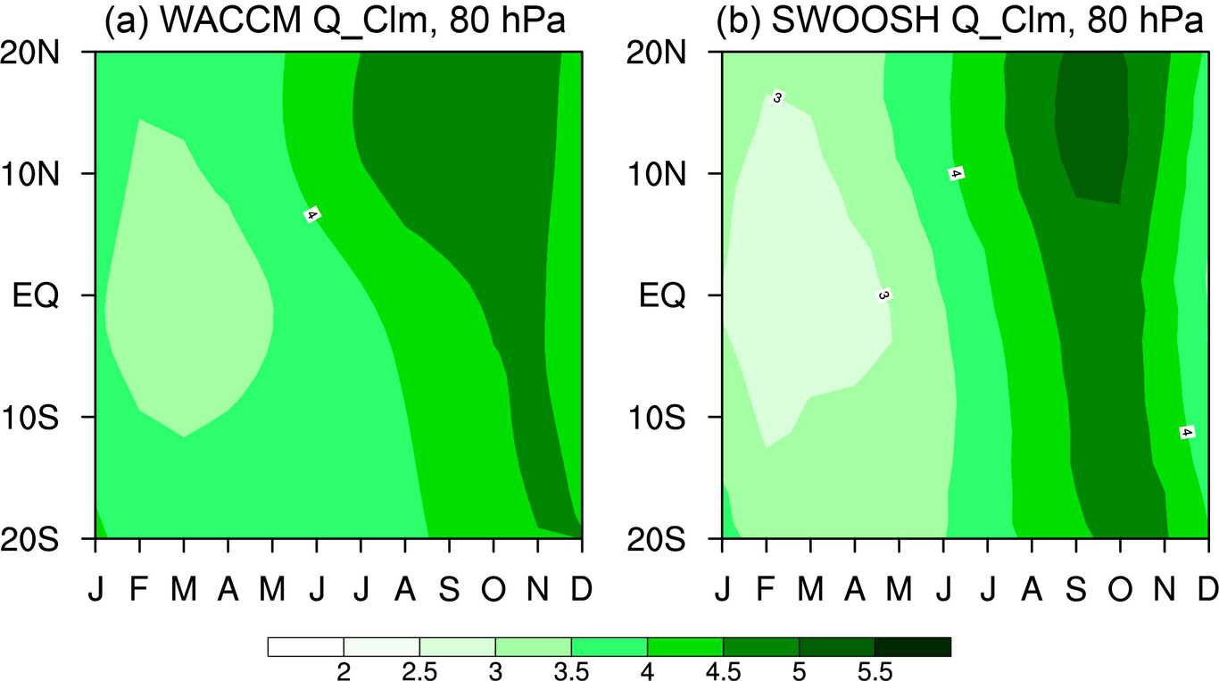
Latitudinal variations of seasonality in the climatological stratospheric water vapour at 80 hPa, based on (a) WACCM4 climatological run and (b) SWOOSH from 1984 to 2019. Contour intervals are every 0.5 ppmv.
Now we have confirmed a good performance of WACCM4 in simulating zonal variance of the tropical stratospheric water vapor, and shown the necessarity in dipicting the hemispheric contrast. Next we examine the hemispheric difference of the lower stratospheric water vapor response to IPWP Niño/Niña events, which have already been shown to have significant effects on the entry of water vapour from tropical troposphere to the stratosphere (Xie et al. 2018). The annual mean tropical stratospheric water vapor is revisited here to further show the hemispheric contrast.
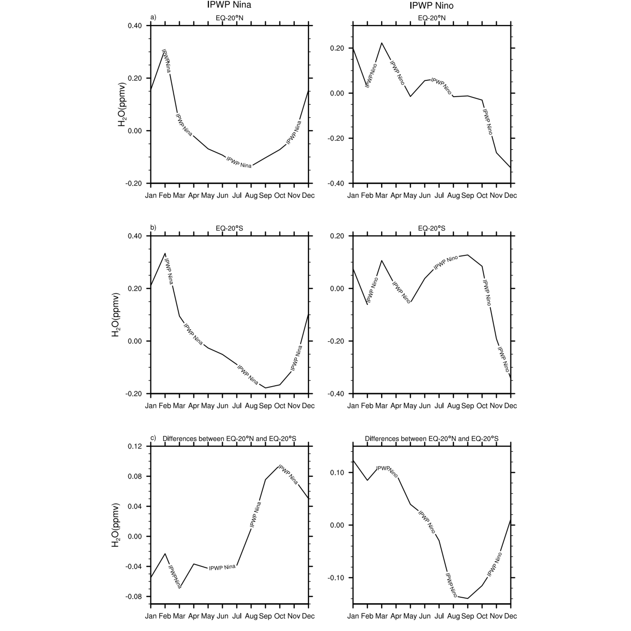
Seasonal evolution of lower stratospheric (80 hPa) water vapour anomalies averaged over (a) NT and (b) ST during (left) IPWP Niño and (right) IPWP Niña events, based on observations and
First, the annual mean NT-ST differences at lower stratosphere (80 hPa) in response to IPWP Niño/Niña based on WACCM4 simulations are shown in Table 1 . The experimental design is described in section 2. Coherent with (Xie et al. 2018), the IPWP Niño events tend to dry the tropical lower stratosphere with negative stratospheric water vapour anomalies in both NT and ST, and vice versa for IPWP Niña. The amplitude of the water vapour response, however, is about two times larger in NT than that in ST during both IPWP Niño and IPWP Niña.
This is a table. Tables should be self-contained and complement, but not duplicate, information contained in the text. They should be not be provided as images. Legends should be concise but comprehensive – the table, legend and footnotes must be understandable without reference to the text.
Simulations | EQ-20°N | EQ-20°S | Absolute Differences
IPWP Niño | -0.15 | -0.08 | 0.07
IPWP Niña | 0.26 | 0.19 | 0.07

Figure 2 shows the seasonal evolution of stratospheric water vapor anomalies at 80 hPa during IPWP Niño/Niña. The seasonal variations are evident, with a winter transition from the dry phase to wet phase during IPWP Niño, and vice versa for IPWP Niña. This sign change is in agreement with the results in Garfinkel et al. (2013), which also shown an phase transition induced by ENSO. The reason for this sign change will be discussed in following dynamical analysis. In addition, differences between the NT and ST seasonal evolution is clearly shown. The drying effect of IPWP Niño have larger absolute values in fall, and the moistening effect of IPWP Niña have the largest hemispheric differences in winter. For IPWP Niño, the peak values of drying effect is between 0.2 ppmv to 0.3 ppmv in NT winter, being ~0.15 ppmv larger than that in ST. For IPWP Niña, the peak values in NT fall is ~0.1 ppmv larger than that in ST.

Acknowledgements
Acknowledgements should include contributions from anyone who does not meet the criteria for authorship (for example, to recognize contributions from people who provided technical help, collation of data, writing assistance, acquisition of funding, or a department chairperson who provided general support), as well as any funding or other support information.

Conflict of interest
You may be asked to provide a conflict of interest statement during the submission process. Please check the journal’s author guidelines for details on what to include in this section. Please ensure you liaise with all co-authors to confirm agreement with the final statement.

References
Dessler, AE, MR Schoeberl, T Wang, SM Davis, and KH Rosenlof. 2013. “Stratospheric Water Vapor Feedback.”. Proc Natl Acad Sci U S A 110: 18087–91.
Zhou, Xin, Jianping Li, Fei Xie, Ruiqiang Ding, Yanjie Li, Sen Zhao, Jiankai Zhang, and Yang Li. 2017. “The Effects of the Indo-Pacific Warm Pool on the Stratosphere”. Climate Dynamics 51 (11-12): 4043–64. https://doi.org/10.1007/s00382-017-3584-2.
Xie, Fei, Xin Zhou, Jianping Li, Quanliang Chen, Jiankai Zhang, Yang Li, Ruiqiang Ding, Jiaqing Xue, and Xuan Ma. 2018. “Effect of the Indo-Pacific Warm Pool on Lower-Stratospheric Water Vapor and Comparison with the Effect of ENSO”. Journal of Climate 31 (3): 929–43. https://doi.org/10.1175/jcli-d-17-0575.1.
Stolarski, Richard S., Darryn W. Waugh, Lei Wang, Luke D. Oman, Anne R. Douglass, and Paul A. Newman. 2014. “Seasonal Variation of Ozone in the Tropical Lower Stratosphere: Southern Tropics Are Different from Northern Tropics”. Journal of Geophysical Research: Atmospheres 119 (10): 6196–6206. https://doi.org/10.1002/2013jd021294.

