Agroforestry: An adaptation measure for sub-Saharan African food systems in response to increased weather extremes due to climate change
Robert Orzanna
Nika Scher

Introduction
Several decades of scientific work on a better understanding of the earth’s climate system have led to increasing certainty that changes in the climate system are influenced by human activity. As the 5th Assessment Report of the IPCC notes, there is 95% confidence that the increase in global surface temperature is caused by the anthropogenic increase in greenhouse gas concentrations (Stocker 2013). As a result, more extreme weather occurrences have been predicted for many regions for the upcoming decades. Successfully coping with changes in weather patterns requires mitigation measures for future GHG emissions reductions along with adaptation measures, the latter adopted particularly in those regions that will be severely affected by future weather extremes.
In most of the developed Annex I countries, a well-functioning governance system provides financial resources and institutional stability for potentially large-scale investments in adaptation and mitigation measures within the national territories. In many developing countries, however, governance and institutions are poorly developed, resulting in a lack of financial investments to cope with climate change. Given these circumstances, affordable adaptation measures are required to be taken by citizens themselves on a local level to avoid adverse effects on their livelihoods.
An important field for investigating the effectiveness of adaptation measures against climate change are African smallholder, or subsistence farmers. In many parts of the African continent, smallholder farmers cultivate more than 70% of the arable and permanent cropland and are responsible for a very high proportion of local food and crop production (Morton 2007). However, their lack of economic resources restricts them access to alternative livelihoods (Slingo et al. 2005). Given these circumstances, a worsening of climate variability, primarily decreases in precipitation and increases of droughts that have been predicted for large parts of Africa, highlight the importance for cost-effective adaptation measures for the agricultural sector in Africa. Without these measures, severe effects on food production are to be expected that greatly endanger the livelihood of local farmers and the people that to a great extent dependent on local food supply (Waha et al. 2013). If not adopted successfully, African food systems are unlikely to provide sufficient nutrition to a population that is growing by 4% annually, and that will thus further increase the stress on arable land (The World Bank 2012).
This paper examines agroforestry as an adaptation measure that can be applied by smallholder farmers in order to increase the resilience of African food systems against increasing climate variability. In doing so this paper aims at responding to the following research question:
What is the adoption potential of agroforestry for smallholder farming in different countries of Sub-Saharan Africa to strengthen the resilience against increasing climate variability?
The paper proceeds as follows. Firstly, based on a literature review the predicted impacts following from climate change are synthesized for different African regions. Secondly, agroforestry is being introduced as a cost-effective adaptation measure. Lastly, adoption potentials for different regions are quantified and advice is given on increasing the adoption of agroforestry methods by addressing several identified barriers.

Predicted impacts for Africa
Several studies have modeled and assessed the potential environmental and socio-economic impacts on the African content from climate change. Table ??? provides a summary of the different studies. (de Wit 2006) assess that predicted precipitation changes will significantly affect present surface water access across 25% of Africa’s land surface by the end of this century. They estimate that a 10% decrease in precipitation in regions with more than 1000 millimeters precipitation per year would reduce drainage by 17%, regions with less than 500 millimeters would experience reduced drainage by up to 50%. (Hulme et al. 2001) estimate a temperature increase between 2 to 6 ${}^{∘}$C by 2100. Temperature changes will have different impacts on different regions in Africa and are strongly related to changes in precipitation. As such, (Burke, Brown, and Christidis 2006) predict increased droughts over Northern Africa and a wetting over central Africa.
Most smallholder farmers in sub-Saharan Africa practice rain-fed agriculture and depend on local hydrological feedbacks (Lasco et al. 2014). Therefore increasing climate variabilities will have significant socio-economic impacts and several studies attempted to estimate these. A study done by (Schlenker and Lobell 2010) showed that damages to yields of typical crops such as maize, sorghum, millet and groundnut are likely to exceed 7% by 2050 whilst yields from tropical crops such as rice could increase in regions with increasing flooding. This corresponds to other studies such as (Jones and Thornton 2003) who predict a 10% decrease in maize production until 2050. (Zinyengere, Crespo, and Hachigonta 2013) predict even more severe yield reductions, with a 18% decline for maize and an average crop decline of 30% for wheat, beans and sugarcane until 2100. Overall, crop responses to increasing climate variability tend to be negative for sub-Saharan Africa. (Kurukulasuriya and Mendelsohn 2006) did an economic estimate in which 10% temperature increase leads to a 13% decline in net revenue for smallholder famers. 10% increase in precipitation would in turn, according to their calculations, lead to a 40% net increase in revenue.
XX Study & Predicted impact
(de Wit 2006) & Decreased drainage 17% - 50%
(Schlenker and Lobell 2010) & Increased crop damage 7% - 27%
(Jones and Thornton 2003) & Decreased maize production by 10% until 2055
(Hulme et al. 2001) & Temperature increase 2 - 6 ${}^{∘}$C by 2100
(Kurukulasuriya and Mendelsohn 2006) & 10% temperature increase leads to 13% decline in net revenue. 10% increase in precipitation leads to 40% increase in net revenue
(Burke, Brown, and Christidis 2006) & Increased droughts over Northern Africa & wetting over central Africa

Agroforestry
The predicted impacts show the necessity for smallholder farmers to adapt in order to counter the negative effects of climate change on their farming operation. In this context, several hundred studies have been evaluating various adaptation measures since the late 1990s (Kamukondiwa 1996). This paper focuses on two recent studies performed by (Deressa et al. 2009) and (Waha et al. 2013) who identified the following coping mechanisms as the most promising measures adapt to climate change:
- Planting trees
- Soil conservation
- Different crop varieties
- Early and late planting
- Irrigation
- Multiple cropping systems
Many of these strategies can easily be implemented by a single adaptation measure called Agroforestry. Agroforestry is often used as a strategy that involves the combination of regular crop cultivation along with trees and shrubs to increase the resilience of the former. It commonly involves the following four aspects (Nair 1993):
- At least two species of plants of which at least one is of woody perennial
- Two or more outputs
- A cycle exceeding one year
- A system that is ecologically (structurally and functionally) more complex than a mono-cropping system, even for the most simplest system
Several methods for agroforestry are available, including: intercropping, alley cropping and hedgerow cropping or more complex systems that form a natural forest ecosystem (Mbow et al. 2014a). The diversity and characteristics of agroforestry can be observed in figure ???. The main advantages of agroforestry over other measures is primarily found in its positive influence on farmers’ income security and through the provision of additional resources and its facilitating role in the growth of crops. Those both aspects add important security in a changing climate setting. Furthermore, agroforestry can even to some extent help mitigating climate change, thus allowing farmers to benefit in multiple ways with respect to food security (Mbow et al. 2014a). A selection of feedback mechanisms under the application of agroforestry can be found in Figure ??? and will be further discussed. By planting trees and shrubs, farmers can directly benefit through the harvest of additional yield such as fruits or firewood. These contribute to the farmers’ own food supply and possibly provide added income if they are able sell these fruits and firewood on local markets. Following the agroforestry typology, this is an example for a multiple cropping systems with the provision of at least two outputs. The cultivation of trees along with their use as firewood provides further benefits such as a decrease in time that is needed to search for firewood and the prevention of deforestation by reforestation (Mbow et al. 2014a). However, the availability of additional cheap firewood can have a negative feedback in that it contributes to emission of greenhouse gasses and contributes to domestic air pollution since stoves in homes are often low efficiency (Kiplagat, Wang, and Li 2011).
It is particularly the indirect effects of agroforestry that are likely to help farmers adapt to a changing climate. For instance, nitrogen-fixing trees bind nitrogen in the ground, and thereby fertilizing it. Since nitrogen is often a limiting factor for plant growth, this extra nitrogen in the ground will help crops to grow without the need for synthetic fertilizers (Fleischer et al. 2013). Studies already showed that using fertilizer tree species contributes to a larger maize yield than without the use of any fertilizer (Lasco et al. 2014). Thus, agroforestry can be seen as a natural adaptation method to ensure soil conservation. Natural soil conservation by trees is also created through year-round surface cover. This stems from the fact that unlike most crops, trees will be on the land for multiple years. In comparison to conventional cultivation with large extents of surface litter and crop residue removal, resulting in soil erosion and increases in probability for water runoff, agroforestry ensures surface covering through trees and thus mitigating these effects (Mbow et al. 2014a).
A second benefit provided by trees is the provision of shade for the surface below them that allows them to buffer against temperature extremes and therefore decreases evaporation (Mbow et al. 2014a). This can contribute to a longer growing period for the crops, making them less likely to fail. Furthermore, shade will create a more comfortable working environment for the farmers with potentially positive socio-economic and health effects.
A third benefit comes as a result from water management by trees. If pruned correctly, the roots will grow to use water from deeper layers and therefore not compete over water with annual crops, which use water from the top soil. Since trees also contribute to soil conservation, the runoff from precipitation can be decreased, increasing the available water for crops. Furthermore, tree cover plays an important role in the water cycle. Analysis showed that trees have a direct influence on precipitation patterns (Mbow et al. 2014a). Since a significant fraction of the precipitation originates from local evaporation, an increase in plant cover can increase the amount of local precipitation (Bierkens and van den Hurk 2008). This might eventually contribute to a positive feedback effect of increasing precipitation in local areas and reduce the need for a mechanical irrigation system. Therefore, planting of trees can be seen as a natural replacement for mechanical irrigation systems.
A fourth benefit from agroforestry refers to the reduction of pests without the use of pesticides. Trees can form a natural barrier and decrease the accessibility of the crops by limiting the movement of the pests. Furthermore, a diverse plant mix evaporates a mixture of odors that can potentially irritate insect pests and the provided free space can encourage the pests’ natural enemies to inhabit the area. Agroforestry can therefore increase yield by protecting it from pest impacts (Rathore 1995).
Finally, agroforestry reduces CO₂ concentration in the atmosphere. Since trees sequester carbon, the overall carbon concentration in the atmosphere will be reduced. Trees will use and store carbon for their entire lifetime, keeping it out of the atmospheric cycle longer than annual crops. If agroforestry is applied on a large scale, the sequestration of carbon can significantly contribute to GHG emission mitigation and thus lessen the severity of impacts due to human-induced climate change (Mbow et al. 2014a).
In summing all these effects, agroforestry covers 4 out of the 6 aforementioned adaptation measures through a single measure of planting trees. Yet, other measures could still be incorporated, such as early and late planting by planting crops at the beginning of the seasonal rain period instead of at traditional dates (Waha et al. 2013). Lastly, different crop varieties as a suggested adaptation measure might not be necessary with agroforestry as the latter harmonizes factors such as water availability and surface temperature, allowing traditional crops to prosper regardless of the increases in regional climate change.
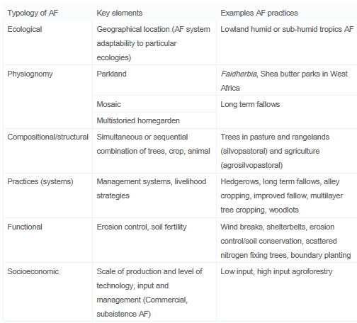
A selection of agroforestry classifications. Source: (Mbow et al. 2014b).
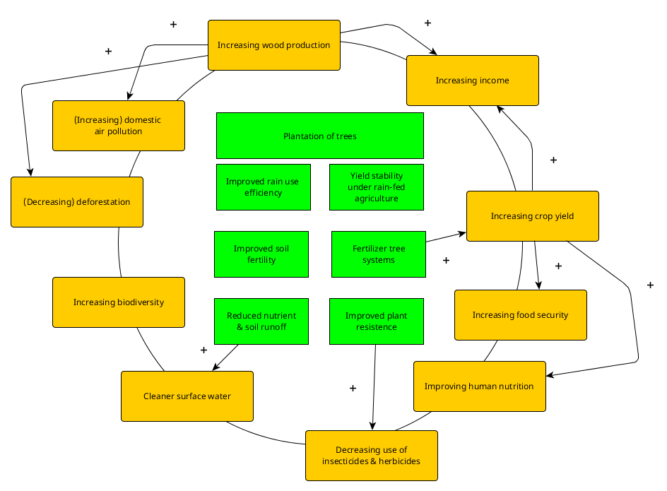
Overview of internal feedbacks and outcomes in an agroforestry system.

Challenges for agroforestry adoption
Despite its potential to adapt local food production to changing climate conditions, the adoption rate of agroforestry technologies in sub-Saharan Africa is still considerably low (Ndjeunga and Bantilan 2005). 8% of the world population is involved in agroforestry, with the majority being located in Southeast Asia, Central America and South America (World Agroforestry Centre, n.d.). This section discusses the challenges for agroforestry as a result of possibly impeding barriers that need to be overcome for its widespread adoption in sub-Saharan Africa. Empirical studies highlight that two different situations have to be distinguished (Dahlquist et al. 2007; Kiptot et al. 2007): (1) a temporary adoption of agroforestry methods with a subsequent dismissal at a later stage and (2) no adoption due to impeding barriers. For the scope of this paper we primarily focus on cases in which agroforestry is not adopted at all in order to investigate the challenges that need to be addressed by policy-makers and future research.
A lack of adoption leads to the presumption of existing barriers that hinder smallholder farmers to adopt agroforestry methods. Therefore it is important to understand the factors that affect farmers’ choices in the decision-making process. A schematic relationship developed by the ’Edinburgh Study of Decision Making on Farms’ (see Figure ???), suggests that smallholder farmers’ choices depend on personal factors, i.e. attitudes to farming and objectives, as well as external farm factors that together influence the decision-making process (Willock et al. 1999).
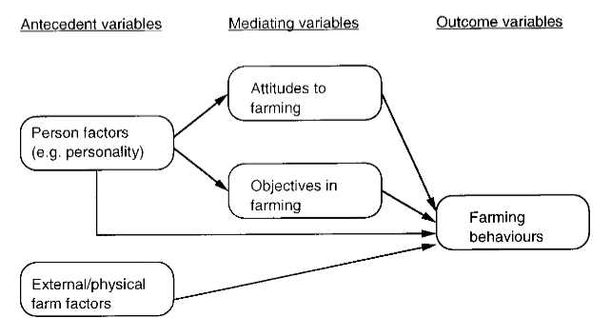
Schematic relationship between personal, external factors and individual farmer behaviour (Willock et al. 1999).
By analysing existing empirical studies we want to investigate the relevancy of each of these factors for smallholder farmers’ choices on agroforestry methods in sub-Saharan Africa. A survey performed by (Deressa et al. 2009) amongst farmers in the Nile Basin of Ethiopia indicates that failures to successfully adapt farming practices are primarily a result of a lack of information, insufficient financial resources, a shortage of labour and land, as well as a poor potential for irrigation methods. In a study specifically looking at agroforestry, (Mbow et al. 2014b) identify the lack of public policy support and the disposition of farmers as the major adoption barriers. More specifically, they highlight the counteracting role of national policies that institutionally segregate forest from agriculture and thus miss the opportunities for synergetic effects.
Another study done by (Rusinga et al. 2014) on smallholder communal famers in Zimbabwe revealed that most farmers received information on adaptive strategies that do not include agroforestry but emphasise different strategies such as evidence and manipulation of seasonal rainfall variability, planting of drought resistant crops, conservation farming methods, early planting and irrigation. Most of the information is provided to the farmers by NGOs, amongst them many internationally operating ones such as Caritas, which frequently recommend adaptation measures that are more compatible with mono-cropping culture than with agroforestry. This is surprising in that the success of monoculture production of annual crops has been proven to be significantly lower in African regions than elsewhere (Djurfeldt et al. 2005).
X|X|X|X|X|X Person factors & External/physical farm factors & Attitudes to farming & Objectives in farming & Other factors & Farming behaviours
& & & & Lack of public policy support & choice for cheapest measures
Lack of information & & & & & keep existing methods
& Shortage of labour & & & & choice for simplest measures
& Shortage of land & & & & maximising single outpus
& & & food security & & day to day practices that lead to immediate effects
& & acquired knowledge from previous generations & & & traditional farming methods
& Uncertain land rights & & & & investing in short-term measures
& & & & Low information sharing & slow diffusion of innovation
& & & & NGOs promoting alternative strategies & slow knowledge diffusion

Discussion
Agroforestry has a large potential to sustainably intensify farming practices that provide (a) enhanced food security, (b) multiple sources of income from the sale of products other than crops, (c) financial resilience to withstand food insecure periods during droughts and floods, and effective climate change mitigation through carbon sequestration (Verchot et al. 2007; Thorlakson and Neufeldt 2012). The previous section highlighted a selection of key challenges that need to be addressed in order to stimulate the adoption of agroforestry in sub-Saharan Africa. However, these challenges are unlikely to be the same in whole sub-Saharan Africa and possibly large differences concerning the adoption potentials for agroforestry between the countries need to be acknowledged.
In order to estimate the adoption potentials for different countries, we follow the differentiation between extrinsic influential factors and intrinsic factors as proposed by (Meijer et al. 2014). Their approach is comparable to the aforementioned Edinburgh relationship by which extrinsic and intrinsic factors both shape the knowledge, attitudes and perceptions of smallholder farmers and thus their decision whether to adopt agroforestry technologies. However, as intrinsic factors such as farmers’ and researchers’ perceptions of technology, use value, tree mortality, or pests are arguably difficult to assess for a large number of countries, in this study we exclusively focus on extrinsic factors. The per-country assessment has been performed based on seven World bank indicators that approximate the explanatory variables for extrinsic factors (Meijer et al. 2014). Each table cell corresponds to a value of a country for a specific indicator whose colour indicates its relationship to the best value of the country selection. Green coloured table cells thus indicate conditions that facilitate the adoption of agroforestry methods.
Evaluation of relevant extrinsic factors for agroforestry adoption for sub-Saharan countries. Source: The World Bank
Evaluation of relevant extrinsic factors for agroforestry adoption for sub-Saharan countries. Source: The World Bank
Evaluation of relevant extrinsic factors for agroforestry adoption for sub-Saharan countries. Source: The World Bank
Evaluation of relevant extrinsic factors for agroforestry adoption for sub-Saharan countries. Source: The World Bank
According to the indicators that approximate extrinsic factors, a high adoption potential for agroforestry is likely to be found in Angola, Botswana, Cameroon, Cabo Verde, Gabon, Ghana, Mauritania and Senegal. On the contrary, a very low potential exists in Somalia, Eritrea, South Sudan and Rwanda. Concerning recommendable advice, we suggest that smallholder farmers of countries with an identified large potential should be receiving stronger public policy support from national and regional governments. Aside national governments, the international community can further encourage farmers to develop a positive perception of the environmental benefits, such as carbon sequestration, that are provided by agroforestry. However, until today the share of Clean Development Mechanism (CDM) projects on agroforestry (group Afforestation & Reforestation) accounts for only 0.8% of all CDM projects issued (UNEP Risoe Centre 2014). Future investigations are required to identify stimuli that can strengthen international cooperation in the CDM on agroforestry projects. For the low-performing countries, future research is needed to identify the key challenges on a per-country basis that lead to a low potential and investigate particularly the relevancy of intrinsic factors on farmers’ perceptions, attitudes and knowledge about agroforestry. Due to a lack of primary data, these intrinsic factors were outside the scope of this study.

Conclusion
In the light of expected future population growth and the growing scarcity of arable land due to climate change and variability, increasing pressure on African food systems is to be expected and the herewith the necessity to provide more food on less land. For most of the countries in sub-Saharan Africa this implies a huge task. This paper introduced agroforestry as a promising adaptation strategy for subsistence farmers. By various cost-effective methods of planting trees, smallholder farmers can increase the resilience of their food crops, whilst simultaneously generate additional income from the sale of firewood and other products and contribute to CO₂ emission mitigation through carbon sequestration. However, despite this synergy between increasing food security and climate change mitigation, the adoption rate of agroforestry in sub-Saharan Africa is still unsatisfactory.
It is therefore important to provide a better understanding on the barriers and reasons that hinder smallholder farmers to adopt agroforestry methods on their cultivated lands. This paper reviewed the approaches taken by different recent studies on the evaluation of intrinsic and extrinsic factors that influence farmers’ attitudes, knowledge and perception and thus their decision-making process. We proposed a first approach for quantifying extrinsic factors based on approximate indicators that can be evaluated using publicly available statistical data. Thereby we were able to identify a set of countries with a large adoption potential for agroforestry and a low potential, respectively. We hope to having achieved a contribution towards a comprehensive understanding of agroforestry as an effective risk management and adaptation technology that is tailored to local and regional needs and circumstances. Yet, in order to really improve human security and livelihoods of the people, it also requires policy-makers to “Governing a transition towards an effective climate response and sustainable development pathway is a challenge involving rethinking our relation to nature.”, said Pachauri, who is chairman of the Intergovernmental Panel on Climate Change (Gulf Times 2014).

References
Stocker, D Qin. 2013. “Climate Change 2013: The Physical Science Basis”. Working Group I Contribution to the Fifth Assessment Report of the Intergovernmental Panel on Climate Change, Summary for Policymakers, IPCC.
Morton, J. F. 2007. “The Impact of Climate Change on Smallholder and Subsistence Agriculture”. Proceedings of the National Academy of Sciences 104 (50): 19680–85. https://doi.org/10.1073/pnas.0701855104.
Slingo, J. M., A. J. Challinor, B. J. Hoskins, and T. R. Wheeler. 2005. “Introduction: Food Crops in a Changing Climate”. Philosophical Transactions of the Royal Society B: Biological Sciences 360 (1463): 1983–89. https://doi.org/10.1098/rstb.2005.1755.
Waha, K., C. Müller, A. Bondeau, J.P. Dietrich, P. Kurukulasuriya, J. Heinke, and H. Lotze-Campen. 2013. “Adaptation to Climate Change through the Choice of Cropping System and Sowing Date in Sub-Saharan Africa”. Global Environmental Change 23 (1): 130–43. https://doi.org/10.1016/j.gloenvcha.2012.11.001.
The World Bank. 2012. “Population Growth (Annual %)”. http://data.worldbank.org/indicator/SP.POP.GROW.
Wit, M. de. 2006. “Changes in Surface Water Supply Across Africa with Predicted Climate Change”. Science 311 (5769): 1917–21. https://doi.org/10.1126/science.1119929.
Hulme, M, R Doherty, T Ngara, M New, and D Lister. 2001. “African Climate Change: 1900-2100”. Climate Research 17: 145–68. https://doi.org/10.3354/cr017145.
Burke, Eleanor J., Simon J. Brown, and Nikolaos Christidis. 2006. “Modeling the Recent Evolution of Global Drought and Projections for the Twenty-First Century with the Hadley Centre Climate Model”. Journal of Hydrometeorology 7 (5): 1113–25. https://doi.org/10.1175/jhm544.1.
Lasco, Rodel D, Rafaela Jane P Delfino, Delia C Catacutan, Elisabeth S Simelton, and David M Wilson. 2014. “Climate Risk Adaptation by Smallholder Farmers: the Roles of Trees and Agroforestry”. Current Opinion in Environmental Sustainability 6 (February): 83–88. https://doi.org/10.1016/j.cosust.2013.11.013.
Schlenker, Wolfram, and David B Lobell. 2010. “Robust Negative Impacts of Climate Change on African Agriculture”. Environmental Research Letters 5 (1): 014010. https://doi.org/10.1088/1748-9326/5/1/014010.
Jones, P, and P Thornton. 2003. “The Potential Impacts of Climate Change on Maize Production in Africa and Latin America in 2055”. Global Environmental Change 13 (1): 51–59. https://doi.org/10.1016/s0959-3780(02)00090-0.
Zinyengere, Nkulumo, Olivier Crespo, and Sepo Hachigonta. 2013. “Crop Response to Climate Change in Southern Africa: A Comprehensive Review”. Global and Planetary Change 111 (December): 118–26. https://doi.org/10.1016/j.gloplacha.2013.08.010.
Kurukulasuriya, Pradeep, and Robert Mendelsohn. 2006. “A Ricardian Analysis of the Impact of Climate Change on African Cropland”. CEEPA Discussion Paper.
Kamukondiwa, W. 1996. “Alternative Food Crops to Adapt to Potential Climatic Change in Southern Africa”. Clim. Res. 6: 153–55. https://doi.org/10.3354/cr006153.
Deressa, Temesgen Tadesse, Rashid M. Hassan, Claudia Ringler, Tekie Alemu, and Mahmud Yesuf. 2009. “Determinants of Farmers’ Choice of Adaptation Methods to Climate Change in the Nile Basin of Ethiopia”. Global Environmental Change 19 (2): 248–55. https://doi.org/10.1016/j.gloenvcha.2009.01.002.
Nair, P. K. Ramachandran. 1993. An Introduction to Agroforestry. Springer Netherlands. https://doi.org/10.1007/978-94-011-1608-4.
Mbow, Cheikh, Pete Smith, David Skole, Lalisa Duguma, and Mercedes Bustamante. 2014a. “Achieving Mitigation and Adaptation to Climate Change through Sustainable Agroforestry Practices in Africa”. Current Opinion in Environmental Sustainability 6 (2014a): 8–14. https://doi.org/10.1016/j.cosust.2013.09.002.
Kiplagat, J.K., R.Z. Wang, and T.X. Li. 2011. “Renewable Energy in Kenya: Resource Potential and Status of Exploitation”. Renewable and Sustainable Energy Reviews 15 (6): 2960–73. https://doi.org/10.1016/j.rser.2011.03.023.
Fleischer, K., K. T. Rebel, M. K. van der Molen, J. W. Erisman, M. J. Wassen, E. E. van Loon, L. Montagnani, et al. 2013. “The Contribution of Nitrogen Deposition to the Photosynthetic Capacity of Forests”. Global Biogeochem. Cycles 27 (1): 187–99. https://doi.org/10.1002/gbc.20026.
Bierkens, Marc, and Bart van den Hurk. 2008. “Feedback Mechanisms: Precipitation and Soil Moisture”. In Climate and the Hydrological Cycle, edited by Marc Bierkens, Han Dolman, and Peter Troch, 175–93. IAHS.
Rathore, M.P. Singh. 1995. “Insect Pests in Agroforestry”. Nairobi: International Centre for Research in Agroforestry. http://www.bugwood.org/agroforestry/insects/.
Mbow, Cheikh, Meine Van Noordwijk, Eike Luedeling, Henry Neufeldt, Peter A Minang, and Godwin Kowero. 2014b. “Agroforestry Solutions to Address Food Security and Climate Change Challenges in Africa”. Current Opinion in Environmental Sustainability 6 (2014b): 8–14. https://doi.org/10.1016/j.cosust.2013.10.014.
Ndjeunga, Jupiter, and CS Bantilan. 2005. “Uptake of Improved Technologies in the Semi-Arid Tropics of West Africa: Why Is Agricultural Transformation Lagging behind?”. Electronic Journal of Agricultural and Development Economics 2 (1): 85–102.
World Agroforestry Centre. n.d. “Agroforestry and Smallholder Farmers”. http://treesonfarms.com/agroforestry/people-and-agroforestry.
Dahlquist, R. M., M. P. Whelan, L. Winowiecki, B. Polidoro, S. Candela, C. A. Harvey, J. D. Wulfhorst, P. A. McDaniel, and N. A. Bosque-Pérez. 2007. “Incorporating Livelihoods in Biodiversity Conservation: a Case Study of Cacao Agroforestry Systems in Talamanca Costa Rica”. Biodivers Conserv 16 (8): 2311–33. https://doi.org/10.1007/s10531-007-9192-4.
Kiptot, Evelyne, Paul Hebinck, Steven Franzel, and Paul Richards. 2007. “Adopters Testers or Pseudo-Adopters? Dynamics of the Use of Improved Tree Fallows by Farmers in Western Kenya”. Agricultural Systems 94 (2): 509–19. https://doi.org/10.1016/j.agsy.2007.01.002.
Willock, Joyce, Ian J. Deary, Murray M. McGregor, Alister Sutherland, Gareth Edwards-Jones, Oliver Morgan, Barry Dent, Robert Grieve, Gavin Gibson, and Elizabeth Austin. 1999. “Farmers’ Attitudes Objectives, Behaviors, and Personality Traits: The Edinburgh Study of Decision Making on Farms”. Journal of Vocational Behavior 54 (1): 5–36. https://doi.org/10.1006/jvbe.1998.1642.
Rusinga, O, L Chapungu, P Moyo, and K Stigter. 2014. “Perceptions of Climate Change and Adaptation to Microclimate Change and Variability among Smallholder Farmers in Mhakwe Communal Area Manicaland Province, Zimbabwe”. Ethiop. J. Env Stud & Manag 7 (3): 310. https://doi.org/10.4314/ejesm.v7i3.11.
Djurfeldt, G., H. Holmén, M. Jirström, and R. Larsson. 2005. “African Food Crisis - the Relevance of Asian Experiences.”. In The African Food Crisis: Lessons from the Asian Green Revolution, 1–8. CABI. https://doi.org/10.1079/9780851999982.0001.
Verchot, Louis V., Meine Noordwijk, Serigne Kandji, Tom Tomich, Chin Ong, Alain Albrecht, Jens Mackensen, Cynthia Bantilan, K. V. Anupama, and Cheryl Palm. 2007. “Climate Change: Linking Adaptation and Mitigation through Agroforestry”. Mitigation and Adaptation Strategies for Global Change 12 (5): 901–18. https://doi.org/10.1007/s11027-007-9105-6.
Thorlakson, Tannis, and Henry Neufeldt. 2012. “Reducing Subsistence Farmers’ Vulnerability to Climate Change: Evaluating the Potential Contributions of Agroforestry in Western Kenya”. Agric Food Secur 1 (1): 15. https://doi.org/10.1186/2048-7010-1-15.
Meijer, Seline S., Delia Catacutan, Oluyede C. Ajayi, Gudeta W. Sileshi, and Maarten Nieuwenhuis. 2014. “The Role of Knowledge Attitudes and Perceptions in the Uptake of Agricultural and Agroforestry Innovations among Smallholder Farmers in Sub-Saharan Africa”. International Journal of Agricultural Sustainability, May, 1–15. https://doi.org/10.1080/14735903.2014.912493.
UNEP Risoe Centre. 2014. “CDM Projects by Type”. http://cdmpipeline.org/cdm-projects-type.htm.
Gulf Times. 2014. “Climate Change Poses Risk to Sustainable Development: Expert”. http://www.gulf-times.com/qatar/178/details/395490/climate-change-poses-risk-to-sustainable-development%3A-expert.

