ggPlantmap: an R package for the graphic mapping of plant images.
Leonardo Jo
Kaisa Kajala

Summary
The development of single-cell techniques revolutionized the field of plant biology. It enabled the characterization of cell-specific events in a wide range of species and allowed us to gain novel insights of minute biological processes occurring in complex plant tissues (Cuperus, 2022; Libault et al., 2017). Such novel approach is greatly improving our understanding of plant development, evolution, and physiology. As these techniques gain more attention within the plant research community, there is a rising need for the development of specialized visualization tools that can effectively explore the rich and complex data they produce.
ggPlantmap is an open-source R package with the goal of facilitating the generation of informative ggplot maps from plant images to explore quantitative cell type-specific data. When combined with external quantitative data, ggPlantmap can be used for the visualization and displaying of spatial profiles in distinct parts/cells of the plant (Figure 1). The conceptual workflow is like other ggplot based geographic map packages, such as ggmap (Kahle and Wickham, 2013).
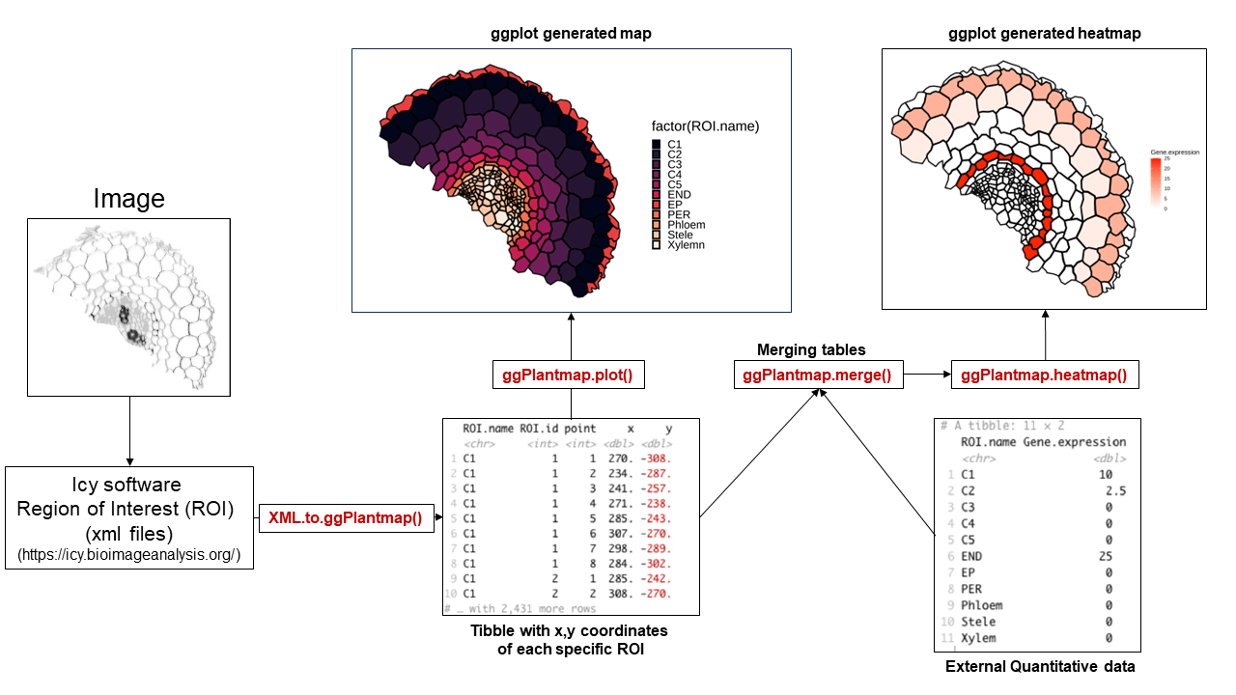
General overview of the ggPlantmap workflow.
Included in the package there is a set of pre-loaded maps created from previously published plant images that can be directly inserted into a ggplot coding workflow (Table 1, Figure 2). ggPlantmap enables users to plot heatmap signatures of gene expression or any other spatial quantitative data onto plant images providing a customizable and extensible platform for visualizing and analyzing spatial quantitative patterns within specific plant regions (Figure 1). This package uses the flexibility of the well-known ggplot2 R package (Wickham, 2011) to allow users to tailor maps to their specific research questions.

List of pre-loaded ggPlantmap in the package and their references
ggPlantmap | Species | Tissue | Reference
ggPm.At.roottip.crosssection | Arabidopsis thaliana | Root | (Sotta and Fujiwara, 2017)
ggPm.At.roottip.longitudinal | Arabidopsis thaliana | Root | (Rahni and Birnbaum, 2019)
ggPm.At.3weekrosette.topview | Arabidopsis thaliana | Rosette | (Nguyen and McCurdy, 2015)
ggPm.At.leafepidermis.topview | Arabidopsis thaliana | Leaf | (Guo et al., 2021)
ggPm.At.leaf.crosssection | Arabidopsis thaliana | Leaf | (Tsukaya, 2013)
ggPm.At.seed.devseries | Arabidopsis thaliana | Seed | (Belmonte et al., 2013)
ggPm.At.earlyembryogenesis.devseries | Arabidopsis thaliana | Embryo | (Wendrich and Weijers, 2013)
ggPm.At.shootapex.longitudinal | Arabidopsis thaliana | Shoot Apex | (Fuchs and Lohmann, 2020)
ggPm.At.inflorescencestem.crosssection | Arabidopsis thaliana | Stem | (Shi et al., 2021)
ggPm.Sl.root.crossection | Solanum lycopersicum | Root | (Ron et al., 2014)
ggPm.At.leaf.topview | Arabidopsis thaliana | Leaf | (Vanhaeren et al., 2015)
ggPm.At.rootelong.longitudinal | Arabidopsis thaliana | Root | (Shahan et al., 2022)
ggPm.At.rootmatur.crosssection | Arabidopsis thaliana | Root | (Shahan et al., 2022)
ggPm.At.flower.diagram | Arabidopsis thaliana | Flower | (Taiz et al., 2015)
ggPm.At.lateralroot.devseries | Arabidopsis thaliana | Lateral Root | (Torres-Martinez et al., 2019)
ggPm.Ms.root.crosssection | Medicago sativa | Root | Unpublished
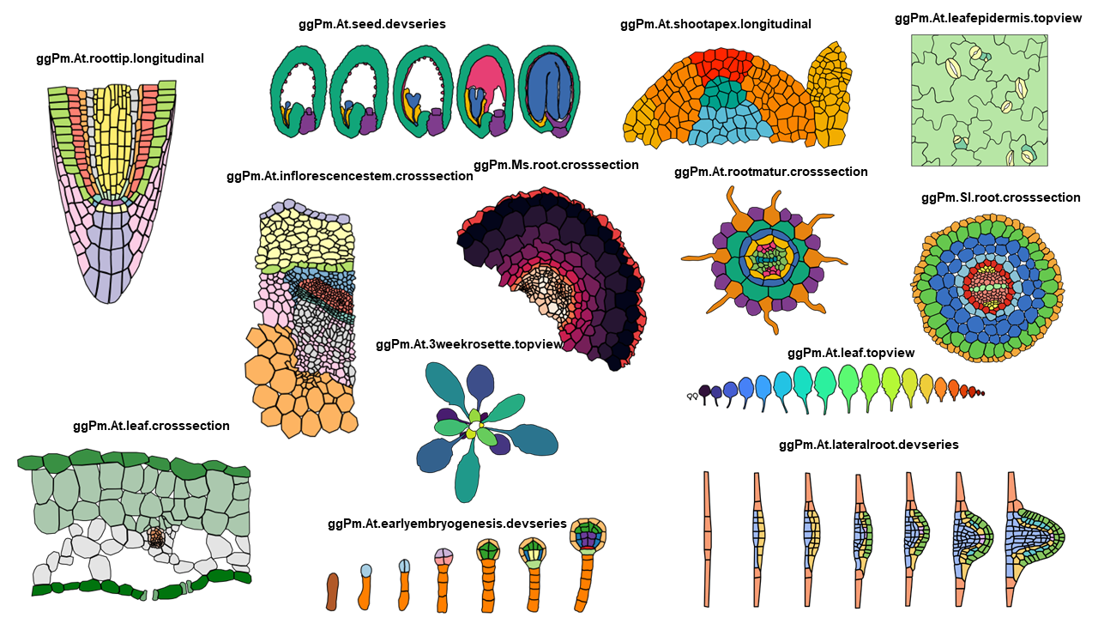
Examples of ggplots generated from pre-loaded ggPlantmaps.
In addition to the pre-loaded maps, we documented the workflow and functions for plant researchers to create their own ggPlantmap. The creation of new ggPlantmaps is based on the manual segmentation of plant shapes into distinct Regions of Interest (ROIs) using the open-source software for image analysis Icy (De Chaumont et al., 2012). With our described method, users can generate new ggPlantmaps without the necessity of high-resolution images and advanced coding skills. The ggPlantmap package is an open-source project, encouraging community contributions and creation of maps that will be continuously loaded into the package. We encourage users to extend its functionality to meet specific research requirements and to better display plant biological data. Its compatibility with R, one of the most comprehensive programing languages in plant biology, makes it a versatile and accessible tool for the plant science community.

Statement of Need
Understanding the spatial distribution of gene expression patterns or any other quantitative data within plant tissues and cells is fundamental to understand the complex and intricate events in plant biology. The Plant eFP (Expression, Function, and Protein Localization) Browser (Winter et al., 2007) has been an extremely valuable resource for researchers seeking to visualize gene expression data in the context of plant tissues across many different plant species (Winter et al., 2007). Although widely used by the plant research community, the Plant eFP browser lacks open and user-friendly tools for the creation of customized expression maps independently. Plant biologists with less coding experience can often encounter challenges when attempting to incorporate their own spatial quantitative data or explore specific aspects of gene expression within plant tissues. To address this issue, we created ggPlantmap to allow plant researchers to create ggplot maps from plant images, like the Plant eFP Browser, with minimal knowledge in the R language (Figure 3). In this sense, ggPlantmap can play an important role in the plant science toolbox by offering an open, accessible, and customizable solution for creating quantitative image maps from plant images. By providing researchers with the means to independently generate maps from plant images, we aim to empower plant scientists to explore the visualization and communication of plant research in creative and exciting ways. We hope that ggPlantmap can assist the plant science community, fostering innovation and improving our understanding of plant development and function.

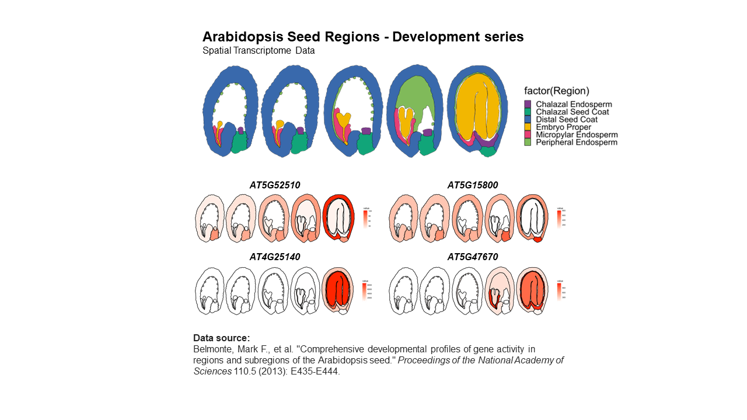
Example of a heatmap generated from a ggPlantmap. Data source: Belmonte et al., 2013

Functionality
The package is available on GitHub under the MIT License at https://github.com/leonardojo/ggPlantmap. We also created a detailed user guide through all the available functionality of ggPlantmap . We also created a walkthrough document to guide users on creating their own ggPlantmap. The following few examples demonstrate the simplicity of using ggPlantmap.
- Instalation
## Installing devtools
install.packages("devtools")
library(devtools)
## Installing ggPlantmap
install_github("leonardojo/ggPlantmap")
library(ggPlantmap)

- Pre-loaded ggPlantmaps
library(ggPlantmap)
ggPm.summary$ggPlantmap.name
## [1] "ggPm.At.roottip.crosssection"
## [2] "ggPm.At.roottip.longitudinal"
## [3] "ggPm.At.3weekrosette.topview"
## [4] "ggPm.At.leafepidermis.topview"
## [5] "ggPm.At.leaf.crosssection"
## [6] "ggPm.At.seed.devseries"
## [7] "ggPm.At.earlyembryogenesis.devseries"
## [8] "ggPm.At.shootapex.longitudinal"
## [9] "ggPm.At.inflorescencestem.crosssection"
## [10] "ggPm.Sl.root.crosssection"
## [11] "ggPm.At.leaf.topview"
## [12] "ggPm.At.rootelong.longitudinal"
## [13] "ggPm.At.rootmatur.crosssection"
## [14] "ggPm.At.flower.diagram"
## [15] "ggPm.At.lateralroot.devseries"
## [16] "ggPm.Ms.root.crosssection"
- ggPlantmap.plot() - Plotting your ggPlantmap
library(ggPlantmap)
ggPlantmap.plot(ggPm.At.inflorescencestem.crosssection,ROI.name)
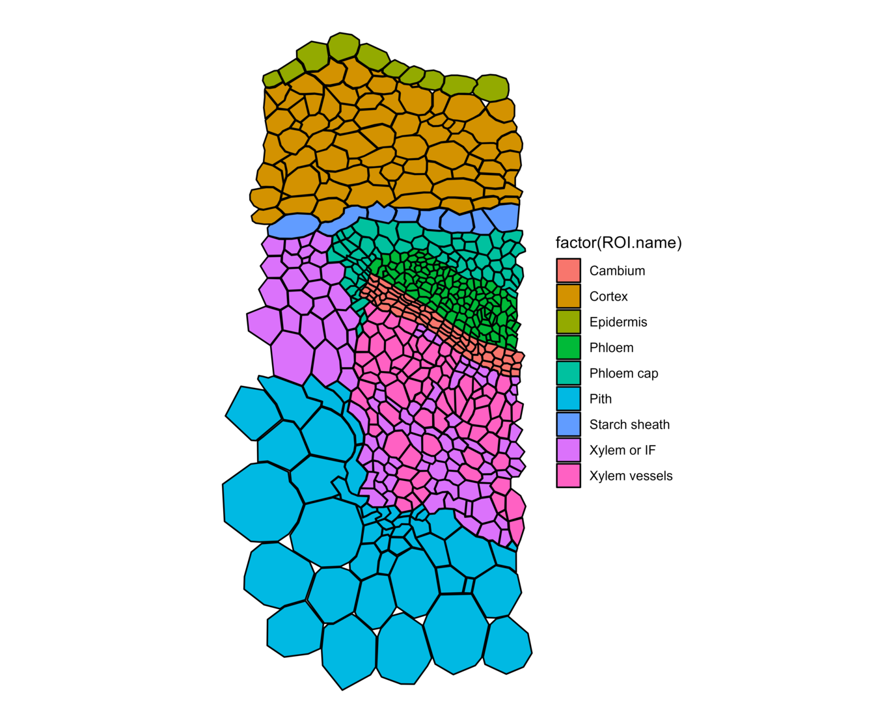
ggPlantmap plotted from ggPm.At.inflorescencestem.crosssection. The column ROI.name was used to color map the ggPlantmap.
- ggPlantmap.merge() - Combining a ggPlantmap with external quantitative data
library(ggPlantmap)
## Expression sample data
ggPm.tomatoatlas.expression.sample
## A tibble: 7 x 2
## Cell.layer SCR.expression
## <chr> <dbl>
## 1 Epidermis 1.24
## 2 Cortex 1.17
## 3 Endodermis 75.8
## 4 Phloem 0.44
## 5 Procambium 0.95
## 6 Pericycle 0.95
## 7 Xylem 2.78

## Combining with the tomato root ggPlantmap
ggPlantmap.merge(ggPm.Sl.root.crosssection,
ggPm.tomatoatlas.expression.sample,
id.x="ROI.name",
"Cell.layer")
## A tibble: 4,314 x 6
## ROI.name ROI.id point x y SCR.expression
## <chr> <int> <int> <dbl> <dbl> <dbl>
## 1 Exodermis 1 1 615. -370. 0
## 2 Exodermis 1 2 601. -349. 0
## 3 Exodermis 1 3 598. -327. 0
## 4 Exodermis 1 4 617. -312. 0
## 5 Exodermis 1 5 636. -307. 0
## 6 Exodermis 1 6 651. -310. 0
## 7 Exodermis 1 7 671. -327. 0
## 8 Exodermis 1 8 684. -343. 0
## 9 Exodermis 1 9 676. -354. 0
## 10 Exodermis 1 10 668. -365. 0
## with 4,304 more rows
- ggPlantmap.heatmap()
library(ggPlantmap)
## Combining with the tomato root ggPlantmap
ggPlantmap.expression <- ggPlantmap.merge(ggPm.Sl.root.crosssection,
ggPm.tomatoatlas.expression.sample,
id.x="ROI.name",
"Cell.layer")
ggPlantmap.heatmap(ggPlantmap.expression,SCR.expression) +
scale_fill_gradient(low="green",high="red",na.value="green")
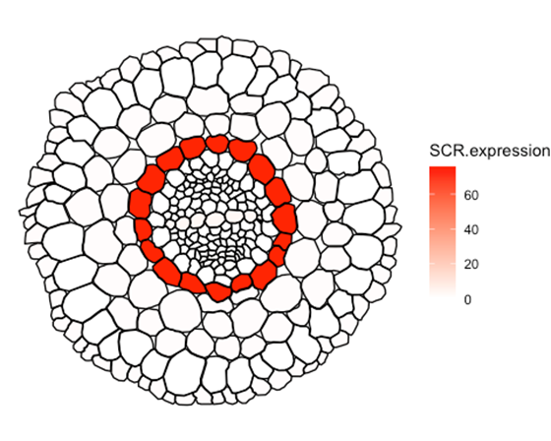
Sample for ggPlantmap heatmap. Expression of tomato SCARECROW (SCR) in distinct cell types of the tomato root. Data obtained from Kajala et al., 2021.

References
Belmonte, M.F., Kirkbride, R.C., Stone, S.L., Pelletier, J.M., Bui, A.Q., Yeung, E.C., Hashimoto, M., Fei, J., Harada, C.M., Munoz, M.D., 2013. Comprehensive developmental profiles of gene activity in regions and subregions of the Arabidopsis seed. Proceedings of the National Academy of Sciences 110, E435–E444.
Cuperus, J.T., 2022. Single-cell genomics in plants: current state, future directions, and hurdles to overcome. Plant Physiology 188, 749–755.
De Chaumont, F., Dallongeville, S., Chenouard, N., Hervé, N., Pop, S., Provoost, T., Meas-Yedid, V., Pankajakshan, P., Lecomte, T., Le Montagner, Y., 2012. Icy: an open bioimage informatics platform for extended reproducible research. Nature methods 9, 690–696.
Fuchs, M., Lohmann, J.U., 2020. Aiming for the top: non-cell autonomous control of shoot stem cells in Arabidopsis. Journal of plant research 133, 297–309.
Guo, X., Park, C.H., Wang, Z.-Y., Nickels, B.E., Dong, J., 2021. A spatiotemporal molecular switch governs plant asymmetric cell division. Nature plants 7, 667–680.
Kahle, D.J., Wickham, H., 2013. ggmap: spatial visualization with ggplot2. R J. 5, 144.
Kajala, K., Gouran, M., Shaar-Moshe, L., Mason, G.A., Rodriguez-Medina, J., Kawa, D., Pauluzzi, G., Reynoso, M., Canto-Pastor, A., Manzano, C., 2021. Innovation, conservation, and repurposing of gene function in root cell type development. Cell 184, 3333-3348. e19.
Libault, M., Pingault, L., Zogli, P., Schiefelbein, J., 2017. Plant systems biology at the single-cell level. Trends in Plant Science 22, 949–960.
Nguyen, S.T., McCurdy, D.W., 2015. High-resolution confocal imaging of wall ingrowth deposition in plant transfer cells: Semi-quantitative analysis of phloem parenchyma transfer cell development in leaf minor veins of Arabidopsis. BMC Plant Biology 15, 1–14.
Rahni, R., Birnbaum, K.D., 2019. Week-long imaging of cell divisions in the Arabidopsis root meristem. Plant Methods 15, 1–14.
Ron, M., Kajala, K., Pauluzzi, G., Wang, D., Reynoso, M.A., Zumstein, K., Garcha, J., Winte, S., Masson, H., Inagaki, S., 2014. Hairy root transformation using Agrobacterium rhizogenes as a tool for exploring cell type-specific gene expression and function using tomato as a model. Plant physiology 166, 455–469.
Shahan, R., Hsu, C.-W., Nolan, T.M., Cole, B.J., Taylor, I.W., Greenstreet, L., Zhang, S., Afanassiev, A., Vlot, A.H.C., Schiebinger, G., 2022. A single-cell Arabidopsis root atlas reveals developmental trajectories in wild-type and cell identity mutants. Developmental cell 57, 543-560. e9.
Shi, D., Jouannet, V., Agustí, J., Kaul, V., Levitsky, V., Sanchez, P., Mironova, V.V., Greb, T., 2021. Tissue-specific transcriptome profiling of the Arabidopsis inflorescence stem reveals local cellular signatures. The Plant Cell 33, 200–223.
Sotta, N., Fujiwara, T., 2017. Preparing thin cross sections of Arabidopsis roots without embedding. BioTechniques 63, 281–283.
Taiz, L., Zeiger, E., Møller, I.M., Murphy, A., 2015. Plant physiology and development. Sinauer Associates Incorporated.
Torres-Martinez, H.H., Rodriguez-Alonso, G., Shishkova, S., Dubrovsky, J.G., 2019. Lateral root primordium morphogenesis in angiosperms. Frontiers in plant science 10, 206.
Tsukaya, H., 2013. Leaf development. The Arabidopsis Book/American Society of Plant Biologists 11.
Vanhaeren, H., Gonzalez, N., Inzé, D., 2015. A journey through a leaf: phenomics analysis of leaf growth in Arabidopsis thaliana. The Arabidopsis Book/American Society of Plant Biologists 13.
Wendrich, J.R., Weijers, D., 2013. The A rabidopsis embryo as a miniature morphogenesis model. New Phytologist 199, 14–25.
Wickham, H., 2011. ggplot2. Wiley interdisciplinary reviews: computational statistics 3, 180–185.
Winter, D., Vinegar, B., Nahal, H., Ammar, R., Wilson, G.V., Provart, N.J., 2007. An “Electronic Fluorescent Pictograph” browser for exploring and analyzing large-scale biological data sets. PloS one 2, e718.

