Environmental “memory” through dynamic DNA methylation provides acclimatization of geoduck clams to ocean acidification
Abstract
We tested the sensitivity of early life stages and the potential for geoduck clams to display acclimatization to ocean acidification through a series of repeat exposure experiments. First, we exposed larval geoducks to ambient (~8.0) and low pH (~7.4) for 10 days and found that larval mortality is decreased and shell size increased in low pH conditions. Second, we exposed juvenile geoduck to ambient (~8.0), low (~7.4) and lower (~7.0) pH for 23 days, placed them in ambient common garden for several months, then re-exposed them to ambient (~8.0) pH and low pH (~7.4) for another 23 days. In geoduck juveniles there was a size benefit of preconditioning to low pH. Juvenile growth initially declined at pH ~7.4 and 7.0 in the first exposure, but when replaced in the ambient conditions, the initial exposure to low pH resulted in compensatory growth, such that the juveniles grew larger. Growth in the pre-exposed juveniles was also more resistant to low pH in the second exposure. The role of DNA methylation as a mechanism of environmental memory was tested using reduced representation bisulfite sequencing. This suggests that acclimatization to OA can result in benefits to geoduck growth, with exposure memory that is potentially linked to epigenetic mechanisms such as DNA methylation.
Introduction
Materials and Methods
Geoduck juveniles were exposed to a three component experiment (Fig. 1) designed to test for: 1) the effects of acute exposure to ocean acidification, 2) the potential for latent effects due to initial exposure, and 3) the potential for initial exposure to provide preconditioning and acclimatization to a secondary exposure. The experiments were conducted at the Kenneth K. Chew Center for Shellfish Research and Restoration in Manchester, WA. Juvenile geoduck clams were received at ~3month of age (Taylor Hatchery Quilcene, WA) on 16 March 2016. Animals were placed in 5L replicate tanks per treatment (35 x 21 x 12cm, lxwxh). The geoducks were allowed to bury themselves as desired in ~4cm of graded sand of the same source and grade from which the clams were collected at the hatchery.
Ocean Acidification Control System and Seawater Chemistry Analysis
The experiments were conducted using a flow-through, pH-stat system, with 1µm filtered seawater. The pH in the header tanks was continuously monitored with DuraFET pH probes (Honeywell, Morristown NJ, USA) that fed data back into a solenoid controlled injection system. The pH set points were achieved by the injection of ambient air or pure $CO_{2}$ into water cycling lines of the header tanks, which continually cycled water from the bottom to the top of each header for even mixing and equilibration of $CO_{2}$, as well as pumping it to the treatment tanks.
Seawater chemistry was assessed in each tank following best practices standards ((Riebesell et al. 2010)). Seawater pH, salinity and temperature were measured in each tank using a handheld probes. pH was measured in mV (resolution = 0.01, DG115SC glass probe, Mettler Toledo, Ohio, USA) and calculated for the in situ temperature against a linear regression of a tris standard (Batch 2/14/16 salinity 27.5) as a function of temperature. Temperature was measured simultaneously, with a traceable digital thermometer (Accuracy: ±0.05°C, resolution: 0.001°, temperature Range: –50 to 150°C, VWR, USA), and salinity with a traceable digital portable conductivity meter (Accuracy: 0.3%, Temperature Range: –30.0 to 130.0°C, VWR, USA). Simultaneously with the probe measurements, 120 ml water samples were collected and stored in sealed borosilicate glass bottles and poisoned with 50µl of HgCl for total alkalinity analysis. Total alkalinity was processed at the X and measured using an open cell gran titration (Dickson SOP3, (Dickson, Sabine, and Christian 2007)). Carbonate chemistry parameters were calculated using the seacarb package in R ((Gattuso et al. 2016)), within measured input parameters of pH (total scale), total alkalinity, salinity, and temperature, using constants of Kf from Perez and Fraga ((Perez and Fraga 1987)), Ks from Dickson ((Dickson 1990)) and $K_{1}K_{2}$ from Lueker et al ((Leuker, Dickson, and Keeling 2000)).
Initial Exposure Conditions
For the initial exposure, treatments were set to pH 8.0 (ambient), pH 7.4, and pH 7.0. Treatment water was delivered through pressure compensating drippers to each tank at a rate of 9.6±0.1 (mean±sem) LPH. Geoducks were fed a mix of diatoms and flagellates (Cheatoceros sp., Cheatoceros muelleri, Pavlova pinguis, Tisochrysis lutea) at a concentration of X cells $ml^{−1}$. Samples were photographed lying flat with a size standard on days 0 (n=4 per treatment), 10 (n= 8 per treatment) for shell size analysis, and 23 (n= 8 per treatment) and samples were snap frozen or sampled in RNALater on days 0 (n=4) and day 10 (n=16 per treatment) for use in molecular analysis and stored at -20 to -80°C until processing. Shell size was assessed by measuring the length (longest distance parallel to the hinge), width (distance from hinge to the ventral edge, perpendicular to length), and area (planar surface area) of clams in photographs using ImageJ ((Schneider et al. 2012)).
Common Garden Conditions
At the end of the 23 days of exposure, clams were transferred from treatment tanks into 6 bins within a 25g ambient common garden tank. The geoducks were allowed to bury themselves as desired in ~4cm of graded sand of the same source and grade from which the clams were collected at the hatchery, at a density of 32 -38 clams $bin^{1}$. Ambient hatchery temperature (14-15°C) and pH (‘7.9) were monitored continuously with an Avtech probe and durafet pH sensor, respectively. Water was exchanged at a rate of X and clams were fed a mix of diatoms and flagellates as above at a concentration of X cells $ml^{−1}$. After 28 days in the indoor common garden, clams were photograpghed for shell size analysis (n=16 per initial treatment group) and clams were pooled by initial treatment and transferred to three 5g buckets with mesh covered water exchange holes and placed hanging from the dock at Manchester, WA. Geoduck juveniles were held at ambient bay conditions (~14°C) with natural food available in Puget Sound (X food citation). After 84 days, clams were photograpghed for shell size analysis (n=28, 53, 54, for the initial treatments of pH 8.0, 7.4, and 7.0, respectively) and samples were collected for molecular analysis (n=8 per initial treatment group).
Second Exposure Conditions
Juvenile geoduck clams were returned to the hatchery for a second exposure to two different pH treatments. Animals were placed in replicate XL tanks per treatment (X x X x Xcm, lxwxh). The geoducks were allowed to bury themselves as desired in ~4cm of the same graded sand used throughout the experiment. Sand was sterilized by autoclaving prior to use in indoor tanks. For the second exposure, treatments were set to pH 8.0 (ambient) and pH 7.4. Treatment water was delivered through pressure compensating drippers to each tank at a rate of X±X (mean±sem) LPH. Geoducks were fed a mix of diatoms and flagellates (x,x,x,x) at a concentration of X cells X cells $ml^{−1}$. Clams were sampled at day 10 of the secondary exposure (n=, as well as day 23 for both shell size and molecular analysis (n=6, 12, 12 in each of the two secondary pH treatments, for the initial treatments of pH 8.0, 7.4, and 7.0, respectively).
Library Preparation
DNA was extracted using the Qiagen DNeasy according to manufacture’s instructions with slight modifications. Briefly, ~25mg samples were incubated with lysis buffer (ATL) and proteinase K at 56°C for 1hr, mixing several times throughout. Samples were incubated an additional 10 minutes following addition of buffer AL. Prior to addition to the columns, 200µl of 100% ethanol was added to each sample and instructions were followed to complete the extraction. Samples were eluted in 125-200µl of buffer AE. Samples were quantified using Qubit BR dsDNA kit and quality checked using 1.5% TAE gel. Reduced representation bisulfite sequencing (RRBS) libraries were generated. DNA samples were spiked with 0.5% (w/w) unmethylated lambda DNA (Promega cat: D1501) incubated with MSPI (20U µl-1 NEB cat: R0106L) and 10x NEBuffer2 (NEB cat: B7002S) for digestion at the cut site of CC in the sequence CCGG. Digested samples were processed with the EZ DNA Methylation-Gold Kit (Zymo Research Catalog Nos. D5005) for bisulfite conversion according to manufacturer’s instructions with a 30µl input sample and a 12µl elution. Sample quality and fragment size was assessed using the Agilent 2011 Bioanalyzer RNA pico chip. Samples passing quality control were then used for Illumina library preparation Illumina TurSeq DNA Methylation library prep kit according to manufacturer’s instructions. Samples were prepared for multiplex sequencing with 12 samples on a single lane using the Illumina DNA Methylation Kit Barcodes
(Illumina Cat #: EGIDX81312). The resulting libraries were quality controlled using the Qubit dsDNA high sensitivity kit for quantification and the Agilent Bioanalyzer DNA High Sensitivity Kit. Libraries that passed QC were pooled in equal molar concentrations and submitted to Genewiz for sequencing on the Illumina HiSeq 2500 (2x100bp).
Bioinformatics
Seqeunce data obtained from Genewiz was quality controlled initially with confrmation of checksum files. The fastq files were checked for quality using FastQC ((Andrews and others 2010)) with the paired option. Quality filter thresholds were set for trimming of sequences in Trim Galore ((Krueger 2015), no RRBS option given adapters were ligated post BS conversion, a minimum quality of 20, with the paired end option). To determine genomic methylation, samples were mapped to a draft geoduck genome (data citation?) using Bismark ((Krueger and Andrews 2011)) with the options of multicore=3, and number of mismatches allowed = 1). These same parameters were used to map the spiked lambda phage DNA to the lambda genome (Enterobacteria phage lambda complete genome Genbank Accession number J02459). The resulting mapping files were used to identify methylated CpG calls and Single Nucleotide Polymorphisms (SNP) via MethylExtract ((Barturen et al. 2014)), with a minimum quality of 30, discarding nucleotides with frequency <0.05, and a maximum p value for SNP =0.01). Lambda phage methylation calls were used to determine conversion efficiency in each sample. Geoduck methylation files were combined using R and SNP calls combined into a relatedness matrix for each statistical comparison using vcf-merge (x), with relatedness calculated vial vcf-tools ((Danecek et al. 2011)) relatedness call.
http://owl.fish.washington.edu/halfshell/working-directory/17-01-30/igv_session-EPI-013017.xml
Statistical Analyses
For clam shell size, linear modeling was used to test hypotheses 1 and 2, with the fixed factors of treatment and time and for hypothesis 3 using the fixed factor of initial pH x secondary pH.
Binomial mixed effects modeling was used to analyze DNA methylation data with the program MACAU ((Lea, Tung, and Zhou 2015)). MACAU provides the benefit of analyzing raw count data thereby including coverage as an indication of the reliability of the DNA methylation estimate and increasing the power to detect true methylation differences. Further MACAU allows the user to include sample relatedness data and thereby controlling for genetic effects on DNA methylation. We used MACAU to model the DNA methylation for each CpG site individually as a function of seawater pH (fixed), and genetic relatedness (random) for data from day 10, to test the hypothesis that acute exposure to low pH resulted in differential DNA methylation . To test the hypothesis that there was a memory of initial pH exposure through differential DNA methylation after grow out in an ambient pH common garden setting, DNA methylation was modeled as a function of seawater pH (fixed), time (fixed), and genetic relatedness (random) for data from day 10 and day 135. To test the hypothesis that initial exposure to low pH modulated DNA methylation in subsequent exposures, DNA methylation was modeled as a function of initial seawater pH (fixed), secondary seawater pH (fixed), and genetic relatedness (random) for data from day 145.
Results
Discussion
Figures and Legends
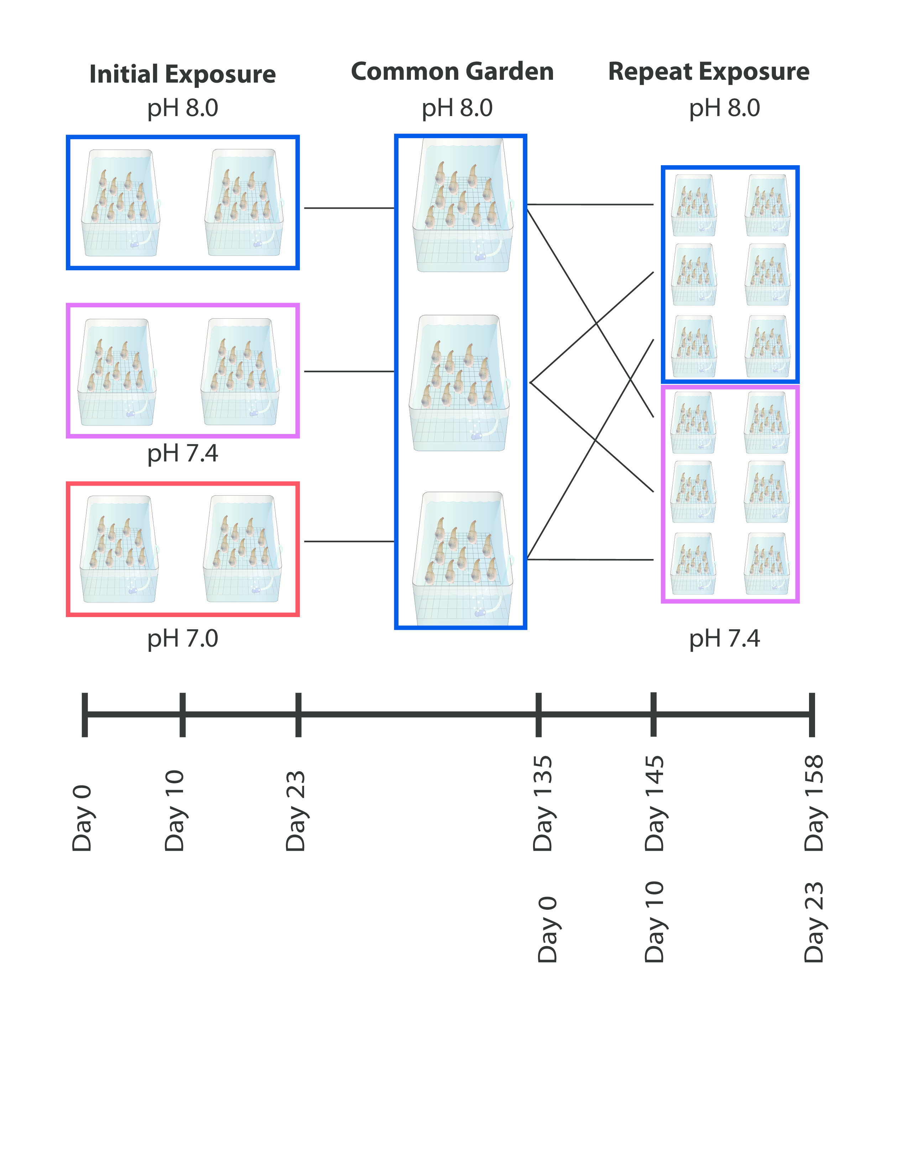
Experimental design and sampling timpoint for geoduck exposure to ocean acidification
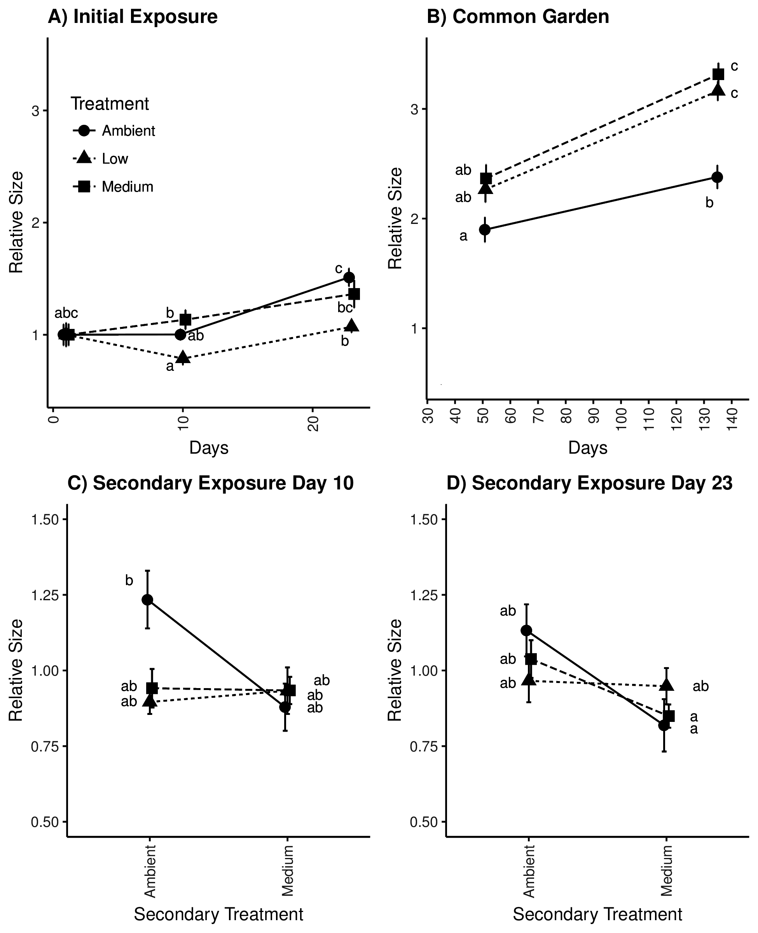
Figure 2. Geoduck clam shell size under different ocean acidification conditions. A) geoduck shell area relative to mean day 0 shell size under three different pH levels, B) geoduck shell area relative to mean day 23 shell size for each treatment during common garden ambient pH exposure, C) geoduck shell area relative to mean day 135 shell size for clams preconditioned to to three different pH conditions under secondary exposure to ambient or medium pH, and D) geoduck shell area relative to mean day 135 shell size for clams preconditioned to to three different pH conditions under secondary exposure to ambient or medium pH.
Data Analysis Outline
Sequencing data was initially trimmed using Trim Galore v0.4.3 (q = 20, paired end) (Krueger, 2012) After trimming, reads were mapped back to the geoduck genome using Bismark v0.17.0 (N = 1) (Krueger and Andrews, 2011). Methylation status was extracted from the Bismark output via Methyl Extract v1.9.1 (minQ=30 varFraction=0.05 maxPval=0.01 flagW=99,147 flagC=83,163) (Barturen et al., 2013)
- FastQC (paired option)
- Trim Galore (No RRBS, min quality value 20, paired option)
- Bismark Genome Prep (Lambda genome found here, P. generosa genome found here
- Bismark Alignment (-multicore = 3, # of mismatches allowed = 1)
- MethylExtract (min quality for base = 30, discard nucleotides with frequency less than 0.05, max p-val for location to be considered SNP is 0.01)
- Combine indivudal sample SNP VCFs via vcf-merge
- Calculate relatedness via vcftools –relatedness
- Combine methylation data using R’s merge function (unless this blows up R, these are some big files, then we’ll need to find an SQL solution)
- Feed relatedness matrix, methylation matrix, and predictor matrix in to MACAU
Andrews S., 2010. FastQC: a quality control tool for high throughput sequence data. Available online at: http://www.bioinformatics.babraham.ac.uk/projects/fastqc
Barturen, G. et al., 2013. MethylExtract: High-Quality methylation maps and SNV calling from whole genome bisulfite sequencing data. [version 2; referees: 3 approved]. F1000Research, 2, p.217.
Danecek, P. et al., 2011. The variant call format and VCFtools. Bioinformatics, 27(15), pp.2156–2158.
Krueger, F. & Andrews, S.R., 2011. Bismark: a flexible aligner and methylation caller for Bisulfite-Seq applications. Bioinformatics, 27(11), pp.1571–1572.
Krueger, F., 2012. Trim Galore: a wrapper tool around CutAdapt and FastQC. Availble online at: http://www.bioinformatics.babraham.ac.uk/projects/trim_galore/
Lea, A.J., Tung, J. & Zhou, X., 2015. A flexible, efficient binomial mixed model for identifying differential DNA methylation in bisulfite sequencing data. PLoS Genetics, 11(11), p.e1005650.
R Core Team, 2016. R: A language and environment for statistical computing. R Foundation for Statistical Computing, Vienna, Austria. Available online at: https://www.R-project.org/.

References
Riebesell, Ulf, Victoria J. Fabry, Lina Hansson, Jean-Pierre Gattuso, and others. 2010. Guide to Best Practices for Ocean Acidification Research and Data Reporting. Vol. 260. Publications Office of the European Union Luxembourg. https://www.researchgate.net/profile/Jean-Pierre_Gattuso/publication/232708105_Guide_to_best_practices_for_ocean_acidification_research_and_data_reporting/links/0912f50d7f51a70413000000.pdf.
Dickson, Andrew Gilmore, Christopher L. Sabine, and James Robert Christian. 2007. “Guide to Best Practices for Ocean CO2 Measurements.”. PICES Special Publication 3. http://www.oceandatapractices.net/handle/11329/249.
Gattuso, J. P., J. M. Epitalon, H. Lavigne, J. Orr, B. Gentili, A. Hofmann, A. Proye, K. Soetaert, and J. Rae. 2016. “Seacarb: Seawater Carbonate Chemistry with R”. R Package Version 3.1.1 (8).
Perez, F F, and F Fraga. 1987. “Association Constant of Fluoride and Hydrogen Ions in Seawater.”. Marine Chemistry 21: 161–68.
Dickson, Andrew Gilmore. 1990. “Standard Potential of the Reaction: AgCI(s) + 1/2H2(g) = Ag(s) + HCI(Aq), and the Standard Acidity Constant of the Ion HSO4 in Synthetic Sea Water from 273.15 to 318.15 K”. Journal of Chemical Thermodynamics 22: 113–27.
Leuker, TJ, Andrew Gilmore Dickson, and CD Keeling. 2000. “Ocean PCO2 Calculated from Dissolved Inor- Ganic Carbon, Alkalinity, and Equations for K1 and K2: Validation Based on Laboratory Measurements of CO2 in Gas and Seawater at Equilibrium.”. Marine Chemistry 70: 105–19.
Schneider, Caroline A., Wayne S. Rasband, Kevin W. Eliceiri, and others. 2012. “NIH Image to ImageJ: 25 Years of Image Analysis”. Nat Methods 9 (7): 671–75. https://www.researchgate.net/profile/Kevin_Eliceiri/publication/228085958_NIH_Image_to_ImageJ_25_years_of_image_analysis/links/0fcfd4fee589e852eb000000.pdf.
Andrews, Simon, and others. 2010. FastQC: a Quality Control Tool for High Throughput Sequence Data.
Krueger, Felix. 2015. “Trim Galore”. A Wrapper Tool around Cutadapt and FastQC to Consistently Apply Quality and Adapter Trimming to FastQ Files.
Krueger, Felix, and Simon R. Andrews. 2011. “Bismark: a Flexible Aligner and Methylation Caller for Bisulfite-Seq Applications”. Bioinformatics 27 (11): 1571–72. http://bioinformatics.oxfordjournals.org/content/27/11/1571.short.
Barturen, Guillermo, Antonio Rueda, José L. Oliver, and Michael Hackenberg. 2014. “MethylExtract: High-Quality Methylation Maps and SNV Calling from Whole Genome Bisulfite Sequencing Data”. F1000Research 2. https://f1000research.com/articles/2-217/.
Danecek, Petr, Adam Auton, Goncalo Abecasis, Cornelis A. Albers, Eric Banks, Mark A. DePristo, Robert E. Handsaker, et al. 2011. “The Variant Call Format and VCFtools”. Bioinformatics 27 (15): 2156–58. http://bioinformatics.oxfordjournals.org/content/27/15/2156.short.
Lea, Amanda J., Jenny Tung, and Xiang Zhou. 2015. “A Flexible, Efficient Binomial Mixed Model for Identifying Differential DNA Methylation in Bisulfite Sequencing Data”. PLoS Genet 11 (11): e1005650. http://journals.plos.org/plosgenetics/article?id=10.1371/journal.pgen.1005650.

