Practical 1 - Collapse of Global Fisheries
Noah Atkin

Q1. There is evidence of non-linear change in fish catches over the time series in the ICES data.

(a) produce an annotated graph of the relevant data for one named species that shows especially marked changes over time;

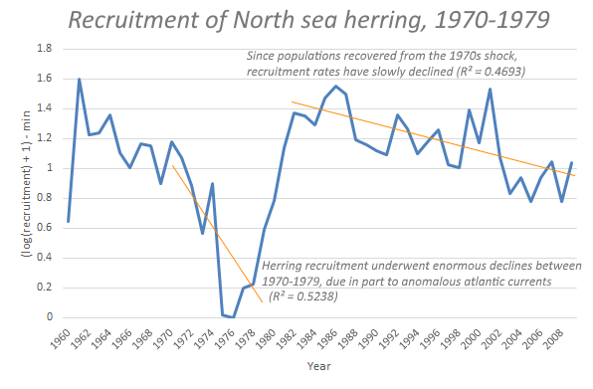
North sea herring populations have undergone dramatic shifts between 1960-2008, most noticeably between 1970-1979 where a decrease in egg laying and anomalous Atlantic current led to a crash of recruitment rates (Turrell, Henderson, Slesser, et al., 1992; Hutchings & Reynolds, 2004). Since recovery, recruitment rates of herring have consistently decreased, which if allowed to continue will reach 1976 recruitment levels by 2047 (Corten, 2012)

(b) suggest an environmental or policy change that might have caused some of these temporal shifts and cite a relevant paper as supporting evidence.
Herring larvae survival rate is intrinsically linked to their rate of drift from their birthplace around the British Isles to the more sheltered areas of the German Bright and Skagerrak, which are capable of supporting larger populations of larvae due to the spring plankton bloom (Bückmann, Mielck & Kotthaus, 1950). If the time taken to drift is too long, the larvae are vulnerable to predation or starvation. Circulation of north sea waters are driven by a number of environmental factors, including oceanic inflow from the Atlantic (Turrell, Henderson, Slesser, et al., 1992). Hydrographic data from this time indicates a number of anomalies in the timing of arrival of oceanic inflow coming much later compared to previous years, and has been backed up by planktonic data showing a significant reduction in transport over this time period(Corten, 2012). Combined, this suggests the 1971-1979 collapse was due in part due to anomalous variance in oceanic inflow from the Atlantic.

Q2. Why might catch data like these give unreliable estimates of the true underlying population abundance and the ability to withstand increased fishing pressure?
Despite the ubiquity of recruitment as the underlying measure for estimating marine populations (due to the relative ease of counting on land compared to at sea), recruitment data is generally considered to underestimate total fish populations. Not all of a catch is landed, due to at-sea discarding of sub-optimal fish, such as juveniles. One such estimate by the FAO suggested 10% of all caught herrings, sardines & anchovies are discarded at sea; this value increases to 45% when examining flounders, halibuts & soles (FAO, 1994). In multi-species fisheries, at-sea discards are proportionally larger due to unintentional capture of unwanted species, as well as rejection of poor quality fish of the intended species. In areas where regulations on catch size are in place, recruitment data is distorted to fit these regulations, leading to certain EEA jurisdictions to climate use of recruitment data as a measure of populations (Cook, 2013).

Q3. (a) Based on current global IUCN status and other sources, which is globally the most vulnerable species in your dataset, and why?
Haddock is currently listed as vulnerable on the IUCN red list, on the basis of previous observed population reduction and projected levels of future population reduction based on potential levels of exploitation (A1 + A2d) (Baillie, Gärdenfors, Groombridge, et al., 1996). The last IUCN estimate took place in 1996, and is in need of updating; however current trends indicate overfishing of haddock is continuing on a global scale, as recently as 2017, the EU and Norway agreeing to reduce haddock catches for 2017, due to a report from ICES indicating significant population declines (ICES, 2018).

(b) from your dataset what is the minimum catch for this species, expressed as a % of its peak, across your time series?
The minimum landings value recorded, which is from 2008 represents only 4.69% of the peak recruitment value, which was collected 39 years earlier in 1969.

(c) Name a key species trait that is commonly related to vulnerability to overfishing for one of the species in Table 1, explain briefly why this trait makes it vulnerable, and cite the source of information related to that named species (e.g. FishBase; Harvard-cited paper; ICES reports etc).
Large body size is associated with vulnerability to overfishing, in part because large body size requires more growth (and sometimes, but not necessarily, more time) before sexual maturity. This is in part because larger individuals are easier to be caught by conventional fishing methods (Pinsky, Jensen, Ricard, et al., 2011). Saithes have a particularly large body size compared to the other species in the dataset, and this trait in saithes has been specifically linked to an increased risk of over-fishing in North-East Atlantic (Jennings, Reynolds & Mills, 1998).

d) Can you find any published evidence of a named species trait (different from the one you have already selected above) that has been linked to declining landings in the N Sea
Age at maturity has been theoretically vulnerability to overfishing vulnerability, using models with a fixed mortality rate (Cardinale & Modin, 1999). Unfortunately, I’ve been unable to locate a paper that specifically links this with declining landings in the North Sea, however I have found a paper that links specifically a) an increase in overfishing vulnerability in species with a later age at maturity b) examination of population trends across a range of north sea fish stock, including the north sea saithe c) Identification of the north sea saithe as a fish that’s at risk of overfishing and to experience relative declines in future years (Jennings, Reynolds & Mills, 1998).

Q4. a) Construct a simple food web, either graphically or as a feeding matrix, for ONLY the 8 species in your database.

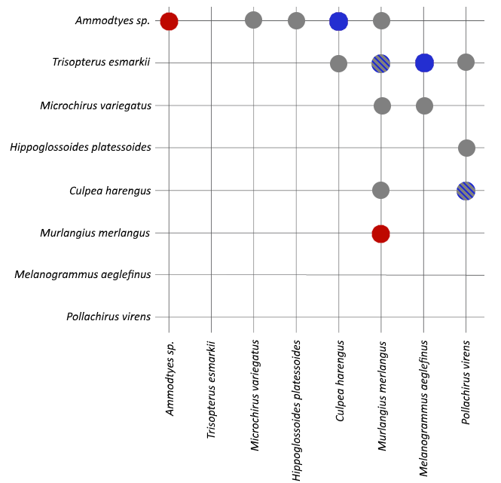
Food web for 8 species found in the North Sea. Grey dots indicate observed feeding interactions established from literature, red dots indicate observed cannibalism, blue dots indicate feeding interactions that are predicted under allometric diet breadth models (ADBM), but haven’t been directly observed; and grey/blue dots indicate observed feeding that was also predicted by ADBM.

b) Which species in your food web module might you expect to be especially prone to (i) bioaccumulation and/or (ii) biomagnification of heavy-metal pollution in marine sediments, and why?
Mercury compounds, including methyl-mercury (MeHg), are particularly toxic and subject to bioaccumulation as they have a strong affinity for sulfhydryl groups (Stadnicka, Schirmer & Ashauer, 2012). The rate of bioaccumulation of mercury has been shown to be predominantly driven by the interaction between growth rate and rate of consumption (i), and the concentrations of mercury compounds in prey (ii) (Ward, Nislow & Folt, 2010).
i) We predict that fish with a higher growth efficiency (ie higher fraction of food mass converted to body mass) will be able to dilute absorbed MeHg in their increased biomass; hence fish with poor growth efficiency as particularly prone to bioaccumulation within a trophic level. Growth efficiency can be estimated mathematically by the size ratio between the prey and the predator; the rarity of the prey and maximum size (Kerr, 1971; Hamre, Johnsen & Hamre, 2014). For these reasons I would suggest the American plaice is particularly susceptible to intra-trophic bioaccumulation, as it has the 2nd largest maximum size and it’s growth rate levels off soon after maturity, radically reducing growth efficiency, leading to less MeHg dilution, leading to increased bioaccumulation (HEATH, 2005).
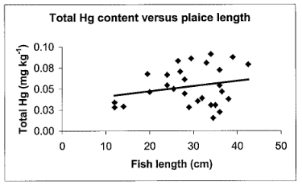
Total Hg content versus fish length in plaice (Baeyens, Leermakers, Papina, et al., 2003)
ii) The risk of biomagnification increases with numerical trophic value, The saithe seems most susceptible to biomagnification, (the increase in concentration of a toxic substance as you increase trophic levels), due to its role as a tertiary consumer at the later stages of its life (Homrum, Hansen, Steingrund, et al., 2012) - as opposed to the whiting and the sole, at maturity secondary consumers make up a greater proportion of its dietary biomass, increasing the magnification of heavy metals within its tissues.

c) Identify a non-fish species (exc. Humans) that is a known major consumer of at least one of your 8 focal species that could be used as a potential ecological indicator of the health of the N Sea fishery (ensure you cite your sources). What functional traits of this species would make it a useful indicator?
The common stingray is a consumer of young herring in the North Sea, and can act as a direct competitor for larger herring (Heath, 2012). It has been previously suggested that the spawning biomass and mortality of the pelagic stingray is a potential ecological indicator for the mortality and spawning biomasss of the herring (Kabuta & Laane, 2003). The common stingray is easy to identify from other ray species due to its distinctive tail, they also have a predictable feeding pattern making catching easier to accomplish high trophic level (3.5-3.8), and so monitoring populations of stingray is considerably easier than monitoring herring stock directly (Coll, Shannon, Kleisner, et al., 2016; Kleisner, Coll, Lynam, et al., 2015).

d) Describe how size-based measures might be developed as ecosystem-level biomonitoring indicators of the health of the N Sea fishery as a whole
Many life history traits of organisms are correlated with body size, and trophic roles are intrinsically linked to overall size (and trophic roles can change over the lifetime of an organism), hence size-based measure can theoretically be used to examine food-web health and changing life history traits of individuals (SHIN, ROCHET, JENNINGS, et al., 2005). Fishing directly decreases the community abundance and biomass, which indirectly affects population selection processes (favouring slow growth, early maturation, smaller overall body size) (Badalamenti, Anna, Pinnegar, et al., 2002). Monitoring key factors such as mean biomass of a population, mean length at maturity and size diversity can indicate shifts in ecosystem roles in the North Sea.

Q5. Atlantic salmon fish farms in Scotland rely heavily on fishmeal derived from sandeels – why has this been criticized on ecological grounds?
Sandeels are a critical part of the north sea foodweb, with many predators including seals, seabirds and many predatory fish. Increases in sandeel stock are associated with significant decrease in the stocks of cod, haddock & herring (Sherman, Jones, Sullivan, et al., 1981), and is predicted to be linked to declines in seabirds and seals as well. Closures of sandeel fisheries has been linked to increases in some populations of top level seabird predators, and fear over the potential link between overfishing of sandeels and nearby declines of seabirds has led some sandeels fisheries to shut down (Greenstreet, Armstrong, Mosegaard, et al., 2006; Daunt, Wanless, Greenstreet, et al., 2008). The effect of intensive sand eel farming on sea bird populations has been debated. One such paper, funded by the International Fishmeal and Oil Manufacturers Association, indicated that the population declines associated with intensive sandeel farming are minor, and limited to a proportionally small number of sea birds (Furness, 2002).

References
Turrell, W.R., Henderson, E.W., Slesser, G., Payne, R., et al. (1992) Seasonal changes in the circulation of the northern North Sea. Continental Shelf Research. [Online] 12 (2-3), 257–286. Available from: doi:10.1016/0278-4343(92)90032-f.
Hutchings, J.A. & Reynolds, J.D. (2004) Marine Fish Population Collapses: Consequences for Recovery and Extinction Risk. BioScience. [Online] 54 (4), 297. Available from: doi:10.1641/0006-3568(2004)054[0297:mfpccf]2.0.co;2.
Corten, A. (2012) Recruitment depressions in North Sea herring. ICES Journal of Marine Science. [Online] 70 (1), 1–15. Available from: doi:10.1093/icesjms/fss187.
Bückmann, A., Mielck, W. & Kotthaus, A. (1950) Die Untersuchungen der Biologischen Anstalt über die Ökologie der Heringsbrut in der Südlichen Nordsee. Helgoländer Wissenschaftliche Meeresuntersuchungen. [Online] 3 (1), 1–57. Available from: doi:10.1007/bf02252087.
FAO (1994) A global assessment of fisheries bycatch and discards. [Online]. p.223. Available from: http://www.fao.org/docrep/003/T4890E/T4890E03.htm.
Cook, R.M. (2013) A fish stock assessment model using survey data when estimates of catch are unreliable. Fisheries Research. [Online] 1431–11. Available from: doi:10.1016/j.fishres.2013.01.003.
Baillie, J., Gärdenfors, U., Groombridge, B., Rabb, G., et al. (1996) 1996 IUCN red list of threatened animals. [Online]. IUCN. Available from: https://portals.iucn.org/library/node/7044 place of publication = Washington D.C. place of publication = Washington D.C..
ICES (2018) ICES Advice on fishing opportunities, catch, and effort Celtic Seas and Oceanic Northeast Atlantic ecoregions: Haddock ( Melanogrammus aeglefinus ) in Division 6.b (Rockall). [Online] Available from: doi:10.17895/ices.pub.4451.
Pinsky, M.L., Jensen, O.P., Ricard, D. & Palumbi, S.R. (2011) Unexpected patterns of fisheries collapse in the world’s oceans.. Proc Natl Acad Sci U S A. 1088317–8322.
Jennings, S., Reynolds, J.D. & Mills, S.C. (1998) Life history correlates of responses to fisheries exploitation. Proceedings of the Royal Society of London. Series B: Biological Sciences. [Online] 265 (1393), 333–339. Available from: doi:10.1098/rspb.1998.0300.
Cardinale, M. & Modin, J. (1999) Changes in size-at-maturity of Baltic cod (Gadus morhua) during a period of large variations in stock size and environmental conditions. Fisheries Research. [Online] 41 (3), 285–295. Available from: doi:10.1016/s0165-7836(99)00021-1.
Stadnicka, J., Schirmer, K. & Ashauer, R. (2012) Predicting Concentrations of Organic Chemicals in Fish by Using Toxicokinetic Models. Environmental Science & Technology. [Online] 46 (6), 3273–3280. Available from: doi:10.1021/es2043728.
Ward, D.M., Nislow, K.H. & Folt, C.L. (2010) Bioaccumulation syndrome: identifying factors that make some stream food webs prone to elevated mercury bioaccumulation.. Ann N Y Acad Sci. 119562–83.
Kerr, S.R. (1971) Prediction of Fish Growth Efficiency in Nature. Journal of the Fisheries Research Board of Canada. [Online] 28 (6), 809–814. Available from: doi:10.1139/f71-121.
Hamre, J., Johnsen, E. & Hamre, K. (2014) A new model for simulating growth in fish.. PeerJ. 2e244.
HEATH, M. (2005) Changes in the structure and function of the North Sea fish foodweb 19732000, and the impacts of fishing and climate. ICES Journal of Marine Science. [Online] 62 (6), 1202–1202. Available from: doi:10.1016/j.icesjms.2005.07.008.
Baeyens, W., Leermakers, M., Papina, T., Saprykin, A., et al. (2003) Bioconcentration and Biomagnification of Mercury and Methylmercury in North Sea and Scheldt Estuary Fish. Archives of Environmental Contamination and Toxicology. [Online] 45 (4), 498–508. Available from: doi:10.1007/s00244-003-2136-4.
Homrum, E.Í., Hansen, B., Steingrund, P. & Hátún, H. (2012) Growth maturation, diet and distribution of saithe (Pollachius virens) in Faroese waters (NE Atlantic). Marine Biology Research. [Online] 8 (3), 246–254. Available from: doi:10.1080/17451000.2011.627921.
Heath, M.R. (2012) Ecosystem limits to food web fluxes and fisheries yields in the North Sea simulated with an end-to-end food web model. Progress in Oceanography. [Online] 10242–66. Available from: doi:10.1016/j.pocean.2012.03.004.
Kabuta, S.H. & Laane, R.W.P.M. (2003) Ecological performance indicators in the North Sea: development and application. Ocean & Coastal Management. [Online] 46 (3-4), 277–297. Available from: doi:10.1016/s0964-5691(03)00009-7.
Coll, M., Shannon, L.J., Kleisner, K.M., Juan-Jordá, M.J., et al. (2016) Ecological indicators to capture the effects of fishing on biodiversity and conservation status of marine ecosystems. Ecological Indicators. [Online] 60947–962. Available from: doi:10.1016/j.ecolind.2015.08.048.
Kleisner, K.M., Coll, M., Lynam, C.P., Bundy, A., et al. (2015) Evaluating changes in marine communities that provide ecosystem services through comparative assessments of community indicators. Ecosystem Services. [Online] 16413–429. Available from: doi:10.1016/j.ecoser.2015.02.002.
SHIN, Y., ROCHET, M., JENNINGS, S., FIELD, J., et al. (2005) Using size-based indicators to evaluate the ecosystem effects of fishing. ICES Journal of Marine Science. [Online] 62 (3), 384–396. Available from: doi:10.1016/j.icesjms.2005.01.004.
Badalamenti, F., Anna, G., Pinnegar, J. & Polunin, N. (2002) Size-related trophodynamic changes in three target fish species recovering from intensive trawling. Marine Biology. [Online] 141 (3), 561–570. Available from: doi:10.1007/s00227-002-0844-3.
Sherman, K., Jones, C., Sullivan, L., Smith, W., et al. (1981) Congruent shifts in sand eel abundance in western and eastern North Atlantic ecosystems. Nature. [Online] 291 (5815), 486–489. Available from: doi:10.1038/291486a0.
Greenstreet, S., Armstrong, E., Mosegaard, H., Jensen, H., et al. (2006) Variation in the abundance of sandeels Ammodytes marinus off southeast Scotland: an evaluation of area-closure fisheries management and stock abundance assessment methods. ICES Journal of Marine Science. [Online] 63 (8), 1530–1550. Available from: doi:10.1016/j.icesjms.2006.05.009.
Daunt, F., Wanless, S., Greenstreet, S.P.R., Jensen, H., et al. (2008) The impact of the sandeel fishery closure on seabird food consumption distribution, and productivity in the northwestern North Sea. Canadian Journal of Fisheries and Aquatic Sciences. [Online] 65 (3), 362–381. Available from: doi:10.1139/f07-164.
Furness, R. (2002) Management implications of interactions between fisheries and sandeel-dependent seabirds and seals in the North Sea. ICES Journal of Marine Science. [Online] 59 (2), 261–269. Available from: doi:10.1006/jmsc.2001.1155.

